Lab-Day-1-Start.R
dhruv
2025-02-06
# Lab Day 1
#
# Please load the data, which contains information about over 1300 episodes of the TV show "Shark Tank".
# Analyze the data using everything you have learned in this course so far and come up with 5 business
# insights regarding the startups/deals on the show. Answer the following questions (in 2-3 sentences)
# and include your final code below. When you are done, click on File > Compile Report > MS Word and
# submit the resulting Word document.
#
# Q: What is your 1st business insight?
# A: High Deal Success Rate Out of 1,317 total pitches, 792 secured a deal,
#. meaning about 60% of pitchers received funding.
#. This indicates a strong investor interest and a relatively high success rate for securing deals.
#
# Q: What is your 2nd business insight?
# A: Industry Investment Trends
# The Travel industry sees the highest average deal amount ($1,170,000),
#. far exceeding the overall average deal ($293,602.5).
#. Liquor/Alcohol ($645,000) and Health/Wellness ($458,289.5) also receive substantial investments,
#. indicating strong investor interest in these sectors.
#
# Q: What is your 3rd business insight?
# A: Asking vs. Deal Amount
# The average ask value ($283,174.6) is slightly lower than the average deal amount ($293,602.5),
# suggesting that pitchers generally receive funding close to or slightly above their initial ask.
# However, this may vary by industry and deal negotiation dynamics.
# Q: What is your 4th business insight?
# A: Geographical Distribution of Pitchers
# California (216) dominates as the state with the most pitchers, followed by New York (77) and Texas (57).
# This indicates strong entrepreneurial and pitching activity in CA, likely due to its startup ecosystem and investment opportunities.
# Q: What is your 5th business insight?
# A: Industry Diversity and Funding Variability
# With 16 industries represented, investment is spread across multiple sectors.
# Some industries, like Children/Education ($220,735.9) and Pet Products ($235,906.2),
# receive smaller average deal amounts, while high-capital industries like Travel ($1,170,000) attract significantly larger deals.
#load liabraries tidyverse and here
library(tidyverse)
## ── Attaching core tidyverse packages ──────────────────────── tidyverse 2.0.0 ──
## ✔ dplyr 1.1.4 ✔ readr 2.1.5
## ✔ forcats 1.0.0 ✔ stringr 1.5.1
## ✔ ggplot2 3.5.1 ✔ tibble 3.2.1
## ✔ lubridate 1.9.4 ✔ tidyr 1.3.1
## ✔ purrr 1.0.2
## ── Conflicts ────────────────────────────────────────── tidyverse_conflicts() ──
## ✖ dplyr::filter() masks stats::filter()
## ✖ dplyr::lag() masks stats::lag()
## ℹ Use the conflicted package (<http://conflicted.r-lib.org/>) to force all conflicts to become errors
library(here)
## here() starts at /Users/dhruv/BAN663/BAN663 Code&Data
# load "Lab Day 1-Data.csv" from file "Lab 1"
data <- read_csv(here("Lab 1", "Lab Day 1-Data.csv"))
## Rows: 1317 Columns: 13
## ── Column specification ────────────────────────────────────────────────────────
## Delimiter: ","
## chr (5): Startup Name, Industry, Pitchers Gender, Pitchers State, Deal Valua...
## dbl (6): Year Aired, Ask Amount, Ask Equity, Deal Amount, Deal Equity, Numbe...
## lgl (2): Multiple Entrepreneurs, Got Deal
##
## ℹ Use `spec()` to retrieve the full column specification for this data.
## ℹ Specify the column types or set `show_col_types = FALSE` to quiet this message.
# show summary
summary(data)
## Startup Name Year Aired Industry Pitchers Gender
## Length:1317 Min. :2009 Length:1317 Length:1317
## Class :character 1st Qu.:2014 Class :character Class :character
## Mode :character Median :2017 Mode :character Mode :character
## Mean :2017
## 3rd Qu.:2020
## Max. :2024
##
## Pitchers State Multiple Entrepreneurs Ask Amount Ask Equity
## Length:1317 Mode :logical Min. : 10000 Min. :0.0100
## Class :character FALSE:489 1st Qu.: 100000 1st Qu.:0.1000
## Mode :character TRUE :401 Median : 200000 Median :0.1000
## NA's :427 Mean : 283175 Mean :0.1365
## 3rd Qu.: 325000 3rd Qu.:0.2000
## Max. :5000000 Max. :1.0000
##
## Got Deal Deal Valuation Deal Amount Deal Equity
## Mode :logical Length:1317 Min. : 10000 Min. :0.0200
## FALSE:525 Class :character 1st Qu.: 100000 1st Qu.:0.1500
## TRUE :792 Mode :character Median : 200000 Median :0.2000
## Mean : 293602 Mean :0.2431
## 3rd Qu.: 350000 3rd Qu.:0.3000
## Max. :5000000 Max. :1.0000
## NA's :525 NA's :525
## Number of Sharks in Deal
## Min. :1.000
## 1st Qu.:1.000
## Median :1.000
## Mean :1.321
## 3rd Qu.:2.000
## Max. :5.000
## NA's :525
# convert "Startup Name" to unordered factor
data$`Startup Name` <- as.factor(data$`Startup Name`)
# convert "Year Aired" to unordered factor
data$`Year Aired` <- as.factor(data$`Year Aired`)
# convert "Industry" to unordered factor
data$Industry <- as.factor(data$Industry)
# convert "Pitchers Gender" to unordered factor
data$`Pitchers Gender` <- as.factor(data$`Pitchers Gender`)
# convert "Pitchers State" to unordered factor
data$`Pitchers State` <- as.factor(data$`Pitchers State`)
# convert "Multiple Entrepreneurs" to unordered factor
data$`Multiple Entrepreneurs` <- as.factor(data$`Multiple Entrepreneurs`)
# convert "Got Deal" to unordered factor
data$`Got Deal` <- as.factor(data$`Got Deal`)
# Show unique values in Deal Valuation
unique(data$`Deal Valuation`)
## [1] NA "Medium Valuation" "Small Valuation" "Large Valuation"
# Convert "Deal Valuation" to ordered factor "Small Valuation<Medium Valuation<Large Valuation"
data$`Deal Valuation` <- factor(data$`Deal Valuation`, levels = c("Small Valuation", "Medium Valuation", "Large Valuation"), ordered = TRUE)
# show summary
summary(data)
## Startup Name Year Aired Industry
## CopadiVino : 2 2016 :115 Food and Beverage :287
## EchoValleyMeats: 2 2014 :114 Lifestyle/Home :232
## FortMagic : 2 2015 :112 Fashion/Beauty :221
## #besomebody : 1 2013 :106 Children/Education :121
## 180Cup : 1 2017 :104 Fitness/Sports/Outdoors:121
## 2400Expert : 1 2021 :104 Health/Wellness : 65
## (Other) :1308 (Other):662 (Other) :270
## Pitchers Gender Pitchers State Multiple Entrepreneurs Ask Amount
## Female :349 CA :216 FALSE:489 Min. : 10000
## Male :719 NY : 77 TRUE :401 1st Qu.: 100000
## Mixed Team:242 TX : 57 NA's :427 Median : 200000
## NA's : 7 FL : 49 Mean : 283175
## IL : 31 3rd Qu.: 325000
## (Other):342 Max. :5000000
## NA's :545
## Ask Equity Got Deal Deal Valuation Deal Amount
## Min. :0.0100 FALSE:525 Small Valuation :270 Min. : 10000
## 1st Qu.:0.1000 TRUE :792 Medium Valuation:265 1st Qu.: 100000
## Median :0.1000 Large Valuation :257 Median : 200000
## Mean :0.1365 NA's :525 Mean : 293602
## 3rd Qu.:0.2000 3rd Qu.: 350000
## Max. :1.0000 Max. :5000000
## NA's :525
## Deal Equity Number of Sharks in Deal
## Min. :0.0200 Min. :1.000
## 1st Qu.:0.1500 1st Qu.:1.000
## Median :0.2000 Median :1.000
## Mean :0.2431 Mean :1.321
## 3rd Qu.:0.3000 3rd Qu.:2.000
## Max. :1.0000 Max. :5.000
## NA's :525 NA's :525
# What is the Average Ask Amount?
# Calculate Average of "Ask Amount"
mean(data$`Ask Amount`, na.rm = TRUE)
## [1] 283174.6
# Gender Distribution
# Plot "Pitchers Gender"using default styling,
ggplot(data, aes(x = `Pitchers Gender`)) + geom_bar() + theme(axis.text.x = element_text(angle = 45, hjust = 1))
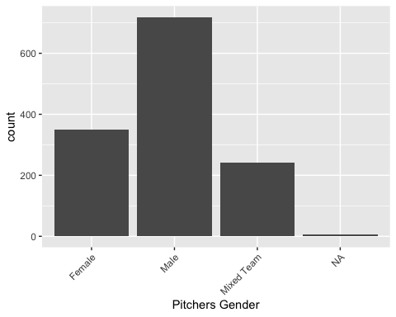
# Give count of "Pitchers Gender"
table(data$`Pitchers Gender`)
##
## Female Male Mixed Team
## 349 719 242
# Calculate the count of total "Got Deals"
table(data$`Got Deal`)
##
## FALSE TRUE
## 525 792
# Calculate count of unique values in "Industry"
length(unique(data$Industry))
## [1] 16
#plot "Industry" using default styling
ggplot(data, aes(x = Industry)) + geom_bar() + theme(axis.text.x = element_text(angle = 45, hjust = 1))
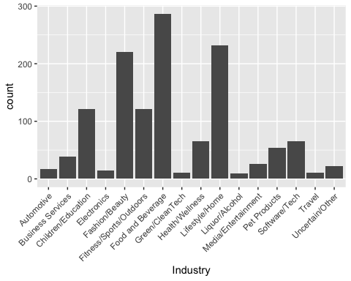
# Plot "Pitchers State" using default styling
ggplot(data, aes(x = `Pitchers State`)) + geom_bar() + theme(axis.text.x = element_text(angle = 45, hjust = 1))
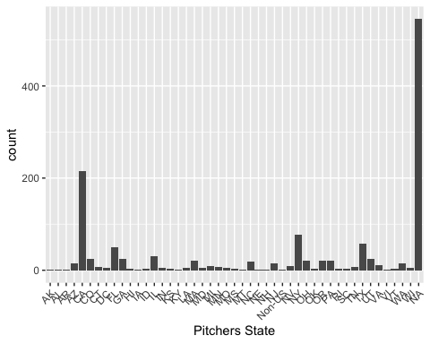
# Calculate count of unique values in "Pitchers State"
length(unique(data$`Pitchers State`))
## [1] 47
# Calculate count of "Pitchers State" sort from most to least
sort(table(data$`Pitchers State`), decreasing = TRUE)
##
## CA NY TX FL IL CO GA UT OR PA MA
## 216 77 57 49 31 25 24 24 21 21 20
## OH NC WA AZ NJ VA MI NV CT MN TN
## 20 19 15 14 14 11 9 9 7 7 7
## DC IN MD LA MO WI HI OK SC VT ID
## 6 6 6 5 5 5 4 4 4 4 3
## KS MS RI AL AR KY Non-US AK IA MT NE
## 3 3 3 2 2 2 2 1 1 1 1
## NH VI
## 1 1
# calculate Average "Deal Amount"
mean(data$`Deal Amount`, na.rm = TRUE)
## [1] 293602.5
# Calculate "Deal Amount" by Industry and sort it from most to least
sort(tapply(data$`Deal Amount`, data$Industry, mean, na.rm = TRUE), decreasing = TRUE)
## Travel Liquor/Alcohol Health/Wellness
## 1170000.0 645000.0 458289.5
## Media/Entertainment Automotive Uncertain/Other
## 427941.2 420384.6 367142.9
## Business Services Green/CleanTech Software/Tech
## 361842.1 325000.0 316714.3
## Food and Beverage Fitness/Sports/Outdoors Electronics
## 311422.0 297905.4 275666.7
## Lifestyle/Home Pet Products Fashion/Beauty
## 241396.1 235906.2 233528.2
## Children/Education
## 220735.9

