Lab-Project-2-Start.R
dhruv
2025-02-25
# Lab Project 2
#
# Please load the data, which contains information about over 3000 customers from
# Orange Telecom. Analyze the data using independence, mean difference, and
# correlation tests to uncover 5 business insights. Answer the following questions
# (in 2-3 sentences) and include your final code below. When you are done, click
# on File > Compile Report > MS Word and submit the resulting Word document.
#
# Q: What is your 1st business insight?
# A: Customers subscribed to the International Plan exhibit significantly higher churn rates.
# This suggests potential dissatisfaction with pricing, perceived value, or service quality.
# Addressing these concerns through competitive pricing strategies, enhanced service offerings,
# or customer engagement initiatives could help mitigate churn.
# Q: What is your 2nd business insight?
# A: Customer tenure (Account Length) does not significantly impact churn likelihood.
# This indicates that loyalty programs or tenure-based retention efforts may not be effective alone.
# Instead, companies should focus on service quality, personalized engagement,
# and proactive issue resolution to improve retention.
# Q: What is your 3rd business insight?
# A: Higher Customer Service Call frequency is strongly associated with increased churn risk.
# This suggests that unresolved customer complaints or poor service experiences may
# be key drivers of churn. Strengthening customer support effectiveness, response times,
# and resolution rates could enhance customer satisfaction and retention.
# Q: What is your 4th business insight?
# A: Churned customers demonstrate significantly different domestic calling behavior.
# This indicates that usage patterns may provide early churn signals.
# Implementing predictive churn models based on usage trends could allow
# for targeted retention campaigns and personalized engagement strategies.
# Q: What is your 5th business insight?
# A: Domestic call usage patterns vary significantly across different regions.
# Understanding these regional differences can help optimize marketing strategies,
# tailor service plans, and enhance localized customer engagement efforts.
# Regionalized retention strategies may be more effective than a one-size-fits-all approach.
#
#load library tiddyverse and here
library(tidyverse)
## ── Attaching core tidyverse packages ──────────────────────── tidyverse 2.0.0 ──
## ✔ dplyr 1.1.4 ✔ readr 2.1.5
## ✔ forcats 1.0.0 ✔ stringr 1.5.1
## ✔ ggplot2 3.5.1 ✔ tibble 3.2.1
## ✔ lubridate 1.9.4 ✔ tidyr 1.3.1
## ✔ purrr 1.0.2
## ── Conflicts ────────────────────────────────────────── tidyverse_conflicts() ──
## ✖ dplyr::filter() masks stats::filter()
## ✖ dplyr::lag() masks stats::lag()
## ℹ Use the conflicted package (<http://conflicted.r-lib.org/>) to force all conflicts to become errors
library(here)
## here() starts at /Users/dhruv/BAN663/BAN663 Code&Data
#load the data "Lab Project 2-Data.csv" from file "Lab 2"
data <- read_csv(here("Lab 2", "Lab Project 2-Data.csv"))
## Rows: 3333 Columns: 7
## ── Column specification ────────────────────────────────────────────────────────
## Delimiter: ","
## chr (2): Region, International_Plan
## dbl (4): Account_Length, Total_Domestic_Minutes, Total_International_Minutes...
## lgl (1): Churn
##
## ℹ Use `spec()` to retrieve the full column specification for this data.
## ℹ Specify the column types or set `show_col_types = FALSE` to quiet this message.
#summary
summary(data)
## Region Account_Length International_Plan Total_Domestic_Minutes
## Length:3333 Min. : 1.0 Length:3333 Min. :275.2
## Class :character 1st Qu.: 74.0 Class :character 1st Qu.:521.0
## Mode :character Median :101.0 Mode :character Median :583.1
## Mean :101.1 Mean :581.6
## 3rd Qu.:127.0 3rd Qu.:642.5
## Max. :243.0 Max. :876.9
## Total_International_Minutes Customer_Service_Calls Churn
## Min. : 0.00 Min. :0.000 Mode :logical
## 1st Qu.: 8.50 1st Qu.:1.000 FALSE:2850
## Median :10.30 Median :1.000 TRUE :483
## Mean :10.24 Mean :1.563
## 3rd Qu.:12.10 3rd Qu.:2.000
## Max. :20.00 Max. :9.000
# convert Region to unordered factor
data$Region <- factor(data$Region, ordered = FALSE)
# convert International_Plan to unordered factor
data$International_Plan <- factor(data$International_Plan, ordered = FALSE)
# convert Churn to unordered factor
data$Churn <- factor(data$Churn, ordered = FALSE)
#summary
summary(data)
## Region Account_Length International_Plan Total_Domestic_Minutes
## Midwest : 802 Min. : 1.0 No :3010 Min. :275.2
## Northeast: 591 1st Qu.: 74.0 Yes: 323 1st Qu.:521.0
## South :1109 Median :101.0 Median :583.1
## West : 831 Mean :101.1 Mean :581.6
## 3rd Qu.:127.0 3rd Qu.:642.5
## Max. :243.0 Max. :876.9
## Total_International_Minutes Customer_Service_Calls Churn
## Min. : 0.00 Min. :0.000 FALSE:2850
## 1st Qu.: 8.50 1st Qu.:1.000 TRUE : 483
## Median :10.30 Median :1.000
## Mean :10.24 Mean :1.563
## 3rd Qu.:12.10 3rd Qu.:2.000
## Max. :20.00 Max. :9.000
# Perform a test to see if " Region" and international plan affect each other
# H0: Region and International_Plan are independent
# Ha: Region and International_Plan are not dependent
chisq.test(data$Region, data$International_Plan)
##
## Pearson's Chi-squared test
##
## data: data$Region and data$International_Plan
## X-squared = 3.4216, df = 3, p-value = 0.3311
# Since the p-value (0.3311) is greater than 0.05, we fail to reject the null hypothesis
#This means there is no significant association between Region and International_Plan—they are statistically independent.
# Perform a test to see if " Region" and "Churn" affect each other
# H0: Region and Churn are independent
# Ha: Region and Churn are not dependent
chisq.test(data$Region, data$Churn)
##
## Pearson's Chi-squared test
##
## data: data$Region and data$Churn
## X-squared = 4.6815, df = 3, p-value = 0.1967
# Since the p-value (0.1967) is greater than 0.05, we fail to reject the null hypothesis
#there is no statistically significant relationship between Region and Churn—churn behavior does not appear to vary significantly by region.
# Perform a test to see if " International_plan" and "Churn" affect each other
# H0: International_Plan and Churn are independent
# Ha: International_Plan and Churn are not dependent
chisq.test(data$International_Plan, data$Churn)
##
## Pearson's Chi-squared test with Yates' continuity correction
##
## data: data$International_Plan and data$Churn
## X-squared = 222.57, df = 1, p-value < 2.2e-16
# The p-value is 0.00000000000000022.This confirms that the relationship between International Plan and Churn is highly significant,
#meaning customers with an International Plan are much more likely to churn.
# Analysis of "Region" (unordered factor w/4 levels) and Account_length (numeric data)
# Calculate descriptive statistics for each level of "Region"
tapply(data, data$Region, summary)
## $Midwest
## Region Account_Length International_Plan Total_Domestic_Minutes
## Midwest :802 Min. : 1.0 No :720 Min. :275.2
## Northeast: 0 1st Qu.: 74.0 Yes: 82 1st Qu.:533.7
## South : 0 Median :100.0 Median :590.2
## West : 0 Mean :101.1 Mean :588.2
## 3rd Qu.:128.0 3rd Qu.:650.6
## Max. :225.0 Max. :841.3
## Total_International_Minutes Customer_Service_Calls Churn
## Min. : 0.0 Min. :0.000 FALSE:698
## 1st Qu.: 8.5 1st Qu.:1.000 TRUE :104
## Median :10.2 Median :1.000
## Mean :10.2 Mean :1.471
## 3rd Qu.:12.0 3rd Qu.:2.000
## Max. :18.2 Max. :9.000
##
## $Northeast
## Region Account_Length International_Plan Total_Domestic_Minutes
## Midwest : 0 Min. : 1.0 No :529 Min. :311.7
## Northeast:591 1st Qu.: 72.5 Yes: 62 1st Qu.:522.2
## South : 0 Median :100.0 Median :584.1
## West : 0 Mean :100.1 Mean :587.1
## 3rd Qu.:127.0 3rd Qu.:655.9
## Max. :212.0 Max. :871.7
## Total_International_Minutes Customer_Service_Calls Churn
## Min. : 0.00 Min. :0.00 FALSE:491
## 1st Qu.: 8.50 1st Qu.:1.00 TRUE :100
## Median :10.20 Median :1.00
## Mean :10.14 Mean :1.55
## 3rd Qu.:11.90 3rd Qu.:2.00
## Max. :20.00 Max. :9.00
##
## $South
## Region Account_Length International_Plan Total_Domestic_Minutes
## Midwest : 0 Min. : 1.0 No :997 Min. :311.4
## Northeast: 0 1st Qu.: 74.0 Yes:112 1st Qu.:519.2
## South :1109 Median :102.0 Median :580.5
## West : 0 Mean :101.1 Mean :579.0
## 3rd Qu.:126.0 3rd Qu.:637.3
## Max. :224.0 Max. :876.9
## Total_International_Minutes Customer_Service_Calls Churn
## Min. : 0.00 Min. :0.00 FALSE:945
## 1st Qu.: 8.50 1st Qu.:1.00 TRUE :164
## Median :10.30 Median :1.00
## Mean :10.32 Mean :1.62
## 3rd Qu.:12.10 3rd Qu.:2.00
## Max. :18.00 Max. :8.00
##
## $West
## Region Account_Length International_Plan Total_Domestic_Minutes
## Midwest : 0 Min. : 1.0 No :764 Min. :333.7
## Northeast: 0 1st Qu.: 74.0 Yes: 67 1st Qu.:513.1
## South : 0 Median :100.0 Median :578.3
## West :831 Mean :101.6 Mean :575.0
## 3rd Qu.:129.0 3rd Qu.:633.8
## Max. :243.0 Max. :821.2
## Total_International_Minutes Customer_Service_Calls Churn
## Min. : 0.00 Min. :0.000 FALSE:716
## 1st Qu.: 8.50 1st Qu.:1.000 TRUE :115
## Median :10.40 Median :1.000
## Mean :10.23 Mean :1.584
## 3rd Qu.:12.20 3rd Qu.:2.000
## Max. :18.90 Max. :7.000
# Plot the distribution of "Account_length" for each level of "Region
ggplot(data = data, aes(x = Region, y = Account_Length)) + geom_boxplot()
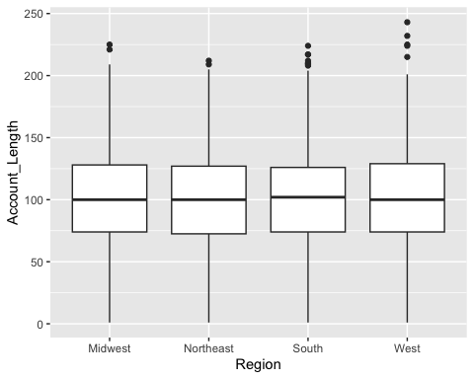
# Perform a one-way ANOVA to test for differences in "Account_length" by "Region"
# H0: There is no difference in "Account_length" by "Region"
# Ha: There is a difference in "Account_length" by "Region"
summary(aov(Account_Length ~ Region, data = data))
## Df Sum Sq Mean Sq F value Pr(>F)
## Region 3 807 269 0.169 0.917
## Residuals 3329 5283079 1587
# Since the p-value (0.917) is much greater than 0.05, we fail to reject the null hypothesis.
#This means there is no statistically significant difference in the Account_Length across different Regions.
# Plot the distribution of "Total_Domestic_Minutes" for each level of "Region"
ggplot(data = data, aes(x = Region, y = Total_Domestic_Minutes)) + geom_boxplot()
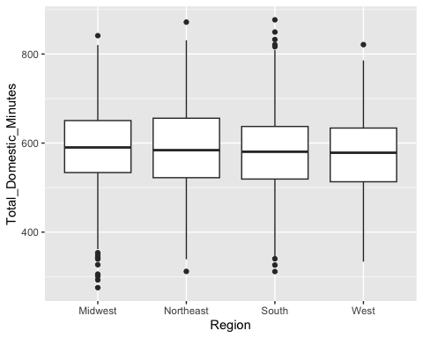
# Perform a one-way ANOVA to test for differences in "Total_Domestic_Minutes" by "Region"
# H0: There is no difference in "Total_Domestic_Minutes" by "Region"
# Ha: There is a difference in "Total_Domestic_Minutes" by "Region"
summary(aov(Total_Domestic_Minutes ~ Region, data = data))
## Df Sum Sq Mean Sq F value Pr(>F)
## Region 3 95845 31948 3.957 0.0079 **
## Residuals 3329 26874964 8073
## ---
## Signif. codes: 0 '***' 0.001 '**' 0.01 '*' 0.05 '.' 0.1 ' ' 1
#Since the p-value (0.0079) is less than 0.05, we reject the null hypothesis.
#This means there is a statistically significant difference in Total_Domestic_Minutes across Regions.
# perform a tukey hsd test to see which regions are different
TukeyHSD(aov(Total_Domestic_Minutes ~ Region, data = data))
## Tukey multiple comparisons of means
## 95% family-wise confidence level
##
## Fit: aov(formula = Total_Domestic_Minutes ~ Region, data = data)
##
## $Region
## diff lwr upr p adj
## Northeast-Midwest -1.090360 -13.61025 11.4295299 0.9960452
## South-Midwest -9.176195 -19.88111 1.5287205 0.1225044
## West-Midwest -13.147788 -24.57950 -1.7160757 0.0165557
## South-Northeast -8.085835 -19.84756 3.6758841 0.2895116
## West-Northeast -12.057428 -24.48429 0.3694328 0.0610232
## West-South -3.971592 -14.56756 6.6243714 0.7702685
# Conclusion:
# - The West region has significantly lower Total_International_Minutes than the Midwest.
# - The West might also have lower values than the Northeast, but this is not statistically confirmed.
# - Other regional differences are not significant.
# Plot the distribution of "Total_International_Minutes" for each level of "Region"
ggplot(data = data, aes(x = Region, y = Total_International_Minutes)) + geom_boxplot()
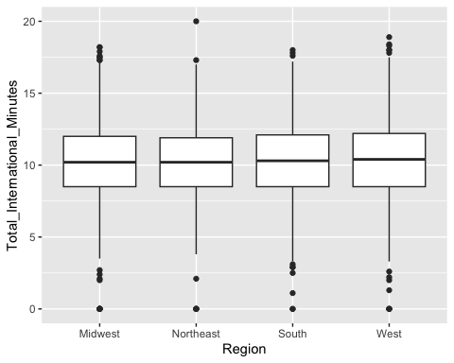
# Perform a one-way ANOVA to test for differences in "Total_International_Minutes" by "Region"
# H0: There is no difference in "Total_International_Minutes" by "Region"
# Ha: There is a difference in "Total_International_Minutes" by "Region"
summary(aov(Total_International_Minutes ~ Region, data = data))
## Df Sum Sq Mean Sq F value Pr(>F)
## Region 3 14 4.688 0.601 0.614
## Residuals 3329 25957 7.797
# Since the p-value (0.614) is greater than 0.05, we fail to reject the null hypothesis.
#This means there is no statistically significant difference in Total_International_Minutes across Regions.
# Plot the distribution of "Customer_Service_Calls" for each level of "Region"
ggplot(data = data, aes(x = Region, y = Customer_Service_Calls)) + geom_boxplot()
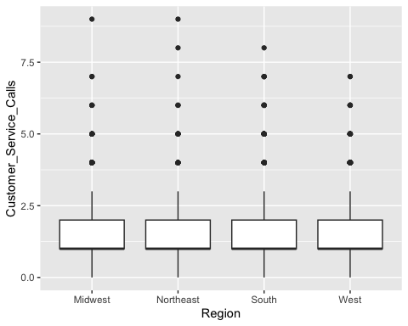
# Perform a one-way ANOVA to test for differences in "Customer_Service_Calls" by "Region"
# H0: There is no difference in "Customer_Service_Calls" by "Region"
# Ha: There is a difference in "Customer_Service_Calls" by "Region"
summary(aov(Customer_Service_Calls ~ Region, data = data))
## Df Sum Sq Mean Sq F value Pr(>F)
## Region 3 11 3.616 2.091 0.0992 .
## Residuals 3329 5755 1.729
## ---
## Signif. codes: 0 '***' 0.001 '**' 0.01 '*' 0.05 '.' 0.1 ' ' 1
#Since the p-value (0.0992) is greater than 0.05 but less than 0.1, the result is marginally significant at the 10% level.
#This suggests that there might be some weak evidence of a difference in Customer_Service_Calls across Regions,
# but it is not strong enough to be statistically significant at the conventional 5% level.
# Calculate descriptive statistics for each level of "International_plan"
tapply(data, data$International_Plan, summary)
## $No
## Region Account_Length International_Plan Total_Domestic_Minutes
## Midwest :720 Min. : 1.0 No :3010 Min. :275.2
## Northeast:529 1st Qu.: 73.0 Yes: 0 1st Qu.:520.2
## South :997 Median :100.0 Median :582.7
## West :764 Mean :100.7 Mean :580.9
## 3rd Qu.:127.0 3rd Qu.:641.7
## Max. :243.0 Max. :876.9
## Total_International_Minutes Customer_Service_Calls Churn
## Min. : 0.0 Min. :0.000 FALSE:2664
## 1st Qu.: 8.4 1st Qu.:1.000 TRUE : 346
## Median :10.2 Median :1.000
## Mean :10.2 Mean :1.573
## 3rd Qu.:12.1 3rd Qu.:2.000
## Max. :18.9 Max. :9.000
##
## $Yes
## Region Account_Length International_Plan Total_Domestic_Minutes
## Midwest : 82 Min. : 2.0 No : 0 Min. :326.0
## Northeast: 62 1st Qu.: 79.5 Yes:323 1st Qu.:527.5
## South :112 Median :104.0 Median :588.8
## West : 67 Mean :104.1 Mean :588.3
## 3rd Qu.:132.5 3rd Qu.:646.6
## Max. :224.0 Max. :871.7
## Total_International_Minutes Customer_Service_Calls Churn
## Min. : 1.30 Min. :0.000 FALSE:186
## 1st Qu.: 9.00 1st Qu.:0.000 TRUE :137
## Median :10.80 Median :1.000
## Mean :10.63 Mean :1.464
## 3rd Qu.:12.20 3rd Qu.:2.000
## Max. :20.00 Max. :9.000
# Plot the distribution of "Account_Length" for each level of "International_Plan"
ggplot(data = data, aes(x = International_Plan, y = Account_Length)) + geom_boxplot()
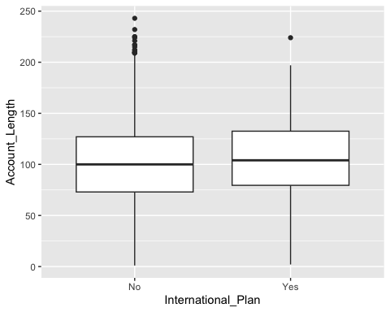
# Perform a t-test to assess if the mean of "Account_Length" is significantly different between customers with and without an International Plan
#h0: There is no difference in Account_Length between customers with and without an International Plan
#Ha: There is a difference in Account_Length between customers with and without an International Plan
t.test(Account_Length ~ International_Plan, data = data)
##
## Welch Two Sample t-test
##
## data: Account_Length by International_Plan
## t = -1.476, df = 400.8, p-value = 0.1407
## alternative hypothesis: true difference in means between group No and group Yes is not equal to 0
## 95 percent confidence interval:
## -7.763076 1.105046
## sample estimates:
## mean in group No mean in group Yes
## 100.7422 104.0712
#Since the p-value (0.1407) is greater than 0.05, we fail to reject the null hypothesis.
#This means there is no statistically significant difference in Account_Length between customers with and without the International Plan.
# Plot the distribution of "Total_Domestic_Minutes" for each level of "International_Plan"
ggplot(data = data, aes(x = International_Plan, y = Total_Domestic_Minutes)) + geom_boxplot()
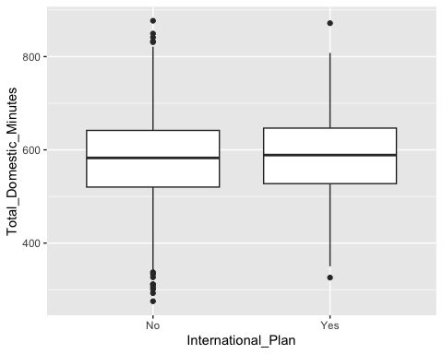
# Perform a t-test to assess if the mean of "Total_Domestic_Minutes" is significantly different between customers with and without an International Plan
#h0: There is no difference in Total_Domestic_Minutes between customers with and without an International Plan
#Ha: There is a difference in Total_Domestic_Minutes between customers with and without an International Plan
t.test(Total_Domestic_Minutes ~ International_Plan, data = data)
##
## Welch Two Sample t-test
##
## data: Total_Domestic_Minutes by International_Plan
## t = -1.4113, df = 394.51, p-value = 0.1589
## alternative hypothesis: true difference in means between group No and group Yes is not equal to 0
## 95 percent confidence interval:
## -17.771326 2.918829
## sample estimates:
## mean in group No mean in group Yes
## 580.9078 588.3341
# Since the p-value (0.1589) is greater than 0.05, we fail to reject the null hypothesis.
#This means there is no statistically significant difference in Total_Domestic_Minutes between customers with and without the International Plan.
# Plot the distribution of "Total_International_Minutes" for each level of "International_Plan"
ggplot(data = data, aes(x = International_Plan, y = Total_International_Minutes)) + geom_boxplot()
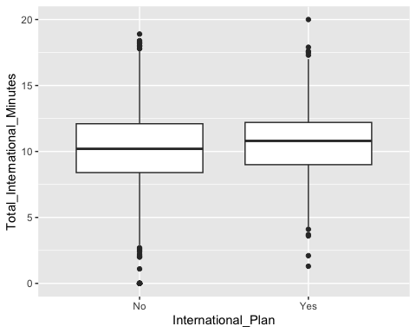
# Perform a t-test to assess if the mean of "Total_International_Minutes" is significantly different between customers with and without an International Plan
#h0: There is no difference in Total_International_Minutes between customers with and without an International Plan
#Ha: There is a difference in Total_International_Minutes between customers with and without an International Plan
t.test(Total_International_Minutes ~ International_Plan, data = data)
##
## Welch Two Sample t-test
##
## data: Total_International_Minutes by International_Plan
## t = -2.73, df = 400.11, p-value = 0.006612
## alternative hypothesis: true difference in means between group No and group Yes is not equal to 0
## 95 percent confidence interval:
## -0.7445026 -0.1211465
## sample estimates:
## mean in group No mean in group Yes
## 10.19535 10.62817
# Since the p-value (0.0066) is less than 0.05, we reject the null hypothesis.
#This means there is a statistically significant difference in Total_International_Minutes between customers with and without the International Plan.
# Plot the distribution of "Customer_Service_Calls" for each level of "International_Plan"
ggplot(data = data, aes(x = International_Plan, y = Customer_Service_Calls)) + geom_boxplot()
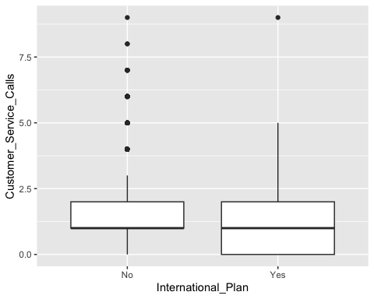
# Perform a t-test to assess if the mean of "Customer_Service_Calls" is significantly different between customers with and without an International Plan
#h0: There is no difference in Customer_Service_Calls between customers with and without an International Plan
#Ha: There is a difference in Customer_Service_Calls between customers with and without an International Plan
t.test(Customer_Service_Calls ~ International_Plan, data = data)
##
## Welch Two Sample t-test
##
## data: Customer_Service_Calls by International_Plan
## t = 1.3943, df = 391.54, p-value = 0.164
## alternative hypothesis: true difference in means between group No and group Yes is not equal to 0
## 95 percent confidence interval:
## -0.04470366 0.26275494
## sample estimates:
## mean in group No mean in group Yes
## 1.573422 1.464396
# Since the p-value (0.164) is greater than 0.05, we fail to reject the null hypothesis.
# This means there is no statistically significant difference in Customer_Service_Calls
# between customers with and without an International Plan.
# Calculate descriptive statistics for each level of "Churn"
tapply(data, data$Churn, summary)
## $`FALSE`
## Region Account_Length International_Plan Total_Domestic_Minutes
## Midwest :698 Min. : 1.0 No :2664 Min. :275.2
## Northeast:491 1st Qu.: 73.0 Yes: 186 1st Qu.:519.4
## South :945 Median :100.0 Median :579.3
## West :716 Mean :100.8 Mean :574.4
## 3rd Qu.:127.0 3rd Qu.:631.5
## Max. :243.0 Max. :831.0
## Total_International_Minutes Customer_Service_Calls Churn
## Min. : 0.00 Min. :0.00 FALSE:2850
## 1st Qu.: 8.40 1st Qu.:1.00 TRUE : 0
## Median :10.20 Median :1.00
## Mean :10.16 Mean :1.45
## 3rd Qu.:12.00 3rd Qu.:2.00
## Max. :18.90 Max. :8.00
##
## $`TRUE`
## Region Account_Length International_Plan Total_Domestic_Minutes
## Midwest :104 Min. : 1.0 No :346 Min. :311.7
## Northeast:100 1st Qu.: 76.0 Yes:137 1st Qu.:535.4
## South :164 Median :103.0 Median :635.8
## West :115 Mean :102.7 Mean :624.6
## 3rd Qu.:127.0 3rd Qu.:714.8
## Max. :225.0 Max. :876.9
## Total_International_Minutes Customer_Service_Calls Churn
## Min. : 2.0 Min. :0.00 FALSE: 0
## 1st Qu.: 8.8 1st Qu.:1.00 TRUE :483
## Median :10.6 Median :2.00
## Mean :10.7 Mean :2.23
## 3rd Qu.:12.8 3rd Qu.:4.00
## Max. :20.0 Max. :9.00
# Plot the distribution of "Account_Length" for each level of "Churn"
ggplot(data = data, aes(x = Churn, y = Account_Length)) + geom_boxplot()
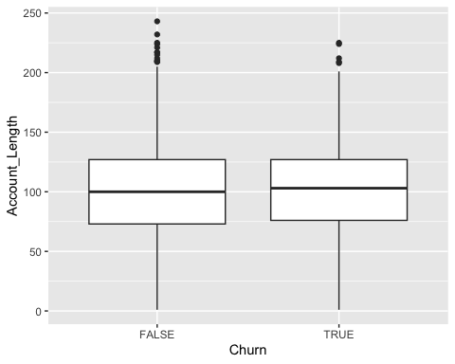
# Perform a t-test to assess if the mean of "Account_Length" is significantly different between customers who churned and those who didn't
#h0: There is no difference in Account_Length between customers who churned and those who didn't
#Ha: There is a difference in Account_Length between customers who churned and those who didn't
t.test(Account_Length ~ Churn, data = data)
##
## Welch Two Sample t-test
##
## data: Account_Length by Churn
## t = -0.96189, df = 659.91, p-value = 0.3365
## alternative hypothesis: true difference in means between group FALSE and group TRUE is not equal to 0
## 95 percent confidence interval:
## -5.690123 1.948299
## sample estimates:
## mean in group FALSE mean in group TRUE
## 100.7937 102.6646
# Since the p-value (0.3365) is greater than 0.05, we fail to reject the null hypothesis.
# This means there is no statistically significant difference in Account_Length
# between customers who churned and those who did not.
# Plot the distribution of "Total_Domestic_Minutes" for each level of "Churn"
ggplot(data = data, aes(x = Churn, y = Total_Domestic_Minutes)) + geom_boxplot()
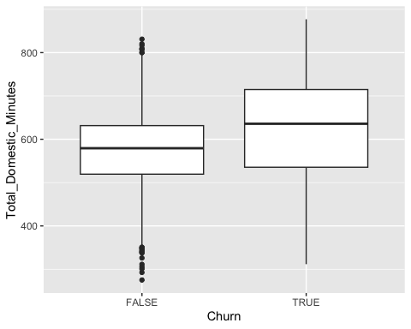
# Perform a t-test to assess if the mean of "Total_Domestic_Minutes" is significantly different between customers who churned and those who didn't
#h0: There is no difference in Total_Domestic_Minutes between customers who churned and those who didn't
#Ha: There is a difference in Total_Domestic_Minutes between customers who churned and those who didn't
t.test(Total_Domestic_Minutes ~ Churn, data = data)
##
## Welch Two Sample t-test
##
## data: Total_Domestic_Minutes by Churn
## t = -9.5053, df = 579.02, p-value < 2.2e-16
## alternative hypothesis: true difference in means between group FALSE and group TRUE is not equal to 0
## 95 percent confidence interval:
## -60.57719 -39.83012
## sample estimates:
## mean in group FALSE mean in group TRUE
## 574.3522 624.5559
# # Since the p-value is extremely small (much less than 0.05), we reject the null hypothesis.
# This means there is a statistically significant difference in Total_Domestic_Minutes
# between customers who churned and those who did not.
# Plot the distribution of "Total_International_Minutes" for each level of "Churn"
ggplot(data = data, aes(x = Churn, y = Total_International_Minutes)) + geom_boxplot()
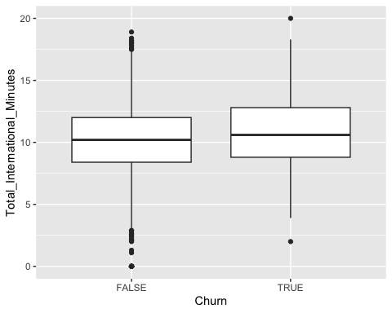
# Perform a t-test to assess if the mean of "Total_International_Minutes" is significantly different between customers who churned and those who didn't
#h0: There is no difference in Total_International_Minutes between customers who churned and those who didn't
#Ha: There is a difference in Total_International_Minutes between customers who churned and those who didn't
t.test(Total_International_Minutes ~ Churn, data = data)
##
## Welch Two Sample t-test
##
## data: Total_International_Minutes by Churn
## t = -3.9389, df = 654.89, p-value = 9.066e-05
## alternative hypothesis: true difference in means between group FALSE and group TRUE is not equal to 0
## 95 percent confidence interval:
## -0.8108829 -0.2713627
## sample estimates:
## mean in group FALSE mean in group TRUE
## 10.15888 10.70000
# Since the p-value (9.066e-05) is much smaller than 0.05, we reject the null hypothesis.
# This means there is a statistically significant difference in Total_International_Minutes
# between customers who churned and those who did not.
# Plot the distribution of "Customer_Service_Calls" for each level of "Churn"
ggplot(data = data, aes(x = Churn, y = Customer_Service_Calls)) + geom_boxplot()
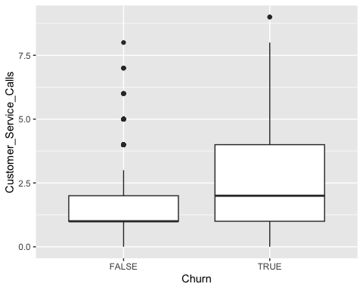
# Perform a t-test to assess if the mean of "Customer_Service_Calls" is significantly different between customers who churned and those who didn't
#h0: There is no difference in Customer_Service_Calls between customers who churned and those who didn't
#Ha: There is a difference in Customer_Service_Calls between customers who churned and those who didn't
t.test(Customer_Service_Calls ~ Churn, data = data)
##
## Welch Two Sample t-test
##
## data: Customer_Service_Calls by Churn
## t = -8.9551, df = 548.17, p-value < 2.2e-16
## alternative hypothesis: true difference in means between group FALSE and group TRUE is not equal to 0
## 95 percent confidence interval:
## -0.9510789 -0.6088993
## sample estimates:
## mean in group FALSE mean in group TRUE
## 1.449825 2.229814
# Since the p-value is extremely small (much less than 0.05), we reject the null hypothesis.
# This means there is a statistically significant difference in Customer_Service_Calls
# between customers who churned and those who did not.
# Calculate the correlation matrix for numeric variables
cor(data[, c("Account_Length", "Total_Domestic_Minutes", "Total_International_Minutes", "Customer_Service_Calls")])
## Account_Length Total_Domestic_Minutes
## Account_Length 1.000000000 -0.005079606
## Total_Domestic_Minutes -0.005079606 1.000000000
## Total_International_Minutes 0.009513902 -0.020915995
## Customer_Service_Calls -0.003795939 -0.020666296
## Total_International_Minutes Customer_Service_Calls
## Account_Length 0.009513902 -0.003795939
## Total_Domestic_Minutes -0.020915995 -0.020666296
## Total_International_Minutes 1.000000000 -0.009639680
## Customer_Service_Calls -0.009639680 1.000000000
# Interpretation:
# - Account_Length has very weak correlations with all other variables.
# - Total_Domestic_Minutes and Total_International_Minutes have a weak negative correlation (-0.0209).
# - Customer_Service_Calls has weak negative correlations with all other variables.
# - No strong correlations are observed between any of the variables.
# Conclusion:
# - These variables do not show strong linear relationships with each other.

