Lab-Project-4-Start.R
dhruv
2025-04-17
# Lab Project 4: Cryptocurrency Price Forecasting
#
# Open investing.com and sign up for a free account. Then select Markets >
# Cryptocurrency > All Cryptocurrencies. Click on a cryptocurrency you want
# to forecast. Above the chart, click on "Historical Data". Use the daterange
# selector to select the past 5 years of data. Click on Download. Using this
# dataset, answer the following questions (in order):
#
# Q1: What is the name of the cryptocurrency you selected?
# A: Solana
#
# Q2: Estimate the best-fitting ETS and ARIMA models on Price using an 80/20
# train/test split. What is the MAE and MAPE of the best-fitting model and how
# would you interpret the metrics?
# A: ETS IS THE BEST-FITTING MODEL WITH A MAE OF 32.5 & MAPE OF 20.9
#
# Q3: What is the specification of the best-fitting model? (Answer like ETS(A,M,N)
# or ARIMA(1,1,0))
# A: ETS(M,A,N)
#
# Q4: How would you interpret the model specification of the best-fitting model?
# A: The high alpha (0.9419) means the model reacts quickly to new data,
# while the very low beta (0.0024) indicates the trend is updated very slowly over time.
#
# Q5: Depending on which model performed better, estimate the best-fitting ETS or
# ARIMA model, but his time using the full dataset (like we did in the Forecasting
# lecture). Forecast the Price over the next month. What is your forecasted price
# on the date of our final exam (May 6)?
# A: 135.0041
#
# Q6: Subtract the MAE you calculated earlier from your forecasted price on the
# date of our final exam. This will be your low estimate. Then add the MAE to
# your forecasted price on the date of our final exam. This will be your high
# estimate. What are your low and high estimates for the forecasted price on the
# date of our final exam?
# A: 135.0041 - 32.5 = 102.5041 (low estimate)
#
# Load required libraries
library(tidyverse)
## ── Attaching core tidyverse packages ──────────────────────── tidyverse 2.0.0 ──
## ✔ dplyr 1.1.4 ✔ readr 2.1.5
## ✔ forcats 1.0.0 ✔ stringr 1.5.1
## ✔ ggplot2 3.5.1 ✔ tibble 3.2.1
## ✔ lubridate 1.9.4 ✔ tidyr 1.3.1
## ✔ purrr 1.0.2
## ── Conflicts ────────────────────────────────────────── tidyverse_conflicts() ──
## ✖ dplyr::filter() masks stats::filter()
## ✖ dplyr::lag() masks stats::lag()
## ℹ Use the conflicted package (<http://conflicted.r-lib.org/>) to force all conflicts to become errors
library(here)
## here() starts at /Users/dhruv/BAN663/BAN663 Code&Data
library(tsibble)
## Registered S3 method overwritten by 'tsibble':
## method from
## as_tibble.grouped_df dplyr
##
## Attaching package: 'tsibble'
##
## The following object is masked from 'package:lubridate':
##
## interval
##
## The following objects are masked from 'package:base':
##
## intersect, setdiff, union
library(fable)
## Loading required package: fabletools
library(feasts)
library(urca)
# load data "solana historical data.csv" from folder "LAB 4"
data <- read_csv(here("LAB 4", "solana historical data.csv"))
## Rows: 1733 Columns: 7
## ── Column specification ────────────────────────────────────────────────────────
## Delimiter: ","
## chr (3): Date, Vol., Change %
## dbl (4): Price, Open, High, Low
##
## ℹ Use `spec()` to retrieve the full column specification for this data.
## ℹ Specify the column types or set `show_col_types = FALSE` to quiet this message.
data$Date <- as.Date(data$Date, "%m/%d/%Y")
data <- filter(data, Date >= "2021-04-09")
# Convert to time series data frame
data <- as_tsibble(data, index = Date)
# Plot the time series data
autoplot(data, Price)
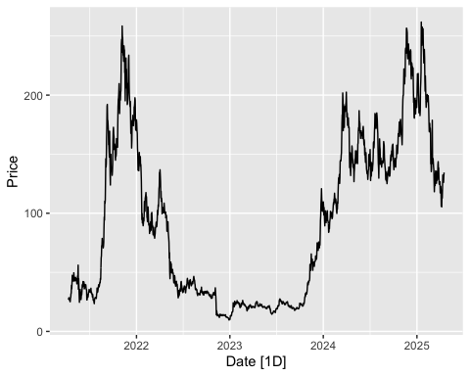
# Perform a seasonal and trend decomposition using Loess (STL)
autoplot(components(model(data, STL(Price))))
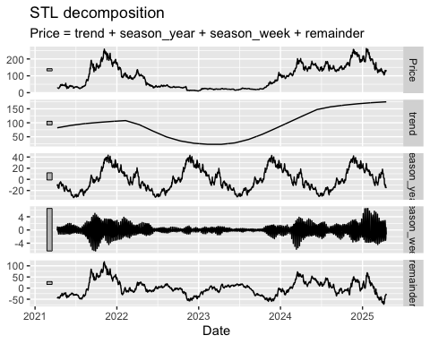
# Create train and test datasets as first 80% and last 20% of full dataset
n <- nrow(data)
train_n <- floor(0.8 * n)
train_data <- slice(data, 1:train_n)
test_data <- slice(data, (train_n + 1):n)
# EXPONENTIAL SMOOTHING (ETS) MODEL
# Estimate the best-fitting model on the train data
fit_ets <- model(train_data, ETS(Price))
# View the estimated model parameters
report(fit_ets)
## Series: Price
## Model: ETS(M,A,N)
## Smoothing parameters:
## alpha = 0.9419005
## beta = 0.002377507
##
## Initial states:
## l[0] b[0]
## 26.05396 0.6548503
##
## sigma^2: 0.0037
##
## AIC AICc BIC
## 10960.82 10960.87 10986.17
# Forecast over the length of the test set using the estimated model
forecasts_ets <- forecast(fit_ets, h=nrow(test_data))
# Plot the forecasts along with the original time series data
autoplot(forecasts_ets, data)
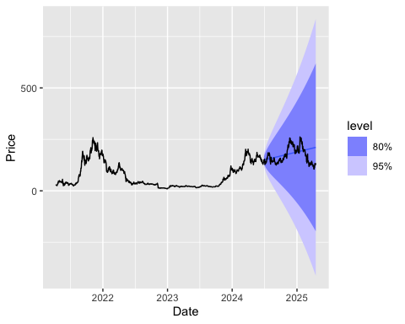
# Calculate accuracy of forecasts against test data
accuracy(forecasts_ets, test_data)
## # A tibble: 1 × 10
## .model .type ME RMSE MAE MPE MAPE MASE RMSSE ACF1
## <chr> <chr> <dbl> <dbl> <dbl> <dbl> <dbl> <dbl> <dbl> <dbl>
## 1 ETS(Price) Test -9.54 41.7 32.5 -10.7 20.9 NaN NaN 0.975
# AUTO-REGRESSIVE INTEGRATED MOVING AVERAGE (ARIMA) MODEL
# Estimate the best-fitting model on the train data
fit_arima <- model(train_data, ARIMA(Price))
# View the estimated model parameters
report(fit_arima)
## Series: Price
## Model: ARIMA(0,1,0)
##
## sigma^2 estimated as 26.26: log likelihood=-3584.15
## AIC=7170.3 AICc=7170.3 BIC=7175.37
# Forecast over the length of the test set using the estimated model
forecasts_arima <- forecast(fit_arima, h=nrow(test_data))
# Plot the forecasts along with the original time series data
autoplot(forecasts_arima, data)
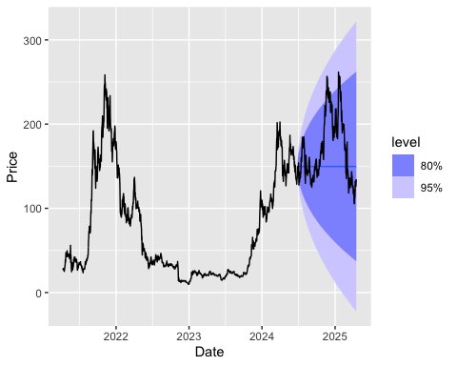
# Calculate accuracy of forecasts against test data
accuracy(forecasts_arima, test_data)
## # A tibble: 1 × 10
## .model .type ME RMSE MAE MPE MAPE MASE RMSSE ACF1
## <chr> <chr> <dbl> <dbl> <dbl> <dbl> <dbl> <dbl> <dbl> <dbl>
## 1 ARIMA(Price) Test 20.9 43.9 33.0 7.91 17.4 NaN NaN 0.975
# Q5
# Estimate the best-fitting exponential smoothing (ETS) model
fit2 <- model(data, ETS(Price))
# View the estimated model parameters
report(fit2)
## Series: Price
## Model: ETS(M,A,N)
## Smoothing parameters:
## alpha = 0.942057
## beta = 0.002314106
##
## Initial states:
## l[0] b[0]
## 26.06741 0.6571289
##
## sigma^2: 0.0034
##
## AIC AICc BIC
## 14613.09 14613.13 14639.55
# Forecast 500 days using the estimated model
forecasts <- forecast(fit2, h=19)
# Plot the forecasts along with the original time series data
autoplot(forecasts, data)
