Mean-Difference-Exercise-Start.R
dhruv
2025-02-18
# Exercise: Mean Difference Tests
#
# Please answer the following questions about Mean-Difference-Exercise-Data.csv
# and include your code below the last question. When you are done, click on
# File > Compile Report > MS Word and submit the resulting Word document.
#
# Q: Is the mean of "Echo" significantly different across levels of "Alpha"?
# (Yes/No, include p-value and results of a post-hoc test if appropriate.)
# A: Yes (p-value = 6.573e-06)
#
# Q: Is the mean of "Echo" significantly different across levels of "Bravo"?
# (Yes/No, include p-value and results of a post-hoc test if appropriate.)
# A: No (p-value=0.366 )
#
# Q: Is the mean of "Echo" significantly different across levels of "Charlie"?
# (Yes/No, include p-value and results of a post-hoc test if appropriate.)
# A: No (p-value = 0.9698)
#
# Q: Is the mean of "Echo" significantly different across levels of "Delta"?
# (Yes/No, include p-value and results of a post-hoc test if appropriate.)
# A: No (p-value = 0.936)
#
# Q: Is the mean of "Foxtrot" significantly different across levels of "Alpha"?
# (Yes/No, include p-value and results of a post-hoc test if appropriate.)
# A: No (p-value = 0.9901)
#
# Q: Is the mean of "Foxtrot" significantly different across levels of "Bravo"?
# (Yes/No, include p-value and results of a post-hoc test if appropriate.)
# A: No (p-value = 0.299)
#
# Q: Is the mean of "Foxtrot" significantly different across levels of "Charlie"?
# (Yes/No, include p-value and results of a post-hoc test if appropriate.)
# A: No (p-value = 0.9676)
#
# Q: Is the mean of "Foxtrot" significantly different across levels of "Delta"?
# (Yes/No, include p-value and results of a post-hoc test if appropriate.)
# A: Yes (p-value = 4.48e-13)
# - DHL has the highest mean.
# - UPS and FedEx have significantly lower means than DHL.
# - USPS is significantly lower than DHL but higher than UPS and FedEx.
# - No significant difference between UPS and FedEx.
#
# Demo: Mean Difference Tests
# Load library "tidyverse" and "here"
library(tidyverse)
## ── Attaching core tidyverse packages ──────────────────────── tidyverse 2.0.0 ──
## ✔ dplyr 1.1.4 ✔ readr 2.1.5
## ✔ forcats 1.0.0 ✔ stringr 1.5.1
## ✔ ggplot2 3.5.1 ✔ tibble 3.2.1
## ✔ lubridate 1.9.4 ✔ tidyr 1.3.1
## ✔ purrr 1.0.2
## ── Conflicts ────────────────────────────────────────── tidyverse_conflicts() ──
## ✖ dplyr::filter() masks stats::filter()
## ✖ dplyr::lag() masks stats::lag()
## ℹ Use the conflicted package (<http://conflicted.r-lib.org/>) to force all conflicts to become errors
library(here)
## here() starts at /Users/dhruv/BAN663/BAN663 Code&Data
# Load "Mean-Difference-Excercise-Data.csv" in "06-Mean-Difference" folder
data <- read_delim(here("06-Mean Difference", "Mean-Difference-Exercise-Data.csv"))
## Rows: 468 Columns: 6
## ── Column specification ────────────────────────────────────────────────────────
## Delimiter: ","
## chr (4): Alpha, Bravo, Charlie, Delta
## dbl (2): Echo, Foxtrot
##
## ℹ Use `spec()` to retrieve the full column specification for this data.
## ℹ Specify the column types or set `show_col_types = FALSE` to quiet this message.
# Calculate descriptive statistics
summary(data)
## Alpha Bravo Charlie Delta
## Length:468 Length:468 Length:468 Length:468
## Class :character Class :character Class :character Class :character
## Mode :character Mode :character Mode :character Mode :character
##
##
##
##
## Echo Foxtrot
## Min. :-2417 Min. :-6905
## 1st Qu.: 8015 1st Qu.: 8443
## Median :11615 Median :13162
## Mean :11512 Mean :12771
## 3rd Qu.:15023 3rd Qu.:17277
## Max. :24551 Max. :36006
## NA's :24 NA's :34
# Convert "Alpha" (logical data) to unordered factor
data$Alpha <- factor(data$Alpha)
# Convert "Bravo" (character data) to unordered factor
data$Bravo <- factor(data$Bravo)
# Convert "Charlie" (character data) to unordered factor
data$Charlie <- factor(data$Charlie)
# Convert "Delta" (character data) to unordered factor
data$Delta <- factor(data$Delta)
# Calculate descriptive statistics
summary(data)
## Alpha Bravo Charlie Delta Echo
## In :201 Center:137 Active :216 DHL :111 Min. :-2417
## Out :244 Left :146 Passive:227 FedEx:104 1st Qu.: 8015
## NA's: 23 Right :161 NA's : 25 UPS :107 Median :11615
## NA's : 24 USPS :118 Mean :11512
## NA's : 28 3rd Qu.:15023
## Max. :24551
## NA's :24
## Foxtrot
## Min. :-6905
## 1st Qu.: 8443
## Median :13162
## Mean :12771
## 3rd Qu.:17277
## Max. :36006
## NA's :34
# Is the mean of "Echo" significantly different across levels of "Alpha"?
tapply(data, data$Alpha, summary)
## $In
## Alpha Bravo Charlie Delta Echo Foxtrot
## In :201 Center:58 Active : 93 DHL :43 Min. : 2776 Min. :-2158
## Out: 0 Left :66 Passive:100 FedEx:49 1st Qu.: 9530 1st Qu.: 7977
## Right :64 NA's : 8 UPS :52 Median :12348 Median :13694
## NA's :13 USPS :43 Mean :12696 Mean :12899
## NA's :14 3rd Qu.:16074 3rd Qu.:17693
## Max. :24551 Max. :27146
## NA's :9 NA's :17
##
## $Out
## Alpha Bravo Charlie Delta Echo Foxtrot
## In : 0 Center:70 Active :111 DHL :64 Min. :-2417 Min. :-2733
## Out:244 Left :74 Passive:117 FedEx:51 1st Qu.: 7504 1st Qu.: 8838
## Right :90 NA's : 16 UPS :50 Median :10772 Median :13054
## NA's :10 USPS :67 Mean :10523 Mean :12891
## NA's :12 3rd Qu.:13698 3rd Qu.:17021
## Max. :23505 Max. :36006
## NA's :13 NA's :16
ggplot(data=data, aes(x=Alpha, y=Echo)) + geom_boxplot()
## Warning: Removed 24 rows containing non-finite outside the scale range
## (`stat_boxplot()`).
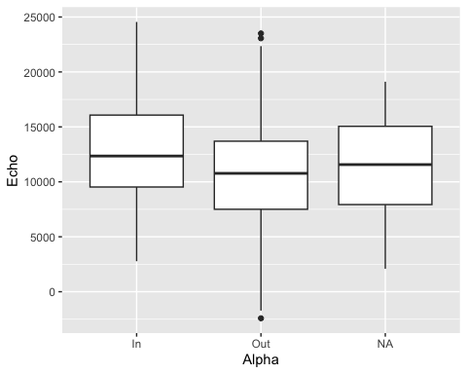
t.test(Echo ~ Alpha, data=data)
##
## Welch Two Sample t-test
##
## data: Echo by Alpha
## t = 4.5658, df = 413.65, p-value = 6.573e-06
## alternative hypothesis: true difference in means between group In and group Out is not equal to 0
## 95 percent confidence interval:
## 1237.673 3109.094
## sample estimates:
## mean in group In mean in group Out
## 12696.13 10522.75
#Is the mean of "Echo" significantly different across levels of "Bravo"?
tapply(data, data$Bravo, summary)
## $Center
## Alpha Bravo Charlie Delta Echo
## In :58 Center:137 Active :63 DHL :31 Min. : -974.6
## Out :70 Left : 0 Passive:69 FedEx:26 1st Qu.: 8491.3
## NA's: 9 Right : 0 NA's : 5 UPS :34 Median :11911.1
## USPS :41 Mean :11964.0
## NA's : 5 3rd Qu.:15470.9
## Max. :24550.9
## NA's :3
## Foxtrot
## Min. :-6905
## 1st Qu.: 7411
## Median :12667
## Mean :11942
## 3rd Qu.:15606
## Max. :36006
## NA's :6
##
## $Left
## Alpha Bravo Charlie Delta Echo Foxtrot
## In :66 Center: 0 Active :70 DHL :40 Min. :-2417 Min. :-3176
## Out :74 Left :146 Passive:61 FedEx:31 1st Qu.: 7706 1st Qu.: 9132
## NA's: 6 Right : 0 NA's :15 UPS :36 Median :11400 Median :13483
## USPS :30 Mean :11457 Mean :13092
## NA's : 9 3rd Qu.:15144 3rd Qu.:17724
## Max. :24487 Max. :29589
## NA's :10 NA's :15
##
## $Right
## Alpha Bravo Charlie Delta Echo Foxtrot
## In :64 Center: 0 Active :71 DHL :35 Min. :-1716 Min. :-2733
## Out :90 Left : 0 Passive:86 FedEx:43 1st Qu.: 7931 1st Qu.: 8334
## NA's: 7 Right :161 NA's : 4 UPS :31 Median :11583 Median :13162
## USPS :40 Mean :11139 Mean :12890
## NA's :12 3rd Qu.:13496 3rd Qu.:17465
## Max. :24179 Max. :27146
## NA's :8 NA's :9
ggplot (data=data, aes(x=Bravo, y=Echo)) + geom_boxplot()
## Warning: Removed 24 rows containing non-finite outside the scale range
## (`stat_boxplot()`).
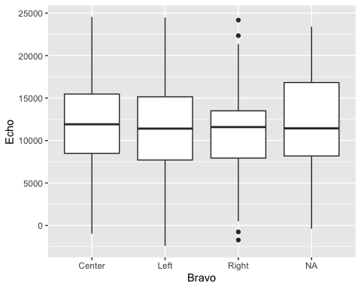
summary(aov(Echo ~ Bravo, data=data))
## Df Sum Sq Mean Sq F value Pr(>F)
## Bravo 2 4.898e+07 24492351 1.009 0.366
## Residuals 420 1.020e+10 24276367
## 45 observations deleted due to missingness
#Is the mean of "Echo" significantly different across levels of "Charlie"?
tapply(data, data$Charlie, summary)
## $Active
## Alpha Bravo Charlie Delta Echo
## In : 93 Center:63 Active :216 DHL :51 Min. :-1716
## Out :111 Left :70 Passive: 0 FedEx:46 1st Qu.: 8051
## NA's: 12 Right :71 UPS :56 Median :11896
## NA's :12 USPS :48 Mean :11571
## NA's :15 3rd Qu.:15022
## Max. :24551
## NA's :15
## Foxtrot
## Min. :-1605
## 1st Qu.: 8482
## Median :12974
## Mean :12730
## 3rd Qu.:16969
## Max. :30114
## NA's :16
##
## $Passive
## Alpha Bravo Charlie Delta Echo
## In :100 Center:69 Active : 0 DHL :55 Min. : -670.5
## Out :117 Left :61 Passive:227 FedEx:52 1st Qu.: 8068.8
## NA's: 10 Right :86 UPS :45 Median :11569.6
## NA's :11 USPS :62 Mean :11588.8
## NA's :13 3rd Qu.:15042.7
## Max. :24178.6
## NA's :8
## Foxtrot
## Min. :-6905
## 1st Qu.: 7976
## Median :13152
## Mean :12756
## 3rd Qu.:17349
## Max. :36006
## NA's :18
ggplot (data=data, aes(x=Charlie, y=Echo)) + geom_boxplot()
## Warning: Removed 24 rows containing non-finite outside the scale range
## (`stat_boxplot()`).
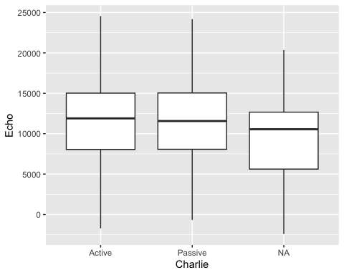
t.test(Echo ~ Charlie, data=data)
##
## Welch Two Sample t-test
##
## data: Echo by Charlie
## t = -0.037934, df = 414.36, p-value = 0.9698
## alternative hypothesis: true difference in means between group Active and group Passive is not equal to 0
## 95 percent confidence interval:
## -964.7447 928.2147
## sample estimates:
## mean in group Active mean in group Passive
## 11570.57 11588.84
# Is the mean of "Echo" significantly different across levels of "Delta"?
tapply(data, data$Delta, summary)
## $DHL
## Alpha Bravo Charlie Delta Echo Foxtrot
## In :43 Center:31 Active :51 DHL :111 Min. :-1716 Min. :-3176
## Out :64 Left :40 Passive:55 FedEx: 0 1st Qu.: 8082 1st Qu.:12329
## NA's: 4 Right :35 NA's : 5 UPS : 0 Median :11535 Median :15743
## NA's : 5 USPS : 0 Mean :11378 Mean :16104
## 3rd Qu.:14351 3rd Qu.:20521
## Max. :22349 Max. :27146
## NA's :3 NA's :8
##
## $FedEx
## Alpha Bravo Charlie Delta Echo
## In :49 Center:26 Active :46 DHL : 0 Min. : 489.7
## Out :51 Left :31 Passive:52 FedEx:104 1st Qu.: 8295.4
## NA's: 4 Right :43 NA's : 6 UPS : 0 Median :11581.7
## NA's : 4 USPS : 0 Mean :11744.7
## 3rd Qu.:15160.9
## Max. :24550.9
## NA's :9
## Foxtrot
## Min. :-6905
## 1st Qu.: 7356
## Median :11434
## Mean :11207
## 3rd Qu.:14729
## Max. :27238
## NA's :5
##
## $UPS
## Alpha Bravo Charlie Delta Echo Foxtrot
## In :52 Center:34 Active :56 DHL : 0 Min. :-2417 Min. :-2733
## Out :50 Left :36 Passive:45 FedEx: 0 1st Qu.: 7627 1st Qu.: 5370
## NA's: 5 Right :31 NA's : 6 UPS :107 Median :12153 Median : 9829
## NA's : 6 USPS : 0 Mean :11618 Mean : 9701
## 3rd Qu.:15048 3rd Qu.:14045
## Max. :24487 Max. :21952
## NA's :5 NA's :8
##
## $USPS
## Alpha Bravo Charlie Delta Echo
## In :43 Center:41 Active :48 DHL : 0 Min. : -974.6
## Out :67 Left :30 Passive:62 FedEx: 0 1st Qu.: 7950.9
## NA's: 8 Right :40 NA's : 8 UPS : 0 Median :11469.9
## NA's : 7 USPS :118 Mean :11370.5
## 3rd Qu.:14915.8
## Max. :24178.6
## NA's :4
## Foxtrot
## Min. :-2158
## 1st Qu.: 9030
## Median :14031
## Mean :13505
## 3rd Qu.:17733
## Max. :36006
## NA's :8
ggplot (data=data, aes(x=Delta, y=Echo)) + geom_boxplot()
## Warning: Removed 24 rows containing non-finite outside the scale range
## (`stat_boxplot()`).
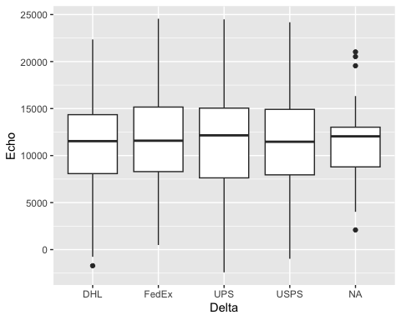
summary(aov(Echo ~ Delta, data=data))
## Df Sum Sq Mean Sq F value Pr(>F)
## Delta 3 1.051e+07 3503555 0.139 0.936
## Residuals 415 1.044e+10 25162573
## 49 observations deleted due to missingness
# Is the mean of "Foxtrot" significantly different across levels of "Alpha"?
tapply(data, data$Alpha, summary)
## $In
## Alpha Bravo Charlie Delta Echo Foxtrot
## In :201 Center:58 Active : 93 DHL :43 Min. : 2776 Min. :-2158
## Out: 0 Left :66 Passive:100 FedEx:49 1st Qu.: 9530 1st Qu.: 7977
## Right :64 NA's : 8 UPS :52 Median :12348 Median :13694
## NA's :13 USPS :43 Mean :12696 Mean :12899
## NA's :14 3rd Qu.:16074 3rd Qu.:17693
## Max. :24551 Max. :27146
## NA's :9 NA's :17
##
## $Out
## Alpha Bravo Charlie Delta Echo Foxtrot
## In : 0 Center:70 Active :111 DHL :64 Min. :-2417 Min. :-2733
## Out:244 Left :74 Passive:117 FedEx:51 1st Qu.: 7504 1st Qu.: 8838
## Right :90 NA's : 16 UPS :50 Median :10772 Median :13054
## NA's :10 USPS :67 Mean :10523 Mean :12891
## NA's :12 3rd Qu.:13698 3rd Qu.:17021
## Max. :23505 Max. :36006
## NA's :13 NA's :16
ggplot(data=data, aes(x=Alpha, y=Foxtrot)) + geom_boxplot()
## Warning: Removed 34 rows containing non-finite outside the scale range
## (`stat_boxplot()`).
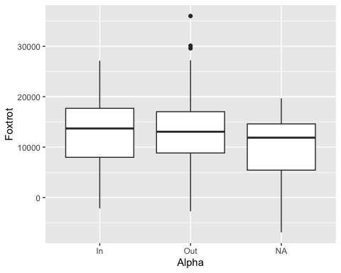
t.test(Foxtrot ~ Alpha, data=data)
##
## Welch Two Sample t-test
##
## data: Foxtrot by Alpha
## t = 0.012399, df = 382.14, p-value = 0.9901
## alternative hypothesis: true difference in means between group In and group Out is not equal to 0
## 95 percent confidence interval:
## -1242.546 1258.317
## sample estimates:
## mean in group In mean in group Out
## 12899.18 12891.30
#Is the mean of "Foxtrot" significantly different across levels of "Bravo"?
tapply(data, data$Bravo, summary)
## $Center
## Alpha Bravo Charlie Delta Echo
## In :58 Center:137 Active :63 DHL :31 Min. : -974.6
## Out :70 Left : 0 Passive:69 FedEx:26 1st Qu.: 8491.3
## NA's: 9 Right : 0 NA's : 5 UPS :34 Median :11911.1
## USPS :41 Mean :11964.0
## NA's : 5 3rd Qu.:15470.9
## Max. :24550.9
## NA's :3
## Foxtrot
## Min. :-6905
## 1st Qu.: 7411
## Median :12667
## Mean :11942
## 3rd Qu.:15606
## Max. :36006
## NA's :6
##
## $Left
## Alpha Bravo Charlie Delta Echo Foxtrot
## In :66 Center: 0 Active :70 DHL :40 Min. :-2417 Min. :-3176
## Out :74 Left :146 Passive:61 FedEx:31 1st Qu.: 7706 1st Qu.: 9132
## NA's: 6 Right : 0 NA's :15 UPS :36 Median :11400 Median :13483
## USPS :30 Mean :11457 Mean :13092
## NA's : 9 3rd Qu.:15144 3rd Qu.:17724
## Max. :24487 Max. :29589
## NA's :10 NA's :15
##
## $Right
## Alpha Bravo Charlie Delta Echo Foxtrot
## In :64 Center: 0 Active :71 DHL :35 Min. :-1716 Min. :-2733
## Out :90 Left : 0 Passive:86 FedEx:43 1st Qu.: 7931 1st Qu.: 8334
## NA's: 7 Right :161 NA's : 4 UPS :31 Median :11583 Median :13162
## USPS :40 Mean :11139 Mean :12890
## NA's :12 3rd Qu.:13496 3rd Qu.:17465
## Max. :24179 Max. :27146
## NA's :8 NA's :9
ggplot (data=data, aes(x=Bravo, y=Foxtrot)) + geom_boxplot()
## Warning: Removed 34 rows containing non-finite outside the scale range
## (`stat_boxplot()`).
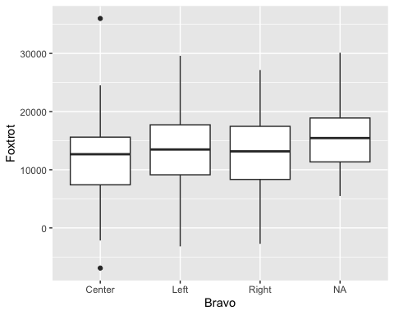
summary(aov(Foxtrot ~ Bravo, data=data))
## Df Sum Sq Mean Sq F value Pr(>F)
## Bravo 2 9.990e+07 49948834 1.21 0.299
## Residuals 411 1.696e+10 41270126
## 54 observations deleted due to missingness
#Is the mean of "Foxtrot" significantly different across levels of "Charlie"?
tapply(data, data$Charlie, summary)
## $Active
## Alpha Bravo Charlie Delta Echo
## In : 93 Center:63 Active :216 DHL :51 Min. :-1716
## Out :111 Left :70 Passive: 0 FedEx:46 1st Qu.: 8051
## NA's: 12 Right :71 UPS :56 Median :11896
## NA's :12 USPS :48 Mean :11571
## NA's :15 3rd Qu.:15022
## Max. :24551
## NA's :15
## Foxtrot
## Min. :-1605
## 1st Qu.: 8482
## Median :12974
## Mean :12730
## 3rd Qu.:16969
## Max. :30114
## NA's :16
##
## $Passive
## Alpha Bravo Charlie Delta Echo
## In :100 Center:69 Active : 0 DHL :55 Min. : -670.5
## Out :117 Left :61 Passive:227 FedEx:52 1st Qu.: 8068.8
## NA's: 10 Right :86 UPS :45 Median :11569.6
## NA's :11 USPS :62 Mean :11588.8
## NA's :13 3rd Qu.:15042.7
## Max. :24178.6
## NA's :8
## Foxtrot
## Min. :-6905
## 1st Qu.: 7976
## Median :13152
## Mean :12756
## 3rd Qu.:17349
## Max. :36006
## NA's :18
ggplot (data=data, aes(x=Charlie, y=Foxtrot)) + geom_boxplot()
## Warning: Removed 34 rows containing non-finite outside the scale range
## (`stat_boxplot()`).
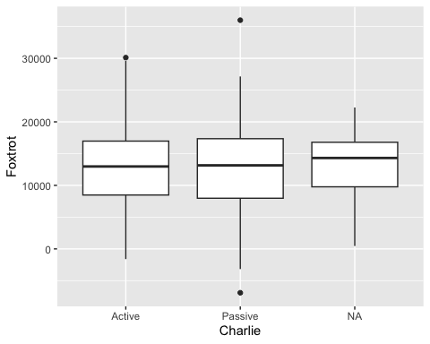
t.test(Foxtrot ~ Charlie, data=data)
##
## Welch Two Sample t-test
##
## data: Foxtrot by Charlie
## t = -0.040652, df = 404.51, p-value = 0.9676
## alternative hypothesis: true difference in means between group Active and group Passive is not equal to 0
## 95 percent confidence interval:
## -1282.040 1230.091
## sample estimates:
## mean in group Active mean in group Passive
## 12729.76 12755.74
# Is the mean of "Foxtrot" significantly different across levels of "Delta"?
tapply(data, data$Delta, summary)
## $DHL
## Alpha Bravo Charlie Delta Echo Foxtrot
## In :43 Center:31 Active :51 DHL :111 Min. :-1716 Min. :-3176
## Out :64 Left :40 Passive:55 FedEx: 0 1st Qu.: 8082 1st Qu.:12329
## NA's: 4 Right :35 NA's : 5 UPS : 0 Median :11535 Median :15743
## NA's : 5 USPS : 0 Mean :11378 Mean :16104
## 3rd Qu.:14351 3rd Qu.:20521
## Max. :22349 Max. :27146
## NA's :3 NA's :8
##
## $FedEx
## Alpha Bravo Charlie Delta Echo
## In :49 Center:26 Active :46 DHL : 0 Min. : 489.7
## Out :51 Left :31 Passive:52 FedEx:104 1st Qu.: 8295.4
## NA's: 4 Right :43 NA's : 6 UPS : 0 Median :11581.7
## NA's : 4 USPS : 0 Mean :11744.7
## 3rd Qu.:15160.9
## Max. :24550.9
## NA's :9
## Foxtrot
## Min. :-6905
## 1st Qu.: 7356
## Median :11434
## Mean :11207
## 3rd Qu.:14729
## Max. :27238
## NA's :5
##
## $UPS
## Alpha Bravo Charlie Delta Echo Foxtrot
## In :52 Center:34 Active :56 DHL : 0 Min. :-2417 Min. :-2733
## Out :50 Left :36 Passive:45 FedEx: 0 1st Qu.: 7627 1st Qu.: 5370
## NA's: 5 Right :31 NA's : 6 UPS :107 Median :12153 Median : 9829
## NA's : 6 USPS : 0 Mean :11618 Mean : 9701
## 3rd Qu.:15048 3rd Qu.:14045
## Max. :24487 Max. :21952
## NA's :5 NA's :8
##
## $USPS
## Alpha Bravo Charlie Delta Echo
## In :43 Center:41 Active :48 DHL : 0 Min. : -974.6
## Out :67 Left :30 Passive:62 FedEx: 0 1st Qu.: 7950.9
## NA's: 8 Right :40 NA's : 8 UPS : 0 Median :11469.9
## NA's : 7 USPS :118 Mean :11370.5
## 3rd Qu.:14915.8
## Max. :24178.6
## NA's :4
## Foxtrot
## Min. :-2158
## 1st Qu.: 9030
## Median :14031
## Mean :13505
## 3rd Qu.:17733
## Max. :36006
## NA's :8
ggplot (data=data, aes(x=Delta, y=Foxtrot)) + geom_boxplot()
## Warning: Removed 34 rows containing non-finite outside the scale range
## (`stat_boxplot()`).
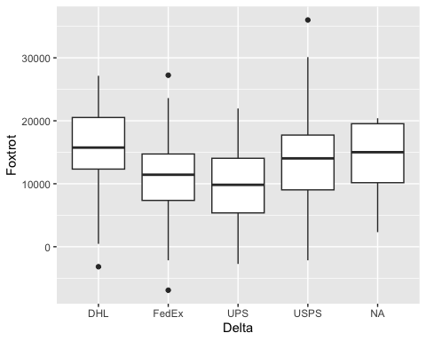
summary(aov(Foxtrot ~ Delta, data=data))
## Df Sum Sq Mean Sq F value Pr(>F)
## Delta 3 2.376e+09 792068485 21.73 4.48e-13 ***
## Residuals 407 1.483e+10 36442540
## ---
## Signif. codes: 0 '***' 0.001 '**' 0.01 '*' 0.05 '.' 0.1 ' ' 1
## 57 observations deleted due to missingness
TukeyHSD(aov(Foxtrot ~ Delta, data=data))
## Tukey multiple comparisons of means
## 95% family-wise confidence level
##
## Fit: aov(formula = Foxtrot ~ Delta, data = data)
##
## $Delta
## diff lwr upr p adj
## FedEx-DHL -4897.769 -7089.6100 -2705.9288 0.0000001
## UPS-DHL -6403.327 -8595.1677 -4211.4864 0.0000000
## USPS-DHL -2598.925 -4734.1530 -463.6962 0.0097717
## UPS-FedEx -1505.558 -3718.9933 707.8779 0.2969482
## USPS-FedEx 2298.845 141.4546 4456.2350 0.0316134
## USPS-UPS 3804.402 1647.0123 5961.7927 0.0000421

