Midterm.R
dhruv
2025-03-21
#load tidyverse and here
library(tidyverse)
## ── Attaching core tidyverse packages ──────────────────────── tidyverse 2.0.0 ──
## ✔ dplyr 1.1.4 ✔ readr 2.1.5
## ✔ forcats 1.0.0 ✔ stringr 1.5.1
## ✔ ggplot2 3.5.1 ✔ tibble 3.2.1
## ✔ lubridate 1.9.4 ✔ tidyr 1.3.1
## ✔ purrr 1.0.2
## ── Conflicts ────────────────────────────────────────── tidyverse_conflicts() ──
## ✖ dplyr::filter() masks stats::filter()
## ✖ dplyr::lag() masks stats::lag()
## ℹ Use the conflicted package (<http://conflicted.r-lib.org/>) to force all conflicts to become errors
library(here)
## here() starts at /Users/dhruv/BAN663/BAN663 Code&Data
#load the data "synthetic_dataset.csv" from the folder "Mid term"
data <- read.csv(here("Mid term", "synthetic_dataset.csv"))
# summary
summary(data)
## Age Income Satisfaction Occupation
## Min. :20.00 Min. : 30321 Min. :1.00 Length:100
## 1st Qu.:31.00 1st Qu.: 48778 1st Qu.:2.00 Class :character
## Median :42.00 Median : 71912 Median :3.00 Mode :character
## Mean :42.43 Mean : 71250 Mean :3.04
## 3rd Qu.:54.00 3rd Qu.: 89955 3rd Qu.:4.00
## Max. :65.00 Max. :119719 Max. :5.00
## Marital_Status City
## Length:100 Length:100
## Class :character Class :character
## Mode :character Mode :character
##
##
##
# convert "Occupation " "Marital_Status" "City" to factor
data$Occupation <- as.factor(data$Occupation)
data$Marital_Status <- as.factor(data$Marital_Status)
data$City <- as.factor(data$City)
# check the structure of the data
str(data)
## 'data.frame': 100 obs. of 6 variables:
## $ Age : int 65 22 48 54 58 37 39 62 42 53 ...
## $ Income : int 70337 42221 81054 50298 115620 98399 75072 64437 39325 34142 ...
## $ Satisfaction : int 4 2 1 1 3 3 3 2 3 4 ...
## $ Occupation : Factor w/ 5 levels "Artist","Doctor",..: 5 4 1 2 2 3 2 1 2 3 ...
## $ Marital_Status: Factor w/ 3 levels "Divorced","Married",..: 3 1 3 2 1 3 2 2 3 3 ...
## $ City : Factor w/ 5 levels "Chicago","Houston",..: 4 4 3 5 2 5 5 5 5 4 ...
# Plot "Age" (numeric data) using default styling, bin width 10, and bins beginning at 0
ggplot(data, aes(x = Age)) + geom_histogram(binwidth = 10, boundary = 0)
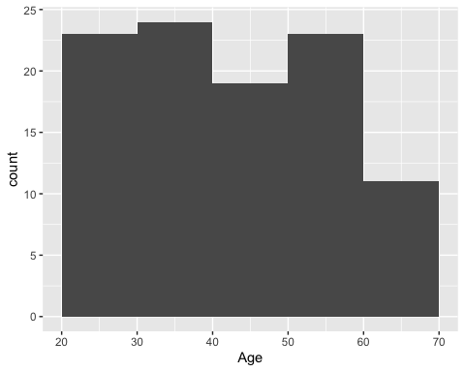
# Boxplot for Income by Occupation
ggplot(data, aes(x = Occupation, y = Income)) + geom_boxplot() +
labs(title = "Boxplot of Income by Occupation", x = "Occupation", y = "Income")
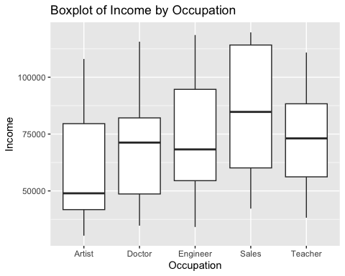
# corr matrix variables cor.test
cor.test(data$Age, data$Income)
##
## Pearson's product-moment correlation
##
## data: data$Age and data$Income
## t = 1.3442, df = 98, p-value = 0.182
## alternative hypothesis: true correlation is not equal to 0
## 95 percent confidence interval:
## -0.06354781 0.32244626
## sample estimates:
## cor
## 0.1345498
# Scatter plot for Income vs Satisfaction
ggplot(data, aes(x = Income, y = Satisfaction)) + geom_point() +
labs(title = "Scatter plot of Income vs Satisfaction", x = "Income", y = "Satisfaction") +
geom_smooth(method = "lm", se = FALSE, color = "blue") # add a linear regression line
## `geom_smooth()` using formula = 'y ~ x'
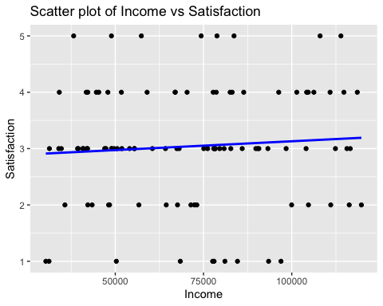
#T test for each level of Occupation for age
tapply(data, data$Occupation, summary)
## $Artist
## Age Income Satisfaction Occupation Marital_Status
## Min. :20.0 Min. : 30321 Min. :1.00 Artist :21 Divorced:7
## 1st Qu.:36.0 1st Qu.: 41771 1st Qu.:2.00 Doctor : 0 Married :7
## Median :40.0 Median : 48947 Median :3.00 Engineer: 0 Single :7
## Mean :43.1 Mean : 57844 Mean :2.81 Sales : 0
## 3rd Qu.:55.0 3rd Qu.: 79576 3rd Qu.:3.00 Teacher : 0
## Max. :62.0 Max. :108021 Max. :5.00
## City
## Chicago :5
## Houston :4
## Los Angeles:6
## Miami :2
## New York :4
##
##
## $Doctor
## Age Income Satisfaction Occupation Marital_Status
## Min. :23.00 Min. : 34718 Min. :1.000 Artist : 0 Divorced:6
## 1st Qu.:31.75 1st Qu.: 48661 1st Qu.:3.000 Doctor :22 Married :9
## Median :45.50 Median : 71256 Median :3.000 Engineer: 0 Single :7
## Mean :43.82 Mean : 70845 Mean :3.045 Sales : 0
## 3rd Qu.:55.50 3rd Qu.: 82111 3rd Qu.:3.750 Teacher : 0
## Max. :64.00 Max. :115620 Max. :5.000
## City
## Chicago :3
## Houston :5
## Los Angeles:2
## Miami :4
## New York :8
##
##
## $Engineer
## Age Income Satisfaction Occupation Marital_Status
## Min. :21.00 Min. : 34142 Min. :1.000 Artist : 0 Divorced: 8
## 1st Qu.:31.50 1st Qu.: 54505 1st Qu.:2.000 Doctor : 0 Married : 3
## Median :38.50 Median : 68252 Median :3.000 Engineer:24 Single :13
## Mean :40.33 Mean : 72684 Mean :3.042 Sales : 0
## 3rd Qu.:52.25 3rd Qu.: 94672 3rd Qu.:4.000 Teacher : 0
## Max. :64.00 Max. :118560 Max. :5.000
## City
## Chicago :1
## Houston :5
## Los Angeles:8
## Miami :6
## New York :4
##
##
## $Sales
## Age Income Satisfaction Occupation Marital_Status
## Min. :22.00 Min. : 42221 Min. :2.000 Artist : 0 Divorced:6
## 1st Qu.:24.25 1st Qu.: 60117 1st Qu.:3.000 Doctor : 0 Married :4
## Median :34.50 Median : 84746 Median :3.000 Engineer: 0 Single :4
## Mean :38.43 Mean : 86052 Mean :3.286 Sales :14
## 3rd Qu.:51.00 3rd Qu.:114162 3rd Qu.:4.000 Teacher : 0
## Max. :65.00 Max. :119719 Max. :5.000
## City
## Chicago :2
## Houston :5
## Los Angeles:4
## Miami :2
## New York :1
##
##
## $Teacher
## Age Income Satisfaction Occupation Marital_Status
## Min. :22.00 Min. : 38209 Min. :1.000 Artist : 0 Divorced:7
## 1st Qu.:35.00 1st Qu.: 56189 1st Qu.:2.500 Doctor : 0 Married :5
## Median :45.00 Median : 73100 Median :3.000 Engineer: 0 Single :7
## Mean :45.68 Mean : 73818 Mean :3.105 Sales : 0
## 3rd Qu.:58.00 3rd Qu.: 88314 3rd Qu.:4.000 Teacher :19
## Max. :65.00 Max. :110849 Max. :5.000
## City
## Chicago :4
## Houston :1
## Los Angeles:3
## Miami :4
## New York :7
##
# plot for each level of Occupation for age
ggplot(data, aes(x = Occupation, y = Age)) + geom_boxplot() +
labs(title = "Boxplot of Age by Occupation", x = "Occupation", y = "Age")
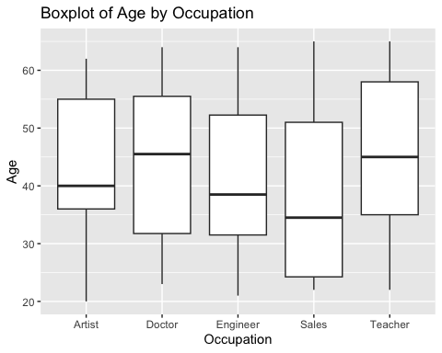
# ANOVA for Age by Occupation
summary(aov(Age ~ Occupation, data = data))
## Df Sum Sq Mean Sq F value Pr(>F)
## Occupation 4 583 145.6 0.789 0.535
## Residuals 95 17540 184.6
# plot for each level of Occupation for income
ggplot(data, aes(x = Occupation, y = Income)) + geom_boxplot() +
labs(title = "Boxplot of income by Occupation", x = "Occupation", y = "Income")
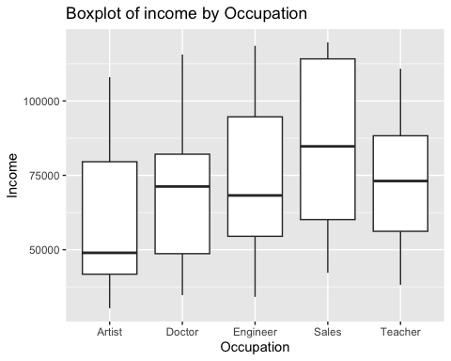
# Anova test for Income by Occupation
summary(aov(Income ~ Occupation, data = data))
## Df Sum Sq Mean Sq F value Pr(>F)
## Occupation 4 7.020e+09 1.755e+09 2.952 0.024 *
## Residuals 95 5.648e+10 5.946e+08
## ---
## Signif. codes: 0 '***' 0.001 '**' 0.01 '*' 0.05 '.' 0.1 ' ' 1
# perform tukey test
TukeyHSD(aov(data = data, Income ~ Occupation))
## Tukey multiple comparisons of means
## 95% family-wise confidence level
##
## Fit: aov(formula = Income ~ Occupation, data = data)
##
## $Occupation
## diff lwr upr p adj
## Doctor-Artist 13001.550 -7685.124 33688.22 0.4101601
## Engineer-Artist 14839.679 -5421.673 35101.03 0.2567205
## Sales-Artist 28208.238 4812.445 51604.03 0.0098967
## Teacher-Artist 15974.306 -5495.147 37443.76 0.2421054
## Engineer-Doctor 1838.129 -18176.124 21852.38 0.9990464
## Sales-Doctor 15206.688 -7975.440 38388.82 0.3659378
## Teacher-Doctor 2972.756 -18263.659 24209.17 0.9950629
## Sales-Engineer 13368.560 -9434.839 36171.96 0.4820242
## Teacher-Engineer 1134.627 -19687.698 21956.95 0.9998794
## Teacher-Sales -12233.932 -36117.190 11649.33 0.6135612

