Validation-Exercise-Start.R
dhruv
2025-04-16
# Exercise: Time Series Validation
#
# Please answer the following questions and include your final code below.
# When you are done, click on File > Compile Report > MS Word and submit the
# resulting Word document.
#
# Q: Load Validation-Exercise-Data1.csv. The file contains the stock price
# of Apple Inc (AAPL). Estimate the best-fitting ETS and ARIMA models on 80/20
# train and test datasets. What is the MAE and MAPE of the best-fitting model and
# how would you interpret that?
# A: ARIMA with a MAE 15.9 and a MAPE 8.14
#
# Q: What is the specification of the best-fitting model? (Answer like ETS(A,M,N)
# or ARIMA(1,1,0))
# A: ARIMA(0,1,0) w/ drift
#
# Q: How would you interpret the model specification of the best-fitting model?
# A: The model includes 0 auto-regressive terms, 1 differences, and
# 0 moving average terms. A constant term is added to each forecast.
#
# Q: Load Validation-Exercise-Data2.csv. The file contains beer production
# output in Australia in million liters. Estimate the best-fitting ETS and ARIMA models on 80/20
# train and test datasets. What is the MAE and MAPE of the best-fitting model and
# how would you interpret that?
# A: ARIMA MAE 8.54 MAPE 2.07
#
# Q: What is the specification of the best-fitting model? (Answer like ETS(A,M,N)
# or ARIMA(1,1,0))
# A: ARIMA(0,0,0)(0,1,1)[4]
#
# Q: How would you interpret the model specification of the best-fitting model?
# A: The model includes 0 auto-regressive terms, 0 differences, and
# 0 moving average term. The seasonal component of the model includes
# 0 seasonal auto-regressive terms, 1 seasonal difference, and 1 seasonal
# moving average term, with a seasonal period of 4.
#
# Q: Load Validation-Exercise-Data3.csv. The file contains brick production
# output in Australia in million bricks. Estimate the best-fitting ETS and ARIMA models on 80/20
# train and test datasets. What is the MAE and MAPE of the best-fitting model and
# how would you interpret that?
# A: ETS MAE 92.2 MAPE 24
#
# Q: What is the specification of the best-fitting model? (Answer like ETS(A,M,N)
# or ARIMA(1,1,0))
# A: ETS(M,A,M)
#
# Q: How would you interpret the model specification of the best-fitting model?
# A: Smoothing parameters:
# alpha = 0.9880084, beta = 0.0001000537, gamma = 0.0001000042
#
# Q: Load Validation-Exercise-Data4.csv. The file contains natural gas
# consumption in Connecticut in million cubic feet. Estimate the best-fitting ETS and ARIMA models on 80/20
# train and test datasets. What is the MAE and MAPE of the best-fitting model and
# how would you interpret that?
# A: ARIMA MAE 12,093 4.57 MAPE
#
# Q: What is the specification of the best-fitting model? (Answer like ETS(A,M,N)
# or ARIMA(1,1,0))
# A: ARIMA(1,1,0) w/ drift
#
# Q: How would you interpret the model specification of the best-fitting model?
# A: The model includes 1 auto-regressive term, 1 difference, and
# 0 moving average terms. A constant term is added to each forecast.
#
# Q: Load Validation-Exercise-Data5.csv. The file contains sales of
# new one-family houses in thousand units. Estimate the best-fitting ETS and ARIMA models on 80/20
# train and test datasets. What is the MAE and MAPE of the best-fitting model and
# how would you interpret that?
# A: ETS MAE 4.36 MAPE 7.41
#
# Q: What is the specification of the best-fitting model? (Answer like ETS(A,M,N)
# or ARIMA(1,1,0))
# A: ETS(M,N,A)
#
# Q: How would you interpret the model specification of the best-fitting model?
# A: Smoothing parameters:
#alpha = 0.8006946 gamma = 0.0001006589
#
# Load required libraries
library(tidyverse)
## ── Attaching core tidyverse packages ──────────────────────── tidyverse 2.0.0 ──
## ✔ dplyr 1.1.4 ✔ readr 2.1.5
## ✔ forcats 1.0.0 ✔ stringr 1.5.1
## ✔ ggplot2 3.5.1 ✔ tibble 3.2.1
## ✔ lubridate 1.9.4 ✔ tidyr 1.3.1
## ✔ purrr 1.0.2
## ── Conflicts ────────────────────────────────────────── tidyverse_conflicts() ──
## ✖ dplyr::filter() masks stats::filter()
## ✖ dplyr::lag() masks stats::lag()
## ℹ Use the conflicted package (<http://conflicted.r-lib.org/>) to force all conflicts to become errors
library(here)
## here() starts at /Users/dhruv/BAN663/BAN663 Code&Data
library(tsibble)
## Registered S3 method overwritten by 'tsibble':
## method from
## as_tibble.grouped_df dplyr
##
## Attaching package: 'tsibble'
##
## The following object is masked from 'package:lubridate':
##
## interval
##
## The following objects are masked from 'package:base':
##
## intersect, setdiff, union
library(fable)
## Loading required package: fabletools
library(feasts)
library(urca)
# Load "Validation-Exercise-Data1.csv" in folder "Validation"
demodata <- read_csv(here("Time Series Validation", "Validation-Exercise-Data1.csv"))
## Rows: 1825 Columns: 2
## ── Column specification ────────────────────────────────────────────────────────
## Delimiter: ","
## chr (1): Alpha
## dbl (1): Foxtrot
##
## ℹ Use `spec()` to retrieve the full column specification for this data.
## ℹ Specify the column types or set `show_col_types = FALSE` to quiet this message.
# Convert the date variable
demodata$Alpha <- as.Date(demodata$Alpha, "%d-%m-%Y")
# Convert to time series data frame
demodata <- as_tsibble(demodata, index = Alpha)
# Plot the time series data
autoplot(demodata, Foxtrot)
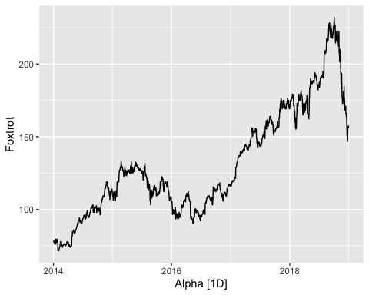
# Perform a seasonal and trend decomposition using Loess (STL)
autoplot(components(model(demodata, STL(Foxtrot))))
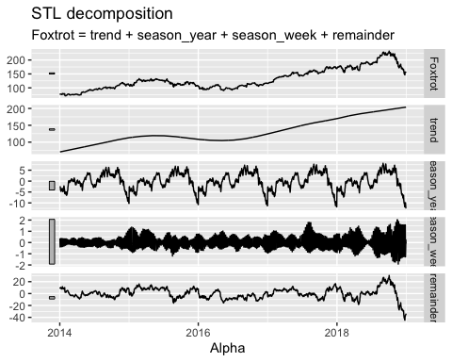
# Create train and test datasets as first 80% and last 20% of full dataset
n <- nrow(demodata)
train_n <- floor(0.8 * n)
train_data <- slice(demodata, 1:train_n)
test_data <- slice(demodata, (train_n + 1):n)
# EXPONENTIAL SMOOTHING (ETS) MODEL
# Estimate the best-fitting model on the train data
fit_ets <- model(train_data, ETS(Foxtrot))
# View the estimated model parameters
report(fit_ets)
## Series: Foxtrot
## Model: ETS(A,N,N)
## Smoothing parameters:
## alpha = 0.9998969
##
## Initial states:
## l[0]
## 79.02017
##
## sigma^2: 1.8177
##
## AIC AICc BIC
## 11514.26 11514.27 11530.11
# Forecast over the length of the test set using the estimated model
forecasts_ets <- forecast(fit_ets, h=nrow(test_data))
# Plot the forecasts along with the original time series data
autoplot(forecasts_ets, demodata)
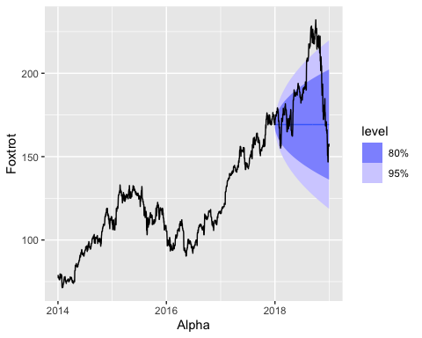
# Calculate accuracy of forecasts against test data
accuracy(forecasts_ets, test_data)
## # A tibble: 1 × 10
## .model .type ME RMSE MAE MPE MAPE MASE RMSSE ACF1
## <chr> <chr> <dbl> <dbl> <dbl> <dbl> <dbl> <dbl> <dbl> <dbl>
## 1 ETS(Foxtrot) Test 19.4 28.4 21.7 9.21 10.7 NaN NaN 0.987
# AUTO-REGRESSIVE INTEGRATED MOVING AVERAGE (ARIMA) MODEL
# Estimate the best-fitting model on the train data
fit_arima <- model(train_data, ARIMA(Foxtrot))
# View the estimated model parameters
report(fit_arima)
## Series: Foxtrot
## Model: ARIMA(0,1,0) w/ drift
##
## Coefficients:
## constant
## 0.0618
## s.e. 0.0352
##
## sigma^2 estimated as 1.814: log likelihood=-2504.1
## AIC=5012.2 AICc=5012.21 BIC=5022.78
# Forecast over the length of the test set using the estimated model
forecasts_arima <- forecast(fit_arima, h=nrow(test_data))
# Plot the forecasts along with the original time series data
autoplot(forecasts_arima, demodata)
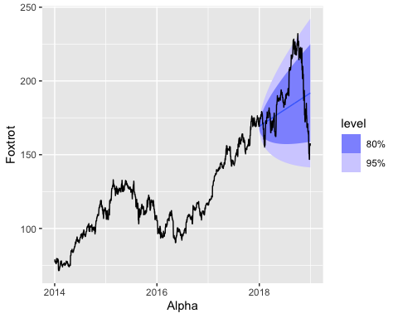
# Calculate accuracy of forecasts against test data
accuracy(forecasts_arima, test_data)
## # A tibble: 1 × 10
## .model .type ME RMSE MAE MPE MAPE MASE RMSSE ACF1
## <chr> <chr> <dbl> <dbl> <dbl> <dbl> <dbl> <dbl> <dbl> <dbl>
## 1 ARIMA(Foxtrot) Test 8.05 20.5 15.9 3.29 8.14 NaN NaN 0.982
# Load "Validation-Exercise-Data2.csv" in folder "Validation"
demodata <- read_csv(here("Time Series Validation", "Validation-Exercise-Data2.csv"))
## Rows: 42 Columns: 2
## ── Column specification ────────────────────────────────────────────────────────
## Delimiter: ","
## chr (1): Alpha
## dbl (1): Charlie
##
## ℹ Use `spec()` to retrieve the full column specification for this data.
## ℹ Specify the column types or set `show_col_types = FALSE` to quiet this message.
# Convert the date variable
demodata$Alpha <- as.Date(demodata$Alpha, "%Y %m %d")
# Convert to quarterly data
demodata$Alpha <- yearquarter(demodata$Alpha)
# Convert to time series data frame
demodata <- as_tsibble(demodata, index = Alpha)
# Plot the time series data
autoplot(demodata, Charlie)
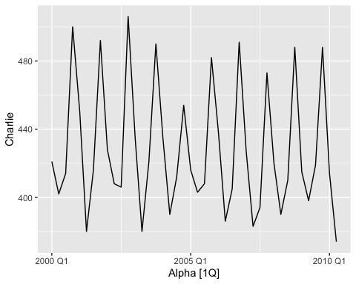
# Perform a seasonal and trend decomposition using Loess (STL)
autoplot(components(model(demodata, STL(Charlie))))
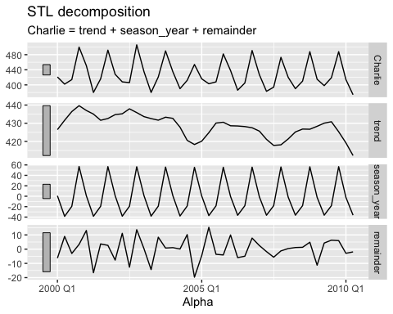
# Create train and test datasets as first 80% and last 20% of full dataset
n <- nrow(demodata)
train_n <- floor(0.8 * n)
train_data <- slice(demodata, 1:train_n)
test_data <- slice(demodata, (train_n + 1):n)
# EXPONENTIAL SMOOTHING (ETS) MODEL
# Estimate the best-fitting model on the train data
fit_ets <- model(train_data, ETS(Charlie))
# View the estimated model parameters
report(fit_ets)
## Series: Charlie
## Model: ETS(M,N,A)
## Smoothing parameters:
## alpha = 0.1110613
## gamma = 0.0001000037
##
## Initial states:
## l[0] s[0] s[-1] s[-2] s[-3]
## 433.9038 57.61909 -19.72427 -37.9353 0.04047146
##
## sigma^2: 8e-04
##
## AIC AICc BIC
## 287.2907 291.7707 297.7662
# Forecast over the length of the test set using the estimated model
forecasts_ets <- forecast(fit_ets, h=nrow(test_data))
# Plot the forecasts along with the original time series data
autoplot(forecasts_ets, demodata)
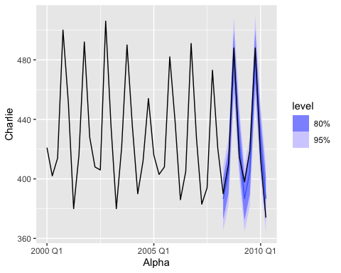
# Calculate accuracy of forecasts against test data
accuracy(forecasts_ets, test_data)
## # A tibble: 1 × 10
## .model .type ME RMSE MAE MPE MAPE MASE RMSSE ACF1
## <chr> <chr> <dbl> <dbl> <dbl> <dbl> <dbl> <dbl> <dbl> <dbl>
## 1 ETS(Charlie) Test 1.44 9.43 8.73 0.280 2.11 NaN NaN 0.210
# AUTO-REGRESSIVE INTEGRATED MOVING AVERAGE (ARIMA) MODEL
# Estimate the best-fitting model on the train data
fit_arima <- model(train_data, ARIMA(Charlie))
# View the estimated model parameters
report(fit_arima)
## Series: Charlie
## Model: ARIMA(0,0,0)(0,1,1)[4]
##
## Coefficients:
## sma1
## -0.7772
## s.e. 0.2293
##
## sigma^2 estimated as 174.8: log likelihood=-117.33
## AIC=238.66 AICc=239.12 BIC=241.39
# Forecast over the length of the test set using the estimated model
forecasts_arima <- forecast(fit_arima, h=nrow(test_data))
# Plot the forecasts along with the original time series data
autoplot(forecasts_arima, demodata)
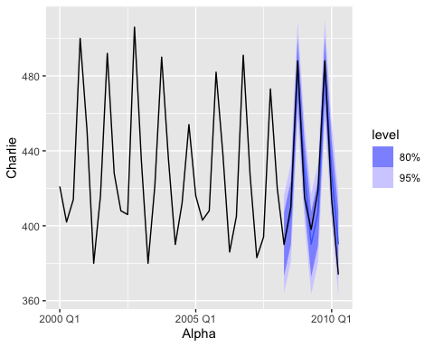
# Calculate accuracy of forecasts against test data
accuracy(forecasts_arima, test_data)
## # A tibble: 1 × 10
## .model .type ME RMSE MAE MPE MAPE MASE RMSSE ACF1
## <chr> <chr> <dbl> <dbl> <dbl> <dbl> <dbl> <dbl> <dbl> <dbl>
## 1 ARIMA(Charlie) Test -1.14 10.0 8.54 -0.357 2.07 NaN NaN 0.187
# Load "Validation-Exercise-Data3.csv" in folder "Validation"
demodata <- read_csv(here("Time Series Validation", "Validation-Exercise-Data3.csv"))
## Rows: 198 Columns: 2
## ── Column specification ────────────────────────────────────────────────────────
## Delimiter: ","
## dbl (1): Delta
## date (1): Bravo
##
## ℹ Use `spec()` to retrieve the full column specification for this data.
## ℹ Specify the column types or set `show_col_types = FALSE` to quiet this message.
# Convert the date variable
demodata$Bravo <- as.Date(demodata$Bravo, "%Y-%m-%d")
# Convert to quarterly data
demodata$Bravo <- yearquarter(demodata$Bravo)
# Convert to time series data frame
demodata <- as_tsibble(demodata, index = Bravo)
# Plot the time series data
autoplot(demodata, Delta)
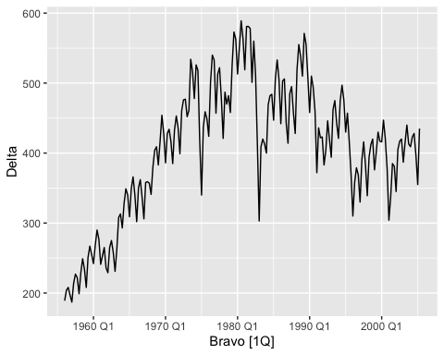
# Perform a seasonal and trend decomposition using Loess (STL)
autoplot(components(model(demodata, STL(Delta))))
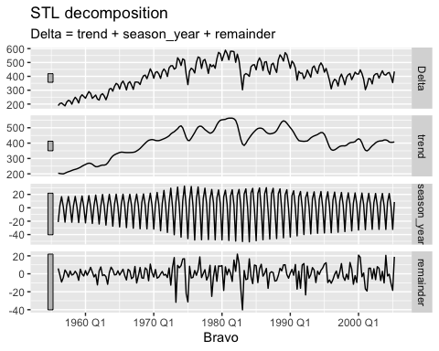
# Create train and test datasets as first 80% and last 20% of full dataset
n <- nrow(demodata)
train_n <- floor(0.8 * n)
train_data <- slice(demodata, 1:train_n)
test_data <- slice(demodata, (train_n + 1):n)
# EXPONENTIAL SMOOTHING (ETS) MODEL
# Estimate the best-fitting model on the train data
fit_ets <- model(train_data, ETS(Delta))
# View the estimated model parameters
report(fit_ets)
## Series: Delta
## Model: ETS(M,A,M)
## Smoothing parameters:
## alpha = 0.9880084
## beta = 0.0001000537
## gamma = 0.0001000042
##
## Initial states:
## l[0] b[0] s[0] s[-1] s[-2] s[-3]
## 193.8454 1.880202 1.004369 1.061183 1.026626 0.9078223
##
## sigma^2: 0.0026
##
## AIC AICc BIC
## 1758.848 1760.065 1786.412
# Forecast over the length of the test set using the estimated model
forecasts_ets <- forecast(fit_ets, h=nrow(test_data))
# Plot the forecasts along with the original time series data
autoplot(forecasts_ets, demodata)
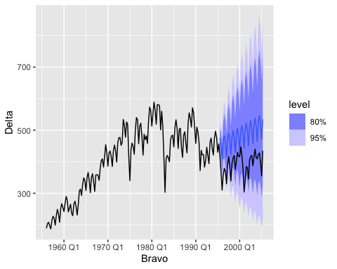
# Calculate accuracy of forecasts against test data
accuracy(forecasts_ets, test_data)
## # A tibble: 1 × 10
## .model .type ME RMSE MAE MPE MAPE MASE RMSSE ACF1
## <chr> <chr> <dbl> <dbl> <dbl> <dbl> <dbl> <dbl> <dbl> <dbl>
## 1 ETS(Delta) Test -92.2 96.1 92.2 -24.0 24.0 NaN NaN 0.657
# AUTO-REGRESSIVE INTEGRATED MOVING AVERAGE (ARIMA) MODEL
# Estimate the best-fitting model on the train data
fit_arima <- model(train_data, ARIMA(Delta))
# View the estimated model parameters
report(fit_arima)
## Series: Delta
## Model: ARIMA(2,0,1)(0,1,1)[4] w/ drift
##
## Coefficients:
## ar1 ar2 ma1 sma1 constant
## 1.5565 -0.6277 -0.4790 -0.7751 0.4442
## s.e. 0.1580 0.1457 0.1779 0.0631 0.2179
##
## sigma^2 estimated as 475: log likelihood=-692.93
## AIC=1397.85 AICc=1398.43 BIC=1416.08
# Forecast over the length of the test set using the estimated model
forecasts_arima <- forecast(fit_arima, h=nrow(test_data))
# Plot the forecasts along with the original time series data
autoplot(forecasts_arima, demodata)
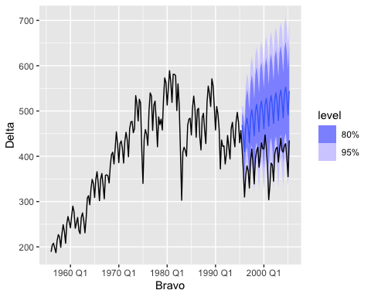
# Calculate accuracy of forecasts against test data
accuracy(forecasts_arima, test_data)
## # A tibble: 1 × 10
## .model .type ME RMSE MAE MPE MAPE MASE RMSSE ACF1
## <chr> <chr> <dbl> <dbl> <dbl> <dbl> <dbl> <dbl> <dbl> <dbl>
## 1 ARIMA(Delta) Test -105. 109. 105. -27.4 27.4 NaN NaN 0.674
# Load "Validation-Exercise-Data4.csv" in folder "Validation"
demodata <- read_csv(here("Time Series Validation", "Validation-Exercise-Data4.csv"))
## Rows: 23 Columns: 2
## ── Column specification ────────────────────────────────────────────────────────
## Delimiter: ","
## dbl (2): Echo, Bravo
##
## ℹ Use `spec()` to retrieve the full column specification for this data.
## ℹ Specify the column types or set `show_col_types = FALSE` to quiet this message.
# Convert to time series data frame
demodata <- as_tsibble(demodata, index = Echo)
# Plot the time series data
autoplot(demodata, Bravo)
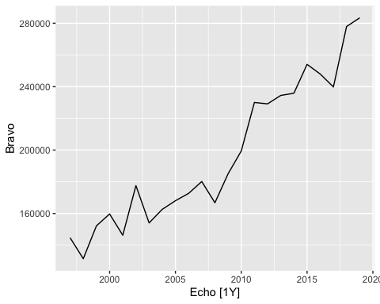
# Perform a seasonal and trend decomposition using Loess (STL)
autoplot(components(model(demodata, STL(Bravo))))
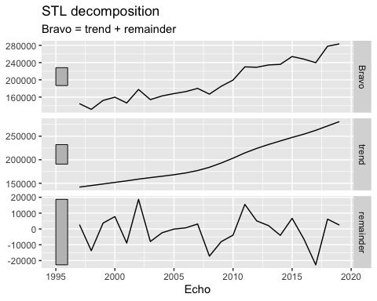
# Create train and test datasets as first 80% and last 20% of full dataset
n <- nrow(demodata)
train_n <- floor(0.8 * n)
train_data <- slice(demodata, 1:train_n)
test_data <- slice(demodata, (train_n + 1):n)
# EXPONENTIAL SMOOTHING (ETS) MODEL
# Estimate the best-fitting model on the train data
fit_ets <- model(train_data, ETS(Bravo))
# View the estimated model parameters
report(fit_ets)
## Series: Bravo
## Model: ETS(A,N,N)
## Smoothing parameters:
## alpha = 0.8153269
##
## Initial states:
## l[0]
## 143032.4
##
## sigma^2: 251716933
##
## AIC AICc BIC
## 404.0953 405.8096 406.7664
# Forecast over the length of the test set using the estimated model
forecasts_ets <- forecast(fit_ets, h=nrow(test_data))
# Plot the forecasts along with the original time series data
autoplot(forecasts_ets, demodata)
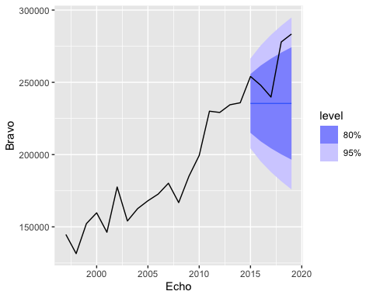
# Calculate accuracy of forecasts against test data
accuracy(forecasts_ets, test_data)
## # A tibble: 1 × 10
## .model .type ME RMSE MAE MPE MAPE MASE RMSSE ACF1
## <chr> <chr> <dbl> <dbl> <dbl> <dbl> <dbl> <dbl> <dbl> <dbl>
## 1 ETS(Bravo) Test 25248. 30470. 25248. 9.30 9.30 NaN NaN 0.262
# AUTO-REGRESSIVE INTEGRATED MOVING AVERAGE (ARIMA) MODEL
# Estimate the best-fitting model on the train data
fit_arima <- model(train_data, ARIMA(Bravo))
# View the estimated model parameters
report(fit_arima)
## Series: Bravo
## Model: ARIMA(1,1,0) w/ drift
##
## Coefficients:
## ar1 constant
## -0.4802 8598.589
## s.e. 0.2139 3223.520
##
## sigma^2 estimated as 191764347: log likelihood=-185.3
## AIC=376.6 AICc=378.44 BIC=379.1
# Forecast over the length of the test set using the estimated model
forecasts_arima <- forecast(fit_arima, h=nrow(test_data))
# Plot the forecasts along with the original time series data
autoplot(forecasts_arima, demodata)
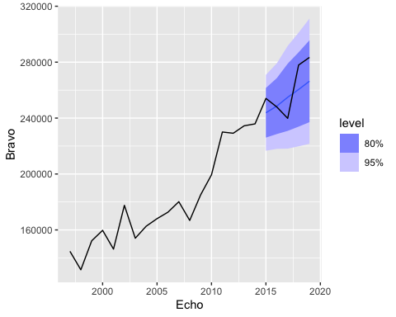
# Calculate accuracy of forecasts against test data
accuracy(forecasts_arima, test_data)
## # A tibble: 1 × 10
## .model .type ME RMSE MAE MPE MAPE MASE RMSSE ACF1
## <chr> <chr> <dbl> <dbl> <dbl> <dbl> <dbl> <dbl> <dbl> <dbl>
## 1 ARIMA(Bravo) Test 5818. 13625. 12093. 1.96 4.57 NaN NaN -0.00907
# Load "Validation-Exercise-Data5.csv" in folder "Validation"
demodata <- read_csv(here("Time Series Validation", "Validation-Exercise-Data5.csv"))
## Rows: 107 Columns: 2
## ── Column specification ────────────────────────────────────────────────────────
## Delimiter: ","
## chr (1): Charlie
## dbl (1): Echo
##
## ℹ Use `spec()` to retrieve the full column specification for this data.
## ℹ Specify the column types or set `show_col_types = FALSE` to quiet this message.
# Convert the date variable
demodata$Charlie <- as.Date(demodata$Charlie, "%d %B %Y")
# Convert to monthly data
demodata$Charlie <- yearmonth(demodata$Charlie)
# Convert to time series data frame
demodata <- as_tsibble(demodata, index = Charlie)
# Plot the time series data
autoplot(demodata, Echo)
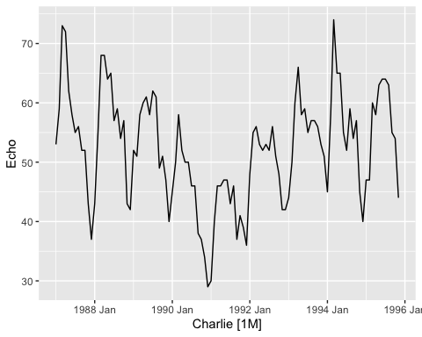
# Perform a seasonal and trend decomposition using Loess (STL)
autoplot(components(model(demodata, STL(Echo))))
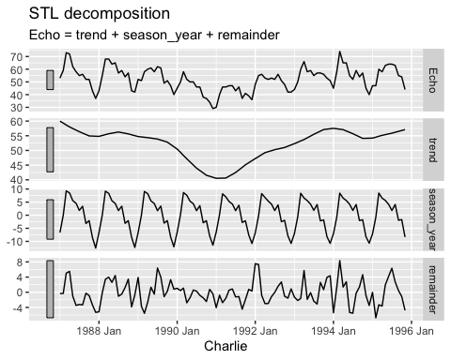
# Create train and test datasets as first 80% and last 20% of full dataset
n <- nrow(demodata)
train_n <- floor(0.8 * n)
train_data <- slice(demodata, 1:train_n)
test_data <- slice(demodata, (train_n + 1):n)
# EXPONENTIAL SMOOTHING (ETS) MODEL
# Estimate the best-fitting model on the train data
fit_ets <- model(train_data, ETS(Echo))
# View the estimated model parameters
report(fit_ets)
## Series: Echo
## Model: ETS(M,N,A)
## Smoothing parameters:
## alpha = 0.8006946
## gamma = 0.0001006589
##
## Initial states:
## l[0] s[0] s[-1] s[-2] s[-3] s[-4] s[-5] s[-6]
## 56.67454 -11.43783 -7.669251 -2.679989 -3.520505 2.991237 1.370756 4.471891
## s[-7] s[-8] s[-9] s[-10] s[-11]
## 5.569579 8.115728 8.560276 0.4079076 -6.179796
##
## sigma^2: 0.0055
##
## AIC AICc BIC
## 616.4716 623.4281 653.1113
# Forecast over the length of the test set using the estimated model
forecasts_ets <- forecast(fit_ets, h=nrow(test_data))
# Plot the forecasts along with the original time series data
autoplot(forecasts_ets, demodata)
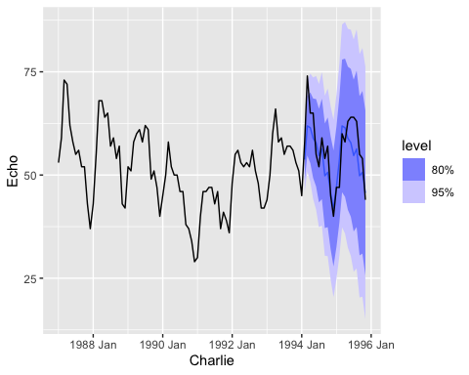
# Calculate accuracy of forecasts against test data
accuracy(forecasts_ets, test_data)
## # A tibble: 1 × 10
## .model .type ME RMSE MAE MPE MAPE MASE RMSSE ACF1
## <chr> <chr> <dbl> <dbl> <dbl> <dbl> <dbl> <dbl> <dbl> <dbl>
## 1 ETS(Echo) Test 2.36 5.16 4.36 3.39 7.41 NaN NaN 0.452
# AUTO-REGRESSIVE INTEGRATED MOVING AVERAGE (ARIMA) MODEL
# Estimate the best-fitting model on the train data
fit_arima <- model(train_data, ARIMA(Echo))
# View the estimated model parameters
report(fit_arima)
## Series: Echo
## Model: ARIMA(0,1,0)(0,1,1)[12]
##
## Coefficients:
## sma1
## -0.7073
## s.e. 0.1801
##
## sigma^2 estimated as 17.85: log likelihood=-209.53
## AIC=423.07 AICc=423.24 BIC=427.62
# Forecast over the length of the test set using the estimated model
forecasts_arima <- forecast(fit_arima, h=nrow(test_data))
# Plot the forecasts along with the original time series data
autoplot(forecasts_arima, demodata)
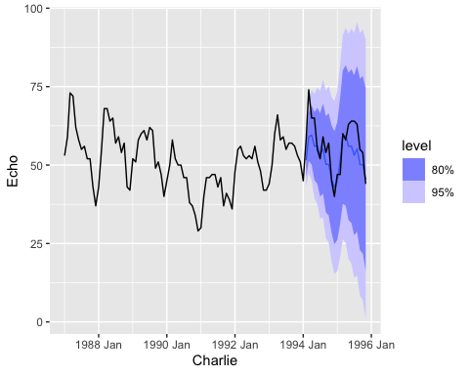
# Calculate accuracy of forecasts against test data
accuracy(forecasts_arima, test_data)
## # A tibble: 1 × 10
## .model .type ME RMSE MAE MPE MAPE MASE RMSSE ACF1
## <chr> <chr> <dbl> <dbl> <dbl> <dbl> <dbl> <dbl> <dbl> <dbl>
## 1 ARIMA(Echo) Test 3.77 6.11 4.94 5.75 8.26 NaN NaN 0.376

