Visualizing-Exercise-Start.R
dhruv
2025-02-04
# Exercise: Visualizing Data
#
# Please answer the following questions and include your final code below. When you are done,
# click on File > Compile Report > MS Word and submit the resulting Word document.
#
# Q: Load Visualizing-Exercise-Data1.csv and convert variables to factors as necessary.
# Plot "Charlie" with bin width 1000 and boundary 0. Which bin has the highest count?
# A: 15000-16000
#
# Q: Plot "Delta" with bin width 500 and boundary 0. Which bin has the highest count?
# A: 1000-1500
#
# Q: Plot "Alpha". Which is the most frequent category?
# A: Brian Thompson
#
# Q: Plot "Bravo". Which is the most frequent category?
# A: False
#
# Q: Load Visualizing-Exercise-Data2.csv and convert variables to factors as necessary.
# Plot "Alpha" with bin width 100 and boundary 0. Which bin has the highest count?
# A: 1000-1100
#
# Q: Plot "Bravo" with bin width 1000 and boundary 0. Which bin has the highest count?
# A: 6250-7250
#
# Q: Plot "Charlie". Which is the most frequent category?
# A: "****"
#
# Q: Plot "Delta". Which is the most frequent category?
# A: UNited States
#
#load tidyverse and here liararies
library(tidyverse)
## ── Attaching core tidyverse packages ──────────────────────── tidyverse 2.0.0 ──
## ✔ dplyr 1.1.4 ✔ readr 2.1.5
## ✔ forcats 1.0.0 ✔ stringr 1.5.1
## ✔ ggplot2 3.5.1 ✔ tibble 3.2.1
## ✔ lubridate 1.9.4 ✔ tidyr 1.3.1
## ✔ purrr 1.0.2
## ── Conflicts ────────────────────────────────────────── tidyverse_conflicts() ──
## ✖ dplyr::filter() masks stats::filter()
## ✖ dplyr::lag() masks stats::lag()
## ℹ Use the conflicted package (<http://conflicted.r-lib.org/>) to force all conflicts to become errors
library(here)
## here() starts at /Users/dhruv/BAN663/BAN663 Code&Data
# Load "Visualizing-Exercise-Data1.csv" from the folder "Viz Ex"
data1 <- read_csv(here("Viz Ex", "Visualizing-Exercise-Data1.csv"))
## Rows: 262 Columns: 4
## ── Column specification ────────────────────────────────────────────────────────
## Delimiter: ","
## chr (1): Alpha
## dbl (2): Charlie, Delta
## lgl (1): Bravo
##
## ℹ Use `spec()` to retrieve the full column specification for this data.
## ℹ Specify the column types or set `show_col_types = FALSE` to quiet this message.
# show Summary stats
summary(data1)
## Alpha Bravo Charlie Delta
## Length:262 Mode :logical Min. : 3677 Min. :-1574
## Class :character FALSE:137 1st Qu.:10585 1st Qu.: 917
## Mode :character TRUE :111 Median :13626 Median : 1716
## NA's :14 Mean :13234 Mean : 1882
## 3rd Qu.:15748 3rd Qu.: 2934
## Max. :21456 Max. : 5349
## NA's :11 NA's :13
#convert 'Alpha' and 'Bravo' to unordered factors
data1$Alpha <- as.factor(data1$Alpha)
data1$Bravo <- as.factor(data1$Bravo)
# show Summary stats
summary(data1)
## Alpha Bravo Charlie Delta
## Brian Thompson :37 FALSE:137 Min. : 3677 Min. :-1574
## Casey Dixon :36 TRUE :111 1st Qu.:10585 1st Qu.: 917
## Andrew Clark :34 NA's : 14 Median :13626 Median : 1716
## Anthony Mcknight:30 Mean :13234 Mean : 1882
## John Williamson :30 3rd Qu.:15748 3rd Qu.: 2934
## (Other) :76 Max. :21456 Max. : 5349
## NA's :19 NA's :11 NA's :13
#Plot "Charlie" with bin width 1000 and boundary 0
ggplot(data1, aes(x = Charlie)) + geom_histogram(binwidth = 1000, boundary = 0)
## Warning: Removed 11 rows containing non-finite outside the scale range
## (`stat_bin()`).
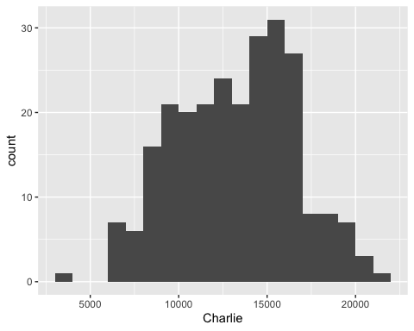
# Plot "Delta" with bin width 500 and boundary 0
ggplot(data1, aes(x = Delta)) + geom_histogram(binwidth = 500, boundary = 0)
## Warning: Removed 13 rows containing non-finite outside the scale range
## (`stat_bin()`).
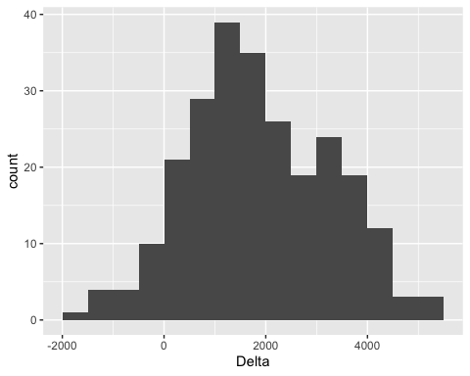
# Plot "Alpha" tilt the x-axis by 45 degrees
ggplot(data1, aes(x = Alpha)) + geom_bar() + theme(axis.text.x = element_text(angle = 45, hjust = 1))
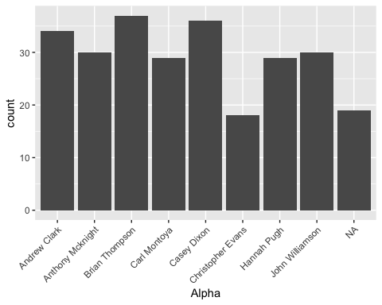
# Plot "Bravo".
ggplot(data1, aes(x = Bravo)) + geom_bar()
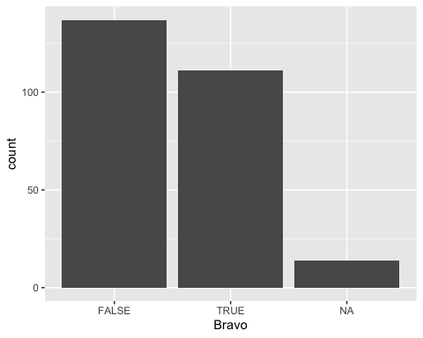
# Load "Visualizing-Exercise-Data2.csv" from the folder "Viz Ex"
data2 <- read_csv(here("Viz Ex", "Visualizing-Exercise-Data2.csv"))
## Rows: 306 Columns: 4
## ── Column specification ────────────────────────────────────────────────────────
## Delimiter: ","
## chr (2): Charlie, Delta
## dbl (2): Alpha, Bravo
##
## ℹ Use `spec()` to retrieve the full column specification for this data.
## ℹ Specify the column types or set `show_col_types = FALSE` to quiet this message.
# show summary sttas
summary(data2)
## Alpha Bravo Charlie Delta
## Min. : 148.0 Min. : 296.3 Length:306 Length:306
## 1st Qu.: 558.5 1st Qu.:3255.9 Class :character Class :character
## Median : 805.0 Median :4837.0 Mode :character Mode :character
## Mean : 795.3 Mean :4843.3
## 3rd Qu.:1037.0 3rd Qu.:6476.9
## Max. :1565.0 Max. :9760.8
## NA's :19 NA's :16
#convert 'Delta' to unordered factors
data2$Delta <- as.factor(data2$Delta)
#show unique values in charile
unique(data2$Charlie)
## [1] "****" "***" "**" "*****" "*" NA
# convert 'Charlie' to ordered factors ("*", "**", "***", "****", "*****")
data2$Charlie <- factor(data2$Charlie, levels = c("*", "**", "***", "****", "*****"), ordered = TRUE)
# show summary
summary(data2)
## Alpha Bravo Charlie Delta
## Min. : 148.0 Min. : 296.3 * :33 United States :76
## 1st Qu.: 558.5 1st Qu.:3255.9 ** :67 Germany :42
## Median : 805.0 Median :4837.0 *** :79 Canada :38
## Mean : 795.3 Mean :4843.3 **** :84 France :36
## 3rd Qu.:1037.0 3rd Qu.:6476.9 *****:29 United Kingdom:33
## Max. :1565.0 Max. :9760.8 NA's :14 (Other) :61
## NA's :19 NA's :16 NA's :20
# Plot "Alpha" with bin width 100 and boundary 0
ggplot(data2, aes(x = Alpha)) + geom_histogram(binwidth = 100, boundary = 0)
## Warning: Removed 19 rows containing non-finite outside the scale range
## (`stat_bin()`).
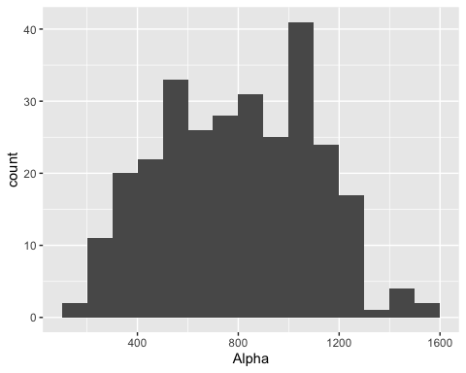
# Plot "Bravo" with bin width 1000 and boundary 0
ggplot(data2, aes(x = Bravo)) + geom_histogram(binwidth = 1000, boundary = 0)
## Warning: Removed 16 rows containing non-finite outside the scale range
## (`stat_bin()`).
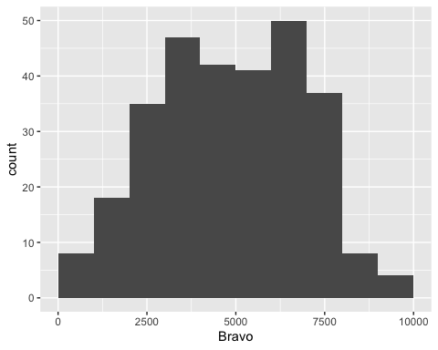
# Plot "Charlie"
ggplot(data2, aes(x = Charlie)) + geom_bar()
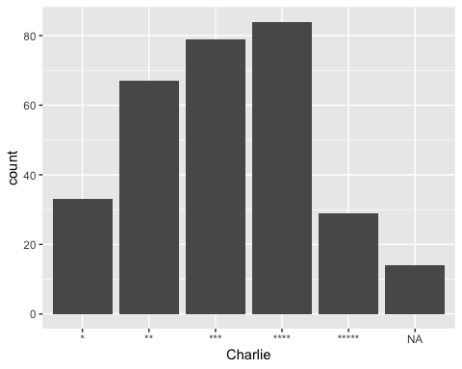
# Plot "Delta"
ggplot(data2, aes(x = Delta)) + geom_bar()
