Indian Padel Tour
Ranking forecast and City Open Chandigarh 2.0 predictions
Prepared for Dhruv Khanna. Data as of 2026-09-24. Chandigarh forecast frozen at 24 Sep 2026, 23:34 IST, after day 1.

1. The short version
- Most ranking points have an expiry date. If last season's points all drop off on 1 July 2027, No. 1 Aditya Jagtap keeps just 888 of his 4,168 points unless he wins more. The men's top 5 keep between 11% and 32% of what they have today.
- This season pays less. Winning a City Open now earns 300 points, down from 400; a quarter-final earns 54, down from 120. Repeating last season's results is no longer enough to keep the same total.
- The site's "12 months" label isn't what happens. If points really expired after 12 months, 12,512 points would already be gone. They still count, so this report shows both possible rules.
- Matches are fairly predictable. Our model called about 7 in 10 matches correctly on tournaments it had never seen (69%). Tossing a coin gets 5 in 10, and simply backing the higher-ranked pair gets 68%. The model's extra value is that its percentages can be trusted.
- Chandigarh 2.0 favourites: Aditya Jagtap & Rahul Motwani in Men's Advance, with a 57% chance of winning the title (a bit better than a coin flip). Odds for five divisions are in section 5 and on the website.

How IPT rankings work, in 30 seconds
- At every tournament, players earn ranking points depending on how far they get. Winning earns the most.
- Bigger events pay more: in the top division, winning a Grand Slam is worth 600 points and winning a City Open 300.
- Points don't last forever. After a while they drop off, and a player's ranking falls unless they win new ones.
- A player's ranking is simply the total of the points they still have.

How to read the percentages
A 57% chance means that if the same match were played 100 times, that pair would win about 57. Favourites still lose often. Words like "about 3 in 5" are used alongside percentages throughout. Technical terms are explained in the glossary at the end.

2. Where the numbers come from
All data comes from indianpadeltour.in and its public API, scraped politely (one request at a time) with ipt_scraper.py. Match-level data exists for only three tournaments (Mumbai City Open 5.0, Goa Grand Slam 11.0 and Kochi City Open 2.0) plus the live Chandigarh draw. Ranking results exist for 22 events going back to December 2024.
- Entry points leak results. The points printed next to each team in a draw are the players' current points, so for past tournaments they already include the result being predicted. All analysis here rebuilds each player's points from dated ranking results instead.
- The ranking window. Every result dated 2025-07-01 or later counts today and nothing older does, with no cap on the number of results. That matches a season-based window, not the "rolling 12 months" the profile pages mention.
- Rebuild check. Rebuilding points from results reproduces all 916 ranking rows exactly (916 of 916).

3. Whose points are about to disappear?
The site shows each player's current total and one "defending points" figure. It does not show when points fall away. This analysis projects every player's total forward, assuming no new points are earned, so it measures how much each player has to defend and by when. It is an exposure view, not a prediction of the final table.

3.1 The points scale changed
Points per finish in the Advance division, by season:
Tier | Finish | 2025-26 points | 2026-27 points | Change
City Open | Winner | 400 | 300 | -25%
City Open | Finalist | 240 | 180 | -25%
City Open | Semi-final | 160 | 108 | -32%
City Open | Quarter-final | 120 | 54 | -55%
Grand Slam | Winner | 600 | 600 | no change
Grand Slam | Finalist | 360 | 360 | no change
Grand Slam | Semi-final | 240 | 216 | -10%
Grand Slam | Quarter-final | 180 | 108 | -40%

If the current top-5 players in each category repeated every 2025-26 result exactly, the new scale would give them between 76% and 94% of the points those results earned.

3.2 Points still counting at each date
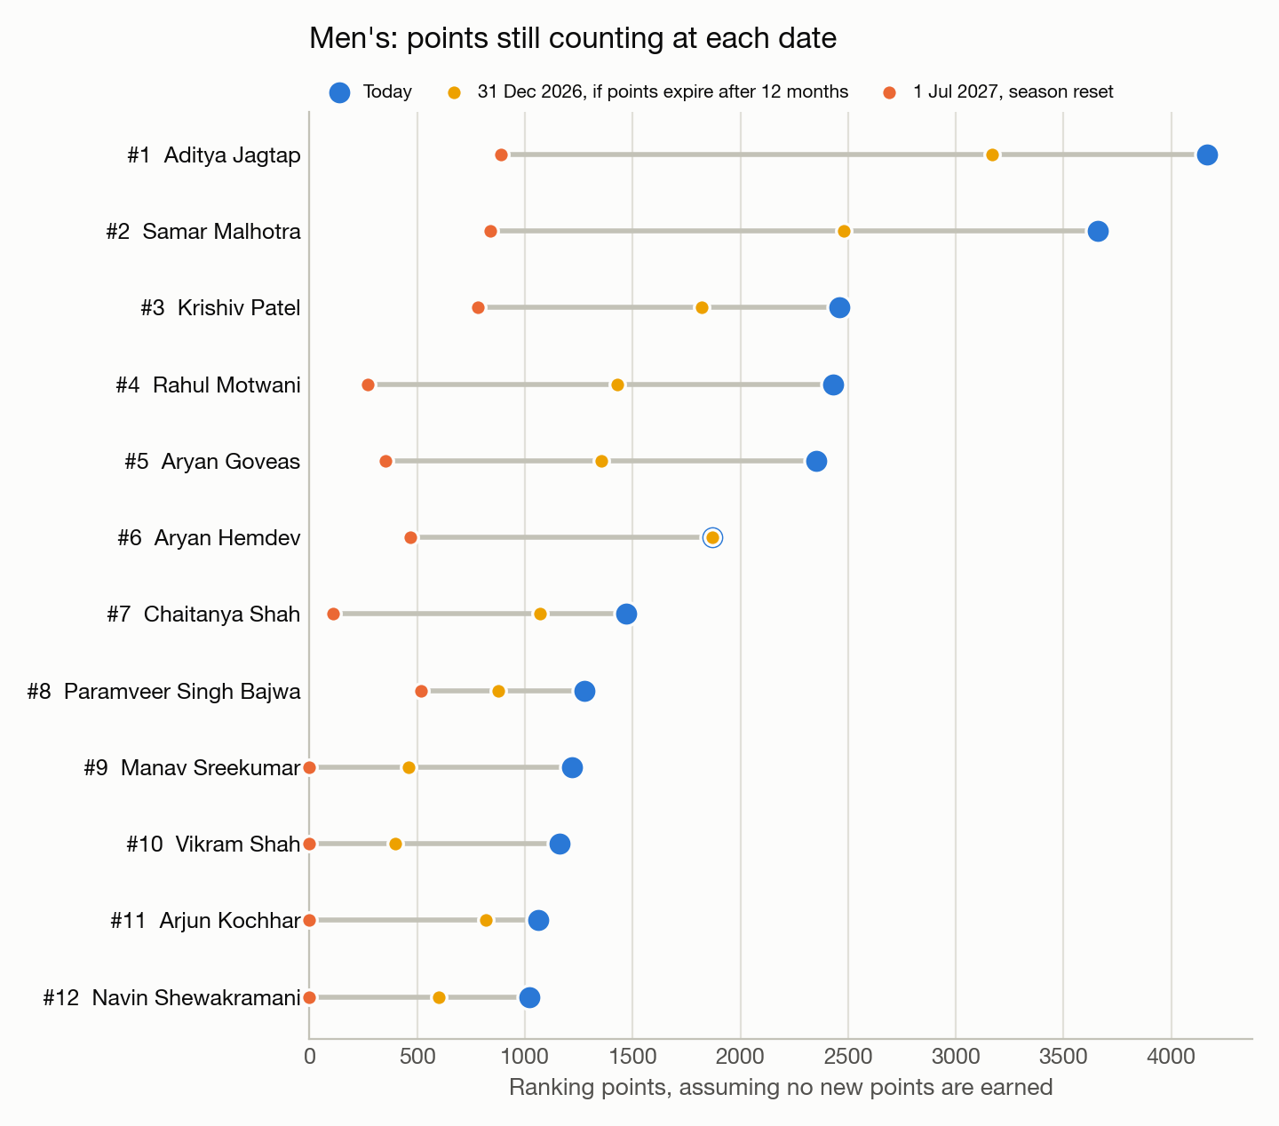
Figure: Men's top 12. Blue is today, yellow is 31 Dec 2026 if points expire after 12 months, orange is 1 Jul 2027 if the season window resets. Source: outputs/a1_ranking_forecast/.
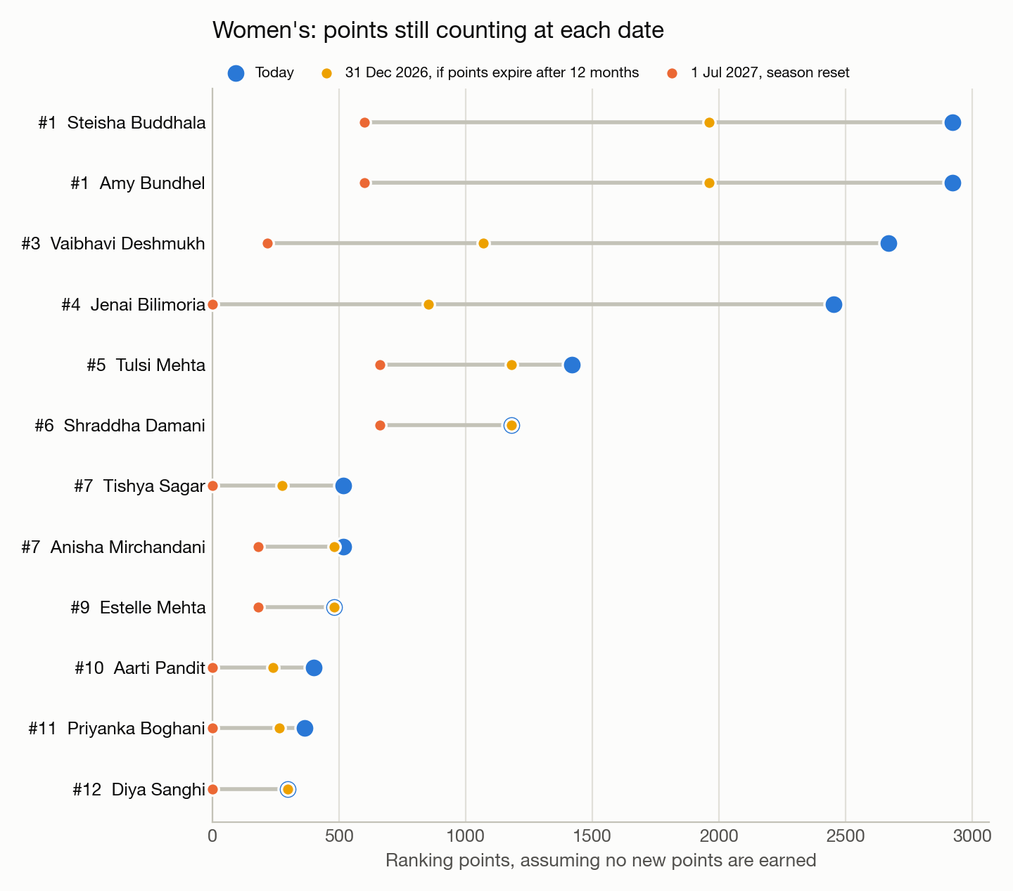
Figure: Women's top 12. Blue is today, yellow is 31 Dec 2026 if points expire after 12 months, orange is 1 Jul 2027 if the season window resets. Source: outputs/a1_ranking_forecast/.
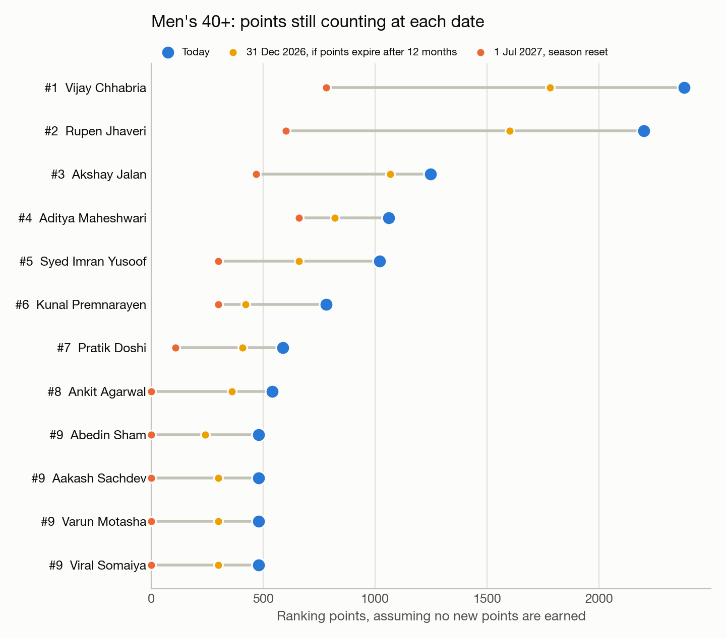
Figure: Men's 40+ top 12. Blue is today, yellow is 31 Dec 2026 if points expire after 12 months, orange is 1 Jul 2027 if the season window resets. Source: outputs/a1_ranking_forecast/.

3.3 Top 10 by category, today and projected

Men's
Rank | Player | Points today | 31 Dec 2026 (rolling) | 1 Jul 2027 (reset)
1 | Aditya Jagtap | 4,168 | 3,168 (#1) | 888 (#1)
2 | Samar Malhotra | 3,660 | 2,480 (#2) | 840 (#2)
3 | Krishiv Patel | 2,460 | 1,820 (#4) | 780 (#3)
4 | Rahul Motwani | 2,430 | 1,430 (#5) | 270 (#8)
5 | Aryan Goveas | 2,354 | 1,354 (#6) | 354 (#6)
6 | Aryan Hemdev | 1,868 | 1,868 (#3) | 468 (#5)
7 | Chaitanya Shah | 1,468 | 1,068 (#7) | 108 (#19)
8 | Paramveer Singh Bajwa | 1,276 | 876 (#9) | 516 (#4)
9 | Manav Sreekumar | 1,220 | 460 (#12) | 0 (#152)
10 | Vikram Shah | 1,160 | 400 (#18) | 0 (#152)

Women's
Rank | Player | Points today | 31 Dec 2026 (rolling) | 1 Jul 2027 (reset)
1 | Steisha Buddhala | 2,920 | 1,960 (#1) | 600 (#3)
1 | Amy Bundhel | 2,920 | 1,960 (#1) | 600 (#3)
3 | Vaibhavi Deshmukh | 2,668 | 1,068 (#5) | 216 (#5)
4 | Jenai Bilimoria | 2,452 | 852 (#6) | 0 (#51)
5 | Tulsi Mehta | 1,420 | 1,180 (#3) | 660 (#1)
6 | Shraddha Damani | 1,180 | 1,180 (#3) | 660 (#1)
7 | Tishya Sagar | 516 | 276 (#10) | 0 (#51)
7 | Anisha Mirchandani | 516 | 480 (#7) | 180 (#9)
9 | Estelle Mehta | 480 | 480 (#7) | 180 (#9)
10 | Aarti Pandit | 400 | 240 (#14) | 0 (#51)

Men's 40+
Rank | Player | Points today | 31 Dec 2026 (rolling) | 1 Jul 2027 (reset)
1 | Vijay Chhabria | 2,380 | 1,780 (#1) | 780 (#1)
2 | Rupen Jhaveri | 2,200 | 1,600 (#2) | 600 (#3)
3 | Akshay Jalan | 1,248 | 1,068 (#3) | 468 (#4)
4 | Aditya Maheshwari | 1,060 | 820 (#4) | 660 (#2)
5 | Syed Imran Yusoof | 1,020 | 660 (#5) | 300 (#5)
6 | Kunal Premnarayen | 780 | 420 (#6) | 300 (#5)
7 | Pratik Doshi | 588 | 408 (#7) | 108 (#15)
8 | Ankit Agarwal | 540 | 360 (#8) | 0 (#18)
9 | Abedin Sham | 480 | 240 (#14) | 0 (#18)
9 | Aakash Sachdev | 480 | 300 (#10) | 0 (#18)

3.4 What it takes to hold rank by 1 Jul 2027
Points each top-10 player would need to earn to keep today's rank at the reset, if nobody else earned anything. Real targets are higher, since rivals will score too, so read this as a floor.

Men's
Rank | Player | Points today | Left at reset | Rank at reset | Needed to hold
1 | Aditya Jagtap | 4,168 | 888 | 1 | 0
2 | Samar Malhotra | 3,660 | 840 | 2 | 0
3 | Krishiv Patel | 2,460 | 780 | 3 | 0
4 | Rahul Motwani | 2,430 | 270 | 8 | 246
5 | Aryan Goveas | 2,354 | 354 | 6 | 114
6 | Aryan Hemdev | 1,868 | 468 | 5 | 0
7 | Chaitanya Shah | 1,468 | 108 | 19 | 192
8 | Paramveer Singh Bajwa | 1,276 | 516 | 4 | 0
9 | Manav Sreekumar | 1,220 | 0 | 152 | 270
10 | Vikram Shah | 1,160 | 0 | 152 | 270

Women's
Rank | Player | Points today | Left at reset | Rank at reset | Needed to hold
1 | Amy Bundhel | 2,920 | 600 | 3 | 60
1 | Steisha Buddhala | 2,920 | 600 | 3 | 60
3 | Vaibhavi Deshmukh | 2,668 | 216 | 5 | 384
4 | Jenai Bilimoria | 2,452 | 0 | 51 | 600
5 | Tulsi Mehta | 1,420 | 660 | 1 | 0
6 | Shraddha Damani | 1,180 | 660 | 1 | 0
7 | Tishya Sagar | 516 | 0 | 51 | 216
7 | Anisha Mirchandani | 516 | 180 | 9 | 36
9 | Estelle Mehta | 480 | 180 | 9 | 0
10 | Aarti Pandit | 400 | 0 | 51 | 180

Men's 40+
Rank | Player | Points today | Left at reset | Rank at reset | Needed to hold
1 | Vijay Chhabria | 2,380 | 780 | 1 | 0
2 | Rupen Jhaveri | 2,200 | 600 | 3 | 60
3 | Akshay Jalan | 1,248 | 468 | 4 | 132
4 | Aditya Maheshwari | 1,060 | 660 | 2 | 0
5 | Syed Imran Yusoof | 1,020 | 300 | 5 | 0
6 | Kunal Premnarayen | 780 | 300 | 5 | 0
7 | Pratik Doshi | 588 | 108 | 15 | 192
8 | Ankit Agarwal | 540 | 0 | 18 | 216
9 | Aakash Sachdev | 480 | 0 | 18 | 216
9 | Abedin Sham | 480 | 0 | 18 | 216
9 | Varun Motasha | 480 | 0 | 18 | 216
9 | Viral Somaiya | 480 | 0 | 18 | 216

4. Can we predict who wins a match?
Most IPT matches are a race to 8 games, so every game is a small contest. The model gives each player a strength made of two parts: their ranking points before the event, and an adjustment learned from the games they have won and lost. The adjustment is held close to zero unless a player has enough games to justify moving it, so a newcomer is judged mostly by their points. A team's strength is the sum of its two players, and the difference between two teams gives the chance of winning each game, which converts into the chance of winning the match for any format (race to 8 or 9, or best of three sets with a super tiebreak).
Each version was trained only on tournaments that finished before the one it was tested on. The penalty that holds adjustments near zero was chosen on the Goa test alone (value 32); Kochi is a clean test.
Test tournament | Method | Matches | Called correctly | Log loss | Brier
Goa GS 11.0 | Toss a coin | 176 | 50.0% | 0.693 | 0.250
Goa GS 11.0 | Back the higher-ranked pair | 176 | 68.2% | 0.565 | 0.197
Goa GS 11.0 | Past games only | 176 | 59.1% | 0.659 | 0.234
Goa GS 11.0 | Our model | 176 | 68.8% | 0.557 | 0.194
Kochi CO 2.0 | Toss a coin | 101 | 50.0% | 0.693 | 0.250
Kochi CO 2.0 | Back the higher-ranked pair | 101 | 68.8% | 0.570 | 0.195
Kochi CO 2.0 | Past games only | 101 | 60.9% | 0.637 | 0.225
Kochi CO 2.0 | Our model | 101 | 70.3% | 0.549 | 0.188

"Called correctly" counts how often the favourite won. Log loss and Brier score (see the glossary) also reward honest percentages; lower is better. Ranking points carry most of the signal; learning from past games adds a smaller, consistent improvement.
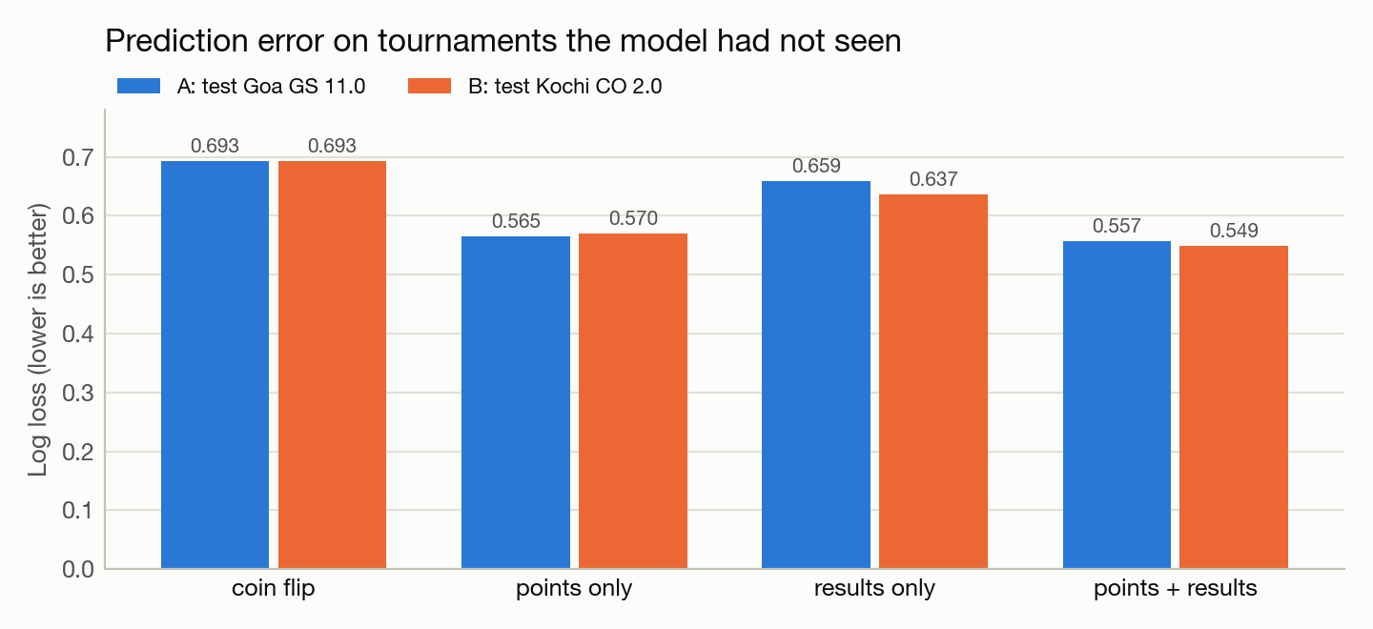
Figure: prediction error by model on the two unseen tournaments. Source: outputs/a2_match_model/.
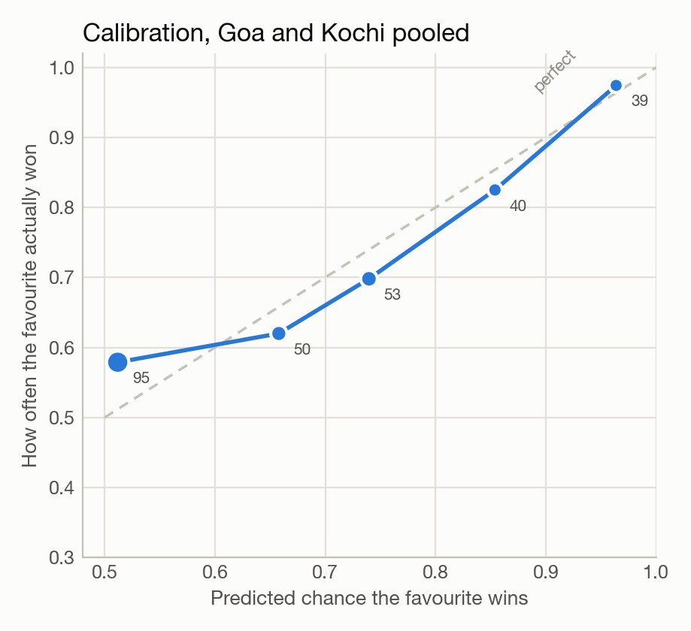
Figure: calibration. When the model gave the favourite about 75%, the favourite won about 70% of the time; near-certain picks came in as expected. Dot size and labels show the number of matches.
Chandigarh's first 33 matches (Men's Beginner groups, played before the forecast was frozen) were harder: 59% correct. Most beginners have no ranking points and no past games, so the model has little to go on.

5. Who will win City Open Chandigarh 2.0?
The model was refitted on all 449 matches played so far and the tournament was simulated 20,000 times using the site's own rules, which were reverse-engineered from earlier events: 2 points per group win plus 1 bonus point for an 8-0 win (this matches all 250 group-standing rows from earlier events), ties broken on game difference, and knockout slots exactly as the draw lists them. Women's Intermediate and Women's Advance share a combined round robin that the draw does not fully describe, so they have match predictions only.
Forecast frozen at 24 Sep 2026, 23:34 IST. 36 matches had already been played and are excluded from scoring; 120 matches with known teams will be scored after the final.

5.1 Title chances
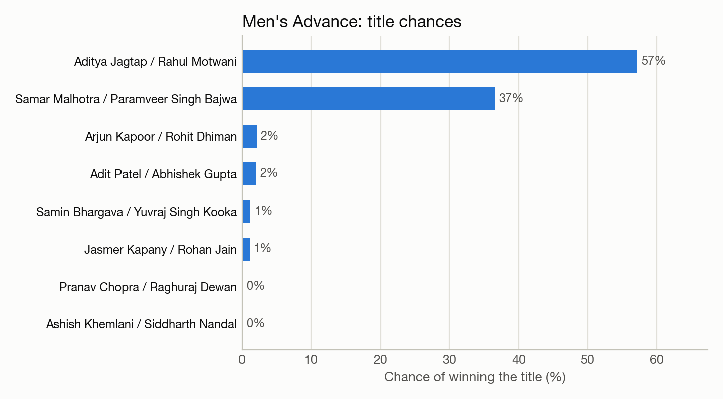
Figure: Men's Advance, chance of winning the title (top 8 teams).
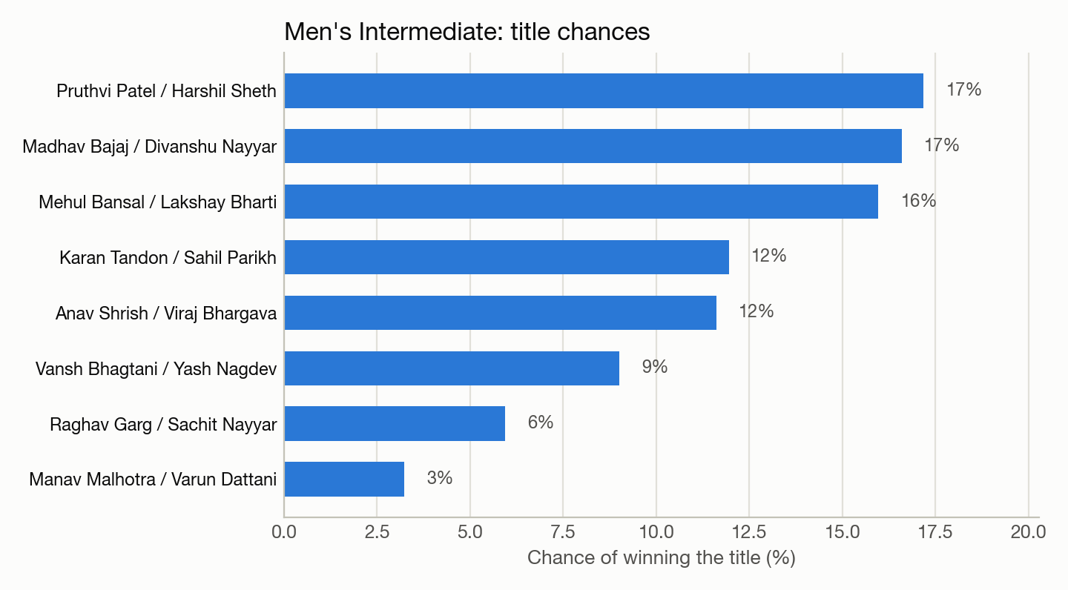
Figure: Men's Intermediate, chance of winning the title (top 8 teams).
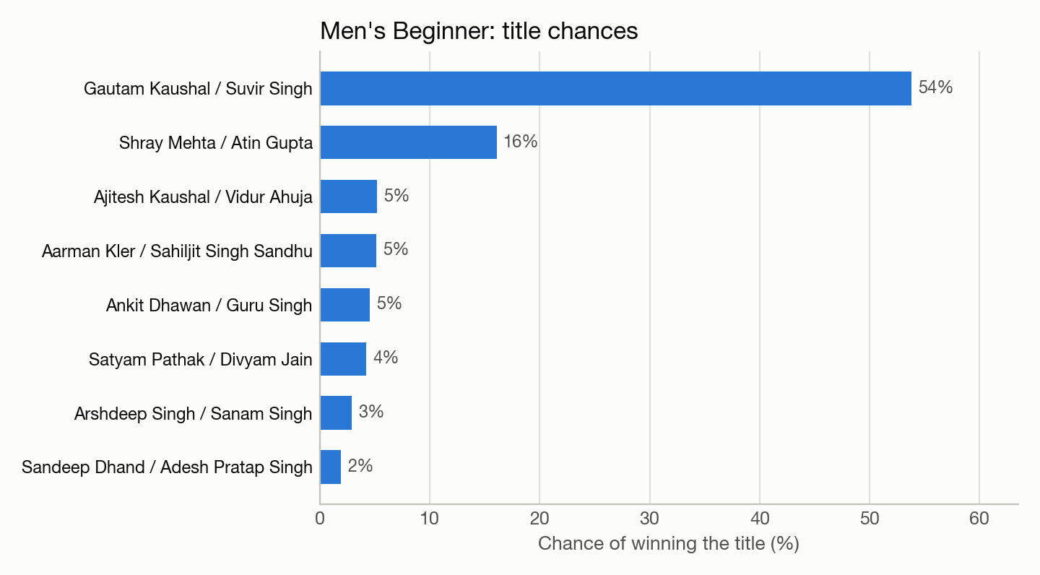
Figure: Men's Beginner, chance of winning the title (top 8 teams).
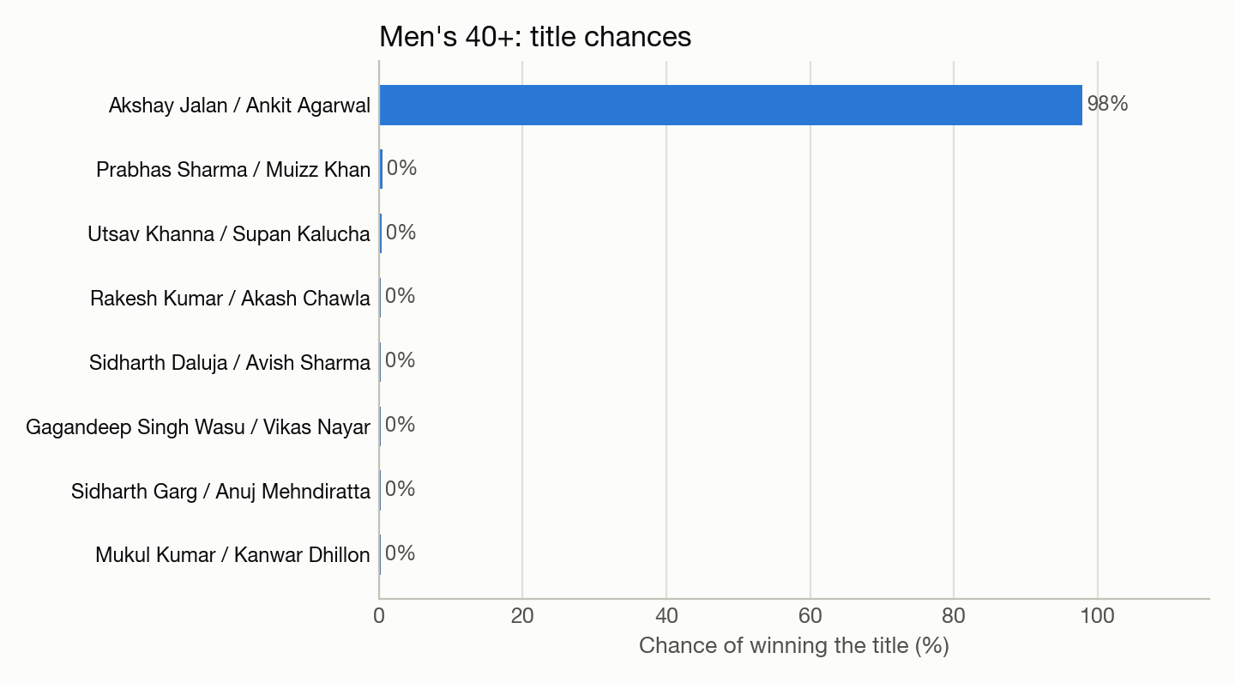
Figure: Men's 40+, chance of winning the title (top 8 teams).
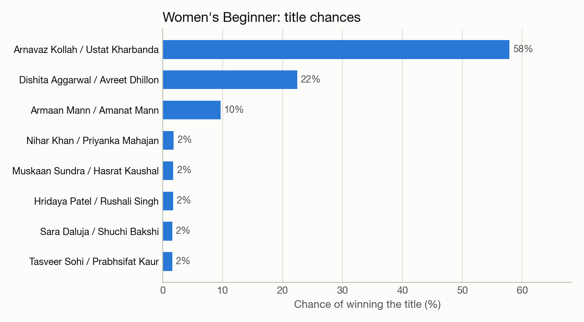
Figure: Women's Beginner, chance of winning the title (top 8 teams).

5.2 Matches to watch
Closest contests where the model has information on both teams:
Division | Round | Team 1 | Team 2 | Team 1 wins
Men's Advance | GROUP C | Tushar Jagota / Aryan Manchanda | Gautam Daluja / Darshan Dilbar Singh | 51%
Men's Intermediate | GROUP F | Rishabh Gupta / Rijul Jain | Arjun Dhanda / Akhil Bansal | 49%
Men's Intermediate | GROUP D | Yashvardhan Sarda / Shreyas Dogial | Manan Gupta / Armaan Garg | 53%
Men's Intermediate | GROUP F | Arjun Dhanda / Akhil Bansal | Rajkanwar Bhangoo / Harneet Singh | 47%
Men's Intermediate | GROUP E | Akshay Dhawan / Animesh Gupta | Vaibhav Sahni / Ishaan Chandhok | 53%
Men's 40+ | GROUP B | Prabhas Sharma / Muizz Khan | Utsav Khanna / Supan Kalucha | 53%
Men's 40+ | GROUP B | Prabhas Sharma / Muizz Khan | Rakesh Kumar / Akash Chawla | 53%
Men's 40+ | GROUP B | Prabhas Sharma / Muizz Khan | Sidharth Daluja / Avish Sharma | 53%

Where the model disagrees with ranking points (the team with fewer points is the model's favourite because of how its players have performed in past games):
Division | Team 1 (points) | Team 2 (points) | Team 1 wins
Men's Intermediate | Manav Malhotra / Varun Dattani (301) | Raghav Garg / Sachit Nayyar (44) | 44%
Men's Intermediate | Nikhil Bansal / Jansher Waraich (51) | Vansh Bhagtani / Yash Nagdev (18) | 33%
Men's Intermediate | Rishabh Gupta / Rijul Jain (20) | Arjun Dhanda / Akhil Bansal (18) | 49%
Men's Intermediate | Ramit Bhargava / Manjot Singh Ahuja (20) | Udhay Mahajan / Hari Singh (18) | 43%
Men's Advance | Advait Bahl / Kabir Anand (213) | Pranav Chopra / Raghuraj Dewan (178) | 25%

13% of the matches still to play are exact 50-50 calls: all four players have no ranking points and no games on record.

5.3 Scorecard
Not scored yet. After the final on 27 Sep 2026, run analysis/a4_evaluate_chandigarh.py and rebuild this report; this section fills in automatically.

6. Limitations
- Three finished tournaments (416 matches with scores) is a small base. Estimates will sharpen with every event.
- Most players have played one event, so for them the model relies on ranking points alone.
- The expiry rule is inferred, not published. Both plausible rules are shown rather than guessed between.
- Games are treated as independent coin flips weighted by strength. Serve, momentum and fatigue are ignored.
- 26 walkovers and retirements at the finished tournaments were excluded from fitting and scoring.
- The Women's Intermediate and Advance combined format is not simulated.

Glossary
Term | Meaning
Ranking points | Points earned for how far a player gets at a tournament. A player's ranking is the total that still counts.
Grand Slam, City Open | The two tournament tiers. Grand Slams pay more points than City Opens.
Division | The level a pair plays at: Beginner, Intermediate, Advance (top) or 40+. Each division has its own draw and points.
Expiry, window | Points only count for a limited time. The window is the period whose points still count.
Race to 8 | The usual match format: the first pair to win 8 games wins the match.
Model | A set of rules, learned from past results, that turns ranking points and past games into a chance of winning.
Tested on unseen tournaments | The model was scored only on tournaments it had not learned from, so the test is fair.
Honest percentages (calibration) | When the model says 70%, the favourite should win about 70 times in 100. The model passes this check.
Log loss | A score for the quality of predicted percentages. It punishes confident wrong calls hard. Lower is better; a coin flip scores 0.693.
Brier score | Another score for percentages: the average squared gap between the prediction and what happened. Lower is better; a coin flip scores 0.250.
Simulation | Playing out the rest of a tournament many times on a computer, using the model's chances for each match, and counting how often each team wins.
Toss-up, favourite | Toss-up: no clear favourite (below 55%). Slight favourite 55-65%, favourite 65-80%, strong favourite above 80%.
Walkover | A match won without being played. Left out of the model.

Appendix: code and files
File | What it does
ipt_scraper.py | Scrapes the site and API into ipt_data/ (CSV + Excel) with QA checks.
analysis/common.py | Shared loading, ranking-window rules and chart style.
analysis/a1_ranking_forecast.py | Analysis 1: projections, points scale, hold-rank targets.
analysis/padel_model.py | Game-level strength model and match-format maths.
analysis/a2_match_model.py | Analysis 2: backtest on unseen tournaments, calibration, final fit.
analysis/a3_chandigarh_forecast.py | Analysis 3: Chandigarh match odds and title simulation (frozen).
analysis/a4_evaluate_chandigarh.py | Scores the frozen forecast after the event.
analysis/build_report.py | Builds this Word document.
analysis/build_site.py | Builds the website in docs/ for GitHub Pages.
run_all.sh | Runs everything in order.

Every table and chart in this report has a matching CSV or PNG in outputs/<analysis>/.

