**ASSIGNMENT 3**

Azure Machine Learning



**FREDDIE MAC SINGLE FAMILY LOAN DATASET**

http://www.freddiemac.com/research/datasets/sf_loanlevel_dataset.html

**TEAM 5**

**AKILAN RAJENDIRAN**

**DHRUV KANAKIA**

UNDER THE GUIDANCE OF:

Prof. SRIKANTH KRISHNAMURTHY

# **TREE DIAGRAM(WORKFLOW)**

WEB SCRAPING and PRE-PROCESSING

BUILDING and EVALUATING MODELS in Azure ML

PREDICTION

CLASSIFICATION



­­

#### **4.1. Pre-Processing and Balancing the Data**

1. A screenshot on how we are handling the missing values based on the documentation.

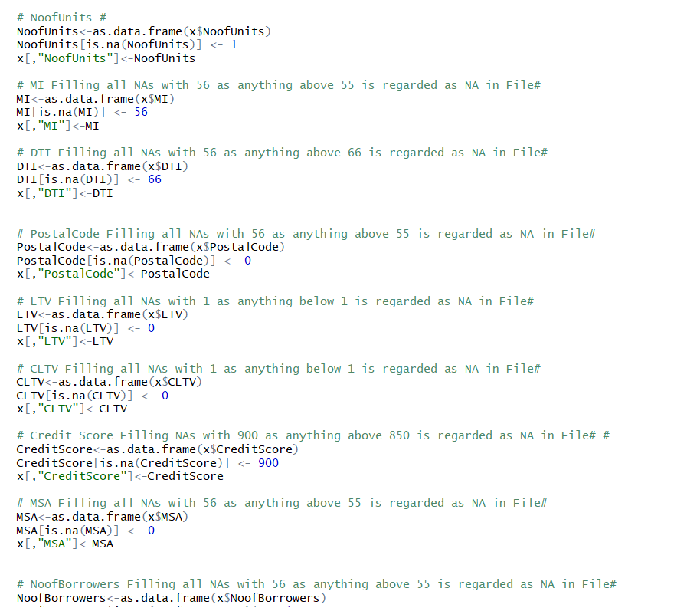

**Balancing the Data:**

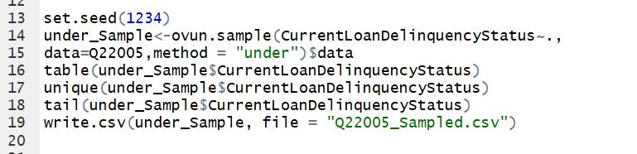

**PREDICTION:**

1. LINEAR REGRESSION:

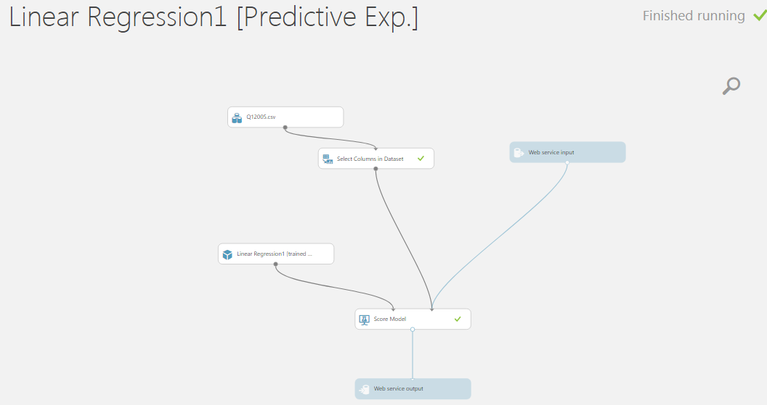

ACCURACY:

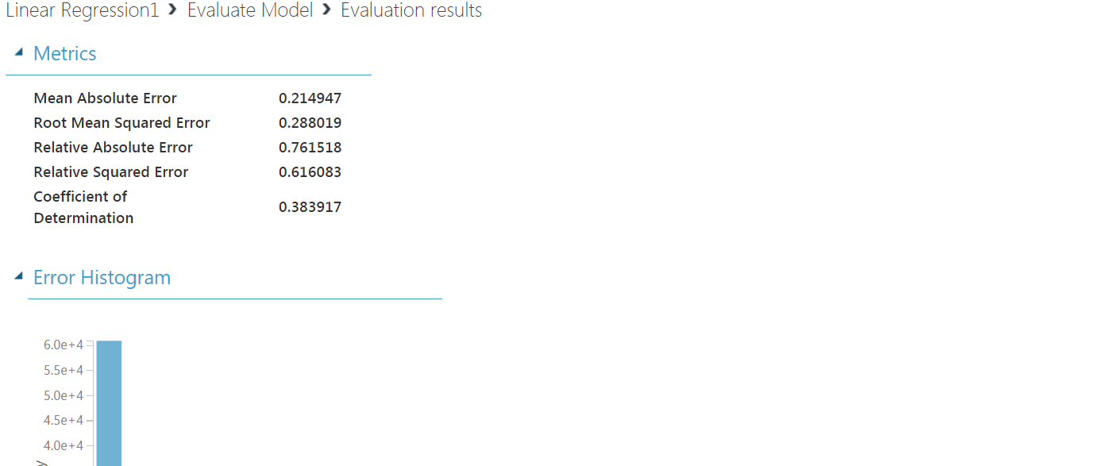

**DEMO:** [**linearprediction.mybluemix.net**](https://linearprediction.mybluemix.net/)

**INPUT**

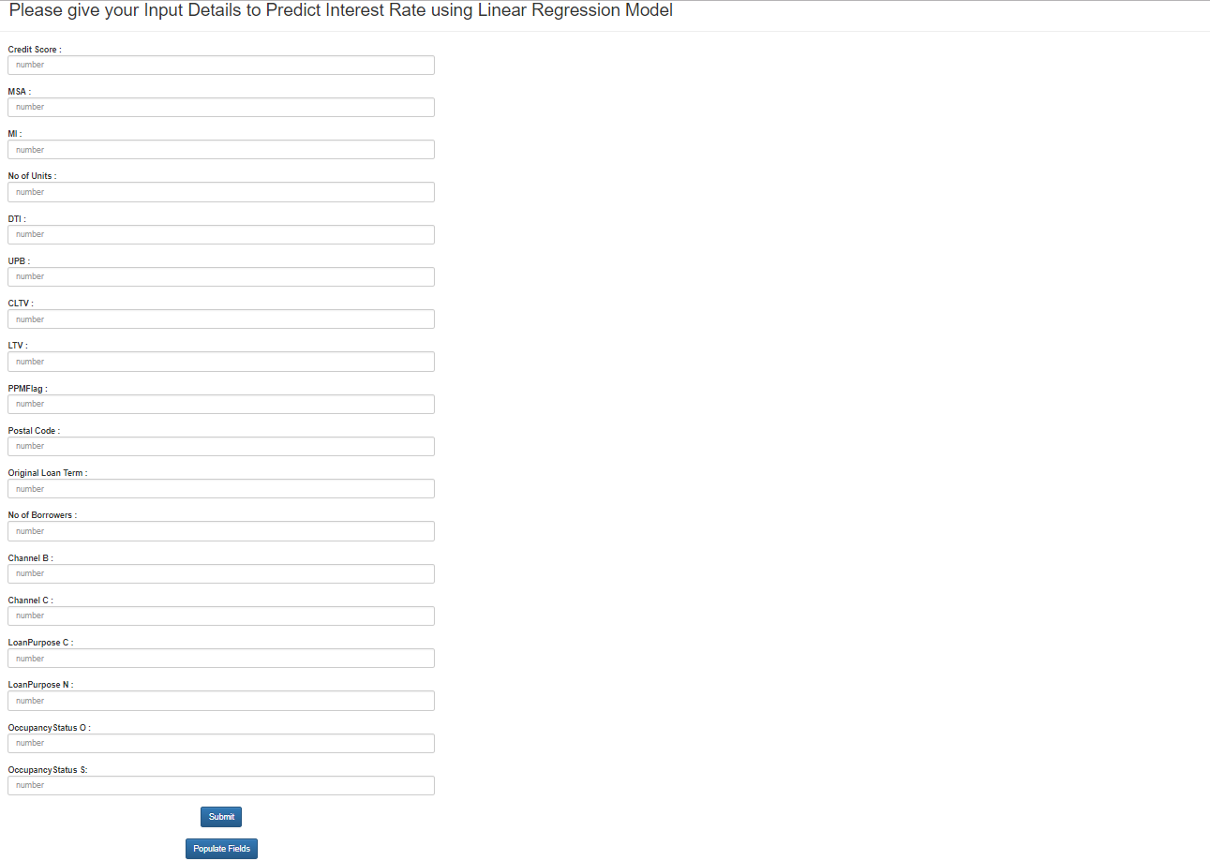

**OUTPUT:**

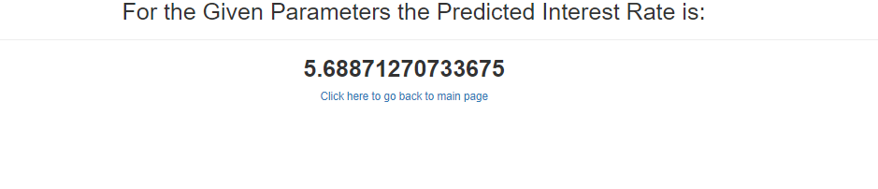

1. RANDOM FOREST:

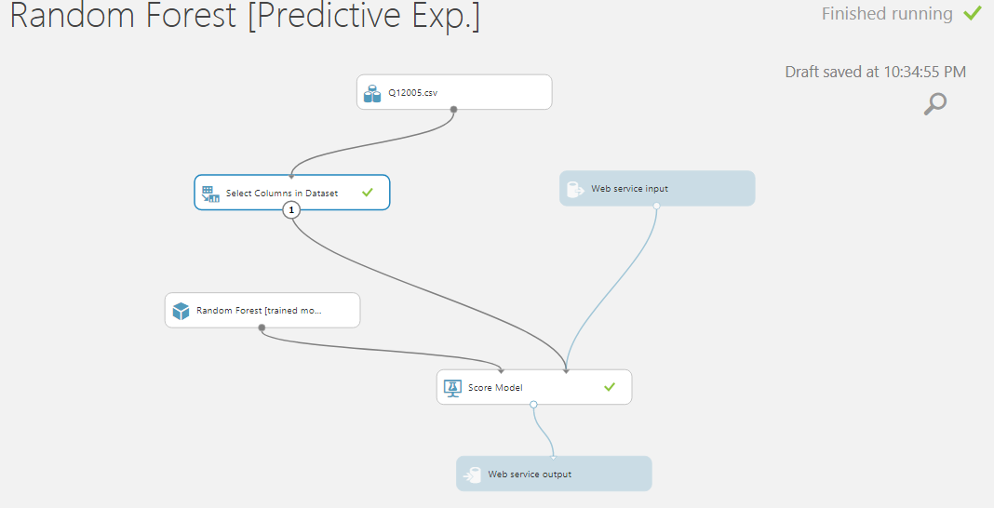

ACCURACY:

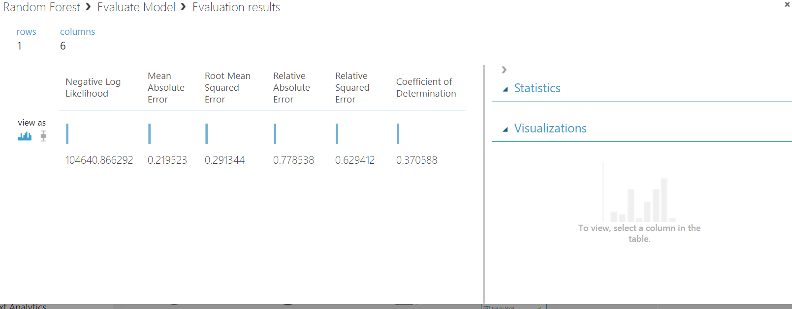

**DEMO:** [**linearprediction.mybluemix.net**](https://linearprediction.mybluemix.net/)

**INPUT:**

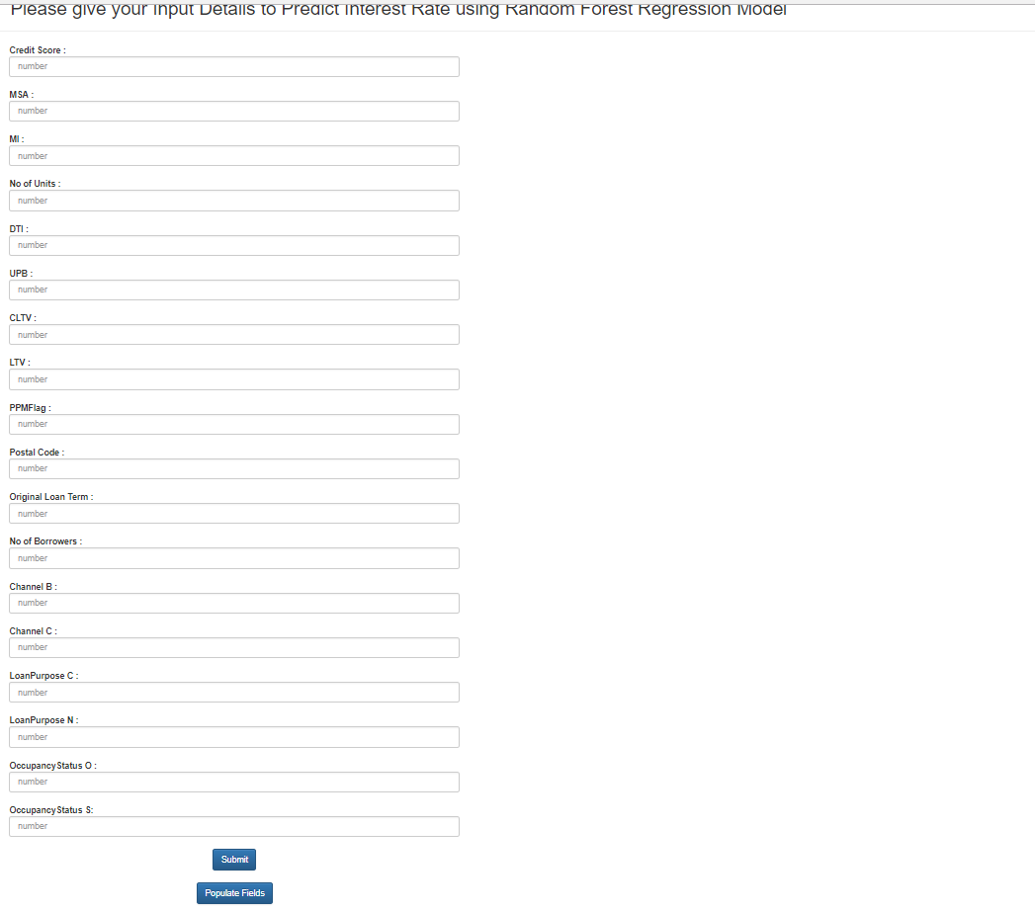

**OUTPUT:**

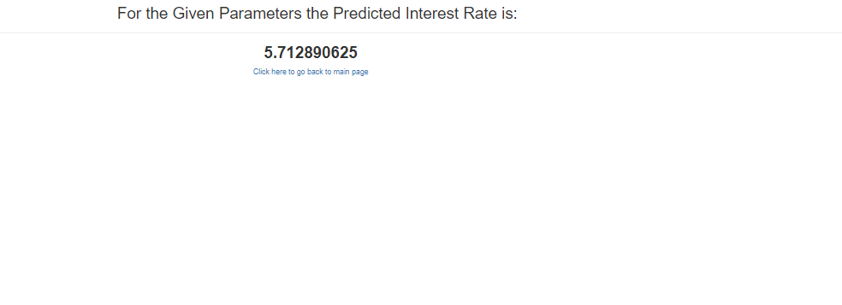

1. NEURAL NETWORK:

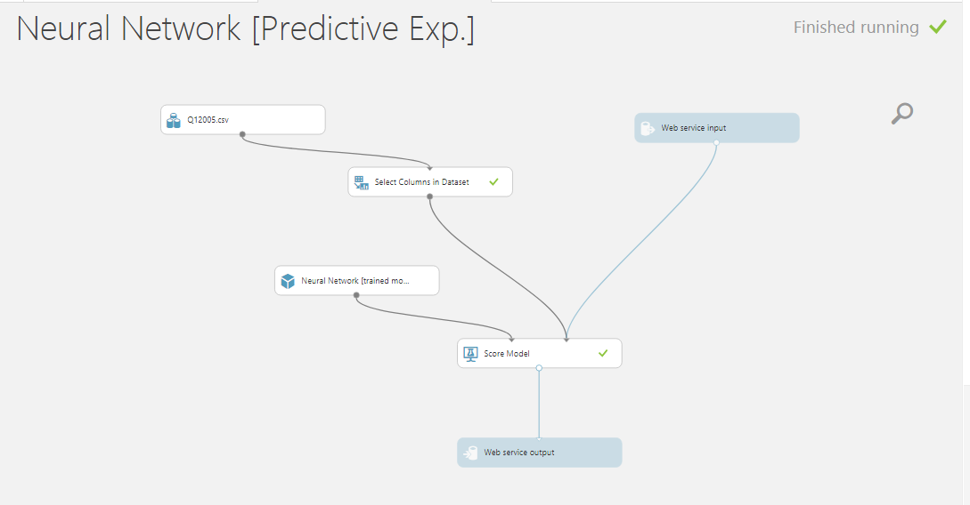

ACCURACY:

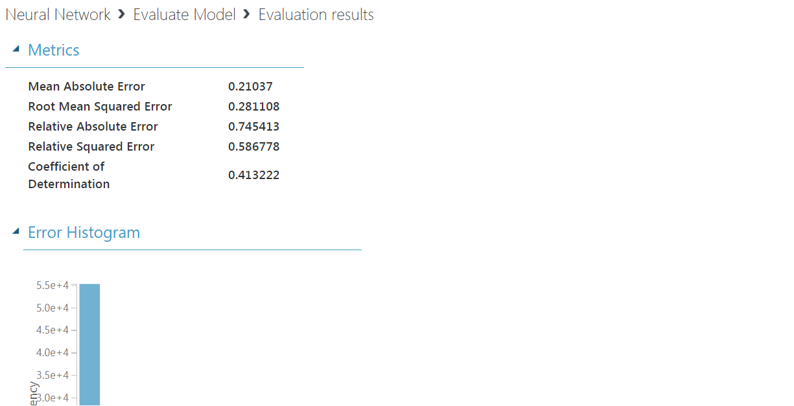

**DEMO: https://neuralnetworkprediction.mybluemix.net/**

**INPUT:**

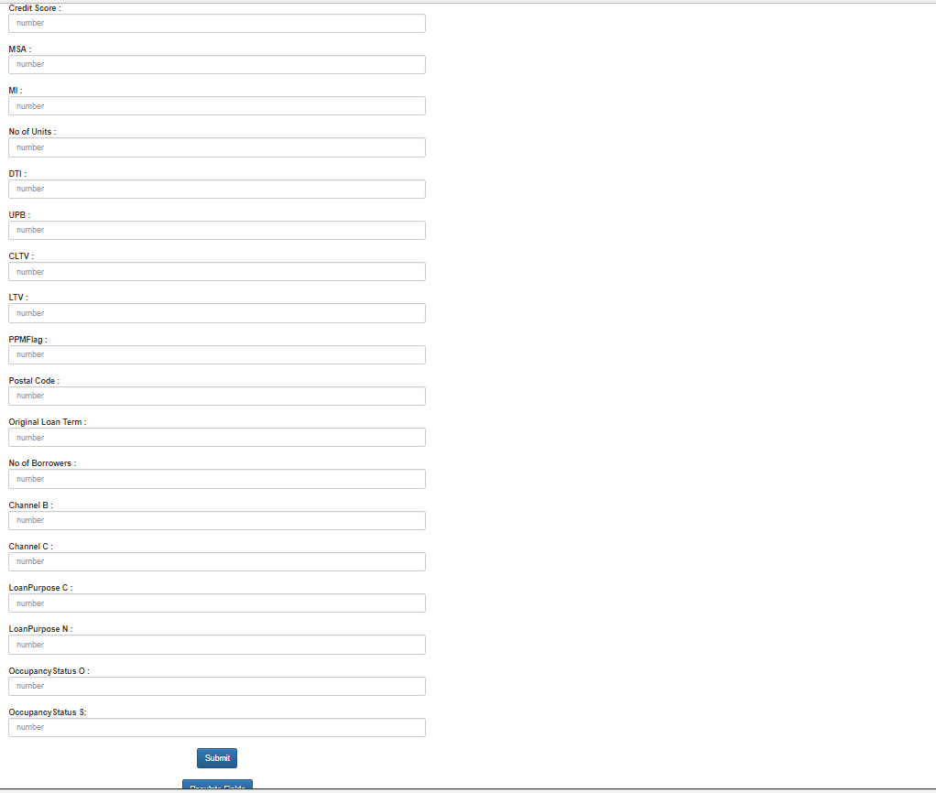

**OUTPUT:**

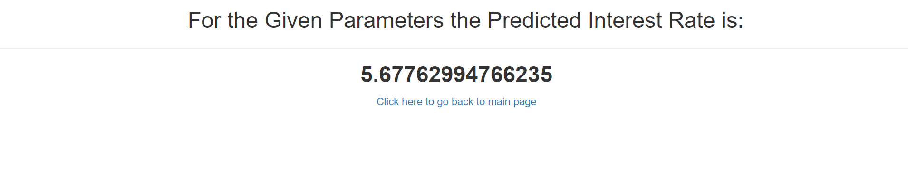

**CLASSIFICATION:**

1. **LOGISTIC CLASSIFICATION:**

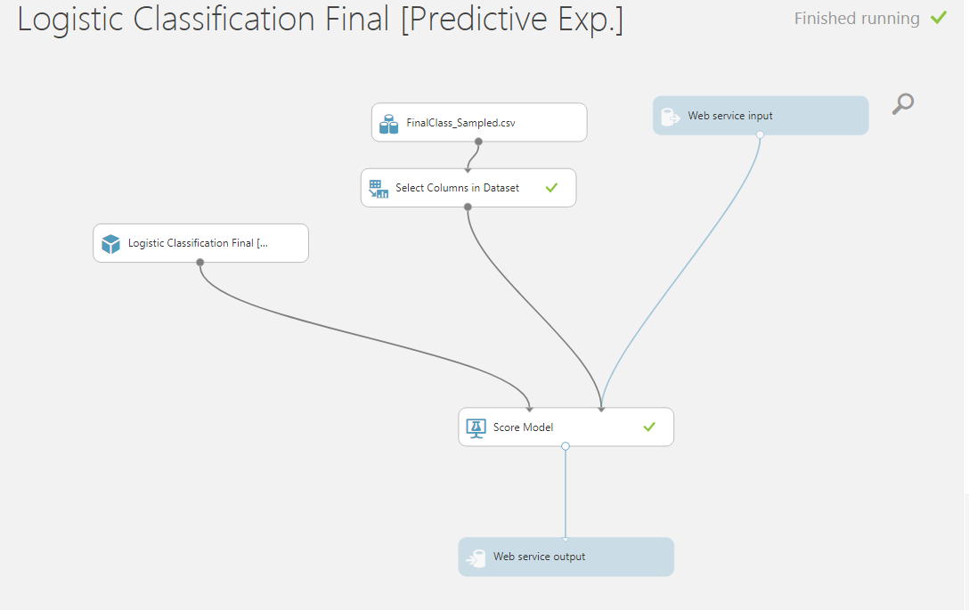

**ROC CURVE:**

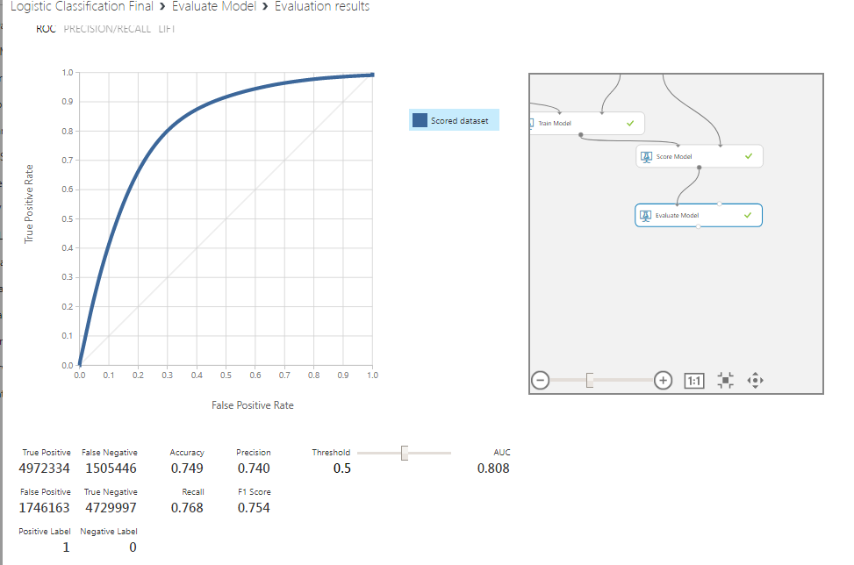

**DEMO:** [**logisticclassification.mybluemix.net**](https://logisticclassification.mybluemix.net/)

**INPUT:**

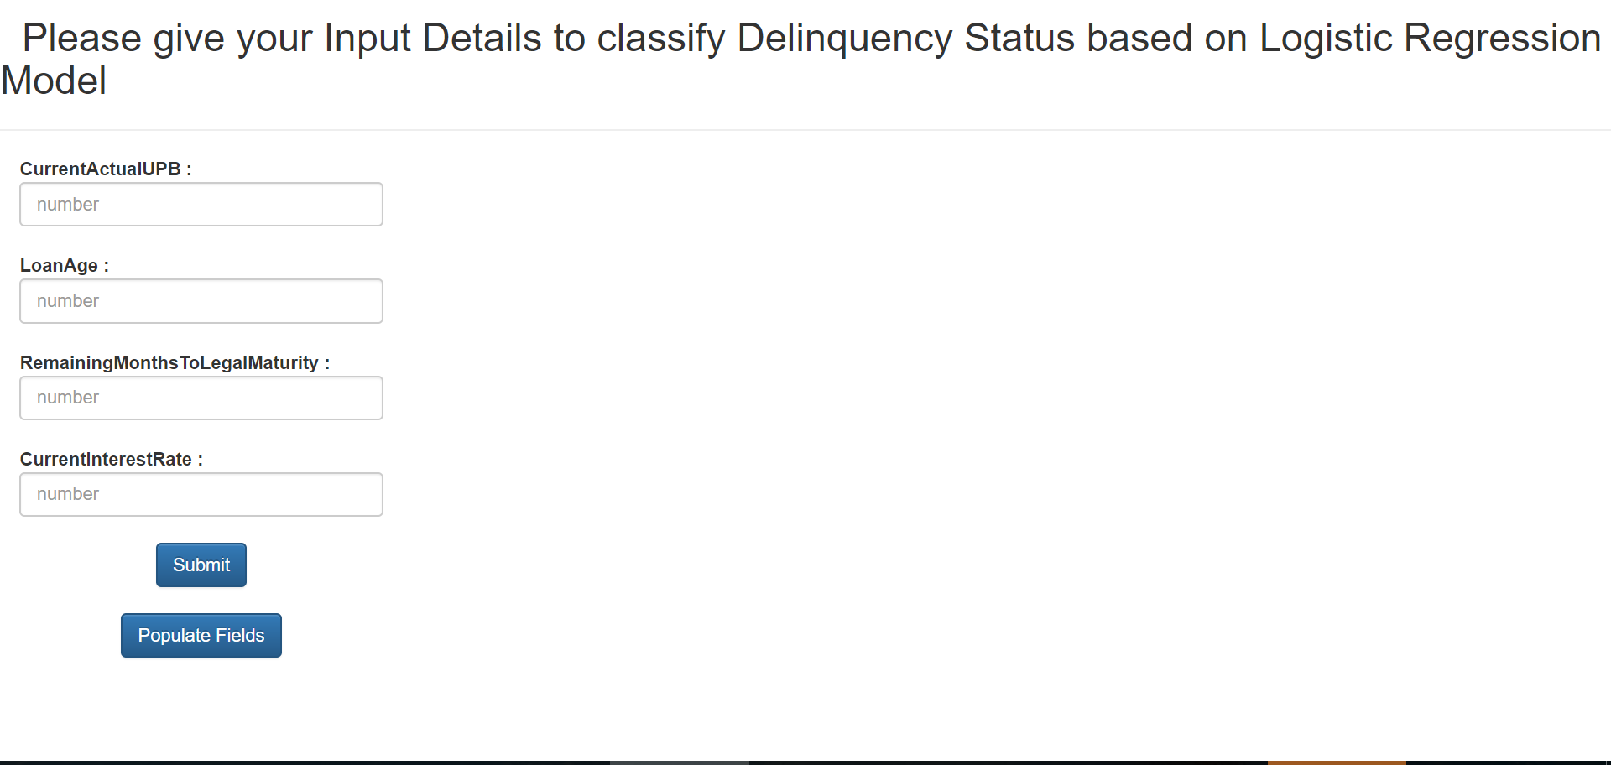

**OUTPUT:**

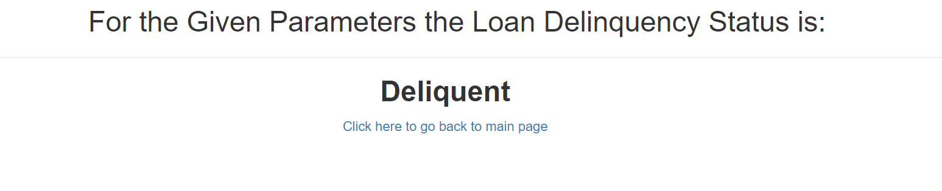

**RANDOM FOREST:**

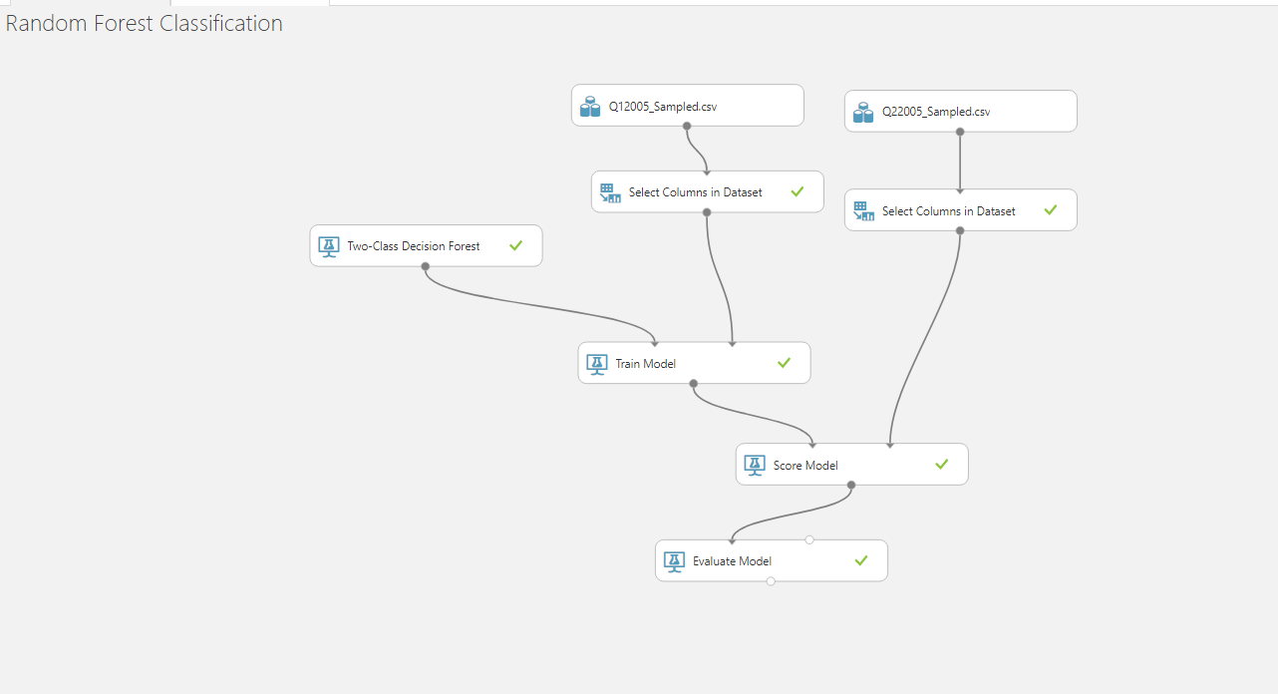

**ROC CURVE:**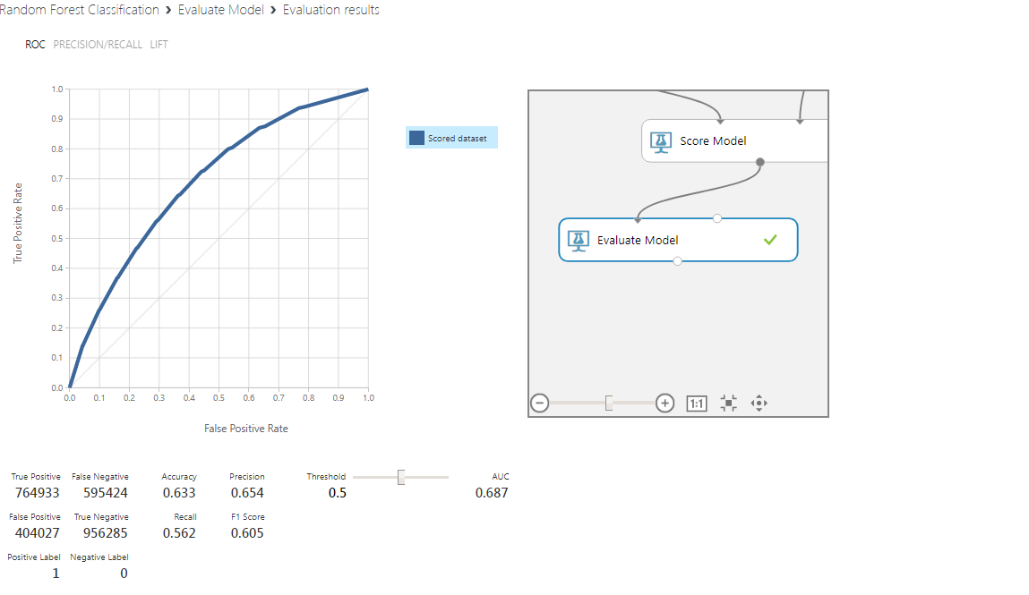

**DEMO: https://randomforestclassification.mybluemix.net/**

**INPUT:** 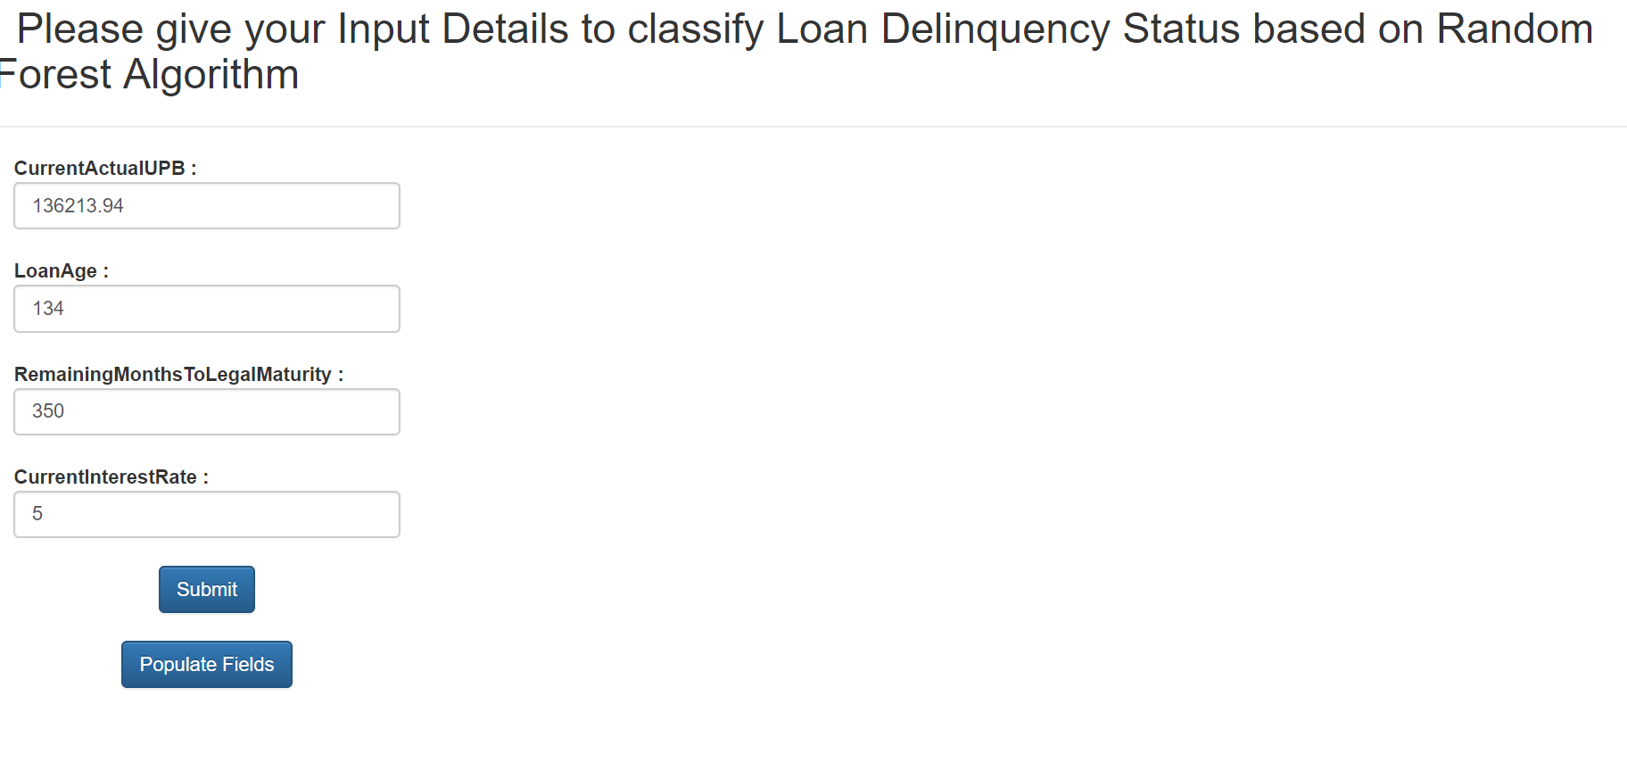

**OUTPUT:**

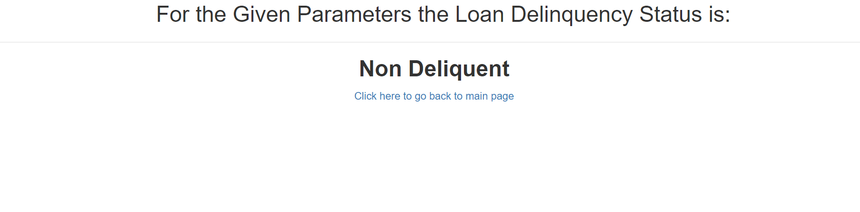

**NEURAL NETWORK:**

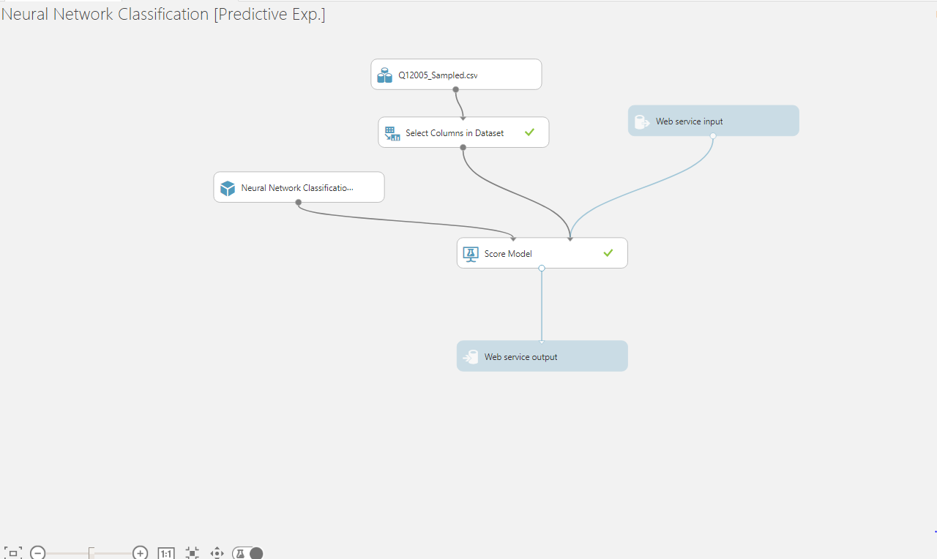

**ROC CURVE:**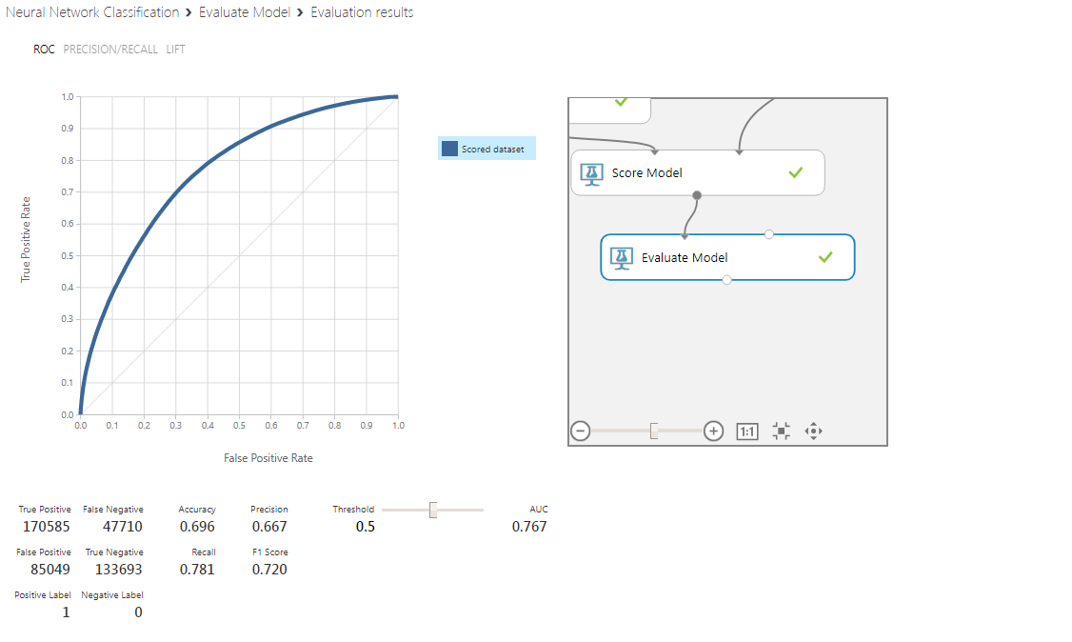

**DEMO: https://neuralnetworkclassification.mybluemix.net/**

**INPUT:**

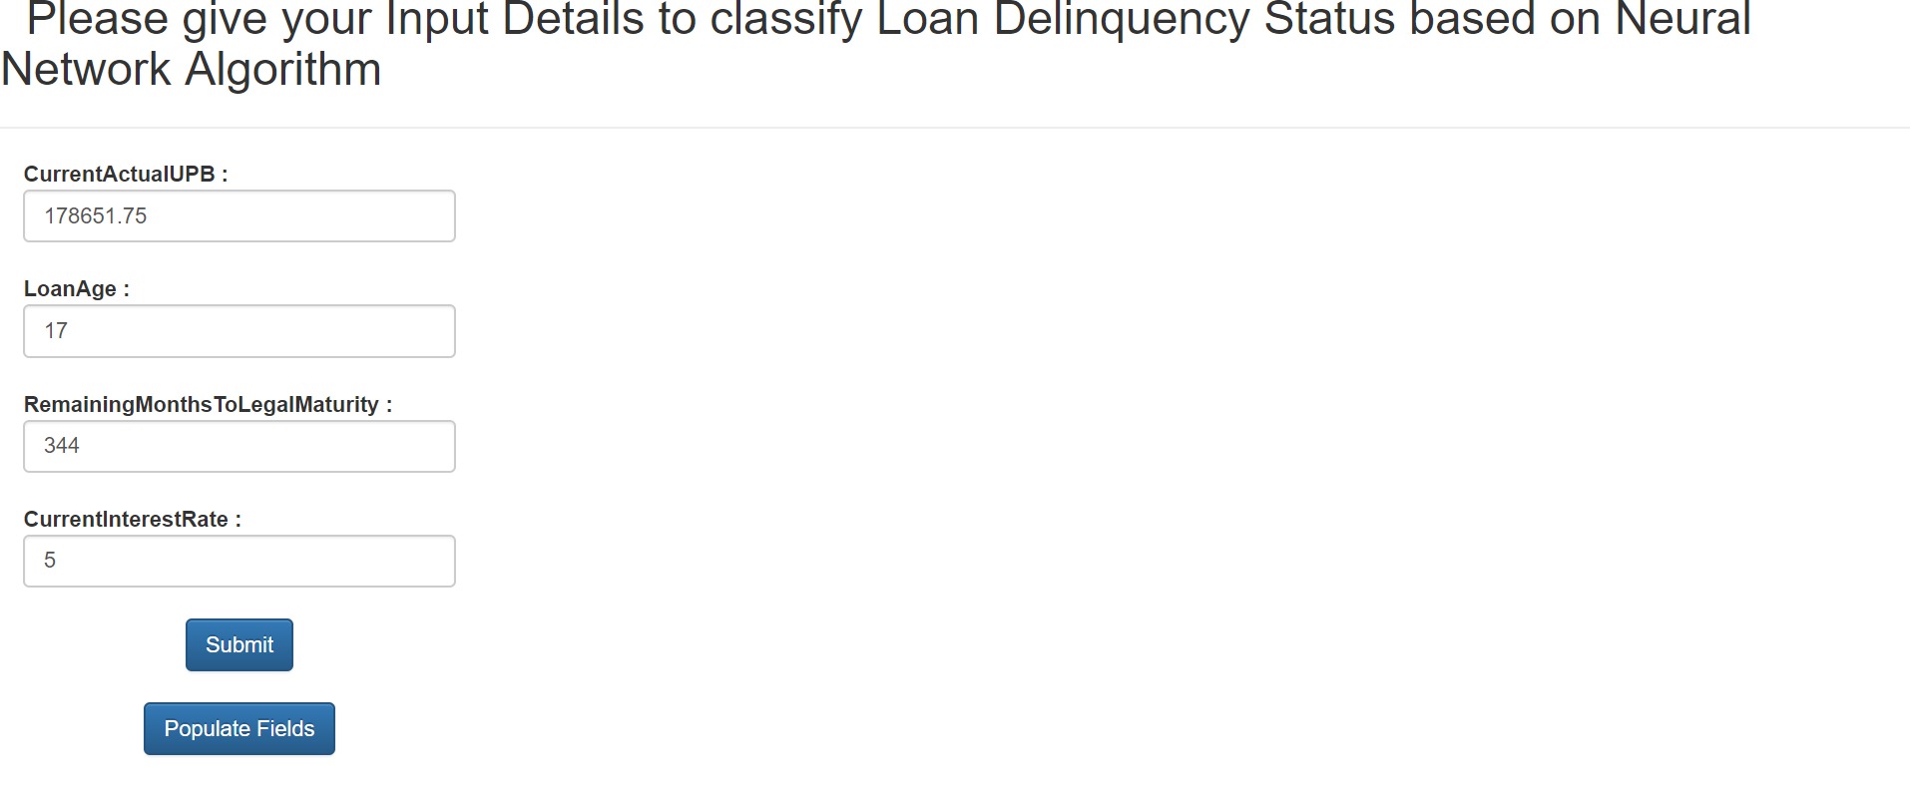

**OUTPUT:**

