Practical - 1

Practical Title: Project Initiation, Requirement Analysis, Sitemap, Wireframe, and GitHub Setup
Problem Definition: Initiate the semester-long StudentHub portal by identifying the problem scope, user roles, key modules, navigation flow, and minimum 10 pages. Create a sitemap, low-fidelity wireframe, project folder structure, README file, and GitHub repository.

Theory
  - What is URL and parts of URL?
Answer: URL stands for Uniform Resource Locator. It is the address used to find a resource, such as a webpage, on the Internet.
https://www.geeksforgeeks.org/html/describe-the-various-components-of-url/

  - How does HTML file process in web browser?
Answer: When an HTML file is opened, the browser reads the HTML code. It converts
the HTML into a DOM (Document Object Model) tree. The browser also processes CSS for styling and JavaScript for functionality. Finally, it combines the information,
calculates the layout, and renders the webpage on the screen. https://developer.mozilla.org/en-US/docs/Web/Performance/Guides/How_browsers_work

  - How will page navigation flow managed among all HTML pages?
Answer: Page navigation is managed using HTML links, The href attribute specifies which HTML page should open when the user clicks the link.
https://www.geeksforgeeks.org/html/html-links/

  - How will GitHub commits be maintained after each practical?
Answer: After completing each practical, the changes should be made using git add and git commit to commit to the repo and maintain the practical files

- Implementation/ Output/Result (Keep only one option which is suitable to practical)
Here you can add your learning code/tags/style etc

Evidence of Work (Screenshots)
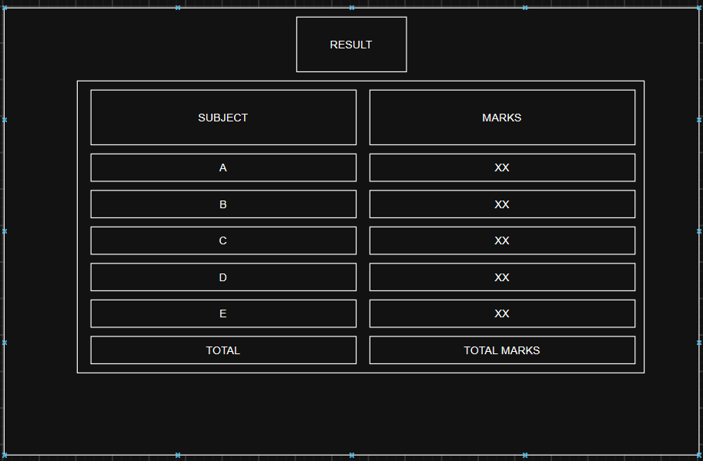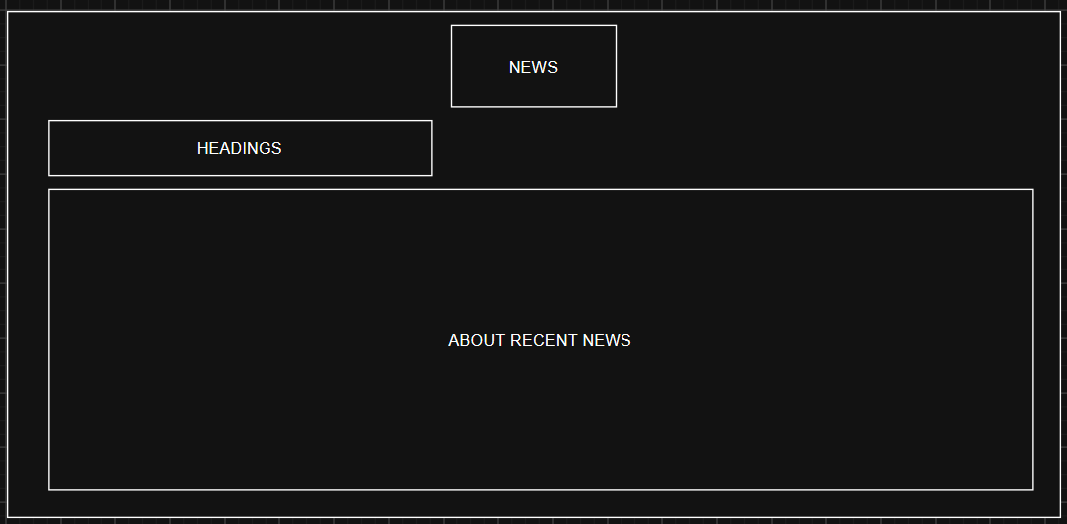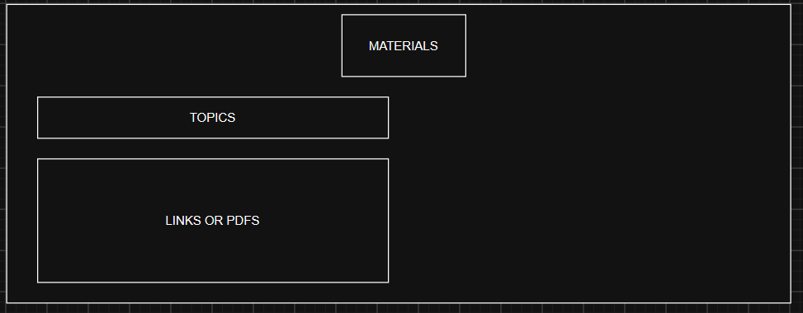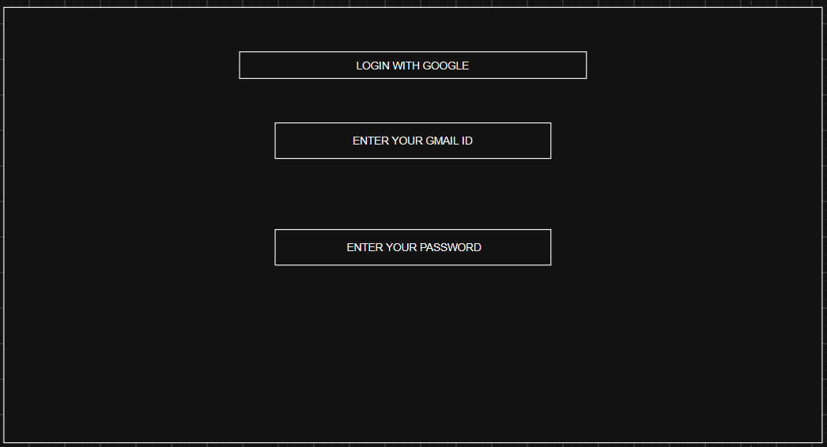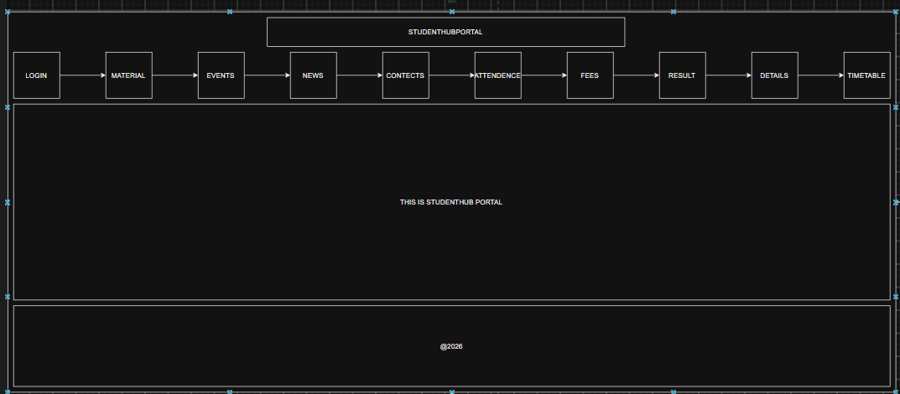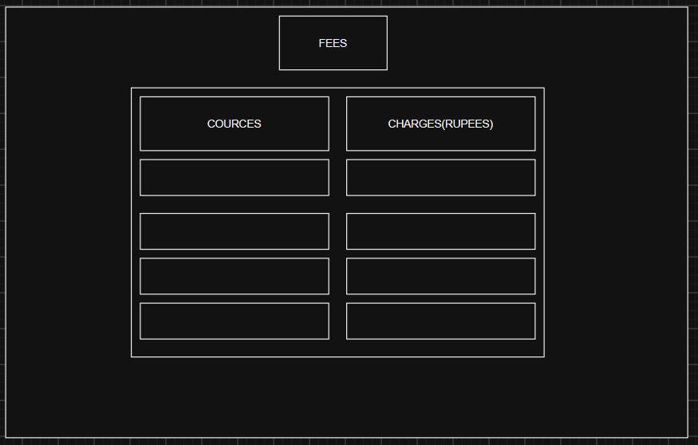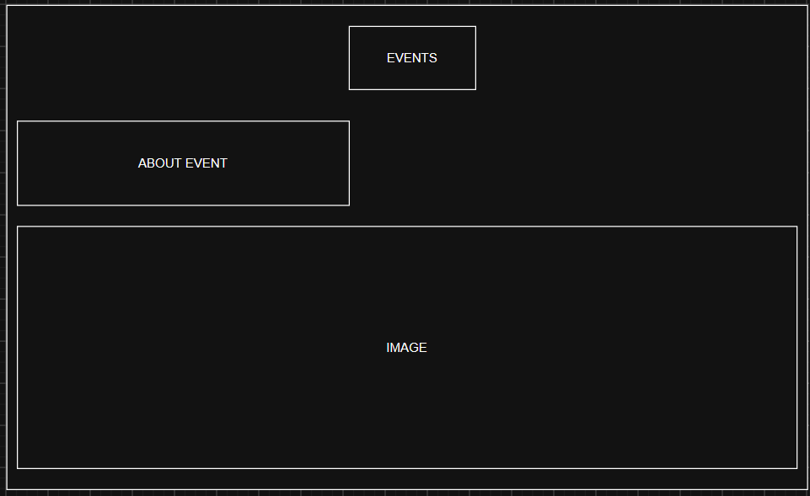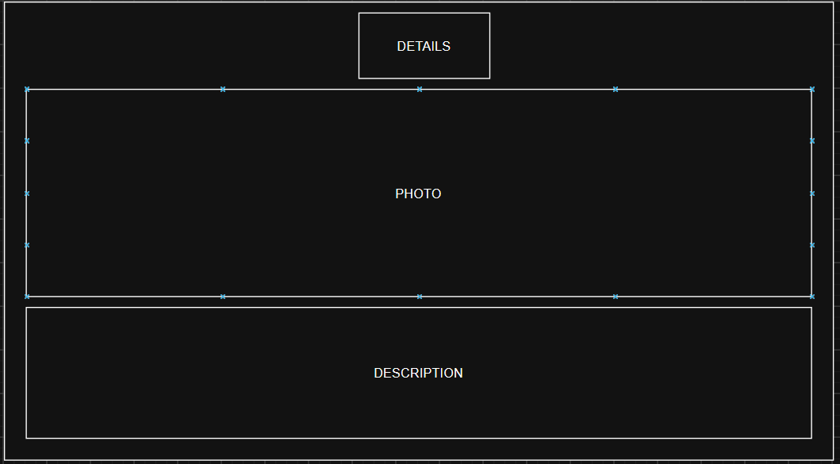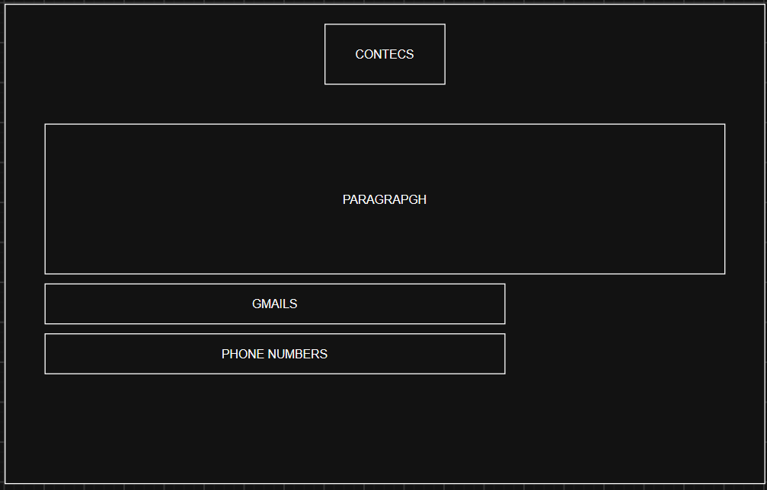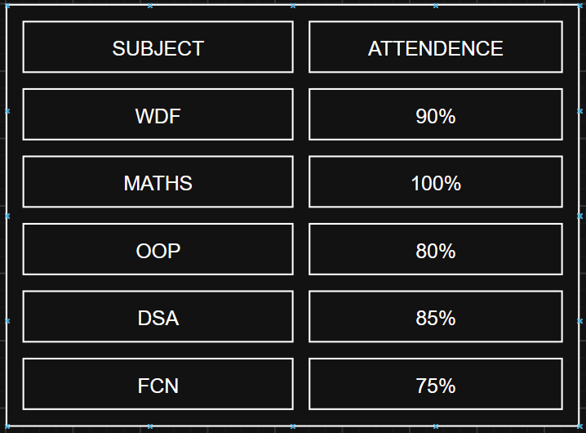

GitHub Repository Link:
https://github.com/dhruvkaravadra955-ux/studenthubportal/tree/main/pages

Challenges Faced:
Imagining the entire structure of the project

Learning Outcomes:
Helped me learned how to design wireframes

Faculty Remarks: (Keep this blank for faculty)

