Practical - 10

Practical Title: Secure Login/Logout with Sessions, Role-Based Access, Timeout, and Remember-Me Token
Implement secure user registration by inserting user details into MySQL using MYSQLi. Validate input on frontend and backend, check duplicate email/username, hash passwords using password_hash(), and display appropriate messages.
WW. Theory

- Are sessions started and destroyed securely?
Answer - Yes, sessions are started and destroyed properly.

- Is password_verify() used correctly?
Answer - Yes, passwords are verified using password_verify().

- Is unauthorized dashboard access blocked?
Answer - Yes, unauthorized users cannot access protected dashboards.

- Is session timeout implemented?
Answer - Yes, sessions expire after 15 minutes of inactivity.

- Are admin and student users redirected to appropriate dashboards?
Answer - Yes, admins and students are redirected to their respective dashboards.

XX. Evidence of Work (Screenshots)

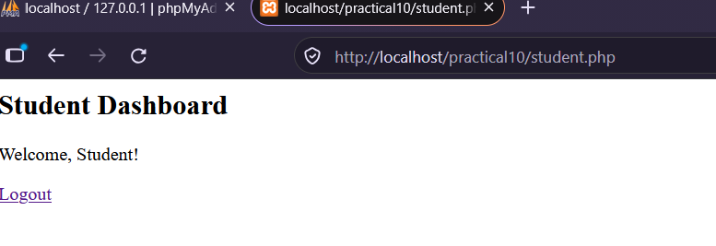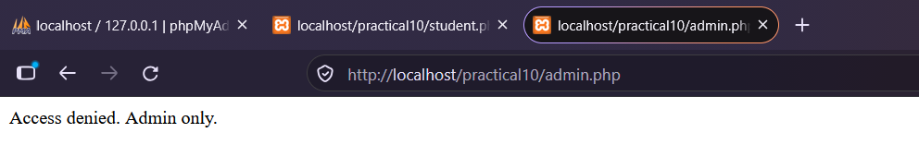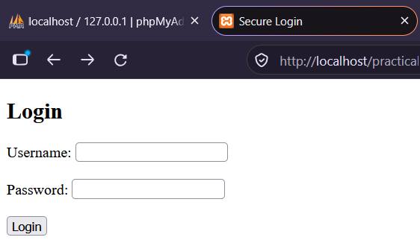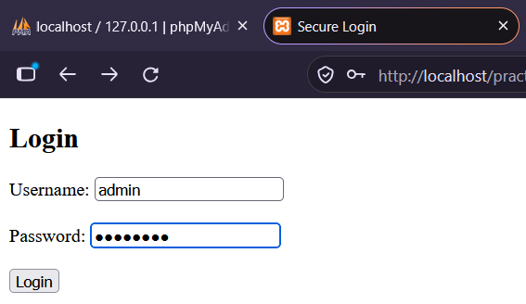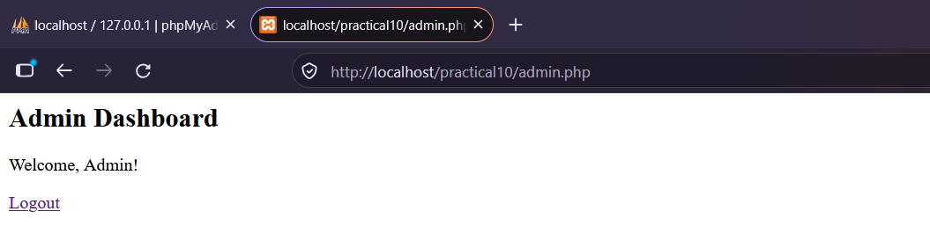
YY. GitHub Repository Link:
https://github.com/dhruvkaravadra955-ux/studenthubportal/tree/main/PRACTICAL%2010
ZZ.Challenges Faced:

Understanding how sessions and cookies work, managing login and logout, and restricting pages based on user roles.

AAA. Learning Outcomes:

Learned how to use PHP sessions, verify passwords using password_verify(), redirect students and admins to different dashboards and implement session timeout.

Faculty Remarks: (Keep this blank for faculty)

