Practical - 11

Practical Title: Student Management CRUD with Search and Filter
Implement secure user registration by inserting user details into MySQL using MYSQLi. Validate input on frontend and backend, check duplicate email/username, hash passwords using password_hash(), and display appropriate messages.
BBB. Theory

- Are SELECT, INSERT, UPDATE, and DELETE operations working? Answer - Yes, all CRUD operations are implemented and working.
- Is search by name/email/course implemented? Answer - Yes, students can be searched by name, email, or course.
- Are delete operations confirmed before execution? Answer - Yes, a confirmation is required before deleting a student.

CCC. Evidence of Work (Screenshots)
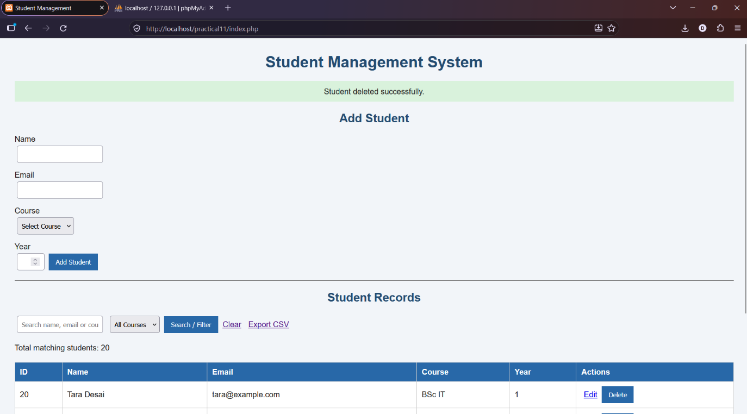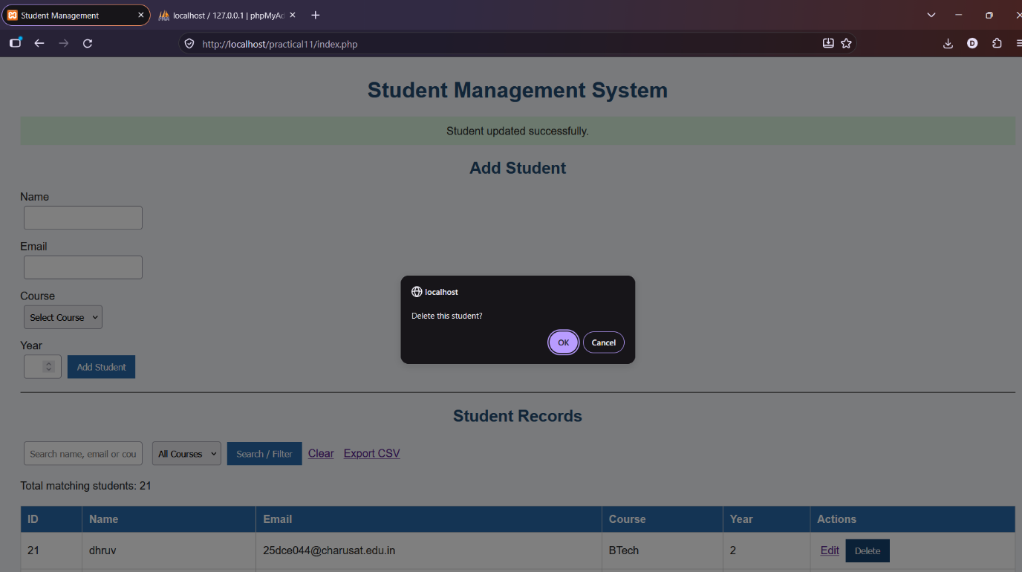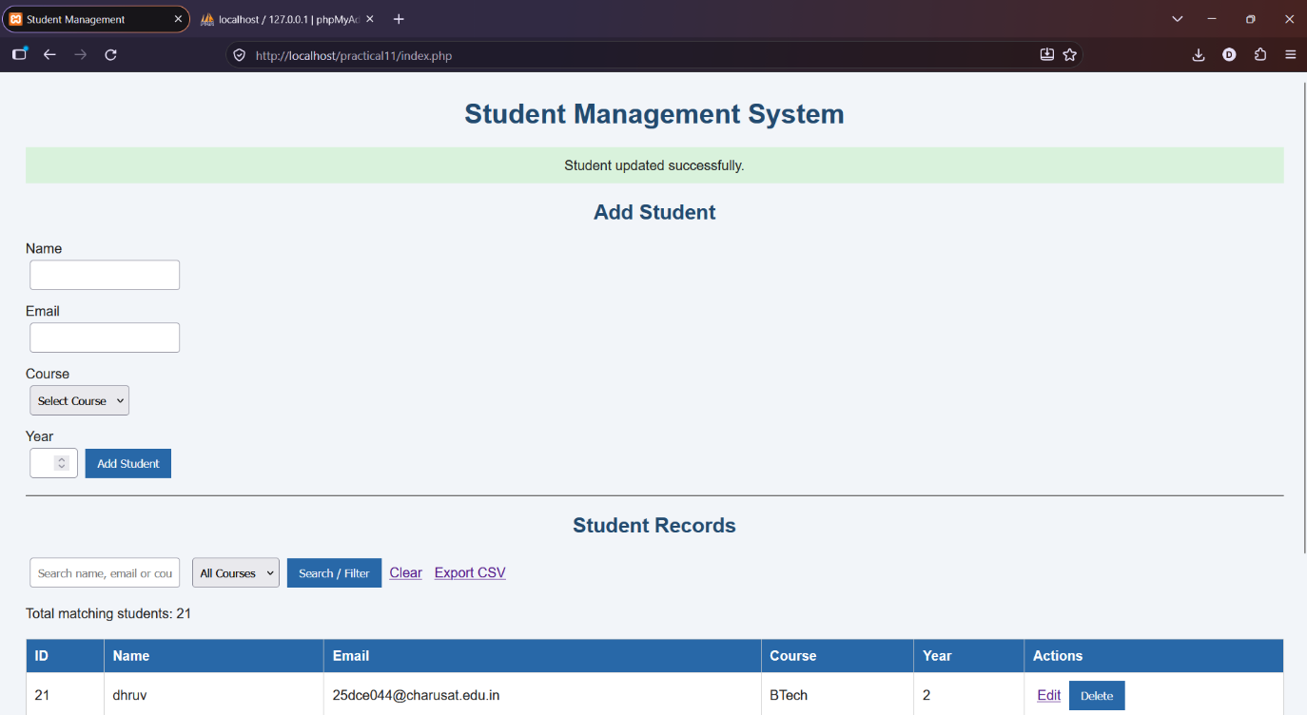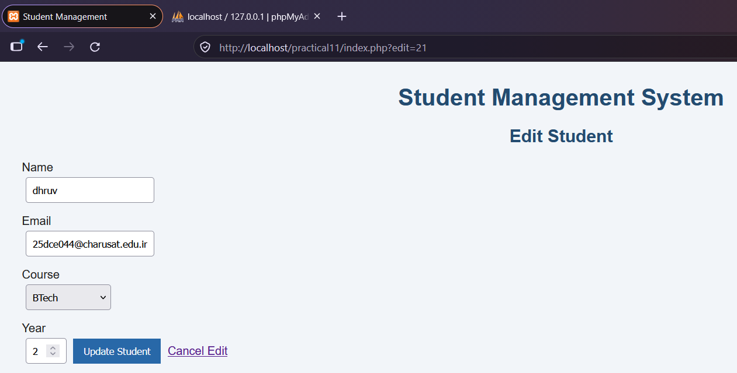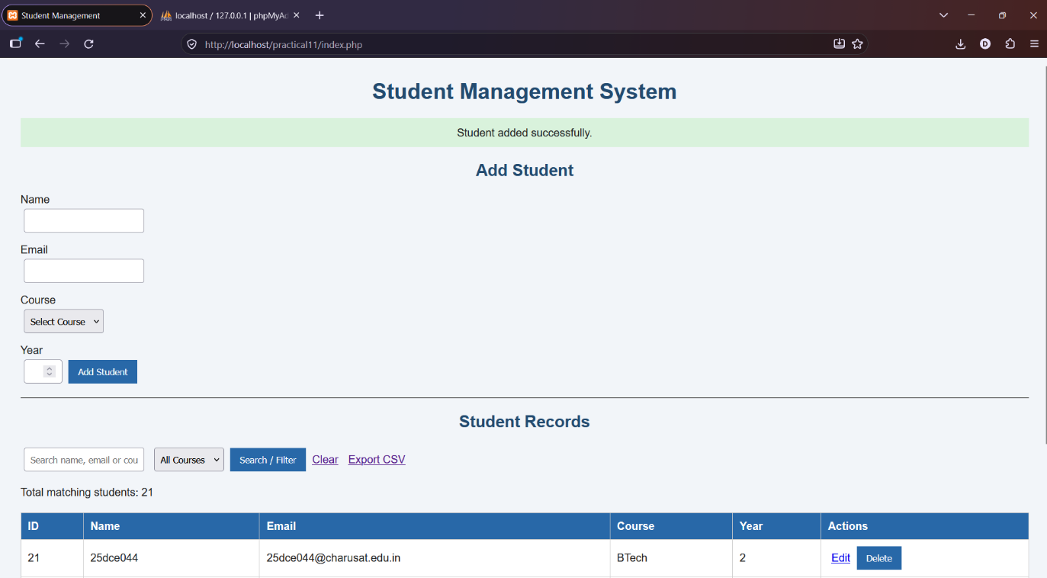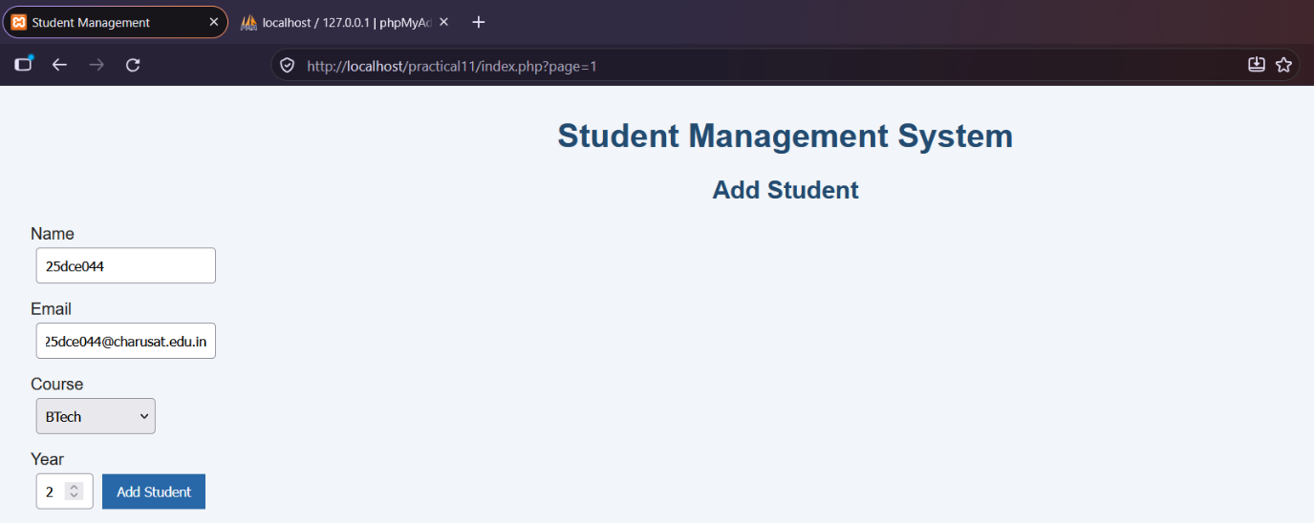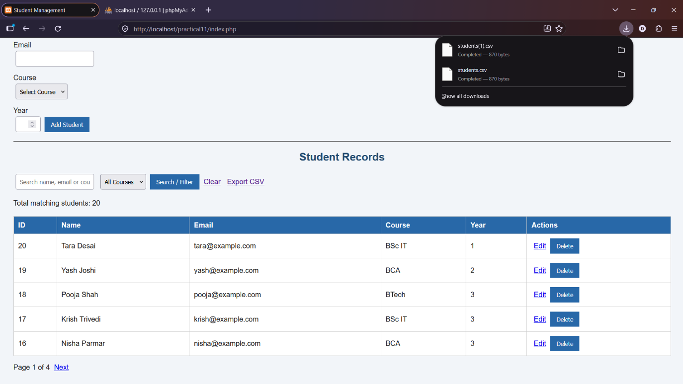

DDD. GitHub Repository Link:
https://github.com/dhruvkaravadra955-ux/studenthubportal/tree/main/PRACTICAL%2011
EEE. Challenges Faced:

Implementing add, edit and delete operations using PHP and MySQL, and making the search and filter functionality work properly.

FFF. Learning Outcomes:

Learned how to perform CRUD operations using MySQLi and search or filter student records from the database.

Faculty Remarks: (Keep this blank for faculty)

