Practical - 12

Practical Title: Event Management CRUD with Poster Upload and File Validation
Develop event management functionality for admin users. Admin can add, view, update, delete, and upload event posters with file type and file size validation
GGG. Theory

- Are add, update, and delete functionalities implemented correctly? Answer - Yes, all CRUD operations are implemented correctly.
- Is the UI linked with the database correctly? Answer - Yes, the UI is connected to the MySQL database using PHP.
- Are poster uploads validated for type and size? Answer - Yes, only JPG/PNG images up to 2 MB are allowed.
- Are success and failure messages displayed? Answer - Yes, success and error messages are displayed for each operation.

HHH. Evidence of Work (Screenshots)
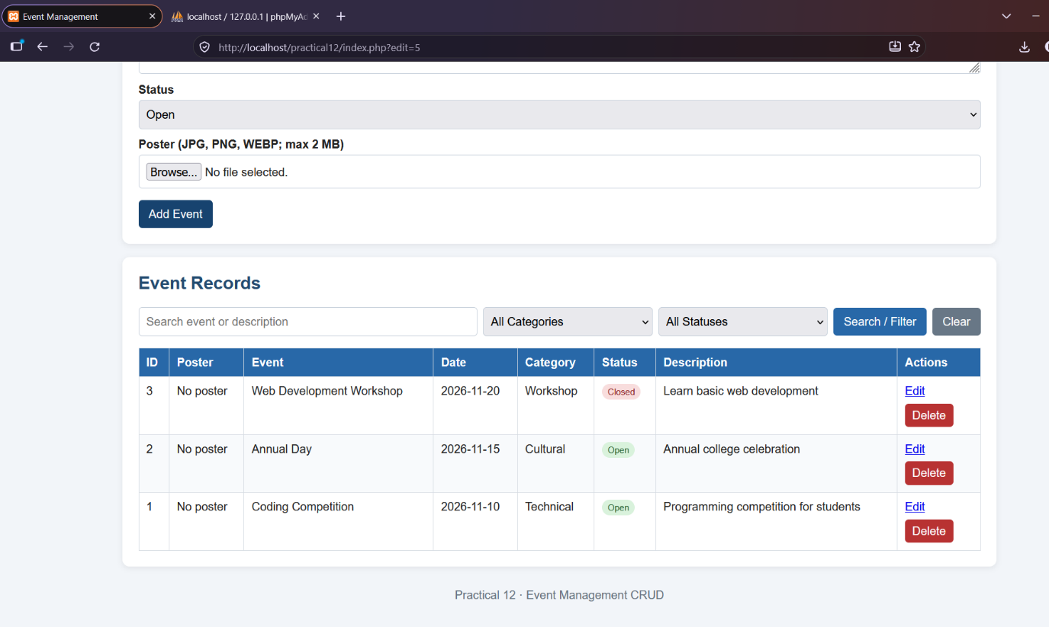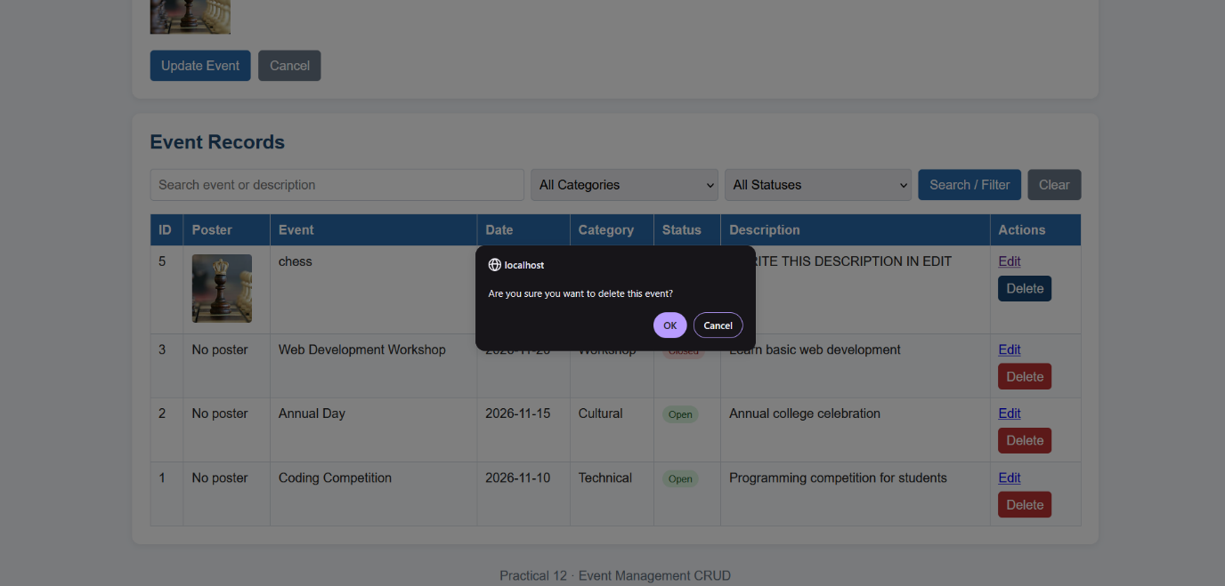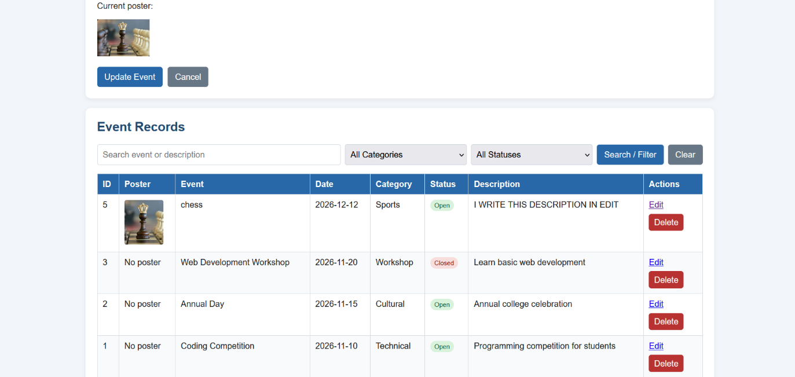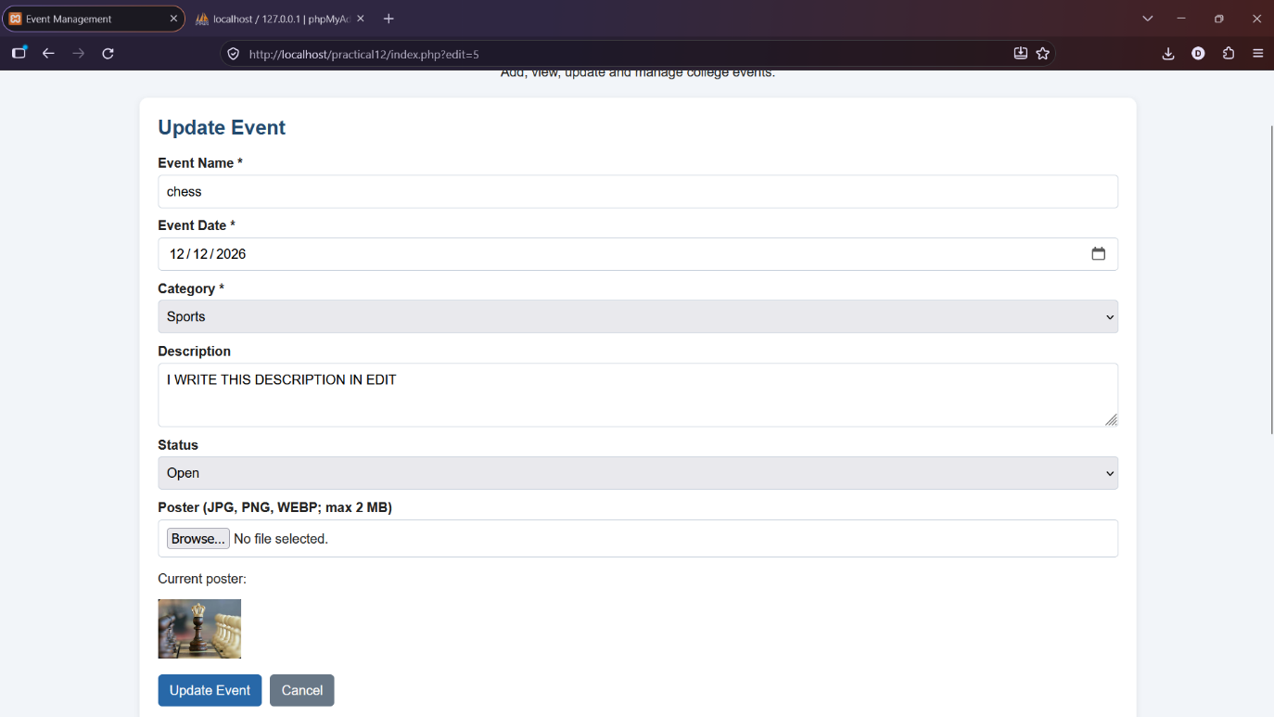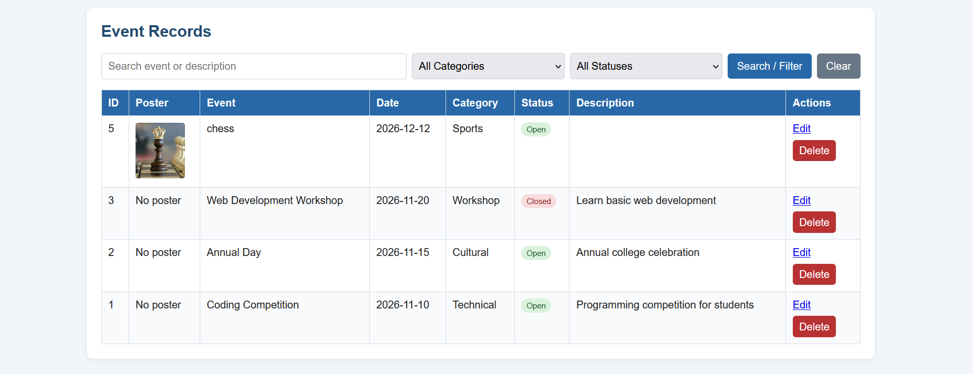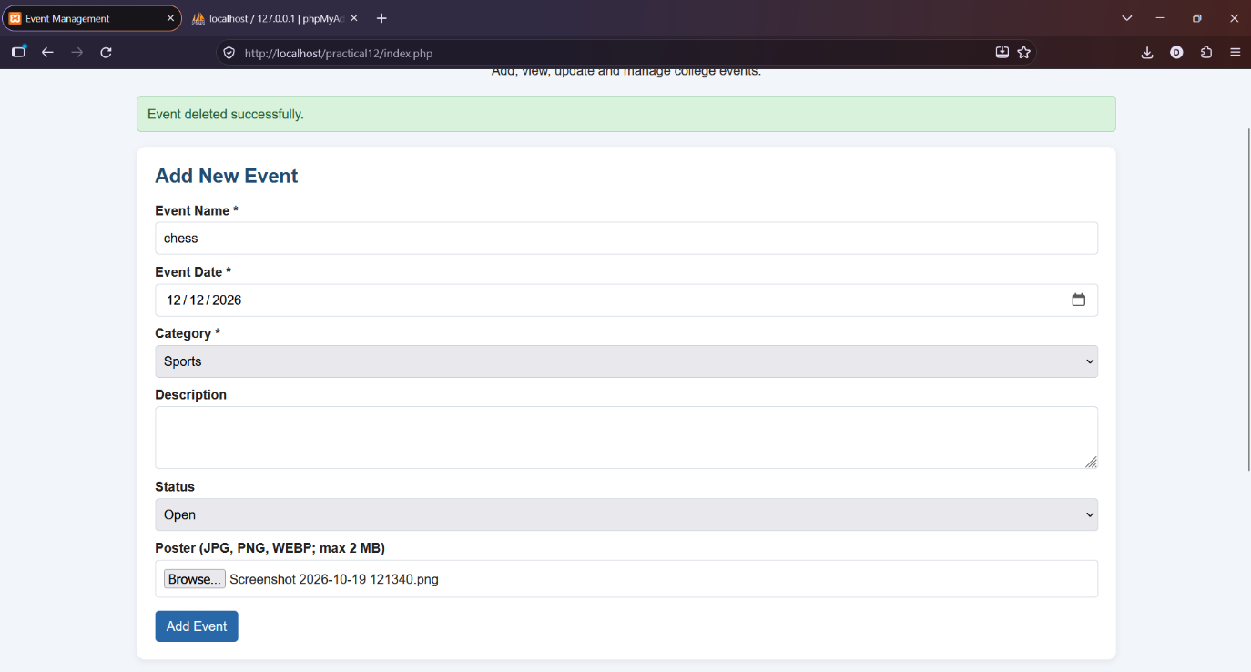

III. GitHub Repository Link:
https://github.com/dhruvkaravadra955-ux/studenthubportal/tree/main/PRACTICAL%2012
JJJ.Challenges Faced:

Handling image uploads using PHP, saving the images in the uploads folder and updating event details in the database.

KKK. Learning Outcomes:

Learned how to upload and validate images, store their file paths in MySQL and perform CRUD operations on events.

Faculty Remarks: (Keep this blank for faculty)

