Practical - 13
Practical Title: PHP JSON API and AJAX/Fetch-Based CRUD without Page Reload
Create simple PHP JSON API endpoints for events or students and consume them using Fetch API. Perform list, add, update, and delete operations asynchronously without full page reload.
LLL. Theory

- Do PHP endpoints return valid JSON responses? Answer - Yes, PHP endpoints return valid JSON responses.
- Are GET and POST requests handled properly? Answer - Yes, GET and POST requests are handled correctly.
- Are loading, success, and error states shown on the frontend? Answer - Yes, loading, success, and error messages are displayed.
- Is input validation performed before database operations? Answer - Yes, inputs are validated before performing database operations.

MMM. Evidence of Work (Screenshots)

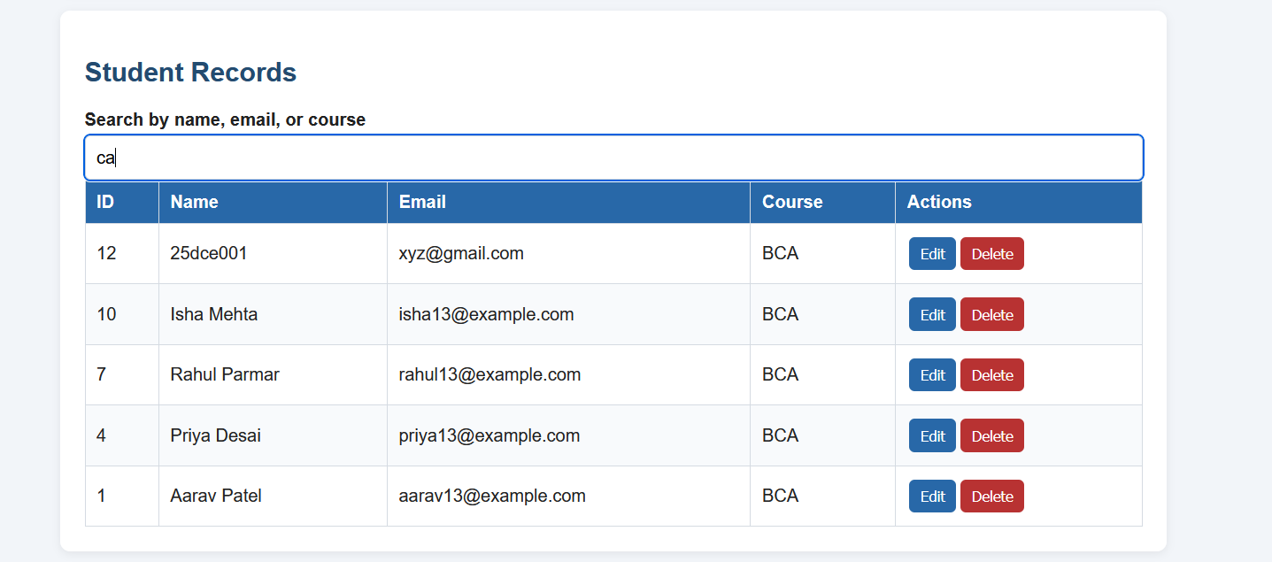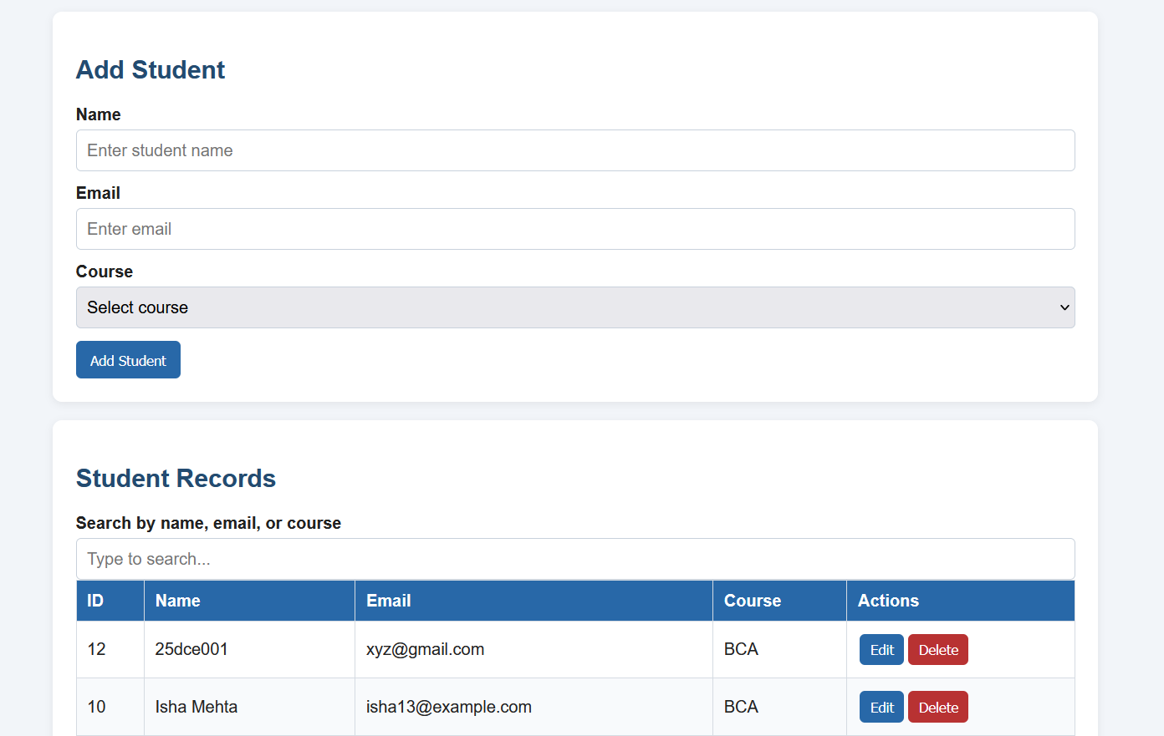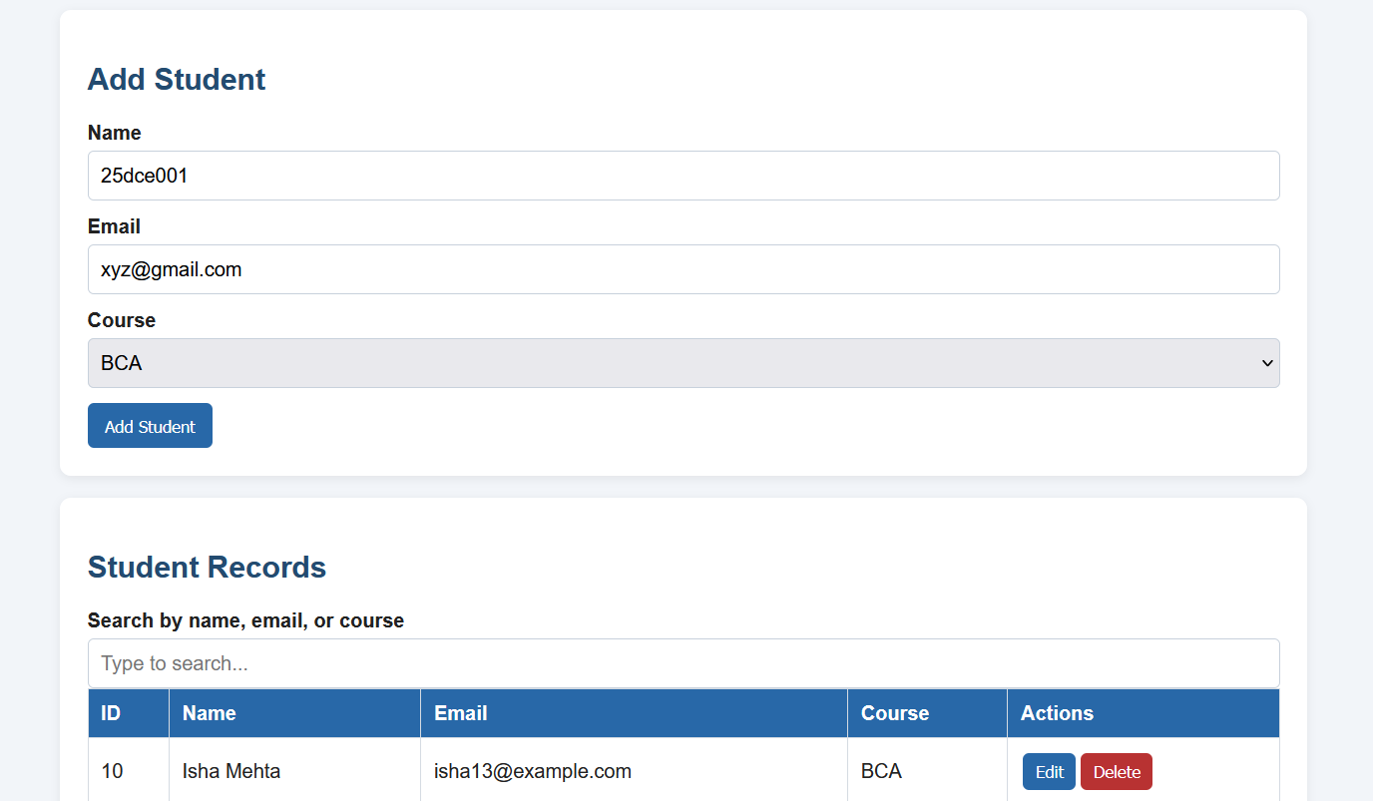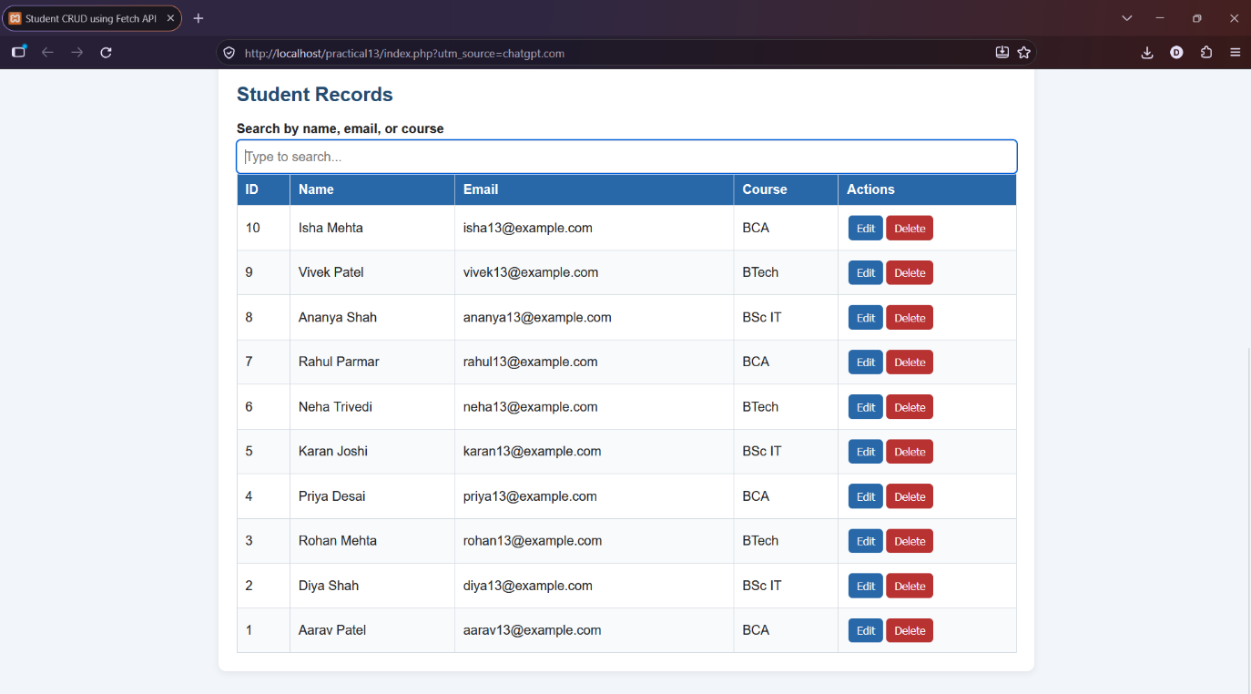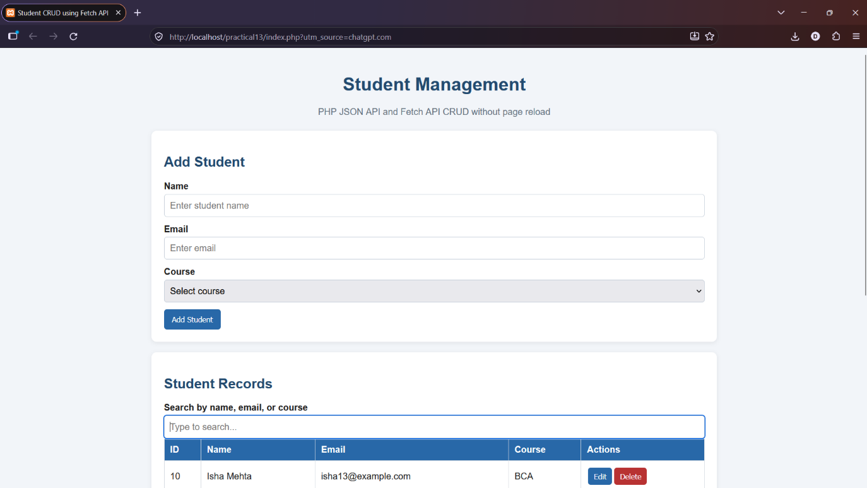

NNN. GitHub Repository Link:
https://github.com/dhruvkaravadra955-ux/studenthubportal/tree/main/PRACTICAL%2013
OOO. Challenges Faced:

Understanding how Fetch API communicates with PHP, handling JSON responses and updating the student table without reloading the page.

PPP. Learning Outcomes:

Learned how to use fetch() with PHP APIs, send GET and POST requests and perform CRUD operations without refreshing the webpage.

Faculty Remarks: (Keep this blank for faculty)

