Practical - 14
Practical Title: Admin Dashboard with Role-Based Access Control, Dynamic Menu, and Audit Log
Develop an admin dashboard that displays user statistics, student count, event count and latest registrations. Restrict access to admin users only and show dynamic menu options based on role.
QQQ. Theory

- Are dashboard values loaded dynamically from the database? Answer - Yes, dashboard values are fetched dynamically from MySQL.
- Is access restricted to admin users?
Answer - Yes, only admin users can access the dashboard.

- Are role-based menus working?
Answer - Yes, menus are displayed based on the user's role.

- Are important admin actions recorded in audit_logs?
Answer - Yes, important admin actions are recorded in the audit_logs table.

RRR. Evidence of Work (Screenshots)
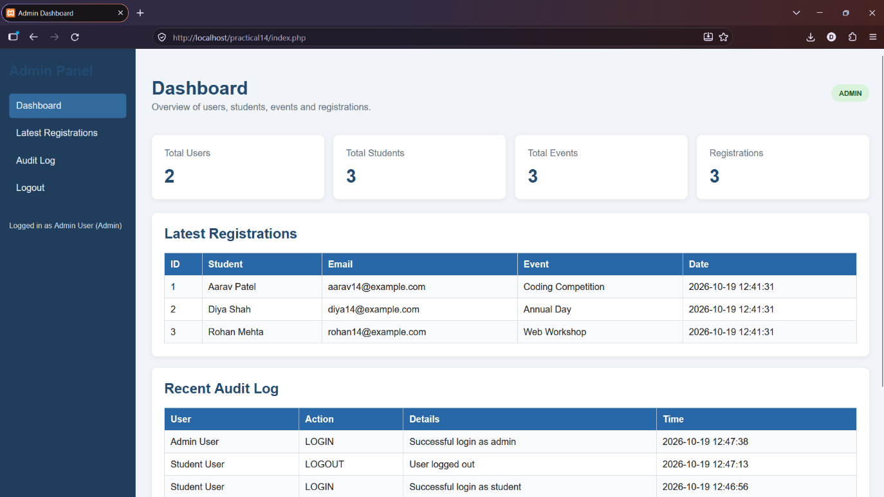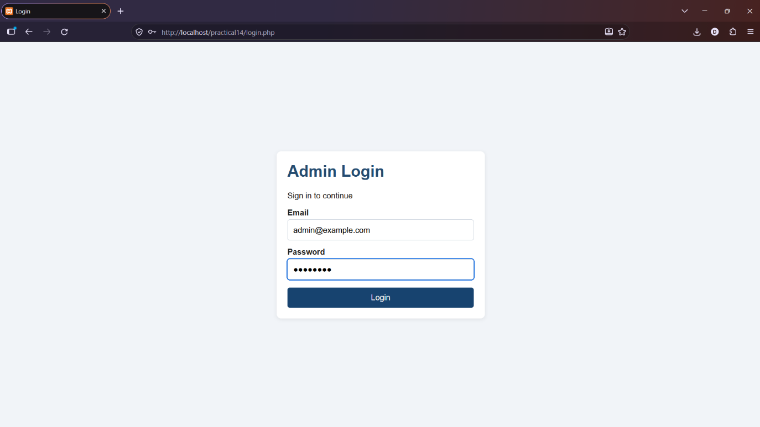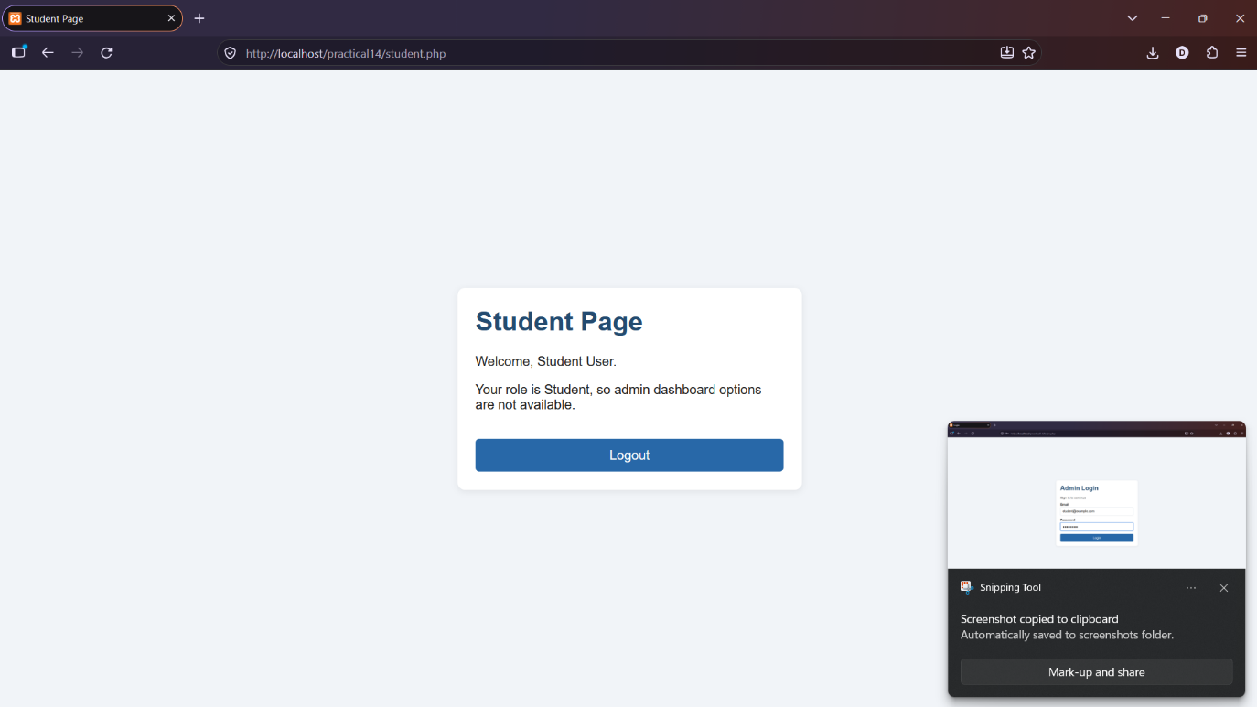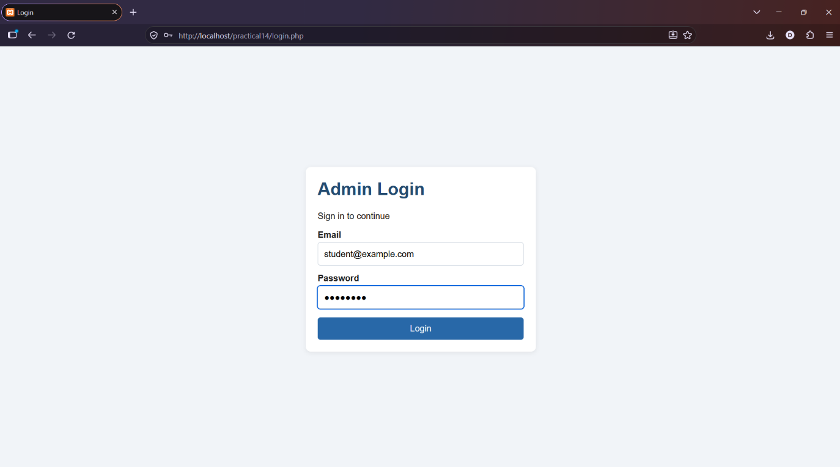

SSS. GitHub Repository Link:
https://github.com/dhruvkaravadra955-ux/studenthubportal/tree/main/PRACTICAL%2014
TTT. Challenges Faced:

Fetching live statistics from the database, restricting dashboard access to admins and storing admin activities in audit logs.

UUU. Learning Outcomes:

Learned how to create a dynamic admin dashboard, display database statistics, manage role-based access and record admin actions using audit logs.

Faculty Remarks: (Keep this blank for faculty)

