Practical - 2

Practical Title: Semantic HTML5 Pages with Accessibility-Ready Structure
Problem Definition: Develop static HTML5 skeletons for at least 10 StudentHub pages such as Home, About, Register, Login, Dashboard, Events, Profile, Contact, Admin, FAQ, and Feedback. Use semantic tags and accessibility-friendly structure.
- Theory
  - Are semantic tags such as header, nav, main, section, article, aside, and footer used properly?
Answer: Yes

  - Are form labels, headings, image alt text, and navigation links accessible? Answer: Yes

  - Is the page structure consistent across all pages? Answer: Yes

- Implementation/ Output/Result (Keep only one option which is suitable to practical)
html, head, title, body, header, nav, main, section, div, h1 to h6, p, a, img, ul, ol, li, table, href, src, alt, class, id, name,

- Evidence of Work (Screenshots)

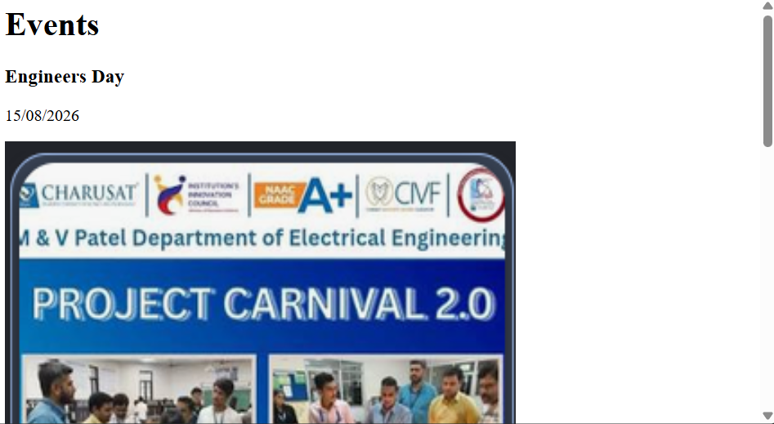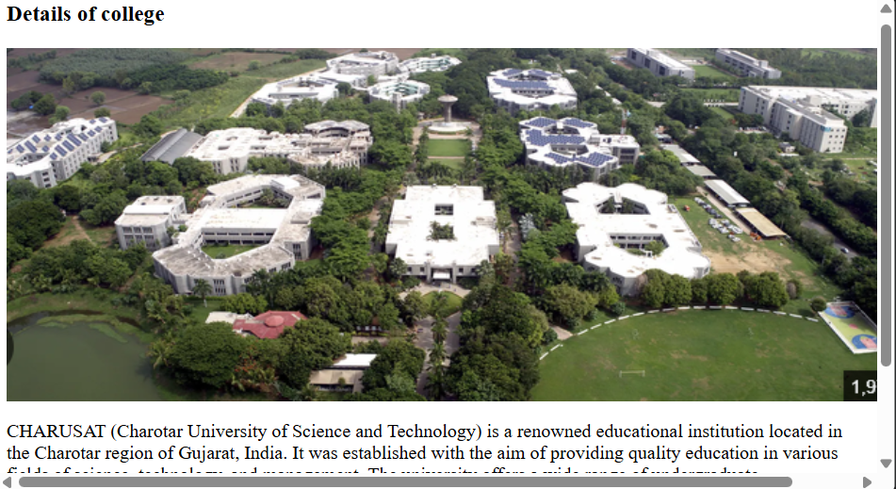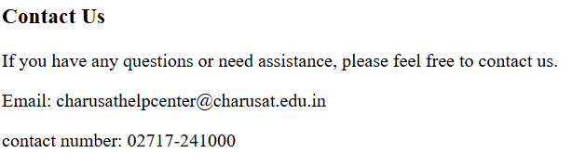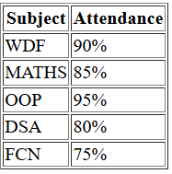
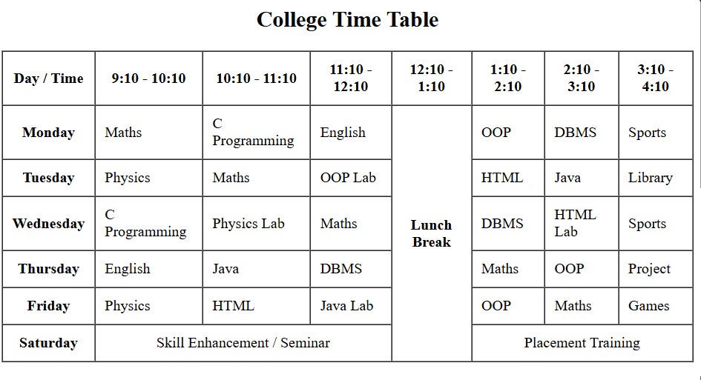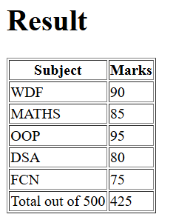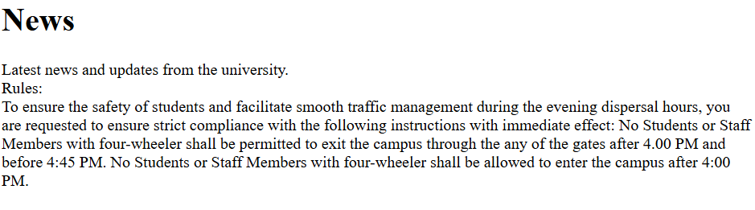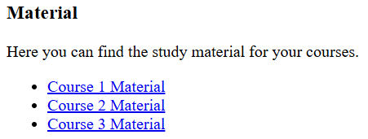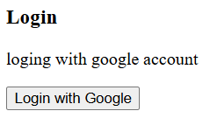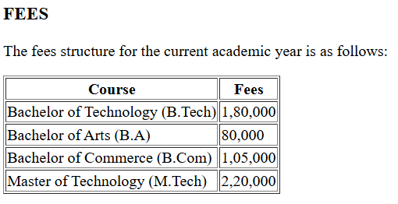

- GitHub Repository Link:
https://github.com/dhruvkaravadra955-ux/studenthubportal/tree/main/IMAGES%20OF%20OUTPUT
- Challenges Faced:
It was hard to structure the pages, creating forms and arranging the elements in order

- Learning Outcomes:
Learned how to create HTML files for a website
semantic tags, html classes, id , block and inline elements headings, paragraphs, how to link images and sites.

Faculty Remarks: (Keep this blank for faculty)

