Practical - 3

Practical Title: Responsive UI Design using CSS Grid, Flexbox, and Bootstrap/Tailwind
Problem Definition: Design responsive layouts for Home, About, Registration, Dashboard, and Events pages using CSS Grid and Flexbox. Optional to use CSS framework such as Bootstrap or Tailwind. Ensure mobile-first responsiveness
- Theory
  - How does the layout adapt for mobile, tablet, and desktop screens?
Answer: Using media queries in css so the website changes css based on the size of the screen
https://www.geeksforgeeks.org/websites-apps/responsive-web-design/

  - Which layout technique is used and why?
Answer: Flexbox and grid is used so that the elements are arranged properly in any way we want
https://www.w3schools.com/css/css_grid.asp
https://www.w3schools.com/css/css3_flexbox.asp

  - Are typography, spacing, colors, and contrast readable? Answer: Yes

  - Is the framework used consistently without unnecessary inline CSS? Answer: Did not use framework

- Implementation/ Output/Result (Keep only one option which is suitable to practical)
CSS selectors, colors, the box model, Flexbox, CSS Grid, positioning, borders, border-radius, transitions, hover effects, form styling and responsive design using media queries
- Evidence of Work (Screenshots)
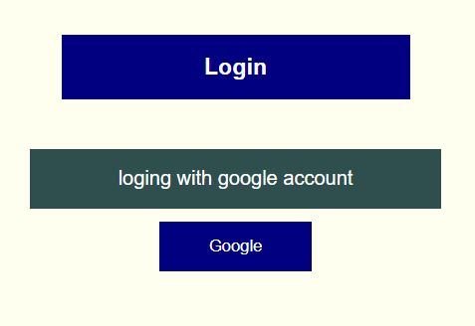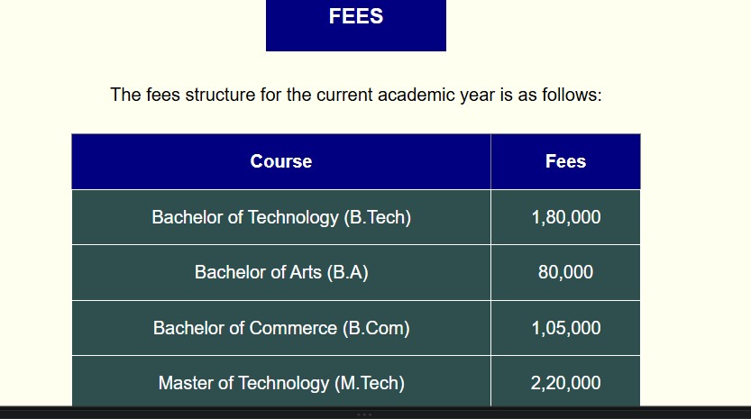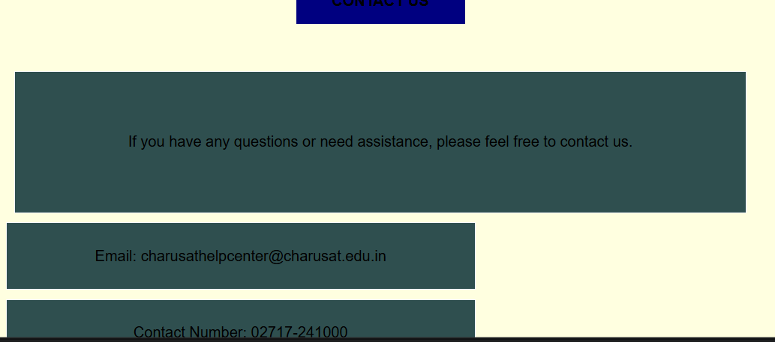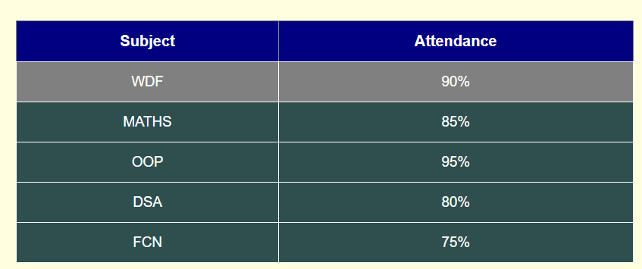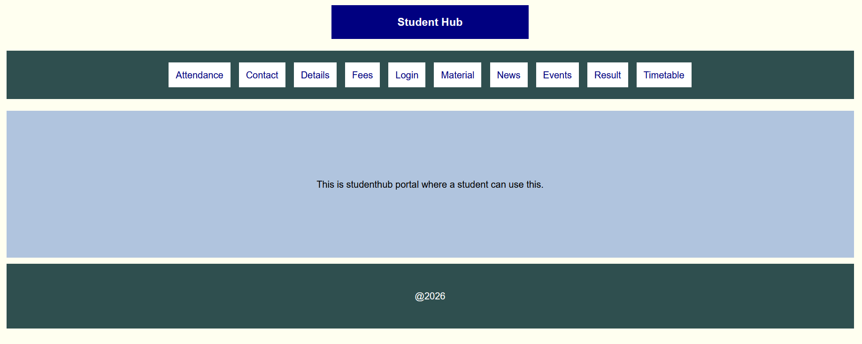
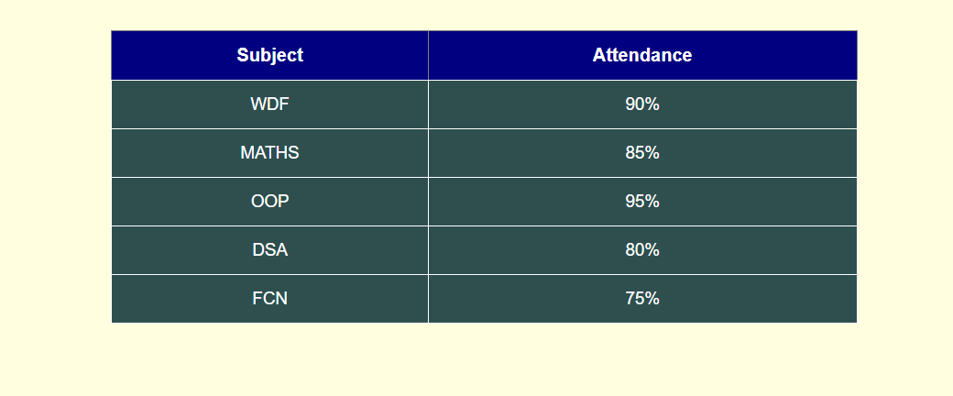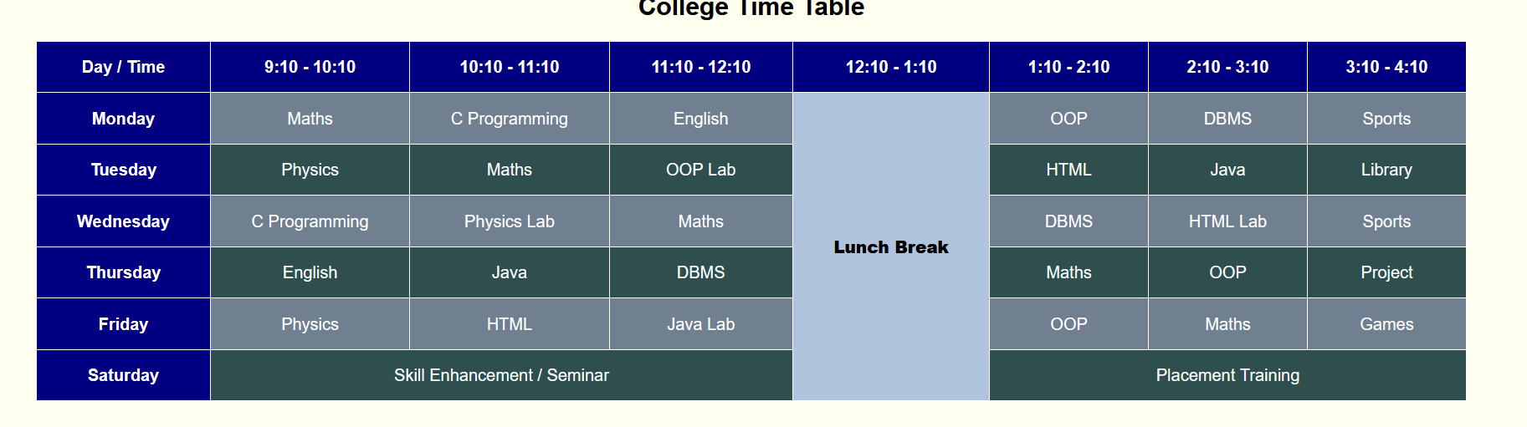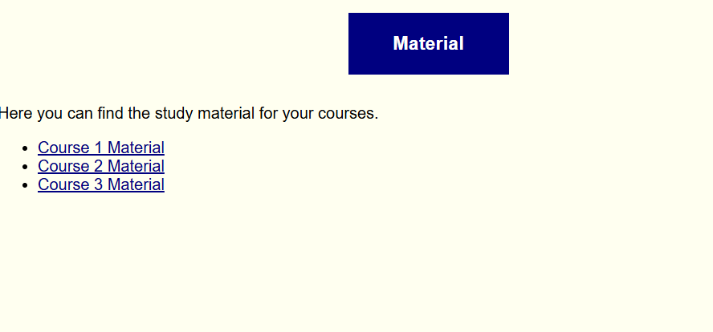
- GitHub Repository Link:
https://github.com/dhruvkaravadra955-ux/studenthubportal/tree/main/CSS
- Challenges Faced:

Designing every page using css, creating animations and transition
Arranging elements using flexbox and grid and changing according to the screen size

- Learning Outcomes:
Learned how to use CSS, selectors, classes and IDs,
apply colors, fonts, borders, spacing and shadows, use Flexbox and Grid for layouts, create hover effects and animations, and media queries.

Faculty Remarks: (Keep this blank for faculty)

