Practical - 4

Practical Title: JavaScript DOM Manipulation, Event Handling, and UI Interactivity
Add dynamic UI components such as collapsible FAQ, modal popup, image/content slider, notification banner, hamburger menu, and light/dark theme switcher using JavaScript.
- Theory
  - How are DOM elements selected and modified?
Answer: DOM elements are selected using methods like getElementById();

  - Are event listeners attached correctly? Answer: Yes, event listeners are attached

  - Is localStorage used for remembering theme choice? Answer: Yes

  - Does interactivity improve usability without breaking accessibility? Answer: Yes

- Evidence of Work (Screenshots)
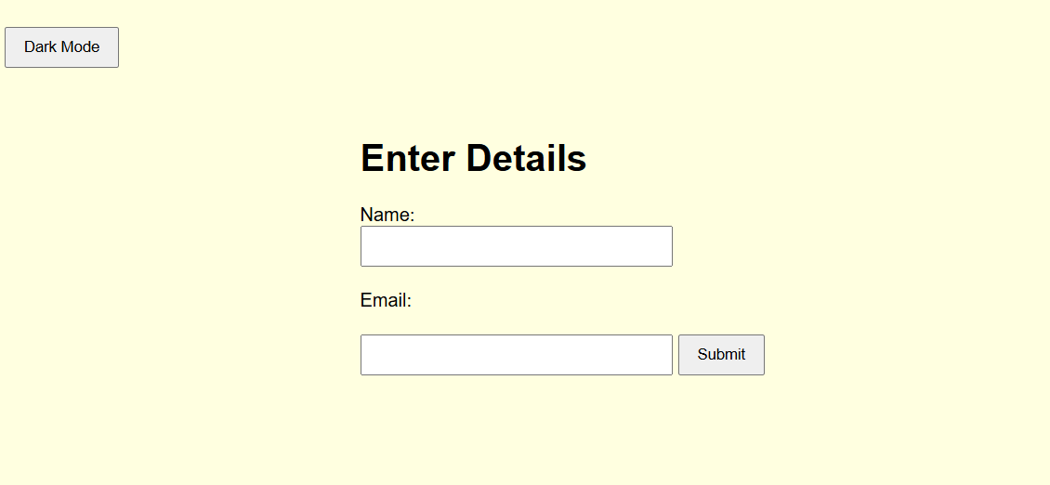
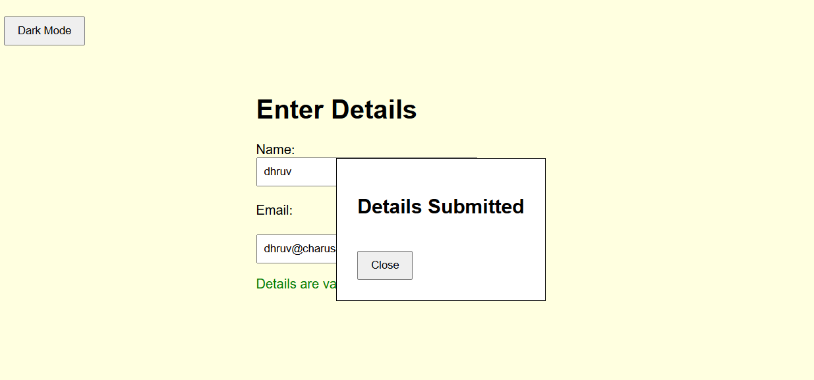

- GitHub Repository Link:
https://github.com/dhruvkaravadra955-ux/studenthubportal/tree/main/PRACTICAL%204
- Challenges Faced:

Adding dark/light theme button using local storage and the slider

- Learning Outcomes:
Learned how to integrate js to a project, how to access DOM elements and use it for interactive website

Faculty Remarks: (Keep this blank for faculty)

