Practical - 5

Practical Title: Registration Form with Frontend Validation and User-Friendly Error Handling
Create a student registration form with HTML5 input types and JavaScript validation for name, email, mobile number, password, confirm password, course, year, gender, and terms acceptance. Use Regular Expression for validations.
X. Theory
- Are correct input types and attributes used? Answer - Yes

- Are validation errors displayed near the relevant fields? Answer - Yes

- Is password strength checked? Answer - Yes

- Is the form accessible using keyboard and screen-reader-friendly labels? Answer - Yes

Y. Evidence of Work (Screenshots)

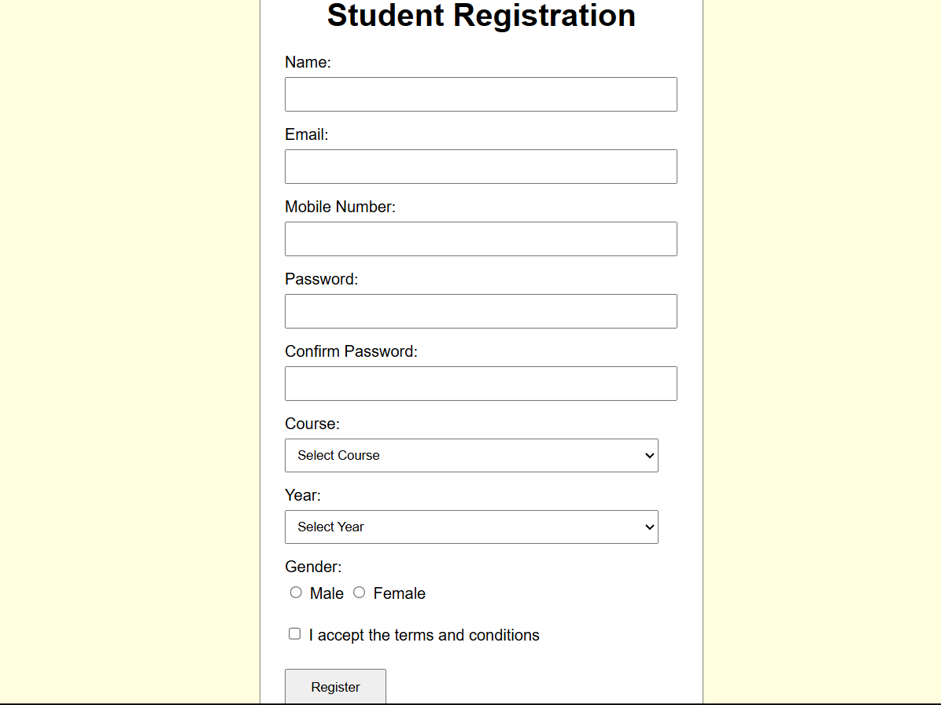
Z. GitHub Repository Link:
https://github.com/dhruvkaravadra955-ux/studenthubportal/tree/main/PRACTICAL%205
AA. Challenges Faced:

Integrating regex to the fields

BB. Learning Outcomes:

Learned how to add regex for input validation

Faculty Remarks: (Keep this blank for faculty)

