Practical - 6

Practical Title: Rendering External JSON Data using Fetch API, Search and Filter
Display event lists, student profiles, notices, or FAQs from external JSON files using Fetch API. Implement dynamic rendering, search, filter, sorting, and pagination
- Theory
  - How is JSON fetched, parsed, and rendered?
Answer - JSON is fetched using fetch(), parsed using .json()

  - Which array methods are used for search, filter, sort, and pagination? Answer - filter(), and slice() are used for filtering and pagination.

  - How are loading and error states handled?
Answer - Loading and error messages are shown when data is being fetched or when fetching fails.

  - How is modularity maintained in JavaScript files?
Answer - Modularity is maintained by separating logic into reusable functions

- Evidence of Work (Screenshots)
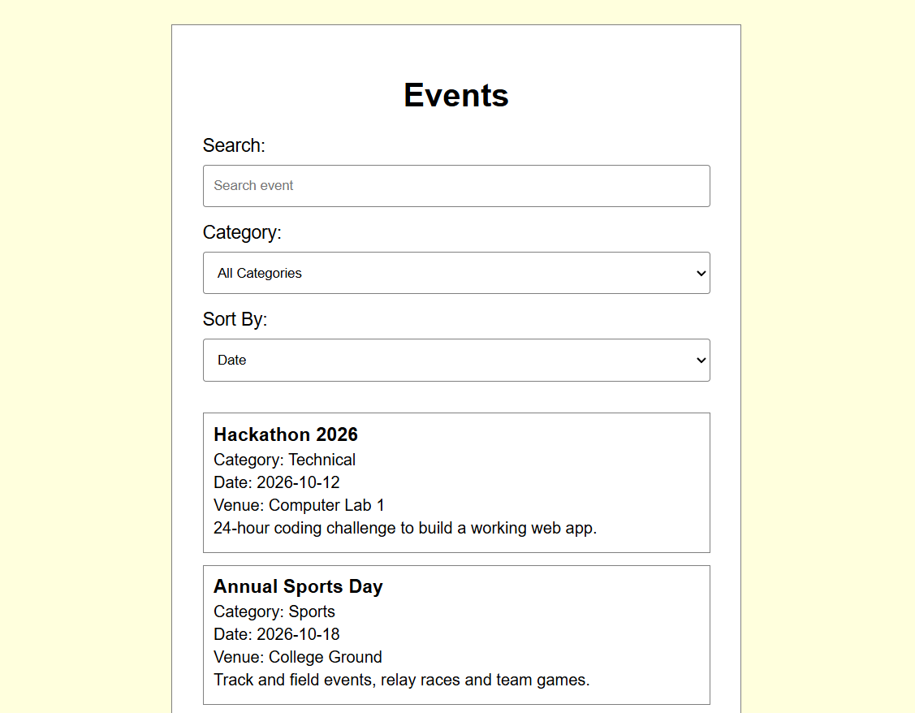
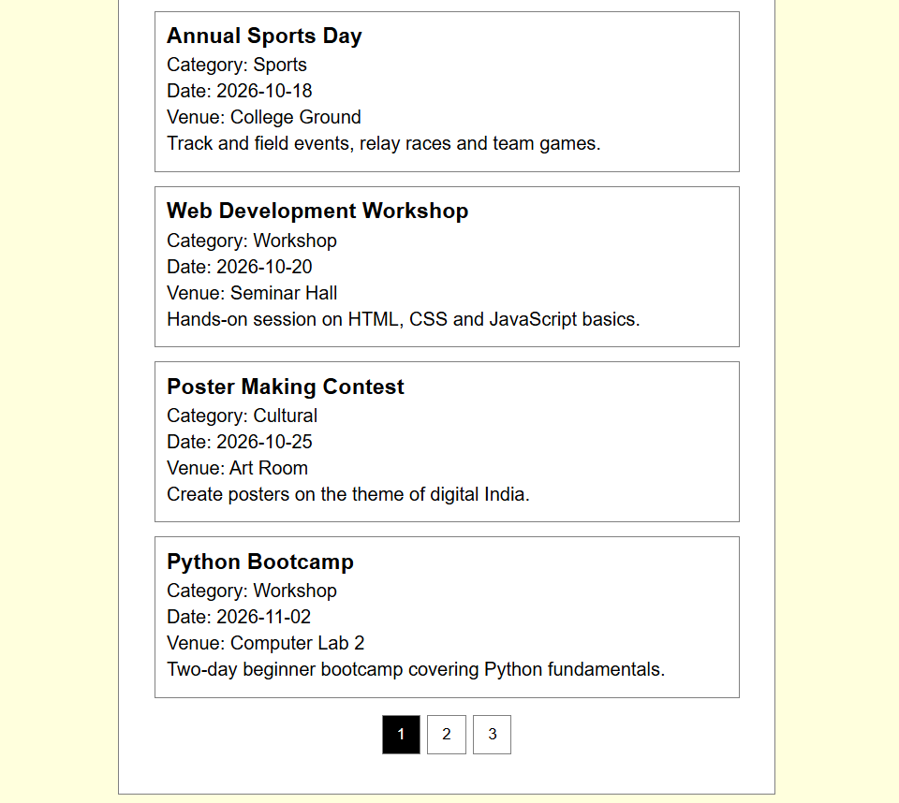
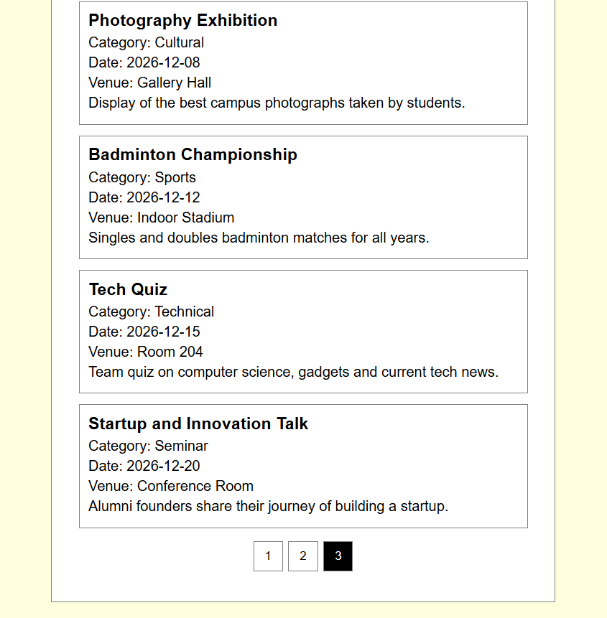
EE.GitHub Repository Link:
https://github.com/dhruvkaravadra955-ux/studenthubportal/tree/main/PRACTICAL%206
- Challenges Faced:

Implementing fetch api, pagination and the events search list

- Learning Outcomes:
I learn how to manage large data

Learned how to use fetch api, how to connect multiple small events for resting searching inside events, learned how pagination works

Faculty Remarks: (Keep this blank for faculty)

