Practical - 7

Practical Title: PHP Form Processing with Server-Side Validation and CSV/JSON File Storage
Process submitted registration/contact form data using PHP. Validate and sanitize inputs on the server side and store records in CSV or JSON file format. Display success/error messages.
- Theory
  - Is the form submitted using POST?
Answer - Yes, the form is submitted using POST.

  - Are inputs validated and sanitized server side?
Answer -Yes, inputs are validated and sanitized on the server side.

  - Is file writing handled safely?
Answer - Yes, file writing is handled safely.

  - Are success and error responses displayed clearly?
Answer - Yes, clear success and error messages are displayed.

II. Evidence of Work (Screenshots)
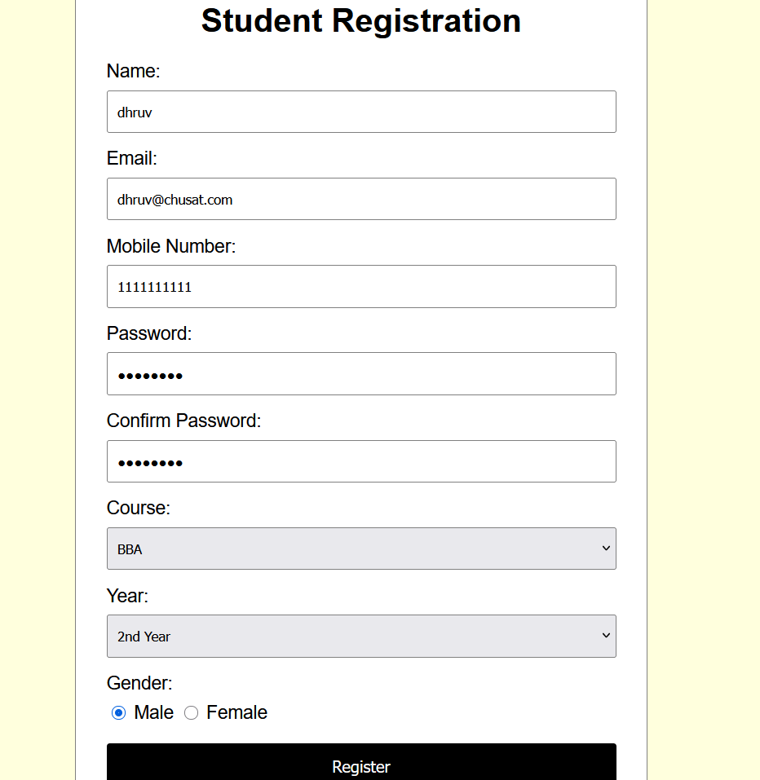
JJ. GitHub Repository Link:
https://github.com/dhruvkaravadra955-ux/studenthubportal/tree/main/PRACTICAL%207
KK. Challenges Faced:

Implementing the php server connection using Apache, writing php code to connect the js to php

LL. Learning Outcomes:

Learned how to use PHP and how to connect the application to a server using XAMPP/Apache.
Learned about csv files creation and data storage.

Faculty Remarks: (Keep this blank for faculty)

