Practical - 8

Practical Title: MySQL Schema Design, ER Model, PDO Connectivity, and Prepared Statements
Design the database for StudentHub with students, events and registrations. Create PHP database connection using MYSQL statements
- Theory
  - Is the schema normalized properly ?
Answer - Yes, the schema is properly normalized.

  - Are primary keys and foreign keys correctly defined?
Answer -Yes, primary keys and foreign keys are correctly defined.

  - Is the database connection handled securely?
Answer - Yes, the database connection is handled securely.

- Evidence of Work (Screenshots)
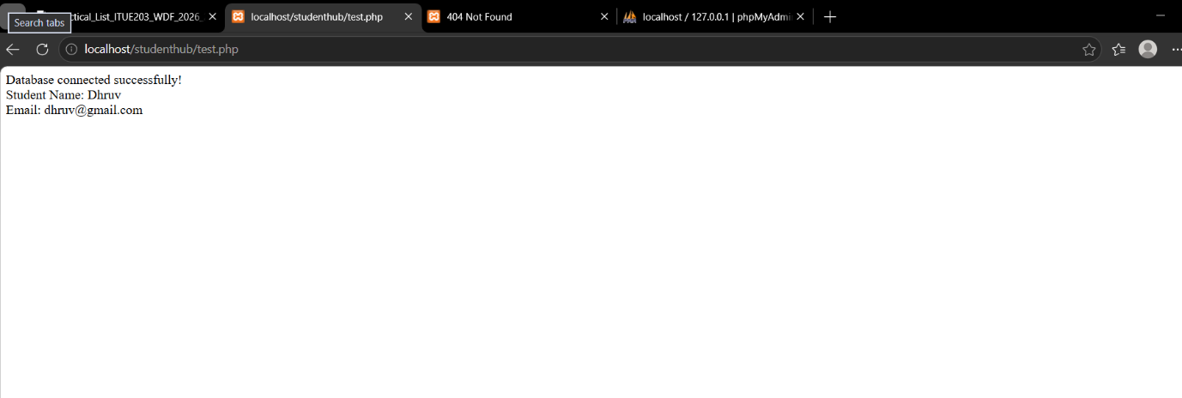

- GitHub Repository Link:
https://github.com/dhruvkaravadra955-ux/studenthubportal/tree/main/PRACTICAL%208
PP. Challenges Faced:

Implementing the sql database using xampp, creating the table and its relations

QQ. Learning Outcomes:

Learned how to create sql tables, create relationships between the tables, primary,foreign key

Faculty Remarks: (Keep this blank for faculty)

