Practical - 9

Practical Title: Secure User Registration with Database Insert, Duplicate Email Check, and Password Hashing
Implement secure user registration by inserting user details into MySQL using MYSQLi. Validate input on frontend and backend, check duplicate email/username, hash passwords using password_hash(), and display appropriate messages.
- Theory
  - Is password_hash() used before storing passwords? Answer - Yes, the passwords are hashed before storing

  - Is duplicate email/username checked? Answer -Yes, duplicate emails are checked

  - Are frontend and backend validations consistent? Answer - Yes, there is validation on both the ends

- Evidence of Work (Screenshots)
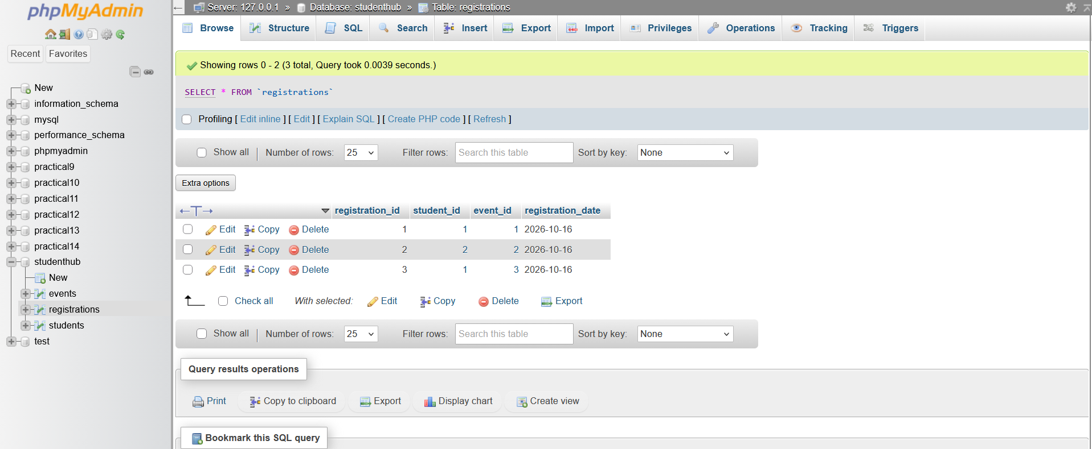
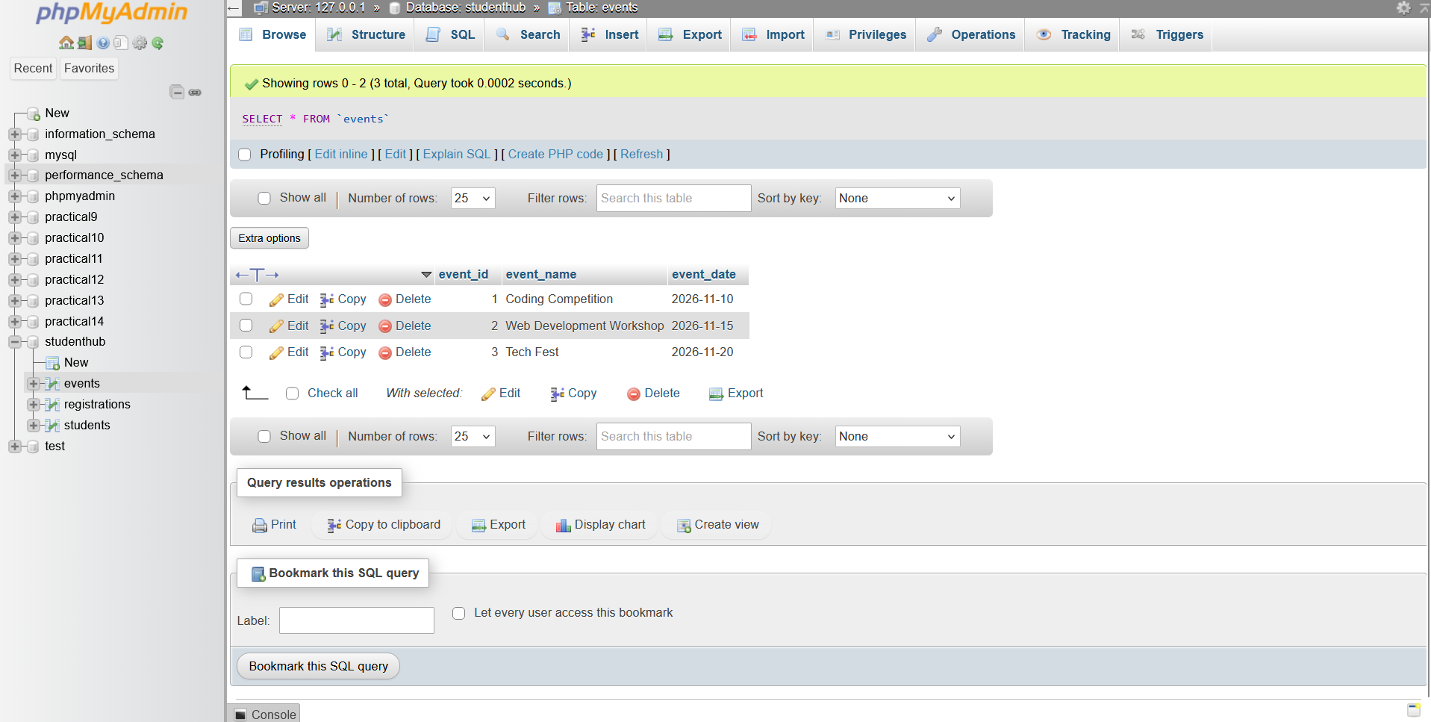
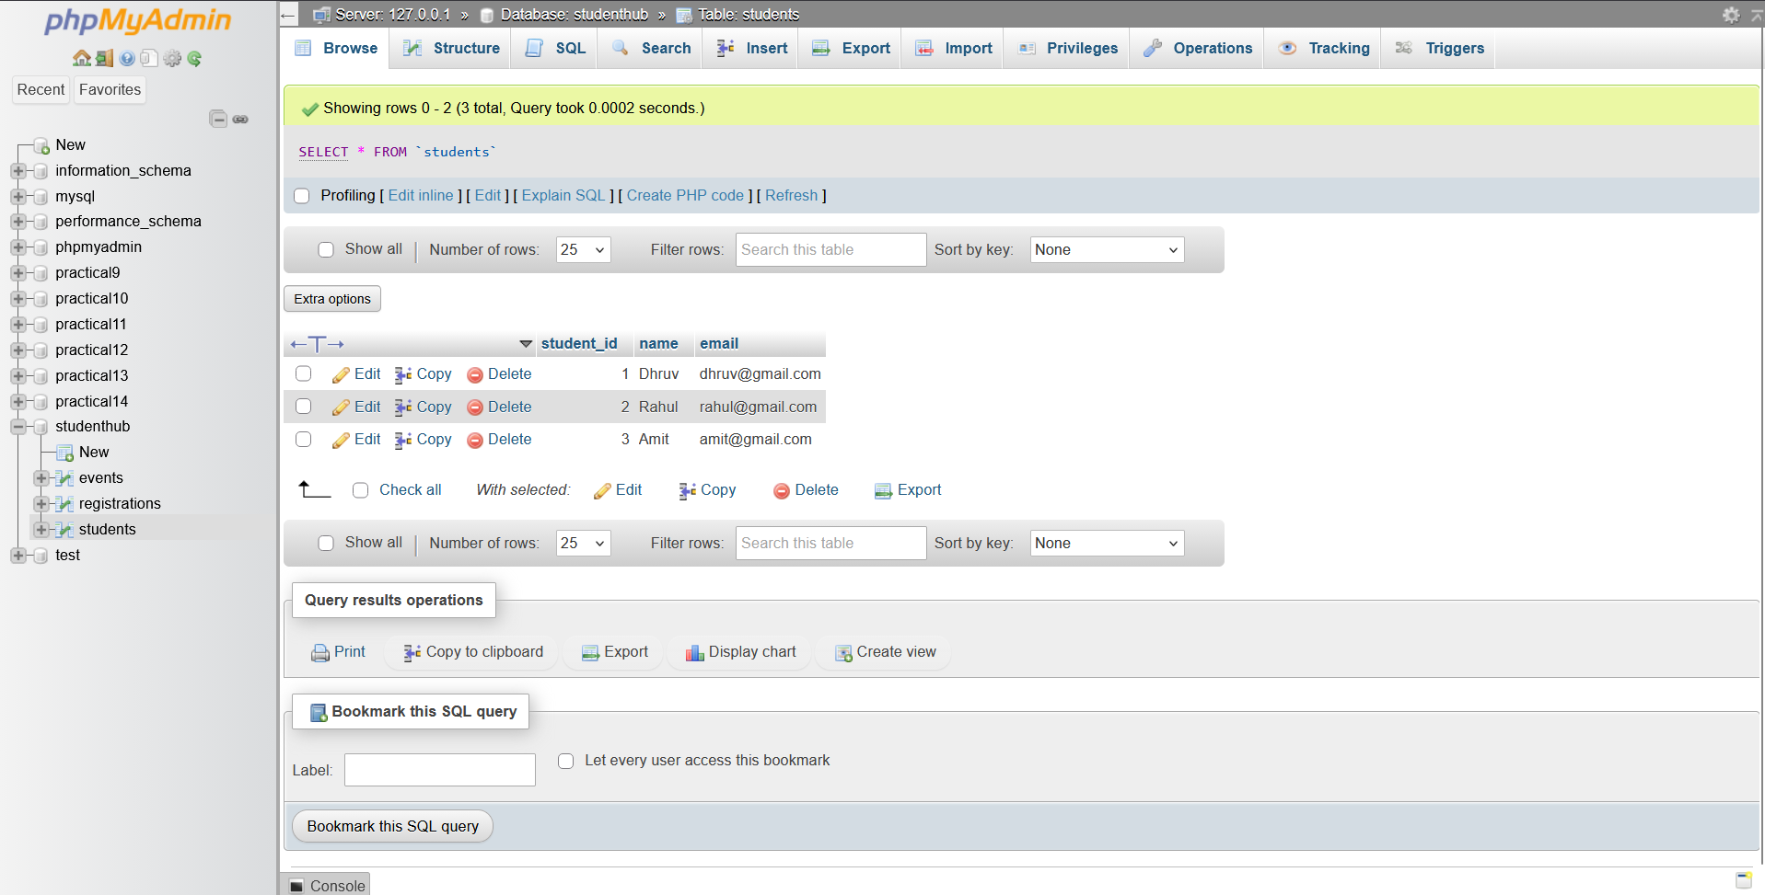
TT. GitHub Repository Link:
https://github.com/dhruvkaravadra955-ux/studenthubportal/tree/main/PRACTICAL%209
UU. Challenges Faced:

Connecting the registration form with MySQL, checking for duplicate emails and storing passwords in hashed form.

VV. Learning Outcomes:
Learned how to insert user data into MySQL, check duplicate emails and use password_hash() to store passwords securely

Faculty Remarks: (Keep this blank for faculty)

