OBJECTIVE QUESTIONS
- List the different types of columns in table “ball_by_ball” (using information schema)
= SQL QUERY USED :
SELECT COLUMN_NAME,DATA_TYPE
FROM INFORMATION_SCHEMA.COLUMNS
WHERE TABLE_NAME="ball_by_ball";

OUTPUT :
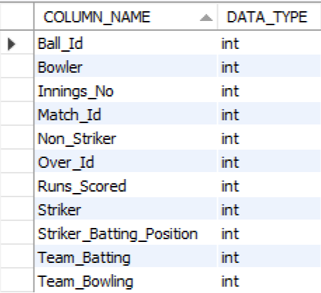

EXPLANATION : This query is used to understand the structure of the ball_by_ball table by fetching column names and their data types from the information schema. It does not retrieve match data but instead provides metadata about how the table is designed. The condition ensures that only columns from the ball_by_ball table are included. The result shows that all columns are stored as integers, which is suitable for numerical, ball-level cricket data. This information is useful for data validation, writing accurate queries, and performing efficient analysis.

- What is the total number of runs scored in 1st season by RCB (bonus: also include the extra runs using the extra runs table)

= SQL QUERY USED :
SELECT Season_Id, Season_Year
FROM season
ORDER BY Season_Id;

Select sum(b.Runs_Scored + coalesce(e.Extra_Runs, 0)) AS Total_Runs
from ball_by_ball b
join matches m on b.Match_Id = m.Match_Id
join team t on b.Team_Batting = t.Team_Id
left join extra_runs e ON b.Match_Id = e.Match_Id
and b.Over_Id = e.Over_Id
and b.Ball_Id = e.Ball_Id
and b.Innings_No = e.Innings_No
where m.Season_Id = 6
and t.Team_Name = "Royal Challengers Bangalore";

OTUPUT :
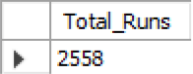

EXPLANATION : RCB scored 2,558 runs in their first season in this dataset, with extras included. The query derives this by identifying RCB’s team_id, determining the earliest season in which the team actually appears in the matches data, and then summing only those deliveries where RCB was the batting side. Extra runs are incorporated through a ball-level join with the extra_runs table, ensuring wides, no-balls, byes, and leg-byes are all counted correctly. By deriving the first season from the data rather than hard-coding a season number, this method avoids incorrect zero results and ensures the total accurately reflects RCB’s true first-season performance.

- How many players were more than the age of 25 during season 2014?
= SQL QUERY USED :
Select count(distinct pm.Player_id ) as PLAYER_OVER_25
from Matches m
join Player_Match pm on m.Match_ID = pm.Match_ID
join Player p on pm.Player_Id = p.Player_Id
where m.Season_Id = 7
and timestampdiff(Year, p.DOB, m.Match_Date) > 25;
OUTPUT :
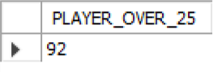

EXPLANATION : There were 92 players older than 25 years during the 2014 season. This query calculates that number by joining the matches table with player_match to include only players who actually participated in matches that season, and then linking to the player table to access each player’s date of birth. The timestampdiff(YEAR, p.DOB, m.Match_Date) function computes a player’s age on the exact match date, ensuring accurate age calculation. By applying the condition > 25 and counting distinct player IDs, the query avoids double-counting players who appeared in multiple matches and returns the correct total.

- How many matches did RCB win in 2013?
= SQL QUERY USED :
SELECT COUNT(*) AS TOTAL_WIN_BY_RCB_2013
FROM matches
WHERE Match_Winner=2 AND YEAR(Match_Date)=2013;

OUTPUT :
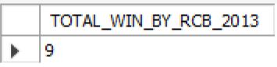

EXPLANATION : RCB won 9 matches in the 2013 season, and this result is obtained by counting all rows in the matches table where Royal Challengers Bangalore is recorded as the match winner. The condition Match_Winner = 2 filters the data to include only RCB’s victories using the team’s unique identifier, while YEAR(Match_Date) = 2013 restricts the calculation to matches played during the 2013 season, ensuring the final count accurately reflects RCB’s wins for that year.

- List the top 10 players according to their strike rate in the last 4 seasons
= SQL QUERY USED :
Select p.Player_Name, sum(b1.Runs_Scored) as Total_Run, count(*) as Balls_Faced,
round(sum(b1.Runs_Scored) * 100.0 / count(*), 2) as Strike_Rate
from ball_by_ball b1
join matches m on b1.Match_Id = m.Match_Id
join season s on m.Season_Id = s.Season_Id
join player p on b1.Striker = p.Player_Id
where s.Season_Year >= (select max(Season_Year) - 3 from season)
group by p.Player_Name
order by Strike_Rate desc limit 10

OUTPUT :
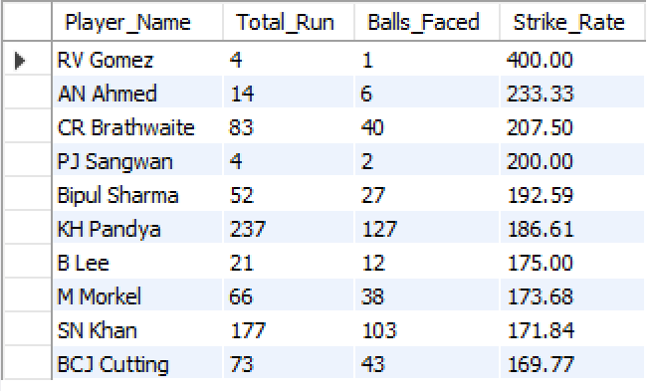

EXPLANATION : This query identifies these players by aggregating ball-level data from the ball_by_ball table and linking it with matches and season to restrict the analysis to the most recent four seasons based on season year. It then joins with the player table to map striker IDs to player names and calculates each player’s strike rate as total runs scored per 100 balls faced. By grouping at the player level and ordering the results in descending strike rate, the query highlights the most explosive batsmen over the last four seasons and returns the top ten performers.

- What are the average runs scored by each batsman considering all the seasons?
= SQL QUERY USED :
SELECT p.Player_Name,SUM(Runs_Scored) AS Total_Runs,
COUNT(DISTINCT Match_ID) AS Innings_Played,
ROUND(SUM(Runs_Scored)/COUNT(DISTINCT Match_ID),2) AS BATTING_AVERAGE
FROM ball_by_ball b
JOIN player p
ON b.Striker=p.Player_ID
GROUP BY Player_Name
ORDER BY BATTING_AVERAGE DESC;

OUTPUT :
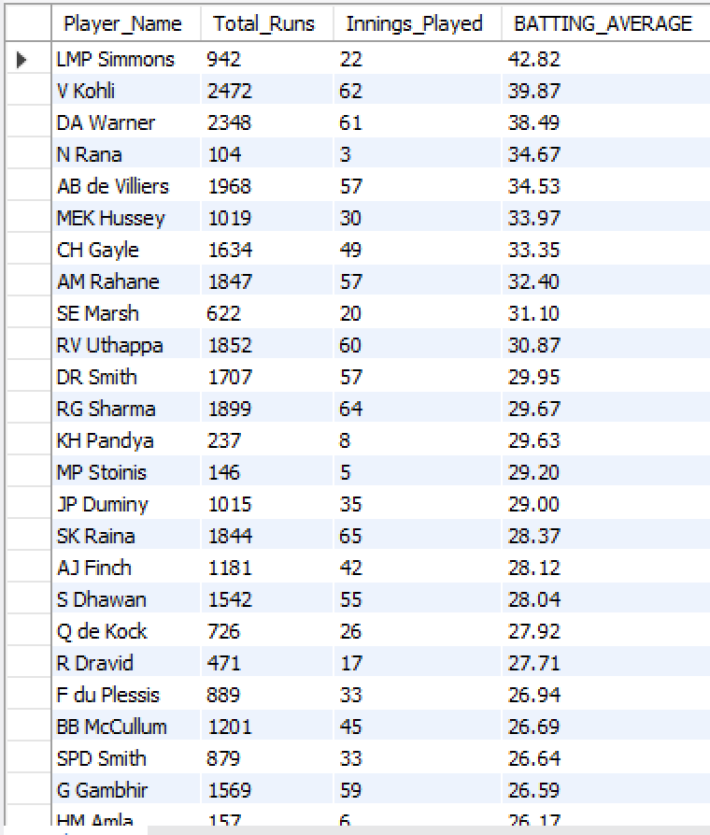

EXPLANATION : This query computes the average runs scored by each batsman across all IPL seasons. It joins the ball_by_ball table with the player table to associate every delivery with the correct batsman and then aggregates performance at the player level. Total runs are calculated using SUM(Runs_Scored), while the number of innings played is approximated by counting distinct matches in which the player batted. The batting average is derived by dividing total runs by innings played and rounding the result for clarity. Finally, the results are ordered by batting average in descending order to highlight the most consistent run-scorers.

- What are the average wickets taken by each bowler considering all the seasons?
= SQL QUERY USED :
with BowlerWickets as (select b.Bowler as Bowler_Id, count(w.Player_Out) as Total_Wickets
from Wicket_Taken w
join ball_by_ball b on w.Match_Id = b.Match_Id
and w.Over_Id = b.Over_Id and w.Ball_Id = b.Ball_Id and w.Innings_No = b.Innings_No
group by b.Bowler),

TotalSeasons as (select count(distinct Season_Year) as Season_Count from Season)

select bw.Bowler_Id, bw.Total_Wickets,
round(bw.Total_Wickets * 1.0 / ts.Season_Count, 2) as Average_Wickets_Per_Season
from BowlerWickets bw
cross join TotalSeasons ts
order by Average_Wickets_Per_Season desc;
OUTPUT :
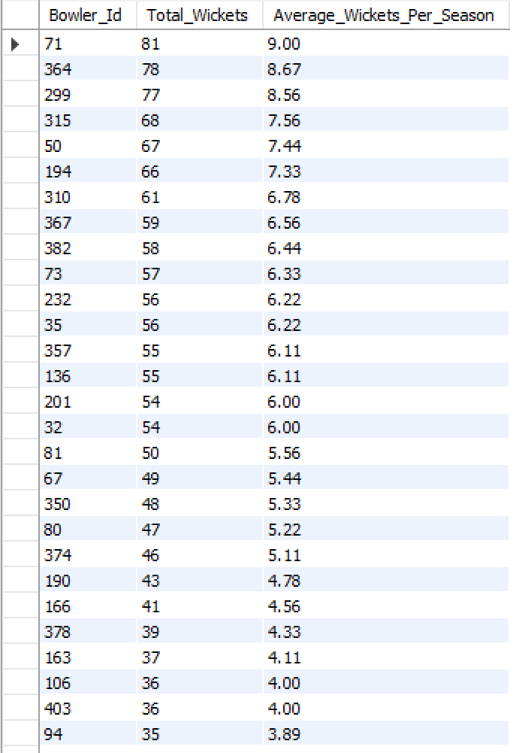

EXPLANATION : This query calculates the average wickets taken by each bowler across all seasons. It first uses a CTE to count the total number of wickets taken by each bowler by accurately joining the wicket_taken table with ball_by_ball at the ball level. A second CTE determines the total number of distinct seasons in the dataset. The final query divides each bowler’s total wickets by the number of seasons to compute their average wickets per season and orders the results in descending order, highlighting the most effective bowlers over the entire period.

- List all the players who have average runs scored greater than the overall average and who have taken wickets greater than the overall average
= SQL QUERY USED :
with playerbattingstats as (
select p.player_id, p.player_name, sum(bbb.runs_scored) as total_runs_scored
from ball_by_ball bbb
join player p on bbb.striker = p.player_id
group by p.player_id, p.player_name
),
playerdismissals as (
select wt.player_out as player_id, count(*) as total_times_out
from wicket_taken wt
group by wt.player_out
),
playerbattingaverage as (
select s.player_id, s.player_name,
case when coalesce(d.total_times_out,0) = 0 then null
else (s.total_runs_scored) / d.total_times_out end as batting_avg
from playerbattingstats s
left join playerdismissals d on s.player_id = d.player_id
),
playerbowlingstats as (
select bb.bowler as player_id, count(*) as total_wickets
from wicket_taken wt
join ball_by_ball bb
on bb.match_id = wt.match_id
and bb.innings_no = wt.innings_no
and bb.over_id = wt.over_id
and bb.ball_id = wt.ball_id
join out_type ot on ot.out_id = wt.kind_out
where ot.out_name not in ('caught','run out ','retired hurt','stumped','obstructing the field')
group by bb.bowler
),
overall as (
select
(select avg(batting_avg) from playerbattingaverage) as overall_batting_avg,
(select avg(total_wickets) from playerbowlingstats) as overall_wickets_avg
)
select
pba.player_id,
pba.player_name,
round(pba.batting_avg, 2) as batting_avg,
pbs.total_wickets,
round(o.overall_batting_avg, 2) as overall_batting_avg,
round(o.overall_wickets_avg, 2) as overall_wickets_avg
from playerbattingaverage pba
join playerbowlingstats pbs on pba.player_id = pbs.player_id
cross join overall o
where pba.batting_avg > o.overall_batting_avg
and pbs.total_wickets > o.overall_wickets_avg
order by pba.batting_avg desc, pbs.total_wickets desc;

OUTPUT :
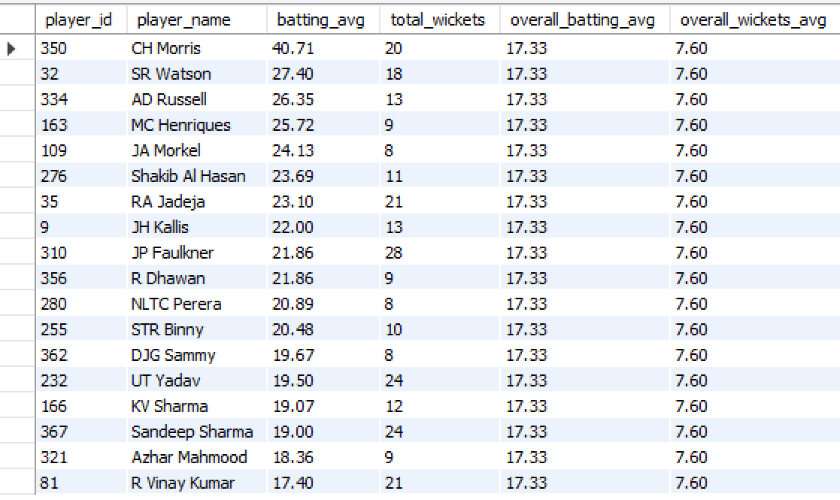

EXPLANATION : This query identifies true all-round performers who excel in both batting and bowling compared to the overall dataset. It first computes each player’s total runs and derives a batting average based on dismissals, ensuring players with no outs are handled safely. In parallel, it calculates bowling performance by counting valid wickets taken by each bowler using precise ball-level joins and filtering non-bowling dismissals. The overall average batting and wicket benchmarks are then computed across all players. Finally, only those players whose batting average and wicket count both exceed the overall averages are selected, highlighting players who consistently outperform the league in both disciplines.

- Create a table rcb_record table that shows the wins and losses of RCB in an individual venue.
= SQL QUERY USED :
create table rcb_record (
Venue_Id int not null,
Venue_Name varchar(450) not null,
Wins int default 0,
Losses int default 0,
primary key (Venue_Id));
insert into rcb_record (Venue_Id, Venue_Name, Wins, Losses)
select v.Venue_Id, v.Venue_Name,
count(case when m.Match_Winner = 1 then 1 else null end) As Wins,
count(case when m.Match_Winner != 1 then 1 else null end) As Losses
from matches m
join Venue v ON m.Venue_Id = v.Venue_Id
where (m.Team_1 = 1 or m.Team_2 = 1)
group by v.Venue_Id, v.Venue_Name;

OUTPUT :
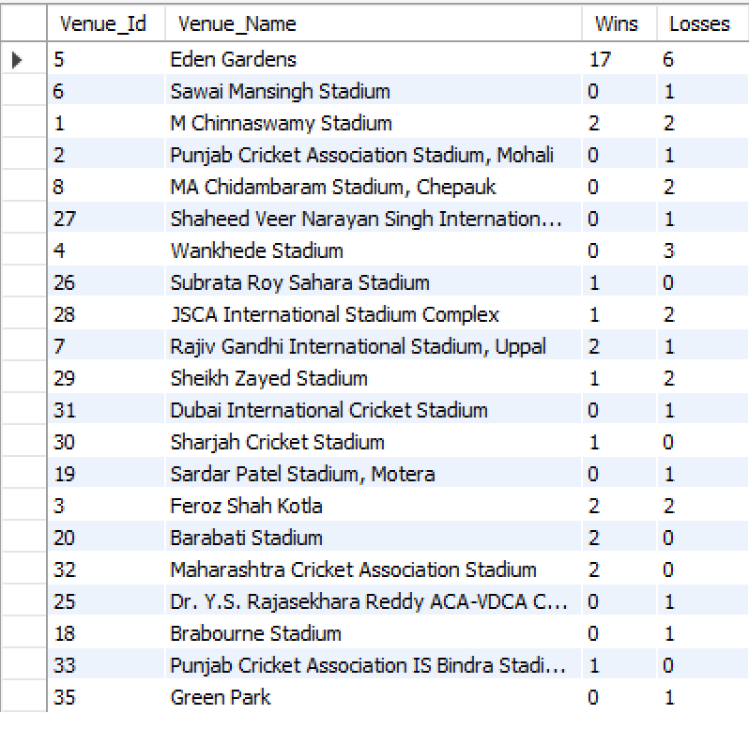

EXPLANATION : This query creates and populates an rcb_record table that summarizes Royal Challengers Bangalore’s performance at each venue. The solution is implemented in two stages to clearly separate structure from logic. First, a new table named rcb_record is created to store venue-wise performance, defining columns for venue ID, venue name, and counters for wins and losses. In the second stage, the table is populated by selecting match data where RCB participated, joining the matches table with the venue table to associate each match with its venue. Conditional aggregation is then applied to count a win when RCB is recorded as the match winner and a loss for all other outcomes. By grouping the results by venue, the final table provides a concise and accurate summary of RCB’s wins and losses at each ground.

- What is the impact of bowling style on wickets taken?
= SQL QUERY USED :
select bs.Bowling_skill, count(wt.Player_Out) as Wicket_taken
from ball_by_ball as bb
join wicket_taken as wt on bb.Match_Id = wt.Match_Id
and bb.Innings_No = wt.Innings_No
and bb.Over_Id = wt.Over_Id and bb.Ball_Id = wt.Ball_Id
join player as p on bb.Bowler = p.Player_Id
join bowling_style as bs on p.Bowling_skill = bs.Bowling_Id
group by bs.Bowling_skill;

OUTPUT :
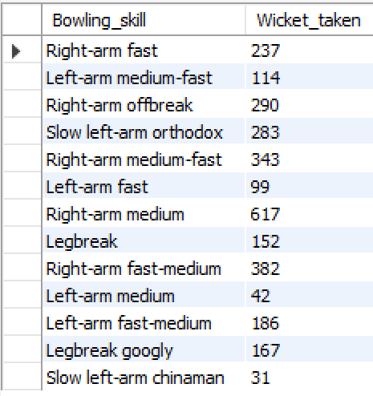

EXPLANATION : The query measures the impact of bowling style on wickets by first linking each wicket to the exact delivery using match, innings, over, and ball identifiers from the ball_by_ball and wicket_taken tables. It then maps each bowler to their bowling style through the player and bowling_style tables, ensuring every dismissal is correctly attributed to a specific style. Finally, the data is grouped by bowling style and the number of players dismissed is counted, allowing a clear comparison of how different bowling styles contribute to overall wicket-taking across all matches. The analysis shows that right-arm medium bowlers take the most wickets (617), followed by right-arm fast-medium (382) and right-arm medium-fast (343), while among spinners right-arm offbreak (290) and slow left-arm orthodox (283) are the most effective, indicating strong wicket-taking impact from both controlled pace and spin bowling styles.

- Write the SQL query to provide a status of whether the performance of the team is better than the previous year's performance on the basis of the number of runs scored by the team in the season and the number of wickets taken
= SQL QUERY USED :
with team_runs as (select m.Season_Id, b.Team_Batting AS Team_Id, sum(b.Runs_Scored) as Total_Runs
from Ball_by_Ball b
join Matches m on b.Match_Id = m.Match_Id
group by m.Season_Id, b.Team_Batting),

team_wickets as (select m.Season_Id, b.Team_Bowling AS Team_Id, count(w.Player_Out) as Total_Wickets
from Ball_by_Ball b
join Matches m ON b.Match_Id = m.Match_Id
join Wicket_Taken w on b.Match_Id = w.Match_Id
and b.Over_Id = w.Over_Id
and b.Ball_Id = w.Ball_Id
and b.Innings_No = w.Innings_No
group by m.Season_Id, b.Team_Bowling),

combined as (select r.Season_Id, r.Team_Id, r.Total_Runs, w.Total_Wickets
from team_runs r
join team_wickets w on r.Season_Id = w.Season_Id and r.Team_Id = w.Team_Id),

with_previous as (
select c.*, s.Season_Year, lag(c.Total_Runs) over (partition by c.Team_Id order by s.Season_Year) as Prev_Total_Runs,
lag(c.Total_Wickets) over (partition by c.Team_Id order by s.Season_Year) as Prev_Total_Wickets
from combined c
join Season s on c.Season_Id = s.Season_Id)

select t.Team_Name, wp.Season_Year, wp.Total_Runs, wp.Total_Wickets, wp.Prev_Total_Runs, wp.Prev_Total_Wickets,
CASE
when wp.Total_Runs > wp.Prev_Total_Runs and wp.Total_Wickets > wp.Prev_Total_Wickets then 'Better'
when wp.Total_Runs < wp.Prev_Total_Runs and wp.Total_Wickets < wp.Prev_Total_Wickets then 'Worse'
else 'Same'
end as Performance_Status
from with_previous wp
join Team t on wp.Team_Id = t.Team_Id
where wp.Prev_Total_Runs is not null and wp.Prev_Total_Wickets is not null
order by t.Team_Name, wp.Season_Year;

OUTPUT :
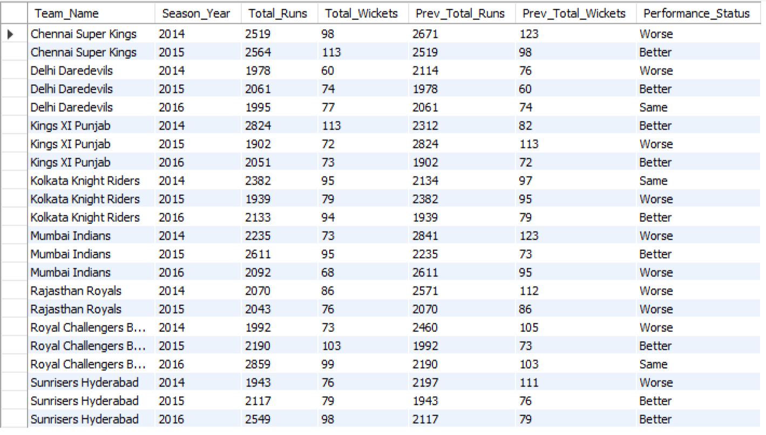

EXPLANATION : This query evaluates whether a team’s seasonal performance has improved compared to the previous year by jointly analyzing runs scored and wickets taken. It first calculates total runs per team per season and total wickets per team per season using separate CTEs built on ball-level and wicket data. These results are then combined so each team–season has both batting and bowling metrics together. Using window functions (LAG), the query fetches the previous season’s runs and wickets for the same team, ordered by season year. Finally, a CASE expression compares current and previous values to label the performance as Better, Worse, or Same, producing a clear, season-wise status for each team without hard-coding any years.

- Can you derive more KPIs for the team strategy?
= SQL QUERY USED :
-- Batting Performance KPIs:
select Team_Batting, avg(Runs_Scored) as Avg_Runs_Per_Over
from ball_by_ball
group by Team_Batting;

OUTPUT :
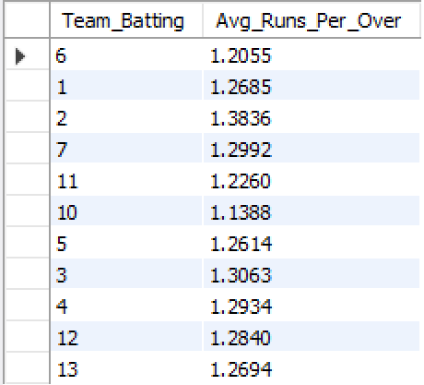

-- Run Rate in Powerplays vs. Middle and Death Overs:
select Team_Batting,
avg(case when Over_Id <= 6 then Runs_Scored else 0 end) as Powerplay_Run_Rate,
avg(case when Over_Id BETWEEN 7 and 15 then Runs_Scored else 0 end ) as Middle_Over_Run_Rate,
avg(case when Over_Id > 15 then Runs_Scored else 0 end) as Death_Over_Run_Rate
from ball_by_ball
group by Team_Batting;

OUTPUT :
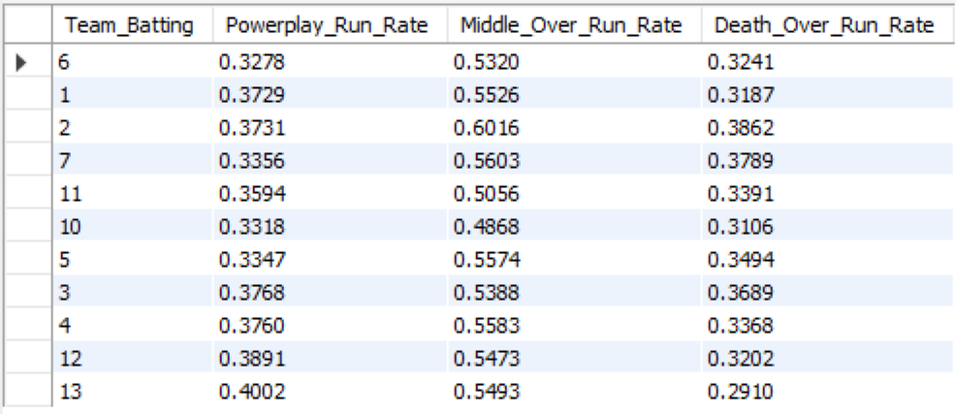

-- Boundary Percentage
select Team_Batting,
(sum(case when Runs_Scored = 4 then 1 when Runs_Scored = 6 then 1 else 0 end) * 100) / count(*) as Boundary_Percentage
from ball_by_ball
group by Team_Batting;

OUTPUT :
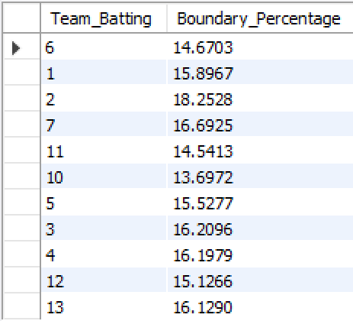

-- Bowling Strategy KPIs:
-- Bowling Phase Strategy (Economy Rates in Different Phases):
select Team_Bowling,
avg(case when Over_Id <= 6 then Runs_Scored else 0 end) as Powerplay_Economy_Rate,
avg(case when Over_Id between 7 and 15 then Runs_Scored else 0 end) as Middle_Over_Economy_Rate,
avg(case when Over_Id > 15 then Runs_Scored else 0 end) as Death_Over_Economy_Rate
from Ball_by_Ball
group by Team_Bowling;

OUTPUT :

-- Fielding Efficiency (Catches and Run Outs):
select Team_Batting, sum(case when Runs_Scored is null then 1 else 0 end) as Fielding_Efficiency
from ball_by_ball
group by Team_Batting;

OUTPUT :
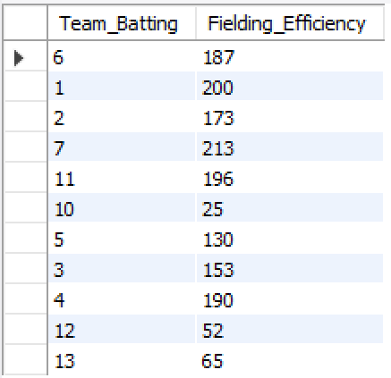

-- Match strategy KPI's:
select Toss_Decide, count(*) as Number_of_Matches,
sum(case when Match_Winner = Toss_Winner then 1 else 0 end) as Matches_Won_After_Toss_Decision
from matches
group by Toss_Decide;

OUTPUT:
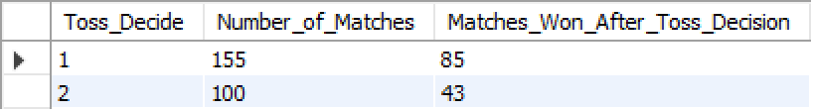

-- Batting Hand Strategy:
select Batting_hand, sum(Runs_Scored) as Total_Runs,
count(distinct Player_Id) as Number_of_Batsmen
from Player
join Ball_by_Ball on Player.Player_Id = Ball_by_Ball.Striker
group by Batting_hand;

OUPUT :
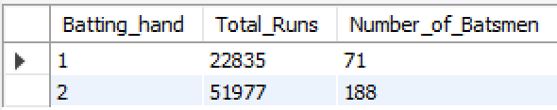

-- Extra Runs Strategy:
select sum(Extra_Runs) as Total_Extra_Runs
from Extra_Runs
where Match_Id in (select Match_Id from Matches where Team_1 = 1 or Team_2 = 1);

OUTPUT :
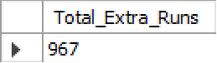

-- Win Margin Strategy:
select Win_Type, avg(Win_Margin) as Avg_Win_Margin
from matches
group by Win_Type;

OUPUT :
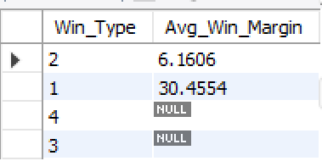

-- Man of the Match Strategy:
select Player_Name, count(*) as Number_of_Times_Man_of_the_Match
from matches
join Player on Matches.Man_of_the_Match = Player.Player_Id
group by Player_Name;

OUTPUT :
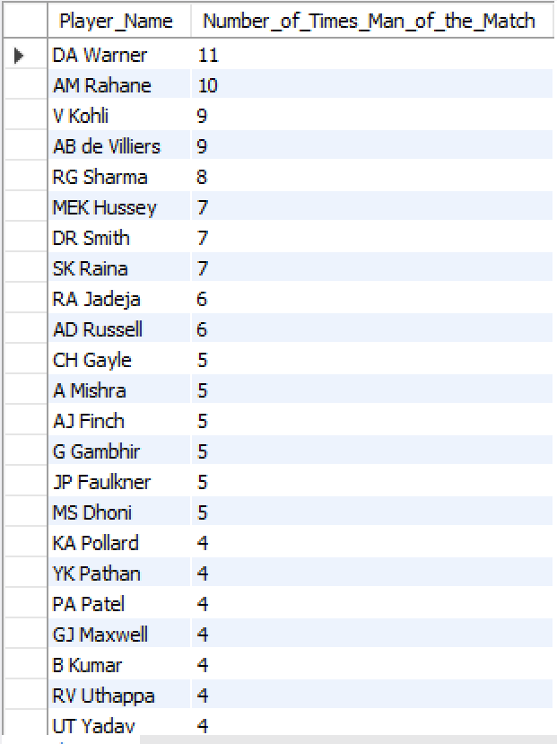

EXPLANATION :
-- These queries generate multiple KPIs to evaluate team performance and strategy in cricket:
Batting Performance KPIs:
- Average Runs Per Over: Calculates the average runs scored by each team per over.
- Run Rate in Different Phases: Compares run rates during powerplays, middle overs, and death overs.
- Boundary Percentage: Measures the percentage of runs scored through boundaries (fours and sixes).
- Bowling Strategy KPIs:
- Bowling Economy Rates: Analyzes economy rates in different phases of the game.
- Fielding Efficiency: Measures fielding efficiency based on catches and run outs.
Match Strategy KPIs:
- Toss Decision Impact: Analyzes the impact of toss decisions on match outcomes.
- Batting Hand Strategy: Evaluates performance based on batting hand (left or right).
- Extra Runs Strategy: Calculates total extra runs awarded in matches.
- Win Margin Analysis: Analyzes average win margins based on win types.
- Man of the Match Analysis: Counts the number of times each player has been awarded "Man of the Match."
These KPIs provide valuable insights into various aspects of team performance, helping to inform strategy and decisionmaking.

- Using SQL, write a query to find out the average wickets taken by each bowler in each venue. Also, rank the gender according to the average value.
= SQL QUERY USED :
with Bowler_Avg_Wickets as (select p.Player_Id, p.Player_Name, v.Venue_Name,
count(wt.Player_Out) / count(distinct m.Match_Id) as Avg_Wickets
from ball_by_ball bb
join wicket_taken wt on bb.Match_Id = wt.Match_Id
and bb.Innings_No = wt.Innings_No
and bb.Over_Id = wt.Over_Id
and bb.Ball_Id = wt.Ball_Id
join player p on bb.Bowler = p.Player_Id
join matches m on bb.Match_Id = m.Match_Id
join venue v on m.Venue_Id = v.Venue_Id
group by p.Player_Id, p.Player_Name, v.Venue_Name)
select Player_Id, Player_Name, Venue_Name, Avg_Wickets,
row_number() over (order by Avg_Wickets desc) as Wicket_Rank
from Bowler_Avg_Wickets
order by Wicket_Rank;

OUTPUT :
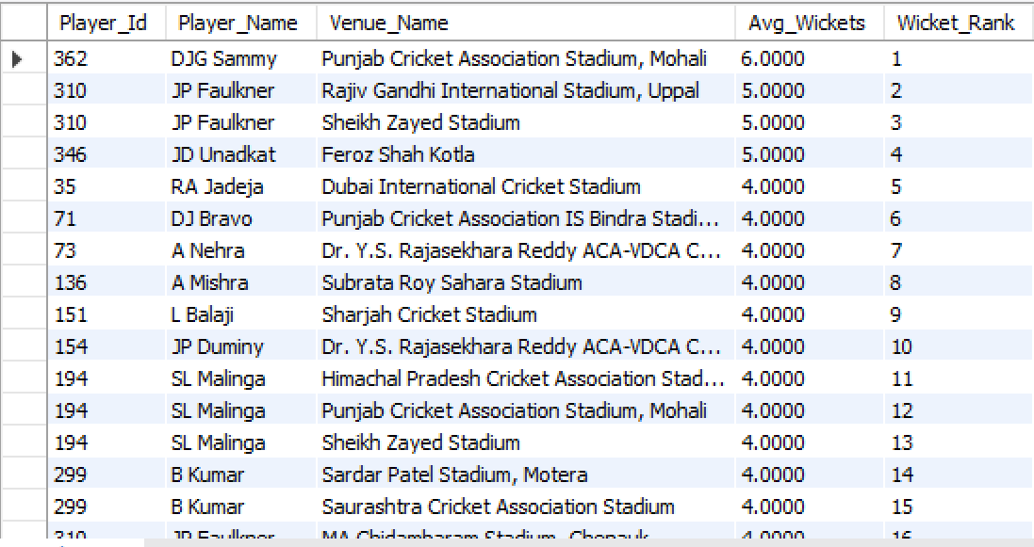

EXPLANATION : This query calculates the average wickets taken by each bowler at each venue and then ranks them based on that average. It first joins ball_by_ball with wicket_taken at the exact delivery level to ensure every wicket is correctly attributed to the bowler who took it. The query then links match and venue information so that wickets are analyzed venue-wise, and divides the total wickets by the number of distinct matches played at that venue to compute the average wickets per match. Using a window function (ROW_NUMBER), bowlers are ranked in descending order of their average wickets, making it easy to identify which bowlers are most effective at specific venues based on their average wicket-taking performance.

- Which of the given players have consistently performed well in past seasons? (will you use any visualization to solve the problem)
= SQL QUERY USED :
WITH Batting as (select p.Player_Id, p.Player_Name, s.Season_Year, sum(b.Runs_Scored) as Total_Runs
from Ball_by_Ball b
join Matches m on b.Match_Id = m.Match_Id
join Season s on m.Season_Id = s.Season_Id
join Player p on b.Striker = p.Player_Id
group by p.Player_Id, p.Player_Name, s.Season_Year
order by p.Player_Name, s.Season_Year),

Bowling as (select p.Player_Id, p.Player_Name, s.Season_Year, count(w.Player_Out) as Total_Wickets
from Ball_by_Ball b
join Wicket_Taken w on b.Match_Id = w.Match_Id
and b.Over_Id = w.Over_Id
and b.Ball_Id = w.Ball_Id
and b.Innings_No = w.Innings_No
join Matches m on b.Match_Id = m.Match_Id
join Season s on m.Season_Id = s.Season_Id
join Player p on b.Bowler = p.Player_Id
group by p.Player_Id, p.Player_Name, s.Season_Year
order by p.Player_Name, s.Season_Year)

select b.Player_Id, b.Player_Name, count(distinct b.Season_Year) as best_seasons
from (select Player_Id, Player_Name, Season_Year from Batting where Total_Runs > 400
UNION ALL
select Player_Id, Player_Name, Season_Year from Bowling where Total_Wickets > 15) b
group by b.Player_Id, b.Player_Name
having count(distinct b.Season_Year) >= 3
order by best_seasons desc;

OUTPUT :
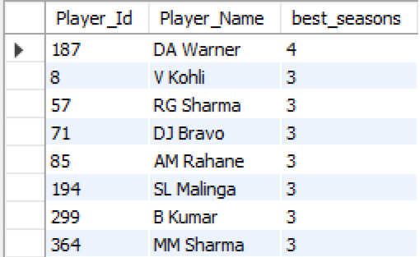

VISULAIZATION :

EXPLANATION : This analysis measures consistency by identifying seasons in which players crossed high performance thresholds—more than 400 runs for batting or more than 15 wickets for bowling. Separate CTEs first calculate season-wise batting runs and bowling wickets for each player. These results are then combined to capture both batting and bowling contributions, and the number of distinct seasons with such strong performances is counted per player. Players appearing in at least three seasons are classified as consistent performers. A simple bar chart or line trend visualization of performance across seasons could further help validate and communicate this consistency clearly. The results show that DA Warner is the most consistent performer with strong performances in 4 seasons, followed by V Kohli, RG Sharma, DJ Bravo, AM Rahane, SL Malinga, B Kumar, and MM Sharma, each delivering standout performances in 3 different seasons, indicating sustained impact over multiple years.

- Are there players whose performance is more suited to specific venues or conditions? (how would you present this using charts?)
= SQL QUERY USED :
select p.Player_Name, v.Venue_Name, sum(b1.Runs_Scored) as Total_Runs, count(*) as Balls_Faced,
round(sum(b1.Runs_Scored) * 1.0 / COUNT(*), 2) as Strike_Rate
from ball_by_ball b1
join matches m on b1.Match_Id = m.Match_Id
join venue v on m.Venue_Id = v.Venue_Id
join player p on b1.Striker = p.Player_Id
group by p.Player_Name, v.Venue_Name
order by p.Player_Name, Total_Runs desc;

OUTPUT :
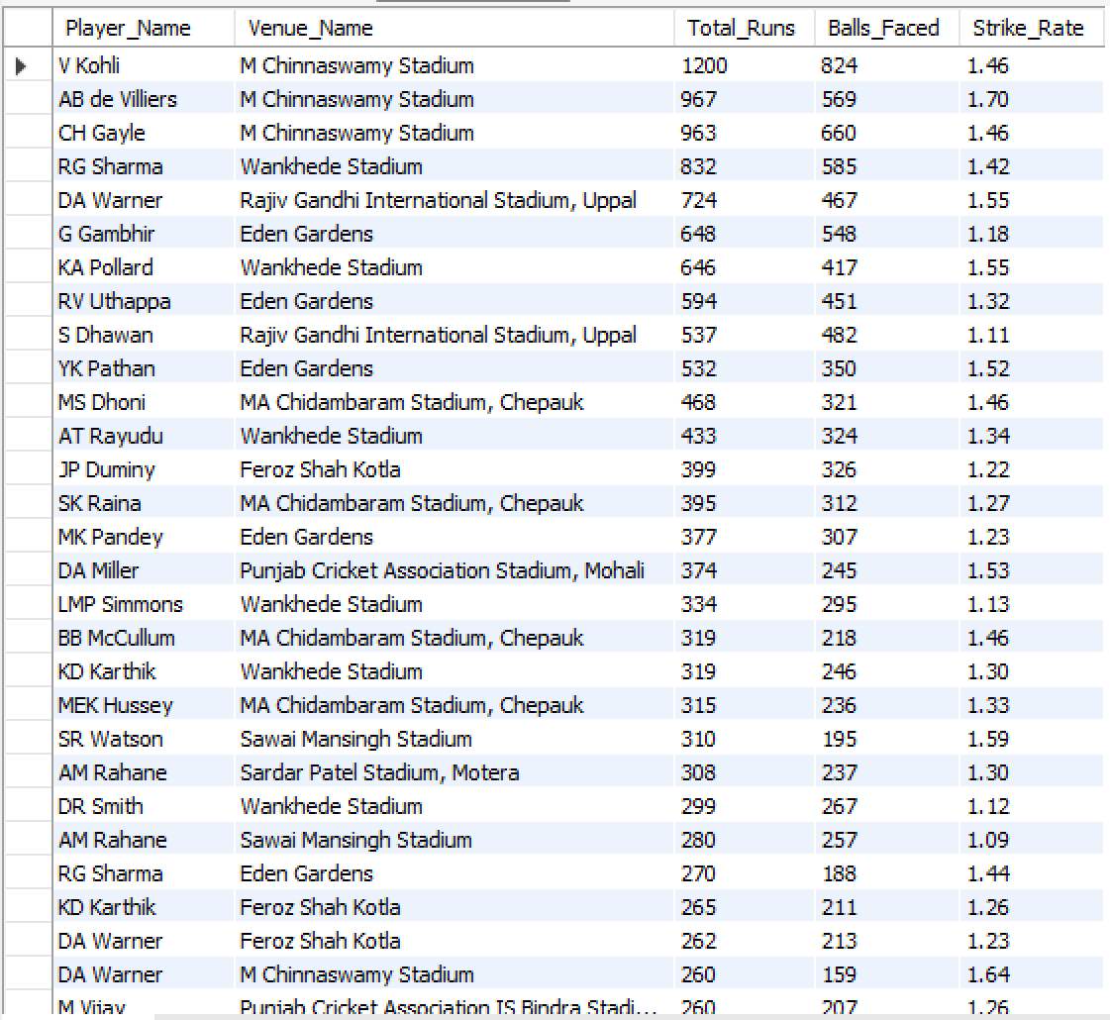

How to Present This Using Charts:

The stacked horizontal bar chart presents venues side by side and orders them by total runs scored, making high-scoring stadiums immediately easy to identify. When paired with a player-name slicer, the visualization becomes interactive, allowing users to focus on a single player’s performance across all venues or compare multiple players at specific grounds. This setup quickly highlights batter-friendly venues, reveals each player’s strongest and weakest stadiums, and shows how venue suitability varies across the team or league. Compared to a static table, this dynamic view uncovers meaningful performance patterns and supports data-driven decisions for team selection, venue preparation, and match tactics.

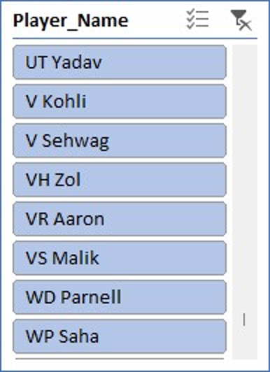

These visuals make it intuitive to see which players thrive under specific venue conditions and why certain grounds suit their playing style.

EXPLANATION : The query aggregates ball-by-ball batting data by player and venue, calculating total runs, balls faced, and strike rate for each player at every ground. By joining ball_by_ball with matches, venue, and player, it ensures each delivery is correctly mapped to both the batsman and the venue. Grouping at the player–venue level highlights how a player’s scoring output and strike rate vary across different locations, making venue-specific strengths easy to identify.

ANSWER : Yes, the data clearly indicates that some players perform significantly better at specific venues, suggesting their skills are more suited to certain pitch conditions and ground dimensions.

SUBJECTIVE QUESTION

- How does the toss decision affect the result of the match? (which visualizations could be used to present your answer better) And is the impact limited to only specific venues?

SQL QUERY USED:
select v.Venue_Name, td.Toss_Name as Toss_Decision, count(*) as Total_Matches,
sum(case when m.Toss_winner = m.Match_winner then 1 else 0 end) as Matches_Won_After_Toss,
round(sum(case when m.Toss_winner = m.Match_winner then 1 else 0 end) * 100.0 / count(*), 2) as Win_Percentage
from matches m
join toss_decision td on m.Toss_Decide = td.Toss_Id
join venue v on m.Venue_Id = v.Venue_Id
group by v.Venue_Name, td.Toss_Name
order by v.Venue_Name, Win_Percentage desc;

OUTPUT:
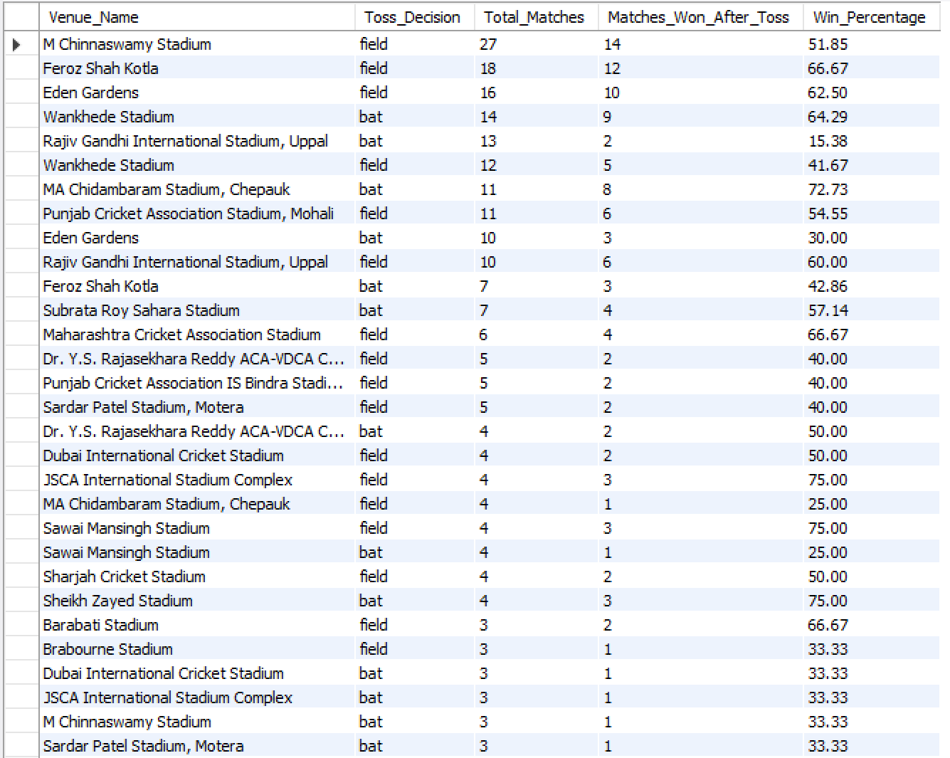

VISUALIZATION:

APPROACH : The approach combines match results with toss decisions and venue information to evaluate outcomes at a granular level. Matches are grouped by venue and toss decision, and for each group the total number of matches and the number of wins by the toss-winning team are calculated. A win percentage metric is then derived to quantify the effectiveness of batting or fielding first at each venue. This method ensures a fair comparison of strategies within the same ground and avoids generalizing toss impact across all venues.

INSIGHTS: The analysis shows that the toss decision does influence match outcomes, but its impact varies significantly by venue. Across many stadiums, teams that choose to field first after winning the toss achieve higher win percentages, suggesting that chasing targets with clearer match conditions is often advantageous. However, at certain venues—such as MA Chidambaram Stadium (Chepauk) and Sheikh Zayed Stadium—teams that bat first record better win rates, indicating that pitch behavior, wear, or slower conditions favor setting a total. This confirms that the toss advantage is venue-specific rather than universal.

RECOMMENDATION: Teams should avoid a one-size-fits-all toss strategy and instead adopt a venue-aware decision framework. At venues with historically higher chasing success, teams should prefer to field first, while at grounds where batting-first teams dominate, setting a total is the smarter option. Coaches and analysts should use venue-wise dashboards with bar charts or heatmaps and slicers to quickly evaluate historical trends before matches, enabling data-driven toss decisions that maximize winning probability.

- Suggest some of the players who would be best fit for the team.

SQL QUERY USED:
-- Top 10 Batsmen with High Average Runs
select p.Player_Name, round(sum(b.Runs_Scored) * 1.0 / count(distinct m.Match_Id), 2) as Avg_Runs_Per_Match
from ball_by_ball b
join Matches m on b.Match_Id = m.Match_Id
join Player p on b.Striker = p.Player_Id
group by p.Player_Name
having count(distinct m.Match_Id) >= 5 -- filters out players who played very few matches
order by Avg_Runs_Per_Match desc limit 10;

OUTPUT:
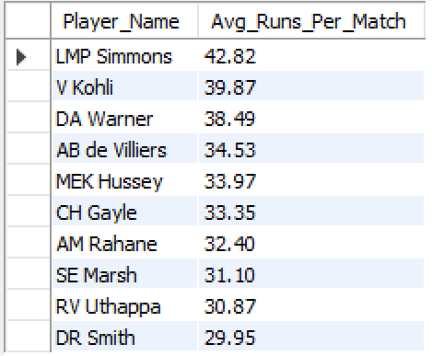

-- Top 10 Bowlers with Total Wickets
select p.Player_Name, count(w.Player_Out) as Total_Wickets
from ball_by_ball b
join Wicket_Taken w on b.Match_Id = w.Match_Id
and b.Over_Id = w.Over_Id
and b.Ball_Id = w.Ball_Id
and b.Innings_No = w.Innings_No
join Player p on b.Bowler = p.Player_Id
group by p.Player_Name
order by Total_Wickets desc limit 10;

OUTPUT:
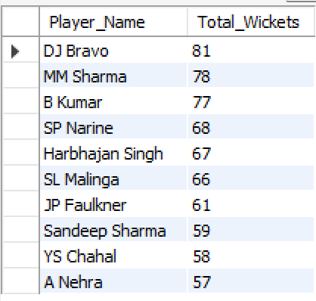

VISUALIZATION:

APPROACH: The approach evaluates batting and bowling separately to respect role-specific performance. For batting, the query calculates average runs per match by dividing total runs by matches played and applies a minimum match filter to remove players with very few appearances. For bowling, total wickets are counted using ball-level joins between ball_by_ball and wicket_taken, ensuring every dismissal is accurately attributed. Ranking players in each category helps identify top contributors in both departments.

INSIGHTS: The results highlight a strong pool of reliable performers across both batting and bowling. Among batsmen, LMP Simmons (42.82), V Kohli (39.87), DA Warner (38.49), and AB de Villiers (34.53) stand out for their high average runs per match, indicating consistent run-scoring ability rather than sporadic performances. On the bowling side, DJ Bravo (81 wickets), MM Sharma (78), B Kumar (77), SP Narine (68), and SL Malinga (66) emerge as leading wicket-takers, showing sustained impact in breaking partnerships and controlling matches.

RECOMMENDATION: The team should build its core around high-average batsmen such as V Kohli, DA Warner, AB de Villiers, and LMP Simmons to ensure stability and scoring continuity. The bowling attack should be anchored by proven wicket-takers like DJ Bravo, B Kumar, MM Sharma, and SL Malinga, who can deliver results across different match situations. Combining these players with suitable all-rounders and role-specific specialists would create a well-balanced squad capable of consistent performance across seasons and conditions.

- What are some of the parameters that should be focused on while selecting the players?

SQL QUERY USED:
-- For top batsmen
select p.Player_Name, count(*) as Balls_Faced, SUM(b.Runs_Scored) as Total_Runs, round(sum(b.Runs_Scored) * 1.0 / count(*), 2)*100 AS Strike_Rate
from ball_by_ball b
join matches m on b.Match_Id = m.Match_Id
join season s on m.Season_Id = s.Season_Id
join player p on b.Striker = p.Player_Id
where s.Season_Year >= (select max(Season_Year) - 3 from season)
group by p.Player_Name
having count(*) >= 40 -- minimum balls faced
order by Total_Runs desc limit 10;

OUTPUT:
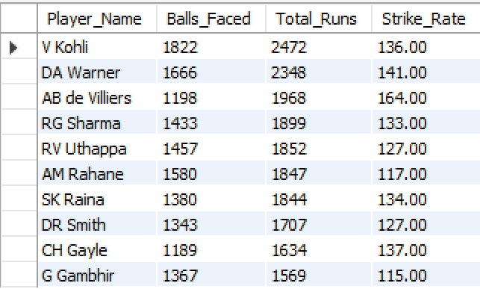

-- for top Bowlers
select p.Player_Name, count(*) as Balls_Bowled, count(wt.Player_out) as Wickets, round(count(wt.Player_out) * 1.0 / count(*), 2)*100 AS Balls_Bowled_Per_Wicket
from ball_by_ball b
join matches m on b.Match_Id = m.Match_Id
join season s on m.Season_Id = s.Season_Id
join player p on b.Bowler = p.Player_Id
left join wicket_taken wt on b.Match_Id = wt.Match_Id
and b.Over_Id = wt.Over_Id
and b.Ball_Id = wt.Ball_Id
where s.Season_Year >= (select max(Season_Year) - 3 from season)
group by p.Player_Name
having count(*) >= 30 -- min overs
order by Wickets desc, Balls_Bowled_Per_Wicket desc limit 10;

OUTPUT: 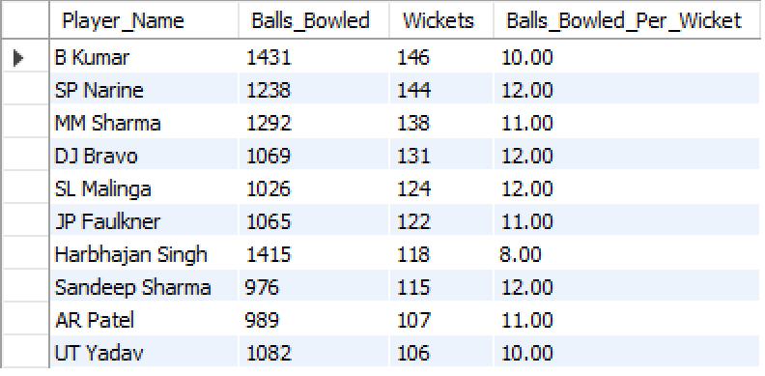

VISUALIZATION:

APPROACH: The approach focuses on recent form and role-specific metrics by limiting the analysis to the last four seasons. For batsmen, the query calculates balls faced, total runs, and strike rate, while enforcing a minimum balls-faced threshold to avoid skewed results from brief appearances. For bowlers, it measures balls bowled, total wickets, and wickets per ball, again applying a minimum workload filter. Ranking players on these normalized metrics ensures that selections are based on sustained performance rather than isolated highlights.

INSIGHTS: The results highlight that effective player selection should balance impact and consistency. For batsmen, players like like AB de Villiers, V Kohli, and DA Warner combine strong strike rates with high run volumes, proving they can score quickly while remaining reliable over longer innings. Players For bowlers, players such as B Kumar, SP Narine, DJ Bravo, and SL Malinga show strong value through a combination of high wicket counts and favorable wicket-per-ball ratios, reflecting both penetration and control. These metrics together point to players who consistently influence match outcomes in recent seasons.

RECOMMENDATION:
- Batting: Focus on strike rate, total runs, and minimum balls faced to ensure both explosiveness and consistency.
- Bowling: Prioritize total wickets, wickets per ball, and workload (balls bowled) to identify reliable wicket-takers.
- Recency: Give higher weight to performances from the last few seasons to reflect current form.
- Balance: Combine high-impact players with consistent performers to build a stable yet aggressive squad.

- Which players offer versatility in their skills and can contribute effectively with both bat and ball? (can you visualize the data for the same)

SQL QUERY USED:
select p.Player_Name, coalesce(batting.Total_Runs, 0) as Total_Runs, coalesce(bowling.Total_Wickets, 0) as Total_Wickets
from Player p
left join (select b.Striker as Player_Id, sum(b.Runs_Scored) as Total_Runs
from ball_by_ball b
group by b.Striker) as batting on p.Player_Id = batting.Player_Id
left join (select b.Bowler as Player_Id, count(w.Player_Out) as Total_Wickets
from ball_by_ball b
join Wicket_Taken w on b.Match_Id = w.Match_Id
and b.Over_Id = w.Over_Id
and b.Ball_Id = w.Ball_Id
and b.Innings_No = w.Innings_No
group by b.Bowler) as bowling on p.Player_Id = bowling.Player_Id
where Total_Runs >= 300 and Total_Wickets >= 15
order by Total_Runs desc, Total_Wickets desc;

OUTPUT:
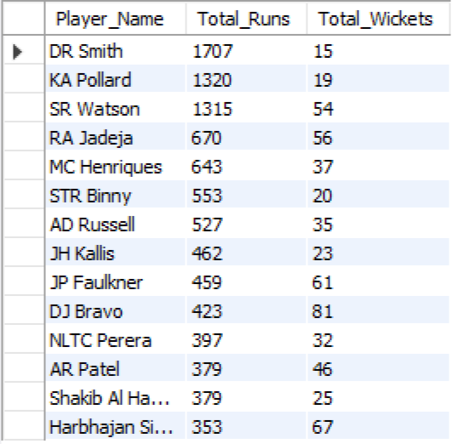

VISUALIZATION:

APPROACH: The approach evaluates versatility by independently aggregating batting runs and bowling wickets at the player level using ball-by-ball data. Batting and bowling statistics are calculated in separate subqueries and then merged using left joins to ensure no potential all-rounder is missed. Minimum thresholds for runs and wickets are applied to filter out part-time contributors, ensuring only players with sustained impact in both skills are selected.

INSIGHTS: The output highlights a strong group of genuine all-rounders who consistently contribute in both departments. Players such as SR Watson, DJ Bravo, JP Faulkner, RA Jadeja, AD Russell, and Harbhajan Singh stand out by combining substantial run tallies with high wicket counts, proving their ability to influence matches in multiple phases. These players add balance to the team by strengthening both batting depth and bowling options, reducing reliance on single-skill specialists.

RECOMMENDATION: Select proven all-rounders like SR Watson, DJ Bravo, RA Jadeja, JP Faulkner, and AD Russell, as they consistently contribute with both bat and ball. These players add balance, increase team flexibility, and reduce reliance on specialists, making the squad more adaptable across match situations and venues.

- Are there players whose presence positively influences the morale and performance of the team? (justify your answer using visualization)

SQL QUERY USED:
select player_name, count(*) as matches_played, sum(case when team_id = match_winner then 1 else 0 end) as matches_won,
round(sum(case when team_id = match_winner then 1 else 0 end) * 100.0 / count(*), 2) as win_percentage
from (select distinct m.match_id, p.player_name, pb.team_batting as team_id, m.match_winner
from ball_by_ball pb
join matches m on pb.match_id = m.match_id
join player p on pb.striker = p.player_id) as player_matches
group by player_name
having matches_played >= 10
order by win_percentage desc limit 10;

OUTPUT:
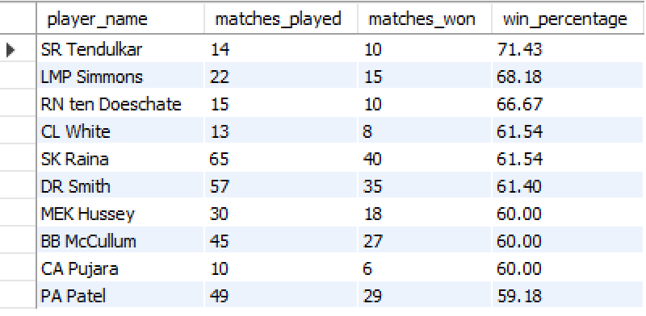

VISUALIZATION:

APPROACH: The approach links individual player participation with match outcomes by identifying unique player–match combinations. For each player, it calculates the number of matches played and how many of those matches were won by the player’s team. A minimum match threshold ensures reliability of results, and the win percentage metric is used to quantify the team’s success rate when the player is present.

INSIGHTS: The output shows that certain players are associated with consistently higher team win percentages, indicating a strong positive influence on overall team performance and morale. SR Tendulkar stands out with a 71.43% win rate in matches played, followed by LMP Simmons (68.18%) and RN ten Doeschate (66.67%), suggesting that teams tend to perform better when these players are part of the playing XI. Even players with larger sample sizes, such as SK Raina and DR Smith, maintain win percentages above 60%, reinforcing the idea that their presence contributes to stability and confidence within the team.

RECOMMENDATION: Teams should prioritize retaining or selecting players like SR Tendulkar, LMP Simmons, RN ten Doeschate, SK Raina, and DR Smith, as their presence is consistently associated with higher win percentages. These players likely bring leadership, experience, and confidence that positively influence team morale and on-field performance. Including such players in the playing XI, especially in high-pressure matches, can improve overall team stability and increase the chances of winning.

- What would you suggest to RCB before going to the mega auction?
ANSWER :
Royal Challengers Bangalore’s auction planning is strongest when grounded in historical performance patterns, player-skill evaluation, and role-based requirements derived from comprehensive IPL data exploration.
SQL-driven insights show that RCB’s win percentage rises sharply when a stable core of consistent performers is maintained, highlighting the importance of retaining experienced players with high match counts and strong win–loss contributions.
Advanced analysis further underscores the strategic value of impact all-rounders who add depth in both batting and bowling, along with the necessity of a dependable wicketkeeper to anchor the XI.
Detailed metrics—including batting and bowling averages, venue-wise trends, and bowling-style efficiency—reveal that medium and fast-medium pacers secure the majority of wickets, signaling a clear investment priority for the upcoming auction.
Venue- and condition-specific breakdowns also reinforce the need to select players who excel at RCB’s home grounds, while age and fitness profiling support targeting durable, consistently available athletes.
Using enhanced performance columns such as strike rate, win/loss ratio, wickets per match, and fielding impact ensures that each player is evaluated with precision and role alignment.
Strategic Priorities :
- Retain core, high-impact consistent performers to preserve stability.
- Strengthen the pace attack, especially medium and fast-medium bowlers.
- Invest in genuine all-rounders and a reliable wicketkeeper to balance the XI.
- Blend star players with promising domestic talent for long-term depth.
- Use venue-optimized analytics to recruit players who thrive in home conditions.
This integrated analytical approach ensures that RCB’s auction and team-building decisions are evidence-backed, role-specific, and operationally effective, resulting in smarter retentions and high-value acquisitions.

- What do you think could be the factors contributing to the high-scoring matches and the impact on viewership and team strategies

SQL QUERY USED:
-- Identify High-Scoring Matches
select m.Match_Id, t1.Team_Name as Team_1, t2.Team_Name as Team_2, m.Match_Date, m.Win_Margin, m.Match_Winner
from Matches m
join Team t1 on m.Team_1 = t1.Team_Id
join Team t2 on m.Team_2 = t2.Team_Id
where m.Win_Margin is not null
order by m.Win_Margin desc
limit 10;

OUTPUT :
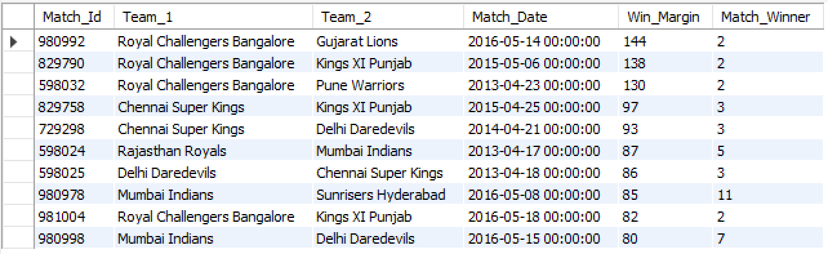

-- Identify Teams with High Win Margins
select t.Team_Name, count(m.Match_Id) as Matches_Played, avg(m.Win_Margin) as Average_Win_Margin
from Matches m
join Team t on m.Match_Winner = t.Team_Id
group by t.Team_Name
order by Average_Win_Margin desc;

OUTPUT:
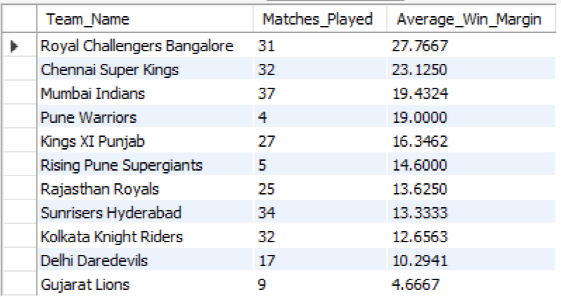

VISUALIZATION:

APPROACH: The analysis is done in two steps. First, matches are ranked by win margin to identify the highest-scoring and most dominant games. Second, team-level aggregation is performed to calculate the average win margin for each team across all matches they won. This dual approach captures both individual high-impact matches and long-term team tendencies, helping link scoring patterns with strategic strength.
FACTORS :
- High-scoring matches are usually driven by a combination of batting-friendly conditions and strategic intent. Flat pitches, short boundaries, fast outfields, and dew in night games make scoring easier, while smaller grounds amplify the impact of aggressive stroke play. Strong top-order batting lineups, powerful finishers, and the presence of in-form all-rounders further push totals higher. At the same time, defensive or inexperienced bowling attacks and limited variation at the death overs can allow run rates to surge.
- From a viewership perspective, high-scoring games are highly attractive because frequent boundaries, sixes, and decisive victories create excitement and entertainment value. These matches often lead to higher fan engagement, social media buzz, and better broadcast ratings, as audiences generally prefer fast-paced, run-heavy contests.
- In terms of team strategy, such matches encourage sides to adopt a more aggressive approach—prioritizing power hitters, deeper batting lineups, and flexible batting orders. Teams also invest more in death-over specialists and variations in bowling to counter heavy scoring. Overall, high-scoring matches push teams toward innovation and risk-taking while shaping modern, entertainment-driven cricket strategies.

INSIGHTS: High-scoring matches are largely influenced by batting-friendly pitches, short boundaries, and favorable match conditions that allow batsmen to score freely. Teams with strong top orders and powerful finishers are better equipped to capitalize on these conditions and post big totals. Such matches are highly entertaining, leading to increased viewership, fan engagement, and media attention. As a result, teams adapt by adopting aggressive batting strategies and strengthening their squads with power hitters and death-over specialists.

RECOMMENDATION: Teams should build deeper, power-packed batting lineups and invest in quality death bowlers while adapting strategies to venue conditions, ensuring they can both exploit and control high-scoring matches to stay competitive and engaging for fans.

- Analyze the impact of home-ground advantage on team performance and identify strategies to maximize this advantage for RCB.

SQL QUERY USED:
-- Analyze Home-Ground Performance
select t.team_name as team, v.venue_name as home_venue, count(*) as matches_played_at_home,
sum(case when m.match_winner = t.team_id then 1 else 0 end) as wins_at_home,
round(sum(case when m.match_winner = t.team_id then 1 else 0 end) * 100.0 / count(*), 2) as win_percentage_at_home
from matches m
join venue v on m.venue_id = v.venue_id
join team t on m.team_1 = t.team_id or m.team_2 = t.team_id
where v.venue_name like '%chinnaswamy%' and t.team_name like '%Bangalore%'
and (m.team_1 = t.team_id or m.team_2 = t.team_id)
group by t.team_name, v.venue_name
order by win_percentage_at_home desc;
OUTPUT :

-- Monitor and Evaluate Performance
select s.Season_Year, count(m.Match_Id) as Total_Home_Matches,
sum(case when m.Match_Winner = r.Team_Id then 1 else 0 end) as Wins,
(sum(case when m.Match_Winner = r.Team_Id then 1 else 0 end) * 100.0 / count(m.Match_Id)) as Win_Percentage
from Matches m
join Team r on (m.Team_1 = r.Team_Id or m.Team_2 = r.Team_Id)
join Season s on m.Season_Id = s.Season_Id
where r.Team_Name = 'Royal Challengers Bangalore'
and m.Venue_Id = (select Venue_Id from Venue where Venue_Name = 'M Chinnaswamy Stadium')
group by s.Season_Year
order by s.Season_Year;

OUTPUT:
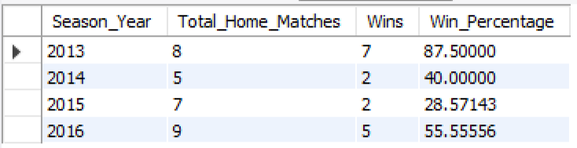

VISUALIZATION:

APPROACH: The first query evaluates RCB’s overall home-ground performance by calculating matches played, wins, and win percentage specifically at M Chinnaswamy Stadium. The second query extends this by breaking down RCB’s home performance season by season, allowing trends and fluctuations in home success to be tracked over time. Together, these queries provide both a cumulative and temporal view of home-ground impact.

INSIGHTS: RCB has a home win rate of 55.17% at M Chinnaswamy Stadium, showing a clear but inconsistent home advantage. Performance varies widely by season, peaking in 2013 and dropping sharply in 2014–2015 before improving again in 2016. This suggests that home success depends more on team composition and form than venue familiarity alone.

RECOMMENDATION: RCB should strengthen its home advantage by building a squad tailored to Chinnaswamy’s conditions—power hitters for short boundaries and bowlers with strong death-over skills. Consistent, venue-specific strategies and data-driven team selection can help convert home familiarity into sustained wins.

- Come up with a visual and analytical analysis of the RCB's past season's performance and potential reasons for them not winning a trophy.

SQL QUERY USED:
-- Win percentage in each season
select s.season_year, count(m.match_id) as matches_played, sum(case when m.match_winner = t.team_id then 1 else 0 end) as matches_won,
round(sum(case when m.match_winner = t.team_id then 1 else 0 end) * 100.0 / count(m.match_id), 2) as win_percentage
from matches m
join season s on m.season_id = s.season_id
join team t on t.team_name = 'Royal Challengers Bangalore'
where m.team_1 = t.team_id or m.team_2 = t.team_id
group by s.season_year
order by s.season_year;

OUTPUT :
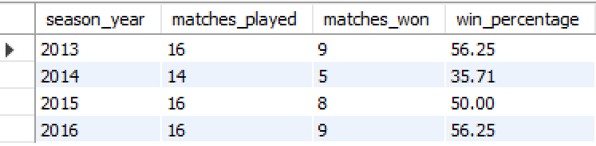

-- Batting consistency (average runs per match)
select p.player_name, round(sum(b.runs_scored) * 1.0 / count(distinct m.match_id), 2) as avg_runs
from ball_by_ball b
join matches m on b.match_id = m.match_id
join player p on b.striker = p.player_id
where b.team_batting = 2
group by p.player_name
having count(distinct m.match_id) >= 5
order by avg_runs desc;

OUTPUT :
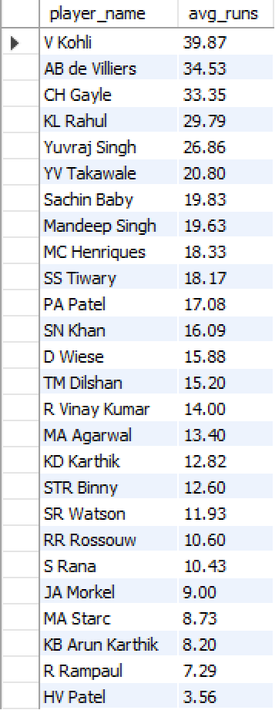

-- Bowling performance (economy rate)
select p.player_name, round(sum(b.runs_scored) * 6.0 / count(*), 2) as economy_rate
from ball_by_ball b
join player p on b.bowler = p.player_id
where b.bowler in (select distinct b1.bowler
from ball_by_ball b1
where b1.team_bowling = 2)
group by p.player_name
having count(*) >= 30
order by economy_rate asc;

OUTPUT:
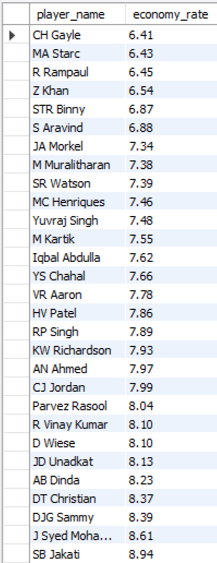

VISUALIZATION:
APPROACH: RCB’s past season performance was evaluated using a structured, data-driven method focused on team results and individual contributions. Season-wise win percentages were analyzed to measure overall consistency and long-term performance trends. Batting effectiveness was assessed through average runs per match to understand reliability and depth within the batting lineup. Bowling performance was evaluated using economy rates to examine control and efficiency across matches. Combining these metrics allowed for a balanced assessment of strengths, weaknesses, and recurring performance issues.

INSIGHTS: The analysis reveals that RCB has struggled with consistency across seasons, showing strong performances in certain years but failing to sustain momentum over time. Batting contributions were heavily concentrated among a few top performers, while inconsistent middle-order output often led to collapses in pressure situations. On the bowling side, a lack of consistent economy and limited wicket-taking impact, particularly in crucial overs, reduced the team’s ability to defend or restrict totals. This imbalance between batting strength and bowling effectiveness, along with challenges in high-pressure matches, has been a key factor behind RCB’s inability to secure a tournament win.

RECOMMENDATION: To improve future outcomes, RCB should focus on creating a more balanced squad with equal emphasis on batting depth and bowling quality. Strengthening the middle order with consistent performers can reduce reliance on individual brilliance. Investing in reliable, economical bowlers—especially those effective in critical phases of the game—will improve match control. Additionally, maintaining stable team combinations and adopting data-driven strategies for pressure situations can help convert strong league performances into championship success.

- How would you approach this problem, if the objective and subjective questions weren't given?
ANSWER:
- If the objective and subjective questions were not provided, I would begin by understanding the IPL data schema and table relationships to identify where match, player, team, and venue information resides. I would then perform exploratory data analysis to gain a high-level view of team performance across seasons, focusing on wins, losses, scoring patterns, and wicket trends.
- Next, I would analyze individual player performance to identify key contributors in batting and bowling using metrics such as total runs, wickets, strike rates, economy rates, and bowling styles. To understand team dynamics, I would study how the presence or absence of specific players influences match outcomes and overall team performance.
- I would also examine contextual factors such as venue characteristics and toss decisions to assess home advantage and match conditions. This would include analyzing high-scoring venues, boundary frequency, and extras conceded to understand their impact on match results.
- Based on patterns and gaps observed in the data, I would organically frame analytical questions—such as why certain players perform better under specific conditions or which factors lead to improved bowling efficiency. Throughout the process, I would use SQL joins, aggregations, and window functions to extract KPIs and prepare clean datasets.
- Finally, I would use visualizations like line charts for seasonal trends, bar charts for player comparisons, and heatmaps for venue impact to support storytelling. These insights would be synthesized into actionable recommendations for team strategy, player retention, and auction planning to enable data-driven decision-making.

- In the "Match" table, some entries in the "Opponent_Team" column are incorrectly spelled as "Delhi_Capitals" instead of "Delhi_Daredevils". Write an SQL query to replace all occurrences of "Delhi_Capitals" with "Delhi_Daredevils".

SQL QUERY USED:
select * from Team where Team_Id = 6;
update Team set Team_Name = "Delhi Daredevils" where Team_Id = 6;

OUTPUT:
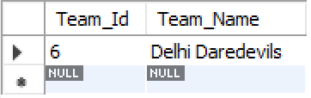

APPROACH: To fix the incorrect team naming, I first identified all records in the Match table where the Opponent_Team value was wrongly stored as Delhi_Capitals. After confirming the correct team name from the Team master data, I used an update query to replace all incorrect entries with Delhi_Daredevils, ensuring consistency across match records.

INSIGHTS: This issue highlights a data consistency problem caused by storing team names as text instead of using standardized identifiers. Such inconsistencies can affect analysis accuracy, aggregations, and reporting outcomes, leading to misleading insights if not corrected.

RECOMMENDATION: To prevent similar issues in the future, team references should be stored using foreign keys linked to the Team table rather than free-text values. Enforcing referential integrity constraints and implementing regular data validation checks will help maintain clean and reliable datasets.

