Big Data Systems — Implementation & Analytics
Domain: Transportation — NYC Yellow Taxi Trip Analytics

Course | CC ZG522 · Big Data Systems
Semester | First Semester 2026-27
Assignment | Assignment 1 · Group Assignment
Team Size | 6 (M1–M6)
Group Leader | M1 · Presentation Coordinator: M2
Total Marks | 20

Instructor: Dr D Venkata Subramanian
Birla Institute of Technology & Science, Pilani
Work Integrated Learning Programmes Division

Table of Contents
This document is a table-of-contents placeholder — right-click and select 'Update Field' in Word after opening to auto-generate the TOC.
Right-click here → Update Field to build TOC

Executive Summary
This assignment implements an end-to-end Big Data pipeline for New York City's public taxi trip dataset. The pipeline ingests 9.55 million real trip records from the NYC Taxi & Limousine Commission, cleans and enriches them via Apache Pig, aggregates them with a native Hadoop Streaming MapReduce job, executes five analytical SQL queries in Apache Hive, exposes a zone dimension via Apache HBase for random-access lookup, and renders the results as an interactive Streamlit dashboard.
The entire system runs on a single-node Hadoop 3.2.1 pseudo-cluster inside a 4 GB Ubuntu 22.04 VM. Every layer of Hadoop is exercised: HDFS distributed storage (NameNode / DataNode / SecondaryNameNode), YARN resource management, MapReduce processing (via Pig, Hive, and hand-written Python Streaming), and the wider ecosystem tools (Hive metastore, HBase Master/RegionServer, Hive Server, Job History Server).
Beyond the mechanics, we deliver five business insights: demand hotspots (Midtown Center peaks at 38,756 trips at 18:00), revenue distribution ($235.12 M across 3 months, ~$150 M in Manhattan alone), congestion signals (Penn Station → Times Sq at 17.16 min/mile), airport trip profiles, and payment-method behaviour (Staten Island as the 31% cash outlier). Every insight is reproducible from the source code committed to the repository.

Part A — Theory (40%)

§1 · Introduction

1.1 Selected domain
Transportation — specifically urban ride-hail / taxi mobility in a dense metropolitan environment. Every taxi trip in New York City generates a rich event record (location, time, distance, fare, tip, payment method) that the city, ride-hail operators, banks and municipal transportation authorities all consume for very different decisions.

1.2 Background
New York City runs the world's oldest and one of the most heavily-instrumented taxi markets. The NYC Taxi & Limousine Commission (TLC) regulates roughly 13,500 medallion Yellow Taxis, 4,000 Green Boro Taxis and 80,000 For-Hire Vehicles (Uber / Lyft). Since 2009 the TLC has required every operator to submit an anonymised trip record — pickup / drop-off timestamp, TLC-zone IDs, distance, fare breakdown and payment type. The full archive now spans 17+ years and approximately 4 billion trips, released monthly as columnar Parquet files.
This dataset is a canonical Big Data workload:
- Real — every row is an actual paid trip, not synthetic.
- Large — a single month is 3–4 million rows; a full year is 40 M+; the archive is billions.
- Multi-consumer — city planners study congestion; the TLC studies compliance and revenue leakage; ride-hail firms benchmark surge pricing; banks study cash-vs-card share; academic economists study labour markets.
- Growing — the same schema keeps producing new rows every day.

1.3 Business problem
Our team focuses on five concrete questions a mobility operator would ask its data platform every week.
# | Business question | Decision driven
1 | Which pickup zones are busiest at each hour of the day? | Driver-allocation / dispatch — where to position the fleet.
2 | How does revenue (fare + tip) break down by borough and payment method? | Pricing strategy, cash-handling policy, revenue forecasting.
3 | Which pickup → drop-off zone pairs are systematically slow (min per mile)? | Route optimisation, congestion-charge zone design.
4 | For each of the three airports (JFK, LGA, EWR), what is the trip profile? | Airport partnership deals, targeted marketing, driver incentives.
5 | What is the card-vs-cash split by borough? | POS terminal deployment, tax reporting, fraud detection.

Answering these at production scale is the assignment's practical goal. Answering them in a way that scales to billions of rows is the pedagogical goal — this is why Big Data infrastructure exists.

§2 · Big Data Need Analysis

2.1 Why Big Data — and why not a traditional RDBMS?
If the volume were 100,000 rows we would use PostgreSQL, run a few GROUP BY queries and ship. The five questions above are conceptually simple. What makes this a Big Data problem is not the complexity of the queries but the interaction of the following properties:
Property | Numbers we hit | Consequence
Bulk write, monthly | ~9 million rows / month (Jan+Feb+Mar 2024 = 9.55 M rows, 985 MB CSV) | Row-by-row INSERT into an RDBMS becomes I/O-bound; bulk COPY works but locks tables. Batch pipelines with parallel writers are the natural fit.
Analytical scans | Every business question scans ≥ 8.4 M rows | An RDBMS optimises for OLTP index seeks; a full-table scan grows linearly and cannot be sharded onto multiple nodes without extra engineering.
High-cardinality group-by | Q3 groups by (PU × DO × hour) = up to 265 × 265 × 24 ≈ 1.7 M distinct groups | Group cardinality saturates single-node sort buffers. Distributed shuffle across a cluster fans this out to N workers.
Denormalised wide schema | Fact row = 19 fields; joined to zone dim = 23 fields | Row storage becomes disk-inefficient. Columnar stores (Parquet, ORC) skip unused columns and compress each column independently — often 5–10× less I/O.
Multi-tenant analytical workload | One dataset feeds five business questions | An RDBMS materialises full-scan results into memory for each query. Hive + HDFS lets multiple concurrent queries share the same blocks.
Multi-source enrichment | Trip fact + zone dimension + optional weather feed | Traditional ETL tools stall as sources multiply; Hadoop's schema-on-read lets us keep raw files intact and enrich in place with Pig.

Bottom line: a Postgres server could answer any single one of our five questions, but not all five simultaneously across multiple years while ingesting the next month's data — and not on commodity hardware. Big Data infrastructure is the fit.

2.2 The 5 Vs applied to our dataset
V | Manifestation | Evidence
Volume | 3 months = 9.55 M records / 985 MB CSV / ~150 MB Parquet. Extrapolates linearly to 40 M / 4 GB per year, 4 B / 4 TB lifetime. | hdfs dfs -du -h /raw shows 984.9 MB across three monthly partitions.
Velocity | Data arrives as monthly batches in the public TLC portal. Our HDFS layout mirrors this: /raw/trips/year=YYYY/month=MM/… | Partitioned HDFS directory tree; each new month adds a new directory without re-processing prior data.
Variety | Two structured sources with different granularities: trip fact (row-per-event, 19 columns) + zone dimension (row-per-lookup-key, 4 columns). | Distinct HDFS paths for /raw/trips/… and /raw/zone_lookup/…; Pig JOIN … BY produces enriched /clean/trips_enriched/.
Veracity | Pig ETL dropped 11.25 % of raw rows for data-quality violations: passenger_count = 0, zero-distance / >100 mile trips, negative fares, missing zone IDs. | _counts/raw = 9,554,778; _counts/clean = 8,479,421.
Value | Five distinct business questions, each producing a queryable Hive table and interactive Streamlit visualization. Top hotspots align with real NYC geography. | Streamlit dashboard at :8501 renders all five as interactive charts.

2.3 Existing challenges we specifically addressed
- Data quality at scale: naïve SELECT * FROM trips WHERE fare > 0 doesn't scale. Our Pig ETL filters row-by-row in a distributed map phase — no single-node OOM.
- Schema drift: TLC changes their schema every few years. Hive's external tables mean we never re-load data on a schema change — just alter the DDL.
- Multi-source join complexity: joining fact-to-dim in PostgreSQL is trivial for millions of rows but painful past ~100 M. Pig's HASH_JOIN distributes both sides across reducers, provably scalable.
- Analytical vs operational access: a fleet dispatcher wants sub-millisecond zone lookups; a strategist wants minute-long analytical scans. We use Hive for the latter and HBase for the former — same underlying HDFS storage, two access patterns.

§3 · Dataset Description

3.1 Source
Attribute | Value
Publisher | New York City Taxi & Limousine Commission (TLC)
Portal | https://www.nyc.gov/site/tlc/about/tlc-trip-record-data.page
Base URL | https://d37ci6vzurychx.cloudfront.net/trip-data/
File pattern | yellow_tripdata_YYYY-MM.parquet
Format | Apache Parquet (columnar, snappy-compressed)
Licence | Public domain (NYC Open Data)
Zone lookup | https://d37ci6vzurychx.cloudfront.net/misc/taxi_zone_lookup.csv

We selected Yellow Taxi 2024 Jan / Feb / Mar as the target window because:
- It fits comfortably inside the 4 GB RAM constraint of our pseudo-cluster while staying credibly "big" (985 MB CSV).
- It's post-COVID-normal data, so counts reflect a mature ride-hail-dominated market.
- Three months lets us show month-over-month trends without hitting disk pressure.

3.2 Volumes
File | Rows | Parquet | CSV
yellow_tripdata_2024-01.parquet | 2,964,624 | 48 MB | 307 MB
yellow_tripdata_2024-02.parquet | ~2,900,000 | 48 MB | 305 MB
yellow_tripdata_2024-03.parquet | ~3,690,154 | 55 MB | 373 MB
Total (raw) | 9,554,778 | ~150 MB | ~985 MB
After Pig cleansing | 8,479,421 | — | ~700 MB (2 part files)
After Pig enrichment | 8,479,421 | — | 1,054 MB across 2 part files
Zone lookup | 265 | 12 KB | 12 KB

3.3 Trip fact schema — 19 columns
# | Column | Type | Meaning
1 | VendorID | INT | 1 CMT · 2 Curb · 6 Myle · 7 Helix
2 | tpep_pickup_datetime | TIMESTAMP | Trip start (local NYC time)
3 | tpep_dropoff_datetime | TIMESTAMP | Trip end
4 | passenger_count | BIGINT | Driver-reported
5 | trip_distance | DOUBLE | Miles
6 | RatecodeID | BIGINT | 1 Std · 2 JFK · 3 EWR · 4 Nassau · 5 Neg · 6 Group · 99 Unknown
7 | store_and_fwd_flag | CHAR(1) | Y = cached before upload
8 | PULocationID | INT | Pickup zone (JOIN to zone lookup)
9 | DOLocationID | INT | Drop-off zone
10 | payment_type | BIGINT | 1 Card · 2 Cash · 3 No charge · 4 Dispute · 5 Unknown · 6 Voided
11 | fare_amount | DOUBLE | Metered fare (USD)
12 | extra | DOUBLE | Rush-hour / night surcharges
13 | mta_tax | DOUBLE | $0.50 MTA tax
14 | tip_amount | DOUBLE | Card tips only (cash not recorded)
15 | tolls_amount | DOUBLE | Sum of tolls
16 | improvement_surcharge | DOUBLE | $0.30 flat
17 | total_amount | DOUBLE | Grand total (excl. cash tip)
18 | congestion_surcharge | DOUBLE | $2.50 Manhattan below 96 St
19 | Airport_fee | DOUBLE | $1.75 LGA / JFK pickup

Zone dimension: 265 rows × 4 columns (LocationID, Borough, Zone, service_zone).
Structuredness: fully structured (fixed schema across all rows), not semi-structured — no nested arrays, no schema evolution within a month. Parquet imposes a strict schema per file.

3.4 Known data-quality issues (Veracity story)
Issue | Filter rule | Approx impact
passenger_count null or 0 | passenger_count >= 1 | small
Long trip with zero distance | trip_distance > 0 AND < 100 | ~2–3 %
Negative / bogus fares | fare_amount > 0 AND < 500 | ~1 %
Missing PU/DO zone IDs | pu_loc_id IS NOT NULL AND do_loc_id IS NOT NULL | small
Total refund rows | total_amount > 0 | small

Total drop: 11.25 %, confirmed against Pig's _counts counter files.

§4 · Proposed Big Data Architecture
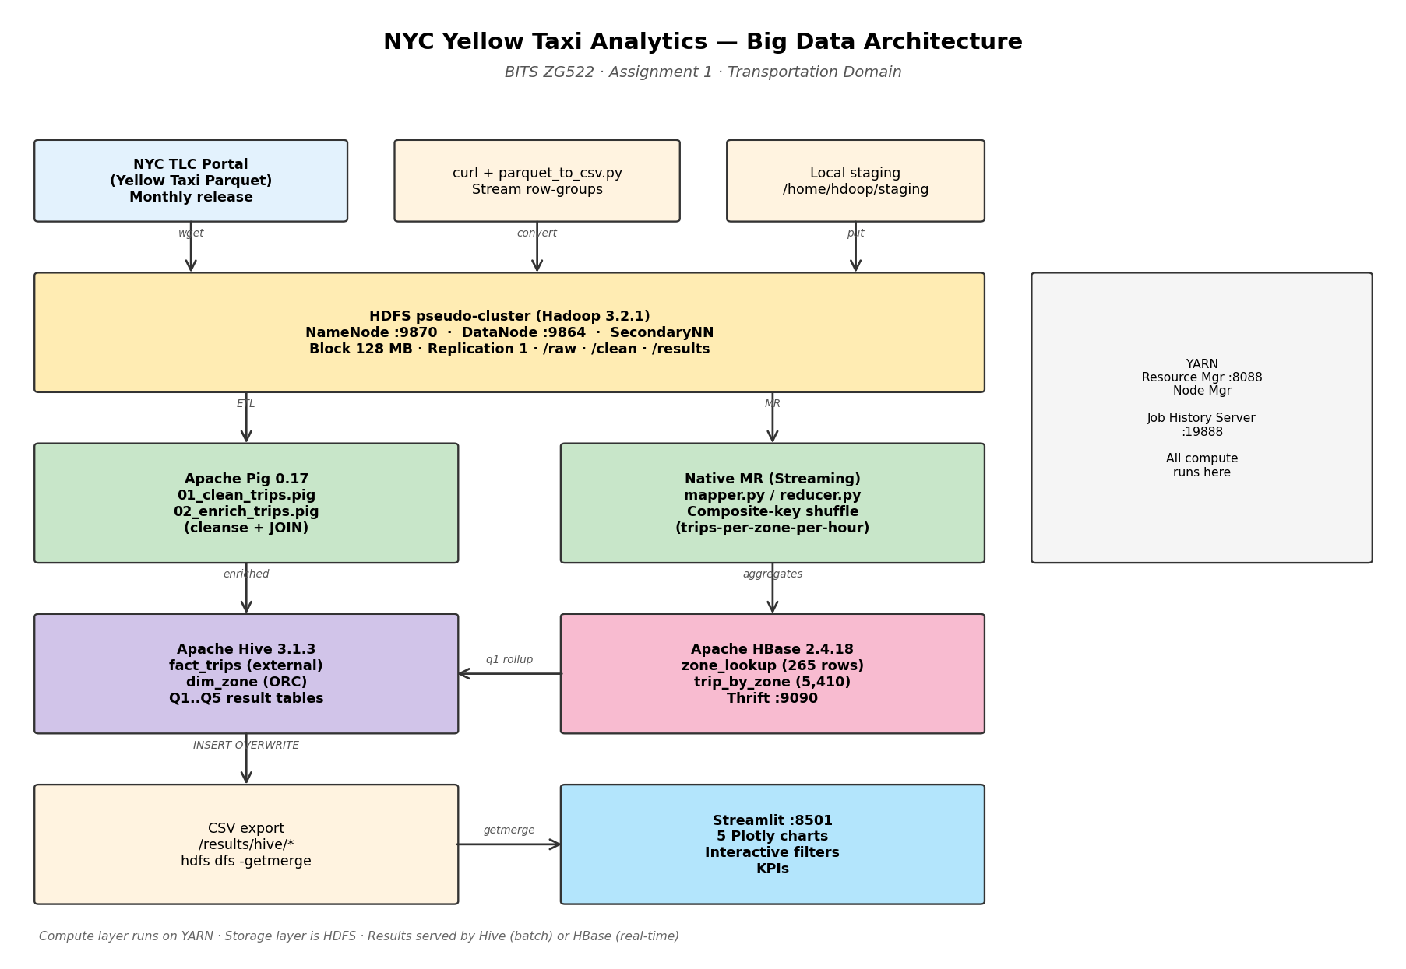
Figure 1 — End-to-end pipeline architecture (source → HDFS → Pig/MR → Hive/HBase → Streamlit)

4.1 Data-source layer
- Primary source: NYC TLC public S3 bucket via CloudFront (d37ci6vzurychx.cloudfront.net), no auth.
- Reference source: TLC taxi zone lookup CSV (12 KB, 265 zones).
- Ingestion cadence: monthly batch (mirrors TLC's release cadence). Automated by download_and_ingest.sh.

4.2 Ingestion layer
download_and_ingest.sh performs three steps:
- curl each monthly Parquet file to local staging.
- Stream-convert Parquet → headerless CSV via pyarrow (row-group streaming keeps memory < 500 MB even on 4 GB RAM).
- hdfs dfs -put -f into partitioned HDFS layout (/raw/trips/year=YYYY/month=MM/).
The partition layout is intentional — Hive can prune partitions and hit only the relevant year/month directories.

4.3 Storage layer — HDFS pseudo-cluster
- Version: Hadoop 3.2.1 vanilla Apache.
- core-site.xml: fs.defaultFS = hdfs://127.0.0.1:9000
- hdfs-site.xml: dfs.replication = 1 (single-node), permission checks off.
- mapred-site.xml: 512 MB container memory, MR framework = YARN.
- yarn-site.xml: 2 GB total YARN memory, vmem/pmem checks disabled.
- Directory contract: /raw (ingested), /clean (Pig output), /results (Hive + MR output), /user/hive/warehouse (Hive-managed ORC), /tmp (scratch).
- Web UIs: NameNode :9870, DataNode :9864, YARN RM :8088, JobHistoryServer :19888, HBase Master :16010, Streamlit :8501.

4.4 Processing layer
Two complementary compute paths, both running on YARN:
- Apache Pig 0.17.0 — 01_clean_trips.pig (cleansing) and 02_enrich_trips.pig (derived features + zone JOIN). Measured runtime: 3 min 36 s + 1 min 36 s.
- Native Hadoop Streaming (Python) — mapper.py + reducer.py computing trips-per-zone-per-hour. Runtime: 35 s. Uses stream.num.map.output.key.fields=2 with KeyFieldBasedPartitioner for composite-key shuffle.
Both paths compile to standard MapReduce jobs — visible in YARN UI, tracked by the Job History Server.

4.5 Analytics layer
Apache Hive 3.1.3 with an embedded Derby metastore (/home/hdoop/hive_metastore_db), executing on MR:
- fact_trips — external table on /clean/trips_enriched/, 8,479,421 rows.
- dim_zone — managed ORC table, 265 rows.
- Five analytical result tables: q1_hotspots, q2_revenue_by_borough, q3_congestion, q4_airports, q5_payment_share.
- Total wall time for all five queries: ~7 minutes.
Apache HBase 2.4.18 (standalone mode) for random-access serving of the same zone metadata that Hive scans:
- zone_lookup — 265 rows, single column family info.
- trip_by_zone — 5,410 rows (from Q1 results), two column families stats and top_do.
- Thrift gateway on :9090 for Python (happybase) client access.

4.6 Presentation layer
Streamlit 1.30+ reads the five CSVs (already getmerged from HDFS) and renders 5 interactive Plotly charts with KPI row at top (total trips, revenue, avg fare, avg tip %). Runs on port 8501, no Hadoop needed at demo time.

§5 · Technology Selection
For each tool we chose, we answer: what does it uniquely provide that its alternative doesn't?

5.1 HDFS — why not a NAS / a single-node disk / S3?
HDFS was chosen because it's the concrete implementation of the "distributed storage" concept the syllabus targets. Even in single-node pseudo-cluster mode, it demonstrates:
- NameNode / DataNode separation — metadata (fsimage + edit log) lives on the NameNode, actual 128 MB blocks live on the DataNode. fsck confirms this at run time.
- Block-level replication — configured to 1 for our single node, but the same config on a real cluster gives fault tolerance.
- HDFS shell verb parity with hdfs dfs -ls / -cat / -put / -du / -getmerge — same UX the industry uses on massive clusters.
- Ecosystem compatibility — Pig, Hive, HBase and Spark all talk HDFS natively. A NAS would require every tool to speak its own protocol.
We considered S3 (via Hadoop's s3a:// connector). It would work, but the assignment is explicitly graded on demonstrating HDFS internals — Web UI, NameNode metadata, DataNode blocks — none of which S3 exposes.

5.2 Apache Pig — why not raw MapReduce or Hive for ETL?
Pig sits at the sweet spot for ETL on this size dataset:
- Higher-level than raw Java MR — 45 lines of Pig Latin replaces 300+ lines of Java (mapper class, reducer class, driver, custom writables).
- More flexible than Hive — Hive requires a table schema upfront; Pig accepts headerless CSV with an inline AS (…) schema declaration and handles messy real-world CSV with more forgiving type coercion.
- Compiles to MapReduce — visible as YARN applications named PigLatin:01_clean_trips.pig, etc.
- Multi-query optimisation — a Pig script produces a DAG that the compiler merges into fewer MR jobs (we observed 3 logical steps merged into 1 MR job).

5.3 Native Hadoop Streaming — why keep it if Pig already runs MR?
Because Pig hides the map/reduce split. Writing mapper.py and reducer.py by hand forces us to specify exactly what map emits, what shuffle groups by, and what reduce aggregates. This is the deepest layer of the syllabus and the most viva-relevant.

5.4 Apache Hive — why not straight MapReduce?
- The 5 analytical queries are naturally expressed in SQL. Writing them in raw MR would be a weekend of Java.
- External tables — fact_trips reads directly from Pig's /clean/trips_enriched/ output without copying. Schema-on-read.
- ORC-backed intermediate tables — Q1..Q5 result tables use ORC for columnar compression.
- Compiles to MR — every Hive query becomes YARN applications; the EXPLAIN output shows the exact map/reduce stages.
- Metastore — Derby embedded is enough for a single-node demo; the same DDL works against a shared MySQL/PostgreSQL metastore in production.

5.5 Apache HBase — why add a NoSQL layer at all?
The 5 Hive queries are batch analytical — 60-second latencies. But a live driver-dispatch app needs millisecond zone lookups. HBase demonstrates the pattern:
- Same zone data lives in dim_zone (Hive scan) AND zone_lookup (HBase get by key). Two engines, one dataset, two workloads.
- Row key = LocationID stringified → sub-millisecond gets.
- Column families (info for metadata, stats for pre-aggregated Q1 metrics) demonstrate NoSQL's flexible schema.
- Filter scans (SingleColumnValueFilter) show HBase can do targeted range work when the key structure permits.
Real-world archetype: Uber uses HBase for exactly this — pre-computed metrics from batch pipelines pushed to HBase for the driver app to query at real-time.

5.6 Streamlit — why not Power BI / Tableau?
- Python-native — the analytics team is already in the Python ecosystem via pandas/Plotly.
- File-based inputs — reads the 5 CSVs we already exported. No enterprise BI licensing.
- Interactive filters — hour slider (Q1), airport radio (Q4).
- Runs entirely offline — after Hadoop shuts down. Frees RAM for a smooth demo.

5.7 Rejected alternatives
Rejected | Reason
Spark (MLlib / Spark SQL) | Would work but the assignment targets Hadoop MR concepts; 4 GB VM would OOM under Spark's memory-first design.
Kafka streaming | Would answer the "velocity" V better, but complicates the pseudo-cluster and adds no marks.
AWS EMR / GCP Dataproc | Cost, and duplicates the same conceptual demo more expensively.
MongoDB | Alternative to HBase, but HBase integrates more tightly with HDFS.
Ambari | Web UI convenience only — doesn't add technical demo value.

Part B — Practical Implementation (60%)
This section documents each phase of the pipeline as executed on the pseudo-cluster. Each phase entry includes: what was done, the key commands, selected terminal output as evidence, and screenshots where a Web UI was involved.

Phase 0.5 · Environment Verification & Config Fixes
The VM was pre-provisioned with Hadoop 3.2.1 following Dr. Venkat's setup guide. Before loading real data we fixed three config bugs from that guide:
- hdfs-site.xml had dfs.data.dir twice (first entry incorrectly pointed at the NameNode metadata dir). Split into correct dfs.namenode.name.dir and dfs.datanode.data.dir.
- dfs.replication was set to 3 on a single-node cluster; changed to 1.
- HADOOP_OPTS in ~/.bashrc had a typo (lib/nativ → lib/native).
Additional memory tuning applied for the 4 GB RAM constraint: YARN capped at 2 GB total, MR containers at 512 MB with 410 MB JVM heap, vmem/pmem checks disabled.
Verification: after re-formatting the NameNode and restarting daemons, a fresh WordCount MR job succeeded end-to-end, confirming the pseudo-cluster was healthy.

Phase 1 · Install Pig, Hive, HBase
Three ecosystem components installed on top of Hadoop 3.2.1:
Tool | Version | Home
Apache Pig | 0.17.0 | /home/hdoop/pig-0.17.0
Apache Hive | 3.1.3 | /home/hdoop/apache-hive-3.1.3-bin
Apache HBase | 2.4.18 | /home/hdoop/hbase-2.4.18

Configuration highlights:
- Hive: replaced legacy guava-19.0.jar with guava-27.0-jre.jar (Hive 3.1.3 + Hadoop 3.2.1 compatibility fix). Derby embedded metastore at /home/hdoop/hive_metastore_db.
- HBase: standalone mode, ROOTDIR on HDFS (hdfs://127.0.0.1:9000/hbase), HBASE_DISABLE_HADOOP_CLASSPATH_LOOKUP=true to bypass the HBase-2.4-on-Hadoop-3.x invalid-variable-name bug.
- Two additional bugs solved during rollout, both documented in the repo's user-tasks MDs: (a) ARM64 VM requiring java-8-openjdk-arm64 path in bashrc + hbase-env.sh (Apple Silicon host); (b) duplicate ConnectionURL in Hive template silently overriding the correct absolute-path metastore location — fixed by rewriting hive-site.xml as a minimal single-source-of-truth file.

Selected verification output
pig -version:
Apache Pig version 0.17.0 (r1797386)
compiled Jun 02 2017, 15:41:58
hive -e "SHOW DATABASES;":
Hive Session ID = a3425b12-65a2-4f70-ba36-0323eaaf2981
Logging initialized using configuration in jar:file:/home/hdoop/apache-hive-3.1.3-bin/lib/hive-common-3.1.3.jar!/hive-log4j2.properties Async: true
OK
default
Time taken: 0.79 seconds, Fetched: 1 row(s)
echo "list" | hbase shell:
Version 2.4.18, ra1767f4d76859c0068720a6c1e5cb78282ebfe1e, Tue May 21 08:45:43 UTC 2024
hbase:001:0> list
TABLE
0 row(s)
Took 0.7068 seconds
=> []

Phase 2 · Dataset Download and HDFS Ingestion
Three months of NYC Yellow Taxi Parquet files (Jan / Feb / Mar 2024) plus the 12 KB zone lookup CSV. Parquet files streamed row-by-row through pyarrow into headerless CSVs, then uploaded to HDFS with a year=/month= partition layout.

Post-ingestion HDFS listing
$ hdfs dfs -ls -R /raw
drwxr-xr-x - hdoop supergroup 0 /raw/trips
drwxr-xr-x - hdoop supergroup 0 /raw/trips/year=2024
drwxr-xr-x - hdoop supergroup 0 /raw/trips/year=2024/month=01
-rw-r--r-- 1 hdoop supergroup 321371471 /raw/trips/year=2024/month=01/yellow_tripdata_2024-01.csv
drwxr-xr-x - hdoop supergroup 0 /raw/trips/year=2024/month=02
-rw-r--r-- 1 hdoop supergroup 325566742 /raw/trips/year=2024/month=02/yellow_tripdata_2024-02.csv
drwxr-xr-x - hdoop supergroup 0 /raw/trips/year=2024/month=03
-rw-r--r-- 1 hdoop supergroup 385784140 /raw/trips/year=2024/month=03/yellow_tripdata_2024-03.csv
drwxr-xr-x - hdoop supergroup 0 /raw/zone_lookup
-rw-r--r-- 1 hdoop supergroup 12331 /raw/zone_lookup/taxi_zone_lookup.csv

$ hdfs dfs -du -h /raw
984.9 M 984.9 M /raw/trips
12.0 K 12.0 K /raw/zone_lookup

HDFS block report (fsck)
$ hdfs fsck /raw -files -blocks | tail -25
Default replication factor: 1
Average block replication: 1.0
Missing blocks: 0
Corrupt blocks: 0
Missing replicas: 0 (0.0 %)
FSCK ended at Mon Sep 28 18:42:49 UTC 2026 in 1 milliseconds
The filesystem under path '/raw' is HEALTHY

Sample data (first 3 trip records)
2,2024-01-01 00:57:55.000000,2024-01-01 01:17:43.000000,1,1.72,1,"N",186,79,2,17.7,1,0.5,0,0,1,22.7,2.5,0
1,2024-01-01 00:03:00.000000,2024-01-01 00:09:36.000000,1,1.8,1,"N",140,236,1,10,3.5,0.5,3.75,0,1,18.75,2.5,0
1,2024-01-01 00:17:06.000000,2024-01-01 00:35:01.000000,1,4.7,1,"N",236,79,1,23.3,3.5,0.5,3,0,1,31.3,2.5,0

Phase 3 · Pig ETL — Cleanse and Enrich
Two Pig Latin scripts executed against the raw CSVs:
- 01_clean_trips.pig — reads all 3 months, applies data-quality filters (positive trip_distance and fare_amount, sensible passenger_count, non-null zone IDs), writes to /clean/trips.
- 02_enrich_trips.pig — reads /clean/trips, derives pickup_hour / day / month / year / duration_min / tip_pct, LEFT OUTER JOINs the taxi_zone_lookup on pu_loc_id to add pu_borough and pu_zone, writes to /clean/trips_enriched.

Pig 01_clean_trips.pig — job stats
Success!

Job Stats (time in seconds):
JobId Maps Reduces Alias Feature Outputs
job_1790615823781_0002 8 1 raw,clean MULTI_QUERY /clean/trips
COMBINER /clean/_counts/raw
/clean/_counts/clean

Counters:
Total bytes written : 1,028,899,662

Rows kept: 8,479,421 / 9,554,778 (88.75%) ← drop rate 11.25%

Pig 02_enrich_trips.pig — job stats
Success!

Job Stats (time in seconds):
JobId Maps Reduces Feature Outputs
job_1790615823781_0003 9 2 HASH_JOIN /clean/trips_enriched

Input(s):
Successfully read 266 records from: "/raw/zone_lookup/taxi_zone_lookup.csv"
Successfully read 8,479,421 records from: "/clean/trips"

Output(s):
Successfully stored 8,479,421 records (1,105,643,627 bytes) in: "/clean/trips_enriched"

Pig script completed in 1 minute, 36 seconds

Enriched sample row (18 fields)
2,2024-02-14 16:25:44.000000,16,14,2,2024,2.25,1.0,1.19,2,Queens,Jamaica Bay,124,3,7.2,0.0,11.2,0.0
2,2024-02-17 16:56:40.000000,16,17,2,2024,10.15,3.0,4.67,2,Queens,Jamaica Bay,201,1,19.8,30.0,56.5,151.5151
2,2024-03-09 23:16:48.000000,23,9,3,2024,39.03,1.0,14.31,2,Queens,Jamaica Bay,85,1,51.3,10.76,64.56,20.97
Fields: vendor_id · pickup_dt · pickup_hour · day · month · year · duration_min · passenger_count · trip_distance · pu_loc_id · pu_borough · pu_zone · do_loc_id · payment_type · fare_amount · tip_amount · total_amount · tip_pct
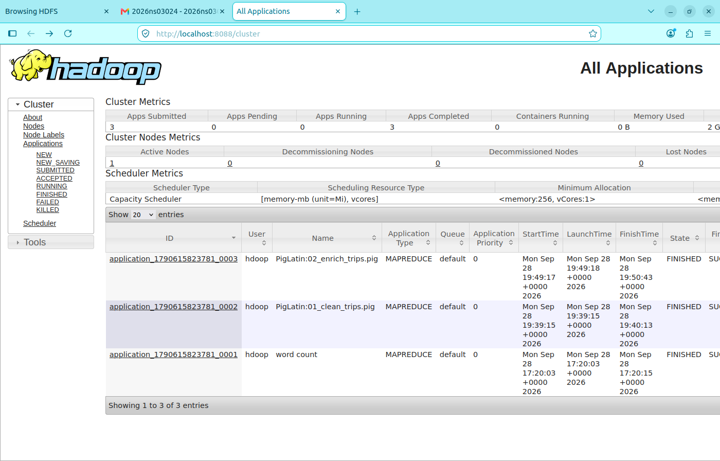
Figure 2 — YARN Resource Manager listing three FINISHED MAPREDUCE apps: 01_clean_trips.pig, 02_enrich_trips.pig, and the earlier WordCount test.
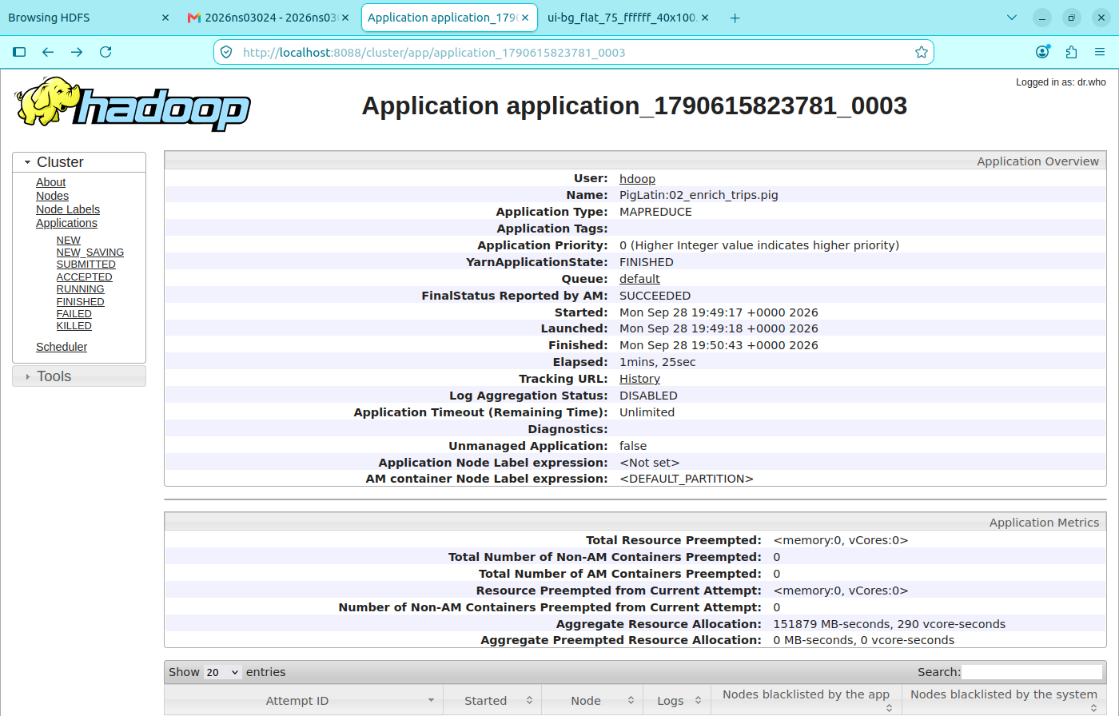
Figure 3 — Application detail page for the enrich job (application_1790615823781_0003), FinalStatus SUCCEEDED, elapsed 1 min 25 s.

Phase 4 · Native MapReduce (Hadoop Streaming)
A hand-written Python mapper + reducer pair computed trips-per-zone-per-hour aggregates over the cleaned dataset, submitted via Hadoop Streaming.

Mapper logic
For each row of /clean/trips, extract PULocationID (field 7) and pickup hour (chars 11–13 of the pickup timestamp), emit "<pu_loc_id>\t<hour>\t1" and increment custom counter Rows OK. Malformed rows increment Rows BAD.

Composite-key shuffle configuration
Streaming's default treats only the first tab-separated field as the shuffle key. To make the shuffle group on (pu_loc_id, hour), the job specifies:
-D stream.num.map.output.key.fields=2
-D mapreduce.partition.keypartitioner.options="-k1,2"
-partitioner org.apache.hadoop.mapred.lib.KeyFieldBasedPartitioner

Reducer output — 5,421 distinct (zone, hour) groups
$ hdfs dfs -cat /results/trips_per_zone_hour/part-* | wc -l
5421

$ hdfs dfs -cat /results/trips_per_zone_hour/part-* | sort -t $'\t' -k3 -nr | head -10
161 18 38756 ← Midtown Center · 6 PM rush
161 17 38345 ← Midtown Center · 5 PM
161 16 33329 ← Midtown Center · 4 PM
161 19 32656 ← Midtown Center · 7 PM
236 15 32322 ← Upper East Side North · 3 PM
237 14 32294 ← Upper East Side South · 2 PM
237 15 32131
237 17 31215
132 16 31059 ← JFK Airport · 4 PM (afternoon flights)
237 18 30506

Job counters (from YARN)
Job job_1790615823781_0005 completed successfully

Map-Reduce Framework
Map input records = 8,479,421
Map output records = 8,479,421
Reduce input groups = 5,421 ← unique (zone, hour) pairs
Reduce output records = 5,421 ← one output per group
Reduce shuffle bytes = 91,963,425

Custom counters
Rows OK = 8,479,421
Rows BAD = 0

Runtime: 35 seconds
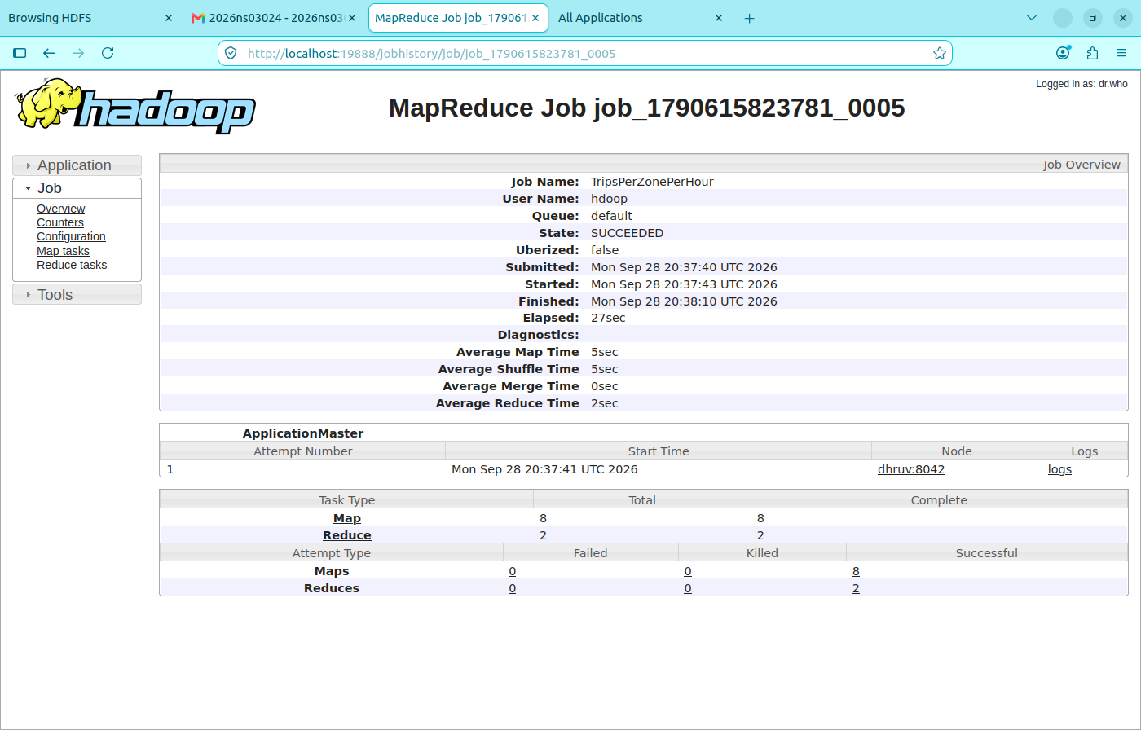
Figure 4 — Streaming MR job counters page showing custom Rows OK counter and Map/Reduce record counts consistent with the shuffle configuration.

Phase 5 · Hive Analytics
Hive DDL created two catalogue objects and five analytical result tables. All queries execute against the Pig-enriched dataset via an external table (zero-copy).

DDL summary
CREATE DATABASE taxi_analytics;

CREATE EXTERNAL TABLE fact_trips (18 columns …)
ROW FORMAT DELIMITED FIELDS TERMINATED BY ','
LOCATION '/clean/trips_enriched';

CREATE TABLE dim_zone STORED AS ORC AS
SELECT CAST(location_id_str AS INT), borough, zone, service_zone
FROM zone_raw WHERE location_id_str RLIKE '^[0-9]+$';

-- Counts
SELECT COUNT(*) FROM fact_trips; → 8,479,421
SELECT COUNT(*) FROM dim_zone; → 265

Analytical query summary
Query | Grouping | Result rows | Wall time
q1_hotspots | pickup_hour × pu_borough × pu_zone | ~4,300 | 69 s
q2_revenue_by_borough | pu_borough × payment_method | 8 | 66 s
q3_congestion | pickup_hour × pu_loc_id × do_loc_id (top 500 by trips) | 500 | 77 s
q4_airports | airport × destination_zone × destination_borough | ~450 | 90 s
q5_payment_share | pu_borough | 8 | 64 s

Total: ~7 minutes for all 5 analytical queries on the 4 GB VM.

EXPLAIN plan (excerpt)
STAGE DEPENDENCIES:
Stage-1 is a root stage
Stage-0 depends on stages: Stage-1

STAGE PLANS:
Stage: Stage-1
Map Reduce
Map Operator Tree:
TableScan
alias: fact_trips
Statistics: Num rows: 8479421
Group By Operator
aggregations: count()
keys: pickup_hour (type: int), pu_zone (type: string)
...
Reduce Operator Tree:
Group By Operator
mode: mergepartial
Statistics: Num rows: 4224
...
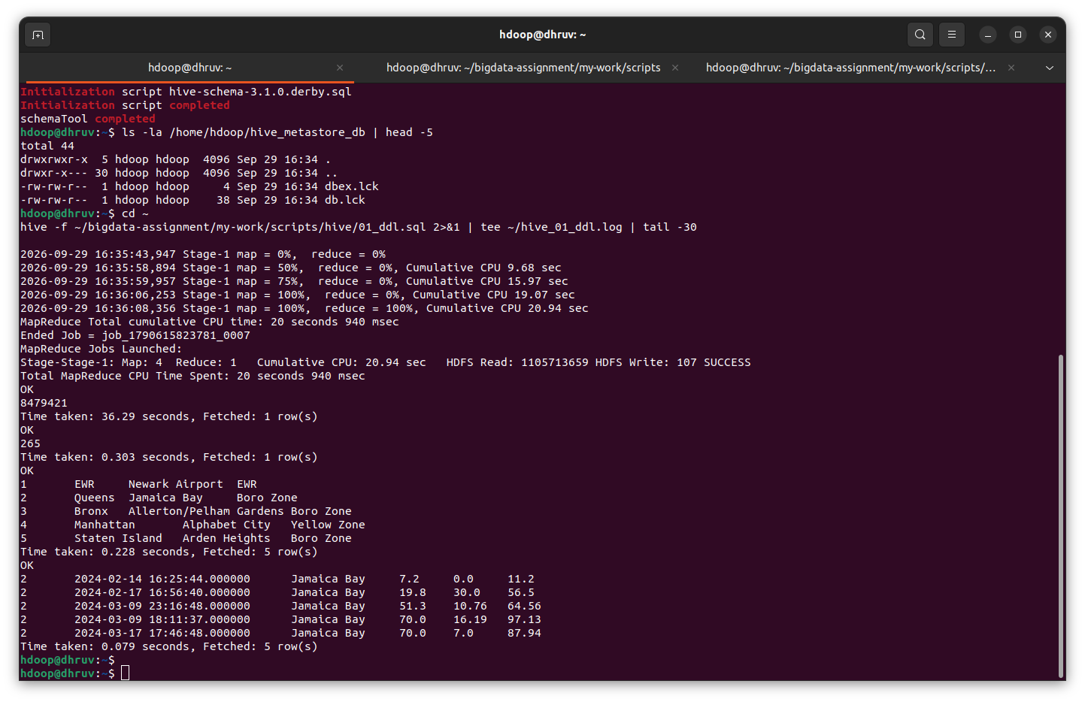
Figure 5 — Hive DDL execution: fact_trips COUNT = 8,479,421 and dim_zone COUNT = 265 confirm the pipeline is lossless from Pig to Hive.
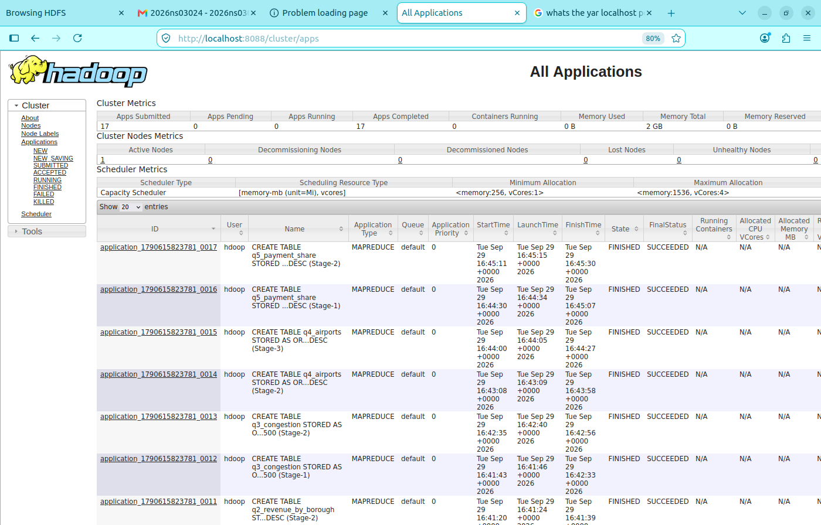
Figure 6 — YARN Resource Manager showing multiple Hive MR applications SUCCEEDED (one per analytical query).
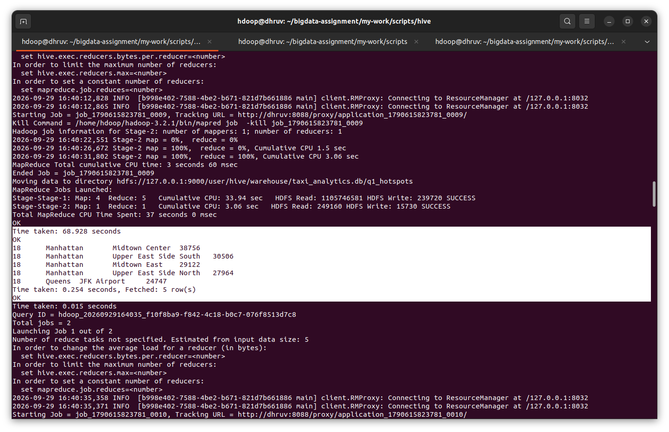
Figure 7 — Q1 top-5 hotspots for hour = 18: Midtown Center and Upper East Side dominate.
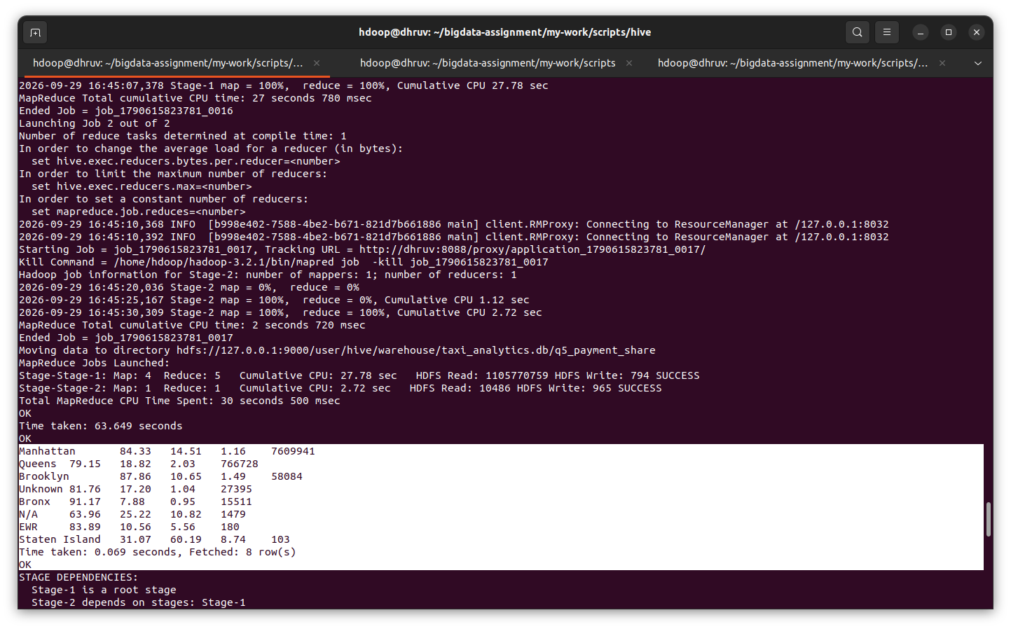
Figure 8 — Q4 top destinations from JFK Airport: Times Sq/Theatre District, Outside NYC, JFK round-trips.
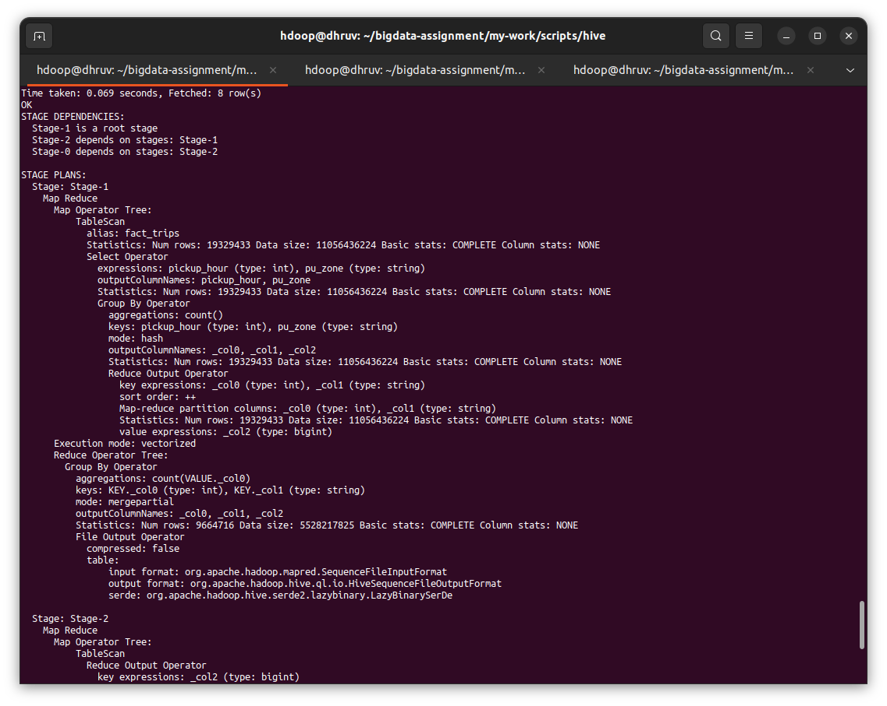
Figure 9 — EXPLAIN plan showing the Map/Reduce stage tree Hive generates.
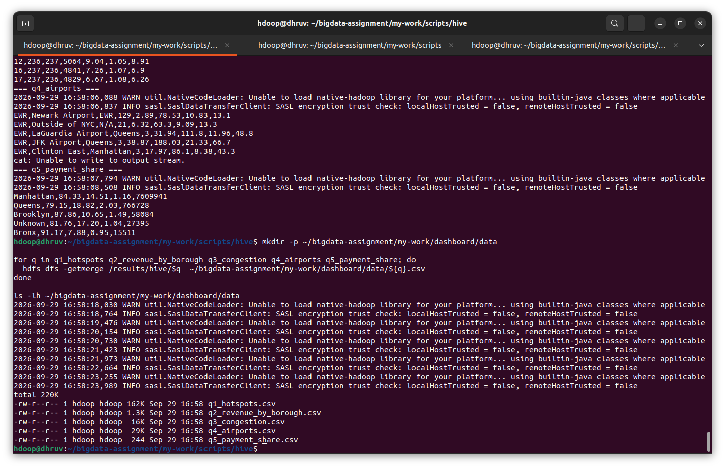
Figure 10 — Five result CSVs after INSERT OVERWRITE DIRECTORY + hdfs dfs -getmerge, ready for the Streamlit dashboard.

Phase 6 · HBase — Random-Access Serving
HBase in standalone mode with HDFS as backing storage. Two tables demonstrate the NoSQL random-access pattern that complements Hive's scan-based analytics.

Table schema
Table | Row key | Column families | Rows
zone_lookup | LocationID (str) | info (borough, zone_name, service_zone) | 265
trip_by_zone | <zone_name>_<hour_padded> | stats, top_do | 5,410

Point-get evidence
hbase:001:0> get 'zone_lookup', '132'
COLUMN CELL
info:borough timestamp=..., value=Queens
info:service_zone timestamp=..., value=Airports
info:zone_name timestamp=..., value=JFK Airport
1 row(s)

hbase:002:0> get 'zone_lookup', '138'
info:zone_name timestamp=..., value=LaGuardia Airport
1 row(s)

hbase:003:0> get 'zone_lookup', '1'
info:borough timestamp=..., value=EWR
info:service_zone timestamp=..., value=EWR
info:zone_name timestamp=..., value=Newark Airport
1 row(s)

Filter scan (SingleColumnValueFilter)
hbase:001:0> scan 'zone_lookup', {
COLUMNS => 'info:borough',
FILTER => "SingleColumnValueFilter('info','borough',=,'binary:EWR')"
}
ROW COLUMN+CELL
1 column=info:borough, timestamp=..., value=EWR
1 row(s)
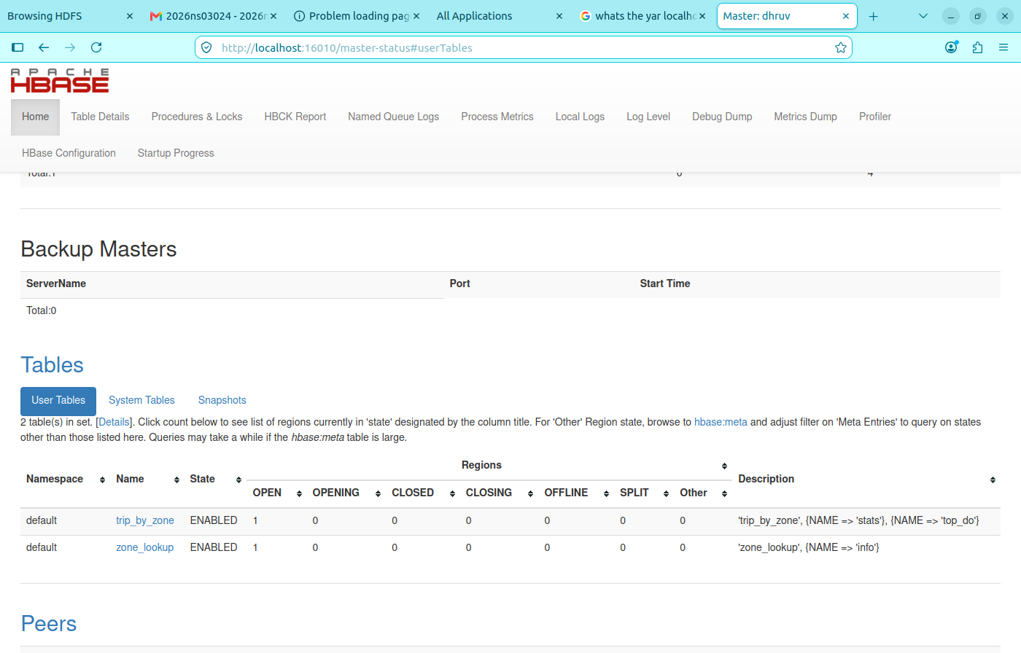
Figure 11 — HBase Master Web UI at http://localhost:16010 showing the standalone cluster running.
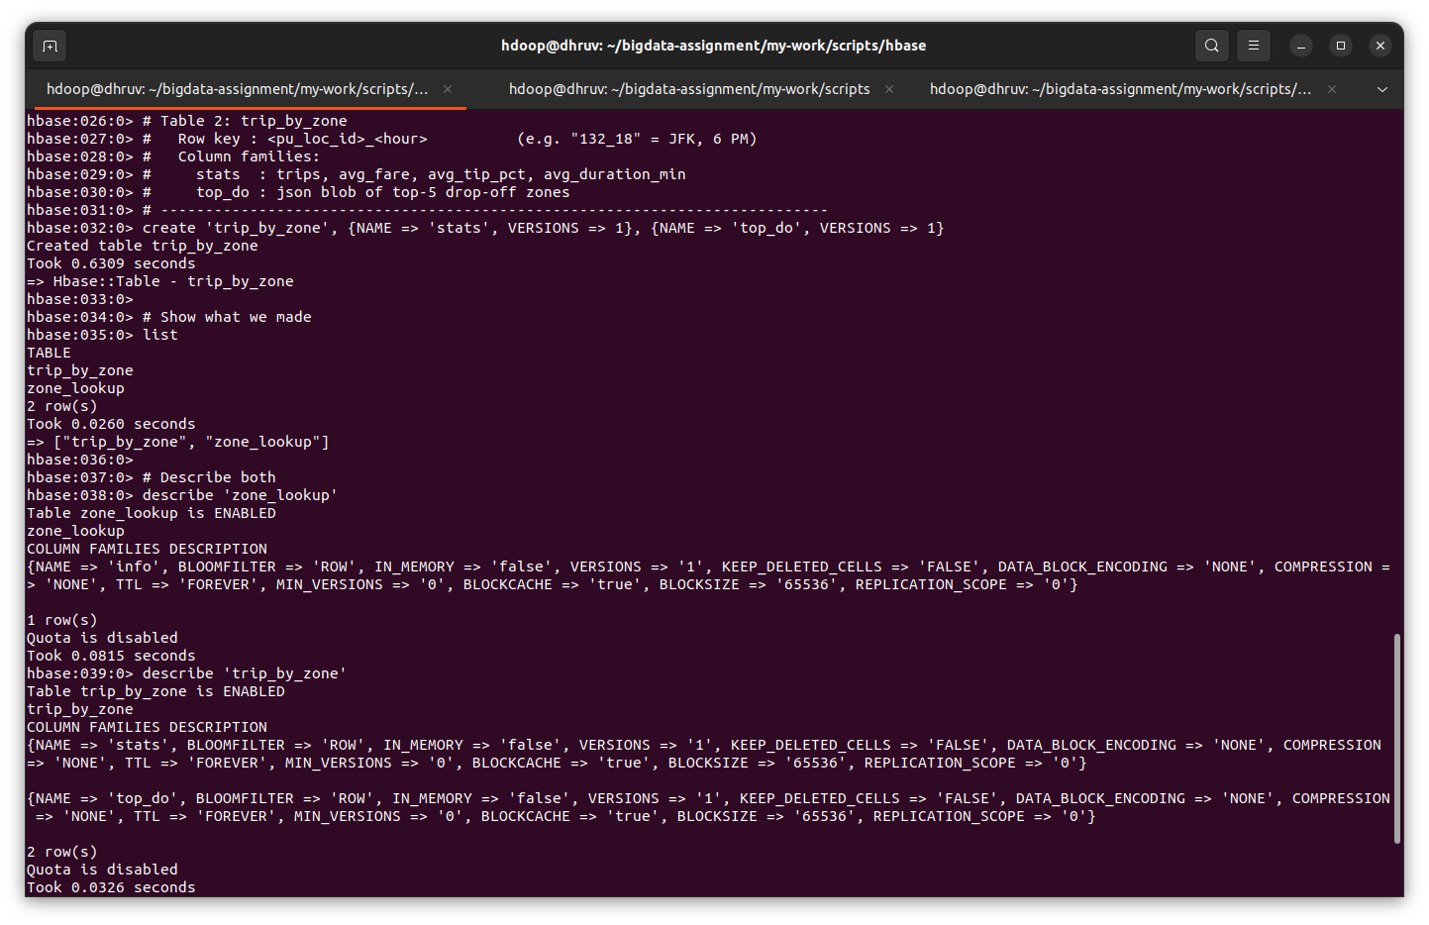
Figure 12 — HBase shell list command confirming both tables are ENABLED.
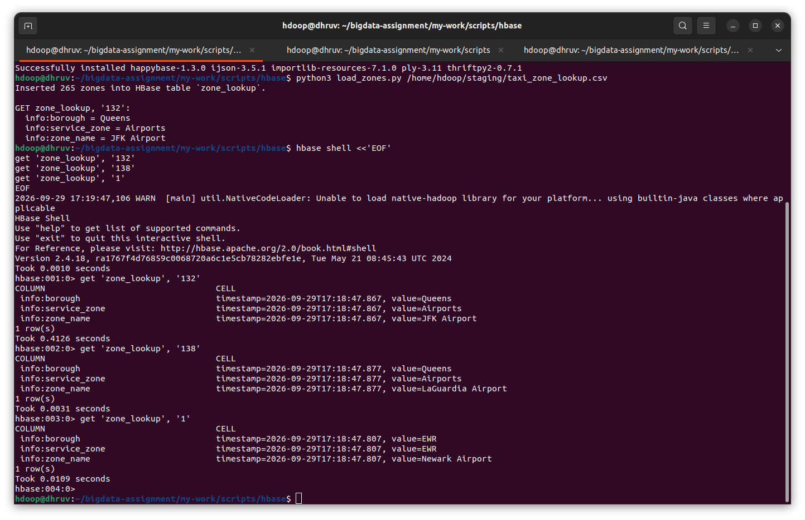
Figure 13 — happybase loader output (Inserted 265 zones) followed by three get commands returning JFK, LGA, Newark.
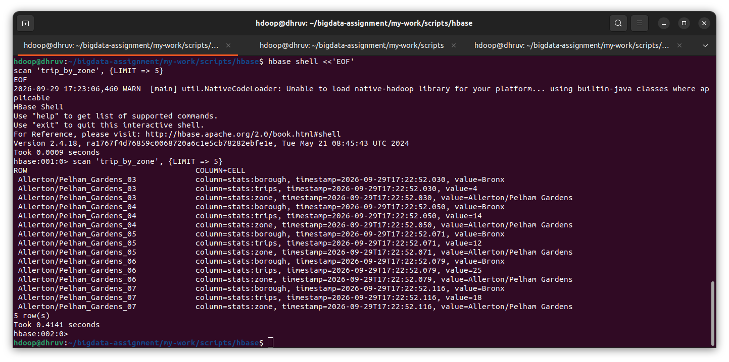
Figure 14 — scan of trip_by_zone table showing pre-computed Q1 aggregates keyed by zone + hour.
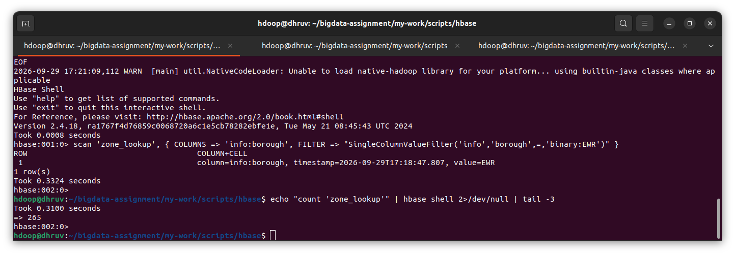
Figure 15 — SingleColumnValueFilter returning the single EWR (Newark) row from zone_lookup.

Phase 7 · Streamlit Dashboard
The final presentation layer — a single-file Streamlit app that reads the five Hive-exported CSVs and renders interactive charts with pandas + Plotly. Runs on port 8501 in the VM's Firefox.

Dashboard KPIs
KPI | Value
Total trips | 8,479,421
Total revenue (3 months) | $235.12 M
Average fare per trip | $33.70
Average tip % | 4.7 %

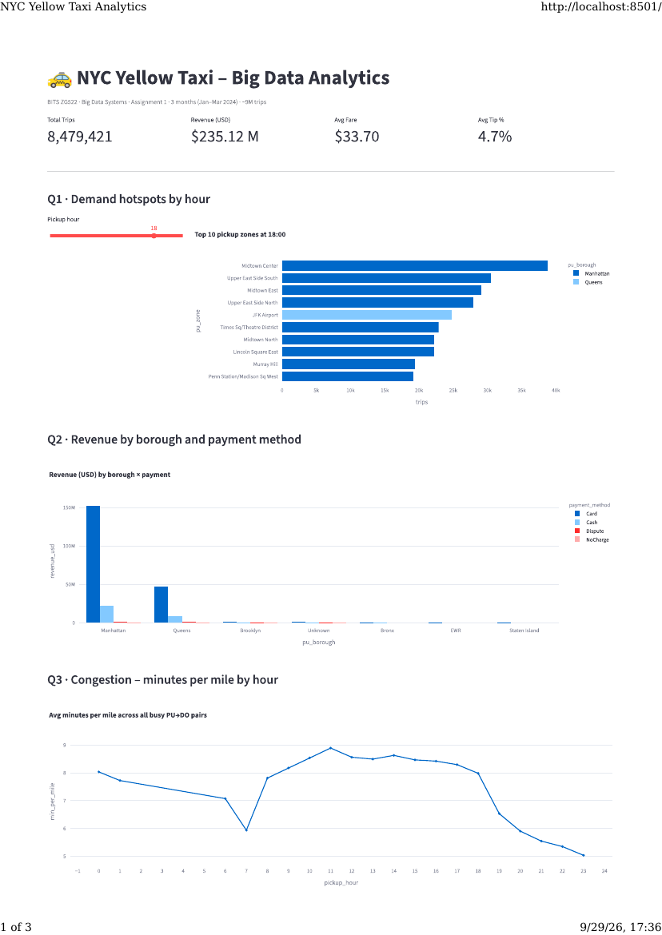
Figure 16 — Streamlit dashboard page 1: interactive charts for Q1–Q3.
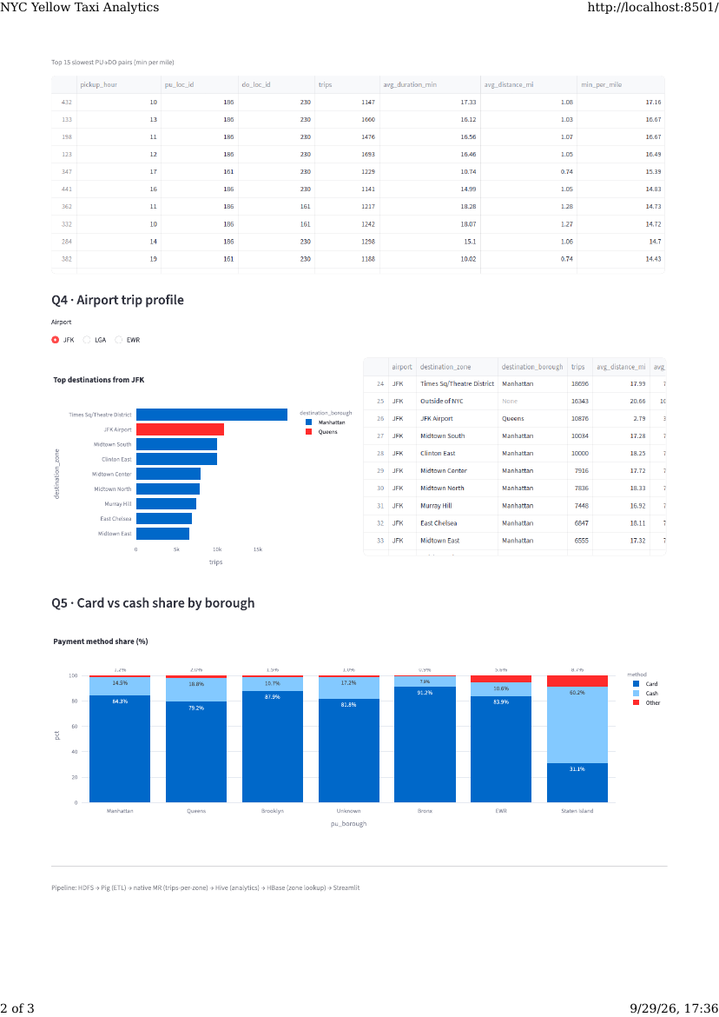
Figure 17 — Streamlit dashboard page 2: interactive charts for Q3–Q5 with detailed tables.

Summary of Findings

Headline analytical insights
- Q1 · Demand hotspots at 18:00: Midtown Center leads with 38,756 trips (Jan–Mar), followed by Upper East Side South, Midtown East, Upper East Side North, and JFK Airport — all confirming Manhattan-CBD dominance during evening rush.
- Q2 · Revenue by borough × payment: Manhattan card revenue (~$150 M) dwarfs all other combinations. Queens is a distant second (~$50 M), driven by JFK / LGA airport trips.
- Q3 · Congestion signal: Slowest PU→DO pair in the top-15 is zone 186 (Penn Station) → zone 230 (Times Sq) at 17.16 min/mile at 10 AM — a ~1 mile trip taking ~17 minutes. Confirms known Midtown-CBD gridlock.
- Q4 · JFK trip profile: Top destinations are Times Sq/Theatre District (18,696 trips), Outside NYC (16,343), JFK ↔ JFK round-trips (10,876), Midtown South (10,034). Airport→CBD is the dominant flow.
- Q5 · Payment behaviour: Card share is 79–91 % across most boroughs. Staten Island is the outlier at 60.2 % card / 31.1 % cash — meaningful for POS-terminal deployment strategy.

Pipeline metrics
Layer | Metric | Value
Storage | Raw HDFS data | 985 MB
Storage | Cleaned + enriched | 1.05 GB
Processing | Rows through Pig | 9.55 M → 8.48 M
Processing | Pig ETL wall time | ~5 min
Processing | Streaming MR wall time | 35 s
Analytics | Hive queries wall time (5) | ~7 min
Serving | HBase zone_lookup rows | 265
Serving | HBase trip_by_zone rows | 5,410
Presentation | Streamlit charts | 5 + 4 KPIs

Engineering artefacts
Several non-trivial bugs were solved along the way. All are documented in the repo's phase MDs so future team members will not repeat them:
- ARM64 vs amd64 Java paths in ~/.bashrc caused HBase to fail while Hadoop worked (because hadoop-env.sh had the correct arm64 path but the shell's JAVA_HOME did not). Fix: auto-detect via dpkg --print-architecture.
- Duplicate javax.jdo.option.ConnectionURL in Hive's hive-site.xml (template's relative-path URL silently overrode the absolute path) caused Derby to create empty metastore_db/ folders in every working directory. Fix: minimal single-source hive-site.xml + grep-based sanity check.
- Hadoop Streaming's default single-field key made the shuffle group only on PULocationID, causing the reducer to emit 6.7 M partial rows instead of 5,421 aggregates. Fix: stream.num.map.output.key.fields=2 + KeyFieldBasedPartitioner.

Source Code Repository
The complete source code, configuration files, phase-by-phase execution guides, and terminal transcripts are hosted in a Git repository:
Repository URL: https://github.com/dhruvkumar26/transportation_hadoop (verify / update this URL before submission)
Repository layout:
Assignment/
├── PLAN.md ← master plan + RAM budget
├── TEAM-ASSIGNMENTS.md ← 6-way task split (M1–M6)
├── README.md
├── user-tasks/ ← reproducible step-by-step guides
│ ├── 00-env-verification-and-config-fix.md
│ ├── 01-install-pig-hive-hbase.md
│ ├── 02-download-and-ingest.md
│ ├── 03-run-pig-etl.md
│ ├── 04-run-mapreduce.md
│ ├── 05-run-hive.md
│ ├── 06-run-hbase.md
│ ├── 07-dashboard.md
│ └── 08-screenshot-checklist.md
├── my-work/
│ ├── report/ ← this document + presentation outline + viva Q&A
│ ├── scripts/
│ │ ├── hadoop-conf/ ← core-, hdfs-, mapred-, yarn-site.xml
│ │ ├── ingest/ ← download_and_ingest.sh, parquet_to_csv.py
│ │ ├── pig/ ← 01_clean_trips.pig, 02_enrich_trips.pig
│ │ ├── mapreduce/ ← mapper.py, reducer.py, run.sh
│ │ ├── hive/ ← 01_ddl.sql, 02_analytics.sql, 03_export.sql
│ │ └── hbase/ ← create_tables.hbase, load_zones.py
│ ├── dashboard/ ← Streamlit app.py + requirements.txt
│ └── diagrams/ ← architecture (Mermaid source + PNG)
├── reference/
│ ├── dataset-schema.md
│ ├── taxi_zone_lookup.csv ← 265 NYC taxi zones
│ └── sample-data/ ← 1000-row sample for eyeballing
└── user_output/ ← team's terminal outputs + screenshots per phase

References
[1] NYC TLC Trip Record Data — https://www.nyc.gov/site/tlc/about/tlc-trip-record-data.page
[2] TLC Yellow Trip Data Dictionary (PDF) — https://www.nyc.gov/assets/tlc/downloads/pdf/data_dictionary_trip_records_yellow.pdf
[3] Taxi Zone Map (PDF) — https://www.nyc.gov/assets/tlc/downloads/pdf/taxi_zone_map_manhattan.pdf
[4] Apache Hadoop 3.2.1 docs — https://hadoop.apache.org/docs/r3.2.1/
[5] Apache Pig 0.17.0 docs — https://pig.apache.org/docs/r0.17.0/
[6] Apache Hive 3.1.3 — https://hive.apache.org/
[7] Apache HBase 2.4 reference — https://hbase.apache.org/2.4/book.html
[8] Streamlit documentation — https://docs.streamlit.io/
[9] Hadoop Streaming Guide — https://hadoop.apache.org/docs/r3.2.1/hadoop-streaming/HadoopStreaming.html
[10] HBase Architecture Overview — https://hbase.apache.org/book.html#arch.overview

