SQL Injection Detection
T.E. mini-project report submitted in fulfillment
of the requirements of the degree of

Information Technology
by

Manaswa Machhi EU1214001 (26)
Yash Pashte EU1214029 (36)
Hardik Mandale EU1214050 (29)
Gaurang Kapse EU1214053 (20)
Under the guidance of
Ms. Shraddha More
Assistant Professor


Department of Information Technology

St. John College of Engineering and Management, Palghar University of Mumbai
2023–2024
CERTIFICATE

This is to certify that the T.E. Mini-Project entitled “SQL Injection Detection” is a bonafide work of “Manaswa Machhi” (EU1214001) (26), “Yash Pashte” (EU1214029) (36), “Hardik Mandale” (EU1214050) (29), and “Gaurang Kapse” (EU1214053) (20) submitted to University of Mumbai in partial fulfillment of the requirement for the award of the degree of “Information Technology Engineering” during the academic year 2023–2024.

Ms. Shraddha More

Guide

Dr. Arun Saxena Dr. G.V. Mulgund

Head of Department Principal

T.E. Mini-Project Report Approval

This mini-project synopsis entitled SQL Injection Detection by Manaswa Machhi (26), Yash Pashte (36), Hardik Mandale (29), and Gaurang Kapse (20) is approved for the degree of Information Technology Engineering from the University of Mumbai.

Examiners

- ________________________

- ________________________

Date: Place:

Declaration
We declare that this written submission represents our ideas in our own words and where others’ ideas or words have been included, we have adequately cited and referenced the sources. We also declare that we have adhered to all principles of academic honesty and integrity and have not misrepresented fabricated or falsified any idea/data/fact/source in our submission. We understand that any violation of the above will be cause for disciplinary action by the Institute and can also evoke penal action from the sources that have thus not been properly cited or from whom proper permission has not been taken when needed.

Signature
Manaswa Machhi (EU1214001)

Signature
Yash Pashte (EU1214029)

Signature
Hardik Mandale (EU1214050)

Signature
Gaurang Kapse (EU1214053)

Date:

Abstract

The rise of SQL injection attacks has emerged as a significant concern in the realm of web application security, posing grave threats to data integrity and user privacy. In response to this escalating problem, "SQL Injection Detection" presents an innovative solution aimed at fortifying web applications against these malicious exploits. By leveraging sophisticated detection algorithms, our system scrutinizes incoming SQL queries in real-time, identifying and neutralizing potential injection attempts before they can wreak havoc on database systems. Through proactive measures and robust security protocols, SQL Injection Detection aims to mitigate the risks associated with SQL injection vulnerabilities, ensuring the integrity and confidentiality of sensitive data. In an era where cybersecurity vulnerabilities abound, our project serves as a critical line of defense, bolstering the resilience of web applications and safeguarding against the perils of SQL injection attacks.

Keywords: SQL injection, Web application security, Detection system, Data integrity, Cybersecurity.
 | Table of Contents
 | Abstract | v
 | List of Figures | viii
 | List of Tables | ix
 | List of Abbreviations | x
Chapter 1 | Introduction | 11
 | 1.1 Motivation | 11
 | 1.2 Problem Statement | 12
 | 1.3 Objectives | 12
 | 1.4 Scope | 12
Chapter 2 | Review of Literature | 13
Chapter 3 | Requirement Analysis | 14
 | 3.1 Hardware Requirements | 14
 | 3.2 Software Requirements | 14
Chapter 4 | Report on Present Investigation | 15
 | 4.1 Proposed System | 15
 | 4.1.1 Block Diagram of Proposed System | 15
 | 4.2 Implementation | 16
 | 4.2.1 Algorithm/Flowchart | 16
 | 4.2.2 Pseudo Code | 16
 | 4.2.3 Screenshots of the Output with Description | 19
 | 4.2.3.1 Bar Plot | 19
 | 4.2.3.2 Line Plot | 20
 | 4.2.3.3 Accuracy Comparison Plot | 20
 | 4.2.3.4 Performance Metrics Heatmap | 21
Chapter 5 | Technologies Used | 22
Chapter 6 | Results and Discussion | 24
Chapter 7 | Conclusion | 25
 | References | 26
 | Acknowledgment | 27

List of Figures

Figure No. | Figure Name | Page No.
4.1.1 | Proposed System | 15
4.2.1.1 | Flowchart | 16
4.2.3.1 | Bar Plot representing the value of each metric of a specific algorithm | 19
4.2.3.2 | Line plot showing the performance metrics across different algorithms | 20
4.2.3.3 | Bar plot comparing the accuracy of different algorithms | 21
4.2.3.4 | Performance Metrics Heatmap Across Algorithms | 21

List of Tables

Figure No. | Figure Name | Page No.
2.1 | Literature Survey | 13

List of Abbreviations

SQL | Structured Query Language
SVM | Support Vector Machine
ANN | Artificial Neural Network

Chapter 1

Introduction

In the realm of cybersecurity, the prevalence of SQL injection attacks poses a significant threat to the integrity and security of web applications. These malicious exploits target vulnerabilities in database systems, allowing attackers to manipulate databases, extract sensitive information, and compromise user data. As the frequency and sophistication of these attacks continue to escalate, there is an urgent need for effective detection and prevention measures to safeguard against SQL injection vulnerabilities.

"SQL Injection Detection," our innovative project, addresses this pressing cybersecurity challenge by introducing a robust detection system designed to identify and neutralize SQL injection attempts in real time. With a focus on proactive security measures, our system leverages advanced algorithms to scrutinize incoming SQL queries, detect suspicious patterns, and thwart potential injection attacks before they can inflict damage. By bolstering the resilience of web applications against SQL injection vulnerabilities, our project aims to enhance data integrity, protect user privacy, and fortify the overall security posture of online platforms.

At the core of our project lies a commitment to cybersecurity excellence and the protection of digital assets. By providing a reliable defense against SQL injection attacks, we aspire to instill confidence in web application developers, empower organizations to safeguard their systems and contribute to the broader mission of cybersecurity resilience in the digital age.

Motivation

Security Vulnerabilities: The pervasive threat of SQL injection attacks poses a substantial risk to web applications, necessitating robust detection mechanisms.

Data Breach Risks: Exploitation of SQL injection vulnerabilities can lead to unauthorized access to sensitive data, compromising user privacy and system integrity.

Need for Proactive Measures: Existing security measures may be insufficient to mitigate the evolving tactics of attackers, highlighting the urgency for advanced detection systems.

Enhanced Web Application Security: By developing effective SQL injection detection techniques, we aim to fortify web applications against potential breaches and safeguard critical data assets.

Problem Statement

SQL injection attacks present a pervasive threat to the security of web applications, allowing malicious actors to exploit vulnerabilities in database systems. Without robust detection mechanisms, these attacks can lead to unauthorized access to sensitive data and compromise the integrity of affected systems. Addressing this issue requires the development of efficient detection systems capable of identifying and mitigating SQL injection vulnerabilities in real-time, thereby enhancing the overall security posture of web applications.

Objectives

Algorithm Evaluation: Assess the performance of multiple machine learning algorithms for SQL injection detection, focusing on metrics such as accuracy, precision, recall, and F1-score.

Model Selection: Identify the most accurate and reliable algorithm for integrating into the SQL injection detection system, considering factors such as computational efficiency and real-world applicability.

Integration Readiness: Prepare the selected algorithm for seamless integration into existing web application environments, ensuring compatibility and interoperability with relevant frameworks and technologies.

Deployment Planning: Strategize the deployment process for the SQL injection detection system, including considerations for scalability, maintainability, and security best practices.

Scope
The scope of the project entails the creation of an efficient SQL injection detection system tailored for web applications. This system will focus on accurately identifying and mitigating SQL injection vulnerabilities in real time, thereby enhancing the security posture of targeted web applications. The project will involve the development and implementation of machine learning algorithms for robust detection capabilities.
Chapter 2

Review of Literature

Table 2.1. Literature Survey

Year | Paper Title | Methodology | Results | Future Scope
2022 | Detection and prevention of SQLI attacks and developing compressive framework using machine learning and hybrid techniques | Naïve Bayes, Decision Tree, SVM, Random Forest | Random Forest machine learning model provides results with an accuracy of 96.64%. | Maximizing the dataset and running with different techniques in a real-world environment.
2022 | Detection of SQL Injection using Machine Learning: A Survey | Naïve Bayes, Gradient Boosting Machine | Naïve Bayes classifier machine learning model provides results with an accuracy of 92.8%. | Implementation of other machine learning algorithms to get better accuracy.
2019 | SQL Injection Detection Using Machine Learning | Naïve Bayes, Gradient Boosting Machine | Naïve Bayes classifier machine learning model provides results with an accuracy of 92.8%. | Implementation of other machine learning algorithms to get better accuracy.
2018 | SQL Injection Detection Using Machine Learning and Multiple Data Sources | Random Forest, SVM, ANN | Random Forest algorithm showed 96.525% accuracy. | Collection of a larger dataset and analysis of additional machine learning techniques for both accuracy and performance.

Chapter 3

Requirements Analysis

3.1 Hardware Requirements
- Hard Disk – 500 GB (minimum)
- RAM required – 8GB (minimum)
- Processor – Intel Core i5 8th Gen

3.2 Software Requirements
- Python
- Google Colab
- Visual Studio Code

Chapter 4

Report on Present Investigation

Proposed System

The proposed system is a robust SQL injection detection solution that leverages machine learning algorithms to identify and mitigate potential security threats in web applications. Through extensive training and evaluation, the system has been equipped with multiple algorithms, including Logistic Regression, Naive Bayes, Random Forest, and Support Vector Machine, to accurately detect SQL injection attacks. While the primary focus has been on algorithm selection and model training, the next phase of development will involve integrating the detection system seamlessly into existing web application frameworks. This integration will enable developers and administrators to deploy the solution effortlessly, bolstering the security posture of their applications. Additionally, ongoing performance optimization efforts will ensure that the system remains effective and efficient in identifying and mitigating SQL injection vulnerabilities.

Block Diagram of Proposed System

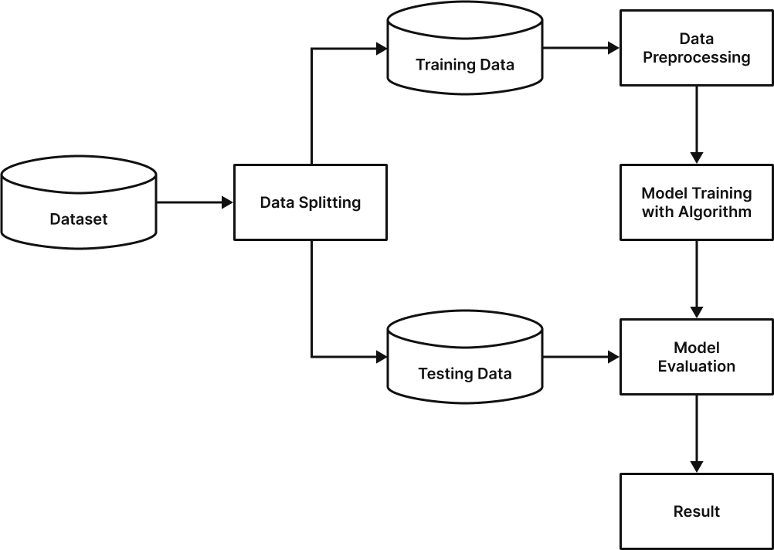
Fig. 4.1.1: Proposed System

Implementation

4.2.1 Flowchart/Algorithm

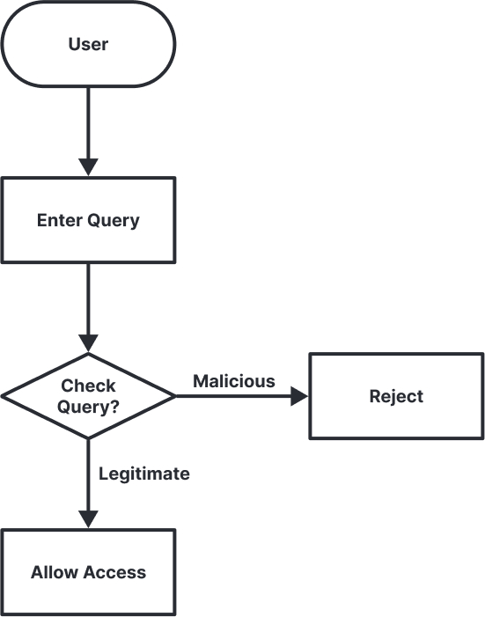

Fig. 4.2.1.1: Flowchart

4.2.2 Pseudo Code

# Step 1: Data Loading and Inspection
import pandas as pd

# Load the dataset
data = pd.read_csv("Dataset-SQLInjection.csv")

# Display the first few rows of the dataset
print("First few rows of the dataset:")
print(data.head())

# Check the data types of each column
print("Data types of each column:")
print(data.dtypes)

# Step 2: Summary Statistics
# Compute summary statistics
print("Summary statistics:")
print(data.describe())

# Count unique values and frequency distribution for categorical columns
print("Frequency distribution for 'Label' column:")
print(data['Label'].value_counts())

# Step 3: Handling Missing Values
# Check for missing values
print("Missing values in dataset:")
print(data.isnull().sum())

# If missing values are present, handle them
# Example:
data.dropna(inplace=True) # Remove rows with missing values
# Step 4: Data Visualization
import matplotlib.pyplot as plt
import seaborn as sns

# Example: Histogram of 'Query' length
data['Query_length'] = data['Query'].apply(len)
plt.figure(figsize=(10, 6))
sns.histplot(data=data, x='Query_length', bins=30, kde=True)
plt.title('Distribution of Query Length')
plt.xlabel('Length of Query')
plt.ylabel('Frequency')
plt.show()

# Step 5: Feature Engineering
# Example: Creating a feature indicating whether the query contains specific keywords
data['Contains_SQL_keywords'] = data['Query'].str.contains('SELECT|UPDATE|DELETE|INSERT')

from sklearn.model_selection import train_test_split
from sklearn.feature_extraction.text import TfidfVectorizer
from sklearn.preprocessing import LabelEncoder

# Step 6: Preprocessing Text Data

# Tokenize the text data
vectorizer = TfidfVectorizer()
X = vectorizer.fit_transform(data['Query'])
y = LabelEncoder().fit_transform(data['Label'])

# Split the data into training and testing sets
X_train, X_test, y_train, y_test = train_test_split(X, y, test_size=0.2, random_state=42)

from sklearn.metrics import accuracy_score, precision_score, recall_score, f1_score
from sklearn.linear_model import LogisticRegression
from sklearn.naive_bayes import MultinomialNB
from sklearn.ensemble import RandomForestClassifier
from sklearn.svm import SVC

# Step 7: Model Implementation

# Initialize models
models = {
"Logistic Regression": LogisticRegression(),
"Multinomial Naive Bayes": MultinomialNB(),
"Random Forest": RandomForestClassifier(),
"Support Vector Machine": SVC()
}

# Train and evaluate models
for name, model in models.items():
model.fit(X_train, y_train)
y_pred = model.predict(X_test)
accuracy = accuracy_score(y_test, y_pred)
precision = precision_score(y_test, y_pred)
recall = recall_score(y_test, y_pred)
f1 = f1_score(y_test, y_pred)
print(f"Metrics for {name}:")
print(f"Accuracy: {accuracy}")
print(f"Precision: {precision}")
print(f"Recall: {recall}")
print(f"F1-score: {f1}")
print()

4.2.3 Screenshot of the Output with Descritption

      - Bar Plot
This bar plot compares the performance metrics (accuracy, precision, recall, and F1-score) of different classification algorithms used in the project. Each bar represents a different algorithm, and the height of the bar indicates the value of the corresponding metric. This visualization helps in identifying which algorithm performs better in terms of each metric.

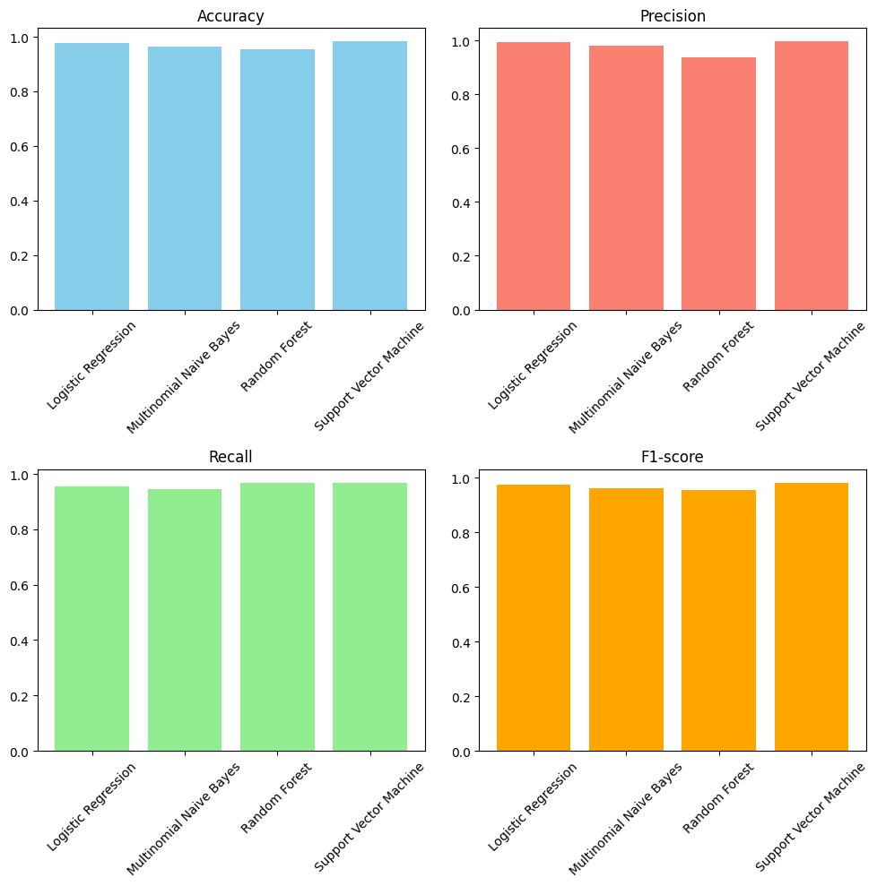
Fig. 4.2.3.1: Bar Plot representing the value of each metric of a specific algorithm

Line Plot:

This line plot shows the change in accuracy of a machine learning model over multiple epochs during training. Each point on the line represents the accuracy achieved after one epoch of training. This visualization helps in understanding how the accuracy of the model improves or stabilizes over time.

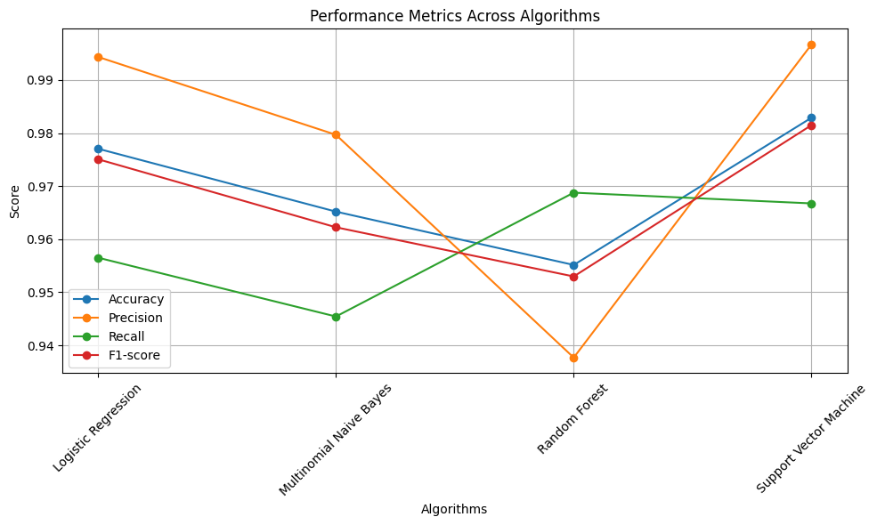
Fig. 4.2.3.2: Line plot showing the performance metrics (Accuracy, Precision, Recall, and F1-score) across different algorithms

Accuracy Comparison Plot:

The bar plot comparing accuracy of different algorithms illustrates the performance of each machine learning model in terms of classification accuracy for detecting SQL injection attacks. Each bar represents the accuracy achieved by a specific algorithm, allowing for a straightforward comparison of their effectiveness.

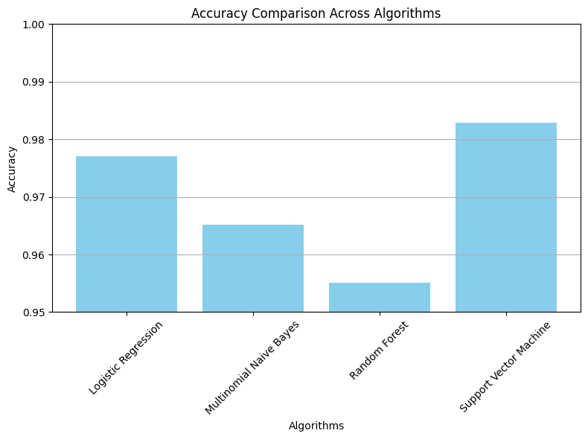

Fig. 4.2.3.3: Bar plot comparing the accuracy of different algorithms

Performance Metrics Heatmap:
The heatmap visually represents the performance metrics (Accuracy, Precision, Recall, and F1-score) across four different algorithms (Logistic Regression, Multinomial Naive Bayes, Random Forest, and Support Vector Machine).
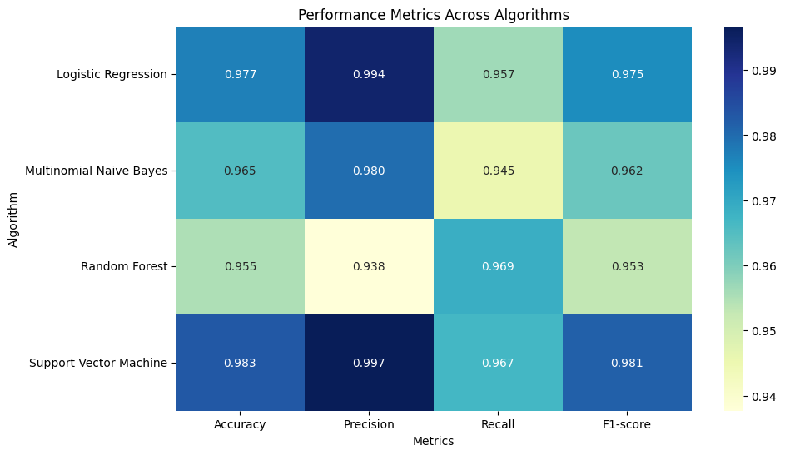

Fig. 4.2.3.4: Performance Metrics Heatmap Across Algorithms
Chapter 5

Technologies Used

- Matplotlib: Matplotlib is a comprehensive library for creating static, animated, and interactive visualizations in Python. It provides a wide range of plotting functions and customization options, making it suitable for various plotting needs.

- Seaborn: Seaborn is a Python data visualization library based on Matplotlib. It provides a high-level interface for creating attractive and informative statistical graphics. Seaborn simplifies the process of creating complex visualizations by offering a set of predefined themes, color palettes, and plotting functions. It is particularly well-suited for visualizing relationships and distributions in datasets, making it popular among data scientists and analysts.

- scikit-learn: Scikit-learn is a popular machine learning library in Python that provides simple and efficient tools for data mining and data analysis. It offers a wide range of algorithms for classification, regression, clustering, dimensionality reduction, and more. Scikit-learn also includes utilities for preprocessing data, model evaluation, and model selection.

- Pandas: Pandas is a powerful data manipulation and analysis library in Python. It provides data structures and functions for working with structured data, such as tabular data and time series. Pandas simplifies tasks like data cleaning, transformation, aggregation, and visualization, making it essential for data processing workflows.

- Plotly: Plotly is a Python graphing library that enables you to create interactive plots and dashboards. It offers a high-level interface for creating a variety of chart types, including scatter plots, bar charts, line charts, and more. Plotly's interactive features allow users to explore and manipulate data directly within the plots.

- Streamlit: Streamlit is a Python library that allows you to create web applications for machine learning and data science projects with simple Python scripts. It enables developers to build interactive and customizable user interfaces quickly and easily.

- Pickle: Pickle is a Python module used for serializing and deserializing Python objects. It allows you to save Python objects (such as models, data structures, etc.) to a file and load them back into memory later. Pickle is commonly used for saving trained machine learning models to disk.

Chapter 6

Result and Discussion

The project evaluated multiple machine learning algorithms to identify the most effective approach for SQL injection detection. Each algorithm was trained and evaluated based on metrics such as accuracy, precision, recall, and F1 score. Notably, the Support Vector Machine (SVM) algorithm exhibited the highest accuracy of 98.29%, showcasing its effectiveness in detecting SQL injection vulnerabilities.
Conversely, other algorithms such as Logistic Regression, Multinomial Naive Bayes, and Random Forest yielded slightly lower accuracy rates, ranging from 95% to 9%. While these algorithms provided respectable performance, their precision and recall scores varied, indicating potential limitations in accurately detecting SQL injection attacks compared to SVM.
Overall, the results highlight the critical role of selecting an appropriate machine-learning algorithm for SQL injection detection. The superior performance of SVM underscores its suitability for real-world applications where precision and accuracy are paramount. Future efforts may involve fine-tuning model hyperparameters and exploring ensemble methods to further enhance detection accuracy and robustness.

Chapter 7

Conclusion and Future Scope

Conclusion:
In conclusion, the "SQL Injection Detection" project has made significant strides in enhancing the security of database systems against SQL injection attacks. By leveraging machine learning algorithms, particularly Support Vector Machine (SVM), the project has demonstrated the ability to accurately detect and mitigate SQL injection vulnerabilities. The development of a robust detection system contributes to bolstering cybersecurity measures for organizations and individuals relying on database technologies.
Moving forward, the project aims to further refine and optimize the detection system, incorporating advanced techniques and continuous monitoring to stay ahead of evolving threats. Additionally, ongoing collaboration with cybersecurity experts and industry stakeholders will ensure the project remains aligned with current best practices and addresses emerging challenges in database security. Overall, the "SQL Injection Detection" project represents a significant step towards safeguarding critical data assets and fortifying defenses against malicious attacks.

Future Scope:
- System Integration: Integrate the SQL injection detection system seamlessly into web application frameworks and platforms, ensuring compatibility and ease of deployment for developers and administrators.
- Performance Optimization: Continuously optimize the detection system for enhanced efficiency and accuracy, leveraging advancements in machine learning algorithms and cybersecurity techniques.

References

[1] Wubetu Barud Demilie and Fitsum Gizachew Deriba, “Detection and prevention of SQLI attacks and developing compressive framework using machine learning and hybrid techniques” (2022).
[2] Maha Alghawazi, Daniyal Alghazzawi and Suaad Alarifi, “Detection of SQL Injection using Machine Learning: A Survey” (2022).
[3] Sonali Mishra, “SQL Injection Detection Using Machine Learning” (2019).
[4] Kevin Ross, “SQL Injection Detection Using Machine Learning and Multiple Data Sources” (2018).
[5] Akhtar, C. G., Reddy, M. H., Keerthana, P., Likitha, P., & Nithya Sri, S., “SQL Injection Detection Using Machine Learning Techniques”, Journal of Critical Reviews, vol. 21, no. 6, pp. 686-728 (2018).
[6] Tareek Pattewar, Hitesh Patil, Harshada Patil, Neha Patil, Muskan Taneja, Tushar Wadile, "Detection of SQL Injection using Machine Learning: A Survey" (2021).
[7] Vinitha Hannah Subburaj, "Experimental setup for Detecting SQLI Attacks using Machine Learning Algorithms” (2022).
[8] Arzu Gorgulu Kakisim, "A deep learning approach based on multi-view consensus for SQL
injection detection" (2024).
[9] Muhammad Amirulluqman Azman, Mohd Fadzli Marhusin, Rossilawati Sulaiman, "Machine Learning-Based Technique to Detect SQL Injection Attack" (2021).
[10] T.P. Latchoumi, M. S. Reddy and K. Balamurugan, "Applied Machine Learning Predictive Analytics to SQL Injection Attack Detection and Prevention" (2020).
[11] M. Kavitha, V. Vennila, G. Padmapriya and A. R. Kannan, "Prevention Of Sql Injection Attack Using Unsupervised Machine Learning Approach" (2021).
[12] M. A. Azman, M. F. Marhusin and R. Sulaiman, "Machine Learning-Based Technique to Detect SQL Injection Attack" (2021).
[13] U. Farooq, "Ensemble Machine Learning Approaches for Detection of SQL Injection Attack" (2021).
[14] S. Mishra, "SQL Injection Detection Using Machine Learning, Master's Projects" (2019).
[15] J. Triloka, H. Hartono and S. Sutedi, "Detection of SQL Injection Attack Using Machine Learning Based on Natural Language Processing" (2022).

Acknowledgement

We would like to extend our immense gratitude towards Mumbai University for keeping this “Mini Project” as a part of our curriculum. We are in debt thankful to our project guide, Ms. Shraddha More, St. College of Engineering and Management for guiding and being with us throughout our project timeline. A very thank you to our HOD of the Information Technology Department, Dr. Arun Saxena, for providing us with all the necessary facilities and best guidance. We also extend our gratitude toward our respected principal, Dr. G. V. Mulgund for providing all the facilities and encouragement towards our project and to the whole Information Technology Department who has been supportive till the end. We would like to give our special thanks to all our teaching and non-teaching staff and to our parents for being supportive with us throughout the process. Indeed, we feel very obliged to be a part of this successful project which was only successful due to our Project Guide, Project Faculty, HOD, Principal, IT Department, Parents and due to the whole teaching and non-teaching staff.

Signature
Manaswa Machhi (EU1214001)

Signature
Yash Pashte (EU1214029)

Signature
Hardik Mandale (EU1214050)

Signature
Gaurang Kapse (EU1214053)

