**Assignment**

**Module – 1**

**1. What is software? What is software engineering?**

**Software :**

Software is a set of instructions, data or programs used to operate computers and execute specific tasks. It is the opposite of hardware, which describes the physical aspects of a computer. Software is a generic term used to refer to applications, scripts and programs that run on a device.

**Software Engineering:**

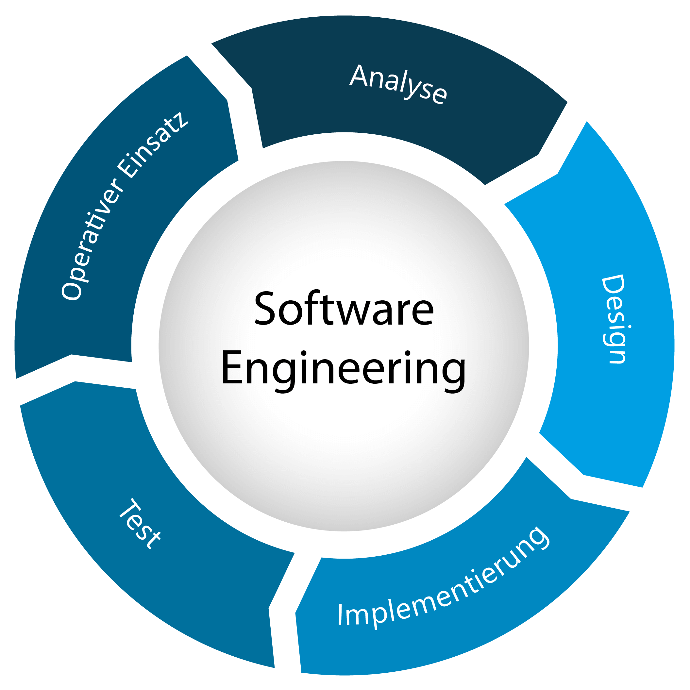  Software engineering is the branch of computer science that deals with the design, development, testing, and maintenance of software applications. Software engineers apply engineering principles and knowledge of programming languages to build software solutions for end users.

**Software Diagram:**

**2. Explain types of software.**

**Types of software:**

● Application software

● System software

● Driver software

● Middleware

● Programming software

1. **Application software:**

* The most common type of software, application software is a computer software package that performs a specific function for a user, or in some cases, for another application.
* An application can be self-contained, or it can be a group of programs that run the application for the user.
* **Examples: Microsoft office, Paint, Powerpoint etc….**

1. **System software:**

* These software programs are designed to run a computer's application programs and hardware.
* System software coordinates the activities and functions of the hardware and software.
* It controls the operations of the computer hardware and provides an environment or platform for all the other types of software to work in.
* **Examples: Notepad, Calculator etc….**

1. **Driver software:**

* Also known as device drivers, this software is often considered a type of system software.
* Device drivers control the devices and peripherals connected to a computer, enabling them to perform their specific tasks.
* Every device that is connected to a computer needs at least one device driver to function.
* **Examples: Audio Driver, Video Driver etc….**

1. **Middleware:**

* The term middleware describes software that mediates between application and system software or between two different kinds of application software. For example, middleware enables Microsoft Windows to talk to Excel and Word.
* It is also used to send a remote work request from an application in a computer that has one kind of OS, to an application in a computer with a different OS. It also enables newer applications to work with legacy ones.
* **Examples: Database middleware, Application server middleware etc….**

1. **Programming software:**

* Computer programmers use programming software to write code. Programming software and programming tools enable developers to develop, write, test and debug other software programs.
* Examples of programming software include assemblers, compilers, debuggers and interpreters.
* **Examples: Turbo C, Eclipse, Subline ect….**

**3. What is SDLC ? Explain each phase of SDLC.**

**SDLC:**

* SDLC means Software Development Life Cycle(SDLC).
* The Software Development Life Cycle (SDLC) refers to a methodology with clearly defined processes for creating high-quality software.
* The Software Development Life Cycle (SDLC) refers to a methodology with clearly defined processes for creating high-quality software.

**Phase of SDLC:**

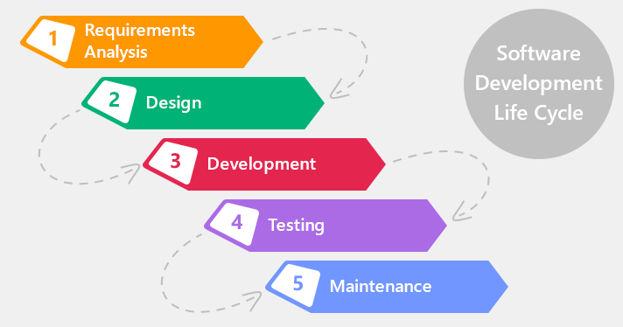

**4. What is DFD ? Create a DFD diagram on Flipkart.**

**DFD:**

* A data flow diagram (DFD) is a graphical or visual representation using a standardized set of symbols and notations to describe a business's operations through data movement. They are often elements of a formal methodology such as Structured Systems Analysis and Design Method (SSADM).
* DFD is the abbreviation for Data Flow Diagram. The flow of data of a system or a process is represented by DFD. It also gives insight into the inputs and outputs of each entity and the process itself.

**DFD diagram on Flipkart:**

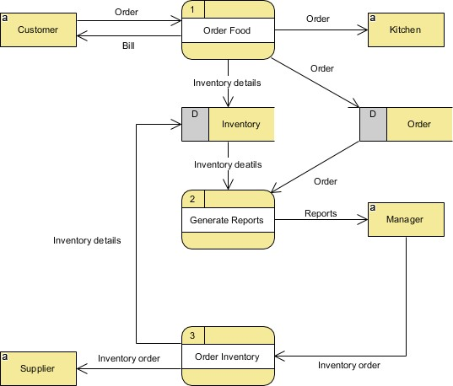

# **What is Flow chart? Create a flowchart to make addition of two numbers.**

**Flow chart:**

A flowchart is a diagram that depicts a process, system or computer algorithm. They are widely used in multiple fields to document, study, plan, improve and communicate often complex processes in clear, easy-to-understand diagrams. Flowcharts, sometimes spelled as flow charts, use rectangles, ovals, diamonds and potentially numerous other shapes to define the type of step, along with connecting arrows to define flow and sequence. They can range from simple, hand-drawn charts to comprehensive computer-drawn diagrams depicting multiple steps and routes. If we consider all the various forms of flowcharts, they are one of the most common diagrams on the planet, used by both technical and non-technical people in numerous fields. Flowcharts are sometimes called by more specialized names such as Process Flowchart, Process Map, Functional Flowchart, Business Process Mapping, Business Process Modeling and Notation (BPMN), or Process Flow Diagram (PFD). They are related to other popular diagrams, such as Data Flow Diagrams (DFDs) and Unified Modeling Language (UML) Activity Diagrams.

1. **What is Use case Diagram? Create a use-case on bill payment on paytm.**

**Use case diagram:**

* Use-case diagrams describe the high-level functions and scope of a system. These diagrams also identify the interactions between the system and its actors. The use cases and actors in use-case diagrams describe what the system does and how the actors use it, but not how the system operates internally.

