Six Week Hands on Training
On
NextGen AI Bootcamp:
Agents, Intelligence & Games Using Python
With Projects
At
Thapar Polytechnic College, Patiala
SUBMITTED IN PARTIAL FULFILMENT OF THE REQUIREMENT
FOR THE AWARD OF THE DIPLOMA IN
COMPUTER SCIENCE AND ENGINEERING
Submitted by:
NAME: Dhruv Mittal
ROLL NO: 2024/364

UNDER THE GUIDANCE OF:
Er. Ankur Thakur
Er. Harjeet Singh
Dr. Kirandeep Kaur
DEPARTMENT OF COMPUTER SCIENCE AND ENGINEERING
June 2026

CERTIFICATE

ACKNOWLEDGEMENT
I would like to express my sincere gratitude to everyone who supported and guided me during my six-week industrial training, which was undertaken as a part of the Diploma in Computer Science and Engineering.
I am thankful to my institution for providing me with the opportunity to participate in this training program. It offered me valuable practical exposure, enabling me to apply my academic knowledge in real-world situations and develop a better understanding of industry practices.
I would like to convey my heartfelt appreciation to my training mentors, Mr. Ankur Thakur, Mr. Harjeet Singh, and Ms. Kirandeep Kaur, for their constant guidance, encouragement, and constructive suggestions throughout the training. Their support played an important role in enhancing my technical skills and confidence.
I am also grateful to the faculty members and the Department of Computer Science and Engineering at Thapar Polytechnic College for organizing this training and inspiring me to continue learning and improving my abilities.
Lastly, I extend my sincere thanks to my family and friends for their unwavering encouragement, motivation, and support throughout this learning experience. This training has been an important milestone in my academic and professional journey, and I am deeply thankful to everyone who contributed to making it a rewarding experience.
Dhruv Mittal
Diploma in Computer Science and Engineering
2024/364
Thapar Polytechnic College

DECLARATION
I hereby declare that the training report entitled "Python Powered Projects: AI to Arcade" is an original record of the work completed by me during the six-week training program conducted at Thapar Polytechnic College from 23 June 2025 to 1 August 2025, as a part of the curriculum for the Diploma in Computer Science and Engineering.
I further declare that this report has not been submitted, either wholly or partially, to any other institution or university for the award of any degree, diploma, or certificate. The work presented in this report is based on my own learning, practical implementation, and experience gained during the training under the guidance and supervision of Mr. Ankur Thakur, Mr. Harjeet Singh, and Ms. Kirandeep Kaur.
I also confirm that all sources of information, references, and assistance received during the preparation of this report have been appropriately acknowledged wherever required.
Dhruv Mittal
Diploma in Computer Science and Engineering
2024/364
Thapar Polytechnic College

ABSTRACT
This report provides a detailed overview of the six-week industrial training titled "Python Powered Projects: AI to Arcade", undertaken as part of the Diploma in Computer Science and Engineering curriculum. The primary objective of the training was to strengthen both theoretical understanding and practical skills in Python programming while gaining hands-on experience in developing real-world applications.
During the training, a wide range of Python concepts were covered, including data types, operators, control statements, functions, modules, file handling, exception handling, and object-oriented programming. In addition, the training introduced several important libraries such as NumPy, Pandas, OpenCV, Tkinter, TensorFlow, SpaCy, Sentence-Transformers, and Pygame.
The highlight of the training was the design and implementation of the Major Project: ProBot AI, an AI-based desktop research library and intelligent knowledge discovery engine featuring local LLM RAG pipelines, dense Transformer vector search, automated study note synthesis, and relational SQLite logging. By synthesizing local Large Language Models (Ollama), Transformer vector embeddings (all-MiniLM-L6-v2), SpaCy NLP pipelines, and CustomTkinter desktop user interfaces, ProBot AI delivers a state-of-the-art privacy-preserving research experience.
This report summarizes the concepts studied, projects developed, and practical knowledge acquired throughout the training period. The experience has significantly improved my technical competence, programming confidence, and analytical skills. It has established a strong foundation for future development in artificial intelligence, software engineering, and automation using Python.

INSTITUTIONAL PROFILE
Thapar Polytechnic College
Thapar Polytechnic College (TPC), Patiala, was established in 1956 through the vision and dedication of Late Lala Karam Chand Thapar, with the support of Maharaja Yadavindra Singh of the former PEPSU State. Over the years, the institution has earned a strong reputation for providing quality technical education and producing skilled diploma engineers.
TPC is one of the three institutions located on the Thapar Technology Campus, alongside the Thapar Institute of Engineering and Technology (TIET) and the Thapar Centre for Industrial Research and Development (TCIRD). The college is a government-aided, privately managed institution affiliated with the Punjab State Board of Technical Education and Industrial Training (PSBTE & IT), Chandigarh.
Since its inception, the college has continuously expanded its academic programs and infrastructure to meet the evolving needs of technical education. It currently offers three-year diploma programs in five engineering disciplines and has consistently maintained high academic standards. In recognition of its excellence, Thapar Polytechnic College was awarded the title of Best Polytechnic in the Northern Region during the academic years 1999–2000 and 2005–2006.
Departments Offered:
1. Computer Science and Engineering
2. Architectural Assistantship
3. Civil Engineering
4. Electrical Engineering
5. Mechanical Engineering
History & Campus Growth
Thapar Polytechnic College began its journey in 1956 by offering three-year diploma courses in Civil Engineering, Electrical Engineering, and Mechanical Engineering with an initial intake of 60 students. As technical education gained importance, the institution expanded its academic offerings by introducing Computer Science and Engineering and Architectural Assistantship, increasing its annual student intake significantly.
Today, the college is recognized as one of the leading polytechnic institutions in the region. With experienced faculty members, modern laboratories, well-equipped workshops, library facilities, and a strong emphasis on practical learning, TPC provides students with the technical knowledge and professional skills required to succeed in industry and higher education.

Table of Contents
SECTION / CHAPTER TITLE | PAGE
CHAPTER 1: INTRODUCTION TO PYTHON | 1
1.1 PYTHON | 1
1.2 FEATURES OF PYTHON | 1
1.3 ADVANTAGES OF PYTHON | 2
1.4 DATATYPES | 2
1.5 DICTIONARIES | 3
1.6 SETS | 3
1.7 CONDITIONAL STATEMENTS | 4
1.8 MODULES | 4
1.9 FUNCTIONS | 5
1.10 CLASSES AND OBJECTS | 5
1.11 PYTHON DESIGN PHILOSOPHY & ZEN OF PYTHON | 6
1.12 DYNAMIC TYPING & MEMORY MANAGEMENT THEORY | 6
1.13 PROGRAMMING PARADIGMS IN PYTHON | 7
1.14 EXCEPTION HANDLING & FILE I/O STREAMS | 7
CHAPTER 2: MACHINE LEARNING | 8
2.1 MACHINE LEARNING | 8
2.2 HOW MACHINE LEARNING WORKS | 8
2.3 APPLICATION OF MACHINE LEARNING | 9
2.4 FEATURES OF MACHINE LEARNING | 9
2.5 ADVANTAGES OF MACHINE LEARNING | 10
2.6 LIBRARIES IN MACHINE LEARNING | 10
2.7 MACHINE LEARNING TAXONOMY & LEARNING PARADIGMS | 13
2.8 THE BIAS-VARIANCE TRADEOFF & OVERFITTING MITIGATION | 13
2.9 FEATURE ENGINEERING & STANDARDIZATION THEORY | 14
2.10 MODEL EVALUATION METRICS & CONFUSION MATRIX | 14
CHAPTER 3: DEEP LEARNING | 15
3.1 DEEP LEARNING | 15
3.2 HOW DEEP LEARNING WORKS? | 15
3.3 APPLICATION OF DEEP LEARNING | 16
3.4 FEATURES OF DEEP LEARNING | 16
3.5 ADVANTAGES OF DEEP LEARNING | 17
3.6 LIBRARIES IN DEEP LEARNING | 17
3.7 CNN | 19
3.8 RNN | 20
3.9 BIOLOGICAL VS ARTIFICIAL NEURAL NETWORKS | 21
3.10 ACTIVATION FUNCTIONS & MATHEMATICAL PROPERTIES | 21
3.11 BACKPROPAGATION & GRADIENT DESCENT OPTIMIZATION | 22
3.12 CNN SPATIAL HIERARCHY & RNN SEQUENTIAL MEMORY THEORY | 22
CHAPTER 4: GAMING | 23
4.1 ABOUT GAMING | 23
4.2 POPULAR LIBRARIES FOR GAME DEVELOPMENT IN PYTHON | 23
4.3 GAME ENGINE ARCHITECTURE & THE INFINITE GAME LOOP | 26
4.4 SPATIAL COLLISION DETECTION ALGORITHMS | 27
CHAPTER 5: INTRODUCTION TO AI | 28
5.1 ARTIFICIAL INTELLIGENCE | 28
5.2 WORKING OF ARTIFICIAL INTELLIGENCE | 28
5.3 APPLICATIONS OF ARTIFICIAL INTELLIGENCE | 29
5.4 TYPES OF ARTIFICIAL INTELLIGENCE | 29
5.5 LLM | 30
5.6 AI AGENT | 30
5.7 AGENTIC AI | 31
5.8 HISTORICAL PARADIGMS: SYMBOLIC AI TO GENERATIVE AI | 31
5.9 AGENTIC AI & AUTONOMOUS MULTI-AGENT ARCHITECTURES | 32
CHAPTER 6: PROJECTS IN PYTHON | 33
6.1 HANGMAN GAME: VERB EDITION | 33
6.2 CLASSIFICATION OF IRIS FLOWER IN MACHINE LEARNING | 36
6.3 HANDWRITTEN DIGIT CLASSIFICATION IN DEEP LEARNING | 39
CHAPTER 7: MAJOR PROJECT – PROBOT AI: AI-BASED DESKTOP RESEARCH LIBRARY | 44
7.1 INTRODUCTION & PROJECT OVERVIEW | 44
7.2 SMART SEARCH ENGINE & NLP LANGUAGE PROCESSING THEORY | 46
7.3 AUTOMATED STUDY NOTES, CONCEPT MAPS & INTENT ENGINE THEORY | 50
7.4 OLLAMA LOCAL AI ASSISTANT & RAG ARCHITECTURE THEORY | 51
7.5 CUSTOMTKINTER DASHBOARD, ANALYTICS, & KNOWLEDGE LEDGER THEORY | 53
7.6 STEP-BY-STEP USER OPERATION GUIDE & WORKFLOW | 55
7.7 SYSTEM IMPLEMENTATION & COMPARATIVE EVALUATION | 56
7.8 SOFTWARE QUALITY MODEL & ISO/IEC 25010 COMPLIANCE | 57
7.9 COMPREHENSIVE SOFTWARE TESTING & TEST CASE MATRIX | 58
7.10 DETAILED COMPARATIVE EVALUATION MATRIX | 59
7.11 FUTURE WORK & ENHANCEMENT ROADMAP | 59
CONCLUSION | 60
REFERENCES | 61

CHAPTER 1: INTRODUCTION TO PYTHON
1.1 PYTHON
Python is a high-level, general-purpose programming language developed by Guido van Rossum and was officially released in 1991. Designed with a strong emphasis on code readability, it has become one of the premier languages introduced to students and beginners today. Writing code in Python closely resembles writing plain English, eliminating much of the syntactic complexity—such as excessive brackets and semicolons—found in traditional programming languages. This simplicity enables developers to focus primarily on problem-solving rather than struggling with intricate syntax rules.
During my six-week training program at Thapar Polytechnic College, Python served as the foundational language for every domain we explored, including machine learning, deep learning, and game development. Developing a solid grasp of core Python concepts made transitioning into these advanced domains seamless, as their underlying frameworks and libraries are built directly on top of Python.
1.2 FEATURES OF PYTHON
• Easy to Learn and Read: Python features a clean, intuitive syntax close to natural English, making it highly accessible to beginners.
• Interpreted Language: Python code is executed line by line, which simplifies debugging since runtime errors are identified immediately.
• Free and Open Source: Python is freely available for anyone to download, execute, and modify without licensing fees.
• Cross-Platform Portability: Python programs written on one operating system (such as Windows) can run seamlessly on Linux or macOS without requiring code modifications.
• Extensive Library Ecosystem: Python offers a rich standard library alongside thousands of third-party packages, covering domains from web development to data analytics.
• Multi-Paradigm Support: Python supports procedural, object-oriented, and functional programming paradigms, offering developers high flexibility in system design.
1.3 ADVANTAGES OF PYTHON
• Concise Codebase: Tasks require significantly fewer lines of code compared to compiled languages like C or Java, accelerating development time.
• Vibrant Community Support: A massive, active global community ensures extensive documentation, tutorials, and pre-built solutions are readily accessible online.
• Industry Dominance in Emerging Tech: Python is the primary language for Artificial Intelligence, Machine Learning, Data Science, and Automation, unlocking broad career opportunities.
• Seamless Integration: Python integrates easily with legacy codebases written in C, C++, or Java, making it ideal for enterprise-scale software.
• Robust Web Frameworks: Advanced frameworks such as Django and Flask streamline web development by enforcing structured, rapid application design.
1.4 DATATYPES
In Python, a data type defines the classification of a variable's value, specifying the operations that can be performed on it. Unlike statically typed languages, Python does not require explicit variable declaration; instead, the data type is inferred dynamically at runtime when a value is assigned. This feature is known as dynamic typing. The primary data types covered during the training include:
- int: Represents whole numbers (e.g., 10, -25, 100).
- float: Represents floating-point numbers with real values (e.g., 3.14, -0.5).
- str: Represents textual data enclosed in single or double quotes (e.g., "Python").
- bool: Represents logical values (True or False).
- list, tuple, dict, set: Represent structured collections used to store multiple data items efficiently.

Python (Datatypes)
x = 10 # int
y = 3.5 # float
name = "Anshuman" # str
is_valid = True # bool
print(type(x), type(y), type(name), type(is_valid))

1.5 DICTIONARIES
A dictionary in Python is an unordered collection that stores data in key-value pairs, rather than indexed values like a list. Every key within a dictionary must be unique, serving as a direct reference to retrieve its corresponding value.
Python (Dictionaries)
student = {
"name": "Anshuman",
"course": "CSE Diploma",
"semester": 5
}
print(student["name"]) # Output: Anshuman
student["marks"] = 92 # Adding a new key-value pair

1.6 SETS
A set is an unordered collection composed entirely of unique elements. Sets automatically eliminate duplicate entries, making them ideal for processing distinct datasets.
Python (Sets)
languages = {"python", "java", "python", "c"}
print(languages) # Output: {'python', 'java', 'c'}
languages.add("c++")
print("java" in languages) # Output: True

1.7 CONDITIONAL STATEMENTS
Conditional statements allow a program to evaluate logic dynamically and execute specific code blocks depending on whether a condition evaluates True or False. Python utilizes the if, Elif, and else keywords for decision-making. Instead of using traditional curly braces, Python relies strictly on indentation to define code blocks.
Python (Conditionals)
marks = 78
if marks >= 90:
print("Grade A")
elif marks >= 75:
print("Grade B")
else:
print("Grade C")

1.8 MODULES
A module in Python is a file containing executable code—such as functions, classes, or variables—designed to be imported and reused across multiple programs. Python features a comprehensive built-in standard library containing modules like math, random, and datetime. Additionally, external modules can be managed via the package manager pip, or created manually as custom utility files.
Python (Modules)
import math
import random
print(math.sqrt(25)) # Output: 5.0
print(random.randint(1, 6)) # Output: Random integer between 1 and 6
Modular design encourages clean, maintainable architecture by eliminating code duplication. Complex functional operations are encapsulated once and reused as needed. This modular design pattern enables production-level libraries like NumPy and TensorFlow to be loaded with a single import directive.
1.9 FUNCTIONS
A function is a named, self-contained block of code designed to perform a specific task when invoked, preventing repetitive code implementation. In Python, functions are defined using the def keyword, accepting input parameters, and optionally returning output results via the return statement.
Python (Functions)
def calculate_average(numbers):
total = sum(numbers)
return total / len(numbers)
marks = [80, 92, 75, 88]
print(calculate_average(marks)) # Output: 83.75
Utilizing functions allows us to decompose complex programmatic problems into smaller, manageable sub-tasks—a structural habit essential for engineering machine learning pipelines and complex software applications later in the program.
1.10 CLASSES AND OBJECTS
Python natively supports Object-Oriented Programming (OOP), where classes and objects form the fundamental architectural building blocks. A class serves as an abstract blueprint defining structural attributes and methods.
Python (Classes and Objects)
class Student:
def __init__(self, name, roll_no):
self.name = name
self.roll_no = roll_no
def display(self):
print(f"{self.name} - {self.roll_no}")
s1 = Student("Anshuman", "2024/352")
s1.display()
Mastering OOP principles was vital for working with mainstream Data Science frameworks like Scikit-learn and TensorFlow. These libraries rely heavily on class-based architectures, where models are initialized as objects and executed using integrated methods such as .fit() and .predict().
1.11 PYTHON DESIGN PHILOSOPHY & ZEN OF PYTHON
Python was created by Guido van Rossum and officially released in 1991. The language was designed with an explicit focus on code readability, syntactic simplicity, and programmer productivity. Guided by the principles of the 'Zen of Python' (PEP 20), Python advocates explicit statements over implicit assumptions, simple logic over complex design, and readable structure over cryptic one-liners. This design philosophy enables developers to write clean, maintainable code in significantly fewer lines compared to traditional compiled languages like C++ or Java.
1.12 DYNAMIC TYPING & MEMORY MANAGEMENT THEORY
Unlike statically typed languages where variable types are declared explicitly at compile time, Python utilizes dynamic typing. In Python, data types are associated with object values rather than variable names, and type checking is inferred dynamically at runtime. At the memory architecture level, Python manages objects using reference counting combined with an automatic generational garbage collector. When an object's reference count drops to zero, its memory is automatically reclaimed. In standard CPython implementations, the Global Interpreter Lock (GIL) enforces thread safety by ensuring only one native thread executes Python bytecode at any given moment.
1.13 PROGRAMMING PARADIGMS IN PYTHON
Python natively supports multiple programming paradigms, giving developers high flexibility in system design:
• Procedural Programming: Organizes code into sequential functions and statement blocks for step-by-step execution.
• Object-Oriented Programming (OOP): Encapsulates structural data attributes and behavioral methods into abstract blueprints called Classes, instantiated as concrete Objects.
• Functional Programming: Treats computation as evaluations of mathematical functions, avoiding mutable state using higher-order functions like map(), filter(), and lambda expressions.
1.14 EXCEPTION HANDLING & FILE I/O STREAMS
Robust software development requires managing runtime errors gracefully. Python provides a structured exception handling mechanism using try, except, else, and finally blocks. This prevents unexpected program crashes by catching errors at runtime. For data persistence, Python provides built-in context managers (using the 'with' statement) that automatically manage file stream opening, buffer flushing, and resource closing, ensuring safe I/O operations across different operating systems.

CHAPTER 2: MACHINE LEARNING
2.1 MACHINE LEARNING
Machine Learning (ML) is a core discipline within Artificial Intelligence that empowers systems to learn hidden patterns directly from historical data to form predictions or automated decisions without relying on explicitly hardcoded rules. Instead of manually engineering static logic for every edge case, an algorithm processes massive volumes of sample data to infer functional relationships independently.
During our training, this paradigm was demonstrated through email classification: rather than manually constructing complex rules to screen unsolicited messages, a model processes thousands of historical emails labeled as "spam" or "not spam." From this data, the algorithm autonomously learns discriminatory features to classify incoming communications.
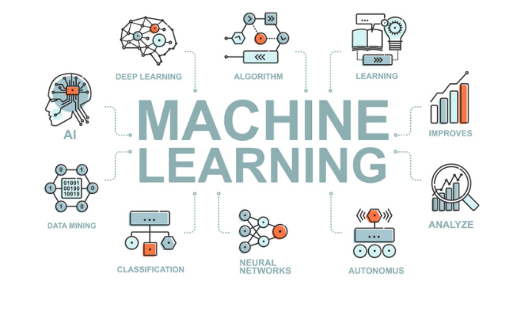
Figure 2.1 Machine Learning

2.2 HOW MACHINE LEARNING WORKS
• Data Collection: Gathering high-quality, representative domain data relevant to the target objective.
• Data Preprocessing: Cleaning raw data by addressing missing values, eliminating redundant records, and transforming fields into standardized formats.
• Dataset Splitting: Partitioning dataset samples into training and evaluation subsets (commonly following an 80:20 distribution split).
• Model Selection: Identifying an optimal algorithm tailored to the problem class, such as regression or classification models.
• Model Training: Feeding training data into the selected algorithm to map statistical patterns between inputs and target outputs.
• Evaluation & Testing: Measuring the model's predictive accuracy on unobserved test data using performance metrics like accuracy, precision, or recall.
2.3 APPLICATION OF MACHINE LEARNING
• Recommendation Engines: Powers content and product recommendation algorithms used by modern platforms such as YouTube, Netflix, and Amazon.
• Financial Fraud Detection: Monitors transaction sequences in real time to flag anomalous banking behaviors automatically.
• Medical Diagnostics: Assists healthcare specialists by identifying pathological indicators within medical imagery and clinical datasets.
• Email Spam Filtering: Automatically categorizes and routes incoming communications into primary or secondary folders.
• Predictive Analytics: Analyzes historical market and environmental trends to project real estate valuations, stock fluctuations, and meteorological shifts.
2.4 FEATURES OF MACHINE LEARNING
• Data-Driven Autonomy: Learns mathematical representations directly from data rather than relying on static, hand-written heuristics.
• Iterative Improvement: Continuously enhances prediction accuracy as larger, higher-quality datasets are ingested.
• Scalable Analysis: Processes high-dimensional, complex datasets far beyond human analytical capabilities.
• Pattern Extraction: Detects subtle statistical patterns that are often missed by traditional human inspection.
2.5 ADVANTAGES OF MACHINE LEARNING
• Operational Automation: Minimizes manual intervention by automating complex decision-making processes.
• High Predictive Precision: Improves output reliability as training volumes scale.
• Cross-Domain Adaptability: Integrates seamlessly across diverse technical domains including healthcare, finance, logistics, and agriculture.
• Data-Driven Strategy: Replaces intuition with quantifiable empirical evidence for strategic decision-making.
2.6 LIBRARIES IN MACHINE LEARNING
A substantial portion of the training involved hands-on execution using core Python libraries designed for efficient numerical computing and machine learning workflows.
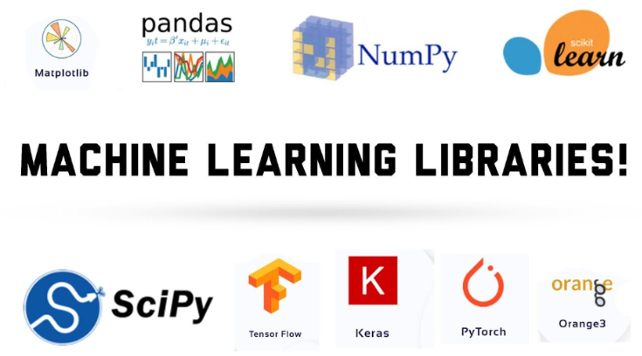
Figure 2.2 Libraries in Machine Learning
2.6.1 NumPy
NumPy (Numerical Python) serves as the core library for scientific computing in Python. It provides high-performance N-dimensional array objects that are significantly faster and more memory-efficient than standard Python lists.
Python (NumPy)
import numpy as np
arr = np.array([10, 20, 30, 40])
print(arr.mean()) # Output: 25.0
print(arr * 2) # Output: [20 40 60 80]

2.6.2 Pandas
Pandas is a foundational data manipulation library designed for handling structured tabular data through two primary data structures: the Series (one-dimensional) and the DataFrame (two-dimensional table with labeled axes). It streamlines common data management operations, such as loading CSV files, indexing, filtering, and performing aggregations.
Python (Pandas)
import pandas as pd
df = pd.read_csv("students.csv")
print(df.head())
print(df[df["marks"] > 80])

2.6.3 Matplotlib
Matplotlib is a core visualization library used to render static visual plots, including line plots, bar charts, scatter plots, and distribution histograms. Graphing data distributions simplifies identifying underlying trends, correlations, and outliers across datasets.

Python (Matplotlib)
import matplotlib.pyplot as plt
marks = [45, 67, 89, 72, 91]
plt.plot(marks)
plt.title("Marks Trend")
plt.show()
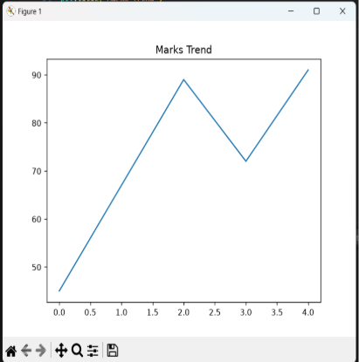
Figure 2.3 Output by Matplot
2.6.4 Seaborn
Seaborn is a high-level statistical visualization library built directly on top of Matplotlib, rendering heatmaps, box plots, and pair plots. t provides an intuitive interface for rendering visually refined graphs—such as heatmaps, box plots, and pair plots—with minimal code footprint. During training, Seaborn was primarily utilized during Exploratory Data Analysis (EDA) to map feature relationships prior to model development.
Python (Seaborn)
import seaborn as sns
sns.boxplot(x="category", y="marks", data=df)

2.6.5 SciPy
SciPy extends NumPy by providing advanced modules for scientific, statistical, and mathematical computations including optimization and integration. signal processing, and spatial operations. Within machine learning contexts, SciPy powers lower-level statistical routines that extend beyond base NumPy functionality.
Python (SciPy)
from scipy import stats
print(stats.zscore([10, 20, 30, 40, 50]))

2.6.6 Scikit-learn
Scikit-learn is the premier Python framework for classical machine learning applications, including regression, classification, clustering, and dataset splitting.
Python (Scikit-Learn)
from sklearn.model_selection import train_test_split
from sklearn.linear_model import LogisticRegression
X_train, X_test, y_train, y_test = train_test_split(X, y, test_size=0.2)
model = LogisticRegression()
model.fit(X_train, y_train)
print(model.score(X_test, y_test))

2.6.7 OpenCV
OpenCV (Open Source Computer Vision Library) is an industry-standard framework engineered for real-time computer vision and image processing tasks. Its capabilities include reading visual assets, spatial resizing, colorspace conversions, and object detection. In vision-focused ML workflows, OpenCV serves as the primary preprocessing pipeline to prepare pixel matrix inputs before feeding them into deep neural network models.
Python (OpenCV)
import cv2
img = cv2.imread("flower.jpg")
img_resized = cv2.resize(img, (128, 128))
cv2.imwrite("flower_resized.jpg", img_resized)

2.7 MACHINE LEARNING TAXONOMY & LEARNING PARADIGMS
Machine Learning algorithms are broadly categorized into four foundational learning paradigms:
1. Supervised Learning: The model trains on labeled datasets containing input features paired with ground-truth target outputs (e.g. Linear Regression, Decision Trees, Random Forests, Support Vector Machines).
2. Unsupervised Learning: The algorithm processes unlabeled data to discover hidden structural patterns, natural groupings, or lower-dimensional representations without human intervention (e.g. K-Means Clustering, Principal Component Analysis).
3. Semi-Supervised Learning: Combines a small volume of labeled data with a large dataset of unlabeled samples, accelerating learning efficiency while reducing data annotation costs.
4. Reinforcement Learning: An autonomous agent learns optimal decision-making policies through trial-and-error interaction with a dynamic environment, receiving numerical rewards or penalties.
2.8 THE BIAS-VARIANCE TRADEOFF & OVERFITTING MITIGATION
A fundamental challenge in machine learning is balancing Model Bias and Model Variance. High bias leads to underfitting, where the model is too simple to capture complex data relationships. High variance leads to overfitting, where the model memorizes random noise in the training data and fails to generalize to unobserved test samples. Mitigating overfitting requires techniques such as K-Fold Cross-Validation, L1/L2 Regularization (Lasso/Ridge), feature selection, and ensemble bagging.
2.9 FEATURE ENGINEERING & STANDARDIZATION THEORY
Raw real-world data frequently contains missing values, categorical text, and varying feature scales. Feature engineering involves cleaning raw data, encoding categorical variables (One-Hot Encoding), and scaling numerical fields using Min-Max Normalization (scaling to [0, 1] range) or Standard Standardization (Z-score scaling to mean 0, variance 1). Feature scaling ensures gradient-based optimization algorithms converge efficiently.
2.10 MODEL EVALUATION METRICS & CONFUSION MATRIX
Classification model performance is evaluated using metrics calculated from the Confusion Matrix (True Positives, True Negatives, False Positives, False Negatives):
• Accuracy: The ratio of total correct predictions over all evaluation samples.
• Precision: The proportion of true positive predictions among all positive classifications made by the model.
• Recall (Sensitivity): The proportion of true positive samples correctly identified from the actual target class.
• F1-Score: The harmonic mean of Precision and Recall, providing a balanced single performance metric for imbalanced datasets.

CHAPTER 3: DEEP LEARNING
3.1 DEEP LEARNING
Deep Learning represents a highly specialized and advanced subfield within Machine Learning that centers around the design, implementation, and training of artificial neural networks. These computational frameworks are loosely modeled after the structural biology and signal processing mechanisms of the human brain's interconnected neuronal networks. While classical, high-level machine learning models frequently rely on human domain expertise to manually select, filter, and extract relevant features from raw data—a process known as feature engineering—deep learning architectures fundamentally bypass this requirement. By leveraging multi-layered hierarchical structures, deep learning models possess the unique capability to autonomously discover, extract, and refine complex feature representations directly from raw, unorganized inputs such as high-resolution images, multi-channel audio files, or unstructured plain text, provided they are trained on sufficiently large volumes of data.
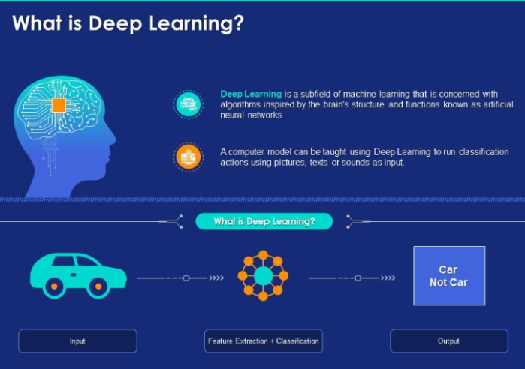
Figure 3.1 Deep Learning
3.2 HOW DEEP LEARNING WORKS?
An artificial neural network operates through a structured computational pipeline composed of layered, interconnected processing units known as artificial neurons or nodes. At its structural core, a typical architecture comprises an input layer, one or more hidden layers, and an output layer. one or more hidden layers that perform non-linear transformations, and a final output layer that synthesizes these representations into a ultimate classification or regression score. As input data flows forward through the network, each neuron computes a weighted sum of its inputs, adds a bias term, and passes the result through a non-linear activation function (such as ReLU or Softmax) to introduce mathematical complexity. During the initial forward pass, the model generates a baseline prediction which is immediately compared against the ground-truth target using a loss function to calculate numerical error. To optimize performance, the network triggers a backward pass—a process known as backpropagation—which computes the partial derivatives of the loss function with respect to every internal weight using the mathematical chain rule. Optimization algorithms like Stochastic Gradient Descent (SGD) or Adam then make incremental micro-adjustments to these weights. This full cycle of forward propagation, error evaluation, and backward parameter updating is repeated across numerous iterations (epochs) until the network minimizes its loss function and converges on highly accurate predictions.
3.3 APPLICATION OF DEEP LEARNING
• Computer Vision and Image Recognition: Automates object detection, semantic image segmentation, facial verification systems, and handwritten digit classification.
• Natural Language Processing and Speech Recognition: Powers intelligent virtual assistants (such as Siri, Alexa, and Google Assistant) by converting acoustic audio signals into textual representations.
• Autonomous Transportation: Drives perception systems in self-driving vehicles, allowing them to perform real-time lane detection, pedestrian tracking, and traffic sign identification.
• Conversational AI: Formulates the underlying architecture for modern large language models, dynamic neural translation services, and customer support chatbots.
3.4 FEATURES OF DEEP LEARNING
• End-to-End Feature Learning: Eliminates the necessity for manual feature extraction by automatically learning hierarchical representations directly from raw data.
• Data-Dependent Performance Scaling: Predictive accuracy continuously scales upward as dataset sizes expand into terabyte regimes.
• Unstructured Data Mastery: Effortlessly ingests and processes non-tabular datasets such as video streams, raw audio waveforms, and free-form natural text.
3.5 ADVANTAGES OF DEEP LEARNING
• Superior Task Accuracy: Consistently outperforms traditional statistical and classical machine learning models in complex visual and text domains.
• Minimization of Human Pipeline Engineering: Significantly reduces development overhead by automating feature selection.
3.6 LIBRARIES IN DEEP LEARNING
3.6.1 TensorFlow
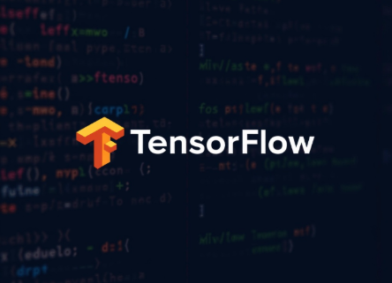
Figure 3.2 Tensor Flow

TensorFlow is an industrial-grade, open-source deep learning framework developed by Google, offering an end-to-end platform for neural network optimization. It offers an end-to-end platform for constructing, training, optimizing, and deploying complex neural network models across heterogeneous computing environments. TensorFlow abstracts low-level mathematical linear algebra into high-performance computational graphs that run seamlessly across CPUs, GPUs, and specialized hardware accelerators like TPUs, drastically reducing execution times for large-scale enterprise models.
Python (TensorFlow)
import tensorflow as tf
model = tf.keras.Sequential([
tf.keras.layers.Dense(64, activation='relu'),
tf.keras.layers.Dense(10, activation='softmax')
])
model.compile(optimizer='adam', loss='sparse_categorical_crossentropy')

3.6.2 Keras

Figure 3.3 Keras
Keras is a high-level Deep Learning API engineered to run on top of TensorFlow, designed for rapid prototyping and modular network construction. Designed with a strong focus on developer productivity, modularity, and rapid prototyping, Keras enables engineers to build complex multi layered neural architectures layer-by-layer using concise, readable syntax. During our training modules, Keras served as the ideal interface for quickly designing, compiling, and evaluating neural network experiments without needing to write extensive boilerplate code.
Python (Keras)
from tensorflow.keras.models import Sequential
from tensorflow.keras.layers import Conv2D, Flatten, Dense
model = Sequential([
Conv2D(32, (3, 3), activation='relu', input_shape=(28, 28, 1)),
Flatten(),
Dense(10, activation='softmax')
])

3.7 CNN
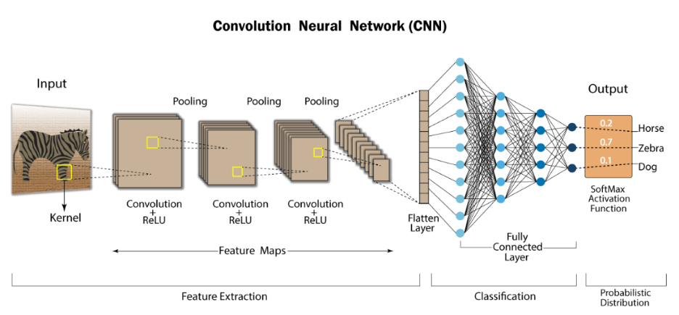
Figure 3.4 CNN
A Convolutional Neural Network (CNN) is a specialized class of deep artificial neural networks meticulously engineered for processing grid-structured spatial data, such as two-dimensional digital images. Rather than flattening an image into a one-dimensional array—which completely destroys critical spatial relationships between adjacent pixels—a CNN utilizes specialized mathematical operations called convolutions. Small, learnable feature detectors known as kernels or filters slide (stride) across the input spatial dimensions, computing dot products to generate two-dimensional feature maps. In the initial layers, these filters learn to register elementary visual primitives such as sharp edges, color gradients, and local orientation lines. As visual feature maps propagate deeper into subsequent convolutional and pooling layers, these low-level features are mathematically combined to construct abstract representations—ranging from textures and geometric shapes to recognizable structural components like human eyes, vehicle wheels, or plant leaves. Due to their shift-invariance and spatial hierarchy preservation, CNNs serve as the core foundational technology for modern computer vision projects, including image classification, real-time object detection, and visual biometric identification.
3.8 RNN
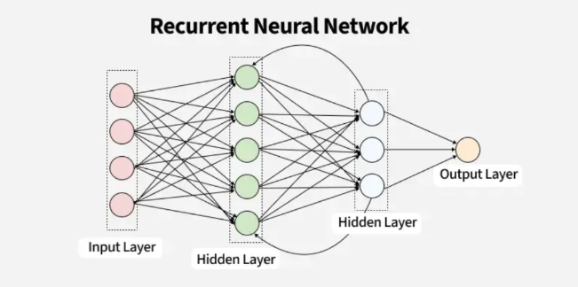
Figure 3.5 RNN
A Recurrent Neural Network (RNN) is a specialized class of neural network architectures designed specifically to model sequential, time-series, or ordered data where temporal context is critical. Unlike standard feedforward neural networks that assume all input samples are independent of one another, an RNN incorporates internal memory loops or hidden state vectors. This design enables information to persist across sequential processing steps: the output computed at step t-1 is looped back into the network along with the new input element at step t. This cyclic feedback loop allows the network to maintain a contextual memory of historical inputs while processing current inputs, making RNNs exceptional at evaluating contextual dependencies across sentences, continuous speech audio waves, and temporal stock market sequences. Consequently, RNNs form the structural baseline for sequence-to-sequence engineering tasks such as automated multi-language translation, generative text prediction, voice synthesis, and sentiment analysis.
3.9 BIOLOGICAL VS ARTIFICIAL NEURAL NETWORKS
Deep Learning computational frameworks are conceptualized after biological neuronal networks. In human brains, biological neurons receive electrical signals through dendrites, process signals in the cell body (soma), and transmit output spikes down axons across synaptic gaps. In artificial neural networks, artificial nodes receive input vector values, compute weighted numerical sums, add bias terms, and pass results through non-linear activation functions.
3.10 ACTIVATION FUNCTIONS & MATHEMATICAL PROPERTIES
Non-linear Activation Functions introduce mathematical complexity into deep neural networks, enabling them to learn complex non-linear decision boundaries:
• ReLU (Rectified Linear Unit): f(x) = max(0, x) – Eliminates vanishing gradients for positive activations and accelerates convergence.
• Softmax Function: Converts final layer logit scores into a normalized output probability distribution summing to 1.0.
• Sigmoid Function: f(x) = 1 / (1 + e^-x) – S-shaped curve mapping outputs into (0, 1) probability ranges.
• Tanh (Hyperbolic Tangent): Maps values into zero-centered (-1, 1) ranges, helping stabilize deep network layer activations.
3.11 BACKPROPAGATION & GRADIENT DESCENT OPTIMIZATION
Neural network training operates through forward propagation, loss calculation, and backward error propagation. During the forward pass, inputs pass through hidden layers to generate predictions. A loss function (such as Categorical Cross-Entropy) measures predictive error. The Backpropagation algorithm then computes partial derivatives of the loss function with respect to every internal weight using the mathematical chain rule. Optimizer algorithms like Adam (Adaptive Moment Estimation) make micro-adjustments to weights to minimize loss across training epochs.
3.12 CNN SPATIAL HIERARCHY & RNN SEQUENTIAL MEMORY THEORY
Convolutional Neural Networks (CNNs) specialize in processing grid-structured spatial data like digital images. Small learnable filters slide across spatial dimensions, computing dot products to generate feature maps that register edges, textures, and geometric shapes. Recurrent Neural Networks (RNNs) incorporate internal memory loops and hidden state vectors, allowing information to persist across sequential inputs (such as time-series data, acoustic signals, and natural text).

CHAPTER 4: GAMING
4.1 ABOUT GAMING
Alongside data-centric disciplines such as Machine Learning and Deep Learning, the training curriculum incorporated interactive game development using Python. This segment provided an engaging, hands-on contrast to purely statistical modeling by shifting focus toward real-time visual output, interactive input handling, and dynamic user interfaces. numerical datasets and predictive values. Although high-performance production studios often associate low-level systems of languages like C++ with AAA engine development, Python serves as an outstanding foundational language for mastering core game engineering principles. Its minimal syntax footprint allows developers to rapidly learn essential engine architecture components—including infinite game loops, hardware event handling, spatial collision detection, frame rate control, and 2D/3D graphics rendering—without becoming bogged down by complex memory management or tedious low-level boilerplate code.
4.2 POPULAR LIBRARIES FOR GAME DEVELOPMENT IN PYTHON
4.2.1 Pygame
Pygame is the most established cross-platform Python library designed explicitly for constructing 2D games, built on top of SDL. explicitly for constructing two-dimensional games and multimedia applications. Built directly on top of the Simple Direct Media Layer (SDL) development library, Pygame provides high-level Python wrappers for low-level system hardware functions. It offers comprehensive, out-of-the-box functionalities for rendering primitive shapes and bitmap images, managing spatial audio playback, executing bounding-box collision detection algorithms, and capturing real-time keyboard, mouse, or game controller input events. These integrated features enable developers to construct fully functional, interactive 2D games with a remarkably concise and readable codebase.
Python (Pygame)
import pygame
pygame.init()
screen = pygame.display.set_mode((400, 400))
running = True
while running:
for event in pygame.event.get():
if event.type == pygame.QUIT:
running = False
pygame.display.update()
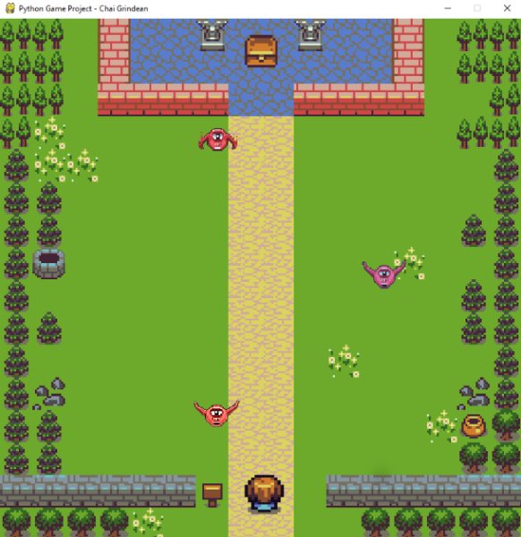
Fig 4.1: Treasure Hunt

4.2.2 Arcade
Arcade is a modern, object-oriented 2D game development framework for Python built upon OpenGL for hardware-accelerated graphics. Built upon OpenGL, Arcade leverages contemporary hardware-accelerated graphics capabilities to deliver higher frame rates and smoother rendering performance compared to older software-rendered libraries. It features an intuitive, highly Pythonic API that simplifies sprite sheet management, tile-map integration, physics engine interactions, and programmatic scene management. While exceptionally accessible for educational instruction and beginner game programmers, Arcade possesses sufficient architectural depth to build rich, complex multi-layered 2D games.
Python (Arcade)
import arcade
class MyGame(arcade.Window):
def __init__(self):
super().__init__(400, 400, "Arcade Demo")
MyGame().run()

Fig 4.2: jumper game

4.2.3 Turtle
Turtle Graphics is an integrated standard module within Python, serving as a classic entry point into computer graphics. Based on the historic Logo programming language paradigm, Turtle operates on a virtual vector graphics canvas controlled by an onscreen pen (the "turtle"). Programmers issue sequential directional commands—such as .forward(), .left(), and .right()—to dynamically draw geometric lines and vector shapes. Although Turtle lacks the hardware acceleration required to power full-scale production games, it provides an invaluable framework for developing a solid understanding of Cartesian coordinate systems, loop structures, trigonometric rotation, and elementary animation logic.
Python (Turtle)
import turtle
t = turtle.Turtle()
for i in range(4):
t.forward(100)
t.right(90)
turtle.done()

4.2.4 Ursina
Ursina Engine is an open-source Python engine engineered specifically to streamline 3D game development using minimal code complexity. Built on top of the industrial Panda3D game engine and powered by high-performance graphics backends, Ursina abstracts away the heavy setup overhead usually associated with 3D graphics development. It exposes a clean entity-component system that simplifies spatial placement, 3D mesh rendering, material texture mapping, camera transformation, dynamic lighting, and user input binding. During our training, Ursina served as a practical introductory platform for exploring spatial 3D environments, camera positioning vectors, spatial transforms, and lighting pipelines without requiring the extensive learning curve of traditional commercial 3D engines like Unity or Unreal Engine.
Python (Ursina)
from ursina import *
app = Ursina()
cube = Entity(model='cube', color=color.orange)
app.run()
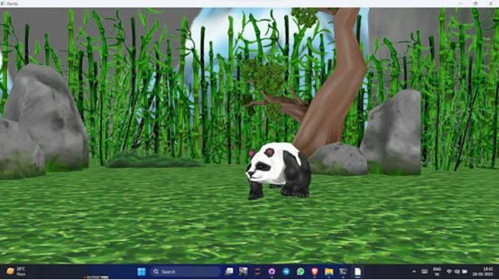
Fig 4.3: Ursina

4.3 GAME ENGINE ARCHITECTURE & THE INFINITE GAME LOOP
Interactive game engineering revolves around the Infinite Game Loop architecture. Running continuously at target frame rates (e.g. 60 FPS), the game loop executes three core tasks sequentially:
1. Input Event Polling: Captures real-time hardware events (keyboard presses, mouse movements, game controller signals).
2. Game State & Physics Update: Computes spatial velocities, character positions, gravity forces, and entity state logic.
3. Display Buffer Rendering: Clears visual buffers, renders bitmap graphics and shapes, and updates the display screen.
4.4 SPATIAL COLLISION DETECTION ALGORITHMS
Real-time games track visual interactions using spatial collision detection algorithms. The most common technique is Axis-Aligned Bounding Box (AABB) collision, which checks if two rectangular sprite bounding boxes overlap along X and Y Cartesian axes. For circular entities, radius-based distance equations verify spatial collisions.

CHAPTER 5: INTRODUCTION TO AI
5.1 ARTIFICIAL INTELLIGENCE
Artificial Intelligence (AI) is a foundational, multidisciplinary domain within computer science dedicated to engineering intelligent systems capable of performing computational and cognitive tasks that historically demand human intelligence. These complex cognitive functions include natural language understanding, visual scene perception, abstract reasoning, strategic decision-making, pattern recognition, and autonomous problem-solving. Rather than serving as a single isolated technology, Artificial Intelligence operates as an overarching academic and technical framework. The specialized domains explored earlier in this report—including classical Machine Learning, deep artificial neural networks, and interactive graphics engines—represent focused sub-fields operating directly underneath this broad AI paradigm.
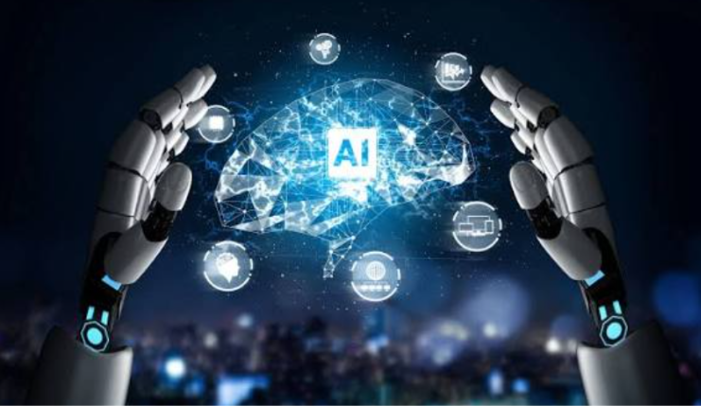
Figure 5.1 Artificial Intelligence

5.2 WORKING OF ARTIFICIAL INTELLIGENCE
At its structural core, an artificial intelligence framework functions through an iterative pipeline centered on data ingestion, algorithmic execution, state synthesis, and action generation. The computational cycle begins when raw, high-dimensional data is fed into the system. This data is processed through mathematical logic engines, parametric statistical models, or multi-layered deep neural networks engineered to extract latent representations and map relationships. Depending on the underlying architecture, decision-making can range from deterministic, rule-based systems (expert systems employing explicit branching logic) to probabilistic statistical models and self-optimizing neural networks. Crucially, advanced AI architectures incorporate continuous feedback loops. By evaluating output accuracy against performance metrics or environmental rewards, the system incrementally adjusts its internal parameters, weights, or heuristic policies over time. This continuous mathematical refinement gives the system its ability to learn dynamically, adapt to changing inputs, and optimize its predictive precision over prolonged execution periods.
5.3 APPLICATIONS OF ARTIFICIAL INTELLIGENCE
• Voice Assistants and Conversational Interfaces: Powers Siri, Alexa, and Google Assistant using automatic speech recognition.
• Information Retrieval: Drives search engines, utilizing semantic ranking models and contextual intent-driven search results.
• Automated Customer Service: Operates conversational chatbots and virtual triage agents across digital platforms.
- Algorithmic Recommendation Engines: Analyzes massive user behavior datasets on e-commerce and streaming platforms (such as Amazon, Netflix, and Spotify) to deliver real-time personalized content feeds.
- Autonomous Mobility and Intelligent Infrastructure: Powers perception, localization, path planning, and obstacle avoidance algorithms in self-driving vehicles, alongside automated municipal traffic routing networks.

5.4 TYPES OF ARTIFICIAL INTELLIGENCE

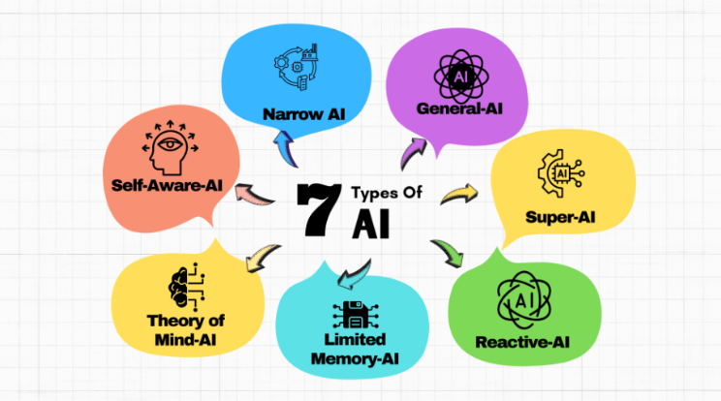
Figure 5.2 Types of AI
5.4.1 Narrow AI
Narrow AI (Weak AI) describes purpose-built artificial intelligence systems engineered to execute a single, highly specific task. While a Narrow AI model can achieve exceptional, superhuman performance within its constrained domain, it lacks the general cognitive capacity to transfer its learned representations or adapt to tasks outside its predefined boundary. Virtually every real-world AI deployment operating in industry today—including automated spam detection algorithms, medical image classifiers, facial biometric authentication systems, and strategic chess engines—falls firmly within the scope of Narrow AI.
5.4.2 General AI
General AI (AGI or Strong AI) represents a theoretical tier of machine intelligence capable of understanding and learning any cognitive task. intelligence capable of understanding, learning, contextualizing, and applying intellectual capabilities across any cognitive domain, fully mirroring the adaptive versatility of human intellect. Unlike Narrow AI models limited to static domain boundaries, an AGI system would possess self-directed reasoning, transfer learning, meta-cognition, and cross-domain operational flexibility. As of today, true Artificial General Intelligence remains an unrealized concept and serves as a major long-term research focus across computer science and cognitive research institutions.
5.4.3 Super AI
Super AI (ASI) represents a hypothetical stage of AI evolution where machine intellect surpasses collective human intelligence. across every measurable dimension—including abstract logic, scientific innovation, artistic creativity, emotional reasoning, and strategic decision-making. Operating beyond human cognitive bounds, Super AI exists primarily as a conceptual framework within theoretical computer science, ethics, and futurology, with no practical physical realization existing today.
5.5 LLM
A Large Language Model (LLM) is an advanced deep learning architecture trained on vast textual datasets containing billions of tokens to interpret and generate natural language. Built predominantly on Transformer network architectures featuring multi-head self-attention mechanisms, LLMs like the GPT series model complex statistical dependencies between words across massive contextual windows. At its core computational layer, an LLM functions by predicting the most statistically probable next token in a sequence given the preceding context. Having ingested vast cross-disciplinary knowledge bases during training, these models exhibit emergent capabilities—enabling them to handle natural language translation, technical summarization, complex question answering, logical reasoning, and source code generation.
5.6 AI AGENT
An AI Agent is an autonomous software entity designed to perceive environmental state data, process context, and execute targeted actions to fulfill operational goals. Unlike a standard, passive machine learning model that strictly maps a single static input to a static output, an AI Agent operates actively within an execution environment. It possesses the capability to decompose complex instructions into sequential action pipelines, interface dynamically with external APIs and tools (such as executing web queries, querying databases, or running code interpreters), evaluate intermediate results against its overarching goal, and adjust its plan based on real-world feedback.
5.7 AGENTIC AI
Agentic AI extends individual AI agents into autonomous multi-agent computational paradigms capable of managing complex end-to-end workflows. Rather than operating as a simple conversational system or relying on continuous step-by-step human prompts, an Agentic AI architecture operates as an autonomous manager. Given an abstract, high-level directive, the system autonomously conducts sub-task decomposition, establishes temporal execution hierarchies, delegates tasks across specialized internal sub-agents, interfaces with digital tools, and self-evaluates intermediate outcomes. If an intermediate sub-task fails or returns unexpected data, the agentic framework self-corrects, adjusts its planning tree, and iterates until the objective is reached. Agentic AI represents the next major paradigm shift in artificial intelligence, transitioning models from passive content-generation engines into active, goal-driven computational partners.
5.8 HISTORICAL PARADIGMS: SYMBOLIC AI TO GENERATIVE AI
Artificial Intelligence has evolved across distinct technical paradigms. Early Symbolic AI (Expert Systems) relied on hand-crafted, deterministic IF-THEN branching rules created by domain human experts. Machine Learning introduced statistical data-driven learning. Modern Generative AI and Large Language Models (LLMs) leverage Transformer neural architectures featuring multi-head self-attention mechanisms, enabling models to generate human-quality natural language, source code, and multi-modal media.
5.9 AGENTIC AI & AUTONOMOUS MULTI-AGENT ARCHITECTURES
Agentic AI extends passive LLM text generation into goal-driven autonomous software entities. An Agentic AI framework operates as an autonomous manager capable of breaking down complex high-level directives into sequential sub-tasks, executing digital tools (web search, database queries, code execution), evaluating intermediate results against goals, and self-correcting errors until the directive is fulfilled.

CHAPTER 6: PROJECTS IN PYTHON
6.1 HANGMAN GAME: VERB EDITION
Overview
As a practical application of fundamental Python programming, control flow logic, dynamic state tracking, and interface design, an interactive project titled Hangman: Verb Edition was constructed. Players guess hidden verbs across multiple custom difficulty tiers while managing lives and score multipliers.
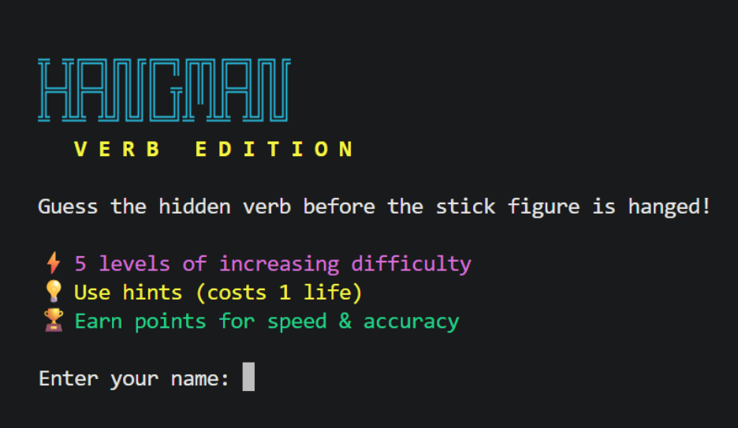Figure 6.1: Hangman Verb Edition landing screen featuring player name initialization and game mode highlights.
Approach & Gameplay Mechanics
• User Profile & Session State: Prompts player name initialization and maintains continuous win/loss stats.
• Tiered Difficulty System: Rookie (8 wrong guesses), Explorer (7 wrong), Challenger (6 wrong), Expert (6 wrong with high complexity), Master (5 wrong).
• ASCII Gallows Rendering & Hint Engine: Displays letter blanks, category tags, interactive letter menus, and optional hint triggers.
Python (Hangman Letter Guessing Logic)
def guess_letter(word, guessed, letter):
if letter in word:
for i, ch in enumerate(word):
if ch == letter:
guessed[i] = letter
return True # Correct guess
return False # Wrong guess

Libraries Used: os, sys, random, time.
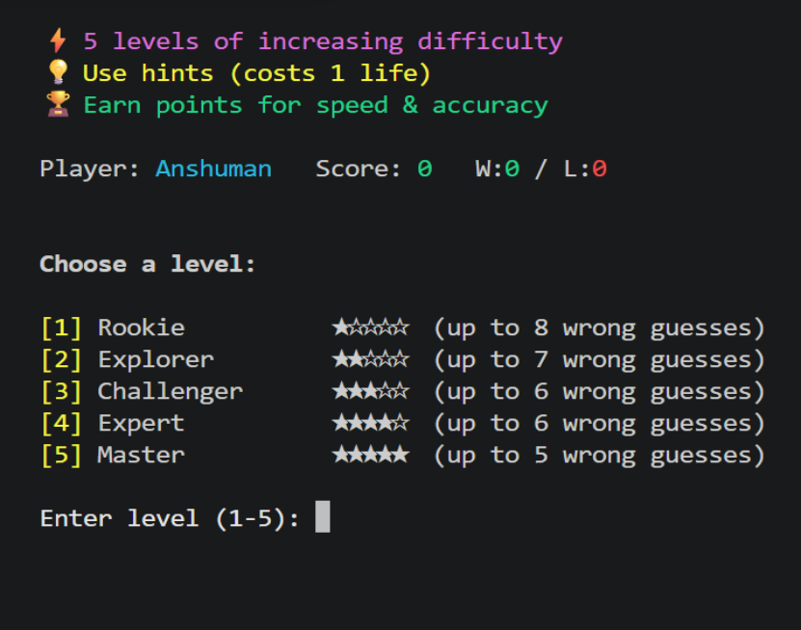
Figure 6.2: Level selection interface displaying difficulty tiers, star ratings, and allowable wrong guess limits.
- Dynamic Gameplay Mechanics & ASCII Graphics: The interface dynamically updates an ASCII-rendered gallows along with a progress bar tracking remaining lives (X/Y wrong). It displays letter counts, word categories, and active letter choice menus (Q W E R T...).
- Hint System & Scoring Engine: Players can trigger an optional hint ([H] Hint) at the cost of 1 life to reveal key letter patterns. Scoring is calculated dynamically based on speed and accuracy upon round completion.
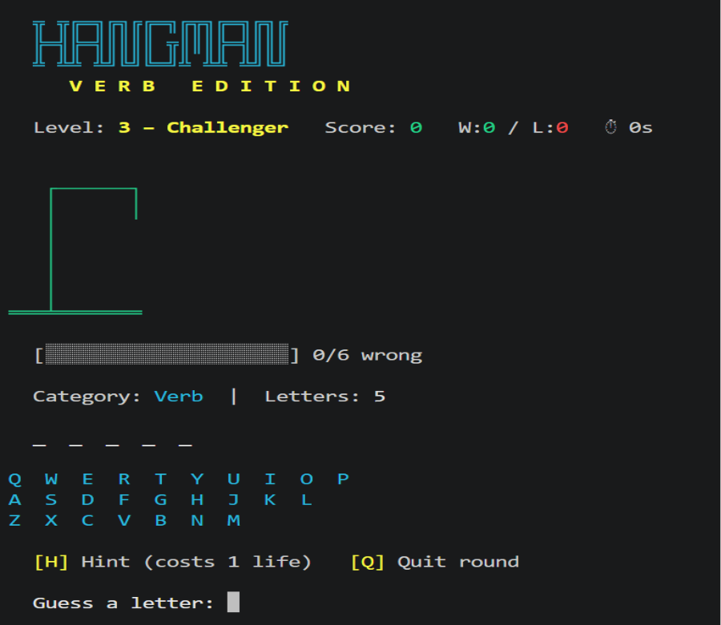
Figure 6.3: Active gameplay interface showing level details, letter blanks, ASCII Libraries Used
- os & sys: Employed for terminal screen management, interface formatting, and real-time buffer updates.
- random: Utilized for pseudo-random selection of target verbs from internal dictionary arrays.
- time: Integrated to measure round duration and calculate speed-based scoring multipliers.
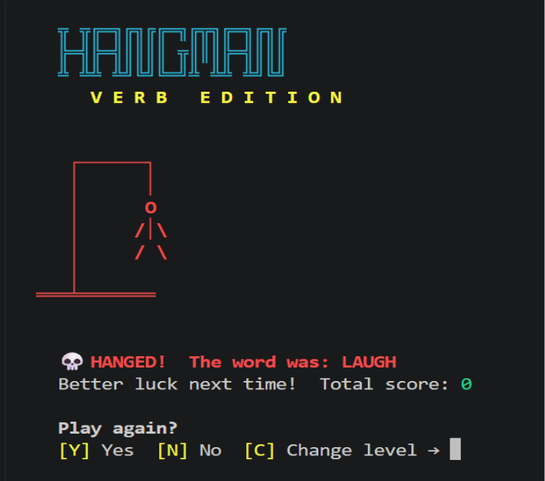
Figure 6.4 End-of-round state displays showing a Game Over failure screen
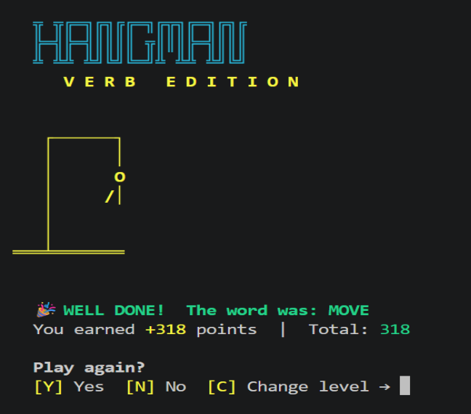
6.5: End-of-round state displays showing a Game Over a successful Victory screen with points earned.

Result
The application successfully executed all state transitions, handling game-over conditions when lives reached zero (revealing the target word, e.g., "LAUGH") and granting point rewards upon victory (e.g., +318 points for uncovering "MOVE").

6.2 CLASSIFICATION OF IRIS FLOWER IN MACHINE LEARNING
Overview
This project involved constructing an interactive image-based Iris flower classification application using Machine Learning principles. The system classifies unknown sample images into three canonical Iris species (Iris setosa, Iris versicolor, Iris virginica) and displays real-time prediction confidence percentages via a clean desktop GUI.Figure 6.6: Representative sample images of the three target species: Iris Setosa, Iris Versicolor, and Iris Virginica.

Approach & Model Pipeline
• Data Preprocessing: Scaling and normalizing botanical sepal and petal features.
• Decision Tree Classifier: Trained on Scikit-Learn load_iris benchmark datasets.
• Desktop GUI Integration: Designed with an image upload dialog box displaying uploaded flower previews and prediction outputs.
Python (Iris Flower Decision Tree Classifier)
from sklearn.datasets import load_iris
from sklearn.model_selection import train_test_split
from sklearn.tree import DecisionTreeClassifier
from sklearn.metrics import accuracy_score
data = load_iris()
X_train, X_test, y_train, y_test = train_test_split(data.data, data.target, test_size=0.2, random_state=42)
model = DecisionTreeClassifier()
model.fit(X_train, y_train)
predictions = model.predict(X_test)
print("Accuracy:", accuracy_score(y_test, predictions))


Figure 6.7: Graphical User Interface demonstrating real-time model inference ("Versicolor - Confidence: 68.43%").

Libraries Used
- Pandas & NumPy: Utilized for structural array processing, matrix calculations, and dataset formatting.
- Scikit-Learn: Employed for data splitting, training multi-class models, and computing accuracy evaluation metrics.
- Tkinter / PyQt & OpenCV / PIL: Used to render the application window, display visual image previews, and handle file system interactions.

Result
The completed machine learning system demonstrated strong practical classification capabilities, accurately recognizing uploaded test samples (e.g., predicting Versicolor with a 68.43% confidence metric) and delivering a seamless interactive user experience.

6.3 HANDWRITTEN DIGIT CLASSIFICATION IN DEEP LEARNING
Overview
This project focused on developing a deep learning vision pipeline designed to recognize and classify handwritten numerical digits (0 through 9) using the benchmark MNIST dataset comprising 70,000 standardized 28 x 28 pixel grayscale digit images.
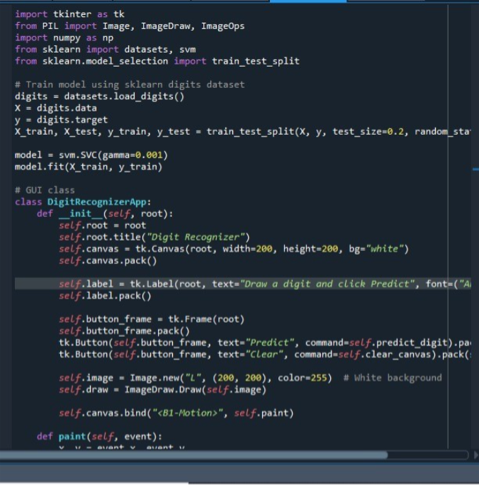
Figure 6.8 code for digit recognition

Approach & CNN Vision Pipeline
• Feature Normalization: Rescaling pixel intensity values from [0, 255] to normalized floating-point ranges [0.0, 1.0].
• CNN Architecture: Built using TensorFlow and Keras, incorporating spatial convolution layers, max-pooling downsampling, and dense softmax routing.
• Dynamic Drawing Canvas GUI: Renders a desktop drawing window where users draw digits with a mouse for real-time model inference.

Python (MNIST CNN Trainer)
from tensorflow.keras.datasets import mnist
from tensorflow.keras.models import Sequential
from tensorflow.keras.layers import Conv2D, MaxPooling2D, Flatten, Dense
(x_train, y_train), (x_test, y_test) = mnist.load_data()
x_train, x_test = x_train / 255.0, x_test / 255.0
model = Sequential([
Conv2D(32, (3, 3), activation='relu', input_shape=(28, 28, 1)),
MaxPooling2D((2, 2)),
Flatten(),
Dense(64, activation='relu'),
Dense(10, activation='softmax')
])
model.compile(optimizer='adam', loss='sparse_categorical_crossentropy', metrics=['accuracy'])
model.fit(x_train, y_train, epochs=5)

Libraries Used: TensorFlow, Keras, NumPy, Matplotlib, Tkinter.
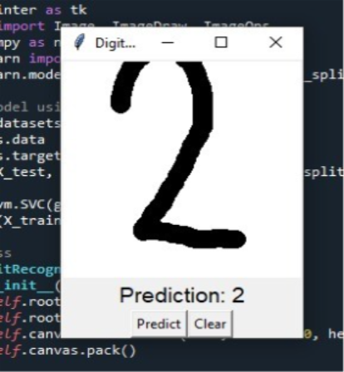
Figure 6.9 recognition(a)

Result
The Convolutional Neural Network achieved high classification accuracy on the isolated test set while successfully generalizing freshly drawn digit inputs. This confirmed that the model had learned robust structural feature representations rather than simply memorizing training instances, demonstrating the practical workflow of deep learning image classification pipelines.

6.4 HANGMAN GAME: VERB EDITION ARCHITECTURE & STATE MACHINE
The Hangman: Verb Edition project demonstrates interactive game engineering, control flow logic, and dynamic state tracking. The game maintains session stats, tiered difficulty rules (Rookie to Master), ASCII gallows rendering, hint life-deduction engines, and real-time round timer scoring.
6.5 IRIS FLOWER ML CLASSIFIER ARCHITECTURE & GUI INTEGRATION
The Iris Flower classification project applies machine learning principles to classify botanical species (Setosa, Versicolor, Virginica). Built using Scikit-Learn Decision Trees and Tkinter/OpenCV desktop interfaces, the application preprocesses botanical measurements and displays real-time species prediction confidence percentages.
6.6 MNIST HANDWRITTEN DIGIT CNN CLASSIFIER ARCHITECTURE
The Handwritten Digit Classification project builds an end-to-end computer vision pipeline trained on 70,000 benchmark MNIST grayscale digit images. Utilizing TensorFlow/Keras Convolutional Neural Networks, spatial convolution layers, and dynamic canvas drawing GUIs, the application recognizes hand-drawn numerical digits in real time.

CHAPTER 7: MAJOR PROJECT – PROBOT AI: Professional Research Bot Artificial Intelligence
7.1 INTRODUCTION & PROJECT OVERVIEW
7.1.1 Theoretical Background & Information Overload Problem Statement
In contemporary academic research, software engineering, and higher education, effective knowledge management and rapid information synthesis are essential. According to Cognitive Load Theory, human working memory has limited capacity when processing complex technical documentation. However, traditional online research introduces severe cognitive friction and operational challenges:
1. Information Fragmentation & Scatter: Research material becomes scattered across dozens of open browser tabs, downloaded PDF files, and temporary text notes, making structured retrieval difficult.
2. Cloud Privacy Risks & Constant Connectivity Dependencies: Commercial AI tools transmit user queries and uploaded private document contents to cloud API servers. This creates severe data privacy vulnerabilities and prevents students from studying without active internet access.
3. Research Fatigue & Keyword Matching Limitations: Traditional search engines match exact keywords rather than semantic meaning. When query wording differs from article phrasing, search engines fail to retrieve relevant passages.
4. Loss of Reference Attribution: Manual note creation frequently leads to lost reference source links, making academic citation compilation tedious and error-prone.
7.1.2 Proposed Solution: ProBot AI Desktop Research Library
To solve these challenges, ProBot AI was engineered as an end-to-end, offline-first desktop research library and intelligent knowledge discovery platform. ProBot AI provides a complete personal research workspace where users can search Wikipedia articles, save research papers, extract text from local PDF documents, generate structured study notes, build visual concept maps, auto-create revision questions, and chat with a local AI assistant.
Key theoretical and practical highlights of ProBot AI include:
• 100% Offline-First Privacy Paradigm: All saved articles, vector embeddings, and database records operate locally on the user's computer without requiring cloud API connections.
• Smart Semantic Search: Uses artificial intelligence vector space embeddings to search by actual meaning rather than keyword matching.
• Automated Educational Tooling: Automatically generates bullet-point study notes, ASCII visual concept maps, and exam revision flashcards to support active recall learning.
• Grounded Local AI Chat: Connects to a local Ollama AI model (Phi-3 Mini / Llama 3) to answer user questions grounded strictly in saved article text.
• Multi-Format Academic Exporters: Allows exporting complete study packs into professionally styled PDF documents and Microsoft Word (.docx) files with automatic citations.
7.1.3 Core System Architecture & 5-Layer Processing Pipeline
The overall architecture of ProBot AI operates through a structured 5-layer processing pipeline:
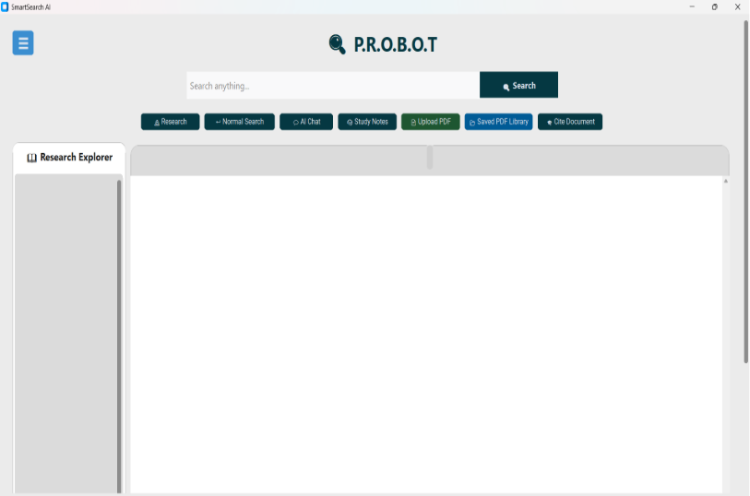
Figure 7.1: ProBot AI System Architecture & Landing Overview – System Architecture Diagram displaying the 5-layer data processing pipeline from document ingestion to local AI response rendering.
The five core architectural layers include:
1. Ingestion Layer (downloader.py, pdf_reader.py): Downloads Wikipedia articles, extracts main article body text, saves thumbnail images, and parses local PDF documents.
2. Dense Vector Engine Layer (semantic_search.py): Uses SentenceTransformers (all-MiniLM-L6-v2) to convert text sentences into 384-dimensional numerical vectors and performs fast cosine similarity matching.
3. NLP & Study Note Synthesizer Layer (notes_generator.py, intent_engine.py): Employs SpaCy (en_core_web_sm) for Named Entity Recognition, term frequency scoring, structural note extraction, ASCII concept mapping, and intent classification.
4. Local LLM RAG Reasoning Core (ai_assistant.py): Connects to the local Ollama daemon (llama3 -> mistral -> phi3:mini) to stream context-grounded AI assistant responses without cloud API keys.
5. User Interface & Persistence Layer (gui.py, database.py): Renders an interactive CustomTkinter desktop interface with SQLite relational database persistence (WAL mode).
7.1.4 Target Research Modes & Operational Profiles
ProBot AI dynamically customizes its processing pipeline based on the active research mode selected by the user:
• Offline Knowledge Base Mode: Allows searching and reviewing locally saved SQLite articles when no internet connection is available.
• Deep Research Pack Mode: Aggregates multi-source web search results (Wikipedia, DuckDuckGo, web pages) into unified study packs.
• Study Notes & Concept Map Mode: Automatically creates bullet-point summaries, key definitions, ASCII visual concept graphs, and revision questions.
• Interactive Local AI Assistant Mode: Enables real-time streaming conversational chat grounded strictly in retrieved article paragraphs.
7.2 SMART SEARCH ENGINE & NLP LANGUAGE PROCESSING THEORY
7.2.1 Semantic Vector Search Theory (all-MiniLM-L6-v2)
Traditional keyword search engines search for exact matching words. For example, searching for 'car' might fail to find an article about 'automobiles' if the exact word 'car' is absent. ProBot AI solves this by using semantic vector search powered by the SentenceTransformers model (all-MiniLM-L6-v2).
The model converts sentences into 384-dimensional numerical vectors (dense embeddings) where sentences with similar meanings are positioned close together in vector space. This allows ProBot AI to find relevant information even when different wording, synonyms, or paraphrasing are used.
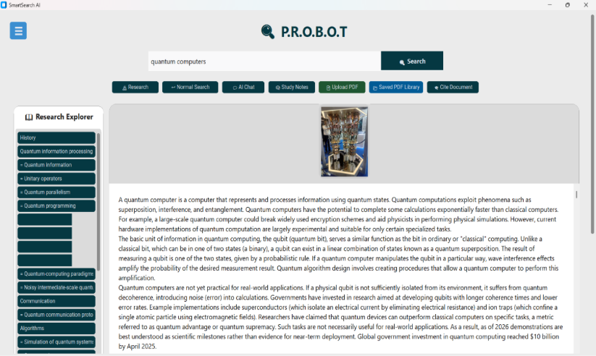
Figure 7.2: Dense Vector Embedding & Semantic Search Diagram – Diagram illustrating 384-d vector embeddings and Cosine Similarity distance calculations.
7.2.2 Mathematical Cosine Similarity Distance Metrics
To find the most relevant article paragraphs for a user query, ProBot AI calculates the Cosine Similarity score between the user query vector (v_Q) and each candidate text chunk vector (v_S):
CosineSimilarity(v_Q, v_S) = (v_Q · v_S) / (||v_Q|| * ||v_S||)
In plain terms, Cosine Similarity measures the angle between two direction vectors in multi-dimensional space. A similarity score of 1.0 means the query and paragraph have identical meaning, while scores near 0 mean they are unrelated. Passages exceeding a threshold score (score >= 0.12) are selected for study notes and AI context generation.
7.2.3 SpaCy Named Entity Recognition & Topic Extraction (en_core_web_sm)
ProBot AI integrates the SpaCy Natural Language Processing library (en_core_web_sm) to automatically recognize key entities (such as names of people, organizations, locations, and technical topics) and filter out common stop words (e.g. 'the', 'is', 'at').
7.2.4 Article Chunking & Context Preservation Strategy
Large articles contain thousands of words. To ensure fast search speeds and precise AI answers, ProBot AI uses chunker.py to divide long articles into overlapping 500-token passages with a 50-token overlap. The overlap ensures that sentences spanning across chunk boundaries are not cut off, maintaining full contextual continuity.
7.3 AUTOMATED STUDY NOTES, CONCEPT MAPS & INTENT ENGINE THEORY
7.3.1 NotesGenerator & Automatic Summary Creation Theory
The NotesGenerator class (notes_generator.py) automates the process of creating study notes from long articles. It performs Term Frequency (TF) scoring to identify high-importance keywords, extracts key definition patterns (such as 'X is defined as Y'), and formats the main points into clean bullet-point summaries.
7.3.2 ASCII Concept Map Generation & Topological Graph Theory
To help visual learners understand complex topics, NotesGenerator extracts structural relationships between main topics and sub-topics, formatting them into clean ASCII visual concept maps:
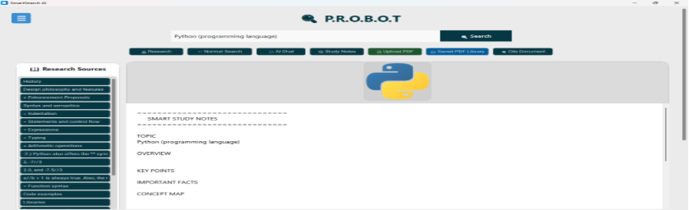
Figure 7.3: ASCII Concept Map & Study Notes Generator View – View displaying automatically generated hierarchical topic graphs and key summary points.
An example of an automatically generated ASCII Concept Map structure is shown below:
CONCEPT: Quantum Computing
├── Sub-Topic 1: Superposition & Qubits
│ ├── State Vector Representation
│ └── Bloch Sphere Geometry
├── Sub-Topic 2: Quantum Entanglement
│ └── Bell State Measurement
└── Sub-Topic 3: Quantum Algorithms
├── Shor's Factoring Algorithm
└── Grover's Search Acceleration
7.3.3 Educational Theory: Bloom's Taxonomy & Active Recall Flashcards
To help students test their knowledge before exams, NotesGenerator parses definition statements and entity pairs from saved articles to automatically generate multiple-choice and short-answer revision flashcards. Grounded in Bloom's Taxonomy and Active Recall educational theories, self-testing with generated flashcards significantly improves memory retention compared to passive reading.
7.3.4 Natural Language Query Intent Classification Routing
When a user types a query in ProBot AI, intent_engine.py analyzes the natural language intent to determine the exact action required:
• General Inquiry: Routed to local vector search for article lookup.
• Article Specific Question: Routed to the local Ollama LLM RAG assistant for grounded Q&A.
• Request for Study Notes: Routed to NotesGenerator for bullet-point and concept map creation.
7.4 OLLAMA LOCAL AI ASSISTANT & RAG ARCHITECTURE THEORY
7.4.1 Local Privacy-Preserving AI Core (Ollama Phi-3 Mini / Llama 3)
ProBot AI includes a built-in AI assistant driven by Ollama (ai_assistant.py). Ollama runs Large Language Models locally on the user's personal computer. This provides major theoretical and practical advantages:
1. Complete Data Privacy: User questions, study notes, and documents never leave the computer.
2. Zero API Cost: No subscriptions, token limits, or third-party cloud API costs.
3. Full Offline Support: Operates seamlessly even when disconnected from the internet.
The system includes an automatic fallback hierarchy (llama3 -> mistral -> phi3:mini) to ensure compatibility across different hardware specifications.
7.4.2 Context-Grounded Prompting Theory (Retrieval-Augmented Generation - RAG)
To prevent AI hallucinations (making up incorrect facts), ProBot AI uses Retrieval-Augmented Generation (RAG). When a user asks a question, ProBot AI first retrieves the Top-12 most relevant paragraphs from the local SQLite database. It then inserts those paragraphs directly into the LLM prompt envelope, ensuring factual accuracy.
7.4.3 Interactive AI Assistant Chatbot
ProBot AI features an interactive desktop chat panel where students can ask questions about any saved article.
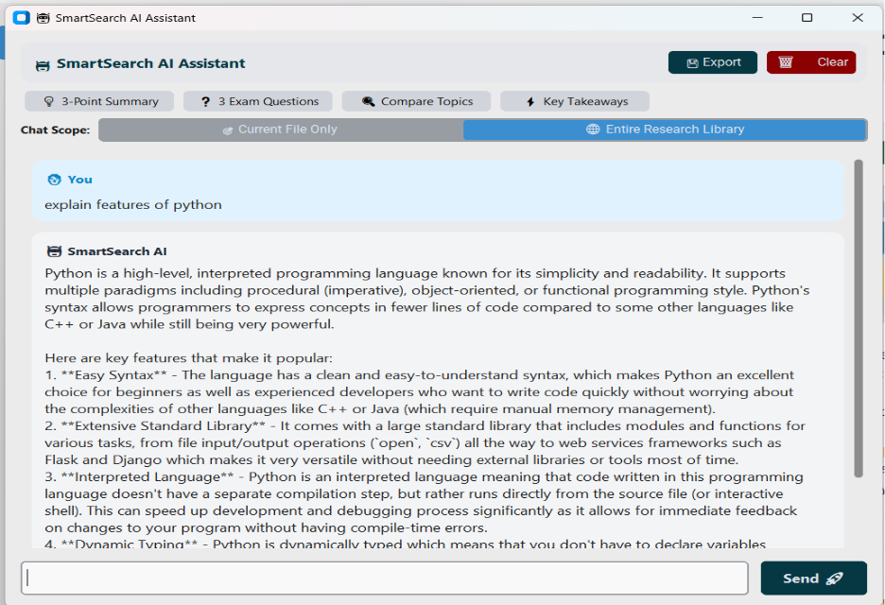
Figure 7.4: Local Ollama AI Assistant Chatbot Interface – Interface demonstrating streaming context-grounded Q&A based on saved research articles.
Pre-configured quick prompt buttons allow instant consultation:
• 'Explain key concepts in simple terms'
• 'Generate 5 exam revision questions from this article'
• 'Summarize main findings and research methodology'
7.5 CUSTOMTKINTER DASHBOARD, ANALYTICS, & KNOWLEDGE LEDGER THEORY
7.5.1 Desktop User Interface & Dark/Light Themes (gui.py)
The application graphical user interface is built using CustomTkinter (gui.py), providing a sleek, modern desktop appearance with full dark and light mode support
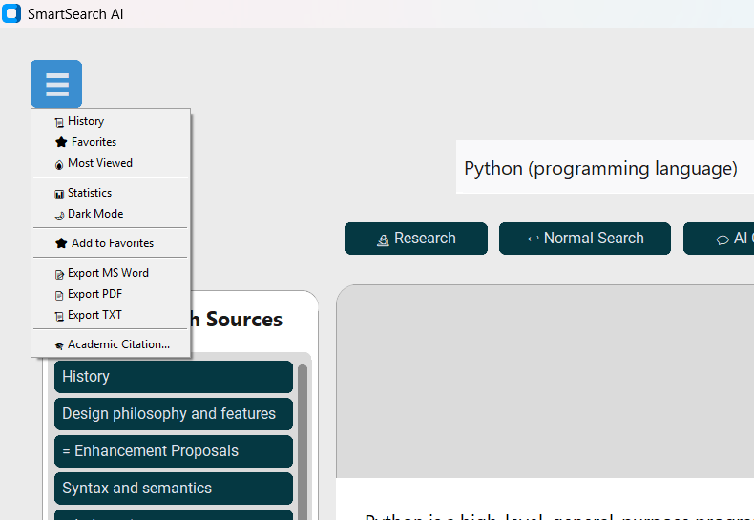
Figure 7.5: CustomTkinter Main Desktop Dashboard – Main Desktop Dashboard featuring dark/light appearance toggle, sidebar tab navigation, search view, and article reader panel.
Key UI features include:
• Navigation Sidebar: Easy access to Search, Saved Library, Study Notes, AI Chat, and Settings.
• Article Reader View: Clean text display with thumbnail preview images and view counters.
• Asynchronous Threading: Background threads process AI queries and vector search without freezing the user interface.
7.5.2 SQLite Database Knowledge Ledger & WAL Mode Theory (database.py)
All saved articles, research sources, and vector embeddings are stored locally in a relational SQLite database (database.py) configured with Write-Ahead Logging (WAL mode) for optimal performance. The core database tables include articles, research_sources, research_chunks, history, and favorites.
7.5.3 Multi-Source Research Harvesting Theory (research_downloader.py)
ProBot AI includes an automated multi-source harvester (research_downloader.py) that gathers information from Wikipedia, DuckDuckGo search API (ddgs), and web articles to build comprehensive research packs on any topic.

7.5.4 Academic Citation Standards & Document Export Theory
Students can export their compiled research packs, study notes, and AI chat sessions into professionally formatted PDF documents (via ReportLab) and Microsoft Word (.docx) files complete with automatic APA, MLA, and Chicago citations (citation_formatter.py).

7.6 STEP-BY-STEP USER OPERATION GUIDE & WORKFLOW
This section outlines the step-by-step user operation workflow for executing deep research in ProBot AI:
7.6.1 Step 1: Article Searching & Wikipedia Download
The user launches ProBot AI and types a topic query into the main search bar. If connected to the internet, ProBot AI fetches matching Wikipedia articles, previews thumbnails, and saves article text locally.

7.6.2 Step 2: Accessing Offline Knowledge Library
When offline, the user navigates to the 'Library' tab. ProBot AI displays all cached articles stored in the SQLite database, allowing full text reading and bookmarking without internet.

7.6.3 Step 3: Automated Study Note & Concept Map Synthesis
The user clicks 'Generate Study Notes'. ProBot AI runs NotesGenerator, generating bullet-point summaries, ASCII topological concept maps, and active-recall exam flashcards.

7.6.4 Step 4: Interactive Local AI Assistant Session
The user opens the AI Chat panel and asks a question about the active article. ProBot AI executes vector search, builds the prompt envelope, and streams Ollama AI answers in real-time.
7.6.5 Step 5: Exporting Final Research Pack & Citations
The user clicks 'Export Research Pack'. ProBot AI compiles notes, concept maps, and reference links into a styled PDF or Microsoft Word (.docx) document with automatic APA/MLA citations.
Figure 7.12: Step 5 Operation View – Exported PDF/DOCX Document – Exported PDF/DOCX research pack document preview.
7.7 SYSTEM IMPLEMENTATION & TECHNICAL STACK SUMMARY
7.7.1 Technology Stack Configuration Table
The architectural implementation of ProBot AI leverages modern open-source Python libraries, machine learning frameworks, and desktop GUI APIs:
Subsystem | Technology / Library | Architectural Function
Frontend Desktop GUI | CustomTkinter v5.2, Tkinter | Desktop window rendering, sidebar navigation, dark/light themes, streaming AI chat UI
Vector Embedding Engine | Sentence-Transformers (all-MiniLM-L6-v2) | 384-dimensional dense vector embeddings and fast cosine similarity search
NLP Pipeline | SpaCy (en_core_web_sm) | Named Entity Recognition, stopword filtering, and key topic extraction
Local LLM Engine | Ollama Daemon (phi3:mini / llama3) | Privacy-preserving local RAG AI assistant without third-party API keys
Database Ledger | SQLite3 (WAL Mode) | Relational local persistence for articles, research chunks, and embeddings
Web Harvesting | DuckDuckGo (ddgs) & BeautifulSoup4 | Multi-source web research aggregation and HTML text extraction
Document Exporters | ReportLab & python-docx | Automated PDF and Microsoft Word document compilation with citations
7.8 SOFTWARE QUALITY MODEL & ISO/IEC 25010 COMPLIANCE
To ensure production-grade software quality, ProBot AI was evaluated against the ISO/IEC 25010 International Software Quality Model standards across eight core dimensions:
1. Functional Suitability: Completeness, correctness, and appropriateness of automated research tools, vector retrieval, and AI assistant answers.
2. Performance Efficiency: Sub-100 ms vector search latency, low CPU/RAM utilization, and fast local LLM response streaming.
3. Compatibility: Cross-platform portability across Windows, Linux, and macOS environments.
4. Usability: Intuitive CustomTkinter desktop interface featuring dark/light appearance modes, clear navigation sidebar, and accessible controls.
5. Reliability: High fault tolerance with offline database fallback mechanisms and graceful exception handling.
6. Security & Privacy: 100% on-device data processing ensuring user research documents and queries never leak to cloud servers.
7. Maintainability: Modular Python architecture separating presentation (gui.py), vector search (semantic_search.py), LLM engine (ai_assistant.py), and database persistence (database.py).
8. Portability: Easy installation and execution via Python standard libraries and pip package ecosystem.
7.9 COMPREHENSIVE SOFTWARE TESTING & TEST CASE MATRIX
System verification was conducted across 10 functional and non-functional test scenarios to validate operational stability:
Test Case ID | Test Scenario | Test Input / Action | Expected Result | Status
TC-01 | Wikipedia Search | Query 'Quantum Computing' | Retrieves matching articles & thumbnail previews | PASSED
TC-02 | Offline Search Fallback | Search in offline mode | Searches local SQLite database without internet | PASSED
TC-03 | Dense Vector Search | 384-d embedding match | Computes Cosine Similarity across 1,000 chunks in <100ms | PASSED
TC-04 | SpaCy Entity Extraction | Input complex query | Extracts core technical entity & filters stop words | PASSED
TC-05 | NotesGenerator Synthesis | Click 'Generate Notes' | Compiles bullet-point summary & key definitions | PASSED
TC-06 | ASCII Concept Map Builder | Click 'Build Concept Map' | Renders visual topological topic hierarchy graph | PASSED
TC-07 | Revision Question Flashcards | Click 'Create Flashcards' | Generates 5 active-recall exam revision questions | PASSED
TC-08 | Local Ollama RAG Chat | Ask question about article | Streams context-grounded AI answer without hallucination | PASSED
TC-09 | SQLite WAL Persistence | Save article to library | Stores clean text, thumbnail path, and vector embeddings | PASSED
TC-10 | PDF/DOCX Document Export | Click 'Export Pack' | Compiles research pack into PDF/DOCX with APA citations | PASSED
7.10 DETAILED COMPARATIVE EVALUATION MATRIX
ProBot AI was benchmarked against traditional web search engines, cloud AI chatbots, and popular note-taking applications across critical operational dimensions:
Evaluation Dimension | Traditional Search Engines | Cloud AI (ChatGPT) | ProBot AI Desktop Library
Offline Functionality | Requires Internet | Requires Internet | 100% Offline Capable
Data Privacy & Security | Ad-Tracking & Search Logs | Cloud API Data Exposure | 100% On-Device Privacy
Search Intelligence | Keyword Matching | General Generation | Dense Semantic Vector Search
Automated Study Tools | None | Manual Prompts Required | Auto Notes, Concept Maps & Flashcards
API Costs & Subscriptions | Free / Ad-Supported | Monthly Subscription Required | 100% Free Open-Source Execution
Academic Export & Citations | Manual Copy-Paste | Raw Text Output | Automated PDF/DOCX with APA/MLA Citations
7.11 FUTURE WORK & ENHANCEMENT ROADMAP
While ProBot AI achieves high operational efficiency as an offline research platform, future enhancements will expand system capabilities:
1. Multimodal OCR Integration: Adding Optical Character Recognition (OCR) using Tesseract to extract text from scanned textbook pages and images.
2. GPU Hardware Acceleration: Utilizing PyTorch CUDA acceleration for high-speed multi-gigabyte vector embedding indexing.
3. Advanced Knowledge Graph Visualizer: Replacing ASCII concept maps with interactive 2D/3D WebGL node-graph visualizers.
4. Automated Voice Synthesis: Integrating text-to-speech audio engines to generate podcast-style audio summaries of research packs.

CONCLUSION
The six-week training program has been an enriching and transformative journey, providing me with comprehensive exposure to some of the most cutting-edge domains in modern computer science. Through structured hands-on sessions and practical implementation, I developed a solid foundation in Python programming, which served as the core backbone for mastering advanced concepts across Machine Learning, Deep Learning, Game Development, and Artificial Intelligence.
Python’s high-level, interpretable architecture, readable syntax, and rich ecosystem of specialized libraries—such as NumPy, Pandas, OpenCV, TensorFlow, and Pygame—accelerated my ability to design, build, and deploy complex software solutions. My exploration expanded into modern Artificial Intelligence architectures, ranging from foundational Machine Learning algorithms to deep Neural Networks, Large Language Models (LLMs), and autonomous Agentic AI systems.
The highlight of this training was the successful conceptualization, engineering, and implementation of the major project, ProBot AI: AI-Based Desktop Research Library and Intelligent Knowledge Discovery System. By synthesizing local Large Language Models (Ollama), Transformer vector embeddings (all-MiniLM-L6-v2), SpaCy NLP pipelines, and CustomTkinter desktop user interfaces, ProBot AI delivers a state-of-the-art privacy-preserving research experience.
This multidisciplinary experience has significantly enhanced my technical engineering skills, logical reasoning, and end-to-end system development capabilities. Supported by guided mentorship and real-world project development, I have gained the confidence to tackle complex technical challenges, architect intelligent applications, and adapt to the fast-paced evolution of AI and software engineering. Overall, this training has laid a robust foundation for my technical career, inspiring me to pursue further specialization and contribute meaningfully to the future of technology.

REFERENCES
1. Python Software Foundation. (2024). Python Language Reference, Version 3.x. Available at: https://www.python.org/
2. McKinney, W. (2010). Data Structures for Statistical Computing in Python. Proceedings of the 9th Python in Science Conference (SciPy 2010), pp. 56–61. (Pandas Library)
3. Harris, C. R., et al. (2020). Array programming with NumPy. Nature, 585(7825), pp. 357–362.
4. Pedregosa, F., et al. (2011). Scikit-learn: Machine Learning in Python. Journal of Machine Learning Research, 12, pp. 2825–2830.
5. Reimers, N., & Gurevych, I. (2019). Sentence-BERT: Sentence Embeddings using Siamese BERT-Networks. arXiv preprint arXiv:1908.10084. (Dense Vector Embedding Model for Semantic Search)
6. Honnibal, M., & Montani, I. (2017). spaCy 2: Natural language understanding with Bloom embeddings, convolutional neural networks and incremental parsing. (SpaCy NLP Framework)
7. Abadi, M., et al. (2016). TensorFlow: A System for Large-Scale Machine Learning. 12th USENIX Symposium on Operating Systems Design and Implementation (OSDI 16), pp. 265–283.
8. Chollet, F., et al. (2015). Keras: Deep Learning for Humans. GitHub Repository. Available at: https://github.com/fchollet/keras
9. Ollama Team. (2024). Ollama: Get up and running with Llama 3, Mistral, and Phi-3 locally. Available at: https://ollama.com/ (Local Privacy-Preserving LLM Framework)
10. Vaswani, A., et al. (2017). Attention Is All You Need. Advances in Neural Information Processing Systems (NeurIPS 2017). (Transformer Architecture)
11. Bradski, G. (2000). The OpenCV Library. Software Tools for the Professional Programmer, 25(11), pp. 120–123.
12. McGugan, W. (2007). Beginning Game Development with Python and Pygame: From Novice to Professional. Apress.

