Predicting Dementia Using Brain Scan Measurements and Patient Health Data: A Person-Wise Validated, Explainable Machine Learning Study on OASIS
DHRUV MUKHERJEE
PRN 23070521047
Healthcare Analytics Mini Project (CA-III)
Symbiosis Institute of Technology, Nagpur
Nagpur, Maharashtra, India

Abstract—This project asks a practical question: does combining simple brain-scan measurements with patient details improve dementia-group classification? I trained Logistic Regression, Random Forest and SVM models on the OASIS-2 longitudinal dataset, using seven inputs: eTIV, nWBV, ASF, age, sex, SES and MMSE. To avoid giving the model repeated views of the same person, I used five-fold validation grouped by subject and repeated it with five seeds. The combined Random Forest reached a mean ROC-AUC of 0.793, compared with 0.639 using scan measurements alone and 0.742 using clinical details alone. On a separate OASIS-1 test set, the Random Forest reached an ROC-AUC of 0.938. SHAP analysis showed that clinical variables accounted for about 66% of the model influence and imaging variables for about 34%. The trained model is also available through a Streamlit dashboard. These results are encouraging, but the dataset is small and the dashboard is an educational prototype, not a diagnostic tool.
Keywords—dementia, OASIS, MRI volumetrics, MMSE, Random Forest, SHAP, explainable AI, person-wise cross-validation

I. Introduction
Dementia gradually affects memory and thinking, so screening usually brings together more than one kind of evidence. A scan can provide structural measurements, while a short cognitive test such as the Mini-Mental State Examination (MMSE) captures current performance [1]. Clinical ratings such as the Clinical Dementia Rating (CDR) are commonly used to describe severity [2]. For this project, I wanted to see whether a small model could use both scan measurements and patient details, and whether one group of variables mattered more than the other.
The Open Access Series of Imaging Studies (OASIS) is a useful public dataset for this question [3], [4]. Published results on OASIS are often above 90% [5]–[8], but those numbers depend heavily on the validation setup. OASIS-2 contains several visits from the same person, so a random row-wise split can place related visits in both training and test sets. Some earlier studies also use CDR, which is closely tied to the group label. I therefore left CDR out and kept each person’s visits together during validation.
The project is deliberately small and easy to inspect. It has three goals: first, compare Logistic Regression, Random Forest and SVM with person-wise validation; second, measure the relative SHAP influence of imaging and clinical inputs; and third, check the trained model on OASIS-1 and expose it through a Streamlit dashboard.
- A person-wise validation protocol (all visits of one person stay together) that avoids the leakage a plain random split would allow, repeated over five seeds, with Logistic Regression, Random Forest and SVM compared under identical conditions.
- A modality-level explanation: SHAP influence is summed separately for the three scan measurements and the four patient details, giving a direct imaging-versus-clinical share.
- An external test on OASIS-1 and a deployed Streamlit dashboard that shows a SHAP chart for each person [9].
The next sections describe the related work, data preparation, validation procedure, model setup, results, comparison with earlier studies, limitations and future work.

II. Related Work and Benchmark Models
I use four published OASIS studies as benchmarks. Faouri et al. [5] worked on the same Kaggle copy of OASIS-2 [10]. They ran 112 experiments with seven classifiers (AdaBoost, Random Forest, kNN, SVM, Decision Tree, Naïve Bayes, Logistic Regression), changing the number of features with information gain and PCA and using 10-fold cross-validation. SVM and Naïve Bayes were the most stable, and AUC reached about 0.96 to 0.97 with all features. In their feature ranking CDR came first and MMSE second, far ahead of the rest.
Kubi and Nazir [6] used OASIS-2 with both tabular data and MRI slices. On the tabular data Gaussian Naïve Bayes was best after tuning (91.30% accuracy, 80/20 split), and on MRI slices DenseNet121 reached 90%. They also used SHAP and found that nWBV varied most in its impact across models. Dhariwal [7] treated every OASIS-2 visit as an independent row and trained XGBoost (learning rate 0.03, depth 3, subsample 0.9). It scored 97.33% accuracy and AUC 0.9706 on a stratified 20% hold-out, with CDR as the strongest predictor. Basheer et al. [8] proposed a modified capsule network on the 373 × 15 OASIS table and reported 92.39% accuracy.
Other recent OASIS studies compare standard classifiers in a similar way. Antor et al. [11] compared SVM, Logistic Regression, Decision Tree and Random Forest and reported SVM as the best. Alshamlan et al. [12] added feature selection to SVM, Random Forest and Logistic Regression, and Cabanillas-Carbonell and Zapata-Paulini [13] compared five models across both OASIS datasets. Mokadem et al. [14] found ensembles best among nine algorithms on neuropsychological data. Studies on community cohorts found that machine learning models performed about the same as logistic regression [15], [16], and one of them found that removing MRI markers did not significantly worsen the model [15].
On explainability, Haddada et al. [17] checked whether SHAP explanations agree with medical knowledge on OASIS-3. They found that clinical features beat FreeSurfer scan features, and that tree-based explanations for clinical features matched medical insight. Duah et al. [18] used SHAP in a longitudinal model on the same OASIS-2 data, and Kamalov et al. [19] proposed an explainable decision tree for OASIS; both are preprints. Reviews [20], [21] report that image-based models give promising results and that most data come from ADNI, and a recent survey focuses on interpretable diagnosis [22].
On validation, work on brain MRI shows how easily scores become optimistic. Yagis et al. [23] found that splitting scans into slices before cross-validation raised accuracy by about 30% on OASIS, and Rumala [24] reported that record-wise splits looked best in cross-validation on longitudinal MRI while subject-wise splits scored lowest, which points to leakage.
The earlier headline scores are useful points of comparison, but they are not directly comparable with this experiment. My goal was not to beat them. I wanted to see what performance remains when the split is person-wise and the variable that defines the label is excluded.

III. Dataset and Preprocessing

A. Datasets
OASIS-2 [3] is the training set. It has 150 people aged 60 to 98 with 373 visits in total, and every visit is labelled Demented, Nondemented or Converted (nondemented at first, demented later). OASIS-1 [4] is cross-sectional, and I use its 198 records of people aged 60 and above who have a CDR score as a second test set. I used the Kaggle copy of the CSV files while my OASIS access request was pending. The data files are not in the GitHub repository because of the OASIS access terms.

B. Features
The model uses seven features (Table I), split into two groups: three brain scan measurements from the OASIS image processing and four patient details. I left out Education because it means years of school in OASIS-2 but a 1 to 5 code in OASIS-1, so the two files cannot share it. I also did not use CDR as an input, since the demented label comes from it.
TABLE I
Input features used by the models
Group | Feature | Meaning
Imaging | eTIV | Estimated total intracranial volume (size of the skull cavity)
Imaging | nWBV | Normalised whole-brain volume (fraction of the cavity filled by brain)
Imaging | ASF | Atlas scaling factor, derived from eTIV
Clinical | Age | Age at the visit (60–98 years)
Clinical | Sex | Encoded M = 1, F = 0
Clinical | SES | Socioeconomic status, ordinal 1–5
Clinical | MMSE | Score on a 30-point memory test
Education and CDR are excluded (see text).

C. Label and cleaning
For OASIS-2 the label is binary, with Converted counted as Demented. That gives 190 nondemented and 183 demented visits (146 Demented plus 37 Converted), a 51% / 49% split, so I did no oversampling. SES is missing for 19 visits and MMSE for 2; I filled both with the median. For OASIS-1 the rule is CDR > 0 means demented, missing SES (18 records) takes the OASIS-2 median, and no other rows had to be dropped. The 198 records split into 100 demented and 98 nondemented. ASF and eTIV are almost exact inverses of each other (their product is nearly constant, median 1755.06), so the dashboard only asks for eTIV and works out ASF itself. Logistic Regression and SVM get standardised features:
$z = (x − μ)/σ$ (1)
where μ and σ come from the training folds only, so nothing leaks in from the validation fold. The Random Forest does not need scaling.

IV. Methodology and Model Architecture

A. Pipeline
Fig. 1 summarises the workflow used in the repository: clean the data, split by person, compare classifiers, compare the three input groups, explain the Random Forest with SHAP, test on OASIS-1 and deploy the model.
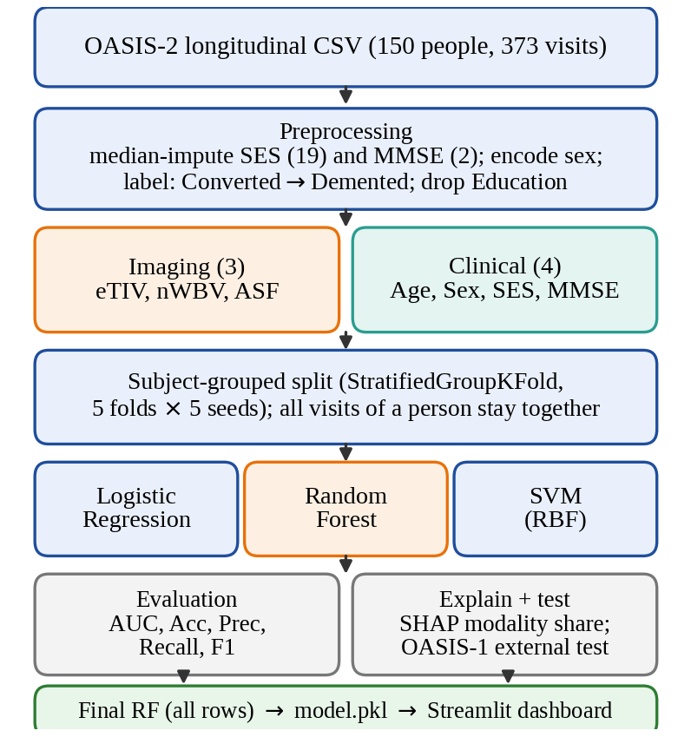
Fig. 1. End-to-end pipeline from the OASIS-2 file to the deployed dashboard. Orange marks the model carried forward to explanation, external testing and deployment.

B. Person-wise validation
Each visit belongs to a subject identified by Subject ID. I used StratifiedGroupKFold with five shuffled folds, so all visits from one person stay in the same fold while the class balance remains approximately similar. I repeated the process with seeds 0 through 4. For the classifier comparison, I pooled out-of-fold probabilities for each seed and calculated the metrics at a threshold of 0.5. For the imaging-versus-clinical comparison, I averaged the fold AUCs and then averaged across seeds. The lowest and highest seed values are reported as a simple indication of variation.

C. Classifiers
Logistic Regression [25] models the probability of dementia with a linear score and a sigmoid:
$p(y=1|x) = \frac{1}{1 + e^{−(w^{T}x + b)}}$ (2)
and is fitted by minimising the L2-regularised logistic loss, with y ∈ {−1, +1} in the loss:
$min \frac{1}{2}‖w‖{}^{2} + C\sum_{i=1}^{N}{log(1+e^{−y_{i}(w^{T}x_{i}+b)})}$ (3)
Random Forest [26] grows B = 200 decision trees, each on a bootstrap sample and with only m = ⌊√7⌋ = 2 randomly chosen features considered at every split (Fig. 2). A node t is split to maximise the drop in Gini impurity:
$G(t) = 1 − \sum_{k}{{p_{k}}^{2}}$ (4)
$ΔG = G(t) − \frac{n_{L}}{n}G(t_{L}) − \frac{n_{R}}{n}G(t_{R})$ (5)
where p_{k} is the share of class k in the node and n_{L}, n_{R} are the sizes of the child nodes. Trees are grown without a depth limit. The forest output is the average of the tree probabilities:
$p̂(x) = \frac{1}{B}\sum_{b=1}^{B}{p_{b}(x)}$ (6)
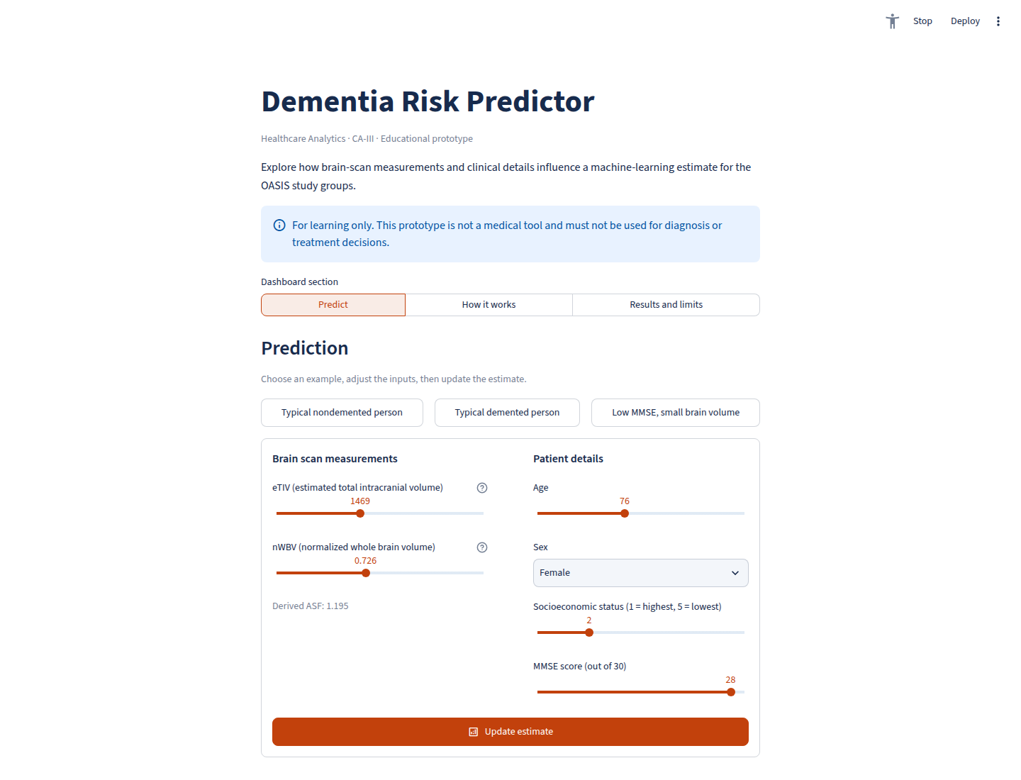
Fig. 2. Streamlit dashboard used for an example prediction and local SHAP explanation.
Support Vector Machine [27] uses the radial basis function (RBF) kernel with γ = 1/(d·Var(X)), the ‘scale’ setting, where d = 7:
$K(x, x′) = exp(−γ‖x − x′‖{}^{2})$ (7)
$f(x) = \sum_{i}{α_{i}y_{i}K(x_{i}, x) + b}$ (8)
Because ROC-AUC needs scores, the decision value f is turned into a probability by Platt scaling [28], P(y=1|f) = 1/(1 + exp(Af + B)), fitted by internal cross-validation (probability = True).

D. Explainability with SHAP
The Random Forest is explained with SHAP [29], [30], which assigns each feature j its Shapley value [31] for a prediction f(x): its average marginal contribution over all subsets S of the feature set F,
$φ_{j} = \sum_{S⊆F∖\{j\}}{\frac{|S|!(|F|−|S|−1)!}{|F|!}[ f_{S∪\{j\}}(x) − f_{S}(x) ]}$ (9)
$f(x) = φ_{0} + \sum_{j=1}^{7}{φ_{j}(x)}$ (10)
The TreeExplainer algorithm computes these values exactly and efficiently for tree ensembles [30]; I take the values for the Demented class. For a modality M (imaging or clinical), the mean absolute SHAP value of each feature over N test visits is summed and expressed as a share of the total:
$I_{j} = \frac{1}{N}\sum_{i=1}^{N}{|φ_{j}(x_{i})|}$ (11)
$Share(M) = \frac{\sum_{j∈M}{I_{j}}}{\sum_{j=1}^{7}{I_{j}}} × 100\%$ (12)
This is repeated on five person-wise 80/20 splits (GroupShuffleSplit, seeds 0–4), and the mean and range of the shares are reported.

E. Evaluation metrics
With TP, FP, TN, FN the usual counts (Demented = positive), accuracy = (TP+TN)/(TP+TN+FP+FN) and precision = TP/(TP+FP). Recall and F1 are
$Recall = \frac{TP}{TP + FN}, F1 = \frac{2 · Precision · Recall}{Precision + Recall}$ (13)
The area under the ROC curve [32] is threshold-free and equals the probability that a randomly chosen demented visit receives a higher score than a randomly chosen nondemented one (ties count one half):
$AUC = Pr[ p̂(x^{+}) > p̂(x^{−}) ]$ (14)

F. External test and deployment
For the external test, each model is trained on all OASIS-2 rows and evaluated once on OASIS-1. The dashboard uses a 200-tree Random Forest trained on all 373 OASIS-2 visits. The saved model bundle includes the feature list, training ranges and ASF constant. In the Streamlit app, users can adjust eTIV, nWBV, age, sex, SES and MMSE or load one of three example profiles. The app returns a model score and a SHAP chart showing which inputs pushed the estimate toward one group or the other. The explainer is cached, and the scikit-learn version is pinned so the saved model can be loaded consistently.

V. Experimental Setup and Hyperparameters

A. Testing environment
I ran the experiments as Python scripts in Google Colab on a CPU. The dataset is small—373 visits and seven features—so a GPU was unnecessary. The code uses pandas and NumPy for data handling, scikit-learn for the models and grouped validation, SHAP for explanations, matplotlib and seaborn for plots, joblib for saving the model and Streamlit for the dashboard. The repository separates preprocessing, model comparison, the final SHAP model, the external test and the app.

B. Hyperparameters
Table II records the settings fixed in the code. Except for the number of trees, I kept the scikit-learn defaults and did not run a grid search or random search. This makes the comparison easier to follow, but it also means the reported models were not heavily tuned.
TABLE II
Hyperparameters and protocol settings
Component | Setting
Logistic Regression | StandardScaler → L2 penalty, C = 1.0, lbfgs solver, max_iter = 100, random_state = 42
Random Forest | n_estimators = 200, criterion = gini, max_features = sqrt (2 of 7), max_depth = None, min_samples_split = 2, min_samples_leaf = 1, bootstrap = True; random_state = 42 (seed in the grouped-CV and SHAP runs)
SVM | StandardScaler → SVC, RBF kernel, C = 1.0, gamma = scale, probability = True, random_state = 42
Validation | StratifiedGroupKFold, 5 folds, shuffle = True, seeds 0–4, groups = Subject ID; threshold 0.5
SHAP runs | GroupShuffleSplit, test_size = 0.2, seeds 0–4; TreeExplainer on Demented-class output
Imputation | Median of SES and MMSE (OASIS-1 SES: OASIS-2 median)
All other parameters take scikit-learn 1.6.1 defaults.

VI. Results and Analysis

A. Comparison of the three classifiers
Table III reports the person-wise cross-validation results on OASIS-2, averaged over five seeds. Fig. 3 shows the ROC curves for one seed. Logistic Regression is the strongest of the three models on every listed metric. Its AUC of 0.851 is 0.065 higher than the Random Forest value of 0.786 and 0.070 higher than the SVM value of 0.781. The Random Forest and SVM are close. With only 150 people and MMSE providing a strong, fairly direct signal, the regularised linear model may have less difficulty than an unrestricted forest. I did not run an ablation study to prove that explanation.
TABLE III
Person-wise 5-fold CV on OASIS-2 (mean of 5 seeds)
Model | Acc. | Prec. | Recall | F1 | AUC | AUC range
Logistic Reg. | 0.777 | 0.813 | 0.708 | 0.757 | 0.851 | 0.843–0.858
Random Forest | 0.729 | 0.739 | 0.692 | 0.714 | 0.786 | 0.770–0.811
SVM (RBF) | 0.726 | 0.740 | 0.682 | 0.709 | 0.781 | 0.764–0.796
Threshold 0.5; AUC range = lowest and highest of the five seeds.
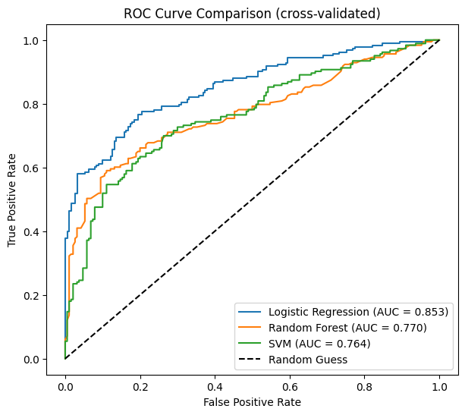
Fig. 3. Cross-validated ROC curves of the three classifiers on OASIS-2 (one seed; AUC 0.853, 0.770 and 0.764). The five-seed averages are in Table III.
Recall is the weakest metric for all three models, ranging from 0.68 to 0.71. At the fixed threshold of 0.5, the models miss roughly three in ten demented visits. Precision is higher, between 0.74 and 0.81, so the models are more cautious than sensitive. Fig. 6(a) illustrates this for Logistic Regression: it finds 130 of 183 demented visits, misses 53, and incorrectly flags 31 of 190 nondemented visits. A lower threshold could improve recall, but that trade-off was not tuned in this project.

B. Imaging only, clinical only and combined
Table IV and Fig. 4 compare the same Random Forest with three input sets. The scan measurements alone give an AUC of 0.639, the clinical variables give 0.742, and the combined set gives 0.793. Adding the scan measurements improves the clinical-only result by 0.051 AUC. The lowest combined seed, 0.777, is still above the highest clinical-only seed, 0.744. The imaging inputs are limited to three global volume summaries rather than the original images, which helps explain why image-based studies can report different results [20].
TABLE IV
Random Forest AUC by input set (grouped CV)
Input set | Mean AUC | Lowest seed | Highest seed
Imaging only (3) | 0.639 | 0.619 | 0.655
Clinical only (4) | 0.742 | 0.739 | 0.744
Combined (7) | 0.793 | 0.777 | 0.817

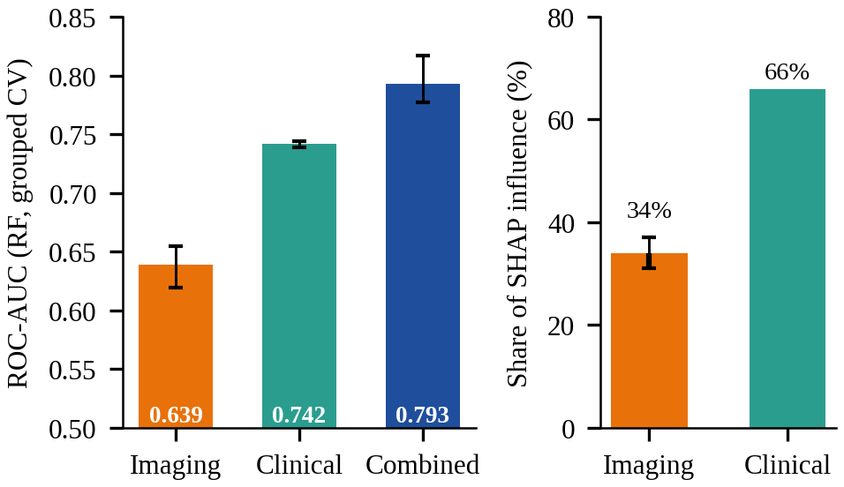
Fig. 4. Left: AUC by input set (whiskers = lowest and highest seed). Right: share of SHAP influence by data type (mean of five splits; imaging whisker 31%–37%).
The combined value in Table IV, 0.793, is slightly higher than the Random Forest value in Table III, 0.786. The difference comes from averaging the fold AUCs in one analysis and pooling out-of-fold scores in the other, as well as using a different forest seed. Both analyses are person-wise and give the same ordering.

C. What the model relies on
Fig. 5 shows how the Random Forest uses the seven inputs. MMSE has the largest influence across the five splits, and lower MMSE values generally push the estimate toward Demented. nWBV is next, with lower brain volume also pushing in that direction. Age, SES, ASF, eTIV and sex contribute less. Summing the absolute SHAP values by input group gives an average of 34% for the three imaging variables and 66% for the four clinical variables. This is consistent with the AUC comparison: the clinical variables carry most of the signal, while the scan measurements still add information. SHAP describes the model’s behaviour; it does not identify causes of dementia.
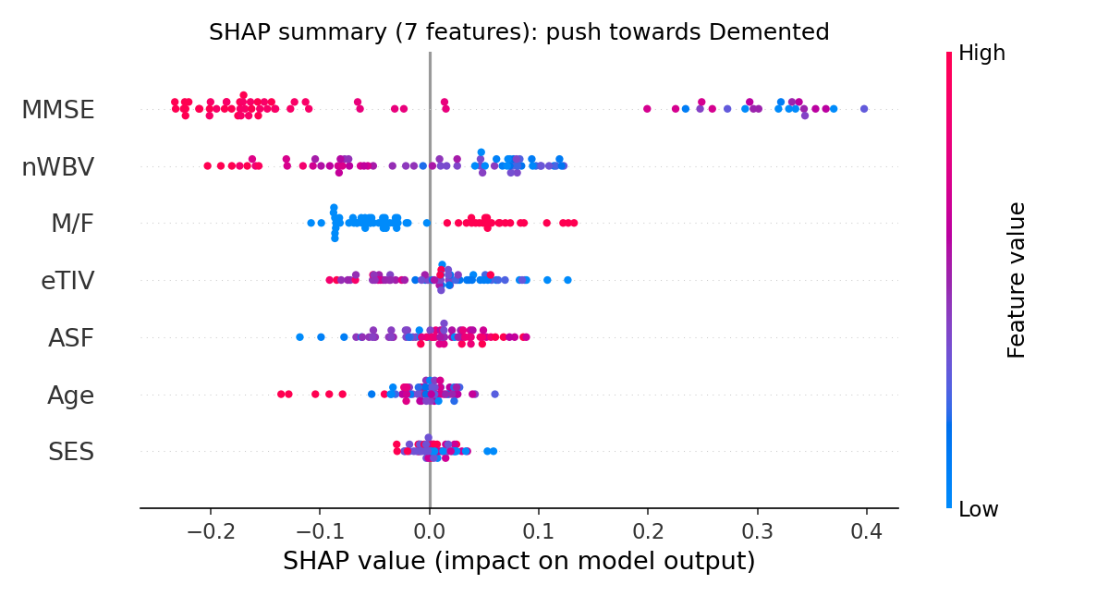
Fig. 5. SHAP summary of the Random Forest (each dot is one visit; colour = feature value; right = pushes towards Demented).

D. Why person-wise validation
I did not include a plain random-split result because it would not answer the main question fairly. If visits from one person appear on both sides of the split, the model can recognise patterns such as similar eTIV, nWBV and age instead of learning a rule that transfers to a new person. That is the leakage concern discussed in [23], [24]. Keeping subjects together removes this particular source of optimism. Measuring the exact size of the inflation would require an additional experiment.

E. External test on OASIS-1
Table V shows the external test: models trained on OASIS-2 and evaluated once on OASIS-1. The ranking changes, with the Random Forest first at AUC 0.938, accuracy 0.874 and recall 0.910, followed by Logistic Regression at 0.896 AUC and SVM at 0.891. The higher OASIS-1 AUCs should not be interpreted as proof of better generalisation. OASIS-1 is cross-sectional, uses the rule CDR > 0 for the label and is evaluated only once without repeated seeds or confidence intervals. The result does show that the model transfers reasonably well to this second cohort, and that the best classifier can depend on the dataset.
TABLE V
Trained on OASIS-2, tested on OASIS-1 (n = 198)
Model | Acc. | Prec. | Recall | F1 | AUC
Logistic Reg. | 0.808 | 0.816 | 0.800 | 0.808 | 0.896
Random Forest | 0.874 | 0.850 | 0.910 | 0.879 | 0.938
SVM (RBF) | 0.813 | 0.871 | 0.740 | 0.800 | 0.891

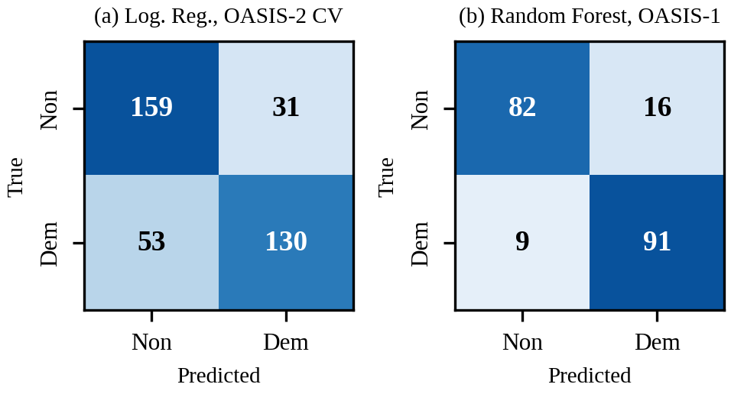
Fig. 6. Confusion matrices (Non = nondemented, Dem = demented). (a) Logistic Regression, pooled out-of-fold predictions on OASIS-2 (one seed). (b) Random Forest trained on OASIS-2 and tested on OASIS-1.

VII. Comparative Analysis with Benchmark Models
The three classifiers are standard baselines, and Faouri et al. [5] evaluated the same model families on the OASIS-2 table. Their reported AUCs using all features and 10-fold CV are 0.885 for Logistic Regression, 0.901 for Random Forest and 0.960 for SVM. Under the person-wise protocol used here, the corresponding values are 0.851, 0.786 and 0.781.
The largest gaps are for the Random Forest and SVM. Three differences are likely important. First, CDR is included in some benchmark pipelines even though the OASIS group label is derived from it. Second, the benchmark papers do not consistently describe subject-wise splitting; treating visits as independent rows can put the same person in training and test data. Third, the samples are small, and an 80/20 split can leave only a few dozen test records. These points are consistent with the lower scores in this report, but I did not re-run the benchmark code, so they should be read as explanations rather than a formal attribution.
The model rankings differ too. Faouri et al. find SVM and Naïve Bayes the most stable and advise against ensembles. Kubi and Nazir find Gaussian Naïve Bayes best on tabular data, and Dhariwal picks gradient boosting. I find Logistic Regression best under person-wise CV and the Random Forest best on OASIS-1. Antor et al. [11] also report SVM as best, and Mokadem et al. [14] find ensembles best on neuropsychological data. What the studies agree on is that no single classifier wins on this small table, so how the validation is designed matters more than which algorithm is used. The deep models [6], [8] reach 90 to 92% accuracy but need images or a special capsule architecture and heavier training, and the DenseNet121 in [6] has a recall of only 0.60. Tree-based models are strong on medium-sized tabular data [33], but my 373 rows are far smaller, which may favour the linear model. My seven-feature Random Forest is small enough to train on a CPU in a notebook, reaches recall 0.91 on OASIS-1, and can be explained exactly.
TABLE VI
Benchmark studies and this work
Study | Data and validation | Best model | Best reported
[5] | OASIS-2 (Kaggle), 10-fold CV, CDR in inputs | NB / DT / SVM | AUC 0.967
[6] | OASIS-2, 227 rows, oversampling, 80/20, CDR in inputs | GNB; DenseNet121 (MRI) | Acc. 0.913; 0.90
[7] | OASIS-2 visits as rows, stratified 80/20, CDR in inputs | XGBoost | Acc. 0.973; AUC 0.971
[8] | OASIS 373 × 15 table, deep network | Modified CapsNet | Acc. 0.924
Ours | OASIS-2 person-wise 5-fold × 5 seeds, no CDR | Logistic Reg. | AUC 0.851; Acc. 0.777
Ours | Train OASIS-2, test OASIS-1, no CDR | Random Forest | AUC 0.938; Acc. 0.874

On explainability, [6] uses SHAP and finds nWBV the most variable contributor, while my model puts MMSE first and nWBV second. That is not surprising, since their feature set includes CDR and uses different models. What I add is summing SHAP by data type, which answers the question from Section I directly: about one third of the model’s influence comes from scan measurements and two thirds from patient details.

VIII. Discussion and Limitations
There are several limitations. The training data contain only 150 people aged 60 and above, so the seed ranges can move and the 0.793 versus 0.742 difference is based on a modest sample. I did not tune hyperparameters, calibrate probabilities or optimise the 0.5 threshold, which likely contributes to the lower recall. Median imputation is simple and was not compared with a model-based imputer. The OASIS-1 test uses a different label rule and was run once without confidence intervals. MMSE is also closely tied to the label definition, so the clinical share partly reflects the way the outcome was constructed. Finally, the CSV came from Kaggle and the benchmark values were taken from published papers rather than reproduced. The dashboard should be treated as a learning project, not a medical tool.

IX. Conclusion and Future Work
Using person-wise validation, the combined inputs performed better than either input group alone: AUC 0.793 compared with 0.639 for imaging and 0.742 for clinical variables. Logistic Regression performed best on OASIS-2 at AUC 0.851, while Random Forest performed best on the OASIS-1 test at AUC 0.938. The SHAP analysis attributes about two thirds of the model influence to patient details and one third to scan measurements, with MMSE and nWBV the strongest individual features. The stricter split and exclusion of CDR probably explain part of the gap between these results and some published OASIS scores, although that explanation was not tested by re-running those studies.
The next useful steps would be to add more participants and test other datasets, tune the models with nested person-wise cross-validation, calibrate the scores, choose a threshold that gives better recall, report confidence intervals for the external test, add more scan measurements and evaluate whether follow-up visits can predict later conversion.

References
[1] M. F. Folstein, S. E. Folstein, and P. R. McHugh, “‘Mini-mental state’: A practical method for grading the cognitive state of patients for the clinician,” J. Psychiatr. Res., vol. 12, no. 3, pp. 189–198, 1975.
[2] J. C. Morris, “The Clinical Dementia Rating (CDR): Current version and scoring rules,” Neurology, vol. 43, no. 11, pp. 2412–2414, 1993.
[3] D. S. Marcus, A. F. Fotenos, J. G. Csernansky, J. C. Morris, and R. L. Buckner, “Open Access Series of Imaging Studies: Longitudinal MRI data in nondemented and demented older adults,” J. Cogn. Neurosci., vol. 22, no. 12, pp. 2677–2684, 2010.
[4] D. S. Marcus et al., “Open Access Series of Imaging Studies (OASIS): Cross-sectional MRI data in young, middle aged, nondemented, and demented older adults,” J. Cogn. Neurosci., vol. 19, no. 9, pp. 1498–1507, 2007.
[5] S. Faouri, M. AlBashayreh, and M. Azzeh, “Examining stability of machine learning methods for predicting dementia at early phases of the disease,” Decis. Sci. Lett., 2022, doi: 10.5267/dsl.2022.1.005.
[6] N. N. B. A. Kubi and S. Nazir, “Dementia prediction with multimodal clinical and imaging data,” Int. J. Inf. Technol., vol. 17, pp. 5–16, 2025, doi: 10.1007/s41870-024-02326-7.
[7] N. Dhariwal, “OASIS-SB: A sex-balanced, distribution-preserving, synthetic phenotypic dataset for bias-resilient clinical prediction,” Front. Comput. Neurosci., vol. 19, Art. no. 1744217, 2026, doi: 10.3389/fncom.2025.1744217.
[8] S. Basheer, S. Bhatia, and S. B. Sakri, “Computational modeling of dementia prediction using deep neural network: Analysis on OASIS dataset,” IEEE Access, vol. 9, pp. 42449–42462, 2021, doi: 10.1109/ACCESS.2021.3066213.
[9] C. Somkuwar, “Dementia-Risk-Predictor,” GitHub repository. [Online]. Available: https://github.com/chirag-2025/Dementia-Risk-Predictor (accessed Oct. 24, 2026).
[10] J. Boysen, “Magnetic resonance imaging comparisons of demented and nondemented adults,” Kaggle, 2017. [Online]. Available: https://www.kaggle.com/jboysen/mri-and-alzheimers
[11] M. B. Antor et al., “A comparative analysis of machine learning algorithms to predict Alzheimer’s disease,” J. Healthc. Eng., vol. 2021, Art. no. 9917919, 2021, doi: 10.1155/2021/9917919.
[12] H. Alshamlan, A. Alwassel, A. Banafa, and L. Alsaleem, “Improving Alzheimer’s disease prediction with different machine learning approaches and feature selection techniques,” Diagnostics, vol. 14, no. 19, Art. no. 2237, 2024, doi: 10.3390/diagnostics14192237.
[13] M. Cabanillas-Carbonell and J. Zapata-Paulini, “Evaluation of machine learning models for the prediction of Alzheimer’s: In search of the best performance,” Brain Behav. Immun. Health, Art. no. 100957, 2025, doi: 10.1016/j.bbih.2025.100957.
[14] Z. Mokadem, M. Djerioui, B. Attallah, and Y. Brik, “A comparison of machine learning algorithms for predicting Alzheimer’s disease using neuropsychological data,” Sci. Eng. Technol., vol. 5, no. 1, 2025, doi: 10.54327/set2025/v5.i1.182.
[15] E. L. Twait, C. L. Andaur Navarro, V. Gudnason, Y.-H. Hu, L. J. Launer, and M. I. Geerlings, “Dementia prediction in the general population using clinically accessible variables: A proof-of-concept study using machine learning. The AGES-Reykjavik study,” BMC Med. Inform. Decis. Mak., vol. 23, no. 1, Art. no. 168, 2023, doi: 10.1186/s12911-023-02244-x.
[16] J. Zhou et al., “Identifying dementia from cognitive footprints in hospital records among Chinese older adults: A machine-learning study,” Lancet Reg. Health West. Pac., vol. 46, Art. no. 101060, 2024, doi: 10.1016/j.lanwpc.2024.101060.
[17] K. Haddada, M. Ibn Khedher, O. Jemai, S. Iben Khedher, and M. El Yacoubi, “Assessing the interpretability of machine learning models in early detection of Alzheimer’s disease,” in Proc. 16th Int. Conf. Human System Interaction (HSI), Paris, France, 2024, pp. 1–6, doi: 10.1109/HSI61632.2024.10613551.
[18] G. Duah, E. Nyarko, J. Y. Effah, I. B. Numoah, and A. Lotsi, “Explainable longitudinal machine learning for dementia progression using cognitive and MRI biomarkers,” medRxiv, 2026, doi: 10.64898/2026.07.12.26357878.
[19] F. Kamalov, F. Thabtah, D. Peebles, and A. Ibrahim, “Selectively augmented decision tree for explainable dementia detection,” medRxiv, 2026, doi: 10.64898/2026.02.03.26345441.
[20] A. Javeed, A. L. Dallora, J. S. Berglund, A. Ali, L. Ali, and P. Anderberg, “Machine learning for dementia prediction: A systematic review and future research directions,” J. Med. Syst., vol. 47, Art. no. 17, 2023, doi: 10.1007/s10916-023-01906-7.
[21] G. Kantayeva, J. Lima, and A. I. Pereira, “Application of machine learning in dementia diagnosis: A systematic literature review,” Heliyon, vol. 9, no. 11, Art. no. e21626, 2023, doi: 10.1016/j.heliyon.2023.e21626.
[22] K. Haddada, M. Ibn Khedher, and O. Jemai, “A survey of early detection and interpretable diagnosis of Alzheimer’s disease,” Multimed. Tools Appl., vol. 84, no. 35, pp. 44033–44061, 2025.
[23] E. Yagis et al., “Effect of data leakage in brain MRI classification using 2D convolutional neural networks,” Sci. Rep., vol. 11, Art. no. 22544, 2021, doi: 10.1038/s41598-021-01681-w.
[24] D. J. Rumala, “How you split matters: Data leakage and subject characteristics studies in longitudinal brain MRI analysis,” in Proc. MICCAI Workshop on Fairness of AI in Medical Imaging (FAIMI). Cham, Switzerland: Springer, 2023, doi: 10.1007/978-3-031-45249-9_23.
[25] F. Pedregosa et al., “Scikit-learn: Machine learning in Python,” J. Mach. Learn. Res., vol. 12, pp. 2825–2830, 2011.
[26] L. Breiman, “Random forests,” Mach. Learn., vol. 45, no. 1, pp. 5–32, 2001.
[27] C. Cortes and V. Vapnik, “Support-vector networks,” Mach. Learn., vol. 20, no. 3, pp. 273–297, 1995.
[28] J. C. Platt, “Probabilistic outputs for support vector machines and comparisons to regularized likelihood methods,” in Advances in Large Margin Classifiers. Cambridge, MA, USA: MIT Press, 1999, pp. 61–74.
[29] S. M. Lundberg and S.-I. Lee, “A unified approach to interpreting model predictions,” in Proc. Adv. Neural Inf. Process. Syst. (NIPS), 2017, pp. 4765–4774.
[30] S. M. Lundberg et al., “From local explanations to global understanding with explainable AI for trees,” Nat. Mach. Intell., vol. 2, no. 1, pp. 56–67, 2020.
[31] L. S. Shapley, “A value for n-person games,” in Contributions to the Theory of Games, vol. II. Princeton, NJ, USA: Princeton Univ. Press, 1953, pp. 307–317.
[32] T. Fawcett, “An introduction to ROC analysis,” Pattern Recognit. Lett., vol. 27, no. 8, pp. 861–874, 2006.
[33] L. Grinsztajn, E. Oyallon, and G. Varoquaux, “Why do tree-based models still outperform deep learning on typical tabular data?,” in Adv. Neural Inf. Process. Syst. (NeurIPS), Datasets and Benchmarks Track, vol. 35, 2022.

