CS 502 - INTRO TO ARTIFICAL INTELLIGENCE

1 . Environments and Algorithms

2 . Analysis and Comparison

i) Find a map size (dim) that is large enough to produce maps that require some work to solve, but small enough that you can run each algorithm multiple times for a range of possible p values. How did you pick a dim?
Based on data from data21.csv

180,0.3 , 18.4330048561,361
180,0.3 , 34.858910799,363
180,0.3 , 53.5991725922,361
Average time : 180,0.3 , 17.8663908641

190,0.3 , 30.4964609146,0
190,0.3 , 63.8783979416,0
190,0.3 , 89.21220994,0
Average time : 190,0.3 , 29.7374033133

200,0.3 , 25.5202560425,0
200,0.3 , 47.8285028934,401
200,0.3 , 87.5201308727,0
Average time : 200,0.3 , 29.1733769576

210,0.3 , 30.0349159241,419
210,0.3 , 67.9114239216,423
210,0.3 , 114.05527091,0
Average time : 210,0.3 , 38.0184236368

220,0.3 , 0.0197241306305,0
220,0.3 , 56.3769080639,0
220,0.3 , 56.3972489834,0
Average time : 220,0.3 , 18.7990829945

230,0.3 , 44.3628149033,459
230,0.3 , 44.384169817,0
230,0.3 , 86.9705517292,461
Average time : 230,0.3 , 28.9901839097

240,0.3 , 52.6711909771,483
240,0.3 , 126.656979084,0
240,0.3 , 126.678338051,0
Average time : 240,0.3 , 42.2261126836

250,0.3 , 0.0236978530884,0
250,0.3 , 0.0487129688263,0
250,0.3 , 61.4870400429,507
Average time : 250,0.3 , 20.4956800143

260,0.3 , 118.85293889,0
260,0.3 , 179.777615786,523
260,0.3 , 179.801734924,0
Average time : 260,0.3 , 59.9339116414

270,0.3 , 105.996675968,0
270,0.3 , 176.069619894,539
270,0.3 , 247.641183853,553
Average time : 270,0.3 , 82.5470612844

180,0.2 , 22.8713760376,359
180,0.2 , 49.943500042,359
180,0.2 , 72.5947010517,359
Average time : 180,0.2 , 24.1982336839

190,0.2 , 29.8823308945,379
190,0.2 , 69.0117118359,0
190,0.2 , 69.024491787,0
Average time : 190,0.2 , 23.008163929

200,0.2 , 36.3557288647,399
200,0.2 , 71.712802887,399
200,0.2 , 106.914407969,399
Average time : 200,0.2 , 35.6381359895

210,0.2 , 44.00364995,419
210,0.2 , 44.0192611217,0
210,0.2 , 109.734645128,419
Average time : 210,0.2 , 36.5782150428

220,0.2 , 83.1315360069,439
220,0.2 , 182.926945925,439
220,0.2 , 182.94629693,0
Average time : 220,0.2 , 60.9820989768

If the chosen time limit for each iteration is 30 seconds, then based on the above data we took 200 as size of dim so that for the solvable probabilities of 0.2 to 0.3 solution appears in 30 seconds , dim is 200

ii) For p ≈ 0.2, generate a solvable map, and show the paths returned for each algorithm. Do the results make sense? ASCII printouts are fine, but good visualizations are a bonus.

Based on data from data22.csv multiple things can be asserted

* Since this is a sparse maze (p = 0.2) so not many back tracks are required so dfs is finding path in very less time compared to other algos however length of path is very high compared to others as it keeps expanding until it reaches end without worrying about the round about ways it may take during the path

* BFS is producing as optimized paths as A*, proves it's correctness as it stops exploring further after it reaches first solution during breadth first search. However since it explores all possibilities at each and every stage it takes longer time than any other algo

* Euclid algo is taking more time than manhattan because of the heuristic, manhattan gives exact estimate of actual shortest path because in a maze we restrict cross paths, where as euclid considers cross movement due to which the estimate is bad. This also proves that heurisitic influences the time taken for A* algorithm. However, shortest path lengths match which prove the correctness of the algorithm.

iii) Given dim, how does maze-solvability depend on p? For a range of p values, estimate the probability that a maze will be solvable by generating multiple mazes and checking them for solvability. What is the best algorithm to use here? Plot density vs solvability, and try to identify as accurately as you can the threshold p0 where for p < p0 , most mazes are solvable, but p > p0 , most mazes are not solvable.

Solving the maze for a range of probability values from 0.2 to 0.5, with maze dimension of 100*100 and 50 mazes for each probability. We get the average solvability as follows -
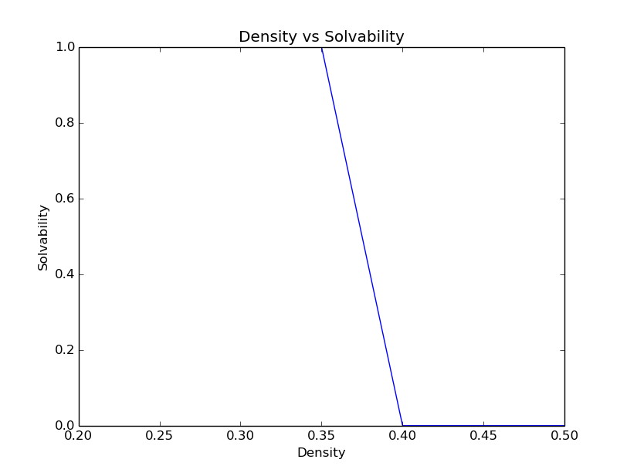

From the graph above, we can deduce that the threshold value of probaility for which most mazes are solvable is 0.35. The alogrithm used to calculate the solvability is A* as it is fast and efficiant as compared to other searching algorithm.

iv) For p in [0, p 0 ] as above, estimate the average or expected length of the shortest path from start to goal. You may discard unsolvable maps. Plot density vs expected shortest path length. What algorithm is most useful here?

v) Is one heuristic uniformly better than the other for running A∗ ? How can they be compared? Plot the relevant data and justify your conclusions.

Below is a graph that compares both the heuristic based search algortithms on 2 parameters – Maximum length of fringe and Length of closed set or the number of nodes visited. The blue line is for Manhattan Distance whereas the green line is for Euclidian Distance.
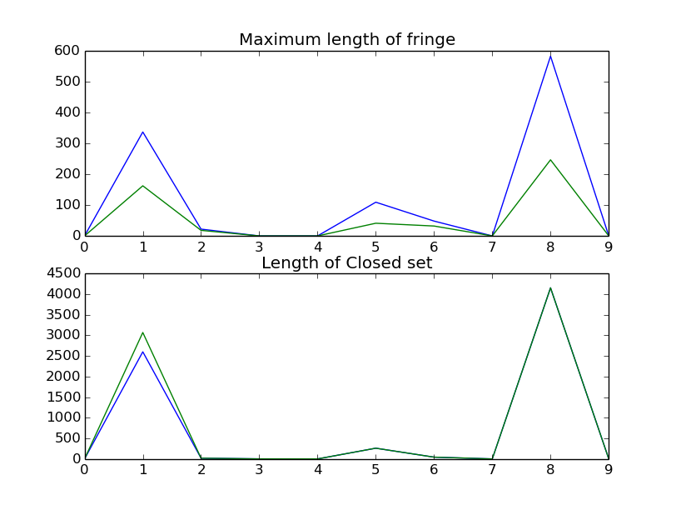
for probaility = 0.3
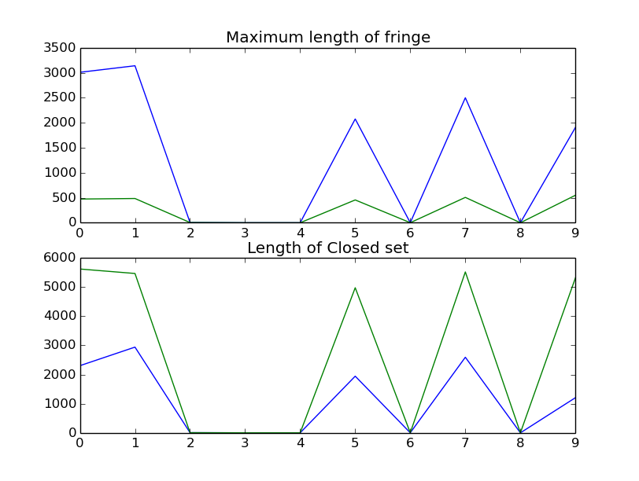
for probability = 0.4

In the first graph i.e. for the maze generated with probability 0.3, we see that Eucld performs better that Manhattan with respect to the length of fringe i.e. it uses lesser memory whereas in terms of length of closed set both are nearly equal. This is the case for most of the mazes with smaller probability.

But for higher probability we see that tho Euclid performs better in terms of Maximum length of fringe but Manhattan is better in terms of the length of closed set.

On repeated number of iterations, we see that Euclid performed better than Manhattan.

vi) Do these algorithms behave as they should?

vii) For DFS, can you improve the performance of the algorithm by choosing what order to load the neighboring rooms into the fringe? What neighbors are ‘worth’ looking at before others? Be thorough and justify yourself.

We can use iterative DFS to perform better as compared to native DFS approch. In iterative DFS we move to a level of 2 depths and if we dont find the child feasible we check the next child instead of traversing till the complete depth. Hence, we save lot of time and memory.

viii) On the same map, are there ever nodes that BD-DFS expands that A ∗ doesn’t? Why or why not? Give an example, and justify.

3. Generating Hard Mazes

i) What local search algorithm did you pick, and why? How are you representing the maze/environment to be able to utilize this search algorithm? What design choices did you have to make to make to apply this search algorithm to this problem?

