Title: Gap Analysis — Credit Card Dispute Resolution System
Author: Dhruv Narang
Date: April 2026

SECTION 1 — PURPOSE
This gap analysis identifies the differences between MapleTrust Bank's current dispute resolution process (As-Is) and the desired future state (To-Be). It provides the basis for project scope, prioritisation, and business case justification.

AS-IS PROCESS DIAGRAM:
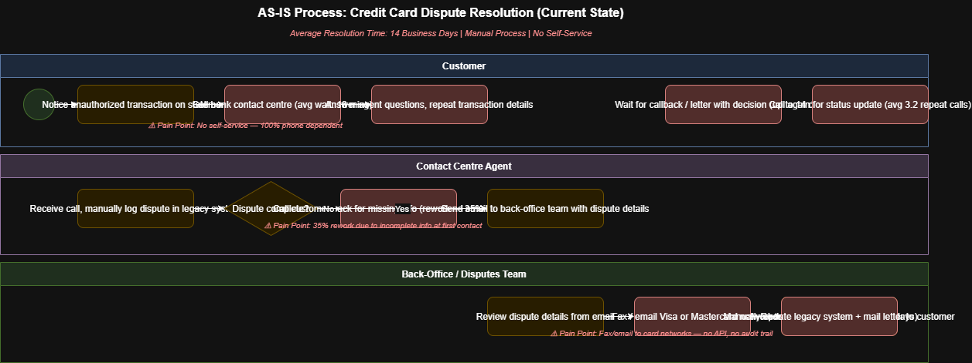

SECTION 2 — GAP ANALYSIS TABLE
# | Capability Area | As-Is (Current State) | To-Be (Future State) | Gap / Action Required
1 | Customer Submission | Phone only, 18-min avg wait | 24/7 online self-service portal | Build customer portal — US-001 to US-005
2 | Dispute Categorisation | Manual by agent, inconsistent | Automated rule engine in 2 mins | Implement rule-based categorisation engine
3 | Resolution Time | 14 business days avg | 5 business days target | Automate tier-1, streamline tier-2 workflow
4 | Customer Communication | Letter by mail only | Real-time SMS + email at every stage | Build notification engine — US-003
5 | Card Network Submission | Fax/email, 2–3 day delay | API integration, same-day submission | Build Visa/MC API connector — US-014
6 | Audit Trail | None — compliance risk | Immutable timestamped log (7yr retention) | Build audit logging module — US-012
7 | Management Reporting | Monthly manual Excel reports | Real-time dashboard, auto-refresh | Build ops dashboard — US-011

TO-BE PROCESS DIAGRAM:
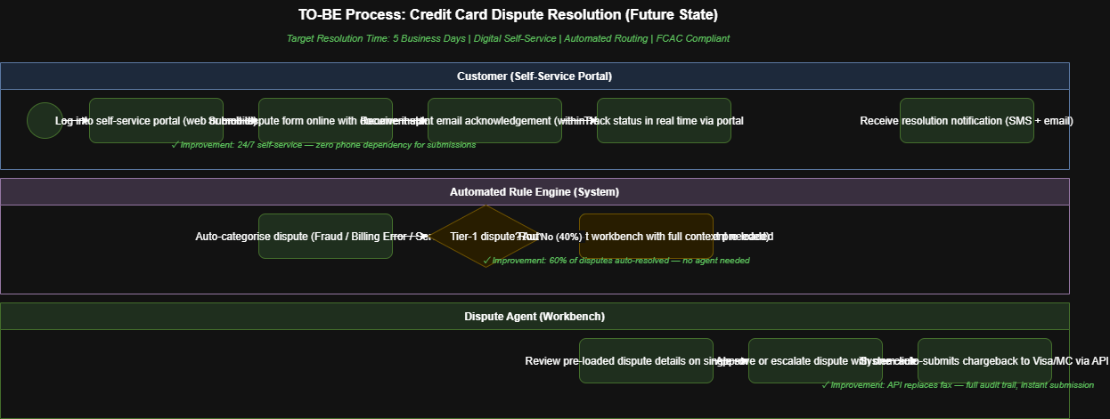
SECTION 3 — BUSINESS IMPACT OF GAPS
Gap 1 (No self-service): Costs $18.50 per phone interaction × 45,000 disputes/year
= $832,500/year in avoidable contact centre costs

Gap 3 (Resolution time): FCAC non-compliance risk — potential fines up to $500,000
+ reputational damage from negative customer experience

Gap 5 (Manual network): 2–3 day delay risks missing Visa/MC chargeback filing windows
Late filings result in 100% loss — avg dispute value $340
= potential $153,000/year in preventable losses
TOTAL QUANTIFIED IMPACT: ~$1.49M/year in direct costs + regulatory risk
SECTION 4 — RECOMMENDATION PRIORITY
Priority 1 (Must Have): Customer portal, automated acknowledgement, audit trail
Priority 2 (Should Have): Rule engine, agent workbench, API connector
Priority 3 (Nice to Have): Real-time dashboard, advanced analytics

