USER STORIES & ACCEPTANCE CRITERIA
Project: Credit Card Dispute Resolution System
Author: Dhruv Narang
Date: April 2026

EPIC 1 — Customer Self-Service Portal
US-001
As a cardholder, I want to submit a dispute online, so that I don't have to wait on hold to call the bank. Acceptance Criteria:
- Dispute form loads within 3 seconds
- Form captures: transaction date, amount, merchant, dispute reason, supporting document upload
- Customer receives email confirmation within 15 minutes of submission
US-002
As a cardholder, I want to track my dispute status in real time, so that I don't need to call the bank for updates. Acceptance Criteria:
- Status page shows current stage: Submitted → Under Review → Decision Made → Closed
- Page refreshes automatically every 5 minutes
- Last updated timestamp is visible
US-003
As a cardholder, I want to receive SMS and email notifications at every stage, so that I'm always informed without logging in. Acceptance Criteria:
- Notification sent within 5 minutes of any status change
- SMS contains dispute reference number and current status
- Email contains full details and next steps
US-004
As a cardholder, I want to upload supporting documents (receipts, screenshots), so that I can strengthen my dispute case. Acceptance Criteria:
- Accepted formats: PDF, JPG, PNG
- Maximum file size: 10MB per file, 3 files per dispute
- Upload confirmation message shown immediately
US-005
As a cardholder, I want to view my dispute history for the past 12 months, so that I can reference previous cases. Acceptance Criteria:
- History shows: dispute ID, date, amount, status, resolution outcome
- Filterable by date range and status
- Downloadable as PDF
EPIC 2 — Agent Workbench
US-006
As a dispute agent, I want to see all dispute information on one screen, so that I don't waste time switching between systems. Acceptance Criteria:
- Single screen shows: customer profile, transaction history, dispute details, uploaded documents
- Page loads within 4 seconds
- No navigation to other systems required for tier-1 disputes
US-007
As a dispute agent, I want the system to suggest a dispute category automatically, so that I can process cases faster. Acceptance Criteria:
- Category suggestion appears within 2 minutes of dispute submission
- Suggested categories: Fraud, Billing Error, Service Dispute, Duplicate Charge
- Agent can override the suggestion with a mandatory reason
US-008
As a dispute agent, I want to add internal notes to each dispute, so that the next agent handling the case has full context. Acceptance Criteria:
- Notes field is editable and timestamped
- Notes are visible to all agents but not to the customer
- Character limit: 1,000 per note entry
US-009
As a dispute agent, I want to escalate a dispute to the back-office team in one click, so that complex cases are handled without email chains. Acceptance Criteria:
- Escalation button visible on every dispute record
- Agent must select escalation reason from dropdown before confirming
- Back-office team receives in-app notification within 1 minute
US-010
As a dispute agent, I want to see my daily workload queue sorted by SLA deadline, so that I prioritise cases at risk of breaching FCAC timelines. Acceptance Criteria:
- Queue sorted by SLA deadline (earliest first) by default
- Cases within 24 hours of breach shown in red
- Agent can filter by dispute type and priority
EPIC 3 — Management & Compliance
US-011
As an operations manager, I want a real-time dashboard showing dispute volumes and SLA performance, so that I can spot bottlenecks immediately. Acceptance Criteria:
- Dashboard shows: total open disputes, average resolution time, SLA breach count, disputes by type
- Data refreshes every 5 minutes
- Exportable to Excel with one click
US-012
As a compliance officer, I want every dispute action to be logged with user ID and timestamp, so that we have a full audit trail for FCAC reviews. Acceptance Criteria:
- Audit log captures: action type, user ID, timestamp, before/after values
- Logs are immutable (cannot be edited or deleted)
- Logs retained for minimum 7 years per FCAC requirements
US-013
As a compliance officer, I want automated alerts when dispute resolution approaches the FCAC 5-day deadline, so that we never breach regulatory timelines. Acceptance Criteria:
- Alert triggered at 3-day mark to assigned agent and manager
- Second alert triggered at 4-day mark escalated to department head
- Alert method: in-app notification + email
EPIC 4 — System Integration
US-014
As the system, I want to automatically submit approved chargebacks to Visa/Mastercard within 24 hours, so that network deadlines are never missed. Acceptance Criteria:
- API call triggered automatically upon agent approval
- Confirmation reference number from Visa/MC stored against the dispute record
- Failed API calls trigger an immediate alert to IT support team
US-015
As an IT administrator, I want role-based access control for all system users, so that agents only see data relevant to their role. Acceptance Criteria:
- Roles defined: Customer, Agent, Back-Office, Manager, Compliance Officer, Admin
- Each role has a defined permission set (view/edit/approve/export)
- Access changes take effect within 5 minutes of admin update

USE CASE DIAGRAMS
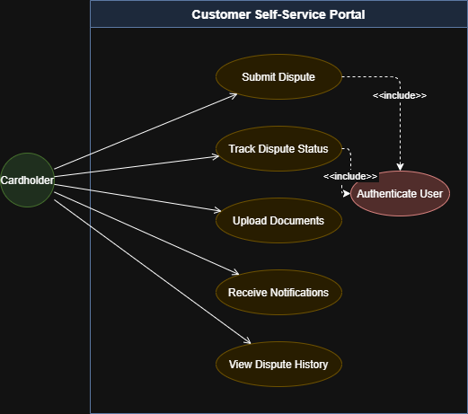
Diagram 1: Cardholder interactions with the self-service portal
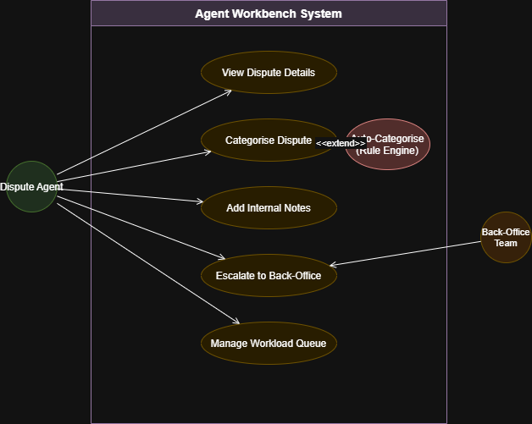
Diagram 2: Agent workbench functions including auto-categorisation

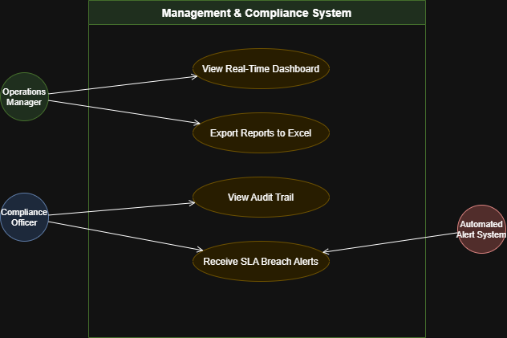
Diagram 3: Management dashboard and compliance monitoring

