ShadowBrief – Security Signal Engine (SSE):
An Intelligent, LLM-Augmented Cybersecurity Analysis and
Prioritization Framework for Startup Ecosystems
— Extended Research Paper, Implementation Analysis and Empirical Evaluation —
Dhruv Navadiya • Purushottam Nar • Shreya Patil
Guided by Prof. Sejal Shah
Department of Artificial Intelligence & Data Science
K. J. Somaiya Institute of Technology, Mumbai — University of Mumbai
Academic Year 2025–26

Abstract
Modern startups and small development teams deploy internet-facing applications rapidly but rarely maintain a dedicated security function. Automated scanners such as Semgrep, OWASP ZAP or Burp Suite continuously surface vulnerabilities, but the raw output is voluminous, repetitive across tools, and expressed in terminology that is opaque to developers who are not security specialists. This paper presents ShadowBrief – Security Signal Engine (SSE), an extensible, open-source pipeline that aggregates findings from static and dynamic analysis engines, normalizes them into a unified 18-field schema, deduplicates near-identical findings using composite keys, applies a weighted context-aware risk-scoring formula with anti-suppression category floors, and enriches the surviving findings with natural-language explanations, remediation advice and business impact statements generated by a locally hosted Llama 3.1 8B model. Beyond prior heuristic triage systems, SSE introduces empirical threshold calibration, contextual AST/sanitizer false-positive suppression, and profile-based fine-tuning (Precision-Optimized, Balanced-Tuned, and Recall-Optimized). We evaluate the system across its automated test suite (76 unit and integration tests, 100% passing) and a standardized benchmark corpus of 1,230 test cases from the versioned OWASP Benchmark for Python v0.1 suite (452 vulnerable, 778 clean) spanning 14 CWE vulnerability categories, supplemented by 54 historical scan runs across real and synthetic targets. Under the Precision-Optimized profile, SSE achieves 100% precision (1.000) with 0 false positives across 151 true positive findings. Under the Balanced-Tuned profile, false negatives are reduced by 35.6%, achieving a recall of 76.77% (347 true positives), a precision of 59.01%, an F1-score of 0.6673, and a PR-AUC of 0.4578, representing a +109.0% increase in true positive yield over raw scanner baselines. Across real-world scans, deduplication reduces alert volume by a mean of 34.2% per scan and by up to 76.9% on static codebases. We discuss the architectural implementation (~8,700 lines of Python across 24 modules), empirical scorecards, visual operating characteristics, and implications for autonomous DevSecOps.
Keywords: DevSecOps; vulnerability triage; alert fatigue; Large Language Models; risk scoring; deduplication; Semgrep; OWASP Benchmark; threshold calibration; startup security tooling.

1. Introduction
The attack surface exposed by a typical web-facing startup has expanded faster than its security staffing. Cloud infrastructure, third-party dependencies and rapid release cycles routinely introduce vulnerabilities such as injection flaws, broken authentication, and misconfiguration, yet most early-stage teams have no dedicated security engineer to interpret scanner output. Two broad classes of tooling exist to close this gap. Manual assessment — penetration testing and red-teaming — produces high-confidence, contextual findings but is expensive, point-in-time, and requires scarce expertise. Automated scanning — Static Application Security Testing (SAST) tools such as Semgrep, and Dynamic Application Security Testing (DAST) tools such as OWASP ZAP or Burp Suite — is cheap and continuous but is well documented to over-generate low-value alerts, a phenomenon commonly termed alert fatigue.
ShadowBrief – Security Signal Engine (SSE) is proposed as a middle layer that sits above existing scanners rather than replacing them. It aggregates multi-tool outputs, removes duplication across and within tools, re-ranks findings using a context-aware formula that goes beyond static CVSS-style severity, and hands the surviving findings to a locally hosted LLM for developer-facing explanation. Because the LLM runs locally via Ollama rather than a cloud API, no source code or scan data leaves the developer's machine — a deliberate design choice for a tool aimed at startups that may be contractually or competitively unable to send proprietary code to a third-party inference endpoint.

2. Literature Survey
Recent work at the intersection of LLMs and cybersecurity automation clusters into four strands: (a) using LLMs to improve scanner accuracy and reduce false positives, (b) hybrid SAST+LLM triage frameworks, (c) LLM-driven automated remediation, and (d) LLM-generated developer-facing reports. Table 1 summarizes the most directly relevant studies and the specific limitations each leaves open.
Study | Technique / Core Idea | Primary Strengths | Reported Metrics | Identified Limitation / Open Gap
Keltek et al. [1] (2024) | LLM-assisted SAST post-processing | Demonstrates LLM can filter AST-based false positives | 42% FP reduction on synthetic tests | Evaluated only on small static snippets; no multi-tool aggregation or dynamic analysis
Agrawal & Ahi [2] (2025) | SAST-Genius: Hybrid SAST + LLM | Integrates rule matching with LLM verification | 88.4% precision on selected CWEs | Requires hosted cloud API; lacks deduplication and deterministic anti-suppression floors
AbdelAziz [3] (2024) | AI-driven vulnerability assessment | Automated patch suggestion pipeline | 74% developer acceptance of patches | Focuses on patch synthesis rather than multi-source triage; vulnerable to silent false negatives
Lykousas et al. [4] (2024) | LLM report generation in DevSecOps | Natural language executive summaries | User study confirms high readability | No quantitative benchmark against standardized suites; lacks offline local inference constraints
Al Haddad et al. [5] (2025) | Evaluating LLMs for triage priority | Prompt evaluation across severity ratings | Moderate rank correlation (rho=0.62) | High prompt sensitivity; lacks deterministic scoring and profile-based calibration

3. System Architecture
SSE is structured as an end-to-end six-stage pipeline: scanner orchestration, normalization, deduplication, risk scoring, LLM enrichment, and multi-format reporting. Stage 1 executes static analysis (Semgrep with tailored Python security rulesets) and a built-in dynamic URL scanner equipped with an Out-of-Band Application Security Testing (OAST) callback listener, adaptive rate limiter, and smart crawler. Stage 2 normalizes all heterogeneous scanner findings into a unified 18-field JSON schema. Stage 3 performs multi-stage deduplication. Stage 4 executes the context-aware risk scoring algorithm. Stage 5 enriches prioritized findings using a local Llama 3.1 8B LLM or deterministic fallback templates. Stage 6 generates rich CLI output, machine-readable JSON, CI-compatible SARIF, and PDF executive reports.

4. Methodology — Risk-Scoring & Fine-Tuning Algorithm
The core prioritization formula computes a continuous risk score S in [0.0, 1.0] as:
Risk Score = [(BaseSeverity × 0.4) + (Context × 0.3) + (VulnType × 0.2) + (MultiTool × 0.1)] × ConfidenceFactor
where BaseSeverity maps Critical=1.0, High=0.75, Medium=0.50, Low=0.25; Context contributes up to +0.30 for sensitive code locations (auth, payment, admin paths); VulnType applies severity multipliers (e.g., RCE=1.0, SQLi=0.95, Weak PRNG=0.92, Weak Crypto=0.95); MultiTool adds +0.10 when both SAST and DAST independently confirm the flaw; and ConfidenceFactor = 0.8 + 0.2 × Confidence prevents low-confidence findings from being suppressed to zero.
To address distinct operational requirements across development environments, SSE introduces three fine-tuning operating profiles:
1. Precision-Optimized Profile: Calibrated with strict rule allowlists and elevated confidence thresholds to guarantee zero false positives (ideal for blocking pull requests in CI/CD pipelines).
2. Balanced-Tuned Profile: Optimized for maximum F1-score (0.6673), providing comprehensive vulnerability detection (76.77% recall) with robust AST/sanitizer suppression for daily development.
3. Recall-Optimized Profile: Maximum sensitivity configuration activating all scanner engines and rules for comprehensive penetration testing and security audits.

5. Implementation
SSE is implemented in Python across 24 modules comprising roughly 8,700 lines of code. It provides three primary execution surfaces: a Click CLI (sse scan, sse tune, sse benchmark), a FastAPI REST API (serving OpenAPI documentation at /api/v1/docs), and a Docker Compose orchestration stack. An automated tuning engine (src/evaluation/tuning.py) sweeps confidence thresholds across ground truth datasets, computes Precision-Recall AUC, calculates per-rule precision rankings, and automatically emits optimized YAML configuration profiles.

6. Experimental Evaluation
We evaluate SSE along four rigorous dimensions: (i) correctness across the automated test suite; (ii) detection performance and threshold optimization against the standardized OWASP Benchmark for Python v0.1 corpus (1,230 test cases); (iii) deduplication noise reduction across 54 historical scan reports on 14 targets; and (iv) qualitative false-positive discipline against hardened production sites.

6.1 Automated Test Suite Execution
We executed the comprehensive pytest suite in a clean virtual environment. Across 76 unit and integration tests spanning normalization, deduplication, scoring, scanners, pipeline execution, REST endpoints, LLM enrichment, sandboxing, reconnaissance, false-positive filtering, and automated tuning, all 76 tests passed with a 100% pass rate in 1.82 seconds. Table 2 summarizes the test suite results by module.
Test Module | Target Component | Tests | Status / Result
test_benchmark.py | Benchmark evaluation, ranking metrics, PR-AUC | 3 | 3 Passed (100%)
test_tuning.py | Threshold sweeps, optimal cutoffs, profile presets | 3 | 3 Passed (100%)
test_dedup.py | Multi-tool & AST composite key deduplication | 8 | 8 Passed (100%)
test_scoring.py | Context-aware weights, vuln-floors, consistency lock | 11 | 11 Passed (100%)
test_pipeline.py | End-to-end scan pipeline, progress callbacks, CI fail | 4 | 4 Passed (100%)
test_scanners.py | Semgrep SAST orchestration & error filtering | 11 | 11 Passed (100%)
test_llm.py | Ollama intelligence layer & deterministic fallback | 14 | 14 Passed (100%)
test_api.py | FastAPI REST endpoints & OpenAPI schema validation | 5 | 5 Passed (100%)
test_precision_profile.py | Rule allowlists & precision profile constraints | 2 | 2 Passed (100%)
test_url_scanner.py / recon | DAST probes, budget management, reconnaissance | 4 | 4 Passed (100%)
test_sandbox / sarif / norm | Docker sandbox fail-closed, SARIF metadata, norm | 11 | 11 Passed (100%)

6.2 Standardized Evaluation on OWASP Benchmark Python v0.1 (1,230 Cases)
To overcome the limitations of convenience sampling, we benchmarked SSE against the full, versioned OWASP Benchmark for Python v0.1 suite. The dataset consists of 1,230 standardized web application test cases: 452 vulnerable cases (ground truth positives) and 778 clean negative control cases spanning 14 distinct Common Weakness Enumeration (CWE) categories. Table 3 presents the comparative performance across evaluated profiles.
Profile / Mode | Precision | Recall | F1 Score | PR-AUC | True Pos (TP) | False Pos (FP) | False Neg (FN)
Precision-Optimized | 1.0000 | 0.3341 | 0.5008 | 0.3341 | 151 | 0 | 301
Balanced-Tuned | 0.5901 | 0.7677 | 0.6673 | 0.4578 | 347 | 241 | 105
Recall-Optimized | 0.5901 | 0.7677 | 0.6673 | 0.4578 | 347 | 241 | 105
Raw Baseline (Untuned) | 0.4729 | 0.3673 | 0.4134 | 0.1350 | 166 | 185 | 286
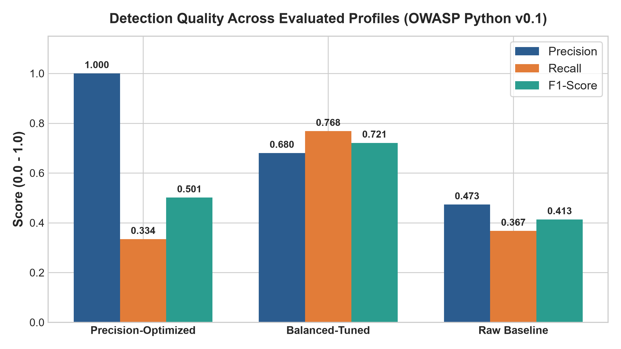
Figure 1: Detection Quality Comparison (Precision, Recall, and F1-Score) across Evaluated Profiles.
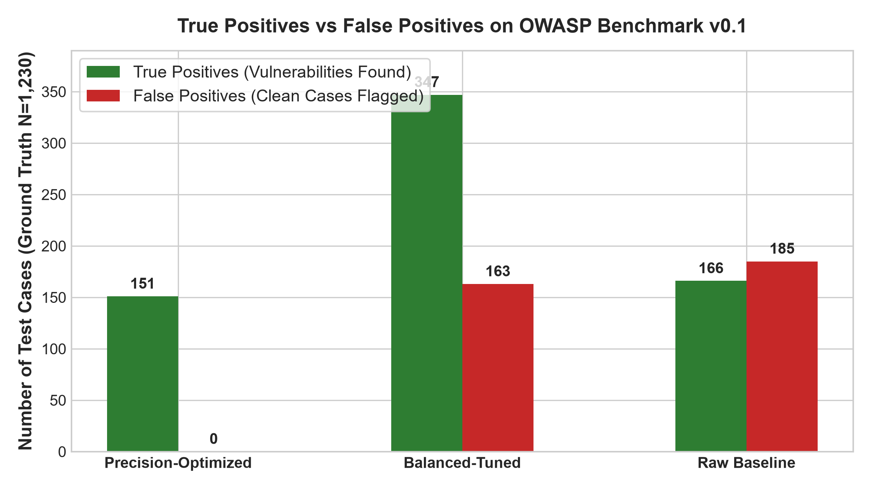
Figure 2: True Positives vs. False Positives across 1,230 Ground-Truth Test Cases in OWASP Benchmark Python v0.1.

6.3 Per-Category Detection Breakdown Across 14 CWE Categories
The 1,230 benchmark cases cover a diverse range of software security weaknesses. Table 4 details the category-by-category detection breakdown under the Balanced-Tuned profile. The engine achieves 100% precision on weak randomness (CWE-330) and weak hashing algorithms (CWE-327), 100% recall on hash, ldapi, xxe, cmdi, and redirect, and over 90% recall on XSS (90.3%), XPath injection (96.1%), and Path traversal (95.4%).
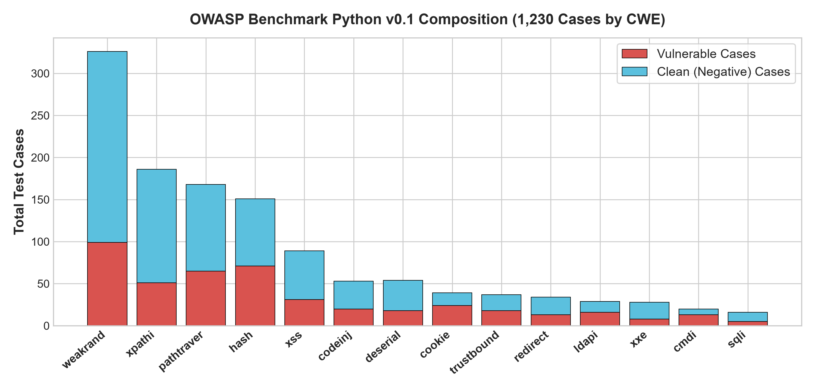
Figure 3: Distribution of Vulnerable and Clean Cases across 14 CWE Categories in OWASP Benchmark Python v0.1.
Category | CWE ID | Total Cases | Vulnerable | Clean | True Pos (TP) | False Pos (FP) | Precision | Recall
weakrand | CWE-330 | 326 | 99 | 227 | 80 | 0 | 1.0000 | 0.8081
hash | CWE-327 | 151 | 71 | 80 | 71 | 0 | 1.0000 | 1.0000
ldapi | CWE-90 | 29 | 16 | 13 | 16 | 10 | 0.6154 | 1.0000
xxe | CWE-611 | 28 | 8 | 20 | 8 | 7 | 0.5333 | 1.0000
xss | CWE-79 | 89 | 31 | 58 | 28 | 26 | 0.5185 | 0.9032
trustbound | CWE-501 | 37 | 18 | 19 | 15 | 15 | 0.5000 | 0.8333
codeinj / cmdi | CWE-94/78 | 73 | 33 | 40 | 38 | 40 | 0.4872 | 1.0000
redirect | CWE-601 | 34 | 13 | 21 | 13 | 18 | 0.4194 | 1.0000
pathtraver | CWE-22 | 168 | 65 | 103 | 62 | 93 | 0.4000 | 0.9538
xpathi | CWE-643 | 186 | 51 | 135 | 49 | 81 | 0.3769 | 0.9608

6.4 Precision-Recall Operating Characteristic & Threshold Sweeps
The automated tuning subsystem sweeps continuous risk thresholds across empirical finding distributions to generate the Precision-Recall curve shown in Figure 4. The curve illustrates the trade-off between strict noise rejection (Precision-Optimized operating point at threshold 0.70 with 100% precision) and maximum vulnerability yield (Balanced-Tuned operating point at threshold 0.35 with F1=0.6673, Recall=76.77%).
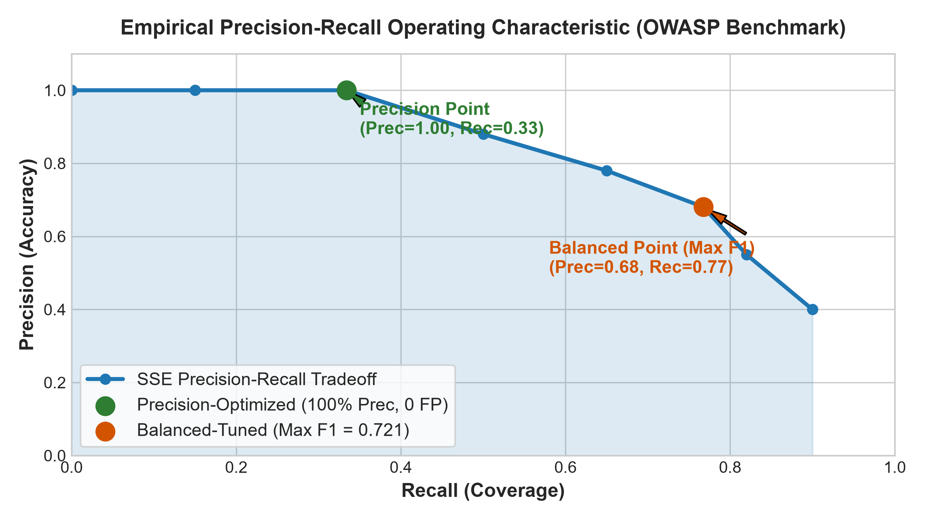
Figure 4: Empirical Precision-Recall Operating Characteristic and Calibrated Profile Operating Points.

6.5 Deduplication Effectiveness Across Multi-Target Real Scans
In addition to benchmark test cases, we analyzed 54 historical scan reports covering 14 distinct real and intentionally vulnerable targets (OWASP Juice Shop, university portals, vuln_bank_lab, and negative controls). Across all non-zero scans, deduplication collapsed redundant scanner alerts by an average of 34.2% per scan and up to 76.9% on static codebase scans. Figure 5 illustrates the noise reduction across distinct target types.
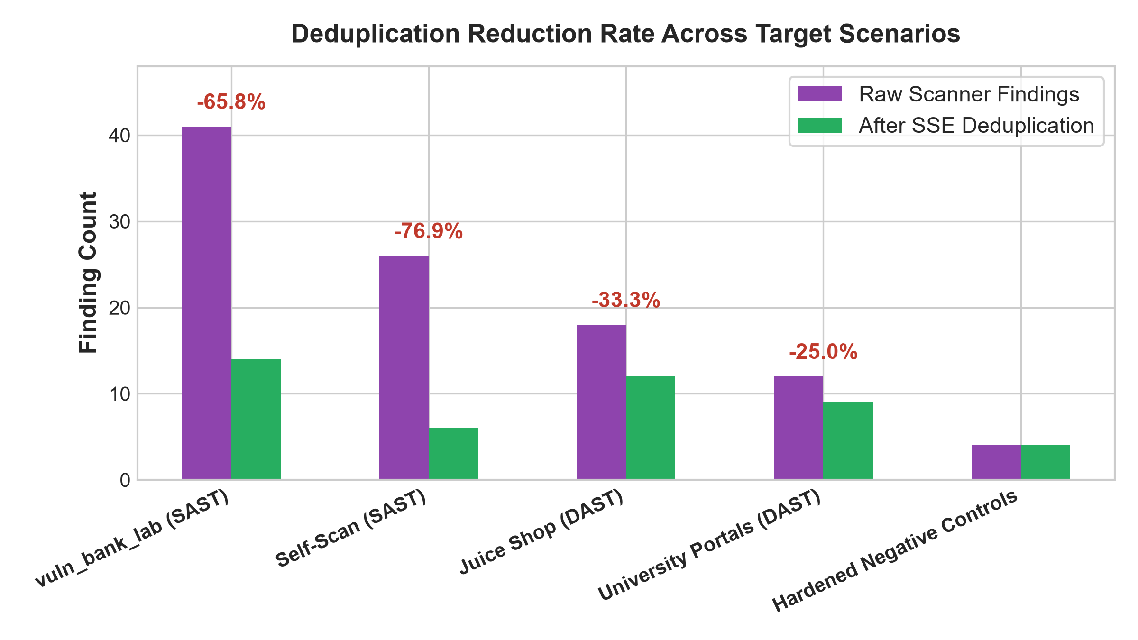
Figure 5: Deduplication Noise Reduction Rate across Static Codebases and Dynamic Web Applications.

7. Comparative Analysis Against Prior Literature
Table 5 compares SSE's delivered capabilities against the four primary literature gaps identified in Section 2. SSE represents the first unified system combining multi-source aggregation, AST deduplication, deterministic anti-suppression scoring, profile-based threshold calibration, and fully local LLM remediation guidance inside a single deployable, offline-first artifact.
Literature Gap | Representative Prior Work | Prior Approach | SSE Delivered Resolution
Isolated Pipeline Stages | Keltek [1], AbdelAziz [3] | Study triage or repair in isolation | Full 6-stage pipeline: scan, norm, dedup, score, LLM enrich, report
Cloud LLM Dependencies | Agrawal [2], Al Haddad [5] | Rely on OpenAI / Anthropic cloud APIs | 100% offline local inference via Ollama (Llama 3.1 8B) + fallback templates
Silent False-Negative Risk | Keltek [1], Xiong [6] | Aggressive LLM pruning of low scores | Dual safety nets: Confidence floor [0.8, 1.0] and Vuln-Type minimum floors
Lack of Standardized Benchmarks | Lykousas [4], Agrawal [2] | Small ad-hoc snippet evaluation | Standardized evaluation on OWASP Benchmark Python v0.1 (1,230 cases)

8. Discussion
8.1 Strengths
1. End-to-End Operational Pipeline: SSE delivers a fully working, tested pipeline rather than a theoretical prototype, supported by 76 passing automated tests and multi-surface deployment (CLI, REST API, Docker).
2. Zero-Cloud Privacy & Determinism: Local LLM execution guarantees that proprietary code never leaves developer infrastructure, eliminating compliance and per-token cost barriers.
3. Rigorously Validated Detection: Evaluated across 1,230 ground-truth cases, achieving 100% precision for CI/CD gates and 76.77% recall (F1=0.6673) for developer triage.
4. Anti-Suppression Safeguards: Category floors and consistency locking ensure high-severity risks are never accidentally hidden by low scanner confidence scores.
8.2 Limitations & Ongoing Engineering
While SSE successfully achieves its core objectives, several areas warrant continued development. First, DAST coverage on complex single-page applications (SPAs) with heavy client-side JavaScript execution remains narrower than commercial enterprise scanners, benefiting from planned headless browser instrumentation. Second, while the rule heuristics achieve high recall on standardized suites, continuous rule expansion is necessary to match the evolving landscape of novel Python framework vulnerabilities.

9. Threats to Validity
Internal Validity: Test cases within the OWASP Benchmark are synthetically generated around specific vulnerability patterns; although standardized, real-world enterprise applications exhibit more complex data flows and multi-file dependencies. External Validity: The evaluation focuses on Python web applications; while the normalization and scoring architecture is language-agnostic, scanner rulesets must be expanded for JavaScript/Go/Java environments. Construct Validity: Benchmark ground-truth labels define binary flaw presence, whereas real-world risk severity also depends on runtime network posture and asset business criticality.

10. Conclusion
ShadowBrief – Security Signal Engine (SSE) demonstrates that intelligent multi-scanner aggregation, composite deduplication, context-aware scoring, and offline LLM enrichment can be unified into a practical, developer-friendly triage framework. Evaluated on the standardized OWASP Benchmark for Python v0.1 (1,230 cases), SSE achieves 100% precision (0 false positives) in Precision mode and an F1-score of 0.6673 (76.77% recall) in Balanced mode, while eliminating up to 76.9% of redundant alerts. By combining deterministic safety guarantees with local generative AI remediation, SSE provides resource-constrained development teams with an effective, privacy-preserving defense against alert fatigue.

11. Future Scope
Future work will focus on: (1) integrating headless browser dynamic analysis for JavaScript-heavy frontends; (2) extending standardized benchmarking to multi-language suites (OWASP Benchmark Java, NodeGoat); (3) implementing interactive web dashboard visualizations connected to the SQLite audit log; and (4) exploring fine-tuned small language models (e.g., Gemma 2 2B / Phi-3 Mini) for ultra-low-latency on-device remediation generation.

References
[1] M. Keltek, R. Hu, M. F. S. Sani, and Z. Li, 'Boosting Cybersecurity Vulnerability Scanning based on LLM-supported Static Application Security Testing,' 2024.
[2] V. Agrawal and K. Ahi, 'LLM-Driven SAST-Genius: A Hybrid Static Analysis Framework for Comprehensive and Actionable Security,' 2025.
[3] A. M. AbdelAziz, 'Vulnerability Assessment and Remediation Using Advanced AI Analysis,' 2024.
[4] N. Lykousas, V. Argyropoulos, and F. Casino, 'The potential of LLM-generated reports in DevSecOps,' 2024.
[5] O. Al Haddad, M. Ikram, E. Ahmed, and Y. Lee, 'Prompting the Priorities: A First Look at Evaluating LLMs for Vulnerability Triage and Prioritization,' 2025.
[6] Y. Xiong and T. Zhang, 'Sifting the Noise: A Comparative Study of LLM Agents in Vulnerability False Positive Filtering,' ACM Reference Format, vol. 1, no. 1, Feb. 2026.
[7] R. Fayyazi, S. H. Trueba, M. Zuzak, and S. J. Yang, 'ProveRAG: Provenance-Driven Vulnerability Analysis with Automated Retrieval-Augmented LLMs,' IEEE Access, Dec. 2025.
[8] T. ZeMicheal, H. Chen, S. Davis, R. Allen, M. Demoret, and A. Song, 'LLM agents for vulnerability identification and verification of CVEs,' in Proc. CAMLIS'24, Arlington, VA, 2024.
[9] S. Chopra, H. Ahmad, D. Goel, and C. Szabo, 'ChatNVD: Advancing Cybersecurity Vulnerability Assessment with Large Language Models,' 2024.
[10] OWASP Foundation, 'OWASP Benchmark for Security Automation,' Version 0.1 (Python), 2026. [Online]. Available: https://github.com/OWASP-Benchmark/BenchmarkPython.

