**Paste the command that you require to achieve steps mentioned below and paste the screenshot whenever needed.**

**(You can save a copy of this file and modify it directly!)**

1. Make a directory on desktop named “Demo”



1. Make 10 files demo1,demo2,demo3,…,demo10 inside Demo directory.



1. Add new user named “testuser”

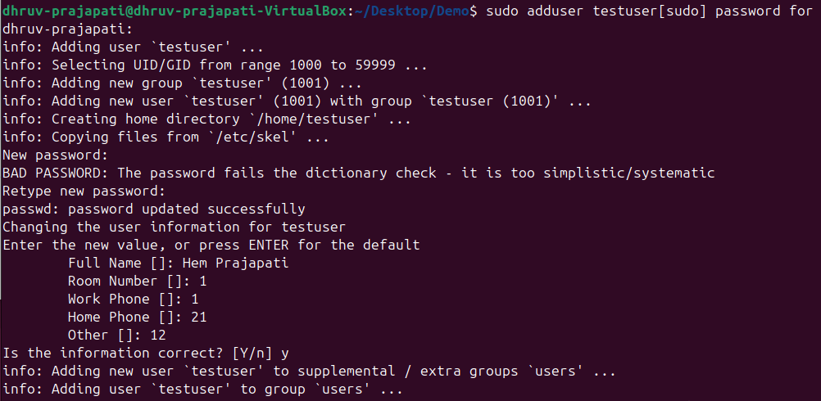

1. Verify that user has been added or not? Mention the steps that you have followed to verify!



1. Login as testuser



1. Create new file named “testuserfile” inside Demo directory.
2. Exit from testuser

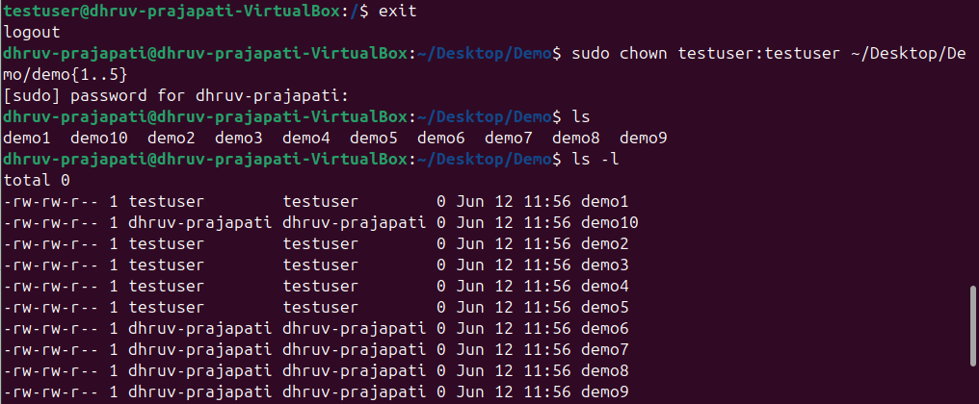

1. Change ownership of first 5 files (demo1, demo2, … demo5) to testuser



1. Create group named “HR”

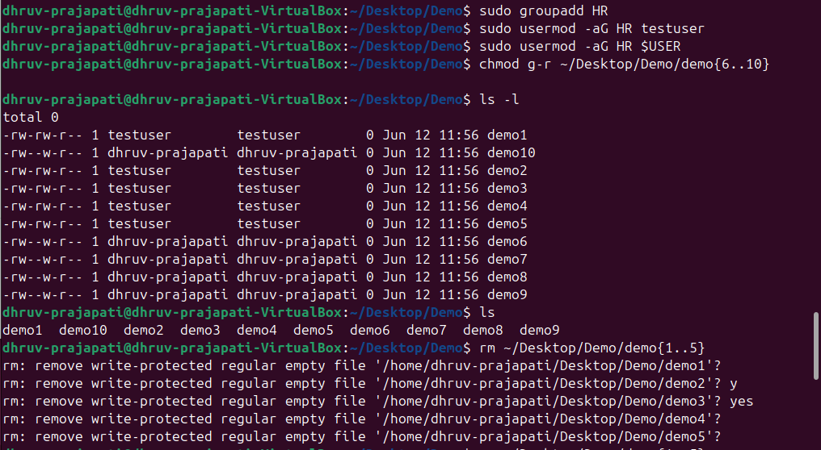

1. Add testuser and your current user to this group (“HR”)



1. Remove read permission from all groups for last five files inside Demo directory (demo6, demo7, … , demo10)



1. Delete first 5 files from demo directory with minimal number of commands.

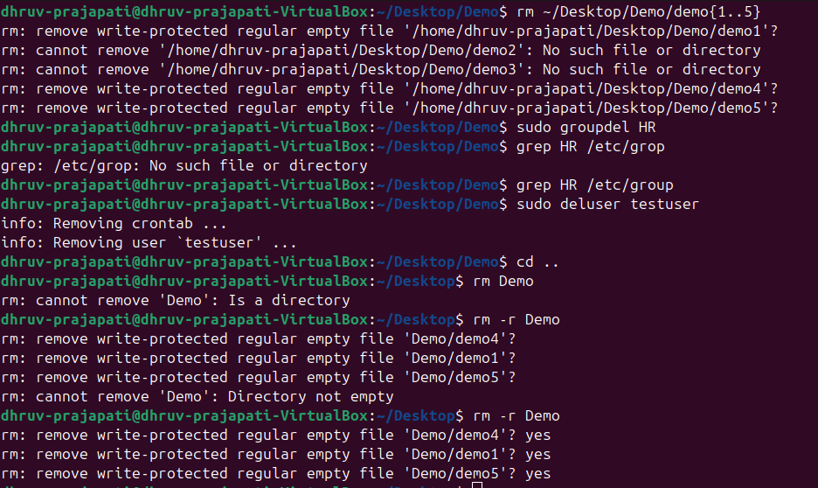

1. Remove group “HR” and verify it.



1. Remove “testuser”



1. Remove Demo directory.



**Paste your cheat sheet here:**

**Write conclusion in few lines for above activity and today’s session:**

In this tasks I learned basic user and group management, file and directory operations, and permission handling in a Linux environment. We created a directory and multiple files, added a new user and verified it, changed file ownerships, managed groups and permissions, and cleaned up by deleting users, groups, and directories. This exercise provided a comprehensive overview of essential administrative tasks in Linux.