FinWealth Advisors
Azure Data Warehouse End-to-End Project Report
Dhruv Panchal
Int ID : 1054

Azure Data Factory | Azure SQL Database | Key Vault
Staging → DWH | SCD Type 1 & Type 2 | Star Schema

Version 1.0 | FinWealth DW Team

Table of Contents

- Project Overview & Architecture
- Azure Resource Setup
  - Resource Group
  - Storage Account & Blob Container
  - Azure Key Vault
  - Azure SQL Server & Database
  - Azure Data Factory
  - ADF Managed Identity & Key Vault Access
- Source Files Analysis
- SQL Database Setup
  - Schema Creation
  - Staging Tables (11 tables)
  - DWH Dimension Tables (SCD Type 1 & 2)
  - DWH Fact Tables
  - dim_date Population
- ADF Configuration
  - GitHub Integration
  - Linked Services (3)
  - Datasets — CSV & SQL (22 total)
- ADF Pipelines
  - pl_ingest_all_csv_to_stg
  - pl_transform_stg_to_dwh
  - pl_master_finwealth_dwh
- Stored Procedures
  - Dimension Load SPs (SCD 1 & 2)
  - Fact Load SPs
  - Audit Logging SPs
- Data Quality & Validation
- Naming Conventions
- Expected Row Counts
- Screenshots
  - Resources
  - PL-TRANSFORM STG TO DWH
  - INGEST_FINWEALTH_ALLSOURCES
  - MASTER PIPELINE
  - BLOB STORAGE CONTAINER
  - DWH TABLE CONTENTS EXAMPLE (QUERY EDITOR)
  - VALIDATION (11.7.1~11.7.4)
12 ER Diagram

01 Project Overview & Architecture
FinWealth Advisors required a centralised Azure Data Warehouse to support wealth analytics dashboards. This document is the complete step-by-step guide covering every resource, script, pipeline, and validation check built during the project.

Architecture Flow

The data pipeline follows a standard Medallion-style two-layer architecture:

Layer | Technology | Description
Source | Azure Blob Storage (raw-data container) | 11 CSV files uploaded manually
Staging | Azure SQL — stg schema | Raw landing zone, all VARCHAR, no constraints
DWH | Azure SQL — dwh schema | Star schema with dimensions and facts, typed columns
Orchestration | Azure Data Factory | 3 pipelines: Ingest, Transform, Master
Secrets | Azure Key Vault | All passwords and connection strings stored securely

Star Schema Design

The DWH follows a Star Schema with 5 dimension tables and 6 fact tables:

Table | Type | SCD | Source File | Rows
dim_advisor | Dimension | Type 1 | Advisors.csv | 350
dim_benchmark | Dimension | Type 1 | Benchmarks.csv | 6 (distinct)
dim_security | Dimension | Type 1 | Securities.csv | 3,000
dim_client | Dimension | Type 2 | Clients.csv | 8,000
dim_account | Dimension | Type 2 | Accounts.csv | 12,000
dim_date | Dimension | Static | Generated | 5,479
fact_holding | Fact | — | Holdings.csv | 96,027
fact_trade | Fact | — | Trades.csv | 100,400
fact_cashflow | Fact | — | Cashflows.csv | 30,000
fact_fee | Fact | — | Fees.csv | 18,000
fact_security_price | Fact | — | Prices.csv | 301,500
fact_performance | Fact | — | Performance.csv | 110,000

02 Azure Resource Setup
All resources are created via Azure Portal GUI. Use the same region for all resources to avoid latency and egress costs.

Resource Group

Navigate to: Azure Portal → Resource groups → + Create

Field | Value
Subscription | Your Azure subscription
Resource group name | rs-finwealth-redo
Region | Central Asia (East India)

Storage Account & Blob Container

Navigate to: Storage accounts → + Create

Field | Value
Resource group | rs-finwealth-redo
Storage account name | safinwealthredo
Region | West India
Performance | Standard
Redundancy | LRS — Locally Redundant Storage
After creation: Go to Containers → + Container → Name: raw-data → Access: Private. Upload all 11 CSV files into this container.

Azure Key Vault

Navigate to: Key vaults → + Create. Key Vault stores all secrets so no passwords are hardcoded in ADF.

Field | Value
Resource group | rs-finwealth-redo
Key vault name | kv-finwealth
Region | West India
Pricing tier | Standard
After creation, add the following secrets under Secrets → + Generate/Import:

Secret Name | Value
secretsqlpsw | SQL admin password

Azure SQL Server & Database

Navigate to: SQL servers → + Create

Field | Value
Server name | sqlsrvrfinwealthredo
Region | Central India
Authentication | SQL Authentication
Admin login | finwealth_admin
Password | Strong password — store in Key Vault
After server creation, create the database: sql-finwealth-dw-prod → + Create database

Field | Value
Database name | sqldbfinwealthredo
Compute + storage | General Purpose, 2 vCores
Backup redundancy | Locally redundant
NOTE: After database creation go to SQL server → Networking → Add your client IP + enable 'Allow Azure services'. Without this ADF cannot connect.

Azure Data Factory

Navigate to: Data factories → + Create

Field | Value
Resource group | rs-finwealth-redo
Name | adf-finwealth-redo
Region | Central India
Version | V2

ADF Managed Identity & Key Vault Access Policy
ADF uses its system-assigned Managed Identity to read secrets from Key Vault — no API keys needed.

    - Go to adf-finwealth-redo → Properties → copy Managed Identity Object ID
    - Go to kv-finwealth → Access policies → + Create
    - Secret permissions: tick Get and List only
    - Principal: paste the ADF Managed Identity Object ID
    - Click Next → Next → Create

GitHub Integration

Go to ADF Studio → Manage → Git configuration → Configure → GitHub

Field | Value
Repository name | ETL-project
Collaboration branch | main
Publish branch | adf_publish

03 Source Files Analysis
All 11 source CSV files were analysed before any pipeline was built. Key findings:

File | Rows | Columns | Key Issues Found
Advisors.csv | 350 | 5 | 1 NULL Region → stored as 'Unknown'
Clients.csv | 8,000 | 7 | 66 NULL RiskProfile → stored as 'Unknown'
Accounts.csv | 12,000 | 6 | Clean
Securities.csv | 3,000 | 7 | 672 NULL Sector → stored as 'N/A' (Bonds/Cash expected)
Benchmarks.csv | 4,020 | 5 | Clean — 6 distinct benchmark codes
Cashflows.csv | 30,000 | 5 | Signed amounts — positive=inflow, negative=outflow
Fees.csv | 18,000 | 5 | All positive amounts — fees always a cost
Holdings.csv | 96,027 | 5 | Single snapshot date: 2025-10-31
Performance.csv | 110,000 | 7 | 109 NULL ReturnPct → loaded as NULL
Prices.csv | 301,500 | 3 | 478 NULL ClosePrice → loaded as NULL
Trades.csv | 100,400 | 9 | 250 negative settle lags; 60 SELL with positive amount (source anomaly)

04 SQL Database Setup
All scripts are run in Azure Portal → SQL databases → sqldbfinwealthredo → Query editor. Run each statement separately.

Schema Creation

Run each line separately in Query Editor:
CREATE SCHEMA stg;
CREATE SCHEMA dwh;

Staging Tables

Staging tables use all VARCHAR columns — this prevents load failures due to type mismatches. A stg_load_timestamp column is added for audit purposes.
- staging tables created:

Staging Table | Source File | Key Columns
stg.stg_advisors | Advisors.csv | AdvisorID, AdvisorName, Region, JoinDate, ExperienceYears
stg.stg_clients | Clients.csv | ClientID, ClientName, Segment, RiskProfile, PrimaryAdvisorID
stg.stg_accounts | Accounts.csv | AccountID, ClientID, AccountType, OpenDate, BaseCurrency, Status
stg.stg_securities | Securities.csv | SecurityID, Ticker, SecurityName, AssetClass, Sector, Currency
stg.stg_benchmarks | Benchmarks.csv | BenchmarkCode, Description, Currency, IndexValueDate, IndexValue
stg.stg_cashflows | Cashflows.csv | CashflowID, AccountID, CashflowDate, Type, Amount
stg.stg_fees | Fees.csv | FeeID, AccountID, FeeDate, FeeType, Amount
stg.stg_holdings | Holdings.csv | AccountID, SecurityID, Quantity, ValuationDate, MarketValue
stg.stg_performance | Performance.csv | AccountID, MonthStart, ReturnPct, BenchmarkCode
stg.stg_prices | Prices.csv | SecurityID, PriceDate, ClosePrice
stg.stg_trades | Trades.csv | TradeID, AccountID, SecurityID, TradeDate, Side, Price, Quantity

DWH Dimension Tables — SCD Type 1 & 2

SCD Type 1 (Overwrite): dim_advisor, dim_benchmark, dim_security — changes overwrite existing record, history not needed.
SCD Type 2 (Full History): dim_client, dim_account — changes create a new row, old row is expired with effective_end_date and is_current = N.

Dimension | SCD Type | Surrogate Key | Natural Key | Special Handling
dim_advisor | Type 1 | advisor_sk | advisor_id | NULL Region → 'Unknown'
dim_benchmark | Type 1 | benchmark_sk | benchmark_code | Clean
dim_security | Type 1 | security_sk | security_id | NULL Sector → 'N/A'
dim_client | Type 2 | client_sk | client_id | NULL RiskProfile → 'Unknown'; effective_start/end dates
dim_account | Type 2 | account_sk | account_id | Status/type changes tracked; effective_start/end dates
dim_date | Static | date_sk | full_date | YYYYMMDD integer key; covers 2012-01-01 to 2026-12-31

DWH Fact Tables

Fact tables use surrogate keys from dimension tables. Natural keys are retained in fact tables for traceability.

Fact Table | Grain | Key FKs | Notes
fact_holding | Account + Security + Date | account_sk, security_sk, date_sk | AUM source; full refresh each run
fact_trade | One row per trade | account_sk, security_sk, trade_date_sk, settle_date_sk | settle_lag_days derived column added
fact_cashflow | One row per cashflow | account_sk, date_sk | is_inflow Y/N derived from amount sign
fact_fee | One row per fee | account_sk, date_sk | All amounts positive
fact_security_price | Security + Date | security_sk, date_sk | 478 NULL prices allowed
fact_performance | Account + Benchmark  + Month | account_sk, benchmark_sk, date_sk | 109 NULL return_pct allowed

Audit Log Table

All pipeline runs are logged to dbo.audit_pipeline_log:

CREATE TABLE dbo.audit_pipeline_log (
log_id INT IDENTITY(1,1) PRIMARY KEY,
pipeline_name VARCHAR(100) NOT NULL,
source_file VARCHAR(100) NOT NULL,
target_table VARCHAR(100) NOT NULL,
run_start_time DATETIME NOT NULL,
run_end_time DATETIME NULL,

rows_loaded INT NULL,
status VARCHAR(20) NOT NULL, -- RUNNING / SUCCESS / FAILED
error_message VARCHAR(2000)NULL,
loaded_by VARCHAR(100) DEFAULT 'ADF'
);

05 ADF Configuration

Linked Services

Three Linked Services connect ADF to external resources. All secrets fetched from Key Vault — no hardcoded passwords.

Linked Service Name | Type | Connection | Secret Used
ls_keyvault_finwealth | Azure Key Vault | kv-finwealth-dw-prod | —
LSAzureBlobStorageFinwealthredo | Azure Blob Storage | safinwealthredo | secret-blob-finwealth-accesskey
LSAzureSqlDatabaseFinwealthredo | Azure SQL Database | sqldbfinwealthredo | secret-sql-finwealth-p assword
NOTE: Always create ls_keyvault_finwealth first. The other two linked services reference it for their secret values.

  - Datasets — CSV Source (ds_csv folder)

11 DelimitedText datasets pointing to Azure Blob Storage. First row as header = checked. Schema imported from connection.
Dataset Name | File | Linked Service
ds_csv_advisors | Advisors.csv | LSAzureBlobStorageFinwealthredo
ds_csv_clients | Clients.csv | LSAzureBlobStorageFinwealthredo
ds_csv_accounts | Accounts.csv | LSAzureBlobStorageFinwealthredo
ds_csv_securities | Securities.csv | LSAzureBlobStorageFinwealthredo
ds_csv_benchmarks | Benchmarks.csv | LSAzureBlobStorageFinwealthredo
ds_csv_cashflows | Cashflows.csv | LSAzureBlobStorageFinwealthredo
ds_csv_fees | Fees.csv | LSAzureBlobStorageFinwealthredo
ds_csv_holdings | Holdings.csv | LSAzureBlobStorageFinwealthredo
ds_csv_performance | Performance.csv | LSAzureBlobStorageFinwealthredo
ds_csv_prices | Prices.csv | LSAzureBlobStorageFinwealthredo
ds_csv_trades | Trades.csv | LSAzureBlobStorageFinwealthredo

  - Datasets — SQL Sink (ds_sql folder)

11 Azure SQL Database datasets pointing to staging tables.

Dataset Name | Table | Linked Service
ds_sql_stg_advisors | stg.stg_advisors | LSAzureSqlDatabaseFinwealthredo
ds_sql_stg_clients | stg.stg_clients | LSAzureSqlDatabaseFinwealthredo
ds_sql_stg_accounts | stg.stg_accounts | LSAzureSqlDatabaseFinwealthredo
ds_sql_stg_securities | stg.stg_securities | LSAzureSqlDatabaseFinwealthredo
ds_sql_stg_benchmarks | stg.stg_benchmarks | LSAzureSqlDatabaseFinwealthredo
ds_sql_stg_cashflows | stg.stg_cashflows | LSAzureSqlDatabaseFinwealthredo
ds_sql_stg_fees | stg.stg_fees | LSAzureSqlDatabaseFinwealthredo
ds_sql_stg_holdings | stg.stg_holdings | LSAzureSqlDatabaseFinwealthredo
ds_sql_stg_performance | stg.stg_performance | LSAzureSqlDatabaseFinwealthredo
ds_sql_stg_prices | stg.stg_prices | LSAzureSqlDatabaseFinwealthredo
ds_sql_stg_trades | stg.stg_trades | LSAzureSqlDatabaseFinwealthredo
NOTE: When mapping columns in Copy activities, delete the stg_load_timestamp row from the mapping. It is auto-filled by SQL DEFAULT GETDATE() and has no CSV source column.

06 ADF Pipelines
Three pipelines are created across two folders. The master pipeline calls both pipelines in sequence with one click.

Pipeline | Purpose
pl_ingest_finwealth_allsources | Truncate all staging tables, copy all 11 CSVs in parallel, log result
pl_transform_stg_to_dwh | Load all dimensions then facts via stored procedures, log result
Master_pipeline_finwealth | Execute ingest then transform end-to-end with single Debug/Trigger

  - pl_ingest_all_csv_to_stg

Pipeline flow:
    - Activity 1 — script_truncate_all_stg (Script activity): Truncates all 11 staging tables in one SQL block
    - Activities 2-12 — 11 Copy Data activities all connected from truncate script with green arrows, running in PARALLEL
    - Activity 13 — sp_log_success (Stored Procedure): Connected from all 11 copy activities with GREEN arrow
    - Activity 14 — sp_log_failure (Stored Procedure): Connected from all 11 copy activities with RED arrow
NOTE: Delete the stg_load_timestamp mapping row in each Copy activity's Mapping tab before publishing.

  - pl_transform_stg_to_dwh

Pipeline flow — strict sequential order for dimensions, then parallel for facts:
    - sp_load_dim_advisor → sp_load_dim_benchmark → sp_load_dim_security → sp_load_dim_client →
sp_load_dim_account (sequential green arrows)
    - sp_load_dim_account → all 6 fact SPs in PARALLEL (6 green arrows out)
    - All 6 fact SPs → sp_log_transform_success (GREEN arrows)
    - All 6 fact SPs → sp_log_transform_failure (RED arrows)

SP Activity Name | Stored Procedure | Type
sp_load_dim_advisor | dwh.usp_load_dim_advisor | SCD Type 1
sp_load_dim_benchmark | dwh.usp_load_dim_benchmark | SCD Type 1
sp_load_dim_security | dwh.usp_load_dim_security | SCD Type 1
sp_load_dim_client | dwh.usp_load_dim_client | SCD Type 2
sp_load_dim_account | dwh.usp_load_dim_account | SCD Type 2
sp_load_fact_holding | dwh.usp_load_fact_holding | Full Refresh

SP Activity Name | Stored Procedure | Type
sp_load_fact_trade | dwh.usp_load_fact_trade | Full Refresh
sp_load_fact_cashflow | dwh.usp_load_fact_cashflow | Full Refresh
sp_load_fact_fee | dwh.usp_load_fact_fee | Full Refresh
sp_load_fact_security_price | dwh.usp_load_fact_security_price | Full Refresh
sp_load_fact_performance | dwh.usp_load_fact_performance | Full Refresh

  - pl_master_finwealth_dwh

Single pipeline with 2 Execute Pipeline activities:
    - exec_pl_ingest_all_csv_to_stg — Invoked pipeline: pl_ingest_all_csv_to_stg — Wait on completion: ON
    - exec_pl_transform_stg_to_dwh — Invoked pipeline: pl_transform_stg_to_dwh — Wait on completion: ON
    - Connect with ONE green arrow: exec_pl_ingest → exec_pl_transform
NOTE: Running pl_master_finwealth_dwh once completes the full end-to-end load from CSV files to DWH star schema.

07 Stored Procedures

Dimension SPs — SCD Logic Explained

SCD Type 1 (dim_advisor, dim_benchmark, dim_security): UPDATE existing record if any tracked column has changed. INSERT new records that do not yet exist. No history preserved — latest values overwrite.
SCD Type 2 (dim_client, dim_account): If a tracked column changes, the existing row is EXPIRED (effective_end_date = today, is_current = N). A new row is INSERTED with effective_start_date = today, effective_end_date = NULL, is_current = Y. Both old and new versions are retained.

SP Name | Schema | SCD | Key Logic
usp_load_dim_advisor | dwh | Type 1 | UPDATE changed; INSERT new; NULL Region →  'Unknown'
usp_load_dim_benchmark | dwh | Type 1 | UPDATE changed; INSERT new (DISTINCT on BenchmarkCode)
usp_load_dim_security | dwh | Type 1 | UPDATE changed; INSERT new; NULL Sector →  'N/A'
usp_load_dim_client | dwh | Type 2 | Expire changed rows; insert new version; insert brand new
usp_load_dim_account | dwh | Type 2 | Expire changed rows; insert new version; insert brand new

Fact SPs — Full Refresh Strategy

All fact SPs use TRUNCATE + full reload strategy. This is appropriate because source files contain complete history each time. Surrogate key lookups use is_current = Y for SCD-2 dimensions.

SP Name | TRUNCAT E |  | Key Joins | Special Logic
usp_load_fact_holding | Yes | dim_account (is_current=Y), dim_security, dim_date |  | MarketValue = AUM source
usp_load_fact_trade | Yes | dim_account, dim_security, dim_date x2 (trade+settle) |  | settle_lag_days = DATEDIFF(trade,settle)
usp_load_fact_cashflow | Yes | dim_account, dim_date |  | is_inflow derived from amount sign
usp_load_fact_fee | Yes | dim_account, dim_date |  | All amounts positive
usp_load_fact_security_price | Yes | dim_security, dim_date |  | NULL ClosePrice loaded as NULL

SP Name | TRUNCAT E | Key Joins | Special Logic
usp_load_fact_performance | Yes | dim_account, dim_benchmark, dim_date | NULL ReturnPct loaded as NULL

Audit Logging SPs

SP Name | Schema | Called By | Parameters
usp_log_ingest_summary | dbo | pl_ingest_all_csv_to_stg (success+failure SP) | status, error_message
usp_log_transform_summary | dbo | pl_transform_stg_to_dwh (success+failure SP) | status, error_message

08 Data Quality & Validation

Validation Checks Performed

Check | Result | Status
Audit log entries | 2 SUCCESS entries (ingest + transform) | - Pass
Staging row counts match source CSV | All 11 tables exact match | - Pass
DWH row counts match staging | All 11 tables exact match | - Pass
dim_advisor NULL region | 1 record → stored as 'Unknown' | - Pass
dim_client NULL risk_profile | 66 records → stored as 'Unknown' | - Pass
dim_security NULL sector | 672 records → stored as 'N/A' (expected) | - Pass
SCD Type 2 — dim_client current rows | 8,000 current records | - Pass
SCD Type 2 — dim_account current rows | 12,000 current records | - Pass
Referential integrity — all facts | Zero orphan records across all 6 facts | - Pass
Cashflow sign rules | Zero violations — all types correctly signed | - Pass
NULL ClosePrice in fact_security_price | 478 NULLs loaded as NULL (documented) | - Pass
NULL ReturnPct in fact_performance | 109 NULLs loaded as NULL (documented) | - Pass
Negative settle lag trades | 250 source anomalies loaded as-is | - Pass
SELL trades with positive amount | 60 source anomalies loaded as-is | - Pass

Data Quality Rules Applied

Rule | Column | Source Value | DWH Value
NULL Region | dim_advisor.region | NULL | 'Unknown'
NULL RiskProfile | dim_client.risk_profile | NULL or empty | 'Unknown'
NULL Sector | dim_security.sector | NULL or empty | 'N/A'
NULL ClosePrice | fact_security_price.close_price | NULL | NULL (allowed, documented)
NULL ReturnPct | fact_performance.return_pct | NULL | NULL (allowed, documented)

Validation SQL Queries

Run these queries anytime to verify data health:

-- Row count verification
SELECT 'dim_advisor', COUNT(*) FROM dwh.dim_advisor UNION ALL
SELECT 'dim_client', COUNT(*) FROM dwh.dim_client UNION ALL
SELECT 'fact_holding',COUNT(*) FROM dwh.fact_holding;

-- Referential integrity check
SELECT 'orphan holdings', COUNT(*) FROM dwh.fact_holding WHERE account_sk IS NULL
UNION ALL
SELECT 'orphan trades', COUNT(*) FROM dwh.fact_trade WHERE account_sk IS NULL;

09 Naming Conventions
All objects follow consistent naming conventions throughout the project:

Object Type | Convention | Example
Resource Group | rs | rsfinwealthredo
Storage Account | sa | safinwealthredo
Key Vault | kv | kv-finwealth
SQL Server | sqlsrvr | sqlsrvrfinwealthredo
SQL Database | sqldb | sqldbfinwealthredo
Data Factory | adf | adf-finwealthredo
ADF Linked Service | ls | LSAzureBlobStorageFinwealthredo
ADF Dataset CSV | ds_csv | ds_csv_advisors
ADF Dataset SQL | ds_sql_stg | ds_sql_stg_advisors
ADF Pipeline | pl | pl_ingest_all_csv_to_stg
Key Vault Secret | secret | secret-sql-finwealth-password
Staging Table | stg. | stg.stg_advisors
Dimension Table | dwh. | dwh.dim_advisor
Fact Table | dwh. | dwh.fact_holding
Stored Procedure | dwh. | dwh.usp_load_dim_advisor

10 Expected Row Counts
Use these counts to verify a successful end-to-end pipeline run:

Table | Layer | Expected Rows | Status
stg.stg_advisors | Staging | 350 | - Pass
stg.stg_clients | Staging | 8,000 | - Pass
stg.stg_accounts | Staging | 12,000 | - Pass
stg.stg_securities | Staging | 3,000 | - Pass
stg.stg_benchmarks | Staging | 4,020 | - Pass
stg.stg_cashflows | Staging | 30,000 | - Pass
stg.stg_fees | Staging | 18,000 | - Pass
stg.stg_holdings | Staging | 96,027 | - Pass
stg.stg_performance | Staging | 110,000 | - Pass
stg.stg_prices | Staging | 301,500 | - Pass
stg.stg_trades | Staging | 100,400 | - Pass
dwh.dim_advisor | DWH | 350 | - Pass
dwh.dim_benchmark | DWH | 6 | - Pass
dwh.dim_security | DWH | 3,000 | - Pass
dwh.dim_client | DWH | 8,000 | - Pass
dwh.dim_account | DWH | 12,000 | - Pass
dwh.fact_holding | DWH | 96,027 | - Pass
dwh.fact_trade | DWH | 100,400 | - Pass
dwh.fact_cashflow | DWH | 30,000 | - Pass
dwh.fact_fee | DWH | 18,000 | - Pass
dwh.fact_security_price | DWH | 301,500 | - Pass
dwh.fact_performance | DWH | 110,000 | - Pass

Total rows in DWH: 683,297 across 11 DWH tables (6 dimensions + 6 facts).

FinWealth Advisors — Azure DWH Project | Generated May 22,

11 Screenshots

11.1 Resources

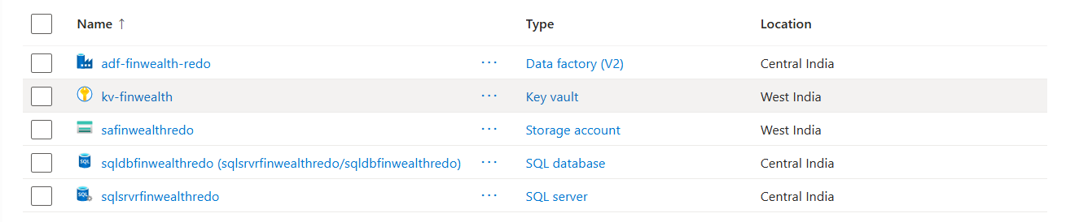

11.2 PL-TRANSFORM STG TO DWH
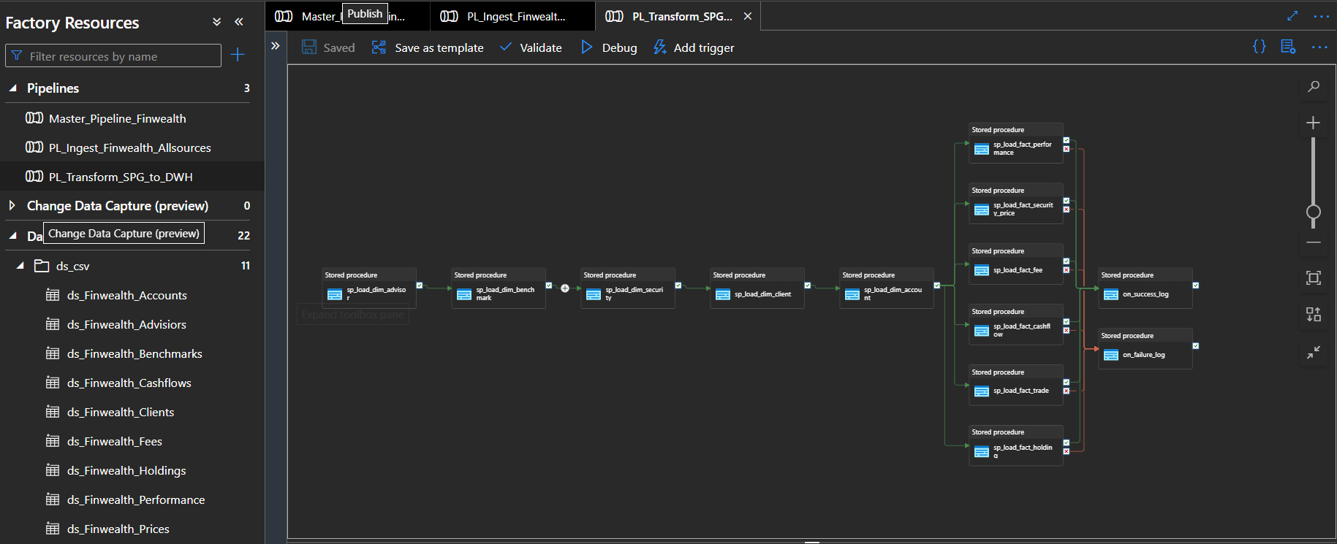

11.3 INGEST_FINWEALTH_ALLSOURCES

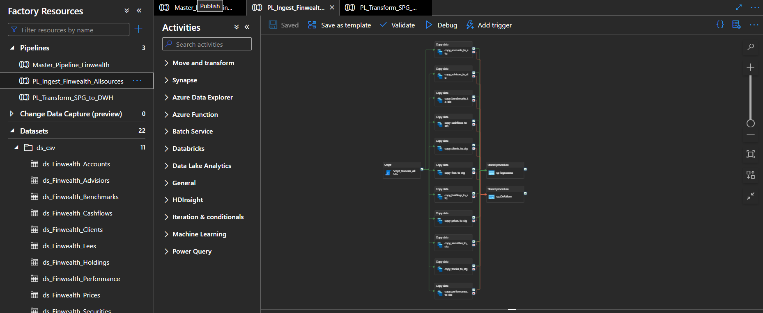

11.4 MASTER PIPELINE

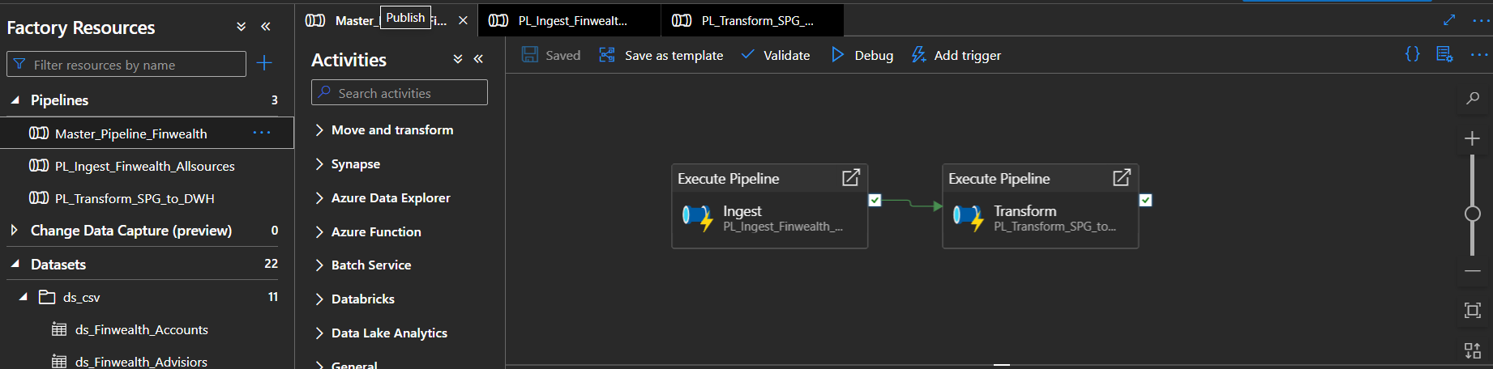

11.5 BLOB STORAGE CONTAINER

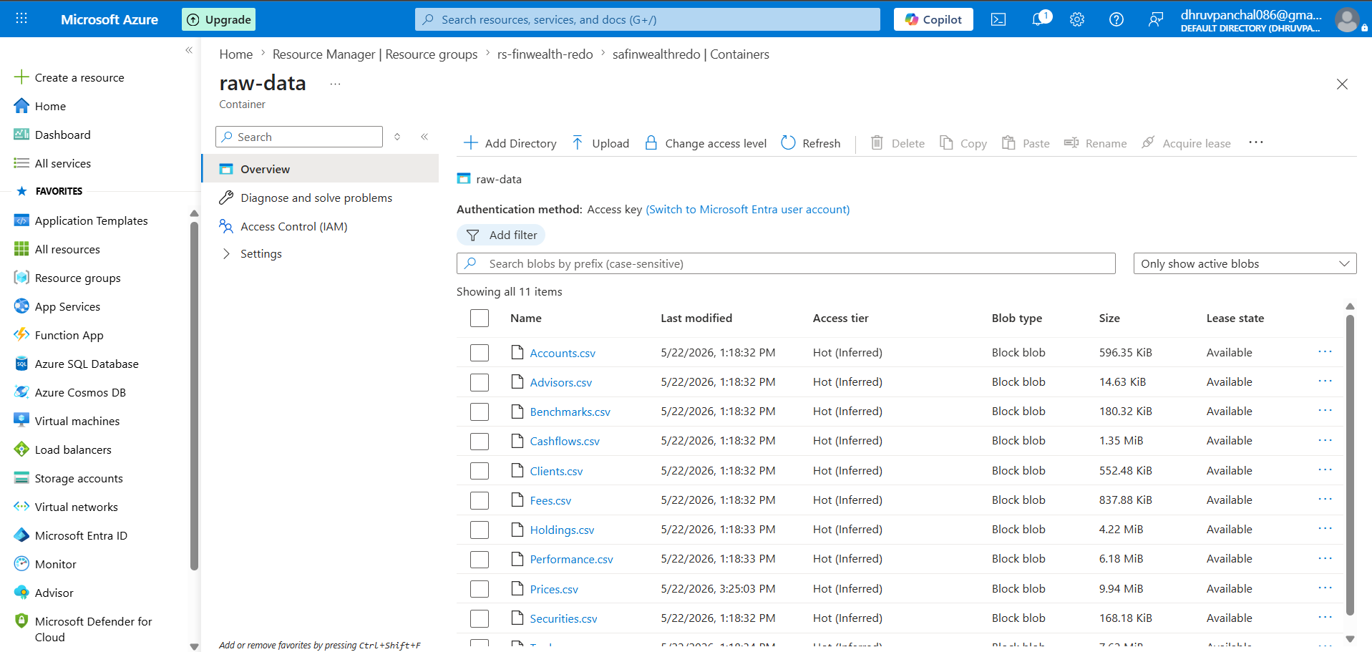

11.6 DWH TABLE CONTENTS EXAMPLE (QUERY EDITOR)

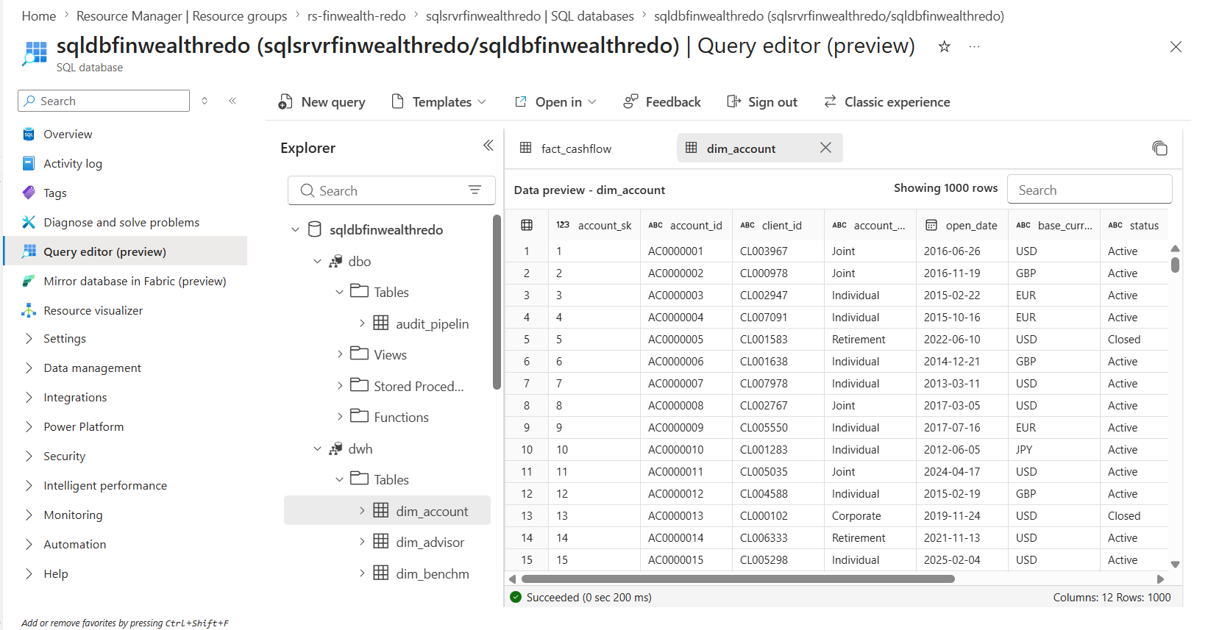

11.7.1 VALIDATION

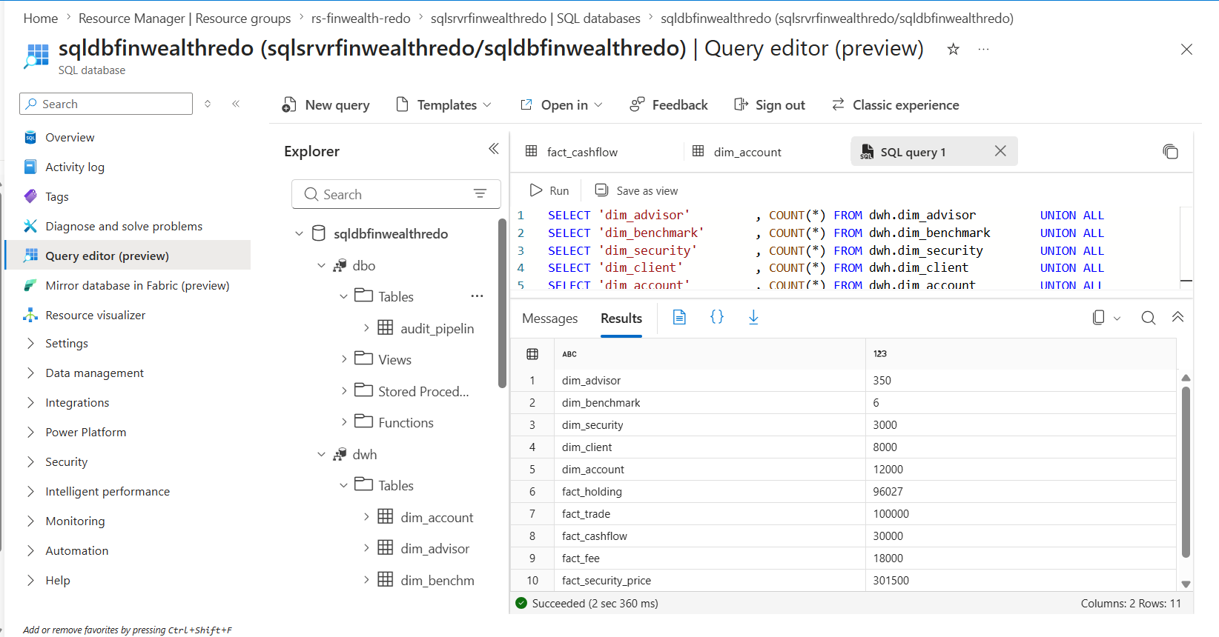

11.7.2 (REFER FEATURED QUERY FOR BETTER UNDERSTANDING)

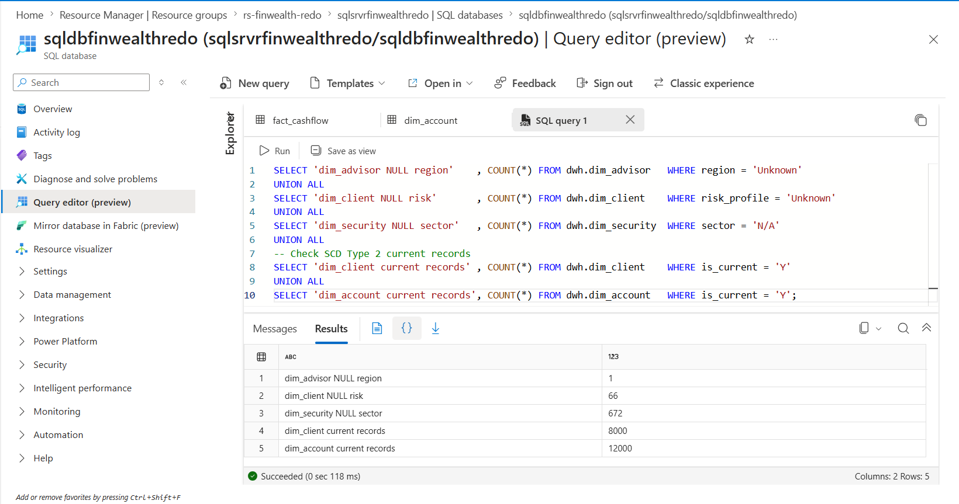

11.7.3

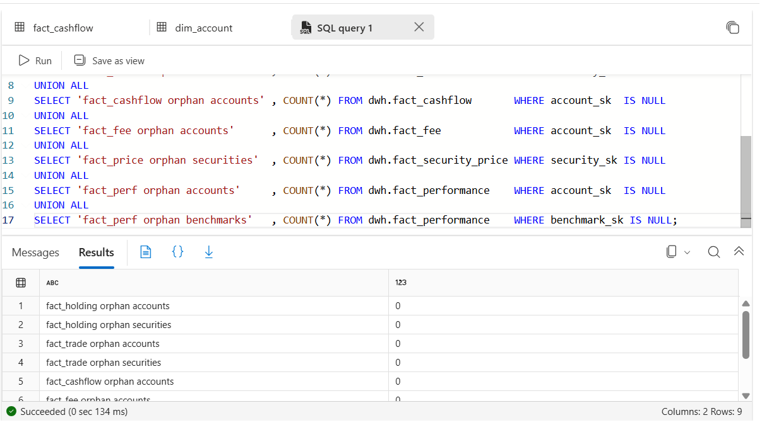

11.7.4 AUM BY CURRENCY

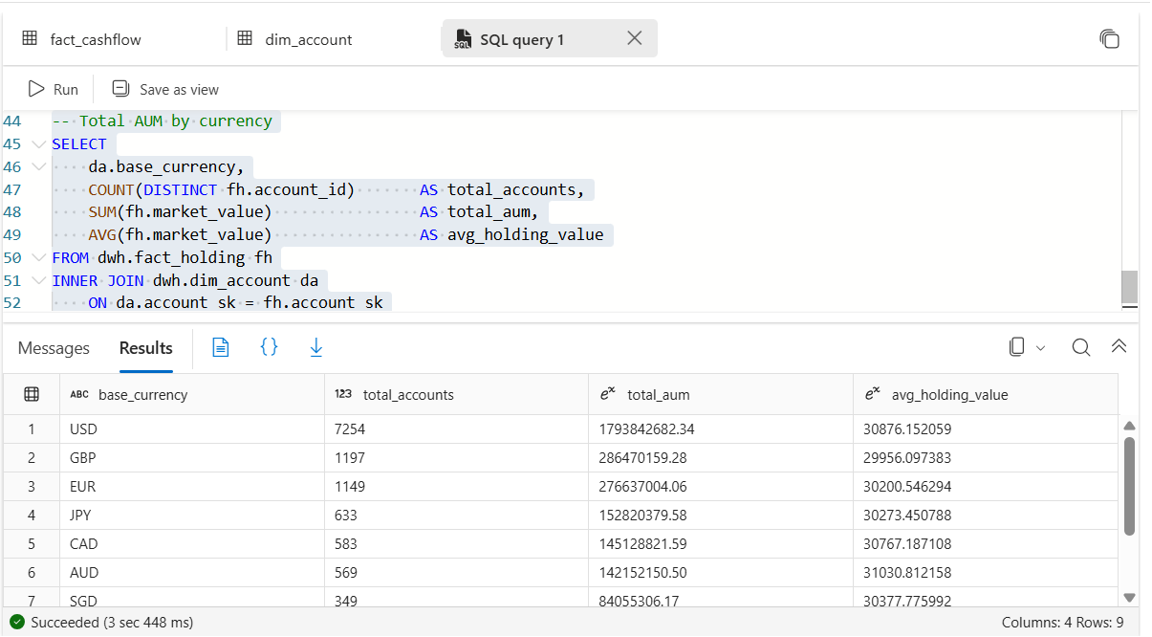

12 ER Diagram

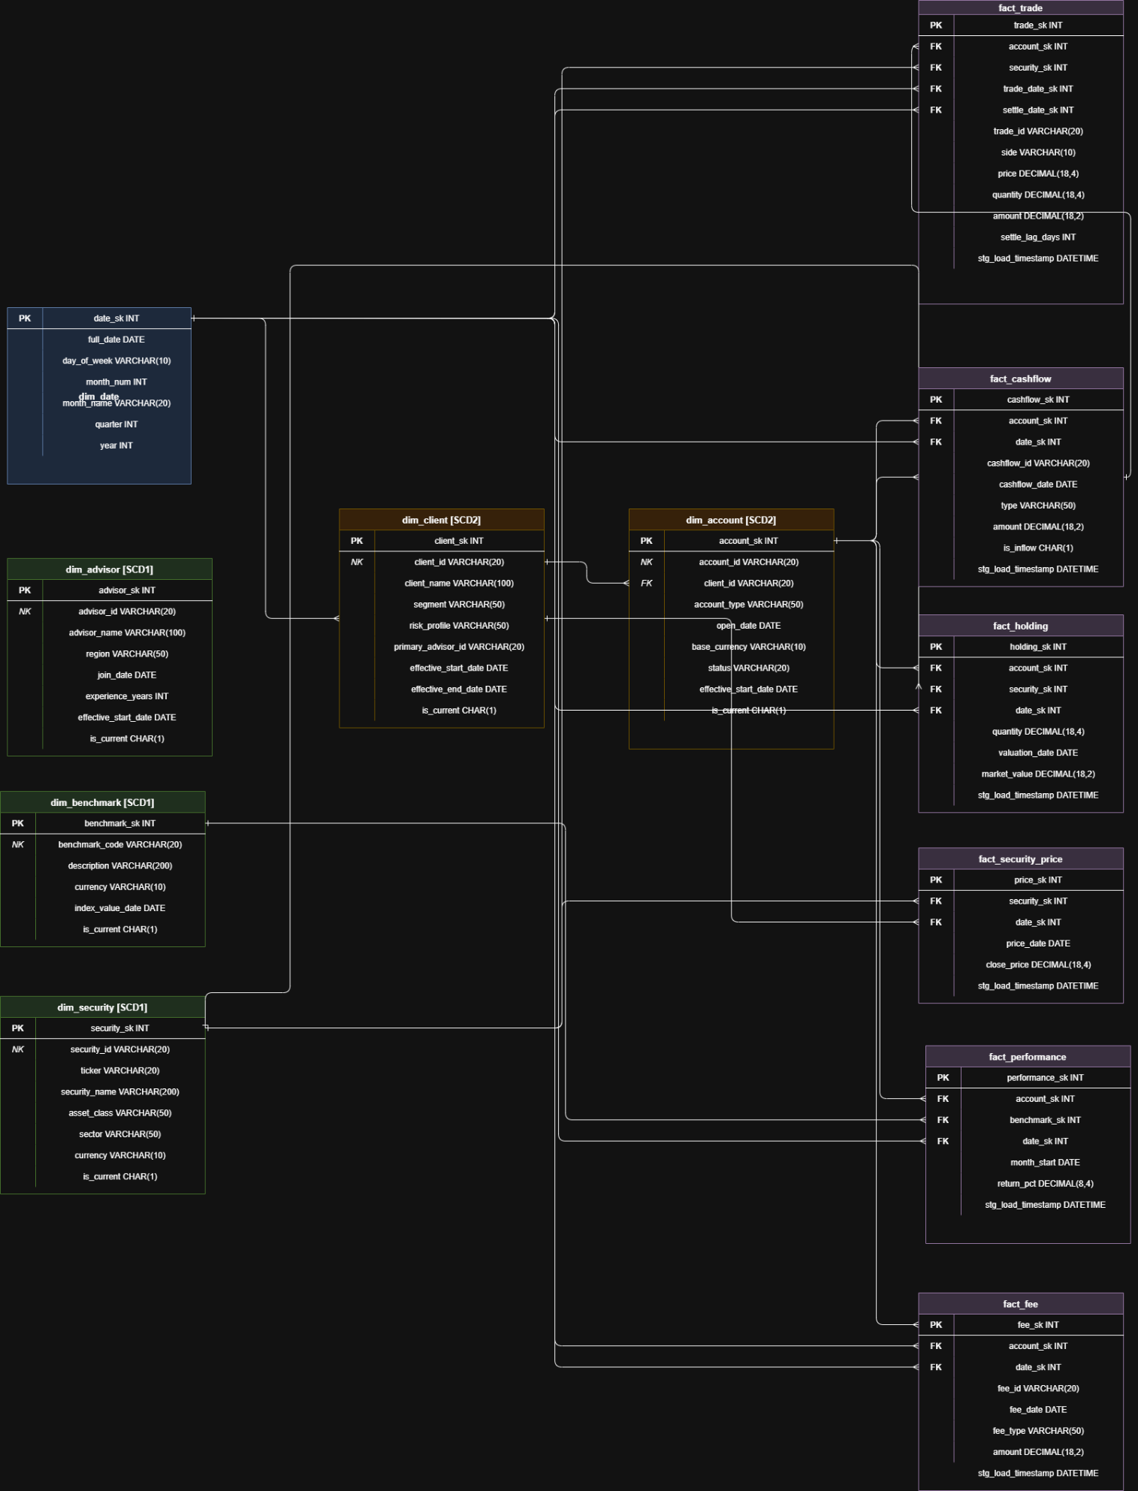

Legend

- Blue — dim_date (static)
- Green — dim_advisor, dim_benchmark, dim_security (SCD Type 1)
- Orange — dim_client, dim_account (SCD Type 2)
- Purple — all 6 fact tables

