**You have to do the coding in Aurdino UNO, sourcecode file has been uploaded**

**Introduction**

**Definition:** This system is based on the concept of IOT. The system helps the users to smartly manage the appliances like lights and fans.

**Purpose:** This system is focused on enabling the user to save energy and to increase the efficiency of the organization.

**Objective:** With this system we wish to help the users save more energy and thereby reducing the carbon footprint.

**Scope:** Home, Offices and Colleges

**System Requirements**

**Requirement analysis** is a process that involves all of the activities required to create and maintain a system requirements document. There are four generic Domain high-level requirements engineering process activities. These are system feasibility study, the elicitation and analysis of requirements, the specification of requirements and their documentation and, finally, the validation of these requirements.

**Introduction**

**Definition:** Our system is based on the concept of IoT. The system helps the users to smartly manage the appliances like lights and fans.

**Purpose:** Our system is focused on enabling the user to save energy and to increase the efficiency of the organization.

**Objective:** With our system we wish to help the users save more energy and thereby reducing the carbon footprint.

**Scope:** Home, Offices and Colleges

**Flow Chart**

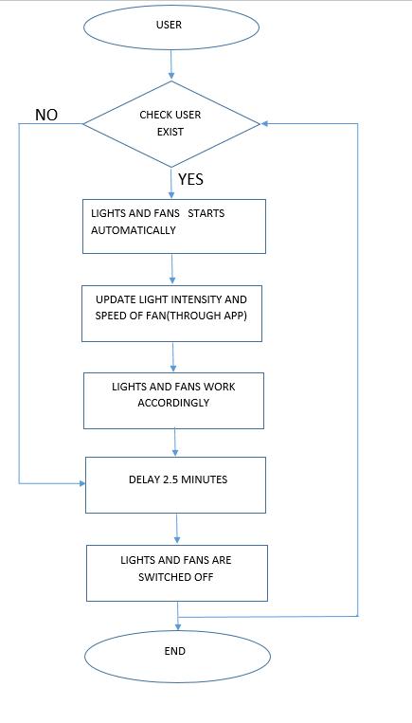

**Hardware**

**Arduino UNO:** Arduino is an open-source electronics platform based on easy-to-use hardware and software. [Arduino boards](https://www.arduino.cc/en/Main/Products) are able to read inputs - light on a sensor, a finger on a button, or a Twitter message - and turn it into an output - activating a motor, turning on an LED, publishing something online. You can tell your board what to do by sending a set of instructions to the microcontroller on the board. To do so you use the [Arduino programming language](https://www.arduino.cc/en/Reference/HomePage) (based on [Wiring](http://wiring.org.co/)), and [the Arduino Software (IDE)](https://www.arduino.cc/en/Main/Software), based on [Processing](https://processing.org/).

**PIR Sensor:** A passive infrared sensor (PIR sensor) is an electronic [sensor](https://en.wikipedia.org/wiki/Sensor) that measures [infrared](https://en.wikipedia.org/wiki/Infrared) (IR) light radiating from objects in its field of view. They are most often used in PIR-based [motion detectors](https://en.wikipedia.org/wiki/Motion_detector). PIR sensors are commonly used in security alarms and automatic lighting applications. PIR sensors detect general movement, but do not give information on who or what moved. For that purpose, an [active IR sensor](https://en.wikipedia.org/wiki/Active_IR_sensor) is required.

The term *passive* refers to the fact that PIR devices do not radiate energy for detection purposes. They work entirely by detecting [infrared radiation](https://en.wikipedia.org/wiki/Infrared_radiation) (radiant heat) emitted by or reflected from objects.

**LDR:** An LDR or [light dependent resistor is also known as photo resistor](http://en.wikipedia.org/wiki/Photoresistor), photocell, photoconductor. It is a one type of resistor whose resistance varies depending on the amount of light falling on its surface. When the light falls on the resistor, then the resistance changes. These resistors are often used in many circuits where it is required to sense the presence of light. These resistors have a variety of functions and resistance. For instance, when the LDR is in darkness, then it can be used to turn ON a light or to turn OFF a light when it is in the light. A typical light dependent resistor has a resistance in the darkness of 1MOhm, and in the brightness a resistance of a couple of KOhm.

**LM35:** The LM35 temperature sensor is used to detect precise centigrade temperature. The output of this sensor changes describes the linearity. The o/p voltage of this IC sensor is linearly comparative to the Celsius temperature. The operating voltage range of this LM35 ranges from-55˚ to +150˚C and it has low-self heating.

**Bluetooth Module:** HC‐05 module is an easy to use Bluetooth SPP (Serial Port Protocol) module, designed for transparent wireless serial connection setup. The HC-05 Bluetooth Module can be used in a Master or Slave configuration, making it a great solution for wireless communication. This serial port Bluetooth module is fully qualified Bluetooth V2.0+EDR (Enhanced Data Rate) 3Mbps Modulation with complete 2.4GHz radio transceiver and baseband. It uses CSR Blue core 04‐External single chip Bluetooth system with CMOS technology and with AFH (Adaptive Frequency Hopping Feature).

