Unit- 4 Renewable Energy
Energy Basics — Conventional Energy
1️⃣ Energy
Definition: Energy is the capacity to do work.
Energy is required for:
- transportation
- electricity generation
- industrial processes
- domestic activities
Example: electricity, heat, fuel energy.

2️⃣ Conventional Energy
Definition : Conventional energy refers to traditional energy sources that have been used for a long time to meet human energy needs.
These sources are mainly fossil fuels and are usually non-renewable.
They were the primary sources of energy during industrial development.

Main Characteristics of Conventional Energy
Characteristic | Explanation
Traditional sources | Used for many decades
Mostly non-renewable | Limited availability
High energy output | Large-scale electricity generation
Environmental impact | Causes pollution and greenhouse gases

Examples of Conventional Energy
1️⃣ Coal : Coal is a fossil fuel formed from plant remains buried underground for millions of years.
Uses
- thermal power plants
- steel production
- cement industry
Advantages
- abundant in many countries
- high energy content
Disadvantages
- air pollution
- carbon dioxide emissions

2️⃣ Petroleum (Crude Oil)
Petroleum is a liquid fossil fuel found underground and refined into many products.
Common Products
- petrol
- diesel
- kerosene
- lubricants
Uses
- transportation fuel
- petrochemical industries
- electricity generation
Problems
- air pollution
- limited reserves

3️⃣ Natural Gas
Natural gas is a gaseous fossil fuel mainly composed of methane.
Uses
- cooking fuel (LPG / PNG)
- electricity generation
- fertilizer production
Advantages
- cleaner than coal and petroleum
- high efficiency
Disadvantages
- still produces greenhouse gases
- limited supply
Renewable Energy
1️⃣ Definition : Renewable energy is energy obtained from natural sources that are continuously replenished and cannot be exhausted by human use.
These energy sources are naturally renewed through environmental processes.
Examples include:
- solar energy
- wind energy
- hydro energy
- biomass energy
- geothermal energy

2️⃣ Meaning of Renewable Resources
Renewable resources are natural resources that can be replaced or regenerated naturally within a short period of time.
They are sustainable because their supply is continuously renewed by nature.
Examples of Renewable Resources
Resource | Source
Solar energy | Sunlight
Wind energy | Moving air
Hydropower | Flowing water
Biomass | Organic matter
Geothermal energy | Heat from Earth

Conventional Energy vs Renewable Energy
Feature | Conventional Energy | Renewable Energy
Definition | Traditional energy sources used for a long time | Energy obtained from naturally replenished resources
Availability | Limited and exhaustible | Abundant and continuously replenished
Examples | Coal, petroleum, natural gas | Solar, wind, hydro, biomass
Pollution | Produces high pollution and greenhouse gases | Very low or no pollution
Sustainability | Not sustainable for long-term use | Sustainable and environmentally friendly
Cost | High environmental cost | Lower environmental impact

Need for Renewable Energy
Renewable energy is important to meet the growing energy demand while protecting the environment and natural resources.

1️⃣ Energy Crisis
Meaning : An energy crisis occurs when the demand for energy exceeds the available supply of energy resources.
Most conventional energy sources such as coal, petroleum, and natural gas are limited and non-renewable. Rapid industrialization and population growth increase energy consumption, leading to shortages.
Role of Renewable Energy
Renewable energy sources such as solar, wind, and hydro energy provide alternative energy and help reduce dependence on fossil fuels.

2️⃣ Pollution Reduction
Conventional energy sources produce large amounts of air pollution and greenhouse gases.
Examples:
- carbon dioxide (CO₂)
- sulfur dioxide (SO₂)
- nitrogen oxides (NOₓ)
These pollutants cause:
- global warming
- climate change
- respiratory diseases
Benefit of Renewable Energy
Renewable energy sources produce little or no pollution, helping to protect the environment and improve air quality.

3️⃣ Sustainability
Meaning : Sustainability refers to the ability to meet present energy needs without compromising the ability of future generations to meet their own needs.
Fossil fuels are exhaustible, meaning they will eventually run out.
Renewable energy sources are naturally replenished, making them suitable for long-term energy supply.

Summary Table
Reason | Explanation
Energy crisis | Renewable energy helps overcome shortage of fossil fuels
Pollution reduction | Produces less pollution compared to conventional energy
Sustainability | Provides long-term and continuous energy supply

Solar Energy
Definition : Solar energy is the energy obtained from the sun’s radiation and converted into useful forms such as electricity or heat.
Solar energy is a renewable and clean source of energy because sunlight is continuously available and does not produce pollution.

Characteristics of Solar Energy
Feature | Explanation
Renewable | Sunlight is continuously available
Clean energy | Produces no air pollution
Abundant | Available in most parts of the world
Sustainable | Can be used for long-term energy supply

Solar Cell
Definition: A solar cell is a device that converts sunlight directly into electrical energy using the photovoltaic effect.
Solar cells are the basic units used in solar panels.
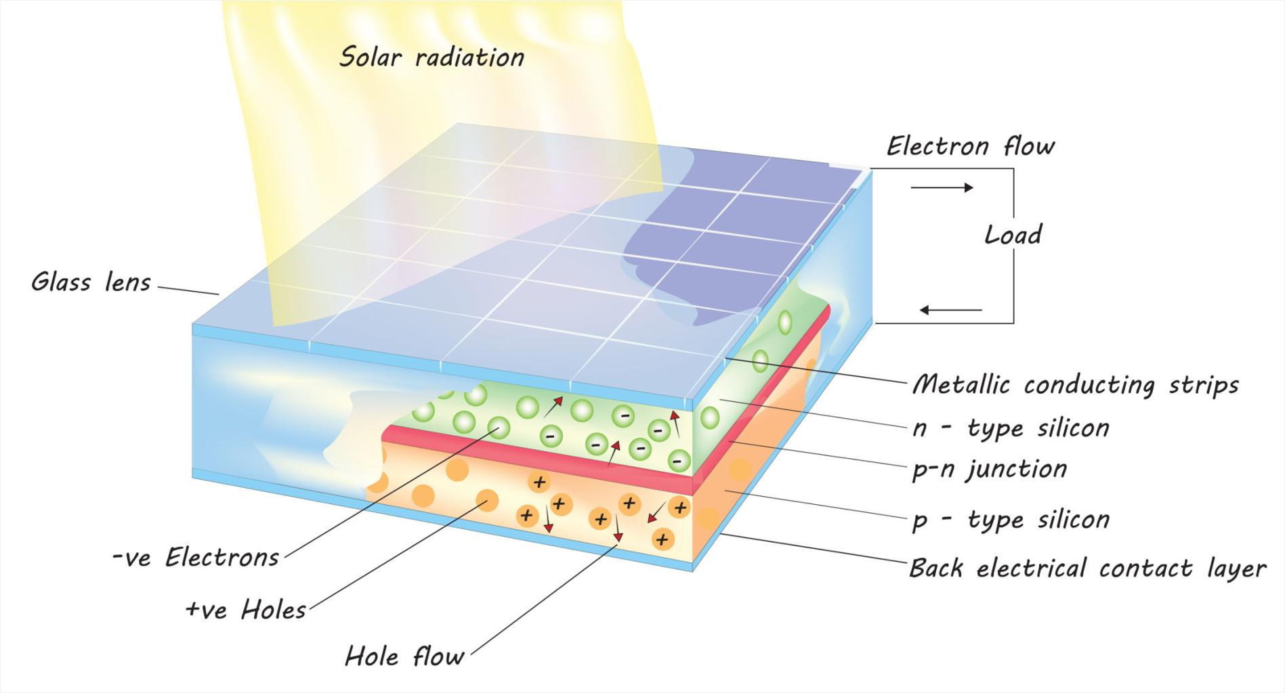
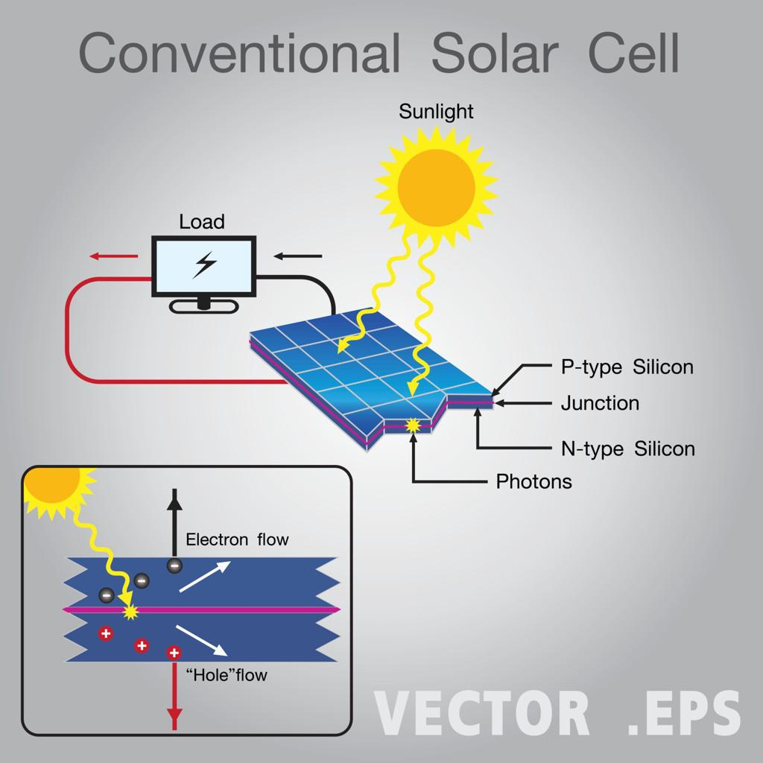
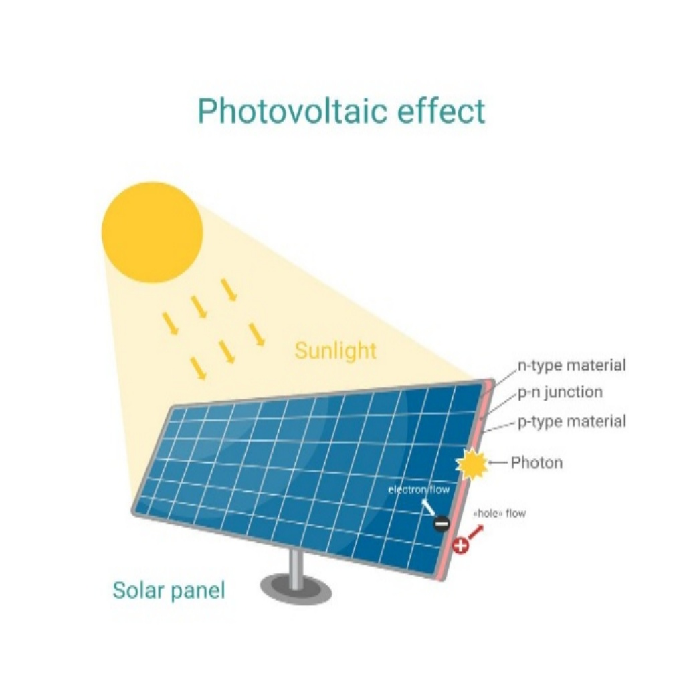

Principle of Solar Energy (Photovoltaic Effect)
Solar cells work on the photovoltaic effect, in which light energy is converted into electrical energy.
When sunlight falls on a semiconductor material (usually silicon), electrons gain energy and start moving, producing electric current.

Working of a Solar Cell
The working process occurs in several steps:
Step 1 — Sunlight Absorption
Sunlight falls on the solar panel containing photovoltaic cells.

Step 2 — Electron Excitation
Photons from sunlight transfer energy to electrons in the semiconductor material.
Electrons become energized and move freely.

Step 3 — Electric Field Action
The p–n junction inside the solar cell creates an electric field.
This field forces electrons to move in a particular direction.

Step 4 — Electric Current Generation
The movement of electrons through an external circuit produces direct current (DC) electricity.

Step 5 — Power Utilization
The electricity generated can be used for:
- lighting
- charging batteries
- running electrical appliances

Components of a Solar Cell
Component | Function
Glass cover | Protects the cell
Anti-reflective coating | Increases sunlight absorption
Semiconductor layer | Generates electric charge
Metal contacts | Collect and transfer electricity

Applications of Solar Energy
Solar energy is used in many areas:
- solar panels for electricity
- solar water heaters
- solar street lights
- solar cooking systems
- satellites and space stations

Advantages of Solar Energy
Advantage | Explanation
Renewable | Unlimited energy source
Environment friendly | No pollution
Low operating cost | Sunlight is free
Widely available | Accessible in many regions

Limitations of Solar Energy
Limitation | Explanation
Weather dependent | Requires sunlight
High installation cost | Solar panels are expensive
Energy storage required | Batteries needed for night use

Solar Energy — Advantages, Limitations, Applications
Advantages
Advantage | Explanation
Clean energy | Solar energy does not produce harmful gases or air pollution.
Abundant | Sunlight is widely available and renewable.
Low operating cost | After installation, maintenance and running costs are very low.

Limitations
Limitation | Explanation
High installation cost | Initial cost of solar panels and equipment is high.
Weather dependency | Energy production depends on sunlight and weather conditions.

Applications
Application | Description
Solar panels | Used to generate electricity from sunlight.
Solar water heaters | Used for heating water using solar energy.
Solar farms | Large-scale solar power plants that produce electricity for cities and industries.

Wind Energy
Definition : Wind energy is the energy obtained from the movement of air (wind) and converted into useful forms such as electricity using wind turbines.
Wind energy is a renewable and clean source of energy because wind is naturally produced by atmospheric processes and does not get exhausted.

Principle of Wind Energy
Wind energy works on the principle of conversion of kinetic energy of moving air into mechanical energy and then into electrical energy.
Steps involved in the principle:
- Wind flows due to difference in air pressure caused by uneven heating of the Earth by the sun.
- Moving air contains kinetic energy.
- When wind strikes the blades of a turbine, it causes them to rotate.
- The rotating blades turn a shaft connected to a generator.
- The generator converts mechanical energy into electrical energy.

Wind Turbines : A wind turbine is a machine that converts the kinetic energy of wind into mechanical energy and then into electrical energy.
Wind turbines are usually installed in wind farms where wind speed is high and consistent.
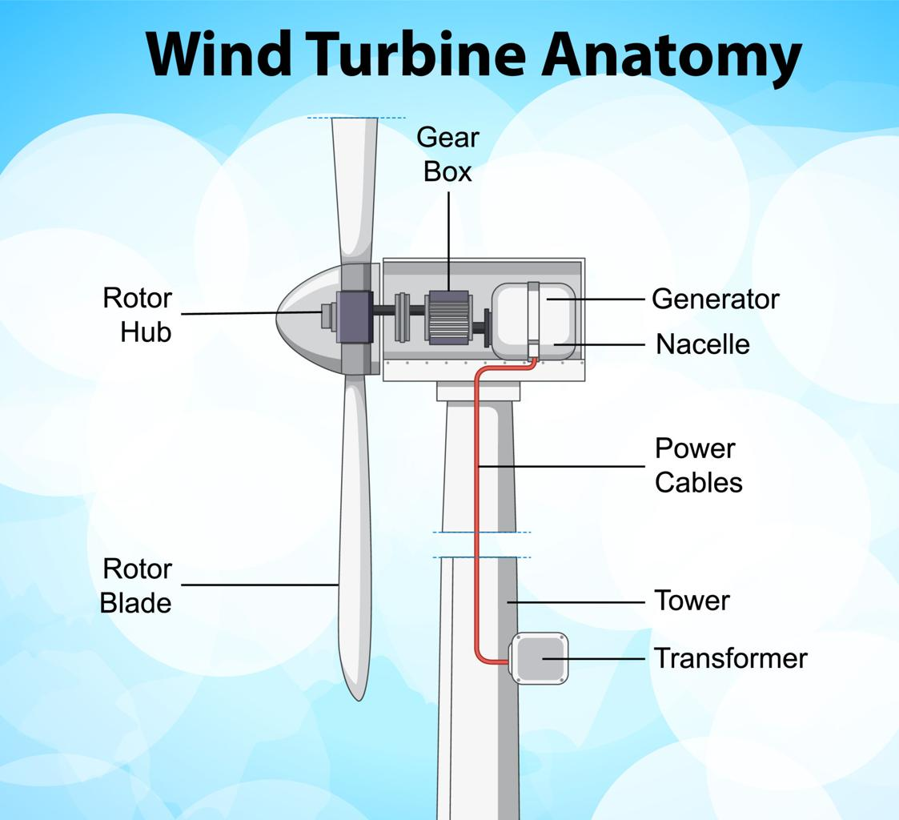
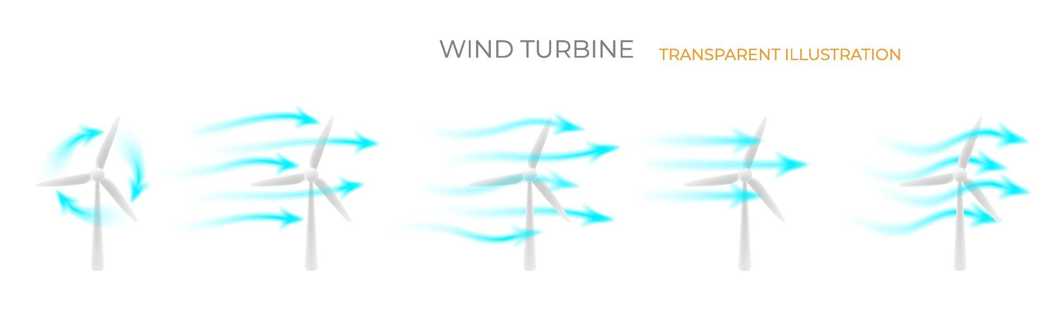
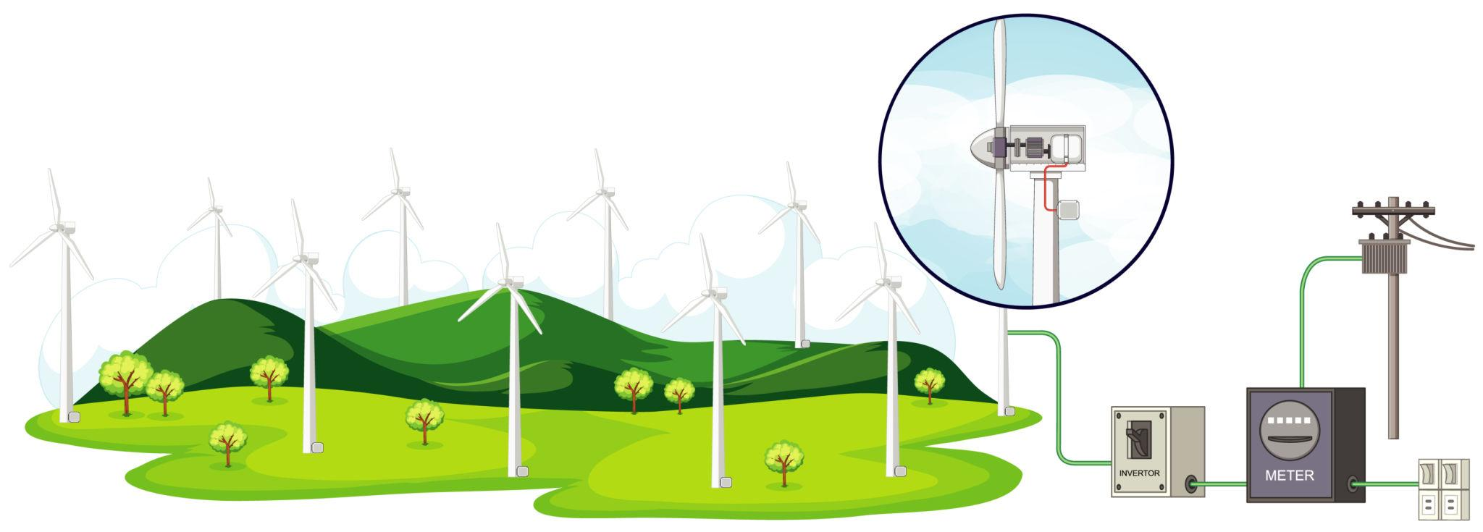
Main Components of a Wind Turbine
Component | Function
Blades | Capture the kinetic energy of wind
Rotor | Rotates when blades move
Shaft | Transfers mechanical energy
Generator | Converts mechanical energy into electricity
Tower | Supports turbine at high altitude
Nacelle | Contains gearbox and generator

Working of Wind Turbines
The working process occurs in several stages:
Step 1 — Wind Flow
Wind moves across the turbine blades.

Step 2 — Blade Rotation
The wind force causes the blades to rotate, turning the rotor.

Step 3 — Shaft Rotation
The rotor is connected to a shaft, which rotates due to blade movement.

Step 4 — Generator Operation
The rotating shaft spins a generator, converting mechanical energy into electricity.

Step 5 — Electricity Transmission
Generated electricity is transferred to power grids for use in homes and industries.

Applications of Wind Energy
Wind energy is widely used for:
- electricity generation
- wind farms
- water pumping
- agricultural irrigation
- remote power supply systems

Advantages of Wind Energy
Advantage | Explanation
Renewable | Wind is naturally replenished
Clean energy | Produces no air pollution
Low operating cost | No fuel cost
Sustainable | Can be used long-term

Limitations of Wind Energy
Limitation | Explanation
Weather dependent | Requires sufficient wind speed
Noise pollution | Turbine operation produces sound
Land requirement | Wind farms need large areas

Hydropower (Hydroelectric Energy)
Definition : Hydropower is the energy produced by using the force of flowing or falling water to generate electricity.
It is a renewable source of energy because the water cycle continuously replenishes water resources.
Hydropower is widely used in hydroelectric power plants.

Principle of Hydropower Plant
Hydropower plants work on the principle of conversion of potential energy of stored water into mechanical energy and then into electrical energy.
Steps of the principle:
- Water is stored in a dam at a higher elevation.
- Stored water has potential energy.
- When water flows down through pipes (penstocks), its potential energy converts into kinetic energy.
- Flowing water strikes the turbine blades, causing them to rotate.
- The rotating turbine drives a generator.
- The generator converts mechanical energy into electrical energy.

Hydropower Plant
A hydropower plant is a facility that generates electricity using the energy of flowing water.
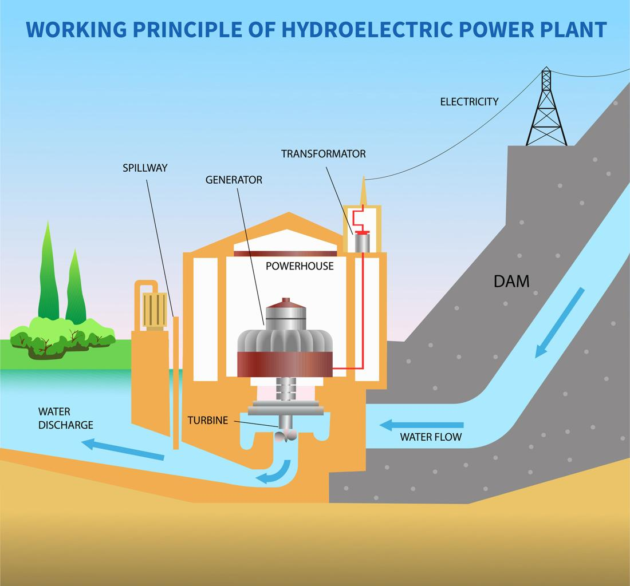

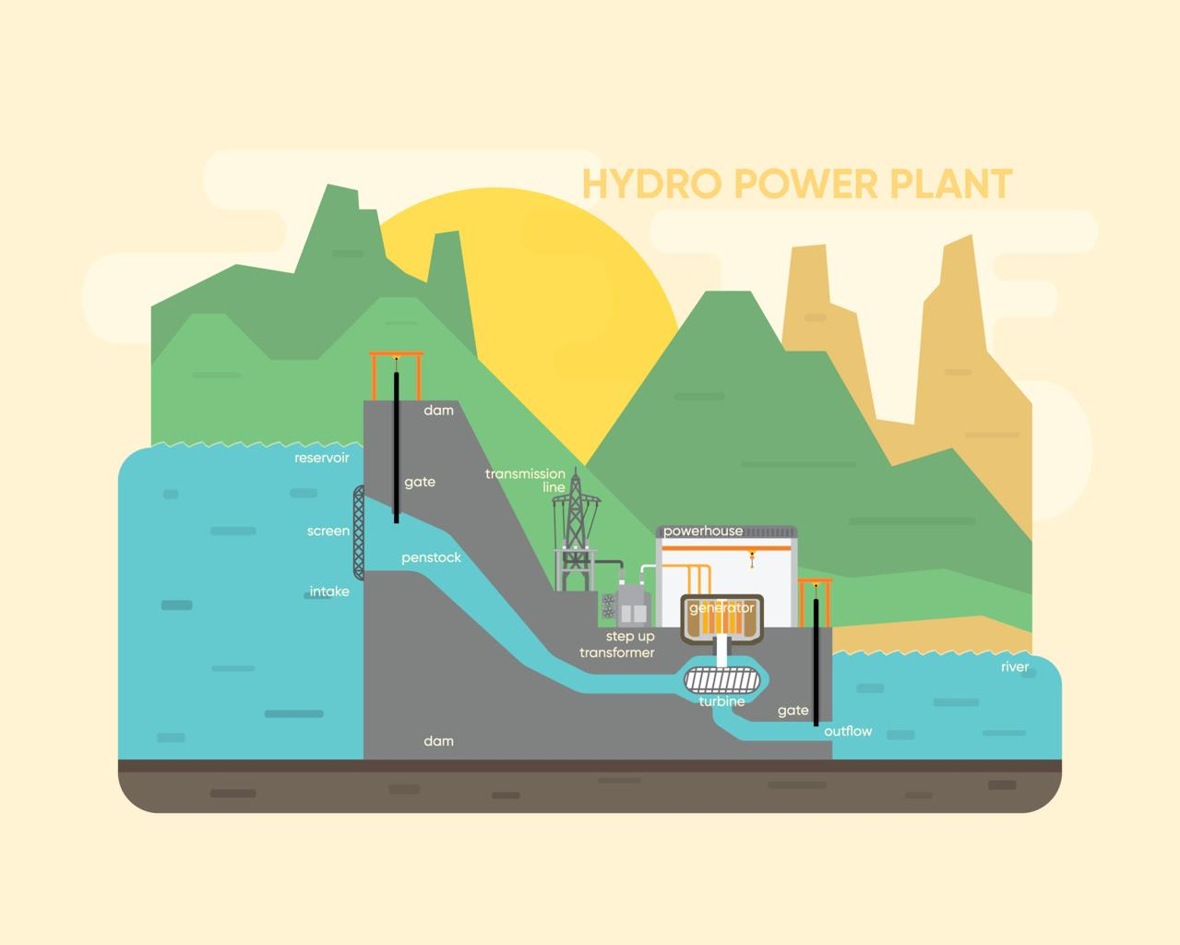

Main Components of a Hydropower Plant
Component | Function
Dam | Stores water at high level
Reservoir | Large water storage behind dam
Penstock | Pipe carrying water to turbine
Turbine | Rotated by flowing water
Generator | Converts mechanical energy into electricity
Transmission lines | Carry electricity to consumers

Working of a Hydropower Plant
Step 1 — Water Storage
Water is stored in a reservoir behind the dam.

Step 2 — Water Flow
Water is released from the reservoir through penstocks.

Step 3 — Turbine Rotation
Flowing water strikes the turbine blades, causing them to rotate.

Step 4 — Generator Operation
The turbine rotates a generator, producing electricity.

Step 5 — Power Distribution
Electricity is transmitted through power lines to homes and industries.

Energy Conversion in Hydropower
Energy Type | Conversion
Potential energy | Stored water in dam
Kinetic energy | Flowing water
Mechanical energy | Rotating turbine
Electrical energy | Generator output

Applications of Hydropower
Hydropower is used for:
- large-scale electricity generation
- irrigation projects
- flood control
- water supply systems

Advantages of Hydropower
Advantage | Explanation
Renewable | Water cycle continuously replenishes supply
Clean energy | Produces very low pollution
Reliable | Stable electricity generation
Low operating cost | No fuel required

Limitations of Hydropower
Limitation | Explanation
High construction cost | Dam construction is expensive
Environmental impact | Affects aquatic ecosystems

Hydropower — Advantages, Limitations, Examples
Advantages
Advantage | Explanation
Reliable | Hydropower plants can generate electricity continuously when sufficient water is available.
Renewable | Water is replenished through the natural water cycle, making hydropower a renewable energy source.

Limitations
Limitation | Explanation
Ecosystem disruption | Construction of dams can disturb aquatic life and natural river ecosystems.
High construction cost | Building dams and hydropower plants requires large initial investment and infrastructure.

Examples
Example | Description
Hydroelectric dams | Large dams built across rivers to generate electricity using flowing water.

Biomass Energy
Definition : Biomass energy is the energy obtained from organic materials such as plants, agricultural waste, animal waste, and other biological matter.
These materials are collectively called biomass, and they can be used as fuel to produce heat, electricity, or biofuels.
Biomass energy is considered renewable because the organic materials used can be regenerated through natural processes.

Meaning of Biomass
Biomass refers to organic matter derived from living or recently living organisms.
Examples of biomass materials:
- wood and plant residues
- agricultural waste (crop residues)
- animal manure
- food waste
- forest residues
These materials contain stored chemical energy from the sun, which plants absorb during photosynthesis.

Principle of Biomass Energy
Biomass energy works on the principle of conversion of chemical energy stored in organic matter into heat or electricity.
Plants absorb solar energy through photosynthesis, storing it in the form of chemical energy. When biomass is burned or processed, this energy is released and used for energy production.

Conversion Methods of Biomass Energy
Biomass energy can be converted into usable energy through different methods.
Method | Explanation
Direct combustion | Biomass is burned to produce heat and electricity
Anaerobic digestion | Organic waste is decomposed by microorganisms to produce biogas
Fermentation | Biomass is converted into biofuels such as ethanol
Gasification | Biomass is converted into combustible gas

Working of Biomass Energy Production
Step 1 — Collection of Biomass
Organic materials such as crop waste, wood, or animal manure are collected.

Step 2 — Processing of Biomass
The biomass is processed through combustion, fermentation, or digestion.

Step 3 — Energy Conversion
The stored chemical energy in biomass is converted into heat or gas fuel.

Step 4 — Electricity Generation
Heat or biogas is used to run turbines or generators, producing electricity.

Biomass Energy Systems
Examples include:
- biomass power plants
- biogas plants
- biofuel production systems

Advantages of Biomass Energy
Advantage | Explanation
Renewable | Biomass resources can be regenerated
Waste management | Uses agricultural and organic waste
Reduces landfill waste | Converts waste into useful energy
Lower carbon emissions | Emits less carbon compared to fossil fuels

Limitations of Biomass Energy
Limitation | Explanation
Air pollution | Burning biomass releases smoke and gases
Land use | Large biomass production requires land
Lower efficiency | Less efficient compared to fossil fuels

Applications of Biomass Energy
Biomass energy is used for:
- electricity generation
- biogas production for cooking
- biofuel production (ethanol, biodiesel)
- heating systems
Biomass Energy — Sources, Advantages, Limitations, Applications
Sources of Biomass Energy
Source | Explanation
Agricultural waste | Crop residues such as rice husk, straw, and corn stalks used as fuel.
Animal waste | Animal manure used to produce biogas through anaerobic digestion.
Wood | Wood and forest residues used for heating and electricity generation.

Advantages
Advantage | Explanation
Renewable | Biomass materials can be replenished through natural processes.
Waste utilization | Converts agricultural and organic waste into useful energy.

Limitations
Limitation | Explanation
Air pollution if poorly managed | Burning biomass inefficiently can release smoke and harmful gases.

Applications
Application | Description
Biogas plants | Convert animal waste and organic materials into biogas for cooking and electricity.
Biomass power plants | Generate electricity by burning biomass fuels such as wood and agricultural residues.

Geothermal Energy
Definition : Geothermal energy is the energy obtained from the heat stored inside the Earth.
The word geothermal comes from:
- Geo = Earth
- Thermal = Heat
This heat from the Earth's interior can be used to generate electricity or provide heating.
Geothermal energy is considered a renewable and sustainable energy source because the Earth's internal heat is continuously produced.

Principle of Geothermal Energy
Geothermal power plants work on the principle of using heat from the Earth’s interior to produce steam, which drives turbines to generate electricity.
The process involves converting thermal energy from underground reservoirs into mechanical energy and then electrical energy.

Source of Geothermal Heat
The heat inside the Earth comes from:
- radioactive decay of minerals
- heat remaining from Earth’s formation
- magma movement beneath the Earth's crust
This heat warms underground water and forms hot water reservoirs and steam.

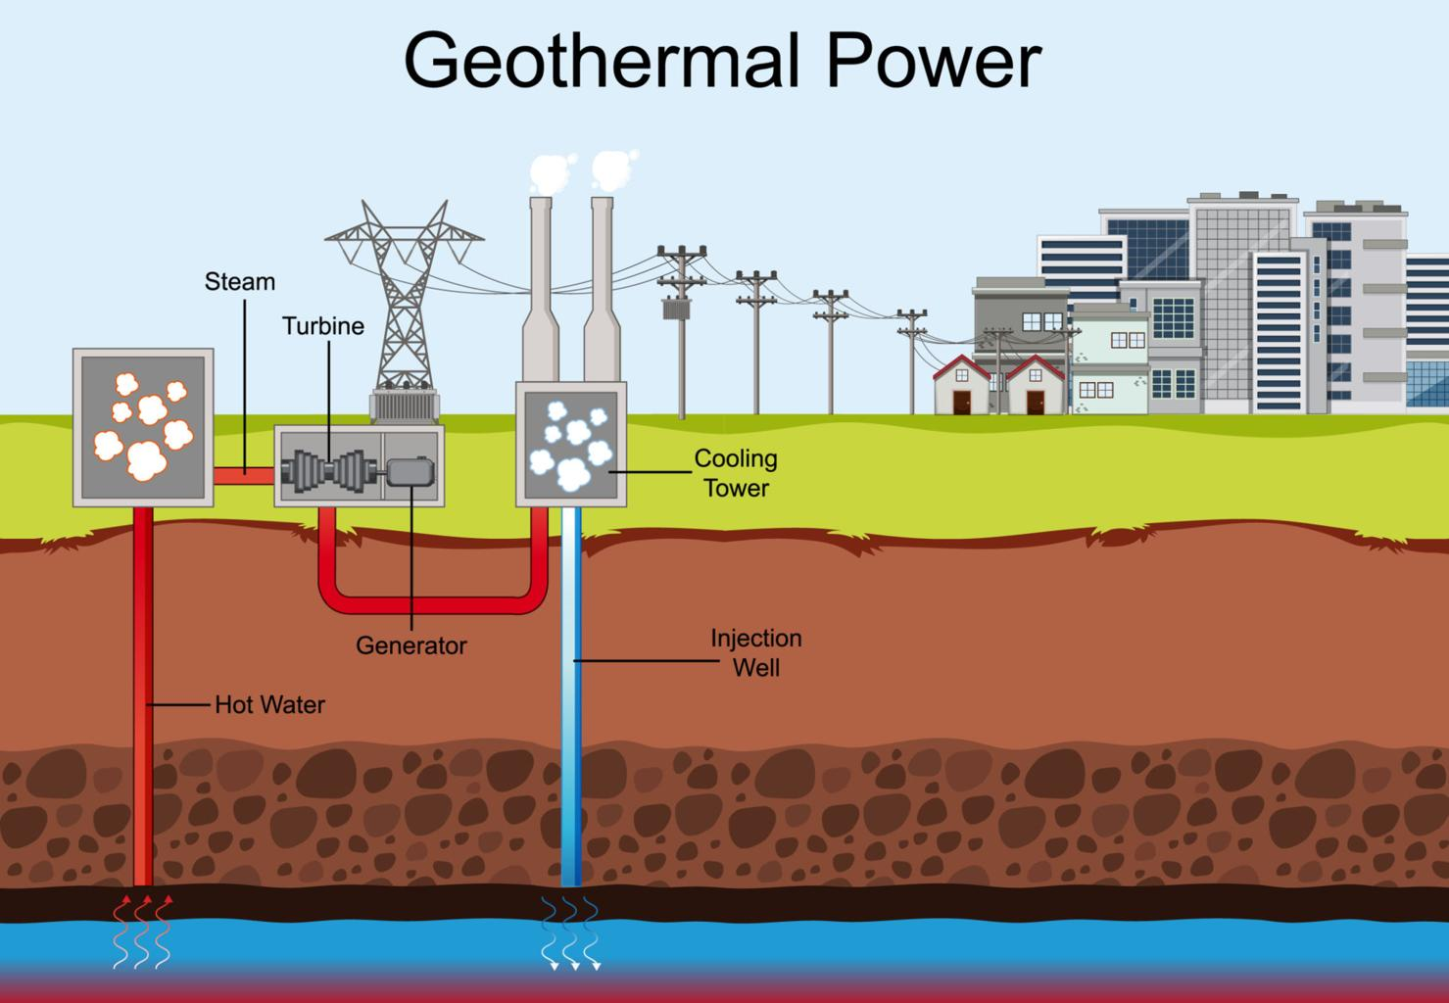
Geothermal Power Plant
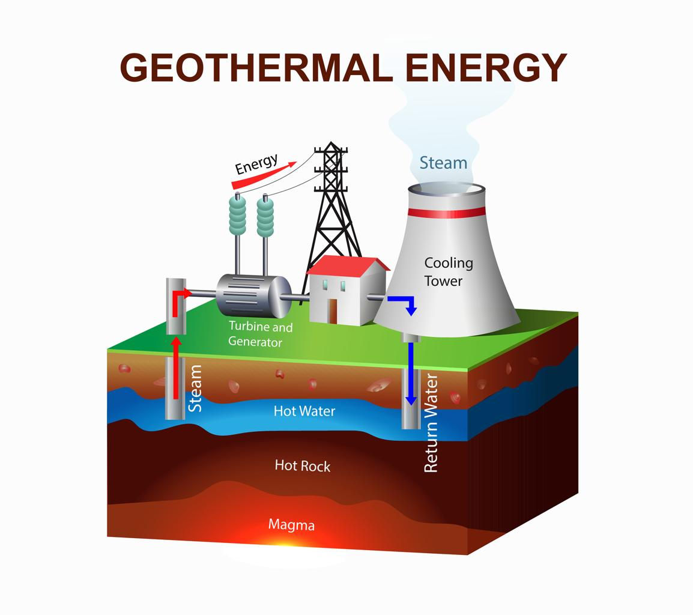

Main Components of a Geothermal Power Plant
Component | Function
Geothermal reservoir | Underground source of hot water or steam
Production well | Brings hot water or steam to the surface
Turbine | Rotated by steam to produce mechanical energy
Generator | Converts mechanical energy into electricity
Injection well | Returns cooled water back underground

Working of Geothermal Power Plant
Step 1 — Heat from Earth's Interior
Heat from underground rocks warms water stored beneath the Earth's surface.

Step 2 — Steam Production
The heated water forms high-pressure steam.

Step 3 — Steam Movement
Steam rises through production wells to the surface.

Step 4 — Turbine Rotation
Steam rotates the turbine blades.

Step 5 — Electricity Generation
The rotating turbine drives a generator, producing electricity.

Step 6 — Water Re-injection
After steam cools, water is pumped back underground through injection wells.
This maintains the geothermal reservoir.

Applications of Geothermal Energy
Geothermal energy is used for:
- electricity generation
- heating buildings
- greenhouse heating
- industrial processes
- hot water supply

Advantages of Geothermal Energy
Advantage | Explanation
Renewable | Earth continuously produces heat
Low pollution | Produces very low greenhouse gases
Reliable | Works continuously unlike solar or wind
Small land requirement | Requires less land compared to other power plants
Continuous energy supply | Geothermal energy is available continuously because heat from the Earth’s interior is constantly produced.

Limitations of Geothermal Energy
Limitation | Explanation
Location specific | Only available in geothermal regions
High initial cost | Drilling wells is expensive
Possible gas emissions | Small amounts of gases may be released

Limitations
Limitation | Explanation
Location dependent | Geothermal power plants can only be built in areas where geothermal heat sources are available, such as volcanic or tectonically active regions.

Applications
Application | Description
Geothermal power plants | Facilities that use heat from underground reservoirs to produce steam and generate electricity.

Tidal Energy
Definition : Tidal energy is the energy obtained from the rise and fall of ocean tides, which is used to generate electricity.
Tides occur due to the gravitational attraction of the Moon and the Sun on Earth's oceans.
Tidal energy is a renewable and predictable source of energy because tides occur regularly.

Principle of Tidal Energy
Tidal power plants work on the principle of converting the kinetic and potential energy of moving seawater during tides into electrical energy.
During high and low tides, large volumes of water move in and out of coastal areas. This moving water rotates turbines, which drive generators to produce electricity.

Tidal Power Plant:
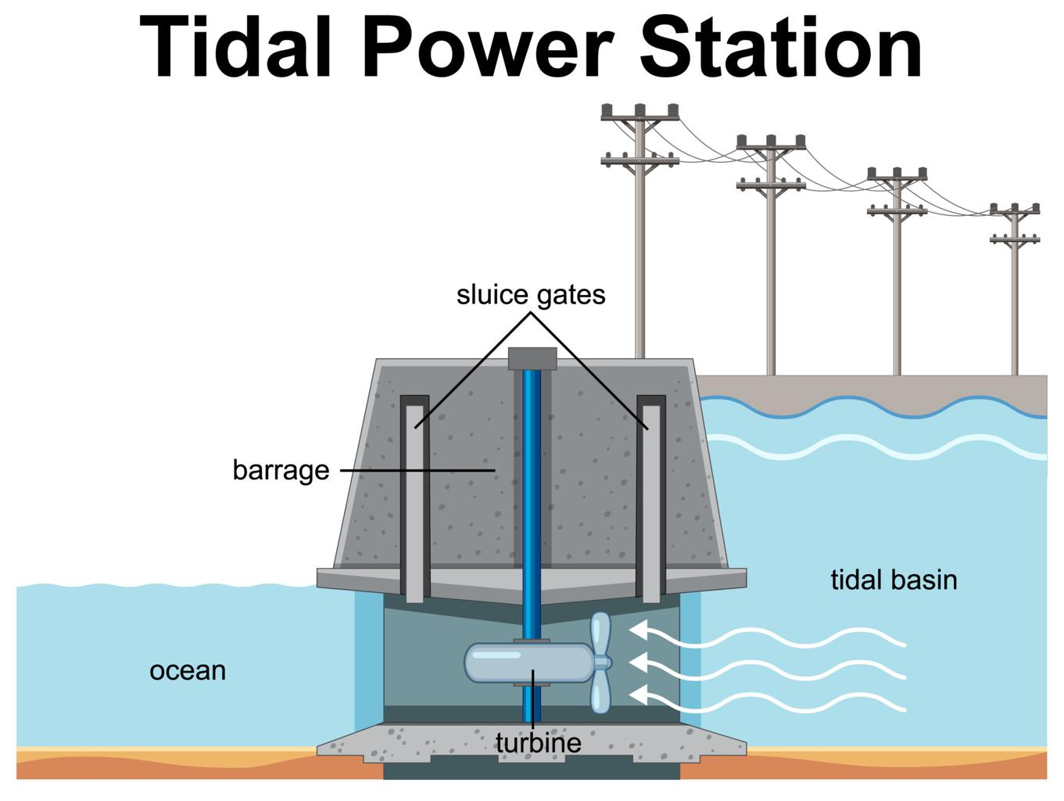
Main Components of a Tidal Power Plant
Component | Function
Tidal barrage | Dam built across an estuary or coastal area
Turbine | Rotated by moving tidal water
Generator | Converts mechanical energy into electricity
Sluice gates | Control water flow during tides
Powerhouse | Contains turbine and generator

Working of Tidal Energy System
Step 1 — High Tide
During high tide, seawater enters the basin behind the tidal barrage.

Step 2 — Water Storage
Water is temporarily stored in the tidal basin.

Step 3 — Water Flow
When the tide recedes, stored water flows back toward the sea through turbines.

Step 4 — Turbine Rotation
The flowing water rotates the turbine blades.

Step 5 — Electricity Generation
The turbine drives a generator, producing electricity.

Types of Tidal Energy Systems
Type | Explanation
Tidal barrage | Dam across tidal estuary
Tidal stream generator | Underwater turbines in fast tidal currents
Tidal lagoon | Artificial lagoon capturing tidal energy

Advantages of Tidal Energy
Advantage | Explanation
Renewable | Tides occur naturally and continuously
Predictable | Tidal cycles are highly predictable
Clean energy | Produces very little pollution
Predictable energy source | Tides occur regularly due to gravitational forces of the Moon and Sun, making tidal energy highly predictable.

Limitations of Tidal Energy
Limitation | Explanation
High construction cost | Building tidal barrages is expensive
Location dependent | Suitable only in coastal areas with large tidal ranges
Environmental impact | May affect marine ecosystems
High infrastructure cost | Construction of tidal barrages and underwater turbines requires large investment and complex infrastructure.

Applications of Tidal Energy
Tidal energy is used for:
- electricity generation in coastal regions
- tidal power stations
- small-scale coastal energy systems
Green Hydrogen
Definition : Green hydrogen is hydrogen fuel produced using renewable energy sources such as solar, wind, or hydropower to split water into hydrogen and oxygen through electrolysis.
It is called green because the process does not produce carbon emissions.
Green hydrogen is considered a clean and sustainable energy carrier.

Meaning of Hydrogen as Energy
Hydrogen is the most abundant element in the universe and can be used as a fuel.
When hydrogen is used as fuel, it produces:
$$H_{2}+O_{2}→H_{2}O+Energy$$
The only by-product is water, making it environmentally friendly.

Principle of Green Hydrogen Production
Green hydrogen is produced using the electrolysis of water powered by renewable energy.
Electrolysis splits water into hydrogen and oxygen using electricity.
Steps of the principle:
- Renewable energy (solar or wind) produces electricity.
- Electricity is supplied to an electrolyzer.
- Water molecules split into hydrogen and oxygen.
- Hydrogen gas is collected and stored as fuel.

Electrolysis Process
Chemical reaction:
$$2H_{2}O→2H_{2}+O_{2}$$
Meaning:
Water → Hydrogen + Oxygen.

Green Hydrogen Production System

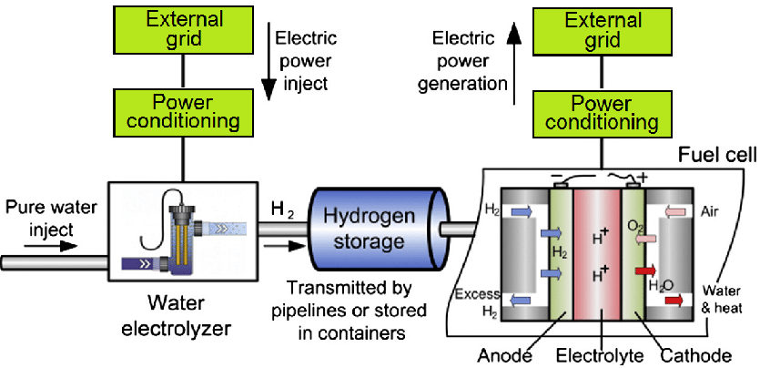

Main Components of Green Hydrogen System
Component | Function
Renewable energy source | Provides electricity
Electrolyzer | Splits water into hydrogen and oxygen
Water supply | Raw material for hydrogen production
Hydrogen storage tanks | Store produced hydrogen
Fuel cells / engines | Use hydrogen to produce energy

Working of Green Hydrogen Production
Step 1 — Renewable Electricity
Electricity is generated using solar panels or wind turbines.

Step 2 — Electrolysis
Electric current passes through water in the electrolyzer, splitting water molecules.

Step 3 — Hydrogen Production
Hydrogen gas is produced at the cathode, and oxygen is produced at the anode.

Step 4 — Storage
Hydrogen gas is collected and stored in high-pressure tanks.

Step 5 — Energy Use
Hydrogen can be used in fuel cells, vehicles, and power generation systems.

Applications of Green Hydrogen
Green hydrogen is used in:
- hydrogen fuel cell vehicles
- electricity generation
- industrial processes (steel production)
- energy storage systems
- fertilizer production

Advantages of Green Hydrogen
Advantage | Explanation
Clean fuel | Produces only water as by-product
Renewable | Produced using renewable energy
Energy storage | Can store excess renewable energy
Versatile | Used in transport, industry, and power generation

Limitations of Green Hydrogen
Limitation | Explanation
High production cost | Electrolyzers and renewable systems are expensive
Energy intensive | Requires large amount of electricity
Storage challenges | Hydrogen storage and transport are difficult

Importance of Green Hydrogen
Green hydrogen is important for:
- reducing carbon emissions
- replacing fossil fuels in industries
- supporting clean energy transition
Many countries are investing heavily in hydrogen energy technologies.
Why It Is Called “Green”
Hydrogen can be produced in different ways.
Type | Production Method | Environmental Impact
Green hydrogen | Renewable energy electrolysis | No carbon emissions
Grey hydrogen | Natural gas reforming | Produces CO₂
Blue hydrogen | Fossil fuels with carbon capture | Reduced emissions
Green hydrogen is the cleanest form of hydrogen energy.

Importance of Green Hydrogen
Green hydrogen helps in:
- reducing greenhouse gas emissions
- replacing fossil fuels in industries
- storing renewable energy
- supporting clean transportation

Key Advantages
Advantage | Explanation
Clean fuel | Produces only water when used
Renewable | Produced using renewable energy
Energy storage | Stores excess renewable electricity

Production of Hydrogen (Electrolysis of Water Using Renewable Electricity)
Definition : Hydrogen can be produced by electrolysis of water, a process in which electricity is used to split water molecules into hydrogen and oxygen gases.
When the electricity used for electrolysis comes from renewable energy sources such as solar, wind, or hydropower, the hydrogen produced is called green hydrogen.

Principle of Hydrogen Production
The production of hydrogen through electrolysis is based on the principle that electric current passing through water can break the chemical bonds between hydrogen and oxygen atoms.
Water contains:
$$H_{2}O$$
When electricity flows through water, it splits into:
$$2H_{2}O→2H_{2}+O_{2}$$
This means:
Water → Hydrogen gas + Oxygen gas.

Electrolysis Process
Electrolysis takes place in a device called an electrolyzer.
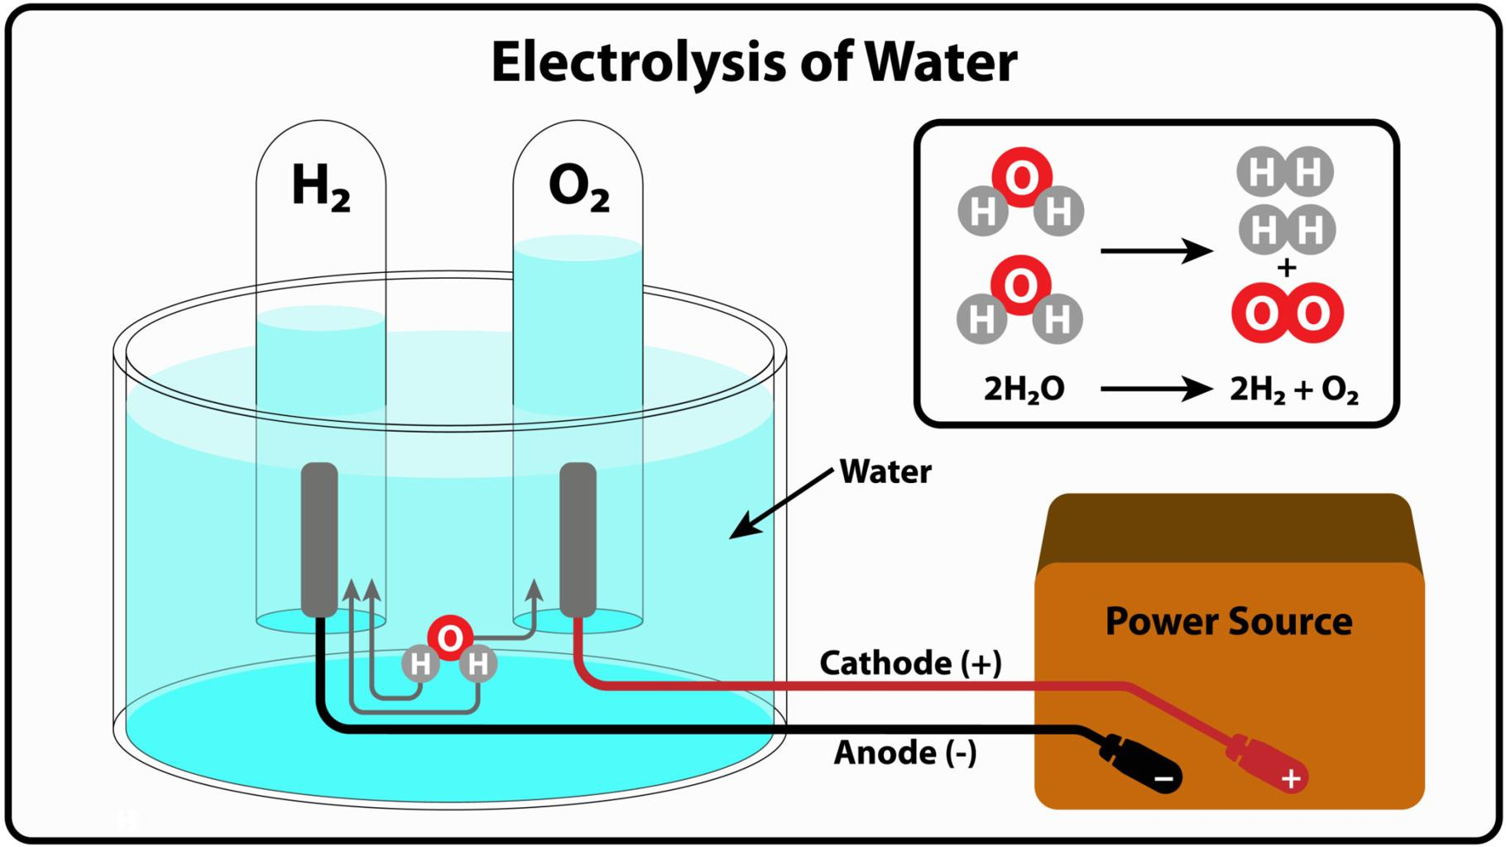

Main Components of Electrolysis System
Component | Function
Electrolyzer | Device where water splitting occurs
Electrodes | Conduct electricity in water
Electrolyte | Conducts electric current
Renewable electricity source | Provides electrical energy
Hydrogen storage tank | Stores produced hydrogen

Working of Electrolysis for Hydrogen Production
Step 1 — Renewable Electricity Supply
Electricity is generated from renewable sources such as solar panels or wind turbines.

Step 2 — Water Supply to Electrolyzer
Water is supplied to the electrolysis chamber.

Step 3 — Electric Current Flow
Electric current passes through the water via two electrodes (anode and cathode).

Step 4 — Water Splitting
Water molecules break into hydrogen and oxygen gases.
- Hydrogen forms at the cathode
- Oxygen forms at the anode

Step 5 — Gas Collection
The hydrogen gas is collected and stored, while oxygen may be released or used for industrial purposes.

Chemical Reactions in Electrolysis
At Cathode:
$$2H_{2}O+2e^{-}→H_{2}+2OH^{-}$$
At Anode:
$$4OH^{-}→O_{2}+2H_{2}O+4e^{-}$$
Overall reaction:
$$2H_{2}O→2H_{2}+O_{2}$$

Applications of Hydrogen Produced
Hydrogen produced by electrolysis can be used for:
- hydrogen fuel cell vehicles
- electricity generation
- industrial processes
- ammonia production
- energy storage systems

Advantages of Electrolysis Using Renewable Energy
Advantage | Explanation
Clean process | Produces no carbon emissions
Renewable | Uses solar or wind electricity
Energy storage | Stores excess renewable energy as hydrogen

Limitations
Limitation | Explanation
High cost | Electrolyzers and renewable systems are expensive
Energy intensive | Requires large amount of electricity

Hydrogen Storage
Hydrogen storage is an important part of the hydrogen energy system because hydrogen must be stored safely before it is transported or used as fuel.
Hydrogen is a very light gas, so it requires special storage methods.

Definition : Hydrogen storage is the process of storing hydrogen gas safely and efficiently for later use as a fuel or energy source.
Hydrogen can be stored in different ways depending on the pressure, temperature, and application.

Methods of Hydrogen Storage
Two common storage methods are:
- High-pressure storage (compressed hydrogen)
- Cryogenic storage (liquid hydrogen)

1️⃣ High-Pressure Hydrogen Storage
Definition : High-pressure storage is the method of storing hydrogen gas in strong tanks at very high pressure.
Hydrogen gas is compressed and stored in cylinders or tanks.

Working Principle
Since hydrogen has very low density, compressing it increases the amount of hydrogen stored in a container.
Typical storage pressure:
- 350 bar
- 700 bar
These tanks are made of high-strength steel or carbon fiber materials.

Applications
High-pressure hydrogen storage is commonly used in:
- hydrogen fuel cell vehicles
- industrial hydrogen supply
- portable hydrogen storage systems

Advantages
Advantage | Explanation
Simple technology | Easier to implement compared to other storage methods
Fast filling | Tanks can be filled quickly
Suitable for vehicles | Used in hydrogen fuel cell cars

Limitations
Limitation | Explanation
High pressure required | Needs very strong tanks
Safety concerns | Risk of leakage if not handled properly

2️⃣ Cryogenic Hydrogen Storage
Definition
Cryogenic storage is the method of storing hydrogen in liquid form at extremely low temperatures.
Hydrogen gas is cooled to very low temperatures until it becomes liquid.
Temperature required:
$$-{253}^{∘}C$$

Working Principle
When hydrogen is cooled to very low temperatures, it changes from gas to liquid, which greatly reduces its volume.
This allows more hydrogen to be stored in a smaller space.

Applications
Cryogenic hydrogen storage is used in:
- space rockets
- aerospace systems
- large-scale hydrogen storage systems

Advantages
Advantage | Explanation
High storage density | Stores large amount of hydrogen
Efficient for large-scale storage | Suitable for industrial applications

Limitations
Limitation | Explanation
Extremely low temperature required | Requires special cooling systems
Energy intensive | Liquefaction requires large energy
Boil-off losses | Hydrogen may slowly evaporate

Comparison of Hydrogen Storage Methods
Feature | High-Pressure Storage | Cryogenic Storage
State of hydrogen | Gas | Liquid
Storage condition | High pressure | Very low temperature
Typical use | Vehicles | Aerospace and large storage
Complexity | Moderate | High

Importance of Hydrogen Storage
Hydrogen storage is essential for:
- hydrogen fuel cell vehicles
- renewable energy storage
- industrial hydrogen supply
- transportation of hydrogen fuel
1️⃣ Transportation of Hydrogen
Definition : Hydrogen transportation refers to the process of moving hydrogen from production sites to storage facilities or places where it will be used.
Hydrogen can be transported in different forms depending on the distance, quantity, and method of storage.

Methods of Hydrogen Transportation
1️⃣ Pipeline Transport
Hydrogen gas can be transported through pipelines, similar to natural gas pipelines.
Features
- pipelines carry compressed hydrogen gas
- suitable for large-scale industrial transport
Advantages
- continuous supply
- efficient for long distances
Limitations
- expensive pipeline infrastructure
- hydrogen leakage risk due to small molecule size

2️⃣ High-Pressure Cylinders
Hydrogen gas can be transported in high-pressure cylinders or tanks mounted on trucks.
Features
- hydrogen compressed at high pressure
- cylinders made of strong steel or carbon fiber
Applications
- hydrogen fuel stations
- laboratory supply

3️⃣ Liquid Hydrogen Transport
Hydrogen can be transported in liquid form using cryogenic tanks.
Hydrogen must be cooled to:
$$-{253}^{∘} C$$
Advantages
- higher storage density
- suitable for large-scale transport
Limitations
- expensive cooling systems
- evaporation losses

4️⃣ Hydrogen Carriers (Ammonia or Liquid Organic Carriers)
Hydrogen can also be transported as chemical compounds.
Example:
- ammonia (NH₃)
- liquid organic hydrogen carriers (LOHC)
Later hydrogen can be extracted from these compounds.

2️⃣ Applications of Hydrogen
Hydrogen has many important applications in energy, transportation, and industry.

1️⃣ Fuel Cell Vehicles
Hydrogen is used in fuel cells to power vehicles.
Examples:
- hydrogen cars
- buses
- trucks
Fuel cells convert hydrogen into electricity to run electric motors.

2️⃣ Electricity Generation
Hydrogen can be used in fuel cells or gas turbines to generate electricity.
This helps store excess renewable energy.

3️⃣ Industrial Applications
Hydrogen is widely used in industries such as:
- petroleum refining
- fertilizer production (ammonia synthesis)
- chemical manufacturing
- steel production

4️⃣ Energy Storage
Hydrogen can store excess renewable energy.
Example:
solar energy → hydrogen → electricity later.
This helps balance energy supply and demand.

5️⃣ Aerospace Applications
Hydrogen is used as a rocket fuel in space missions.
Example:
liquid hydrogen used in spacecraft propulsion systems.

Advantages of Hydrogen as Energy Carrier
Advantage | Explanation
Clean fuel | Produces only water when used
High energy content | Contains high energy per unit mass
Versatile | Used in transport, electricity, and industry

Limitations of Hydrogen Use
Limitation | Explanation
Storage difficulty | Hydrogen is very light and requires special storage
High infrastructure cost | Transport and storage systems are expensiv

