Unit-5: Graph Theory
Basic Terms (Foundation)
Graph theory models relationships between objects. It is widely used in computer science (networks, social graphs, routing, etc.).

1️⃣ Graph
Definition : A graph is a mathematical structure consisting of a set of vertices (nodes) and a set of edges that connect pairs of vertices.
Notation
G=(V,E)
Where:
Symbol | Meaning
V | Set of vertices (nodes)
E | Set of edges

Example
Let:
V = {A, B, C}
E = {(A,B), (B,C)}
Graph representation:
A —— B —— C

2️⃣ Nodes / Vertices
Definition : A vertex (or node) is a fundamental unit of a graph that represents an object or entity.
Example
In a social network:
- Each person = vertex
- Friendship = edge
Example graph:
V = {1,2,3,4}
Each number represents a vertex.
3️⃣ Edge
Definition : An edge is a connection between two vertices in a graph.
Example:
If vertex A is connected to B:
Edge = (A,B)
Graph: A —— B
Edge represents the relationship.

Types of Edges
Type | Meaning
Undirected Edge | Connection without direction
Directed Edge | Connection with direction
Examples:
Undirected : A —— B
Directed : A → B

4️⃣ Adjacent Nodes (Adjacent Vertices)
Definition : Two vertices are said to be adjacent if they are connected by an edge.
Example
Graph:
A —— B —— C
Adjacency:
Vertex | Adjacent To
A | B
B | A, C
C | B
So:
- A and B are adjacent
- B and C are adjacent
- A and C are not adjacent

5️⃣ Endpoints of an Edge
Definition : The vertices connected by an edge are called endpoints of that edge.
Example:
Edge (A,B)
Endpoints = A and B.

6️⃣ Order and Size of a Graph
Term | Meaning
Order | Number of vertices
Size | Number of edges
Example:
V = {A,B,C,D}
E = {(A,B),(B,C),(C,D)}
Order = 4
Size = 3
1️⃣ Undirected Graph
Definition : An undirected graph is a graph in which edges have no direction; the connection between two vertices is mutual.
Notation
If vertices A and B are connected:
(A,B) = (B,A)
Meaning: Connection works both ways.

Example
Vertices:
V = {A, B, C}
Edges:
E = {(A,B), (B,C)}
Graph:
A —— B —— C
Meaning:
- A connected to B
- B connected to C
Connections are two-way.

Real Life Example
- Friendship network
- Road between two cities
- Communication between computers
If A connects to B → B connects to A.

2️⃣ Directed Graph (Digraph)
Definition : A directed graph is a graph in which each edge has a direction, represented by an ordered pair of vertices.
Notation
$$\left(A,B\right)≠\left(B,A\right)$$
Meaning:
Edge goes from A to B only.

Example
Vertices:
V = {A, B, C}
Edges:
E = {(A,B), (B,C)}
Graph:
A → B → C
Meaning:
- A points to B
- B points to C
Connection has direction.

Real Life Example
- Twitter follow system
- Web page links
- One-way streets
If A follows B → B may not follow A.

Key Differences
Feature | Undirected Graph | Directed Graph
Edge Direction | No direction | Has direction
Edge Representation | (A,B) = (B,A) | (A,B) ≠ (B,A)
Arrow | No arrow | Arrow present
Example | Facebook friends | Twitter follow

Small Example Comparison
Undirected
Edges:
{(A,B),(B,C)}
Graph:
A —— B —— C

Directed
Edges:
{(A,B),(B,C)}
Graph:
A → B → C
1️⃣ In-Degree of a Node
Definition : The in-degree of a vertex in a directed graph is the number of edges directed toward that vertex.
Notation
$$deg^{-}\left(v\right)$$
Example
If edges are:
A → B
C → B
Then:
$$deg^{-}\left(B\right)=2$$
Two edges enter node B.

2️⃣ Out-Degree of a Node
Definition : The out-degree of a vertex in a directed graph is the number of edges leaving that vertex.
Notation
$$deg^{+}\left(v\right)$$
Example
If edges are:
A → B
A → C
Then:
$$deg^{+}\left(A\right)=2$$
Two edges start from A.

3️⃣ Total Degree of a Node
Definition : The total degree of a vertex in a directed graph is the sum of its in-degree and out-degree.
Formula
$$deg\left(v\right)=deg^{-}\left(v\right)+deg^{+}\left(v\right)$$

Example
Edges:
A → B
B → C
C → B
For vertex B:
In-degree = 2
Out-degree = 1
Total degree = 3

4️⃣ Null Graph
Definition: A null graph is a graph that has vertices but no edges.
Example
V = {A, B, C}
E = ∅
Graph:
A B C
(no connections)
5️⃣ Trivial Graph
Definition : A trivial graph is a graph that contains exactly one vertex and no edges.
Example
V = {A}
E = ∅
Graph:
A

6️⃣ Loop (Self-Edge)
Definition : A loop is an edge that connects a vertex to itself.
Example
Edge: (A, A)
Graph:
A ↺
Meaning vertex connects to itself.

7️⃣ Isolated Vertex
Definition : A vertex that has no edges connected to it is called an isolated vertex.
Property
Degree = 0
Example
Graph:
A —— B C
Here C is isolated.

8️⃣ Distinct Edges
Definition : Distinct edges are edges that connect different pairs of vertices.
Example:
(A,B)
(B,C)
These edges connect different vertices.

9️⃣ Parallel Edges
Definition : Parallel edges are two or more edges that connect the same pair of vertices.
Example
A ==== B
Two edges between A and B.
Such graphs are called multigraphs.

🔟 Initiating and Terminating Nodes
(Used in directed graphs)
Initiating Node
The vertex from which a directed edge starts.
Terminating Node
The vertex where the directed edge ends.

Example
Edge:
A → B
Node | Role
A | Initiating node
B | Terminating node

1️⃣ Simple Graph
Definition : A simple graph is an undirected graph that contains no loops and no parallel edges.
Properties
- Only one edge between any two vertices
- No vertex connected to itself
Example
Vertices
V = {A, B, C}
Edges
E = {(A,B), (B,C)}
Graph:
A —— B —— C

2️⃣ Multigraph
Definition : A multigraph is a graph in which two or more edges can connect the same pair of vertices.
These edges are called parallel edges.
Example
A ==== B
Two edges between A and B.
Used when multiple relationships exist between same nodes.
Example: multiple roads between cities.

3️⃣ Pseudograph
Definition: A pseudograph is a graph that may contain both loops and parallel edges.
Properties
- Loops allowed
- Parallel edges allowed
Example
A ↺
A ==== B
Loop on A and multiple edges between A and B.

4️⃣ Weighted Graph
Definition: A weighted graph is a graph in which each edge is assigned a numerical value called weight.
Weights represent:
- distance
- cost
- time
- capacity
Example
A --5-- B --3-- C
Edge weights:
- A–B = 5
- B–C = 3
Used in shortest path algorithms.

5️⃣ Subgraph
Definition : A subgraph is a graph whose vertices and edges are subsets of another graph.
If:
G = (V,E)
Then subgraph:
H = (V',E')
Where
$$V^{'}⊆V$$
$$E^{'}⊆E$$
Example
Original graph:
A —— B —— C
|
D
Subgraph:
A —— B

6️⃣ Isomorphic Graphs (⭐ important topic )
Definition : Two graphs are isomorphic if they have the same structure but their vertices are labeled differently.
Conditions
Two graphs are isomorphic if they have:
- Same number of vertices
- Same number of edges
- Same vertex degrees
- Same connectivity pattern

Example
Graph 1
A —— B
| |
D —— C
Graph 2
1 —— 2
| |
4 —— 3
Although labels differ, structure is same → Isomorphic graphs.

1️⃣ Definition of Isomorphic Graph
Exam Definition
Two graphs are said to be isomorphic if there exists a one-to-one correspondence between their vertex sets such that adjacency between vertices is preserved.
In simple words:
Two graphs are structurally identical, only the vertex names are different.

2️⃣ Mathematical Representation
If:
$$G_{1}=\left(V_{1},E_{1}\right)$$
$$G_{2}=\left(V_{2},E_{2}\right)$$
Graphs are isomorphic if there exists a bijective function
$$f:V_{1}→V_{2}$$
such that
$$\left(u,v\right)∈E_{1}⟺\left(f\left(u\right),f\left(v\right)\right)∈E_{2}$$
Meaning: connections remain the same after relabeling.

3️⃣ Example of Isomorphic Graphs
Graph G₁
Vertices:
A, B, C, D
Edges:
(A,B), (B,C), (C,D), (D,A)
Graph:
A —— B
| |
D —— C

Graph G₂
Vertices:
1, 2, 3, 4
Edges:
(1,2), (2,3), (3,4), (4,1)
Graph:
1 —— 2
| |
4 —— 3
Mapping:
G₁ | G₂
A | 1
B | 2
C | 3
D | 4
Edges remain same → Graphs are isomorphic

4️⃣ Conditions for Isomorphic Graphs
Two graphs must satisfy these conditions.
Condition | Explanation
Same number of vertices
Same number of edges
Same degree sequence | Vertex degrees identical
Same adjacency relationships | Connectivity pattern same

5️⃣ Degree Sequence Method (Important for Exams)
Step 1
Write degree of each vertex.
Step 2
Sort them.
Step 3
Compare both graphs.
If sequences differ → Not isomorphic

Example
Graph G₁ degrees:
3, 2, 2, 1
Graph G₂ degrees:
3, 2, 2, 1
Since equal → possibly isomorphic
Then check adjacency.

6️⃣ When Graphs Are NOT Isomorphic
Graphs cannot be isomorphic if:
- Number of vertices differs
- Number of edges differs
- Degree sequences differ
- Connectivity pattern differs

Example
Graph 1
A —— B —— C
Degrees:
1,2,1
Graph 2
1 —— 2
Degrees:
1,1
Not same → Not isomorphic

7️⃣ Steps to Check Graph Isomorphism (Exam Method)
1️⃣ Count vertices
2️⃣ Count edges
3️⃣ Compare degree sequence
4️⃣ Compare adjacency structure
5️⃣ Try vertex mapping
If all match → isomorphic.

8️⃣ Real Life Meaning
Isomorphic graphs represent same network with different labels.
Example:
- Computer networks
- Chemical structures
- Social network structures

9️⃣ Important Observation
Isomorphic graphs:
- Look different visually
- But are structurally identical.

🔟 Quick Example
Graph 1
A —— B
\ /
C
Graph 2
1 —— 2
\ /
3
Mapping:
A → 1
B → 2
C → 3
Graphs are isomorphic.
What Professors Usually Ask
1️⃣ Define isomorphic graph
2️⃣ Check if two graphs are isomorphic
3️⃣ Write vertex mapping
4️⃣ Compare degree sequences

Graph Theory – Paths and Related Terms (Unit 5)
These concepts describe how vertices are connected and traversed in a graph.
1️⃣ Walk
Definition : A walk in a graph is a sequence of vertices and edges where each edge connects the preceding vertex to the following vertex.
Vertices and edges may repeat.
Example
Graph: A — B — C — D
Walk: A → B → C → B → D
Here vertex B repeats, so it is still a walk.
2️⃣ Path
Definition A path is a walk in which all edges are distinct (no edge is repeated). Vertices may repeat, but edges cannot repeat.
Example
Graph:
A — B — C — D
Path:
A → B → C → D

3️⃣ Length of a Path
Definition : The length of a path is the number of edges in the path.
Example
Path: A → B → C → D
Edges:
(A,B), (B,C), (C,D)
Length = 3

4️⃣ Paths of a Given Graph
These are all possible paths between vertices in a graph.
Example graph:
A — B — C
Possible paths:
- A → B
- B → C
- A → B → C

5️⃣ Simple Path (Edge-Simple Path)
Definition : A simple path is a path in which no edge is repeated.
Vertices may repeat but edges cannot.
Example:
A → B → C → B → D
(Edges are different)

6️⃣ Elementary Path (Node-Simple Path)
Definition : An elementary path is a path in which no vertex is repeated.
Example
A → B → C → D
Each vertex appears only once.

Difference
Type | Edge Repetition | Vertex Repetition
Walk | Allowed | Allowed
Path | Not allowed | Allowed
Elementary Path | Not allowed | Not allowed

7️⃣ Circuit
Definition: A circuit is a path that starts and ends at the same vertex.
Edges cannot repeat. But vertex are repeated
Example
A → B → C → A
Start = End = A

8️⃣ Cycle
Definition : A cycle is a closed path in which the starting and ending vertices are the same and no other vertices are repeated.
Example
A → B → C → A
Vertices B and C appear once.

9️⃣ Elementary Cycle
Definition: An elementary cycle is a cycle in which no vertex is repeated except the starting and ending vertex.
Example:
A → B → C → D → A
Notes
- Circuit: Closed path with no repeated edges, but vertices may repeat.
- Cycle: Closed path where no vertex repeats except the first/last vertex.
- Elementary Cycle: Same condition as cycle; no vertex repetition except the start/end vertex.

🔟 Converse (Reversal) of a Digraph
Definition : The converse of a directed graph is obtained by reversing the direction of every edge in the graph.
Example
Original digraph:
A → B
B → C
Converse graph:
A ← B
B ← C
or
B → A
C → B
- Regular Graph
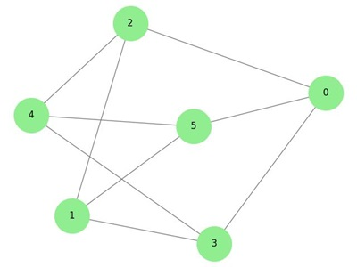
Definition : A regular graph is a graph in which every vertex has the same degree.
If every vertex has degree k, the graph is called a k-regular graph.
Example
If each vertex connects to 2 edges, the graph is 2-regular.
Example graph:
A—B
| |
D—C
Each vertex has degree = 2.
Key Points
- All vertices have equal number of edges.
- Degree of every vertex is constant.
Examples of Regular Graphs
Graph | Degree
Cycle graph C₄ | 2-regular
Cube graph | 3-regular

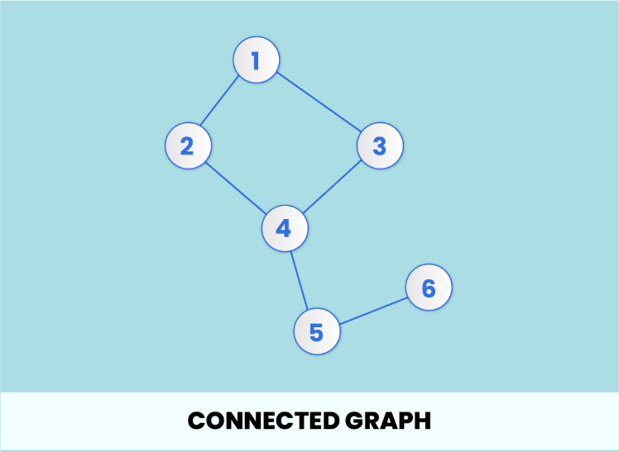
2. Connected Graph:
Definition : A graph is connected if there exists at least one path between every pair of vertices.
Meaning:
Every vertex can reach every other vertex.
Example
A—B—C
|
D
All vertices are reachable from one another.
Key Idea : If you can travel from any node to any other node, the graph is connected.
Opposite Case
If some vertices cannot reach others → Disconnected graph.
Example:
A — B C — D
Two separate components.

3. Bipartite Graph
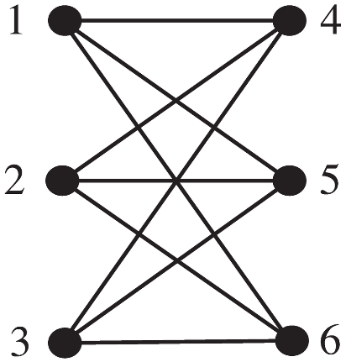
Definition (Exam Ready)
A bipartite graph is a graph whose vertex set can be divided into two disjoint sets such that every edge connects a vertex from one set to a vertex in the other set.
Structure
Vertices split into two groups:
Set U
Set V
Edges only go between sets, not inside the same set.
Example
U = {A, B}
V = {C, D}
Edges:
A — C
A — D
B — C
Key Rule : No edge exists between vertices within the same set.
Real Life Example
- Job assignment (workers ↔ jobs)
- Students ↔ courses

4. Complete Graph
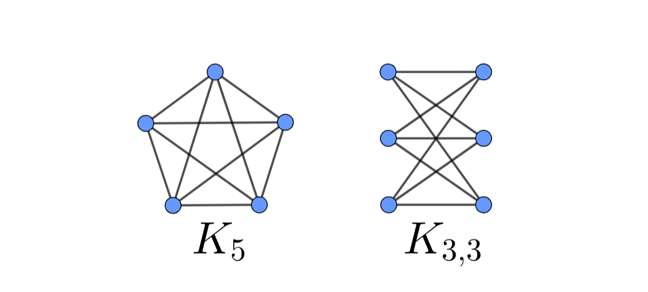
Definition: A complete graph is a simple graph in which every pair of distinct vertices is connected by an edge.
Notation: Complete graph with n vertices:
$$K_{n}$$
Example
For 4 vertices:
K₄
Each vertex connects to all others.
Number of Edges
Formula:
$$E=\frac{n\left(n-1\right)}{2}$$
Example:
K₄
$$E=\frac{4\left(3\right)}{2}=6$$
Key Idea : Maximum number of edges possible in a simple graph.
Quick Memory Trick
Regular → same degree
Connected → reachable nodes
Bipartite → two groups
Complete → all connected
Theorem 1 — Handshaking Theorem (Graph Theory)
Statement : For any graph GGG with vertices v1,v2,…,vnv_1, v_2, \dots , v_nv1​,v2​,…,vn​ and edge set EEE, the sum of the degrees of all vertices is equal to twice the number of edges in the graph.
Mathematically:
$$\deg\left(v_{1}\right)+\deg\left(v_{2}\right)+…+\deg\left(v_{n}\right)=2\left|E\right|$$
Or

$$\sum_{i=1}^{n}{}\deg\left(v_{i}\right)=2\left|E\right|$$
Where,
- $\deg\left(v_{i}\right)$ = degree of vertex v_{i}
- ∣E∣ = number of edges in graph

Intuition Behind the Theorem
Each edge connects two vertices.
So every edge contributes 1 degree to each endpoint.
Therefore:
- One edge contributes 2 degrees total.
Hence:
Total degree count = 2 × number of edges.

Example
Consider graph:
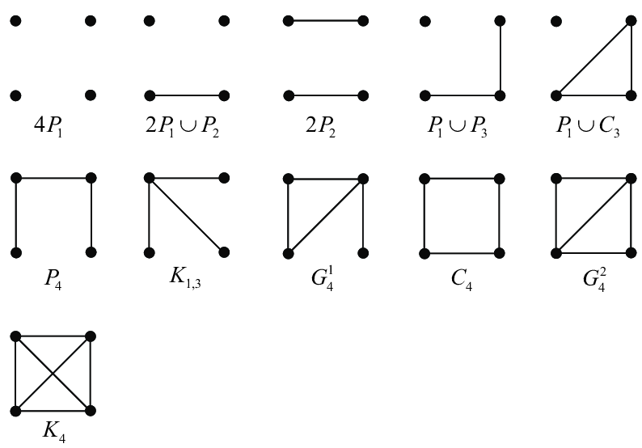
Suppose graph:
Vertices:
A, B, C, D
Edges:
AB, BC, CD, DA
Number of edges:
∣E∣=4|E| = 4∣E∣=4

Step 1 — Calculate Degrees
Vertex | Degree
A | 2
B | 2
C | 2
D | 2

Step 2 — Sum of Degrees
2+2+2+2=8

Step 3 — Apply Theorem
$$2\left|E\right|=2×4=8$$
Both sides equal.
Theorem verified.

Important Consequence of the Theorem
From this theorem we get another result:
The number of vertices with odd degree in a graph is always even.
Example: Odd-degree vertices must appear in pairs.

Why It Is Called Handshaking Lemma
Imagine a group of people shaking hands.
- Every handshake involves two people.
- If we count all handshakes per person, each handshake gets counted twice.
So total handshakes = half of total degree count.

Theorem 2 — Number of Odd Degree Vertices
Definition: A vertex of a graph is called an odd vertex if the degree of that vertex is an odd number.
Example: If degree of vertex = 1, 3, 5, 7, etc., then it is an odd vertex.

Theorem Statement : In any graph GGG, the number of vertices having odd degree is always even.

Proof
From the Handshaking Theorem:
$$\sum_{i=1}^{n}{}\deg\left(v_{i}\right)=2\left|E\right|$$
Since 2∣E∣ is even, the sum of the degrees of all vertices in a graph is even.
Now divide vertices into two groups:
- Vertices with even degree
- Vertices with odd degree
- Sum of degrees of even vertices → even number
- Sum of degrees of odd vertices → depends on count of odd vertices
Property of numbers:
- Sum of an odd number of odd integers = odd
- Sum of an even number of odd integers = even
Since total degree sum must be even, the number of odd-degree vertices must be even.
Therefore,
The number of vertices with odd degree in any graph is always even.
Conclusion : Number of odd-degree vertices is always even
1️⃣ Euler Graph
Definition : A graph is called a Euler graph if it contains a closed path that uses every edge of the graph exactly once.
This path is called an Euler circuit.
Euler Circuit : A path that:
- starts and ends at the same vertex
- uses every edge exactly once
Euler Path : An Euler path is a path that uses every edge of the graph exactly once but does not necessarily start and end at the same vertex.

Euler Graph Conditions
A connected graph is Eulerian if and only if:
- Every vertex has even degree
- The graph is connected

Example
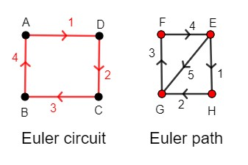
Example graph:
A — B
| |
D — C
Degrees:
Vertex | Degree
A | 2
B | 2
C | 2
D | 2
All degrees even → Euler graph
Possible Euler circuit:
A → B → C → D → A

2️⃣ Hamiltonian Graph
Definition : A graph is called a Hamiltonian graph if it contains a cycle that visits every vertex exactly once.
This cycle is called a Hamiltonian cycle.
Important:
- Every vertex visited once
- Start and end vertices are same

Hamiltonian Path
A Hamiltonian path is a path that visits every vertex exactly once but does not necessarily return to the starting vertex.

Example
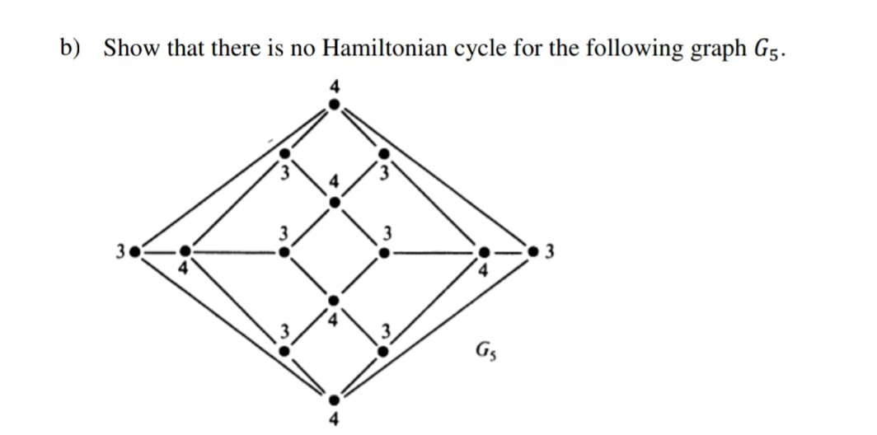
Example graph:
A — B
| |
D — C
Hamiltonian cycle:
A → B → C → D → A
Every vertex visited once.
Key Difference
Feature | Euler Graph | Hamiltonian Graph
Focus | Edges | Vertices
Rule | Every edge used once | Every vertex visited once
Condition | All vertices even degree | No simple universal condition

Simple Memory Trick
Euler → Edges
Hamilton → Vertices
1️⃣ Connected Graph
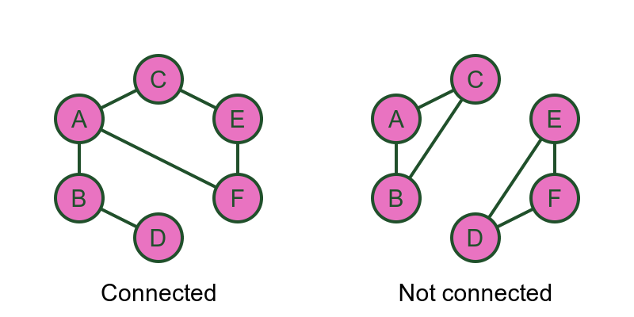

Definition: A graph is called connected if there exists at least one path between every pair of vertices.
Meaning
Every vertex can reach every other vertex.
Example
Graph:
A — B — C
|
D
Paths exist between all vertices.
So the graph is connected.

2️⃣ Strongly Connected Graph (Directed Graph)
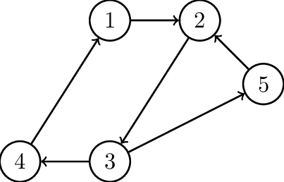
Definition : A directed graph is strongly connected if there exists a directed path from every vertex to every other vertex.
Meaning
For vertices u and v:
- u can reach v
- v can reach u
Example
A → B
B → C
C → A
From any vertex you can reach all others.
Therefore strongly connected.

3️⃣ Weakly Connected Graph
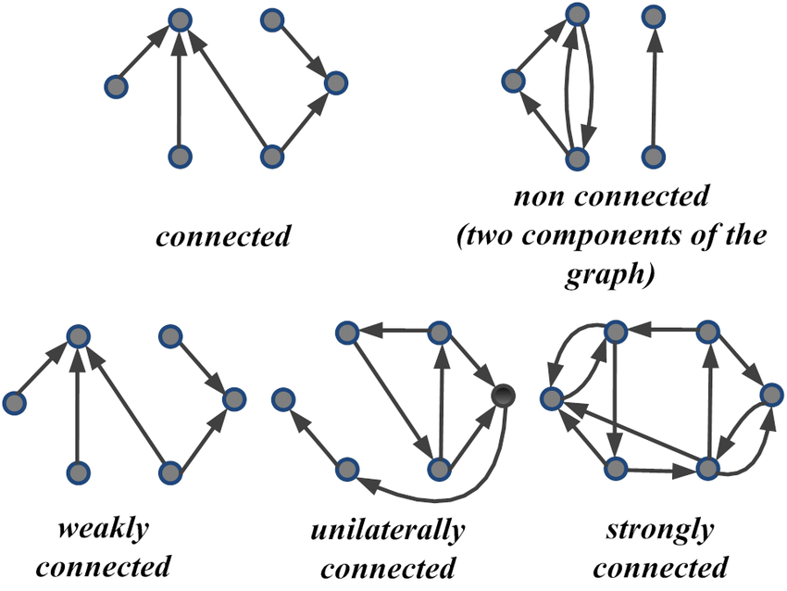
Definition : A directed graph is weakly connected if replacing all directed edges with undirected edges results in a connected graph.
Meaning
Ignoring edge direction → graph becomes connected.
Example
A → B
C → B

Ignoring direction:
A — B — C
Graph becomes connected → weakly connected.

4️⃣ Unilaterally Connected Graph
Definition : A directed graph is unilaterally connected if for every pair of vertices uuu and vvv, there exists a directed path from u to v or from v to u.
Meaning:
At least one directional path exists.
Not necessarily both.

Example
A → B → C
- A can reach C
- C cannot reach A
Still unilaterally connected.

5️⃣ Components of a Graph
A component is a maximal connected subgraph.

Strong Component
A maximal subgraph in which every vertex is reachable from every other vertex.
Example:
A → B → C → A
These three form a strong component.

Weak Component
A maximal subgraph that becomes connected if edge directions are ignored.
Example:
A → B
C → B
Ignoring directions → connected.

Unilateral Component
A maximal subgraph in which every pair of vertices is unilaterally connected.
Example:
A → B → C
Paths exist in one direction.

Comparison Table
Type | Condition
Connected Graph | Path between every pair of vertices
Strongly Connected | Directed path exists both ways
Weakly Connected | Ignoring directions makes graph connected
Unilaterally Connected | Path exists in at least one direction

Quick Example Comparison
Graph:
A → B → C
Type | Result
Strongly Connected | ❌ No
Weakly Connected | ✔ Yes
Unilaterally Connected | ✔ Yes

Exam Tip
Students usually confuse strong vs weak connectivity.
Remember:
Strong → both directions
Weak → ignore directions
Unilateral → one direction enough
Application of Graphs in Operating Systems
Resource Allocation and Deadlock Detection
Graph theory is used in operating systems to represent how resources are allocated to processes and to detect deadlocks.

1️⃣ Resource Allocation Graph (RAG)
Definition : A resource allocation graph is a directed graph used to represent the allocation of resources to processes in an operating system.
It helps determine whether the system is in a deadlock state.

Components of Resource Allocation Graph
Component | Representation | Meaning
Process | Circle | Program requesting resources
Resource | Square | System resource (CPU, printer, memory)
Request Edge | P → R | Process requesting resource
Assignment Edge | R → P | Resource assigned to process

Example
Example graph:
Processes
P1, P2
Resources
R1, R2
Edges:
P1 → R1 (request)
R1 → P2 (allocated)
P2 → R2 (request)

2️⃣ Deadlock
Definition : A deadlock is a situation in which two or more processes are waiting indefinitely for resources held by each other.
Meaning:
No process can proceed.

Example
P1 holds R1 and waits for R2
P2 holds R2 and waits for R1
Both wait forever → deadlock occurs.

3️⃣ Deadlock Detection Using Graph
In a resource allocation graph, deadlock appears as a cycle.
Example cycle:
P1 → R1 → P2 → R2 → P1
Cycle indicates deadlock.

4️⃣ Deadlock Detection Rule
Condition | Result
Graph has no cycle | No deadlock
Graph has cycle | Deadlock possible
Cycle with single resource instance | Deadlock occurs

5️⃣ Deadlock Prevention :
Operating systems use strategies to avoid or break deadlocks.
Methods
- Resource ordering
- Resource preemption
- Deadlock detection algorithms
- Terminating processes

6️⃣ Example of Deadlock Correction
Suppose:
P1 → R1 → P2 → R2 → P1
Break the cycle by:
- releasing a resource
- stopping one process
Then the graph becomes acyclic.
Deadlock resolved.

Key Exam Points
Always remember:
- RAG represents resource allocation
- Cycle detection identifies deadlock
- Graph theory helps analyse operating system behaviour
Matrix Representation of Graphs
Graphs can also be represented using matrices, which is useful in algorithms and computer implementations.
1️⃣ Matrix Representation of a Graph
Definition : A matrix representation of a graph is a way of representing a graph using a matrix to show the connections between vertices.
If a graph has n vertices, we form an n × n matrix.
Each row and column represent a vertex.

2️⃣ Adjacency Matrix
Definition : The adjacency matrix of a graph is a square matrix used to represent which vertices are adjacent to which other vertices.
Notation:
$A=\left[a_{ij}\right]$
Where:
$a_{ij}=\left\{1if there is an edge between v_{i}​ and v_{j , }otherwise 0\right.$
Example Graph
1. draw graph from descriptions:
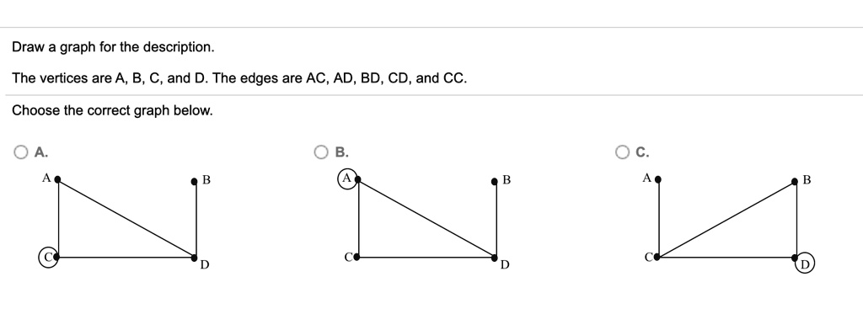
2. make graph from adjency metrix :
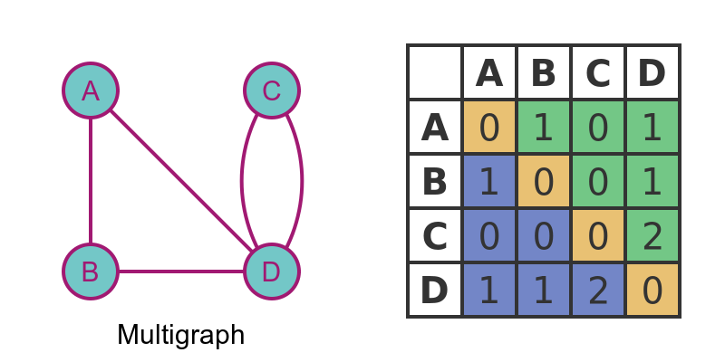
Vertices
A, B, C, D
Edges
(A,B)
(A,C)
(B,D)

Adjacency Matrix
 | A | B | C | D
A | 0 | 1 | 1 | 0
B | 1 | 0 | 0 | 1
C | 1 | 0 | 0 | 0
D | 0 | 1 | 0 | 0
Explanation
1 = edge exists
0 = no edge

3️⃣ Boolean (Bit) Matrix
Definition : A Boolean matrix is a matrix where entries are only 0 or 1 indicating absence or presence of edges.
Adjacency matrix itself is often a Boolean matrix.
Values used:
Value | Meaning
1 | Edge exists
0 | No edge
So adjacency matrices are usually Boolean matrices.

4️⃣ Number of Paths Using Adjacency Matrix
If
A
is the adjacency matrix of graph G,
then
$$A^{n}$$
gives the number of paths of length n between vertices.
Meaning:
$${\left(A^{n}\right)}_{ij}$$
= number of paths from vertex I to vertex j of length n.

Example
Graph
A — B — C
Vertices:
A, B, C

Step 1 — Adjacency Matrix
 | A | B | C
A | 0 | 1 | 0
B | 1 | 0 | 1
C | 0 | 1 | 0

Step 2 — Square the Matrix
$$A^{2}=A×A$$
Result
 | A | B | C
A | 1 | 0 | 1
B | 0 | 2 | 0
C | 1 | 0 | 1

Interpretation
Example:
Entry (A,C) = 1
There is 1 path of length 2 from A to C.
Path:
A → B → C

Key Points
Concept | Meaning
Adjacency Matrix | Shows connections between vertices
Boolean Matrix | Matrix with only 0 and 1
Matrix Power $A^{n}$ | Number of paths of length n

1️⃣ Incidence Matrix
Definition : The incidence matrix of a graph is a matrix that shows the relationship between vertices and edges.
If a graph has:
- n vertices
- m edges
Then the incidence matrix will be:
$$n ×m$$
Rows → vertices
Columns → edges

Rule
Value | Meaning
1 | Vertex is incident with edge
0 | Vertex not incident with edge

Example Graph
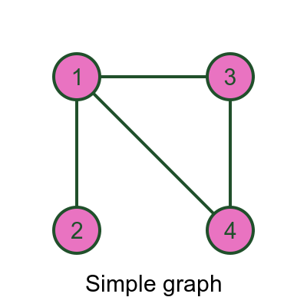
Vertices: A, B, C
Edges:
e₁ = (A,B)
e₂ = (B,C)
e₃ = (C,A)

Incidence Matrix
 | e₁ | e₂ | e₃
A | 1 | 0 | 1
B | 1 | 1 | 0
C | 0 | 1 | 1
Example:
Edge e₁ (A,B)
A = 1
B = 1
C = 0

2️⃣ Path Matrix
Definition: The path matrix of a graph shows whether a path exists between two vertices.

Rule
Value | Meaning
1 | Path exists
0 | No path

Example Graph
A — B — C

Path Matrix
 | A | B | C
A | 1 | 1 | 1
B | 1 | 1 | 1
C | 1 | 1 | 1
Because every vertex is reachable.

3️⃣ Reachability Matrix (Path Matrix)
Definition : The reachability matrix of a graph shows whether a vertex can reach another vertex through any path.
It indicates connectivity between vertices.

Construction
Reachability matrix is obtained using:
$$R=A+A^{2}+A^{3}+…+A^{n}$$
Where
A = adjacency matrix

Example
Graph
A → B → C

Adjacency Matrix
 | A | B | C
A | 0 | 1 | 0
B | 0 | 0 | 1
C | 0 | 0 | 0

Reachability Matrix
 | A | B | C
A | 0 | 1 | 1
B | 0 | 0 | 1
C | 0 | 0 | 0

Explanation :
A can reach B and C
B can reach C
Warshall’s Algorithm (Graph Theory)
Warshall’s Algorithm is used to determine reachability between vertices in a directed graph.
It computes the transitive closure or reachability matrix of a graph.

1️⃣ Definition : Warshall’s Algorithm is a method used to compute the reachability matrix of a directed graph from its adjacency matrix.
It determines whether there exists a path between every pair of vertices.

2️⃣ Purpose of the Algorithm
Warshall’s Algorithm helps to:
- Find all possible paths between vertices
- Determine reachability
- Detect connectivity in graphs

3️⃣ Idea of the Algorithm
Starting with the adjacency matrix, the algorithm checks whether a path exists through intermediate vertices.
If
vertex i can reach vertex k
and
vertex K can reach vertex j
then
vertex i can reach vertex j .

4️⃣ Mathematical Rule
If $W_{k}​$ is the matrix at step k :
$$w_{ij}^{\left(k\right)}=w_{ij}^{\left(k-1\right)} OR \left(w_{ik}^{\left(k-1\right)}∧w_{kj}^{\left(k-1\right)}\right)$$
Meaning:
Existing path OR path through vertex k.

5️⃣ Algorithm Steps
- Start with adjacency matrix A
- Let W=A
- For each vertex k
Update matrix using rule:
$$w_{ij}=w_{ij} OR \left(w_{ik}∧w_{kj}\right)$$
Repeat until all vertices are processed.
Final matrix = reachability matrix

6️⃣ Example
Graph:

Vertices
A, B, C
Edges
A → B
B → C

Step 1 — Adjacency Matrix
 | A | B | C
A | 0 | 1 | 0
B | 0 | 0 | 1
C | 0 | 0 | 0

Step 2 — Apply Warshall’s Algorithm
We check intermediate vertices.
From A → B
and B → C
Therefore
A → C exists.

Step 3 — Reachability Matrix
 | A | B | C
A | 0 | 1 | 1
B | 0 | 0 | 1
C | 0 | 0 | 0
Meaning:
- A can reach B and C
- B can reach C
- C cannot reach others

7️⃣ Key Observations
Concept | Meaning
Adjacency matrix | Direct connections
Warshall algorithm | Computes reachability
Result | Path matrix

8️⃣ Why It Is Important
Warshall’s Algorithm is used in:
- Graph connectivity analysis
- Network routing
- Database dependency analysis
- Operating system resource graphs

9️⃣ Exam Pattern
Students are usually asked:
- Given adjacency matrix
- Apply Warshall’s algorithm step-by-step
- Find reachability matrix

Summary
Step | Action
1 | Start with adjacency matrix
2 | Use OR and AND rule
3 | Check intermediate vertices
4 | Final matrix gives reachability

