Trees in Graph Theory
A tree is a special type of graph used to represent hierarchical structures such as file systems, organizational charts, and decision trees.

1️⃣ Tree
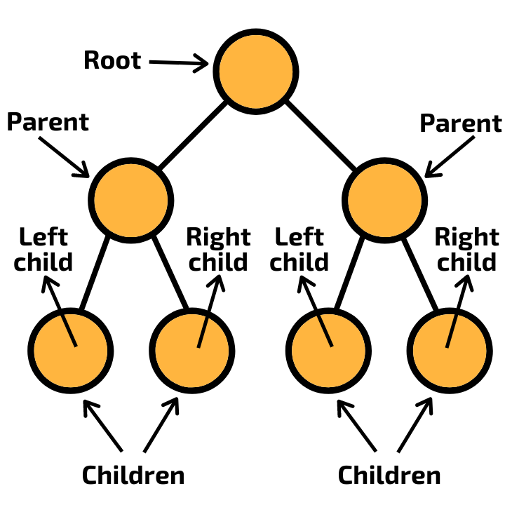

Definition : A tree is a connected graph with no cycles.
Properties:
- It contains n vertices and n−1 edges
- Only one path exists between any two vertices

2️⃣ Root of a Tree
Definition: The root is the topmost vertex of a tree from which all other vertices originate.
Example:
If vertex A is the starting node, then A is the root.

3️⃣ Branch Nodes (Internal Nodes)
Definition : Branch nodes are vertices that have at least one child node.
They are also called internal nodes.
Example:
If node B has children D and E, then B is a branch node.

4️⃣ Leaf Nodes (Terminal Nodes)
Definition: A leaf node is a vertex that has no children.
It represents the end of a branch.
Example:
Nodes D, E, F that have no further nodes.

Example Tree Structure
Root:
A
Children:
B, C
Further nodes:
B → D, E
C → F
Classification:
Node | Type
A | Root
B, C | Branch nodes
D, E, F | Leaf nodes

5️⃣ Different Representations of a Tree
Trees can be represented in multiple ways.

(a) Graphical Representation
Nodes connected with edges.
Example
A
/ \
B C
/ \ \
D E F

(b) Parent Representation
Each node stores its parent node.
Example table:
Node | Parent
A | –
B | A
C | A
D | B
E | B
F | C

(c) Adjacency Matrix Representation
Vertices are represented using a matrix.
Example:
 | A | B | C | D
A | 0 | 1 | 1 | 0
B | 1 | 0 | 0 | 1
C | 1 | 0 | 0 | 0
D | 0 | 1 | 0 | 0

(d) Adjacency List Representation
Each vertex stores its connected vertices.
Example:
Vertex | Adjacent Nodes
A | B, C
B | D, E
C | F

Key Properties of Trees
Property | Meaning
No cycles | Tree has no loops
Connected | Every node reachable
Edges | n − 1 edges
Unique path | Only one path between vertices

1️⃣ Eccentricity of a Vertex
Definition: The eccentricity of a vertex in a graph or tree is the maximum distance from that vertex to any other vertex in the graph.
Formula
$$e\left(v\right)=\max{\{}d\left(v,u\right)\}$$
Where
d(v,u) = distance between vertices v and u.
Meaning: Find the longest shortest path from that vertex to any other vertex.

2️⃣ Canter of a Tree
Definition: The center of a tree is the vertex (or vertices) whose eccentricity is minimum among all vertices of the tree.
Meaning:
The node that is closest to all other nodes in terms of distance.
Important property:
- A tree has either one center or two centers.

3️⃣ Cut Points
Definition : A cut point is a vertex whose removal increases the number of connected components of a graph.
Meaning:
If we remove that vertex, the graph becomes disconnected.
Example idea:
A — B — C
If B is removed, A and C become disconnected.
So B is a cut point.

4️⃣ Rooted Tree
Definition: A rooted tree is a tree in which one vertex is designated as the root, and every edge is directed away from the root.
Meaning: The root acts as the starting point of the tree hierarchy.
Example structure
A
/ \
B C
/ \
D E
Root = A

5️⃣ Level of a Node
Definition: The level of a node is the number of edges in the path from the root to that node.
Example
A
/ \
B C
/
D
Node | Level
A | 0
B, C | 1
D | 2

6️⃣ Height of a Tree
Definition: The height of a tree is the maximum level of any vertex in the tree.
Meaning:
Distance from root to the deepest leaf node.
Example
If deepest node level = 3 → height = 3.
7️⃣ Ordered Tree
Definition: An ordered tree is a rooted tree in which the order of the children of each vertex matters.
Example: If node A has children B then C, this is different from C then B.
Order matters.

8️⃣ Subtrees
Definition: A subtree is a tree formed by a vertex and all of its descendants in a larger tree.
Example
A
/ \
B C
/ \
D E
Subtree rooted at B:
B
/ \
D E

9️⃣ m- ary Tree
Definition : An m-ary tree is a rooted tree in which every node has at most m children.
Where m is a positive integer.

Example
Binary tree:
m = 2
Ternary tree:
m = 3
Example structure
A
/ | \
B C D
Here each node can have maximum 3 children.
Binary Tree
A binary tree is a special type of tree where each node can have at most two children.
1️⃣ Binary Tree
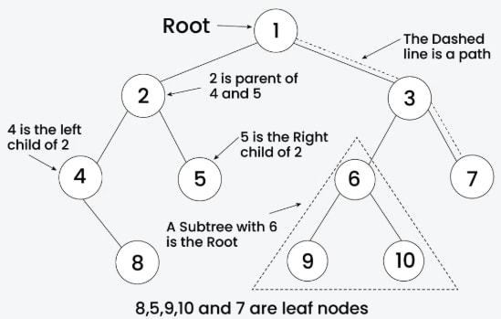

Definition : A binary tree is a tree data structure in which each node has at most two children called the left child and the right child.

2️⃣ Structure of Binary Tree
Each node contains:
- Root node
- Left subtree
- Right subtree
Example structure
A
/ \
B C
/ \ \
D E F

3️⃣ Types of Nodes in Binary Tree
Node Type | Meaning
Root node | Topmost node
Internal node | Node with children
Leaf node | Node with no children
Example
Node | Type
A | Root
B, C | Internal
D, E, F | Leaf

4️⃣ Important Properties of Binary Trees
Property 1 : Maximum nodes at level i
$$2^{i}$$

Property 2
Maximum nodes in binary tree of height h
$$2^{h+1}-1$$

Property 3
Maximum number of leaf nodes
$$2^{h}$$
5️⃣ Types of Binary Trees
(a) Full Binary Tree
Definition: A full binary tree is a binary tree where every node has either 0 or 2 children.
Example:
A
/ \
B C
/ \
D E

(b) Complete Binary Tree
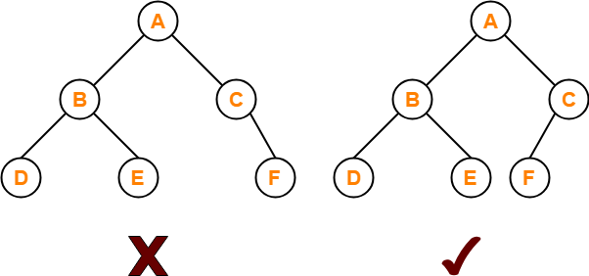

Definition: A complete binary tree is a binary tree where all levels are completely filled except possibly the last level.
The last level is filled from left to right.

(c) Perfect Binary Tree
Definition: A perfect binary tree is a binary tree in which all internal nodes have two children and all leaves are at the same level.

6️⃣ Binary Tree Terminology
Term | Meaning
Parent | Node above
Child | Node below
Sibling | Nodes with same parent
Subtree | Portion of tree

7️⃣ Applications of Binary Trees
Binary trees are used in:
- Searching algorithms
- Expression trees
- Binary search trees
- File systems
- AI decision trees
Converting an m-ary Tree to a Binary Tree
An m-ary tree can be converted into a binary tree using the Left-Child Right-Sibling (LCRS) method.

1️⃣ Idea of Conversion
In a binary tree, each node has at most two children:
- Left child
- Right child
So we represent:
m-ary Tree Relation | Binary Tree Relation
First child | Left child
Next sibling | Right child
Meaning:
- First child of a node → becomes left child
- Next sibling → becomes right child

Example m-ary Tree
Tree:
A
/ | \
B C D
/ \
E F

Converted Binary Tree
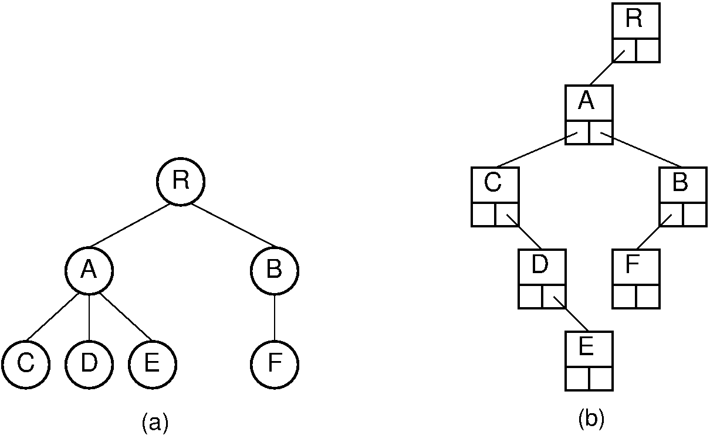
Binary tree representation:
A
/
B
/ \
E C
\ \
F D
Explanation
Node | Binary Tree Relation
B | Left child of A
C | Right sibling of B
D | Right sibling of C
E | Left child of B
F | Right sibling of E

Steps for Conversion
- Connect each node to its first child (left link).
- Connect each node to its next sibling (right link).
- Remove other child connections.
This produces a binary tree representation of the m-ary tree.

Representation of a Binary Tree (Linked List)
Binary trees are commonly implemented using linked lists.

Structure of Binary Tree Node
Each node contains:
- Data
- Pointer to left child
- Pointer to right child

Node Representation
| Left Pointer | Data | Right Pointer |

Example Binary Tree
A
/ \
B C
/ \
D E

Linked List Representation
Node | Left Pointer | Data | Right Pointer
A | B | A | C
B | D | B | E
C | NULL | C | NULL
D | NULL | D | NULL
E | NULL | E | NULL

Advantages of Linked-List Representation
- Dynamic memory allocation
- Easy insertion and deletion
- Efficient tree traversal
Tree Traversal Algorithms (Binary Trees)
Tree traversal means visiting each node of a tree exactly once in a specific order.
There are three main traversal methods.

Example Binary Tree
Use this tree to understand all traversals.
A
/ \
B C
/ \ \
D E F

1️⃣ Preorder Traversal (Root–Left–Right)
Definition : In preorder traversal, the root node is visited first, then the left subtree, and finally the right subtree.
Order
Root → Left → Right
Steps
- Visit root
- Traverse left subtree
- Traverse right subtree
Example
Tree
A
/ \
B C
/ \ \
D E F
Traversal
A → B → D → E → C → F

2️⃣ Inorder Traversal (Left–Root–Right)
Definition : In inorder traversal, the left subtree is visited first, then the root node, and finally the right subtree.
Order
Left → Root → Right
Steps
- Traverse left subtree
- Visit root
- Traverse right subtree
Example
Traversal
D → B → E → A → C → F

3️⃣ Postorder Traversal (Left–Right–Root)
Definition: In postorder traversal, the left subtree is visited first, then the right subtree, and finally the root node.
Order
Left → Right → Root
Steps
- Traverse left subtree
- Traverse right subtree
- Visit root
Example
Traversal
D → E → B → F → C → A

Comparison Table
Traversal | Order | Result for Example Tree
Preorder | Root–Left–Right | A B D E C F
Inorder | Left–Root–Right | D B E A C F
Postorder | Left–Right–Root | D E B F C A

Applications:
Traversal | Use
Preorder | Copy tree / prefix expression
Inorder | Binary search tree sorting
Postorder | Delete tree / postfix expression
1️⃣ Spanning Tree :
Definition : A spanning tree of a connected graph is a subgraph that includes all the vertices of the graph and forms a tree.
Meaning:
- Contains all vertices
- Has no cycles
- Uses minimum edges to keep graph connected

Example
Original graph:
Vertices
A, B, C, D
Edges
AB, AC, AD, BC, CD
A spanning tree may contain:
AB, AC, AD
This connects all vertices without forming a cycle.

2️⃣ Properties of Spanning Trees
Important properties frequently asked in exams.
Property | Explanation
Contains all vertices | Every vertex of the graph appears
No cycles | Spanning tree is acyclic
Minimum edges | If graph has n vertices, spanning tree has n−1 edges
Connected | Every vertex reachable
Removing any edge disconnects tree | Tree becomes disconnected
Adding any edge creates cycle | Because tree already minimal

Important Theorem
If a graph has n vertices, a spanning tree has:
n−1
edges.
Example
If vertices = 5
Edges in spanning tree = 4.

3️⃣ Minimum Spanning Tree (MST)
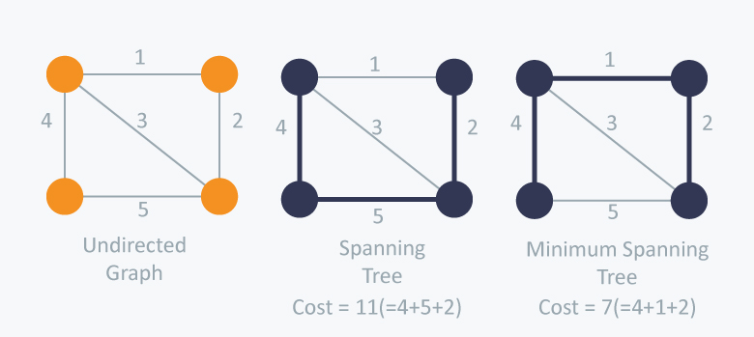
Definition : A minimum spanning tree is a spanning tree of a weighted connected graph in which the sum of edge weights is minimum.
Meaning: Among all possible spanning trees, choose the one with lowest total weight.

Example
Graph with weights
Edges
AB = 2
AC = 3
BC = 4
BD = 1
CD = 5
Possible spanning tree:
AB + AC + BD
Total weight:
2+3+1=6
If this is the minimum possible → Minimum Spanning Tree.
Applications of Minimum Spanning Tree
MST is used in:
- Network design (telephone, internet)
- Road and railway planning
- Electrical network design
- Data clustering
- Image segmentation
Difference
Concept | Meaning
Spanning Tree | Any tree connecting all vertices
Minimum Spanning Tree | Spanning tree with minimum weight

Algorithms to Find MST
Two famous algorithms:
- Kruskal’s Algorithm
- Prim’s Algorithm
Kruskal’s Algorithm (Minimum Spanning Tree)
Definition : Kruskal’s Algorithm is a greedy algorithm used to find the minimum spanning tree (MST) of a weighted connected graph by selecting edges in increasing order of weight without forming a cycle.
Goal: Construct a spanning tree with minimum total weight.

Steps of Kruskal’s Algorithm
- List all edges of the graph with their weights.
- Sort the edges in ascending order of weights.
- Select the smallest edge.
- Add the edge to the spanning tree if it does not create a cycle.
- Repeat until the spanning tree contains n − 1 edges.
Where
n = number of vertices.

Steps to Write in Exam
Step 1
Write the adjacency matrix of the graph.
Let the graph have n vertices.

Step 2
List all the edges from the adjacency matrix with their weights.
Example:
If matrix entry
$$A_{ij}=w$$

then edge:
$$\left(v_{i},v_{j}\right)$$
with weight w.
Ignore entries with 0 (no edge).

Step 3
Arrange all edges in ascending order of weights.
Make a table:
Edge | Weight
e1 | w1
e2 | w2
... | ...

Step 4
Select the smallest weight edge.
Add it to the Minimum Spanning Tree (MST).

Step 5
Check if adding the edge creates a cycle.
- If cycle forms → reject edge
- If no cycle → include edge

Step 6
Repeat the process for the next smallest edge.

Step 7
Stop when the number of edges selected becomes:
n - 1
where n = number of vertices.

Example Format to Write in Exam
Given Adjacency Matrix
 | A | B | C | D
A | 0 | 1 | 3 | 0
B | 1 | 0 | 2 | 4
C | 3 | 2 | 0 | 5
D | 0 | 4 | 5 | 0

Step 1 — Extract Edges
Edge | Weight
AB | 1
AC | 3
BC | 2
BD | 4
CD | 5

Step 2 — Sort Edges
Edge | Weight
AB | 1
BC | 2
AC | 3
BD | 4
CD | 5

Step 3 — Select Edges
Edge | Action
AB | Selected
BC | Selected
AC | Rejected (cycle)
BD | Selected
Edges selected = 3 = n−1

Minimum Spanning Tree
Edges: AB, BC, BD
Total weight: 1 + 2 + 4 = 7

Important Points
Property | Explanation
Algorithm type | Greedy algorithm
Edge selection | Smallest weight first
Cycle rule | Cycles not allowed
Stop condition | n − 1 edges

Time Complexity
$$O\left(E\log{E}\right)$$
Where
E = number of edges.

Advantages
- Simple to implement
- Works well for sparse graphs

Prim’s Algorithm (Minimum Spanning Tree)
Definition : Prim’s Algorithm is a greedy algorithm used to find the minimum spanning tree (MST) of a weighted connected graph by starting from a vertex and repeatedly adding the minimum weight edge that connects a visited vertex to an unvisited vertex.
Goal: Construct a spanning tree with minimum total weight.

Steps of Prim’s Algorithm
- Start with any vertex as the initial vertex.
- Mark the starting vertex as visited.
- From all edges connecting visited vertices to unvisited vertices, choose the edge with minimum weight.
- Add that edge and the new vertex to the spanning tree.
- Mark the new vertex as visited.
- Repeat the process until all vertices are included in the tree.
Where
n = number of vertices.

Steps to Write in Exam (Using Adjacency Matrix)
Step 1
Write the adjacency matrix of the graph.
Let the graph have n vertices.

Step 2
Choose any vertex as the starting vertex.
Mark it as visited.

Step 3
Look at all edges connecting the visited vertex to unvisited vertices.
Select the minimum weight edge.

Step 4
Add the selected edge to the Minimum Spanning Tree (MST).
Mark the new vertex as visited.

Step 5
From all visited vertices, check edges connecting to unvisited vertices.
Choose the minimum weight edge.

Step 6
Repeat the process until the number of edges in MST becomes:
n−1n - 1n−1
where n = number of vertices.

Example Format to Write in Exam
Given Adjacency Matrix
 | A | B | C | D
A | 0 | 1 | 3 | 0
B | 1 | 0 | 2 | 4
C | 3 | 2 | 0 | 5
D | 0 | 4 | 5 | 0

Step 1 — Start from Vertex A
Visited = {A}
Possible edges
Edge | Weight
AB | 1
AC | 3
Choose AB (1).

Step 2
Visited = {A, B}
Possible edges
Edge | Weight
AC | 3
BC | 2
BD | 4
Choose BC (2).

Step 3
Visited = {A, B, C}
Possible edges
Edge | Weight
BD | 4
CD | 5
Choose BD (4).

Step 4
Visited = {A, B, C, D}
Number of edges = 3 = n − 1
Stop.

Minimum Spanning Tree
Edges:
AB, BC, BD
Total weight:
1+2+4=7

Important Points
Property | Explanation
Algorithm type | Greedy algorithm
Starting point | Any vertex
Edge selection | Minimum edge connecting visited to unvisited
Cycle rule | Cycles automatically avoided
Stop condition | n − 1 edges

Time Complexity
$$O\left(V^{2}\right)$$
Using adjacency matrix.
Where
V = number of vertices.

Advantages
- Easy to implement with adjacency matrix
- Efficient for dense graphs
- No need to sort all edges (unlike Kruskal)

Key Difference Between Kruskal and Prim
Feature | Kruskal’s Algorithm | Prim’s Algorithm
Approach | Edge-based | Vertex-based
Start point | No starting vertex needed | Must start from a vertex
Edge selection | Smallest edge in the whole graph | Smallest edge connected to visited vertex
Cycle check | Must check for cycles | Cycle avoided automatically
Data structure | Uses edge list | Uses adjacency matrix / priority queue
Best for | Sparse graphs | Dense graphs

One-Line Memory Trick
Kruskal: smallest edge anywhere
Prim: grow tree from a vertex
Reachability (Graph Theory)
Reachability describes whether one node in a graph can reach another node through a path.
It is mainly used in directed graphs (digraphs).

1️⃣ Definition of Reachability
Definition : A vertex v is said to be reachable from another vertex u if there exists a path from u to v in the graph.
Meaning:
If we can travel from node u to v following edges, then v is reachable from u.

Example
Graph
A → B → C
Reachability:
- B is reachable from A
- C is reachable from A
- C is reachable from B
But
- A is not reachable from C

2️⃣ Reachable Node
Definition : A node v is called a reachable node from node u if there exists a path from u to v.
In simple words:
If a node can be visited starting from another node, it is a reachable node.

Example
Graph
A → B → C → D
Reachable nodes from A
B, C, D
So
Starting Node | Reachable Nodes
A | B, C, D

3️⃣ Reachable Set of a Node
Definition: The reachable set of a node is the set of all vertices that can be reached from that node by following paths in the graph.
It contains all reachable nodes from that vertex.

Example
Graph
A → B → C
↓
D
Reachable set of A
R(A)={B,C,D}
Reachable set of B
R(B)={C,D}
Reachable set of C
R(C) = ∅
1️⃣ Geodesic (Shortest Path)
Definition : A geodesic between two vertices is the shortest path connecting those vertices in a graph.
Meaning:
Among all possible paths between two nodes, the path with minimum number of edges is called the geodesic.

Example
Graph
A → B → C → D
\ /
---------------
Possible paths from A to D
- A → B → C → D (length = 3)
- A → D (length = 1)
Shortest path = A → D
So A → D is the geodesic.

2️⃣ Distance Between Two Nodes
Definition : The distance between two vertices u and v is the length of the shortest path (geodesic) between them.
Notation
D ( u, v )
Meaning:
Distance = number of edges in the shortest path.

Example
Graph
A → B → C → D
Distance values
Nodes | Distance
d(A,B) | 1
d(A,C) | 2
d(A,D) | 3

3️⃣ Properties of Reachability
Reachability has several important properties.
Property | Explanation
Reflexive | Every vertex is reachable from itself
Transitive | If A reaches B and B reaches C, then A reaches C
Connectivity | Reachability determines connectivity of graph

Example of Transitive Property
Graph
A → B → C
A reaches B
B reaches C
Therefore
A reaches C

4️⃣ Strongly Reachable
Definition : Two vertices u and v are strongly reachable if there exists a path from u to v and also a path from v to u.
Meaning:
Both vertices can reach each other.

Example
Graph
A → B
↑ ↓
D ← C
A can reach B
B can reach C
C can reach D
D can reach A
So all vertices are strongly reachable.

5️⃣ Weakly Reachable
Definition : Two vertices are weakly reachable if they become connected when the directions of edges are ignored.
Meaning: Ignore arrow directions → graph becomes connected.

Example
Graph
A → B ← C
Ignoring directions
A — B — C
So A and C are weakly reachable.
Triangle Inequality (Graph Theory)
Definition : The triangle inequality states that for any three vertices u, v, and w in a graph, the distance from u to v is less than or equal to the sum of the distances from u to w and from w to v.
Mathematically:
$$d\left(u,v\right)≤d\left(u,w\right)+d\left(w,v\right)$$
Where
- d(u,v) = distance between vertices u and v

Meaning : The shortest path between two vertices is never longer than going through another intermediate vertex.
In other words:
Direct shortest distance ≤ indirect path distance.

Example
Graph
A —— B —— C
\ /
---------------
Distances:
Pair | Distance
d(A,B) | 1
d(B,C) | 1
d(A,C) | 2

Check triangle inequality:
$$d\left(A,C\right)≤d\left(A,B\right)+d\left(B,C\right)$$
$$2 ≤1 + 1$$
$$2 ≤2$$
Condition satisfied.

Intuition
Just like a triangle in geometry:
Direct side ≤ sum of other two sides.
Same idea applies to graph distances.

Key Points for Exam
- Used in shortest path theory
- Applies to distance between vertices
- Ensures shortest paths behave consistently

Node Base (Graph Theory)
Definition : A node base of a directed graph is a set of vertices such that every vertex in the graph is reachable from at least one vertex in that set.
Meaning: If we start from the vertices in the node base, we can reach all other vertices in the graph.

Simple Explanation
Node base = minimum starting nodes needed to reach the entire graph.
If you know those starting nodes, you can visit every vertex.

Example
Graph
A → B → C
D → E
Reachability:
- From A → B, C
- From D → E
So the node base is:
$$\{A, D\}$$
Because starting from A and D we can reach all nodes.

Important Property
A node base is often formed by selecting one vertex from each strongly connected component that has no incoming edges from other components.

Another Example
Graph
A → B → C
↑ ↓
D ←-----
All nodes can reach each other.
So node base = {A} (any one vertex works).
Warshall’s Algorithm Flowchart : Warshall’s algorithm computes the reachability matrix (transitive closure) from the adjacency matrix of a directed graph.

Explanation of Flowchart Steps
Step | Operation
Start | Begin algorithm
Input | Read adjacency matrix
Initialize | W = adjacency matrix
Outer loop | Select intermediate vertex k
Middle loop | Iterate through rows (i)
Inner loop | Iterate through columns (j)
Update rule | W[i,j] = W[i,j] OR (W[i,k] AND W[k,j])
End | Final matrix = reachability matrix

Important Formula Used
$$W_{ij}=W_{ij} OR \left(W_{ik}∧W_{kj}\right)$$
Meaning:
A path exists between i and j if:
- direct path exists OR
- path exists through vertex k

Result
Final matrix produced by the algorithm is called the Reachability Matrix.
It shows whether a path exists between every pair of vertices.

Key Exam Points
- Input → Adjacency matrix
- Output → Reachability matrix
- Uses Boolean operations (AND, OR)
- Works using three nested loops

