Programming Paradigms
What is programming paradigm ?
A programming paradigm is a style or way of structuring programs. It defines how problems are modeled and how solutions are written.
The three foundational paradigms are:
- Procedural-Oriented Programming (POP)
- Functional Programming
- Object-Oriented Programming (OOP)

- Procedural-Oriented Programming(POP):
Definition : Procedural-Oriented programming organizes code as a sequence of procedures (functions) that operate on data.
Programs are executed step-by-step, like following instructions in a recipe.
Core Features
- Focus on functions and procedures
- Uses variables and control structures (loops, conditions)
- Data and functions are separate
- Top-down execution flow

Basic Idea
Input → Process → Output
Example:
def add(a, b):
return a + b
print(add(2, 3))

Characteristics
Feature | Description
Structure | Linear and step-by-step
Data Handling | Shared global/local variables
Reusability | Through functions
Complexity Handling | Limited for large systems

Advantages
- Simple and easy to learn
- Fast execution
- Good for small programs
Limitations
- Hard to manage large projects
- Poor data protection
- Difficult maintenance
- Functional Programming:
Definition: Functional programming treats computation as the evaluation of mathematical functions and avoids changing data.
It emphasizes immutability and pure functions.
Core Features
- Pure functions (no side effects)
- Immutable data
- Function composition
- First-class and higher-order functions
Example:
numbers = [1, 2, 3, 4]
squared = list(map(lambda x: x*x, numbers))
print(squared)
Key Concepts
Concept | Meaning
Pure function | Same input → same output
Immutability | Data cannot change
Higher-order function | Function that takes/returns functions

Advantages
- Predictable behavior
- Easier debugging
- Good for parallel processing
Limitations
- Harder to understand initially
- Can be less intuitive for real-world modeling
- Object-Oriented Programming (OOP):
Definition : OOP organizes programs around classes & objects that contain both data and behavior.
It models real-world entities using classes and objects.
Core Features or main pillars of OOPs:
- Encapsulation
- Abstraction
- Inheritance
- Polymorphism

Example:
class Car:
def __init__(self, color):
self.color = color

def drive(self):
print("Driving", self.color, "car")

c = Car("red")
c.drive()

Advantages
- Good for large systems
- Code reuse and modularity
- Real-world modeling
Limitations
- More complex than procedural
- Slight overhead in performance
Key Insight
Modern languages like Python support all three paradigms. Real-world software often mixes them:
- Procedural → basic logic
- Functional → data processing
- OOP → system architecture
Aspect | Procedural-Oriented Programming (POP) | Object-Oriented Programming (OOP)
Basic concept | Program is organized around procedures/functions | Program is organized around objects and classes
Main focus | Functions and sequence of steps | Data and objects with behavior
Approach | Top-down approach | Bottom-up approach
Data handling | Data is separate from functions | Data is bundled with methods (encapsulation)
Data security | Less secure, uses global/shared data | More secure due to data hiding
Code reuse | Limited reuse through functions | High reuse via inheritance and classes
Program structure | Divided into functions | Divided into classes and objects
Modularity | Weak modularity | Strong modularity
Maintenance | Harder to maintain in large programs | Easier to maintain and extend
Real-world modeling | Poor representation of real-world entities | Models real-world entities effectively
Scalability | Not suitable for very large systems | Suitable for large and complex systems
Example languages | C, Pascal | Python, Java, C++
Example unit | Function/procedure | Object/class

Object-Oriented Programming(OOPs):
Object-Oriented Programming (OOP) is a programming model where software is built using objects that combine:
- Data (attributes/state)
- Behavior (methods/functions)
Instead of writing programs as a list of instructions, OOP builds a system as a collection of interacting objects, similar to how real-world systems work.
An object is created from a class, which acts as a blueprint.

Simple analogy
- Class = blueprint of a house
- Object = actual house built from that blueprint
Purpose of OOP
The purpose of OOP is to make programs:
- Structured – organized into logical units
- Reusable – components can be reused in many places
- Maintainable – easier to modify and debug
- Scalable – able to grow without breaking
OOP shifts programming from writing instructions to designing systems.
2. Real-World Modeling
Real systems consist of entities that interact:
- Bank system → Account, Customer, Transaction
- E-commerce → Product, Cart, Order
OOP maps these entities directly into code.
Why OOP is Necessary for Complex and Real-World Programs
1. Managing Complexity
Large systems contain thousands of components. OOP:
- Breaks systems into smaller objects
- Assigns clear responsibilities
- Reduces interdependency
2. Real-World Modeling
Real systems consist of entities that interact:
- Bank system → Account, Customer, Transaction
- E-commerce → Product, Cart, Order
OOP maps these entities directly into code.
3. Code Reusability
OOP supports reuse through:
- Inheritance
- Composition
- Modular design
This reduces duplication and development time.
4. Team Collaboration
In large projects:
- Different teams work on different classes
- Clear interfaces reduce conflicts
5. Maintainability
Encapsulation isolates changes. Modifying one class rarely affects the entire system.
Key Terms to Know Before Starting OOP
Class : A template that defines properties and behaviors.
class Car:
pass
Object : An instance of a class.it use blueprint(Class) to build real world entity.
BMW = Car()
Audi = Car()
Attribute : A variable inside a class that stores data is Knowns Object Attribute.
self.color = "red"
Method : A function inside a class that define specific behavior of object in real world is called Method.
def drive(self):
pass
Constructor : A special method used to initialize objects.it run when Object is created.
def __init__(self):
pass
Encapsulation: It Bundling data and methods together and restricting access of attributes and method where needed.
Abstraction: It Showing essential features while hiding internal details. It provides Data Hiding & Security.
Inheritance: It gives features like Creating new classes from existing ones. Provide reusability in code
Polymorphism: it refers to Same Name but different purpose of things like “Same interface, different behavior.”

Core Building Blocks of OOP
Building Block | Role in OOP
Class | Blueprint of objects
Object | Real entity created from class
Attributes | Data/state of object
Methods | Behavior/actions
Encapsulation | Protects internal data
Inheritance | Enables reuse
Polymorphism | Allows flexible behavior
Abstraction | Reduces complexity

Main Focus in OOP
1. Designing Good Classes
Focus on:
- Clear responsibility per class
- Minimal unnecessary data
- Logical grouping of behavior
A class should represent one clear concept.
2. Relationships Between Objects
Objects interact through:
- Association
- Inheritance
- Composition
Designing clean relationships is central to OOP.
3. Encapsulation First
Protect internal state:
- Use controlled access
- Avoid exposing internal details
This prevents bugs and misuse.
4. Reusability and Extensibility
Write classes that can be:
- Extended without rewriting
- Reused in other programs
5. Thinking in Objects, Not Functions
Instead of asking: What steps should the program execute?
OOP asks: What objects exist, and how do they interact?
This shift in thinking is essential.

Overview of the Four Pillars of OOP
The four pillars of Object-Oriented Programming are the foundation of OOP design. They define how objects are created, protected, reused, and extended.
They are:
- Encapsulation
- Abstraction
- Inheritance
- Polymorphism
Each pillar solves a specific problem in software design.
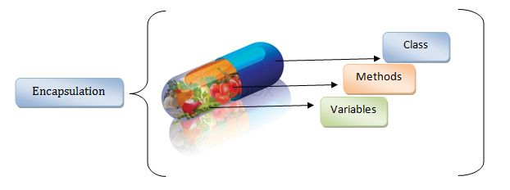
- Encapsulation:
Core Idea
Encapsulation means bundling data and methods inside a class and restricting direct access to internal data.
The object controls how its data is accessed or modified.
Purpose
  - Protect internal state
  - Prevent accidental misuse
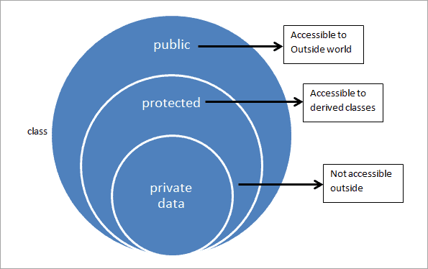
  - Improve reliability
Key Points
  - Use private variables
  - Provide controlled access via methods
  - Hide implementation details
Simple Example:
class Account:
def __init__(self, balance):
self.__balance = balance
def deposit(self, amount):
self.__balance += amount
2. Abstraction:

Core Idea : Abstraction exposes only essential features and hides internal complexity. Users interact with an interface, not implementation.
Purpose
- Reduce system complexity
- Improve usability
- Focus on what an object does
Key Points
- Define clear interfaces
- Hide internal logic
- Separate usage from implementation
Simple Example :
from abc import ABC, abstractmethod
class Shape(ABC):
@abstractmethod
def area(self):
pass
3. Inheritance:
Core Idea : Inheritance allows a class to reuse properties and behavior from another class.
It creates a hierarchical relationship.

Purpose
- Promote code reuse
- Reduce duplication
- Build logical class hierarchies
Key Points
- Base class → shared behavior
- Derived class → specialized behavior
- Supports extension without rewriting
Simple Example (Python)
class Animal:
def move(self):
print("Moving")
class Bird(Animal):
def fly(self):
print("Flying")
4. Polymorphism:
Polymorphism is a concept in Object-Oriented Programming where one interface or method name can behave differently depending on the object using it.
In simple terms, the same action gives different results based on the situation.
The word polymorphism means “many forms.”
In OOP, different objects can use the same method name, but each object performs that method in its own way.
Key Points (Exam-friendly)
- One method name → many behaviors
- Achieved using method overriding or interfaces
- Makes programs flexible and easy to extend
- Allows objects to be used interchangeably
Simple Example
A method called sound():
- Dog object → “Bark”
- Cat object → “Meow”
The method name is the same, but behavior is different. This is polymorphism.

Four Pillars of OOP Working Together
Pillar | Main Goal | Effect on Software | Funny Real-World Example
Encapsulation | Protect data by hiding it | Keeps data safe and prevents misuse | Like a chocolate box locked in a drawer so siblings cannot steal it without permission
Abstraction | Hide complexity and show only essentials | Makes systems easier to use and understand | Driving a car without knowing how the engine works — you press pedal, car goes zoom
Inheritance | Reuse existing features | Saves time and reduces duplicate code | A child inheriting dad’s height and mom’s nose without redesigning the whole human
Polymorphism | One interface, many behaviors | Makes code flexible and extensible | Saying “run” — humans run on legs or computers run programs, noses run during cold

Encapsulation in OOP:
Encapsulation: Encapsulation is an OOP principle where data (variables) and methods (functions) are bundled together inside a class, and direct access to internal data is restricted.
It is also called data hiding.
Only controlled access is allowed through public methods.
Exam Definition: Encapsulation is the process of wrapping data and methods into a single unit (class) and restricting direct access to the internal data to protect it from unauthorized modification.

Core Idea in Simple Words
Encapsulation means:
- Keep important data private
- Allow access only through safe methods
- Prevent outsiders from directly changing internal values
Think of it as a protective capsule around data.

Why Encapsulation is Important
1. Data Protection
Prevents accidental or unauthorized changes.
2. Controlled Access
You decide how data can be modified.
3. Better Maintenance
Changes inside a class do not affect outside code.
4. Improved Security
Sensitive information remains hidden.

Real-Life Example
A bank ATM machine:
- You cannot access bank server data directly
- You must use ATM interface (withdraw, deposit)
The ATM controls how data is accessed.
That is encapsulation.

Encapsulation in Python (Simple Example)
class BankAccount:
def __init__(self, balance):
self.__balance = balance # private variable

def deposit(self, amount):
if amount > 0:
self.__balance += amount

def get_balance(self):
return self.__balance
Explanation
- __balance is private
- It cannot be accessed directly from outside
- Only methods control changes

Key Features of Encapsulation
Feature | Meaning
Data hiding | Internal data is protected
Controlled access | Methods manage interaction
Single unit | Data + methods inside class
Security | Prevents misuse

Encapsulation for Interview Explanation
Encapsulation is a mechanism of bundling data and behavior inside a class and restricting direct access to the internal state of an object. It ensures data safety by exposing only necessary interfaces and hiding implementation details. This improves modularity, maintainability, and security of software systems. In real-world applications, encapsulation allows controlled interaction with objects, reducing bugs and unintended side effects.

How Encapsulation is Achieved in Python
Python uses naming conventions:
Access Level | Syntax | Meaning | Syntax
Public | variable | Accessible anywhere | Variable name
Protected | _variable | Internal use (convention) | Variable name with single underscore
Private | __variable | Restricted access | Variable name with double underscore

Advantages of Encapsulation
- Protects sensitive data
- Reduces system complexity
- Makes debugging easier
- Improves code organization
- Supports modular programming

Disadvantages:
- Slight increase in code length
- Requires careful class design

One-Line Memory Trick : Encapsulation = Data hiding + Controlled access
Data Abstraction in OOP
Abstraction in OOP:
Abstraction is an OOP principle where only essential features of an object are shown to the user, while internal implementation details are hidden.
It focuses on what an object does, not how it does it.
It is also called implementation hiding.
Users interact with a simple interface without knowing internal complexity.
Exam Definition:
Abstraction is the process of hiding internal implementation details and showing only the essential features of an object to reduce complexity and improve usability.

Core Idea in Simple Words
Abstraction means:
• Show only important features
• Hide complex internal working
• Provide a simple interface to use
Think of it as a remote control — you press buttons without knowing the internal electronics.

Why Abstraction is Important
1. Reduces Complexity
Users deal with simple interfaces instead of complex logic.
2. Improves Readability
Code becomes easier to understand.
3. Increases Maintainability
Internal changes do not affect users.
4. Encourages Modular Design
Each component has a clear role.

Real-Life Example
A car driving system:
• You use steering wheel and pedals
• You do not see engine or transmission working
The car hides internal complexity and shows only controls.
That is abstraction.

Abstraction in Python (Simple Example)
from abc import ABC, abstractmethod

class Shape(ABC):
@abstractmethod
def area(self):
pass
class Circle(Shape):
def __init__(self, r):
self.r = r
def area(self):
return 3.14 * self.r * self.r
Explanation
• Shape is an abstract class
• It defines a method without implementation
• Circle provides the actual working
• Users only call area() without knowing internal formula

Key Features of Abstraction
Feature | Meaning
Interface focus | Shows only necessary features
Implementation hiding | Internal logic is hidden
Simplicity | Reduces user complexity
Modularity | Clear separation of roles

Abstraction for Interview Explanation
Abstraction is an OOP concept that hides implementation details and exposes only essential functionality through interfaces. It simplifies complex systems by separating what an object does from how it works. This improves maintainability, scalability, and readability, allowing developers to change internal logic without affecting users of the object.

How Abstraction is Achieved in Python
Python achieves abstraction using:
Method | Description
Abstract classes | Using abc module
Interfaces (via abstract methods) | Method definitions without body
Functions and modules | Hide internal implementation

Advantages of Abstraction
• Reduces system complexity
• Improves code readability
• Makes maintenance easier
• Enhances modular design
• Supports scalable architecture

Disadvantages
• Can increase design effort
• Requires careful planning

One-Line Memory Trick : Abstraction = Hide complexity + Show essentials
Inheritance in OOP
Inheritance is an OOP principle where one class (child/subclass) acquires properties and methods of another class (parent/superclass).
It allows creation of new classes using existing classes.
The child class can reuse, extend, or modify the behavior of the parent class.
Exam Definition:
Inheritance is the mechanism by which one class derives the properties and behavior of another class, enabling code reuse and hierarchical classification.

Core Idea in Simple Words
Inheritance means:
• Create a new class from an existing class
• Reuse existing features
• Add new or specialized behavior

Why Inheritance is Important
1. Code Reusability
Avoids rewriting the same code.
2. Logical Hierarchy
Creates parent–child relationships.
3. Easy Extension
New features can be added without changing old code.
4. Better Maintenance
Common code exists in one place.

Real-Life Example
A Vehicle system:
• Vehicle → common features (speed, fuel)
• Car and Bike inherit from Vehicle
• Each adds its own behavior
That is inheritance.
There are five main types of inheritance:
Type | Meaning
Single inheritance | One child inherits from one parent
Multiple inheritance | One child inherits from multiple parents
Multilevel inheritance | Inheritance chain (grandparent → parent → child)
Hierarchical inheritance | Multiple children inherit from one parent
Hybrid inheritance | Combination of multiple inheritance types
Key Features of Inheritance
Feature | Meaning
Code reuse | Shared behavior from parent
Extensibility | Add new features easily
Hierarchy | Organized class structure
Method overriding | Child can change parent behavior

Inheritance for Interview Explanation
Inheritance is an OOP mechanism that allows a class to acquire properties and methods from another class. It promotes code reuse, reduces redundancy, and establishes hierarchical relationships between classes. Inheritance enables extension of existing functionality and supports polymorphism by allowing method overriding.

Advantages of Inheritance
• Reduces code duplication
• Improves reusability
• Supports extensibility
• Simplifies maintenance

Disadvantages
• Tight coupling between classes
• Improper design can increase complexity
One-Line Memory Trick : Inheritance = Reuse + Extend existing class
Single Inheritance:
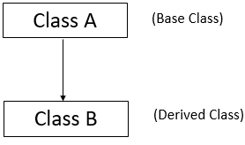
Single inheritance is a type of inheritance where one child class inherits from only one parent class.
The child class gets all accessible properties and methods of the parent class and can also add its own features.
Exam Definition: Single inheritance is a mechanism in which a subclass inherits properties and behavior from a single superclass, enabling code reuse and extension.
Core Idea in Simple Words
Single inheritance means:
• One parent class
• One child class
• Child reuses parent features
• Child can add new behavior
Think of it as a student learning from one teacher.
Why Single Inheritance is Important
1. Simple Code Reuse : Child class uses parent functionality.
2. Clear Structure : Easy to understand parent–child relationship.
3. Easy Maintenance : Common logic stays in parent class.

Real-Life Example
A Person → Student relationship:
• Person has name and age
• Student inherits these features
• Student adds roll number and grade
That is single inheritance.
Single Inheritance in Python:
class Person:
def __init__(self, name):
self.name = name
def show(self):
print("Name:", self.name)

class Student(Person):
def __init__(self, name, roll):
super().__init__(name)
self.roll = roll
def display(self):
print("Roll No:", self.roll)
Explanation
• Student inherits from Person
• super() calls parent constructor
• Student uses parent data and adds new data
Single Inheritance for Interview Explanation
Single inheritance is a form of inheritance where a subclass derives from one superclass and reuses its functionality. It promotes clean design, reduces duplication, and establishes a straightforward parent–child hierarchy. It is commonly used to extend base functionality while keeping the system simple and maintainable.
Advantages of Single Inheritance
• Simple and easy to implement
• Promotes code reuse
• Improves maintainability
• Clear hierarchy
Disadvantages
• Limited flexibility compared to multiple inheritance

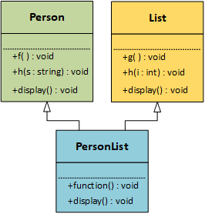
Multiple Inheritance:
Multiple inheritance is a type of inheritance where one child class inherits from more than one parent class.
- The child class combines features from all parent classes and can also add its own behavior.
Exam Definition: Multiple inheritance is a mechanism in which a subclass inherits properties and behavior from two or more superclasses, allowing combination of functionalities from multiple sources.

Core Idea in Simple Words
Multiple inheritance means:
• One child class
• Two or more parent classes
• Child combines features from all parents
• Child can add its own behavior
Think of it as a student learning from multiple teachers.

Why Multiple Inheritance is Important
- Combining Features: Child class can use abilities from multiple parents.
- Code Reuse: Reduces duplication by sharing logic.
- Flexible Design: Supports complex real-world modeling.

Real-Life Example
A Smart Device:
• Phone class → calling feature
• Camera class → photo feature
• SmartPhone inherits both
It can call and take photos.
That is multiple inheritance.

Multiple Inheritance in Python (Simple Example)
class Phone:
def call(self):
print("Calling...")
class Camera:
def click(self):
print("Photo taken")
class SmartPhone(Phone, Camera):
pass
Explanation
• SmartPhone inherits from Phone and Camera
• It can use both call() and click() methods
• Child combines parent features

Multiple Inheritance for Interview Explanation
Multiple inheritance allows a subclass to inherit behavior and properties from more than one superclass. It enables combining functionalities from different classes into a single class. While powerful, it must be used carefully to avoid ambiguity and complexity in design.
Advantages of Multiple Inheritance
• Combines features from multiple classes
• Promotes high code reuse
• Supports flexible and rich design
Disadvantages
• Can create ambiguity (diamond problem)
• Increases design complexity

Multilevel Inheritance:
Multilevel inheritance is a type of inheritance where a class inherits from another class, which itself inherits from another class, forming a chain.
It creates a grandparent → parent → child relationship.
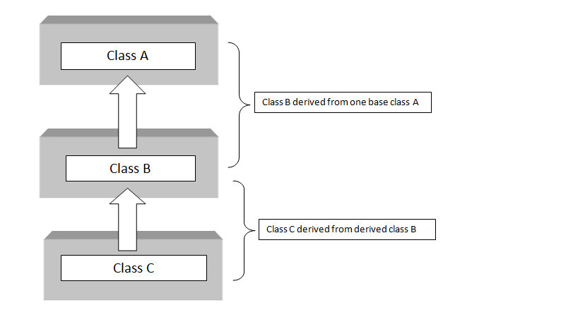
Exam Definition:
Multilevel inheritance is a mechanism in which a subclass inherits from a superclass that is itself derived from another superclass, forming an inheritance chain.
Core Idea in Simple Words
Multilevel inheritance means:
• Inheritance happens in levels
• One class becomes parent of another
• Features pass down the chain
• Each level can add new behavior
Think of it as knowledge passed from grandfather → father → child.
Why Multilevel Inheritance is Important
- Step-by-step Reuse: Features are reused across levels.
- Logical Progression: Represents gradual specialization.
- Better Organization: Creates layered class structure.

Real-Life Example
A Living Being hierarchy:
• LivingBeing → basic life features
• Animal inherits LivingBeing
• Dog inherits Animal
Dog gets features from both Animal and LivingBeing.
That is multilevel inheritance.
Multilevel Inheritance in Python (Simple Example)
class LivingBeing:
def breathe(self):
print("Breathing")

class Animal(LivingBeing):
def eat(self):
print("Eating")
class Dog(Animal):
def bark(self):
print("Barking")
Explanation
• Animal inherits from LivingBeing
• Dog inherits from Animal
• Dog can use all methods from upper levels

Multilevel Inheritance for Interview Explanation
Multilevel inheritance is a hierarchical inheritance structure where a class derives from another derived class. It enables gradual extension of functionality and supports organized layering of behavior. It is useful for modeling real-world hierarchies and improving code reuse.

Advantages of Multilevel Inheritance
• Promotes layered code reuse
• Models real-world hierarchies well
• Improves organization
Disadvantages
• Deep inheritance chains can increase complexity
Hierarchical Inheritance

Hierarchical Inheritance: Hierarchical inheritance is a type of inheritance where multiple child classes inherit from a single parent class.
Each child class gets common features from the parent and can add its own specialized behavior.
Exam Definition:
Hierarchical inheritance is a mechanism in which multiple subclasses inherit properties and behavior from a single superclass, allowing shared functionality across several derived classes.
Core Idea in Simple Words
Hierarchical inheritance means:
• One parent class
• Multiple child classes
• All children reuse parent features
• Each child adds its own behavior
Think of it as one teacher teaching many students.
Why Hierarchical Inheritance is Important
- Shared Functionality: Common features are reused by many classes.
- Reduced Duplication: Parent code is written once.
- Specialization: Each child focuses on its own role.
Real-Life Example
An Employee system:
• Employee → common features (name, salary)
• Manager and Engineer inherit Employee
• Each adds its own responsibilities
That is hierarchical inheritance.
Hierarchical Inheritance in Python (Simple Example)
class Employee:
def __init__(self, name):
self.name = name
def show(self):
print("Employee:", self.name)
class Manager(Employee):
def role(self):
print("Manages team")
class Engineer(Employee):
def role(self):
print("Builds software")
Explanation
• Manager and Engineer inherit from Employee
• Both reuse parent features
• Each child adds its own behavior
Hierarchical Inheritance for Interview Explanation
Hierarchical inheritance occurs when multiple subclasses inherit from a single superclass. It enables sharing of common functionality across several related classes while allowing each subclass to specialize its behavior. This structure improves reuse and organization.

Advantages of Hierarchical Inheritance
• Efficient code reuse
• Clear shared structure
• Easy specialization
Disadvantages
• Changes in parent affect all children

Hybrid Inheritance:
Hybrid Inheritance: Hybrid inheritance is a type of inheritance that combines two or more types of inheritance (such as multiple, multilevel, and hierarchical inheritance) in a single system.
It is used to model complex real-world relationships.
Exam Definition: Hybrid inheritance is a mechanism that combines multiple forms of inheritance to create flexible and complex class relationships.
Core Idea in Simple Words
Hybrid inheritance means:
• Combination of inheritance types
• Complex parent–child relationships
• Reuse features from many sources
• Flexible class structure
Think of it as a student learning from school, parents, and online courses at the same time.
Why Hybrid Inheritance is Important
- Models Complex Systems: Suitable for large applications.
- Maximum Code Reuse: Combines features from many classes.
- Flexible Design: Supports advanced architecture.
Real-Life Example
A Smart Electric Car system:
• Vehicle → base features
• ElectricSystem inherits Vehicle
• SmartFeatures inherits Vehicle
• SmartElectricCar inherits both
It combines all abilities.
That is hybrid inheritance.
Hybrid Inheritance in Python
class Vehicle:
def move(self):
print("Moving")

class ElectricSystem(Vehicle):
def charge(self):
print("Charging")

class SmartFeatures(Vehicle):
def autopilot(self):
print("Auto driving")

class SmartElectricCar(ElectricSystem, SmartFeatures):
pass
Explanation
• ElectricSystem and SmartFeatures inherit Vehicle
• SmartElectricCar inherits both
• Child combines all features
Hybrid Inheritance for Interview Explanation
Hybrid inheritance is a combination of different inheritance types used to design complex class structures. It enables flexible reuse of functionality but must be carefully managed to avoid ambiguity and maintain clarity in design.
Advantages of Hybrid Inheritance
• Highly flexible design
• Maximum code reuse
• Suitable for complex systems
Disadvantages
• Can become complex and hard to manage

Method Overriding:
Method overriding is a concept in inheritance where a child class provides its own implementation of a method that already exists in the parent class.
The child method has the same name and parameters, but different behavior.
Exam Definition:
Method overriding is a mechanism in which a subclass redefines a method of its superclass to provide a specific implementation.
Core Idea in Simple Words
Method overriding means:
• Parent and child have the same method name
• Child changes the behavior
• Child version runs instead of parent version
Think of it as a child improving a family recipe with their own style.
Why Method Overriding is Important
- Customization: Child classes adapt parent behavior.
- Supports Polymorphism: Same interface, different behavior.
- Flexibility: Programs become easier to extend.
Real-Life Example
An Animal sound system:
• Animal class → sound() method
• Dog overrides sound() → Bark
• Cat overrides sound() → Meow
Each animal gives its own sound.
That is method overriding.
Method Overriding in Python (Simple Example)
class Animal:
def sound(self):
print("Animal makes sound")

class Dog(Animal):
def sound(self):
print("Dog barks")
Explanation
• Dog inherits from Animal
• It overrides the sound() method
• Dog’s version runs instead of parent version
Rules of Method Overriding
Rule | Meaning
Same method name | Child method name must match parent
Same parameters | Method signature should be compatible
Inheritance required | Overriding happens only in inheritance

Method Overriding for Interview Explanation
Method overriding is an OOP feature where a subclass provides a specialized implementation of a method already defined in its superclass. It enables runtime polymorphism by allowing different classes to respond differently to the same method call while maintaining a common interface.
Advantages of Method Overriding
• Allows behavior customization
• Supports polymorphism
• Improves flexibility
• Encourages extensible design

Disadvantages
• Can increase complexity if overused

One-Line Memory Trick: Method overriding = Same method name, new behavior

Method Overloading:
Method overloading is a concept where multiple methods have the same name but different parameters in the same class.
Each method performs a similar task but works with different inputs.
Exam Definition:
Method overloading is a mechanism in which multiple methods share the same name but differ in the number or type of parameters, enabling compile-time polymorphism.

Important Note (Python-Specific)
Python does not support traditional method overloading like Java or C++.
If multiple methods with the same name are written, the last one overrides the previous ones.
In Python, overloading is achieved using:
- Default arguments
- Variable-length arguments (*args)
- Conditional logic
Core Idea in Simple Words
Method overloading means:
• Same method name
• Different number or type of inputs
• Different behavior based on input
Think of it as one remote button doing different actions depending on how you press it.
Why Method Overloading is Important
- Improves readability: Same name for related tasks.
- Convenience: One interface handles many input types.
- Cleaner design: Reduces unnecessary method names.
Real-Life Example
A Calculator:
• add(a, b) → adds two numbers
• add(a, b, c) → adds three numbers
Same action name, different inputs.
That is method overloading.
Method Overloading in Python (Simple Example)
Using Default Arguments
class Calculator:
def add(self, a, b, c=0):
return a + b + c
Using Variable Arguments
class Calculator:
def add(self, *numbers):
return sum(numbers)
Explanation
• Same method handles different inputs
• Behavior changes based on arguments
• Simulates overloading in Python

Method Overloading for Interview Explanation
Method overloading is a form of compile-time polymorphism where multiple methods share the same name but differ in parameters. Python does not support true method overloading, but similar behavior can be implemented using default parameters or variable-length arguments to handle multiple input cases within a single method.

Advantages of Method Overloading
• Improves code readability
• Provides flexible interfaces
• Reduces method name clutter
Disadvantages
• Can reduce clarity if overused
One-Line Memory Trick : Method overloading = Same name, different inputs

super() Keyword in Inheritance
super() Keyword:
The super() keyword is used in inheritance to call methods or constructors of the parent class from the child class.
It allows the child class to reuse and extend parent functionality without rewriting code.
Exam Definition:
super() is a built-in function used to access methods and constructors of a superclass from a subclass.
Core Idea in Simple Words
super() means:
• Call parent class method
• Reuse parent constructor
• Extend parent behavior safely
Think of it as asking your parent for help before adding your own work.

Why super() is Important
- Avoids Code Duplication: Reuses parent logic.
- Ensures Proper Initialization: Calls parent constructor.
- Supports Clean Inheritance: Maintains hierarchy order.

Real-Life Example
A Company Employee system:
• Base employee sets name and salary
• Manager adds department
• Manager first uses base setup, then adds extra details
That is how super() works.

super() in Python (Simple Example)
class Person:
def __init__(self, name):
self.name = name
class Student(Person):
def __init__(self, name, roll):
super().__init__(name)
self.roll = roll
Explanation
• Student calls parent constructor using super()
• Parent initializes common data
• Child adds its own data

Using super() with Methods
class Animal:
def sound(self):
print("Animal sound")
class Dog(Animal):
def sound(self):
super().sound()
print("Dog barks")
Explanation
• Parent method runs first
• Child extends behavior

super() for Interview Explanation
The super() keyword is used to invoke parent class methods and constructors from a subclass. It supports code reuse and proper initialization in inheritance hierarchies. It is especially important in multiple inheritance, where Python uses method resolution order (MRO) to determine which parent method to call.

Advantages of super()
• Promotes code reuse
• Prevents duplication
• Maintains clean inheritance flow
• Supports multiple inheritance
Disadvantages
• Can be confusing in complex hierarchies
One-Line Memory Trick : super() = Call parent before extending

Method Resolution Order (MRO):
Method Resolution Order (MRO) is the rule Python follows to decide the order in which classes are searched when executing a method in inheritance, especially in multiple inheritance.
It determines which method runs first when multiple parent classes have the same method name.
Exam Definition:
Method Resolution Order (MRO) is the sequence in which Python searches classes in an inheritance hierarchy to resolve method calls.

Core Idea in Simple Words
MRO means:
• Python searches classes in a fixed order
• It finds the first matching method
• That method gets executed
Think of it as following a priority list to find the right answer.
Why MRO is Important
- Avoids Ambiguity: Prevents confusion in multiple inheritance.
- Ensures Predictable Behavior: Fixed search order.
- Solves Diamond Problem: Handles shared parent classes safely.
Real-Life Example
A family advice system:
• You ask parents and grandparents the same question
• You follow a fixed order of asking
• The first clear answer is accepted
That order is like MRO.

MRO in Python (Simple Example)
class A:
def show(self):
print("Class A")
class B(A):
pass
class C(A):
pass
class D(B, C):
pass
obj = D()
obj.show()
Explanation
• Python searches in order: D → B → C → A
• First matching method is used
• This order is defined by MRO
How to Check MRO in Python
print(D.mro())
or
help(D)
This prints the class search order.

Key Rule Behind MRO
Python uses the C3 Linearization algorithm to:
• Maintain consistent hierarchy
• Respect inheritance order
• Avoid repetition
MRO for Interview Explanation
Method Resolution Order is the algorithm Python uses to determine the order in which classes are searched for a method in an inheritance hierarchy. It ensures consistent and predictable behavior in multiple inheritance by following C3 linearization, which resolves ambiguity and maintains logical class precedence.
Advantages of MRO
• Prevents method conflicts
• Ensures stable inheritance behavior
• Supports complex hierarchies
Disadvantages
• Can be difficult to understand in deep hierarchies
One-Line Memory Trick : MRO = Fixed search order for methods

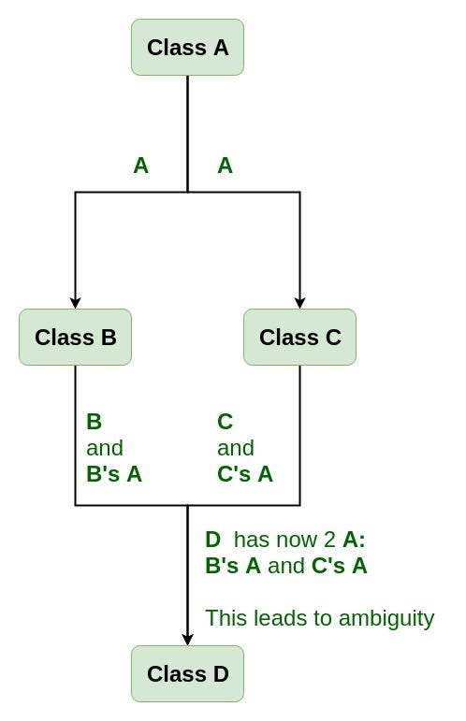
Diamond Problem in Inheritance

Diamond Problem: The Diamond Problem is a situation in multiple inheritance where two parent classes inherit from the same base class, and a child class inherits from both parents.
This creates a diamond-shaped class structure.
The problem occurs when all classes contain the same method, and Python must decide which method to execute.
Exam Definition: The Diamond Problem is an ambiguity issue in multiple inheritance where a class inherits the same method from multiple parent paths, creating confusion about which method should be called.
Core Idea in Simple Words
Diamond problem means:
• One base class at the top
• Two classes inherit from it
• A child inherits from both
• Same method exists in all paths
• Confusion about which method to run
Think of it as getting the same advice from two parents who learned it from the same grandparent.
Why Diamond Problem Happens
- Duplicate inheritance paths
- Method name conflicts
- Ambiguity in method selection
Diamond Problem in Python (Simple Example)
class A:
def show(self):
print("Class A")
class B(A):
def show(self):
print("Class B")
class C(A):
def show(self):
print("Class C")
class D(B, C):
pass
obj = D()
obj.show()
Explanation
• D inherits from both B and C
• Both override show()
• Python follows MRO: D → B → C → A
• First match is used → Class B runs
How Python Solves the Diamond Problem
Python solves it using Method Resolution Order (MRO) and C3 Linearization:
• Python creates a fixed search order
• Each class is visited only once
• The first matching method is executed
• No duplicate calls happen
You can check order using:
print(D.mro())
Diamond Problem for Interview Explanation
The Diamond Problem occurs in multiple inheritance when a subclass inherits from two classes that share a common parent, leading to ambiguity in method resolution. Python resolves this issue using Method Resolution Order based on C3 linearization, which ensures a consistent and conflict-free method lookup path.

Advantages of Python’s Solution
• Removes ambiguity
• Prevents duplicate execution
• Ensures predictable behavior
Disadvantages
• Can be confusing in complex hierarchies
One-Line Memory Trick : Diamond problem = Multiple paths, one method conflict

Polymorphism in OOP:
Polymorphism is an OOP principle where the same method or interface can behave differently depending on the object that calls it.
It allows one interface to represent many forms of behavior.
The word polymorphism means “many forms.”
Exam Definition: Polymorphism is the ability of different objects to respond differently to the same method call, enabling one interface to have multiple implementations.

Core Idea in Simple Words
Polymorphism means:
• Same method name
• Different objects
• Different behavior
Think of it as the same command producing different actions depending on who receives it.

Types of Polymorphism
There are two main types:
Type | Also Called | When It Happens
Compile-time polymorphism | Method overloading | Decided during coding
Runtime polymorphism | Method overriding | Decided during execution

Why Polymorphism is Important
- Flexibility: Objects can be used interchangeably.
- Extensibility: Easy to add new behaviors.
- Cleaner Code: Common interface for many objects.

Real-Life Example
An Animal action system:
• Dog → sound() → Bark
• Cat → sound() → Meow
• Cow → sound() → Moo
Same method, different outputs.
That is polymorphism.

Polymorphism in Python (Simple Example)
class Dog:
def sound(self):
print("Bark")
class Cat:
def sound(self):
print("Meow")
animals = [Dog(), Cat()]
for a in animals:
a.sound()
Explanation
• Loop calls same method name
• Each object behaves differently
• Python chooses correct implementation

Polymorphism for Interview Explanation
Polymorphism is an OOP concept where a common interface is used to represent different behaviors. It allows objects of different classes to be treated uniformly while executing their specific implementations. Polymorphism improves flexibility and extensibility in software design.

Advantages of Polymorphism
• Increases flexibility
• Improves scalability
• Simplifies code structure
• Supports extensible design
Disadvantages
• Can increase debugging complexity
One-Line Memory Trick: Polymorphism = One interface, many behaviors

Runtime Polymorphism in OOP
Runtime Polymorphism: Runtime polymorphism is a type of polymorphism where the method to be executed is decided during program execution (runtime), not during coding.
It is mainly achieved through method overriding and inheritance.
Python decides which method to call based on the object type at runtime.
Exam Definition: Runtime polymorphism is a mechanism where a method call is resolved during execution based on the object invoking it, typically achieved using method overriding.
Core Idea in Simple Words
Runtime polymorphism means:
• Same method name
• Different object types
• Decision made at runtime
• Correct method runs automatically
Think of it as calling a person by name and they respond in their own voice.

How Runtime Polymorphism Works
Runtime polymorphism works using:
- Inheritance — child classes share a common interface
- Method overriding — each child defines its own behavior
- Dynamic dispatch — Python selects the correct method at runtime
This process is called dynamic method dispatch.

Real-Life Example
A payment system:
• CreditCard → pay() processes card payment
• UPI → pay() processes digital payment
• Cash → pay() handles cash
Same method name pay(), different behavior.

Runtime Polymorphism in Python (Example)
class Payment:
def pay(self):
print("Processing payment")
class CreditCard(Payment):
def pay(self):
print("Paid using Credit Card")

class UPI(Payment):
def pay(self):
print("Paid using UPI")
payments = [CreditCard(), UPI()]

for p in payments:
p.pay()
Explanation
• Loop calls the same method pay()
• Python checks object type at runtime
• Correct overridden method runs

Key Characteristics
Characteristic | Meaning
Dynamic binding | Method chosen at runtime
Method overriding | Child customizes behavior
Common interface | Shared method name
Flexibility | Objects used interchangeably

Runtime vs Compile-Time Polymorphism
Feature | Runtime Polymorphism | Compile-Time Polymorphism
Decision time | During execution | During coding
Achieved by | Method overriding | Method overloading
Flexibility | High | Moderate
Python support | Fully supported | Simulated only

Runtime Polymorphism for Interview Explanation
Runtime polymorphism is achieved through method overriding, where the method call is resolved during execution based on the object type. It uses dynamic dispatch to ensure that the correct implementation runs. This allows flexible and extensible system design by enabling objects to share a common interface while providing specialized behavior.

Advantages of Runtime Polymorphism
• High flexibility
• Easy extensibility
• Cleaner and reusable code
• Supports scalable architecture
Disadvantages
• Slight performance overhead
• Can complicate debugging in large systems

One-Line Memory Trick: Runtime polymorphism = Decide method during execution
Abstract Classes & Interfaces in OOP
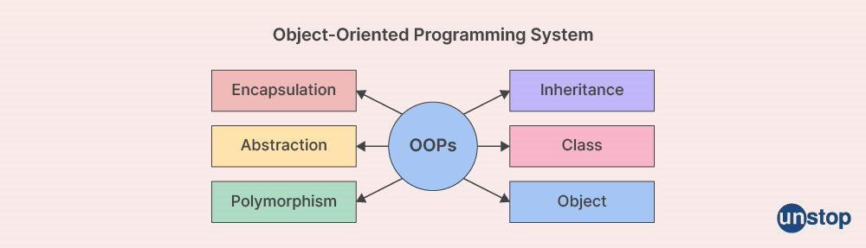
Abstract Class: An abstract class is a class that cannot be instantiated directly and is designed to be inherited by other classes.
It contains:
- Abstract methods (without implementation)
- Concrete methods (with implementation)
Child classes must implement the abstract methods.
Exam Definition: An abstract class is a class that contains one or more abstract methods and cannot be instantiated, serving as a blueprint for subclasses.
Core Idea in Simple Words
Abstract class means:
• Blueprint for other classes
• Defines required methods
• Cannot create objects directly
• Forces child classes to implement methods
Think of it as a rulebook that children must follow.
Abstract Class in Python (Example)
from abc import ABC, abstractmethod

class Shape(ABC):
@abstractmethod
def area(self):
pass
class Circle(Shape):
def __init__(self, r):
self.r = r
def area(self):
return 3.14 * self.r * self.r
Explanation
• Shape is an abstract class
• area() must be implemented by child classes
• Circle provides actual implementation
Advantages of Abstract Classes
• Enforces method implementation
• Provides partial implementation
• Supports consistent design
Disadvantages
• Adds design complexity

Interfaces in OOP
Interface:
An interface is a structure that contains only method declarations and no implementation.
It defines what a class must do, not how.
Python does not have a strict interface keyword, but interfaces are created using abstract classes with only abstract methods.
Exam Definition: An interface is a contract that defines a set of methods a class must implement without providing their implementation.
Core Idea in Simple Words
Interface means:
• A contract for classes
• Only method signatures
• No implementation
• Forces uniform behavior
Think of it as a job contract describing responsibilities.

Interface in Python (Example)
from abc import ABC, abstractmethod
class PaymentInterface(ABC):
@abstractmethod
def pay(self):
pass
class UPI(PaymentInterface):
def pay(self):
print("Paid using UPI")
Explanation
• Interface defines required method
• Child class must implement it
• Ensures uniform behavior

Abstract Class vs Interface
Feature | Abstract Class | Interface
Methods | Abstract + concrete | Only abstract
Implementation | Partial allowed | None
Purpose | Base class with shared code | Contract for behavior
Instantiation | Not allowed | Not allowed

Abstract Classes & Interfaces for Interview Explanation
Abstract classes provide a base blueprint with partial implementation, while interfaces define a contract that enforces method implementation. They promote consistent architecture, loose coupling, and scalable design by separating what a class should do from how it does it.
When to Use Which
Situation | Use
Need shared base logic | Abstract class
Need strict behavior contract | Interface

One-Line Memory Trick
Abstract class = Blueprint with some code
Interface = Contract with no code

Composition vs Inheritance:
In Python OOP, composition and inheritance are two ways to reuse code and build relationships between classes.
- Inheritance = “is-a” relationship
- Composition = “has-a” relationship
Both are important design tools.
Exam Definition: Inheritance creates an “is-a” relationship where a subclass extends a superclass, while composition creates a “has-a” relationship where a class contains objects of other classes to reuse functionality.

Core Idea in Simple Words
Inheritance
Inheritance means:
• Child class extends parent class
• Reuses and modifies parent behavior
• Strong coupling between classes
Think: Dog is an Animal
Composition
Composition means:
• One class contains another class as an member
• Reuses functionality by delegation
• Loose coupling between classes
Think: Car has an Engine
Inheritance in Python (Example)
class Animal:
def speak(self):
print("Animal speaks")
class Dog(Animal):
def bark(self):
print("Dog barks")
Explanation
• Dog inherits Animal
• Dog gets parent behavior automatically
• Strong parent–child relationship
Composition in Python (Example)
class Engine:
def start(self):
print("Engine starts")
class Car:
def __init__(self):
self.engine = Engine()

def drive(self):
self.engine.start()
print("Car is moving")
Explanation
• Car contains Engine object
• Car uses Engine behavior
• No inheritance involved
Key Differences
Feature | Inheritance | Composition
Relationship | is-a | has-a
Coupling | Tight | Loose
Flexibility | Less flexible | More flexible
Code reuse | Through extension | Through delegation
Change impact | Parent changes affect child | Minimal impact
Design style | Hierarchical | Modular

When to Use Inheritance
Use inheritance when:
• There is a true “is-a” relationship
• You want to extend behavior
• Classes share strong logical hierarchy
Example: Student is a Person

When to Use Composition
Use composition when:
• You want flexible design
• You want to reuse functionality
• Relationship is “has-a”
Example: Car has an Engine

Composition vs Inheritance for Interview Explanation
Inheritance models an “is-a” relationship and allows subclasses to extend base classes, but it creates tight coupling. Composition models a “has-a” relationship by embedding objects inside other objects, promoting flexibility and loose coupling. Modern software design often prefers composition over inheritance for better maintainability.
Advantages of Composition over Inheritance
• More flexible design
• Easier to modify and extend
• Reduces dependency
• Encourages modular architecture
Disadvantages of Composition
• Requires more object coordination
One-Line Memory Trick
Inheritance = is-a relationship
Composition = has-a relationship

Object Relationships in OOP: Association, Aggregation, Composition
Association: Association is a general relationship where two classes are connected and can interact, but each class can exist independently.
It represents a uses-a relationship.
Exam Definition: Association is a relationship between two independent classes where objects can interact without owning each other.
Core Idea in Simple Words
Association means:
• Two objects are connected
• They work together
• Both can exist separately
Think of it as a teacher and a student — both exist independently.
Association in Python (Example)
class Teacher:
def teach(self):
print("Teaching")
class Student:
def __init__(self, teacher):
self.teacher = teacher

def learn(self):
self.teacher.teach()
Explanation
• Student uses Teacher
• Both can exist independently
Aggregation
Aggregation: Aggregation is a special form of association where one class contains another class, but both can exist independently.
It represents a weak has-a relationship.
Exam Definition:
Aggregation is a relationship where a class contains another class as a part, but the contained object can exist independently of the container.

Core Idea in Simple Words
Aggregation means:
• Whole–part relationship
• Part can exist without the whole
• Weak ownership
Think of it as a department and teachers — teachers can exist without a department.

Aggregation in Python (Example)
class Teacher:
def __init__(self, name):
self.name = name
class Department:
def __init__(self, teacher):
self.teacher = teacher
Explanation
• Department has Teacher
• Teacher can exist independently

Composition
Composition:
Composition is a strong form of aggregation where the contained object cannot exist independently of the container.
It represents a strong has-a relationship.
Exam Definition: Composition is a relationship where one class owns another class completely, and the lifetime of the contained object depends on the container.

Core Idea in Simple Words
Composition means:
• Strong ownership
• Part depends on the whole
• Destroy whole → part is destroyed
Think of it as a house and its rooms — rooms do not exist without the house.
Composition in Python (Example)
class Engine:
def start(self):
print("Engine starts")
class Car:
def __init__(self):
self.engine = Engine()
Explanation
• Car creates Engine internally
• Engine depends on Car
Key Differences Table
Feature | Association | Aggregation | Composition
Relationship type | Uses-a | Weak has-a | Strong has-a
Ownership | No ownership | Partial ownership | Full ownership
Lifetime dependency | Independent | Independent | Dependent
Coupling | Loose | Medium | Strong
Interview Explanation
Association is a general relationship where objects collaborate. Aggregation is a weak ownership relationship where parts can exist independently. Composition is a strong ownership relationship where parts depend on the whole. These relationships help design modular and maintainable object systems.
One-Line Memory Trick
Association = Works together
Aggregation = Has-a (independent)
Composition = Has-a (dependent)

SOLID Design Principles in OOP:
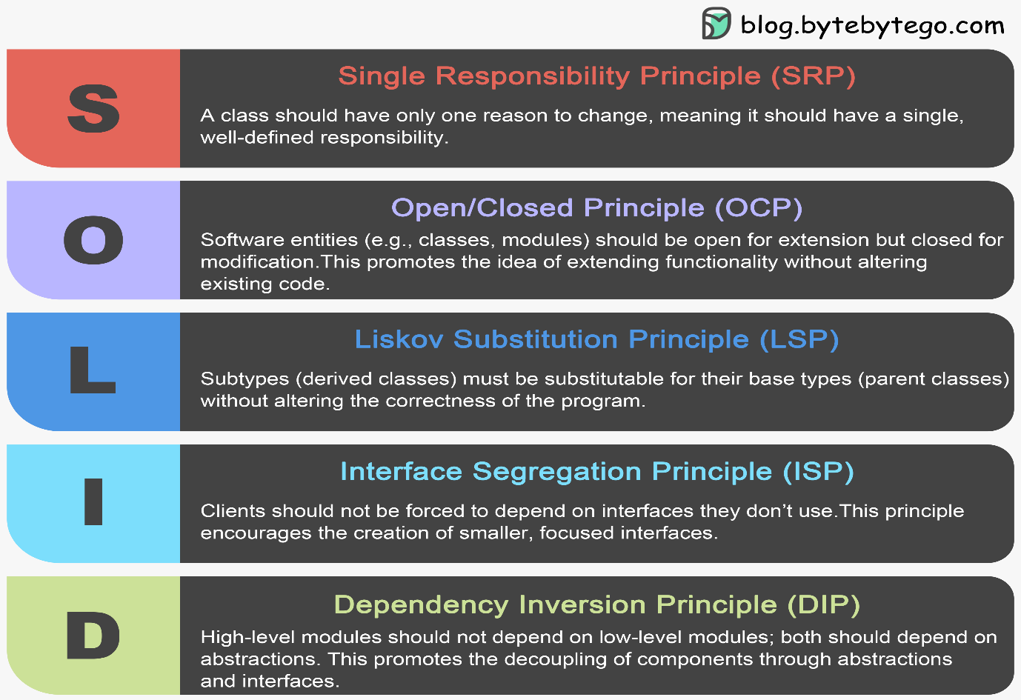
SOLID Principles:
SOLID is a set of five object-oriented design principles that help build software that is easy to maintain, extend, and understand.
SOLID stands for:
- S — Single Responsibility Principle (SRP)
- O — Open/Closed Principle (OCP)
- L — Liskov Substitution Principle (LSP)
- I — Interface Segregation Principle (ISP)
- D — Dependency Inversion Principle (DIP)
Exam Definition:
SOLID principles are five design guidelines that improve modularity, flexibility, and maintainability in object-oriented systems.

1. Single Responsibility Principle (SRP) - S
Definition : A class should have only one reason to change, meaning it should have one responsibility.
Core Idea
One class → one job.
Example (Python)
class Report:
def generate(self):
print("Generating report")
class ReportPrinter:
def print_report(self, report):
print("Printing report")
Why Important
- Easier debugging
- Better organization
- Reduced complexity
Memory Trick : SRP = One class, one job

2. Open/Closed Principle (OCP)
Definition : Software entities should be open for extension but closed for modification.
You should add new behavior without changing existing code.
Example (Python)
class Discount:
def apply(self, price):
pass

class StudentDiscount(Discount):
def apply(self, price):
return price * 0.8
Why Important
- Prevents breaking existing code
- Encourages extension
Memory Trick : OCP = Extend, don’t modify

3. Liskov Substitution Principle (LSP)
Definition : Child classes should be usable in place of parent classes without breaking behavior.
Example Idea : If Bird has fly(), then a Penguin subclass should not break expectations.

Bad design:
class Bird:
def fly(self):
pass
class Penguin(Bird):
def fly(self):
raise Exception("Penguins cannot fly")
Why Important
- Ensures reliable inheritance
- Prevents logical errors
Memory Trick : LSP = Child must behave like parent

4. Interface Segregation Principle (ISP)
Definition : Clients should not be forced to depend on methods they do not use.
Better to have many small interfaces than one large interface.
Example Idea
Instead of one big interface:
Worker → work(), eat(), sleep()
Split into smaller roles if needed.
Why Important
- Reduces unnecessary dependencies
- Improves flexibility
Memory Trick
ISP = Small, focused interfaces

5. Dependency Inversion Principle (DIP)
Definition :High-level modules should depend on abstractions, not concrete implementations.
Example (Python)
class Database:
def save(self):
pass
class App:
def __init__(self, db: Database):
self.db = db
Why Important
- Makes systems flexible
- Easier testing and replacement
Memory Trick
DIP = Depend on abstraction, not details

SOLID Summary Table
Principle | Main Rule | Goal
SRP | One class, one responsibility | Simplicity
OCP | Extend without modifying | Stability
LSP | Child behaves like parent | Reliability
ISP | Small focused interfaces | Flexibility
DIP | Depend on abstractions | Loose coupling

SOLID for Interview Explanation
SOLID principles are five object-oriented design guidelines that promote modular, maintainable, and extensible software. They reduce coupling, increase cohesion, and help developers build scalable systems by focusing on responsibility separation, safe inheritance, interface design, and abstraction-based dependencies.
One-Line Memory Trick : SOLID = Rules for clean and scalable OOP design
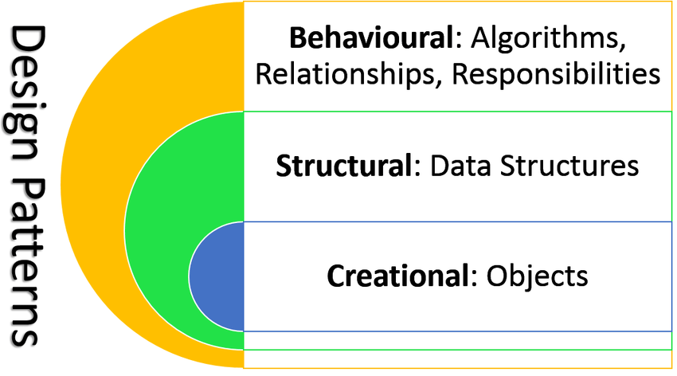
OOP Design Patterns
OOP Design Patterns: Design patterns are reusable solutions to common software design problems.
They are not finished code, but templates or strategies that guide how to structure classes and objects.
Design patterns improve:
- Code organization
- Reusability
- Maintainability
- Scalability
Exam Definition:
Design patterns are general reusable solutions to recurring problems in object-oriented software design.

Main Categories of Design Patterns
There are three major categories:
Category | Purpose
Creational patterns | Object creation mechanisms
Structural patterns | Class and object structure
Behavioral patterns | Object communication and behavior

1. Creational Design Patterns
These patterns deal with how objects are created.
Common Creational Patterns
Pattern | Purpose (Simple Meaning)
Singleton | Only one object exists
Factory Method | Create objects without specifying exact class
Abstract Factory | Create related object families
Builder | Build complex objects step by step
Prototype | Clone existing objects

Example: Singleton (Python)
class Singleton:
_instance = None
def __new__(cls):
if cls._instance is None:
cls._instance = super().__new__(cls)
return cls._instance
Idea: Only one object is created.
2. Structural Design Patterns
These patterns deal with how classes and objects are arranged.
Common Structural Patterns
Pattern | Purpose
Adapter | Make incompatible classes work together
Decorator | Add behavior dynamically
Composite | Treat groups like single objects
Facade | Simplify complex systems
Proxy | Control access to objects
Example: Decorator (Python)
def decorator(func):
def wrapper():
print("Before")
func()
print("After")
return wrapper
Idea: Add behavior without changing original code.
3. Behavioral Design Patterns
These patterns manage communication between objects.
Common Behavioral Patterns
Pattern | Purpose
Observer | Notify multiple objects of changes
Strategy | Switch algorithms easily
Command | Encapsulate requests as objects
Iterator | Traverse collections
State | Change behavior based on state

Example: Strategy (Python)
class StrategyA:
def execute(self):
print("Strategy A")

class StrategyB:
def execute(self):
print("Strategy B")
Idea: Swap behaviors easily.
Why Design Patterns are Important
- Provide proven solutions
- Improve software architecture
- Encourage best practices
- Make code easier to understand
- Help team communication
Design Patterns for Interview Explanation
Design patterns are standard reusable solutions to common design problems in object-oriented programming. They provide structured approaches to object creation, composition, and interaction, improving flexibility, maintainability, and scalability of software systems.
Summary Table
Category | Focus | Goal
Creational | Object creation | Controlled instantiation
Structural | Object structure | Flexible composition
Behavioral | Object interaction | Efficient communication

One-Line Memory Trick : Design patterns = Proven templates for solving design problems

Most Important OOP Design Patterns:
1. Singleton Pattern
Singleton Pattern:
The Singleton pattern ensures that only one object of a class exists and provides a global access point to it.
It is used when exactly one shared resource is needed.
Exam Definition:
Singleton is a creational design pattern that restricts a class to a single instance and provides global access to it.

Core Idea in Simple Words
Singleton means:
• Only one object allowed
• Shared across the program
• Central control point
Think of it as a country having only one president.

Singleton in Python
class Singleton:
_instance = None

def __new__(cls):
if cls._instance is None:
cls._instance = super().__new__(cls)
return cls._instance
Use Cases
- Database connection
- Configuration manager
- Logging system
Memory Trick
Singleton = One class, one object

2. Factory Pattern
Factory Pattern:
The Factory pattern creates objects without exposing the exact class being instantiated.
It centralizes object creation.
Exam Definition:
Factory is a creational pattern that defines an interface for creating objects while allowing subclasses to decide which class to instantiate.
Core Idea in Simple Words
Factory means:
• Creation is handled by a separate class
• User asks for object, factory builds it
• Hides creation details
Think of it as ordering food at a restaurant kitchen.

Factory in Python
class Dog:
def speak(self):
return "Bark"
class Cat:
def speak(self):
return "Meow"
class AnimalFactory:
@staticmethod
def get_animal(name):
if name == "dog":
return Dog()
return Cat()
Use Cases
- UI component creation
- Game object generation
- Plugin systems
Memory Trick
Factory = Central object creator

3. Strategy Pattern
Strategy Pattern: The Strategy pattern allows selecting an algorithm or behavior at runtime.
It encapsulates interchangeable behaviors.
Exam Definition: Strategy is a behavioral pattern that defines a family of algorithms and makes them interchangeable at runtime.
Core Idea in Simple Words
Strategy means:
• Multiple ways to perform a task
• Choose behavior dynamically
• Swap logic easily
Think of it as choosing a travel route (bus/train/flight).

Strategy in Python
class PaymentStrategy:
def pay(self, amount):
pass

class CreditCard(PaymentStrategy):
def pay(self, amount):
print("Paid by card:", amount)

class UPI(PaymentStrategy):
def pay(self, amount):
print("Paid by UPI:", amount)
Use Cases
- Payment systems
- Sorting algorithms
- Game AI behaviors
Memory Trick
Strategy = Switch behavior anytime

4. Observer Pattern
Observer Pattern: The Observer pattern defines a one-to-many relationship where observers are notified automatically when the subject changes.
Exam Definition: Observer is a behavioral pattern where objects subscribe to another object and receive updates automatically when its state changes.

Core Idea in Simple Words
Observer means:
• One main object (subject)
• Many listeners (observers)
• Automatic notifications
Think of it as YouTube subscribers getting video alerts.
Observer in Python
class Subject:
def __init__(self):
self.observers = []
def subscribe(self, obs):
self.observers.append(obs)
def notify(self):
for obs in self.observers:
obs.update()

class Observer:
def update(self):
print("Notified!")
Use Cases
- Notification systems
- Event handling
- Stock market updates
Memory Trick
Observer = Subscribe and notify

Pattern Comparison Summary
Pattern | Category | Main Purpose | Key Idea
Singleton | Creational | One shared instance | Single object
Factory | Creational | Centralized creation | Hide construction
Strategy | Behavioral | Switch behaviors | Replace algorithms
Observer | Behavioral | Automatic updates | Publish–subscribe
Interview Explanation (Short)
Singleton controls instance creation, Factory centralizes object construction, Strategy enables runtime behavior switching, and Observer implements automatic notification between objects. Together, these patterns improve flexibility, reuse, and maintainability.
Advanced Python OOP features:
Advanced Python OOP goes beyond basic classes and inheritance. It focuses on how Python’s object model works internally and how to write flexible, powerful class designs.
This section covers the most important advanced features used in real projects and interviews.
1. Dunder (Magic) Methods
Dunder Methods:
Dunder methods (double underscore methods like __init__, __str__) are special methods that let objects interact with Python’s built-in behavior.
They allow operator overloading and custom object behavior.
Exam Definition:
Dunder methods are special predefined methods in Python that enable objects to interact with built-in operations.
Common Dunder Methods
Method | Purpose
__init__ | Constructor
__str__ | String representation
__len__ | Length behavior
__add__ | Operator overloading
__eq__ | Equality comparison
Example
class Vector:
def __init__(self, x):
self.x = x

def __add__(self, other):
return Vector(self.x + other.x)

def __str__(self):
return f"Vector({self.x})"
Key Idea
Objects behave like built-in types.
Memory Trick: Dunder = Customize Python behavior

2. Operator Overloading
Operator overloading lets objects use operators like +, -, ==.
It is implemented using dunder methods.
Python lets objects define how operators work using magic methods.
Example: + uses __add__.
class Vector:
def __init__(self, x):
self.x = x

def __add__(self, other):
return Vector(self.x + other.x)
Idea: Objects behave like numbers.
Memory Trick: Operator overloading = Custom math behavior

3. Decorators in OOP
Decorators: Decorators modify or enhance methods without changing their code.
Python OOP commonly uses:
- @staticmethod
- @classmethod
- @property
Static Method
class Math:
@staticmethod
def add(a, b):
return a + b
No access to instance or class.

Class Method
class Person:
count = 0
@classmethod
def total(cls):
return cls.count
Works with class data.

Property Decorator
class Student:
def __init__(self):
self._marks = 0

@property
def marks(self):
return self._marks
Controls attribute access.
Memory Trick: Decorators = Smart method wrappers
Static Method
Utility method unrelated to object state.
class Math:
@staticmethod
def add(a, b):
return a + b
Memory Trick:
Class method = Class data
Static method = Utility tool

4. Method Resolution Order (Advanced View)
Python uses C3 linearization to determine method lookup order in multiple inheritance.
This ensures:
- No duplicate calls
- Consistent hierarchy
- Predictable behavior
Check using:
ClassName.mro()

5. Properties (@property)
Properties:
Properties allow controlled access to attributes like getters/setters.
class Person:
def __init__(self, age):
self._age = age

@property
def age(self):
return self._age
Idea: Protect and manage attributes.
Memory Trick:
Property = Smart variable

6. Composition and Delegation
Advanced OOP prefers composition over inheritance.
Delegation means forwarding tasks to internal objects.
class Car:
def __init__(self, engine):
self.engine = engine
This improves flexibility.

7. Duck Typing
Duck Typing: Python focuses on behavior, not type.
“If it behaves like a duck, it is a duck.”
Objects don’t need shared inheritance — only compatible methods.
Example:
def speak(animal):
animal.sound()
Any object with sound() works.

8. Data Classes
Data classes simplify class creation for storing data.
from dataclasses import dataclass

@dataclass
class Point:
x: int
y: int
Automatically generates:
- __init__
- __repr__
- __eq__

9. Slots (Memory Optimization)
__slots__ restricts dynamic attributes and reduces memory usage.
class Person:
__slots__ = ['name', 'age']
Used in performance-critical systems.

Python OOP Best Practices — Overview
Python OOP best practices are guidelines for writing clean, maintainable, and scalable object-oriented code.
They focus on:
- Simplicity
- Readability
- Maintainability
- Reusability

1. Follow the Single Responsibility Principle
Each class should have one clear purpose.
Bad design:
User class handles login + database + email
Good design:
User → user data
AuthService → login
EmailService → email
Rule: One class = one responsibility.

2. Prefer Composition Over Inheritance
Use inheritance only when there is a true “is-a” relationship.
Use composition for flexibility.
Example:
Car has Engine ✅
Car is Engine ❌
Rule: Use inheritance carefully.

3. Keep Classes Small and Focused
Large classes become hard to maintain.
Guidelines:
- Few attributes
- Few methods
- Clear purpose
Rule: If a class feels too big, split it.

4. Use Meaningful Class and Method Names
Names should describe behavior clearly.
Bad:
class A:
def do(self): pass
Good:
class PaymentProcessor:
def process_payment(self): pass
Rule: Code should read like English.

5. Encapsulate Internal Data
Protect internal state using private attributes and properties.
self._balance
Avoid exposing internal variables directly.
Rule: Control access to important data.

6. Use Abstract Classes and Interfaces
Define contracts using abstract base classes.
This improves extensibility and testing.
Use when:
- Multiple implementations exist
- Behavior must be enforced

7. Avoid Deep Inheritance Chains
Too many inheritance levels increase complexity.
Bad:
A → B → C → D → E
Prefer shallow hierarchies.
Rule: Keep inheritance simple.

8. Follow Python Naming Conventions (PEP 8)
Item | Convention
Class names | PascalCase
Methods/variables | snake_case
Private attributes | _single_underscore
Consistency improves readability.

9. Write Reusable and Testable Classes
Design classes that are:
- Independent
- Easy to test
- Loosely coupled
Avoid hard-coded dependencies.
Use dependency injection when possible.

10. Use Data Classes for Simple Data Containers
For classes that only store data:
@dataclass
class User:
name: str
Reduces boilerplate code.

11. Favor Readability Over Cleverness
Simple code is better than complex tricks.
Follow Python philosophy:
Explicit is better than implicit.

12. Document Classes and Methods
Use docstrings:
class User:
"""Represents a system user."""
Good documentation improves teamwork.

Summary Table
Practice | Main Benefit
Single responsibility | Cleaner design
Composition over inheritance | Flexibility
Small focused classes | Maintainability
Clear naming | Readability
Encapsulation | Safety
Abstract classes | Extensibility
Shallow inheritance | Simplicity
Naming conventions | Consistency
Reusable design | Testability
Data classes | Less boilerplate
Readable code | Easier debugging
Documentation | Collaboration

