PodLens
Context-Aware Podcast Enrichment App

Project Overview
PodLens is an AI-powered podcast enrichment application that automatically surfaces contextual information while you listen. When a host mentions a person, place, technology, or event, PodLens detects it in real time and displays relevant images, Wikipedia summaries, news articles, and interactive maps — all without the listener ever having to pause and search manually.

The core problem this solves is the cognitive overhead of manual lookup during podcast listening. Technical podcasts in particular are dense with references to tools, companies, concepts, and locations that listeners often have to search for separately. PodLens bridges that gap by running a live enrichment pipeline in the background, keeping the listening experience uninterrupted.

Application UI

Transcript View
The left panel displays a real-time scrolling transcript of the podcast audio. Each segment is timestamped and highlighted as it is spoken. Clicking any segment jumps the audio playback to that moment.

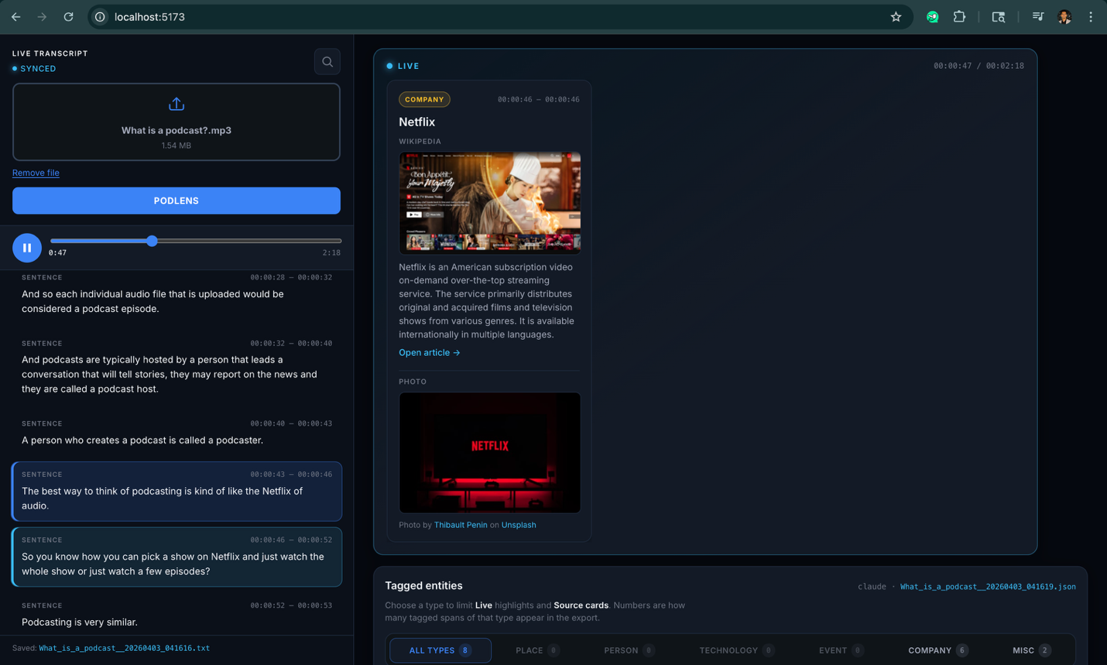

Entity Cards Panel
The right panel displays context cards that appear automatically as entities are detected. Each card is anchored to the timestamp at which the entity was mentioned. Cards animate into view as the audio reaches that moment.

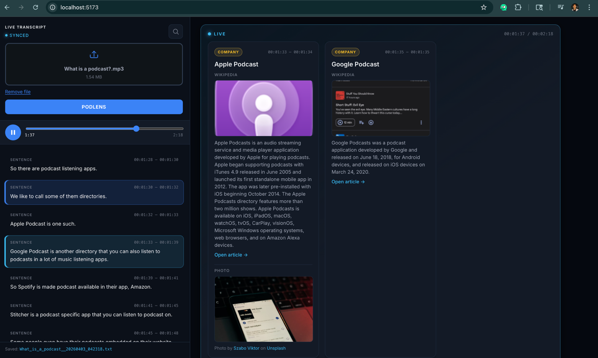

Map & Media View
For places, an embedded interactive map is shown using Leaflet.js and OpenStreetMap data. For people and technologies, a relevant image sourced from Unsplash or the Wikipedia thumbnail is displayed alongside a summary.

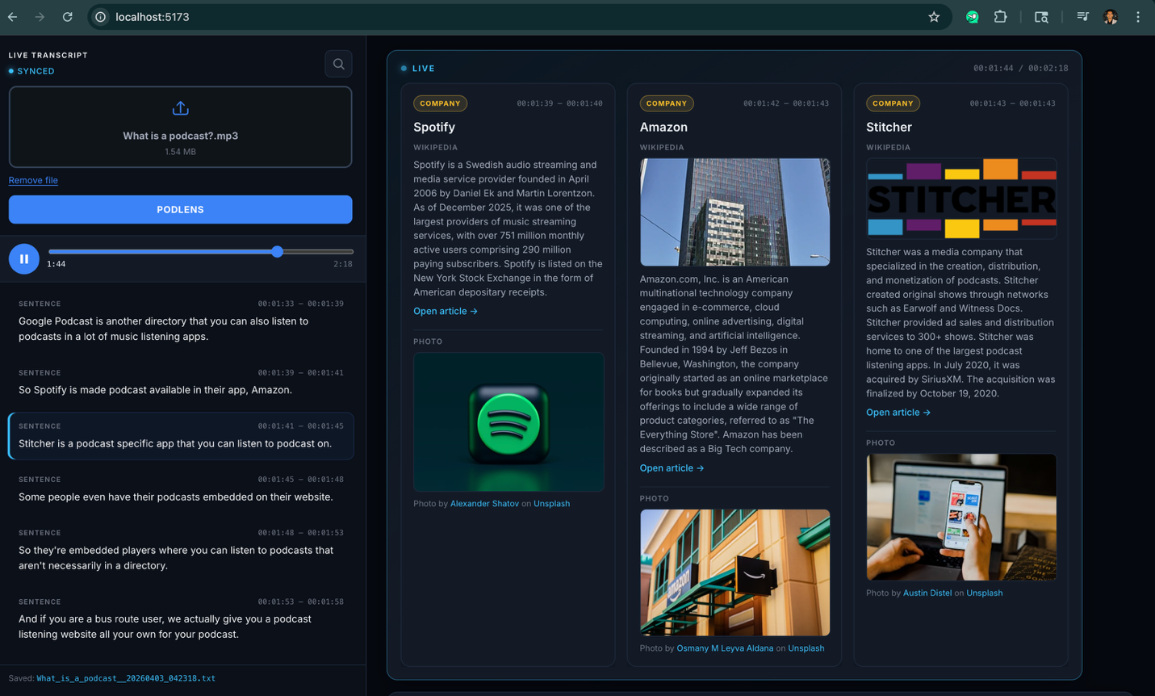

How It Works
PodLens runs a multi-stage pipeline from audio input to enriched UI output. Each stage builds on the previous one and produces a structured JSON artifact that feeds the next step.

Stage | Name | Description
1 | Transcription | Audio file is processed by OpenAI Whisper locally. Output is a timestamped JSON transcript with word-level timestamps.
2 | Entity Extraction | Transcript segments are passed through spaCy NER and the Claude API to classify entities as PERSON, PLACE, TECHNOLOGY, ORGANIZATION, or EVENT.
3 | Content Enrichment | Each entity triggers parallel API calls to Wikipedia, Nominatim, Unsplash, and The Guardian to retrieve summaries, coordinates, images, and news.
4 | UI Rendering | React frontend consumes the enriched JSON and renders a synchronized transcript panel alongside animated context cards.
5 | Real-time Sync | Audio playback timestamp drives card visibility. Cards appear and fade in sync with the spoken content.

External APIs Used

API | Purpose | Free Tier | Notes
OpenAI Whisper | Audio transcription | Unlimited (local) | Runs locally, no API key needed
Claude API | Entity classification fallback | Via Anthropic account | Used for ambiguous/tech entities
Wikipedia REST API | Summaries + thumbnails | Unlimited | No key required
Nominatim (OSM) | Place coordinates | Unlimited (1 req/s) | No key, rate limit applies
Unsplash API | Photos for entities | 50 req/hour | Free developer account
The Guardian API | News articles | Unlimited (free tier) | High quality journalism source

Claude API Integration
The Claude API is one of the most important components in the PodLens pipeline. It is used at the entity extraction stage to handle cases where spaCy's general-purpose NER model makes incorrect classifications, particularly for technical and domain-specific vocabulary.

Why Claude API is needed
spaCy is trained on news and general text corpora. It has no understanding that PHP is a programming language, that DSA stands for Data Structures and Algorithms, or that CARLA is a driving simulator. When these terms appear in a podcast, spaCy tends to misclassify them as organizations or proper nouns.

Claude is used as a smart fallback layer. When spaCy assigns low confidence or a likely-incorrect label, the entity is passed to Claude with a structured prompt that includes classification rules, examples, and the surrounding transcript context. Claude returns a corrected label with reasoning.

Prompt design
The Claude prompt is designed to return structured JSON output. It includes explicit rules such as: programming languages go to TECHNOLOGY, real people go to PERSON, and abbreviated CS concepts like DSA, OOP, and REST are always TECHNOLOGY. The surrounding transcript window (two sentences before and after) is included to help resolve ambiguous cases.

