# 

**Tech-E Trash**

**A Project Report**

Web Programming

*Submitted by*

**Dhruv Pathak**

**Shivansh Sharma**

**Shrey Thapar**

***Under the Guidance of***

Prof. Vijayetha Thoday

***in partial fulfillment for the award of the degree of***

## B. Tech (Computer Engineering)

At



**MPSTME, Mumbai**

**Nov, 2020**

## DECLARATION

I, Dhruv Pathak, Shivansh Sharma, Shrey Thapar, Roll No. E008, E027, E049 B. Tech (Computer Engineering), V semester understand that plagiarism is defined as anyone or combination of the following:

1. Un-credited verbatim copying of individual sentences, paragraphs or illustration (such as graphs, diagrams, etc.) from any source, published or unpublished, including the internet.
2. Un-credited improper paraphrasing of pages paragraphs (changing a few words phrases, or rearranging the original sentence order)
3. Credited verbatim copying of a major portion of a paper (or thesis chapter) without clear delineation of who did wrote what. ( Source: IEEE, The institute, Dec. 2004)
4. I have made sure that all the ideas, expressions, graphs, diagrams, etc., that are not a result of my work, are properly credited. Long phrases or sentences that had to be used verbatim from published literature have been clearly identified using quotation marks.
5. I affirm that no portion of my work can be considered as plagiarism and I take full responsibility if such a complaint occurs. I understand fully well that the guide of the seminar/ project report may not be in a position to check for the possibility of such incidences of plagiarism in this body of work.

Names: Dhruv Pathak, Shivansh Sharma, Shrey Thapar

Roll Nos. : E008, E027, E049

Place: Mumbai

Date: 03/11/2020

## CERTIFICATE

This is to certify that the project entitled “ Tech-E Trash ” is the bonafide work carried out by Dhruv Pathak, Shivansh Sharma, Shrey Thapar of BTech, MPSTME (NMIMS), Mumbai, during the IV semester of the academic year 2020-2021, in partial fulfillment of the requirements for the Course Programming Language.

___________________

Prof. Vijayetha Thoday

Internal Mentor

_______________________ ________________________

Examiner 1 Examiner 2

## Table of Contents

**CHAPTER NO. TITLE PAGE NO.**

1. PROJECT INTRODUCTION 5
2. MODULES IMPLEMENTED 6
3. SCREENSHOTS 9
4. CONCLUSION & FUTURE SCOPE 16
5. SOCIETAL APPLICATION (If any) 17

**Project Introduction**

In this project a website has been made using the ReactJS library on the NodeJS framework, wherein the development was done on a React-based open source framework “Gatsby” and the deployment of the app was done using Heroku.

**E-Waste** is the topic chosen for this project. As we all know technology is improving at a rapid pace like never before. Though this seems to be a positive growth, it has left negative effects on our planet. There has been a drastic increase in the volume of e-waste all around the world leading to more than 80% of it being dumped in landfills. This waste has the potential to be reused and to help the environment in multiple ways.

The e-waste thrown away can be used to extract reusable components and elements which not only helps in it becoming useful, but, it also decreases the need to mine and produce newer components. Waste when properly disposed, results in less pollution on earth. By recycling these e-wastes, minimum harm is caused to the planet as mining and factories will have less effects on the planet when reusable elements are recycled. To help spread this information and to make people aware about their responsibility towards the society, this website was made, thereby named “Tech-E Trash”, with a motto - For the E-Future Ahead.

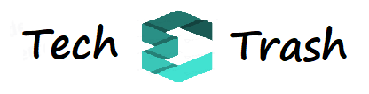

**Link:** [**https://tech-e-trash.herokuapp.com**](https://tech-e-trash.herokuapp.com)

Tech-E-Trash is a website that provides a user-friendly interface and has multiple functionalities helping in various aspects of e-waste awareness. From locating different e-waste collection centers to making the users aware of the different steps of disposal their phone faces after they are dumped. A very informative function of the website lies in the “know your waste” page, wherein input is taken from the user asking about their device after which, he/she is made aware of the detrimental effect their device would have on the earth if not disposed properly. Building on the above information, a page is dedicated entirely to make the users aware of the impact that e-waste has on the environment. A section of the website has a map with 150+ e-waste recycles and their details to help users in disposing off the e-waste in a manner that does not harm the future of the planet.

Therefore, the aim to educate and make people aware that an E-Future is only possible if and only if responsible measures are taken. Otherwise the technologically perfect future that is dreamt of would be destroyed by the old discarded technology.

**Modules Implemented**

We have implemented multiple modules for the website, explained below:-

* **Common Modules for every page**

1. **Header :** The header module has a User button that opens a modal for the user to Log In or Sign Up.
2. **Footer :** The footer module has 2 parts. One is a row of links for navigating through the website. Second part has a small information paragraph about Tech-E Trash and a properly working Contact Form that helps viewers to get in touch with us. Also, it has the personal website, GitHub and LinkedIn links of the project creators.
3. **AI Chat Box :** The AI Chat Box module is available on every pages right side corner. It prompts the user that it can help the user when he/she visits the website for the very first time. The AI Bot has 4 general E-Waste related questions we have added to help the user. The AI will answer those questions with the correct answers, emoticons and images. Any other questions can be manually answered by us.
4. **Responsiveness :** The website is majorly responsive and it adjusts correctly with different screen sizes of devices like mobile phones, tablets and laptops.

* **Home Page**

1. **Information Block :**

The home page is presented in a blocks format where we have animated the title and information to fade in when that particular website section is present on the device the website is being visited on.

1. **Live E-Waste Count :**

An API with the actual data of the tons of E-Waste being dumped about the world is also present on the home screen.

1. **Cards :**

There are 3 cards with featured data present on. On hover, it has an animation of moving down in the negative Y-axis direction.

* **Know Your Waste Page**

1. **Card Updating :**

This page has a module that will update the category, device chosen and data depending on the electronic device whose information the user selects to be searched for. On selecting different devices, the category info, device and its e-waste related information gets updated, clearing the previous data, therefore updating the card on every device the user searches.

1. **Image and Data :**

On scrolling, 2 sections consisting of an image each appears with a flip animation and a few lines of information.

* **Journey of a Device Page**

1. **Timeline :**

This page was dedicated to animate a timeline that depicts the life of any electronic device and how it ends up in a waste land causing environmental issues. The page and small images with one line explanations that change with respect to the scroll. Therefore by scrolling from top to bottom of the page, animations and images present the journey of a device as a timeline.

* **Impact of E-Waste Page**

1. **Infographics :**

With every scroll, new infographic images appear on the screen. Each infographic image has a different animation like fade in/out, slide from left/right or zoom in/out. This module shares alarming e-waste data with the users, scrolling from top to down. The last few infographic suggest solutions to e-waste.

1. **Google My Maps API :**

This module has the use of the Google My Maps API where we added 150+ real locations E-Waste Recyclers in India to help users contact one nearest to their location.

* **About Us Page**

1. **Carousel :**

The About Us page is simple and has the information about Tech-E Trash, their goals, motto and their team. It also has a carousel that has banners and images of e-waste awareness messages. The module has automatic slider set at 4 seconds. So the image changes every 4 seconds and will continue in a loop.

**Screenshots**

**Home Page**

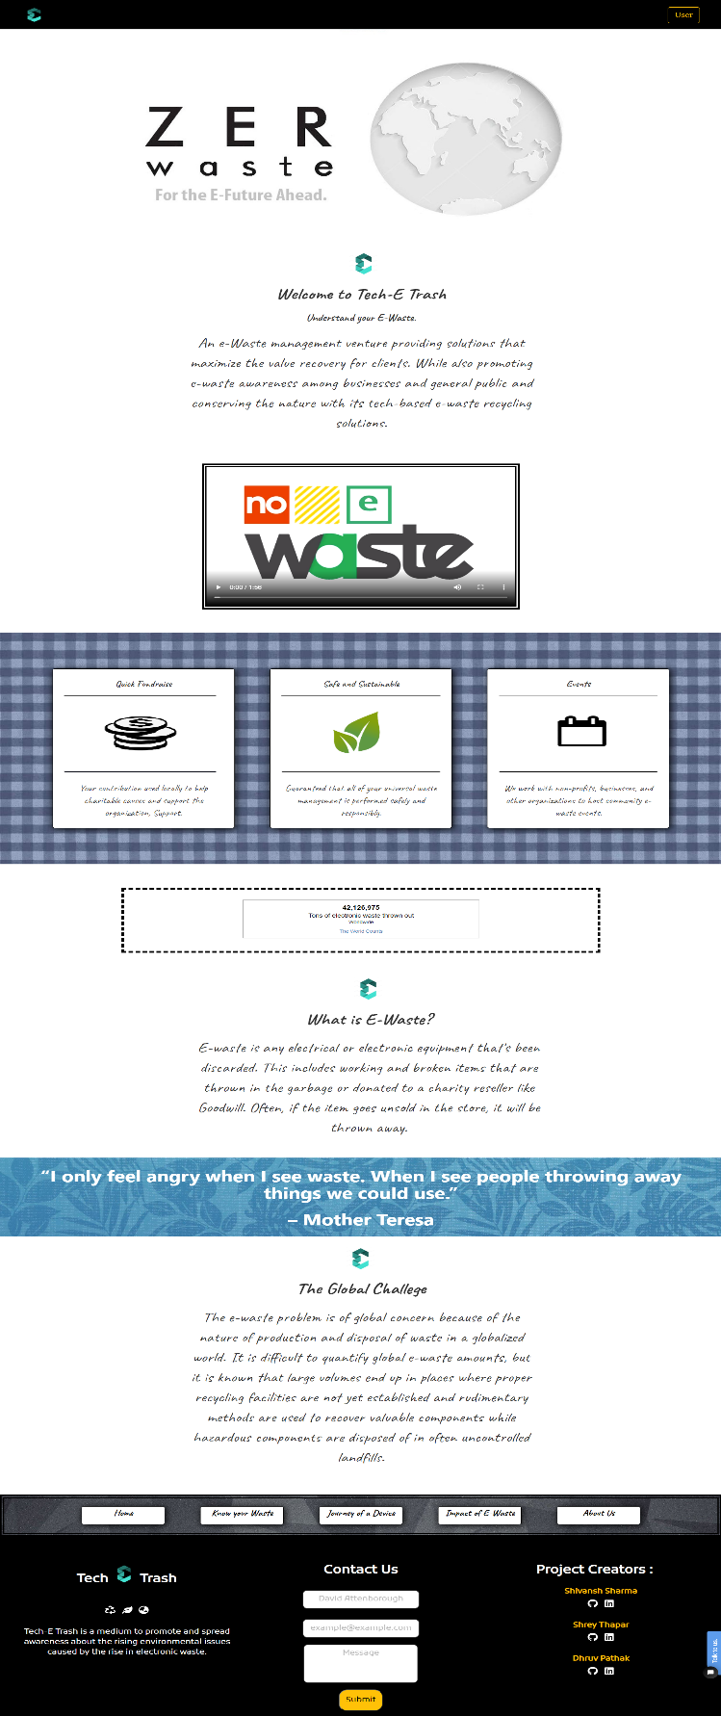

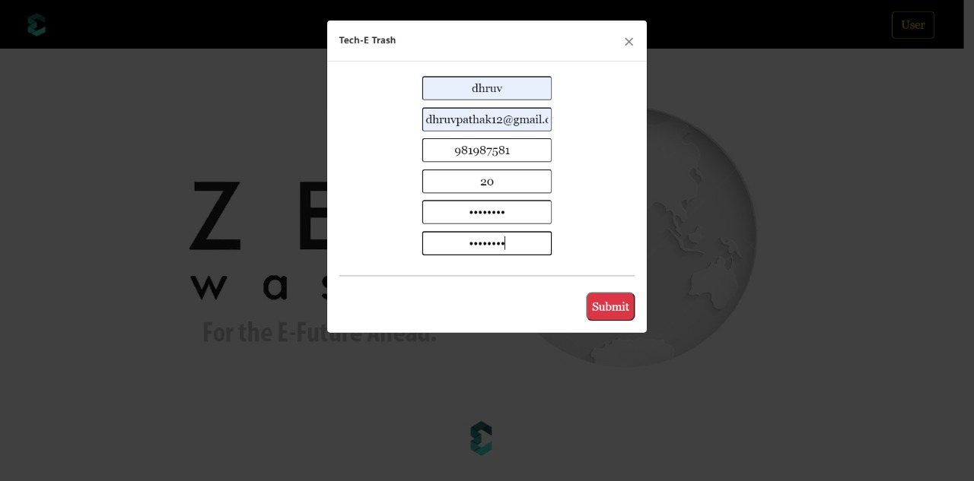

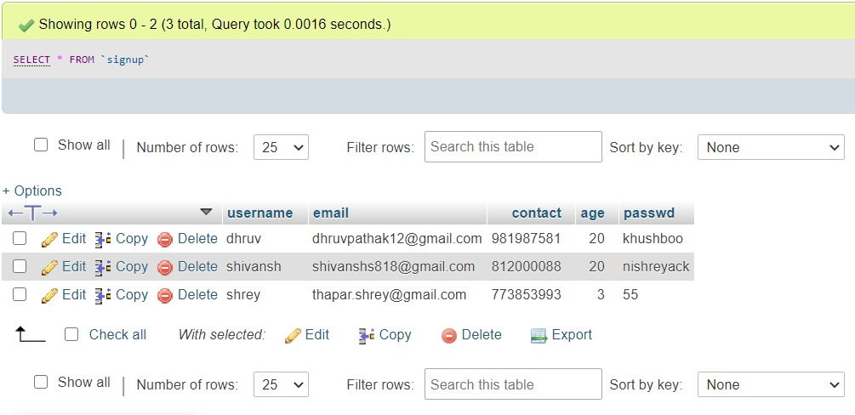

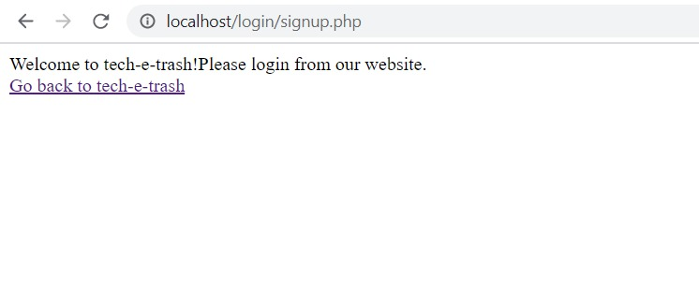

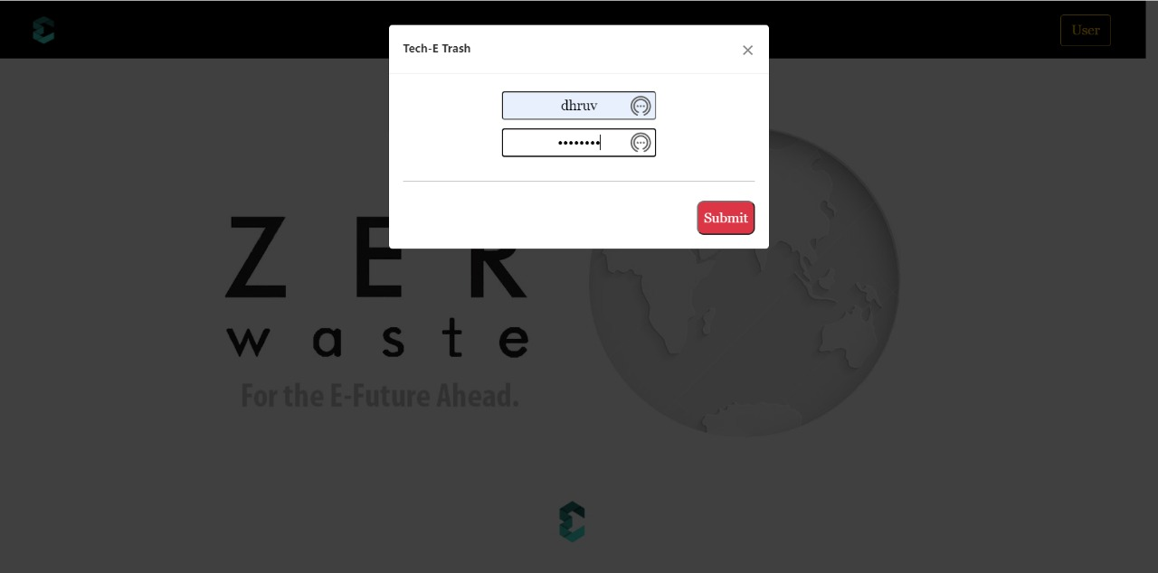

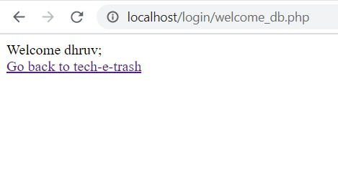

**Know Your Waste**

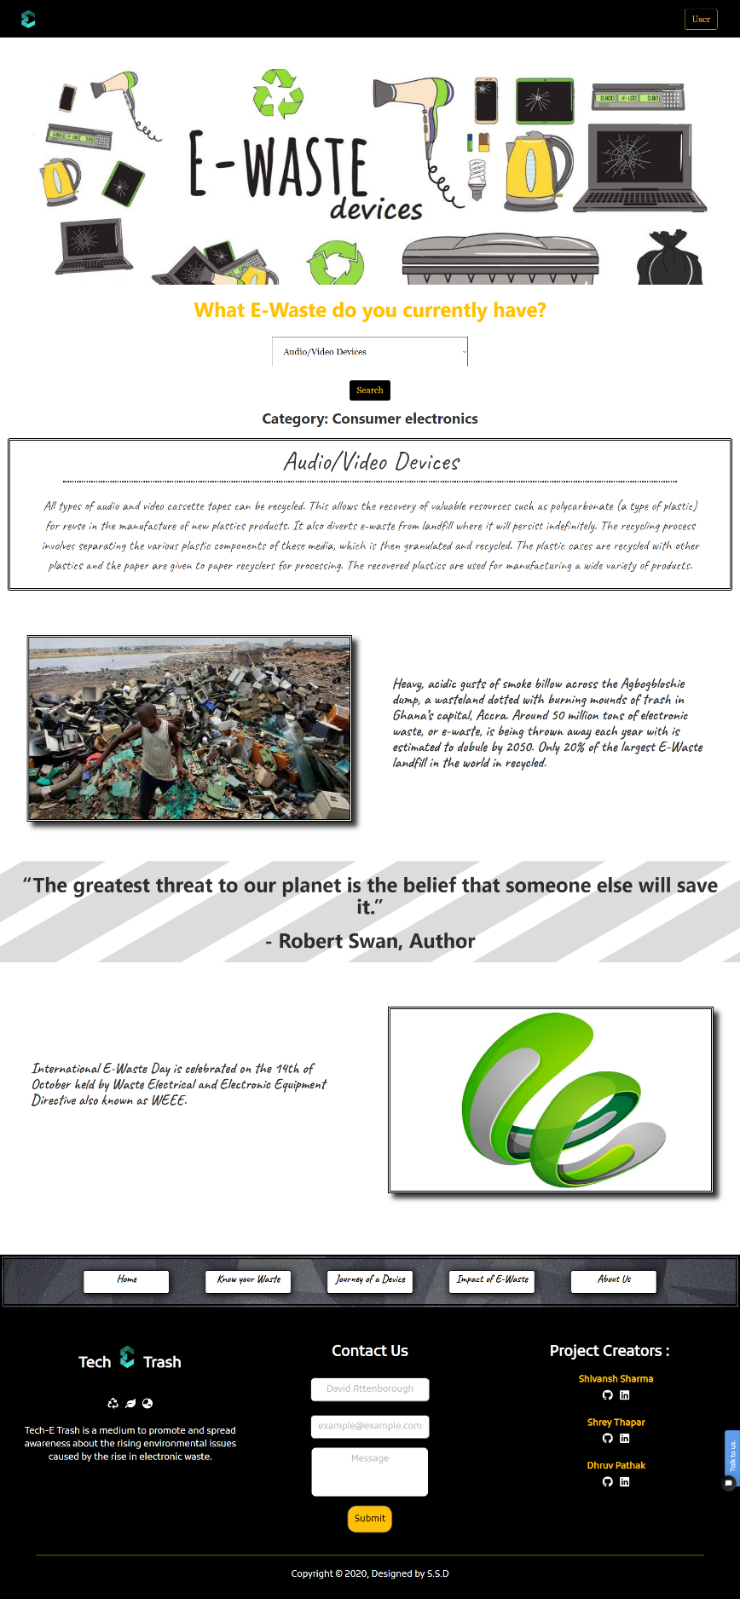

**Journey of a Device**

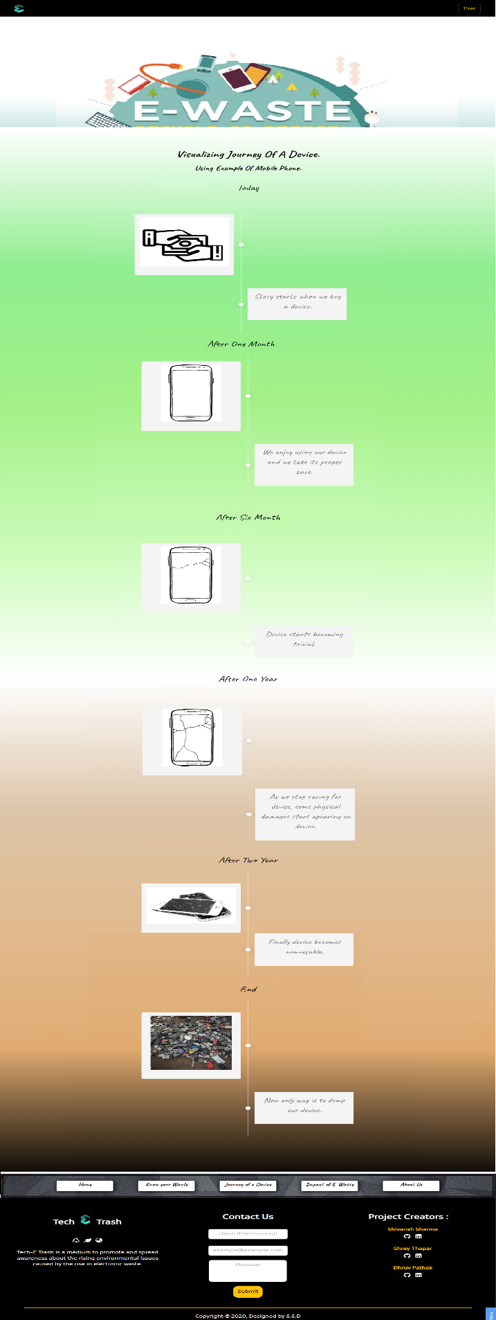

**Impact of E-Waste**

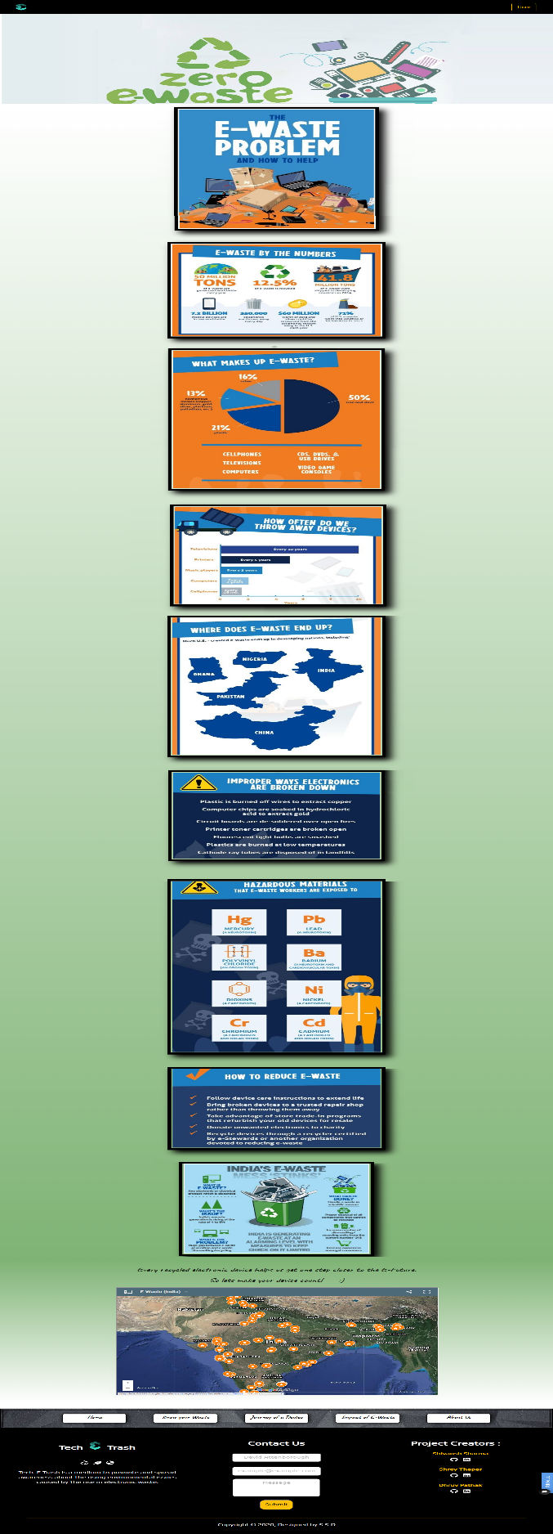

**About Us**

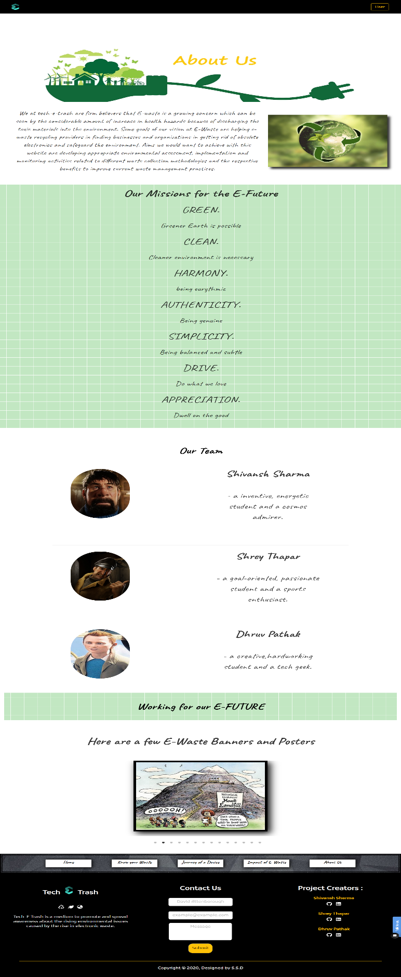

**Conclusion & Future Scope**

After the completion of this project, we learnt how to : -

1. Implement JavaScript, Cascading Style Sheet (CSS) and Hypertext Mark-up Language (HTML) to make a fully functional website with many components and multiple pages.

1. Use the Gatsby JS framework.
2. Deploy a website on a server by using Heroku.
3. Use phpMyAdmin and mySQL to make a database.
4. Use php to link the created database to our website.

We can safety conclude with all the learnings that we could complete our website, which has a good front-end and user-friendly interface. We now are more aware about the situation of e-waste and seriousness of the problem that is caused by the improper disposal of e-waste.

There is always scope for improvement and the website will keep on improving and will contain more utilities and functionalities in the future. Website improvisation will be done in areas based on database connectivity and would have a smoother user experience. The overall goal is to achieve a user profile section, an event page - to help NGO’s gain attraction etc.

Our mission is to add more information about e-waste and recyclers near-by. We wish to take our website and the initiative to the next level by providing a pick-up option to the customer, making it much more convenient and thereby helping the environment. We aim for an E-Future, with a greener and cleaner Earth !!!

**Societal Application (If Any)**

The societal application of the project is in making people more aware of the drastic effect e-waste has been having in the environment owing to the rapid increase in the number of gadgets and appliances used resulting in people not being entirely aware of how to dispose their gadgets after they are no longer required. Because of people not disposing their gadgets and appliances properly, the situation keeps getting worse in terms of the e-waste accumulation. At this point, wide use of the website would result in rising awareness amongst people regarding e-waste and would help them in locating the respective e-waste collection centers in their areas.

Education and awareness about this issue is a must. It is our responsibility and obligation to play our part towards saving the planet from the dark sides of technology. So we aim to contribute to this global mission by making our website a medium to spread awareness.

**Thank You 😊**