Assignment : 10

Using Map-Reduce function comply the following requirements

1. 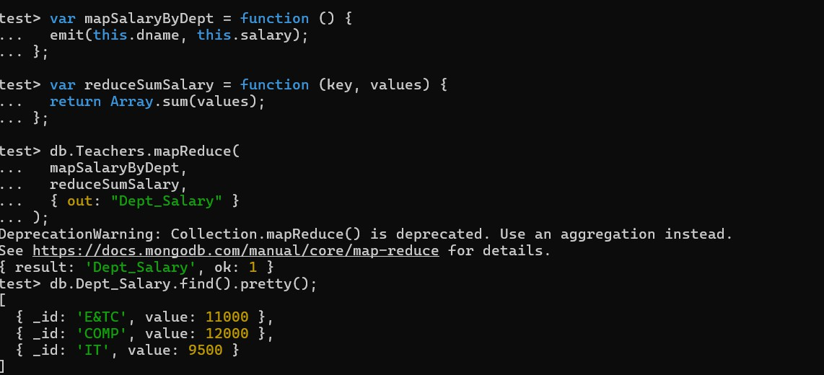**Display the salary of employees department wise**
2. **Display the count of employees departmentwise**
3. **Consider the collection “Orders “ with the following types of doccuments**

**{**

_id: ObjectId("50a8240b927d5d8b5891743c"), cust_id: "abc123",

status: 'A', price: 25,

**}**

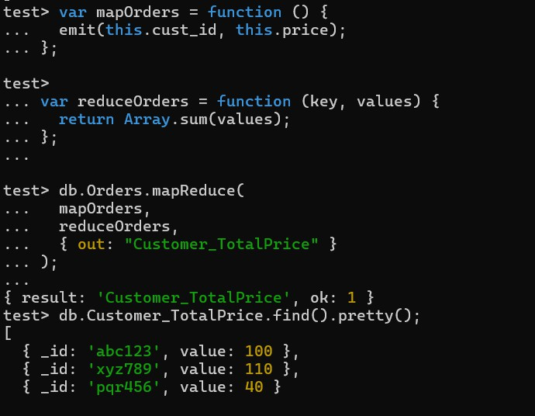Return the Total Price Per Customer

1. 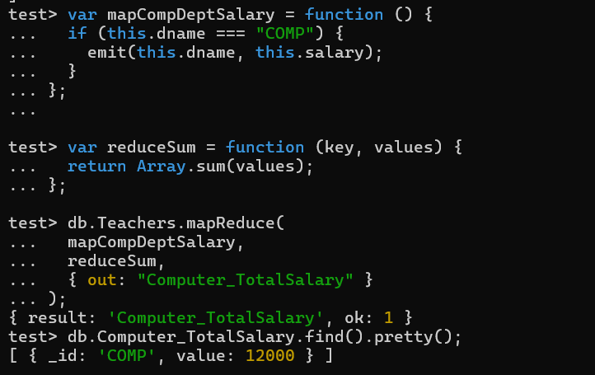**Find the information about all teachers of computer department**
2. **Consider each document in the zipcode collection has the following form:**

**{**

"_id": "10280",

"city": "NEW YORK",

"state": "NY", "pop": 5574,

**}**

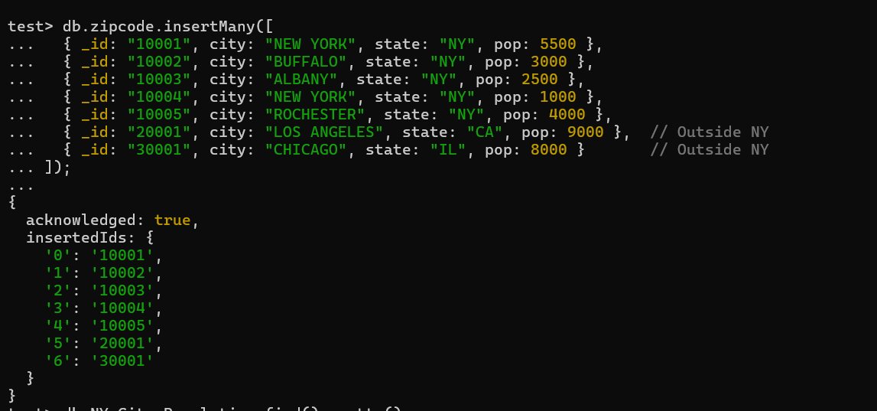Return the city wise population of the cities in the NY state.

