|  |  |  |
| --- | --- | --- |
|  | Pimpri Chinchwad Education Trust’s  **Pimpri Chinchwad College of Engineering** An Autonomous Institute  (Permanently affiliated to Savitribai Phule Pune University) |  |
| SEMESTER-III |
| Assignment 2 | | |

**Department : Computer Engg (Regional) Subject : DBMSL**

1. **Create StudentManagement database.**

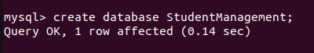

1. **Create the Students table under StudentManagement database.**

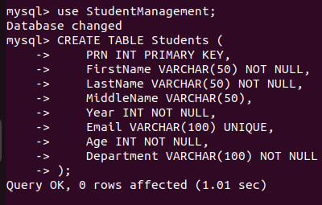

1. **Insert records into the Students table.**

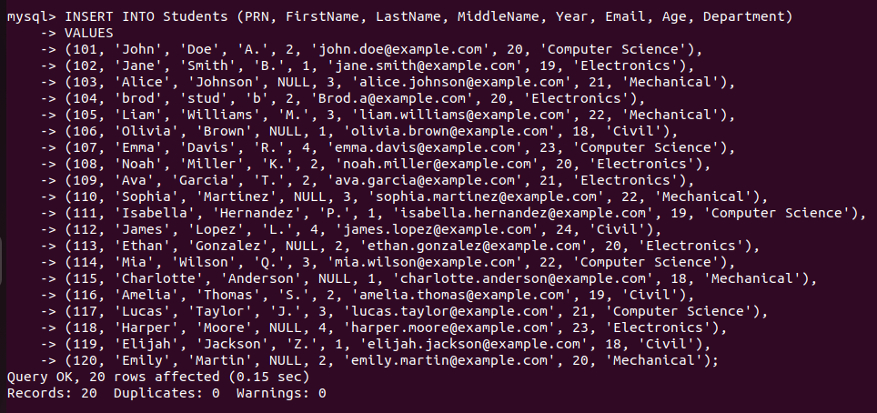

1. Write a query to retrieve all records from the Students table.

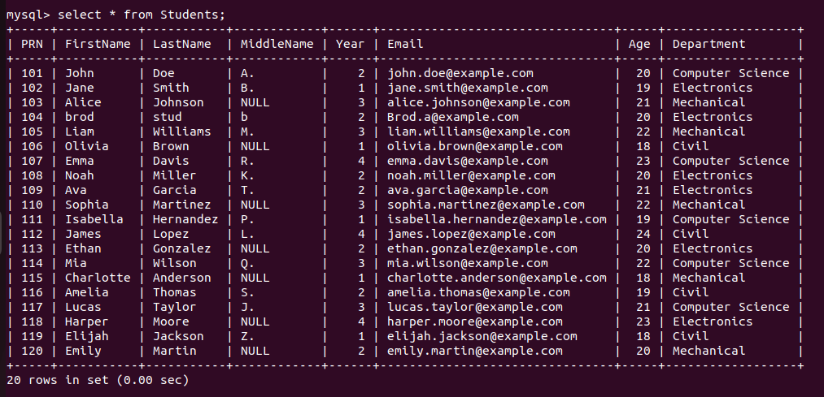

1. Write a query to update the Year of the student with PRN 102 to 2.



1. Write a query to delete the record of the student whose PRN is 103.

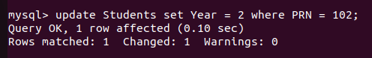

1. **Alter the Students table**

Write a query to add a new column PhoneNumber of type VARCHAR(15) to the Students table.

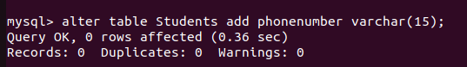

1. Write a query to retrieve all distinct departments from the Students

table.

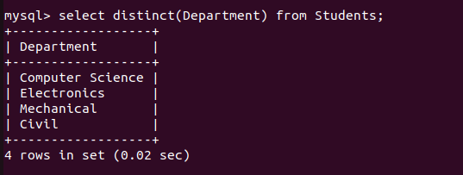

1. Write a query to find number of distinct departments from the

Students table.

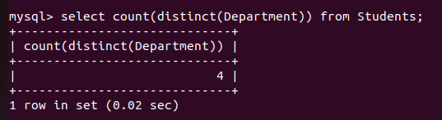

1. Write a query to retrieve the distinct years in which students are enrolled.

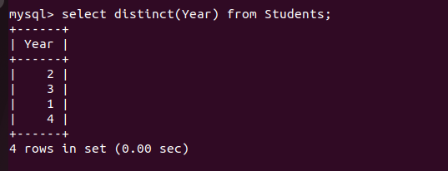

1. Write a query to retrieve all distinct ages of students in the "Computer Science" department.

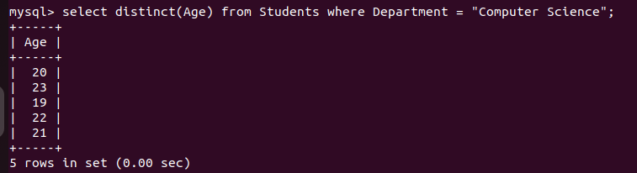

1. Write a query to retrieve distinct first names of students whose age is less than 21.

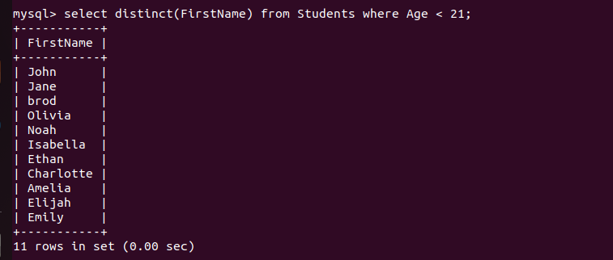

1. Write a query to retrieve the full details of students who are older than 20 years.

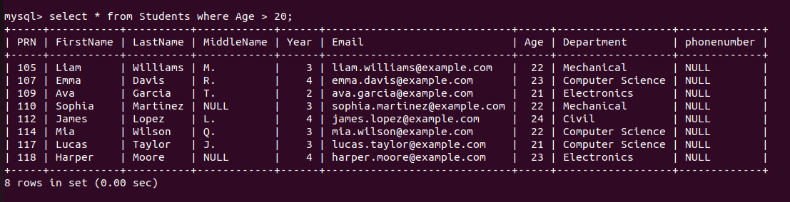

1. Write a query to retrieve all students enrolled in their third year.

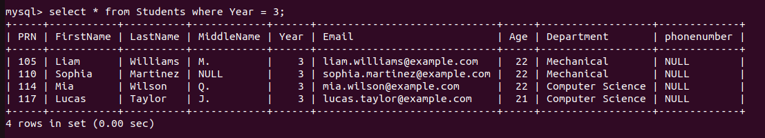

1. Write a query to display the first and last names of students along with their department, but only for students whose PRN is greater than 101.

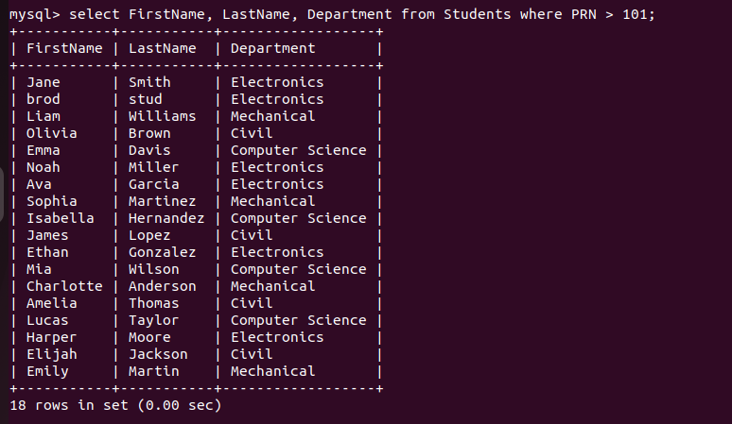

1. Write a query to fetch the first names and email addresses of all students in the "Electronics" department.

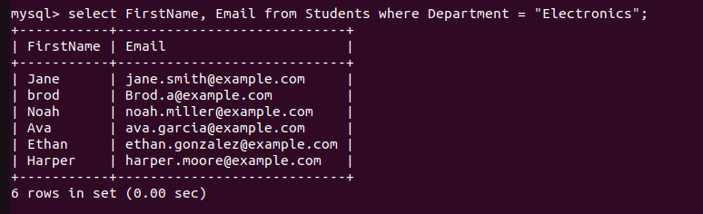

1. Write a query to fetch details of students in the "Computer Science" department who are older than 19.

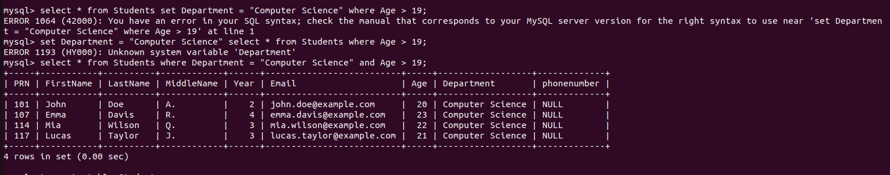

1. Write a query to remove all records from the Students table without deleting the structure of the table.

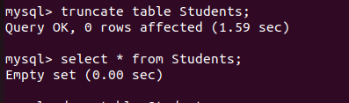

1. **Drop the Students table**

Write a query to delete the Students table from the

StudentManagement

