|  |  |  |
| --- | --- | --- |
|  | Pimpri Chinchwad Education Trust’s  **Pimpri Chinchwad College of Engineering** An Autonomous Institute  (Permanently affiliated to Savitribai Phule Pune University) |  |
| SEMESTER-III |
| Assignment 3 | | |

**Department : Computer Engg (Regional) Subject : DBMSL**

1. Create a database named StudentManagement.

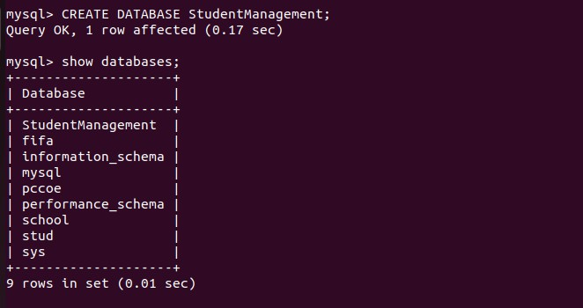

1. Define the following tables with appropriate constraints:

# Table 1: Students

Columns:

* + StudentID (Integer, PRIMARY KEY, NOT NULL)
  + FirstName (VARCHAR(50), NOT NULL)
  + LastName (VARCHAR(50))
  + Email (VARCHAR(100), UNIQUE)
  + DOB (DATE, NOT NULL)
  + CourseID (Integer, FOREIGN KEY references Courses(CourseID))

# Table 2: Courses

Columns:

* + CourseID (Integer, PRIMARY KEY, NOT NULL)
  + CourseName (VARCHAR(100), NOT NULL, UNIQUE)
  + Credits (Integer, DEFAULT 3)

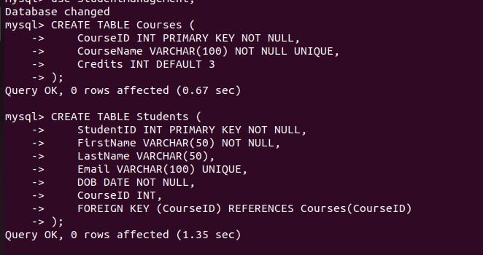

1. Insert records into the tables while ensuring the constraints are not violated.

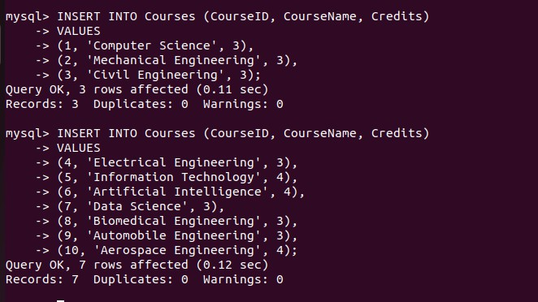

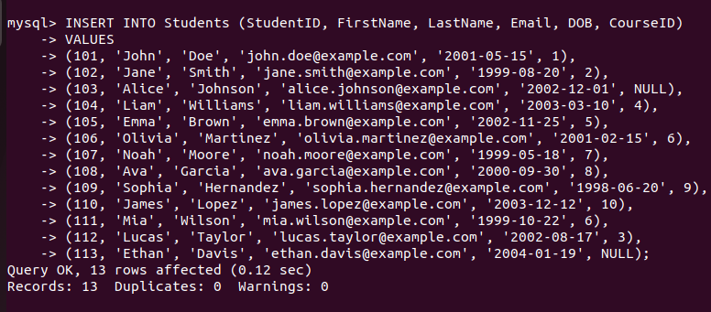

# Test the Constraints

Attempt to violate the constraints and observe the results:

1. Test 1: Insert a NULL value into a NOT NULL column.
2. Test 2: Insert a duplicate value in the UNIQUE column.
3. Test 3: Insert a record with an invalid FOREIGN KEY reference.

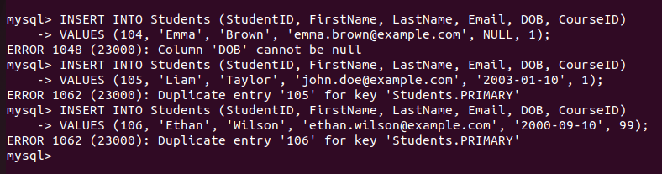

1. Attempt following questions:
2. Write a query to display the names of students who were born after the year 2000.

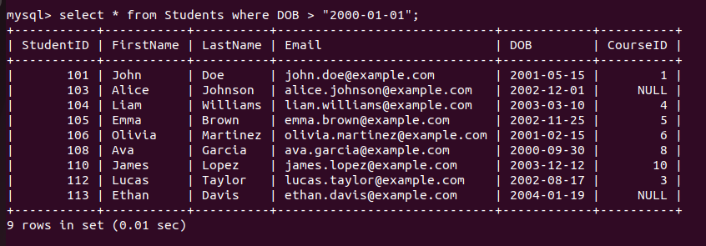

1. Write a query to update the course credits for "Computer Science" to 4.

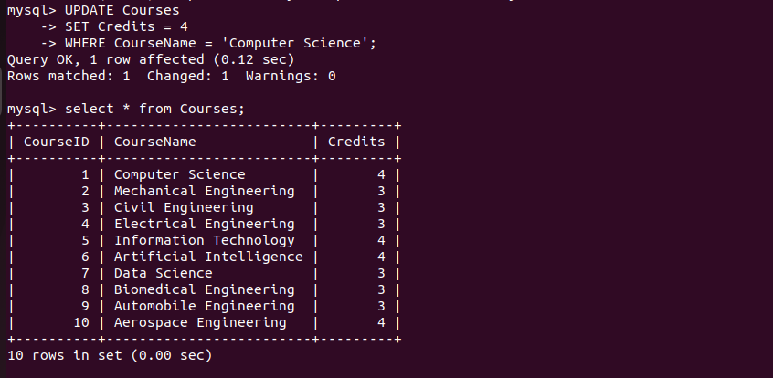

1. Write a query to delete a student record whose email is ['test@example.com'.](mailto:%27test@example.com)

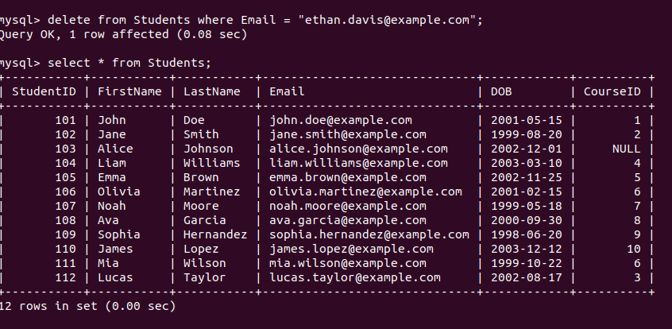

1. Write a query to find students who are not enrolled in any course.



1. Test the UNIQUE constraint by inserting a duplicate email into the Students table.



1. Test the FOREIGN KEY constraint by inserting a student with a CourseID that does not exist in the Courses table.

