Assignment no:08

1. **Create Database PCCOE**

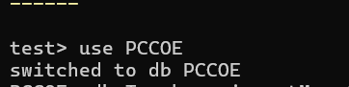

1. **Create following Collections Teachers(Tname,dno,dname,experience,salary,date_of_joining ) Students(Sname,roll_no,class)**

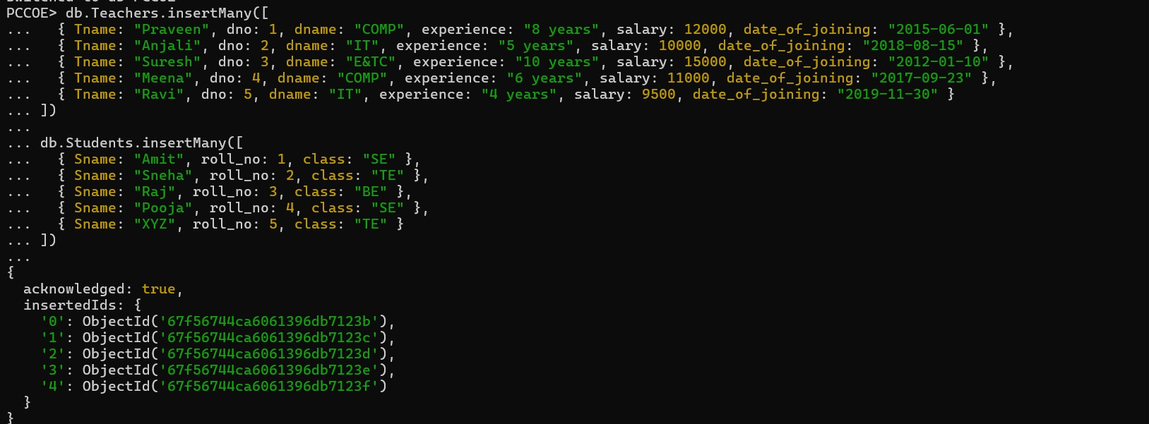

1. **Find the information about all teachers**

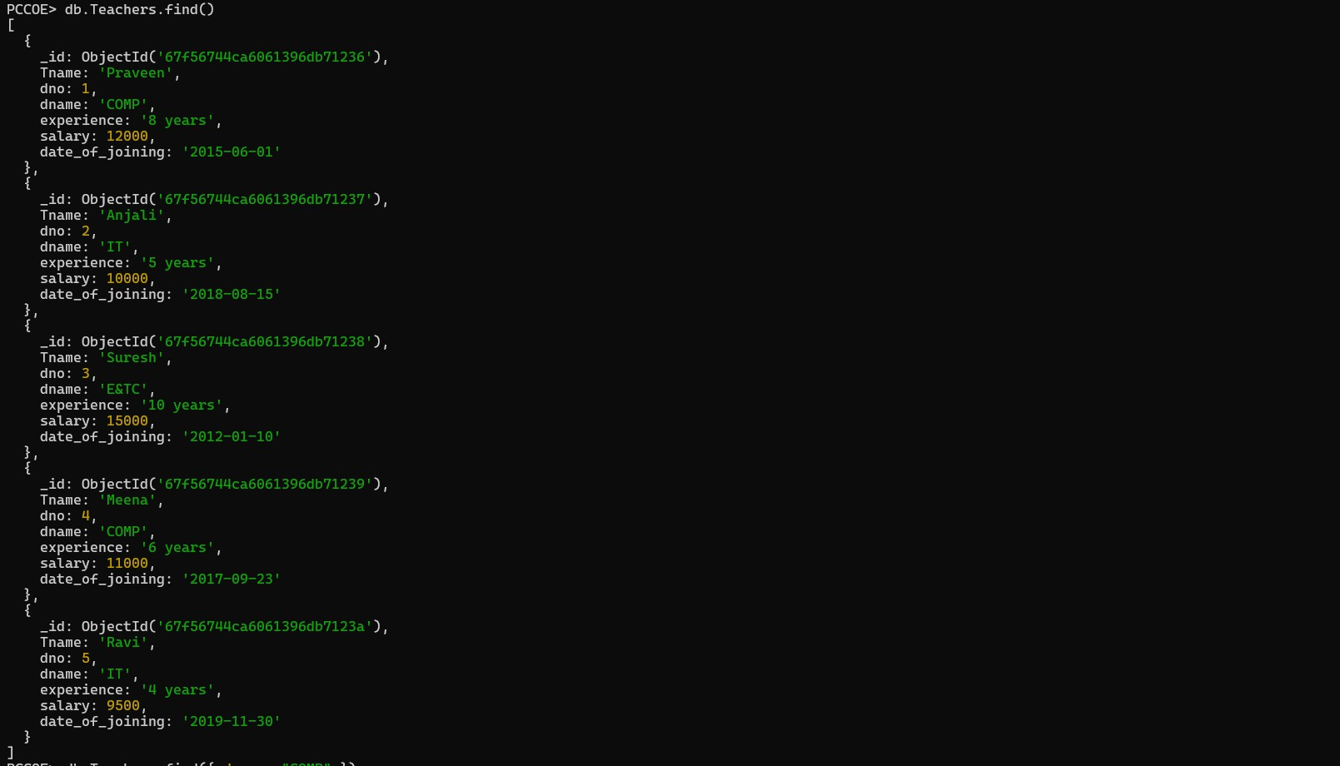

1. **Find the information about all teachers of computer department**

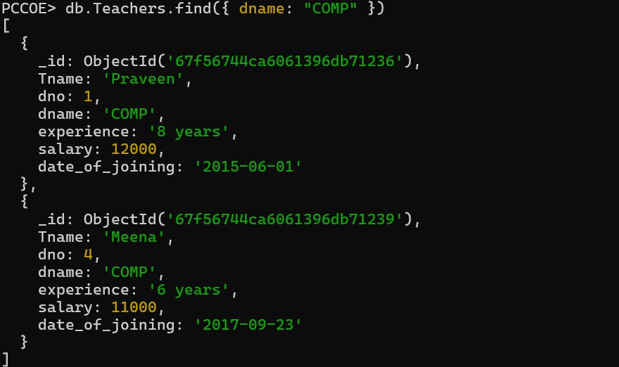

1. **Find the information about all teachers of computer,IT,and e&TC department**

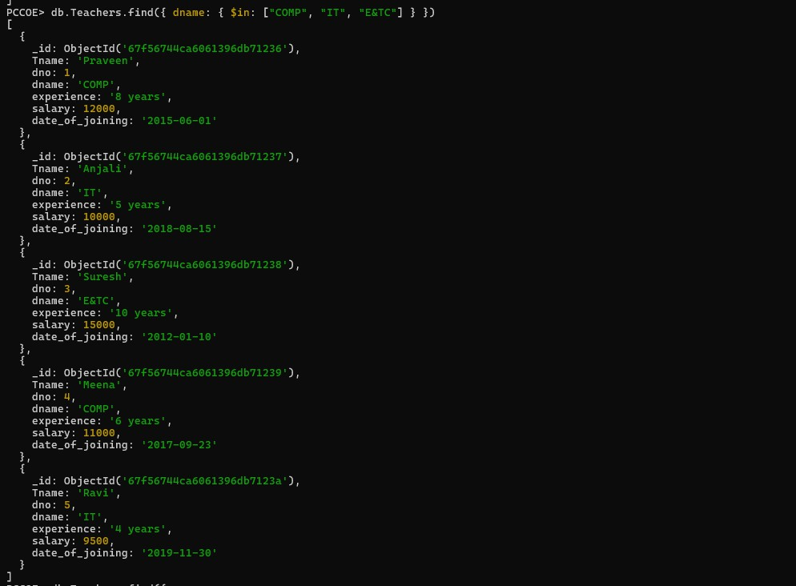

1. 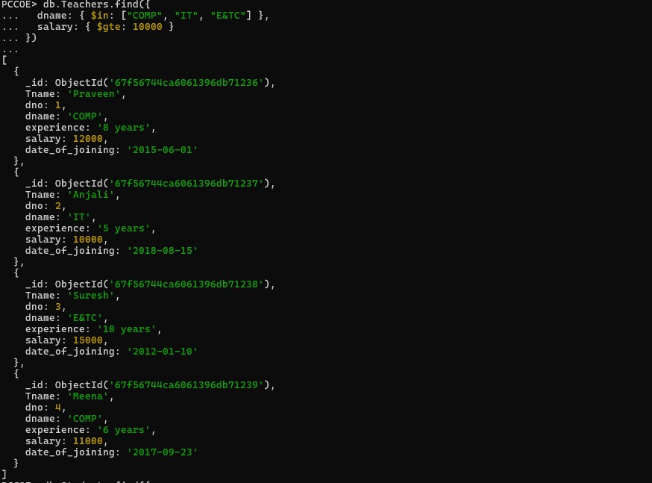**Find the information about all teachers of computer,IT,and E&TC department having salary greateer than or equal to 10000/-**
2. **Find the student information having roll_no = 2 or Sname=xyz**

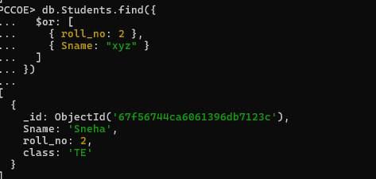

1. 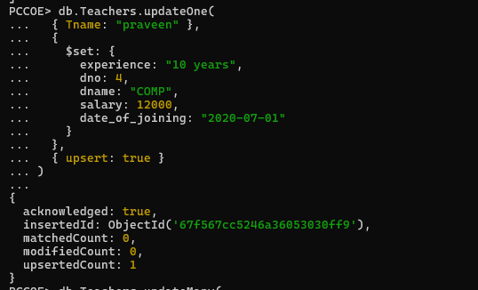**Update the experience of teacher-praveen to 10years, if the entry is not available in database consider the entry as new entry.**
2. **Update the deparment of all the teachers working in IT deprtment to COMP**

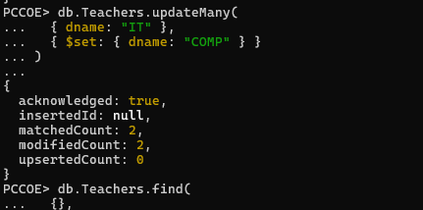

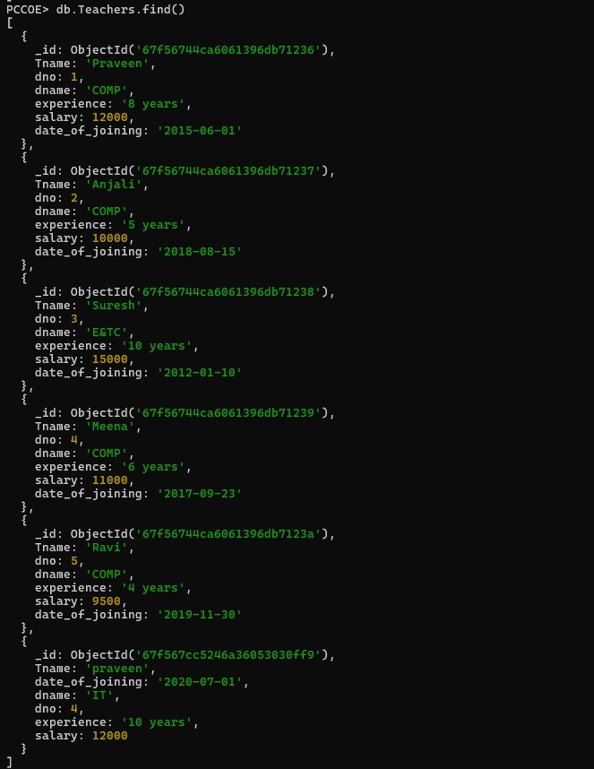

1. **find the teachers name and their experience from teachers collection**

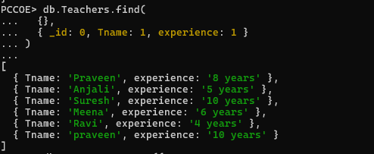

1. **Insert one entry in department collection**

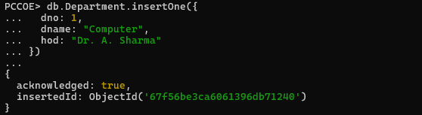

1. **Change the dept of teacher praveen to IT**

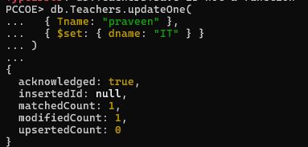

1. **Delete all the doccuments from teachers collection having IT dept.**

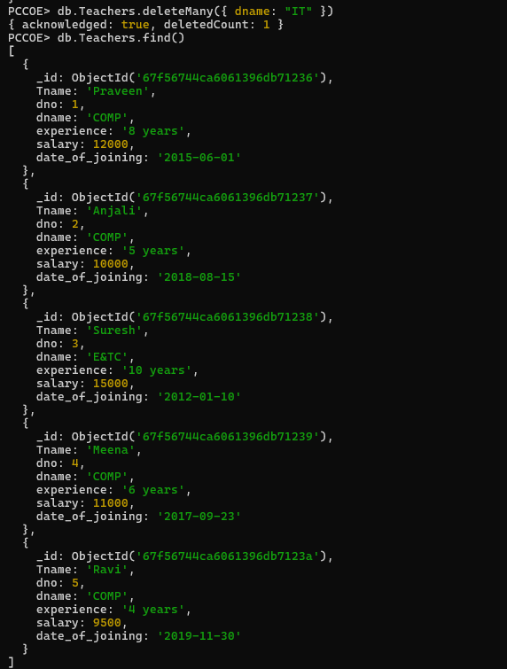

1. 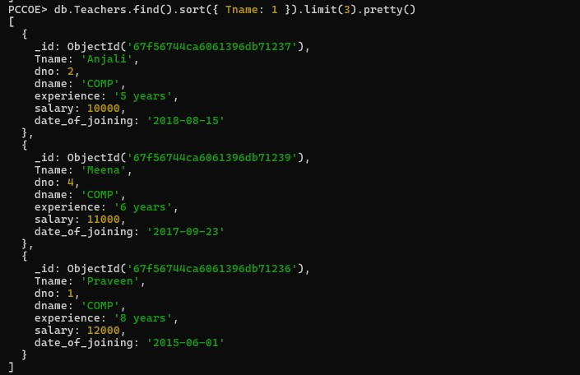**display with pretty() method, the first 3 doccuments in teachers collection in ascending order**