Assignment no:09

1. **Consider each document in the zipcode collection has the following form:**

**{**

"_id": "10280",

"city": "NEW YORK",

"state": "NY", "pop": 5574,

**}**

Return States with population above 10 Million

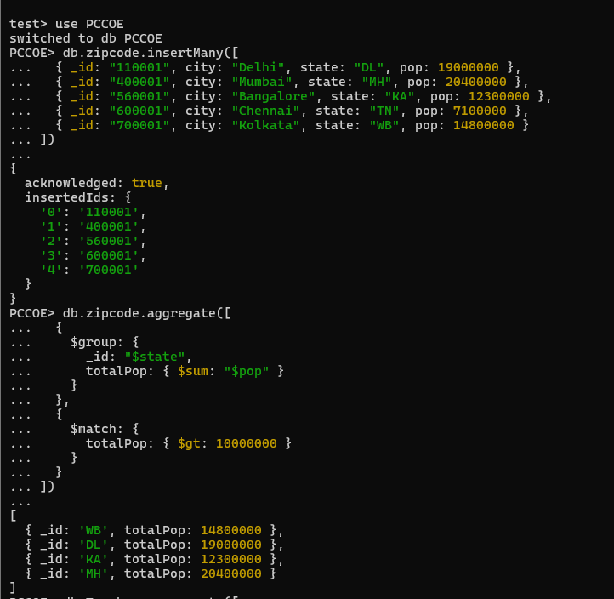

1. **Display the department wise average salary**

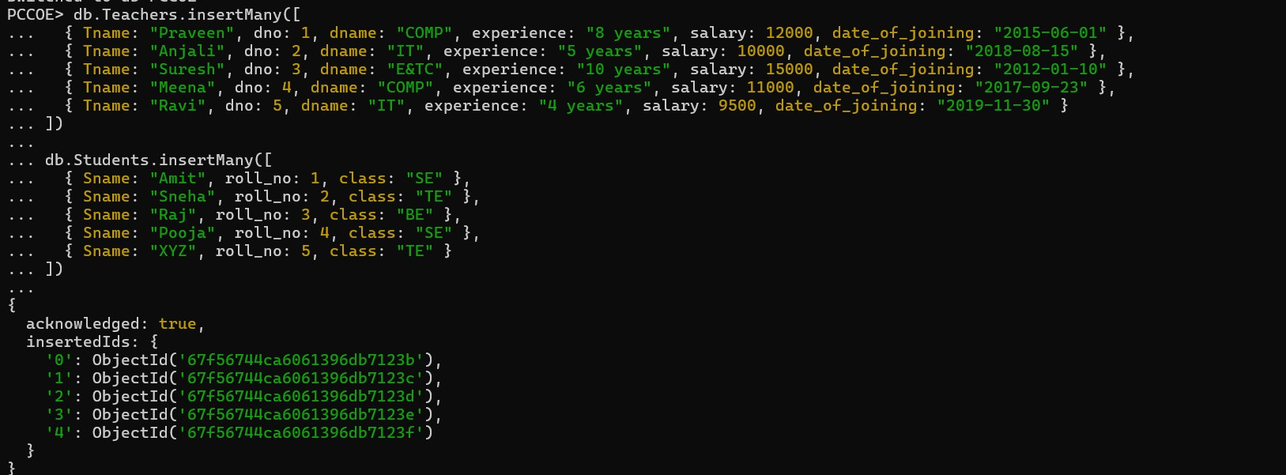

1. **display the no. Of employees working in each department**

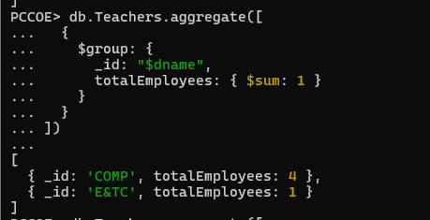

1. 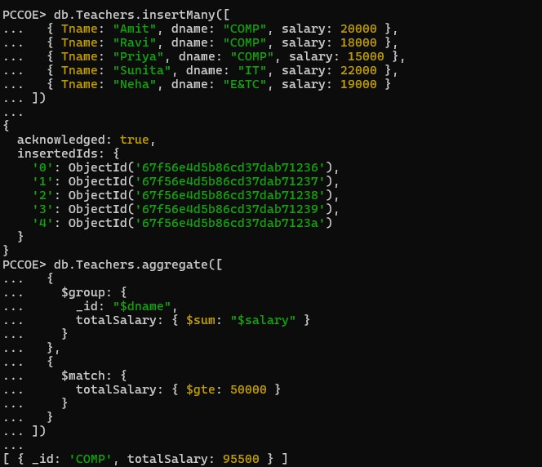**Display the department wise total salary of departments having total salary greater than or equals to 50000/-**
2. **Write the queries using the different operators like max, min. Etc.**

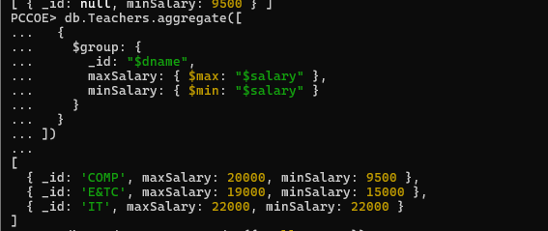

1. **Create the simple index on roll_no field**



1. **create unique index on any field for above given collections**



1. **create compound index on any fields for above given collections**



1. **Show all the indexes created in the database PCCOE**

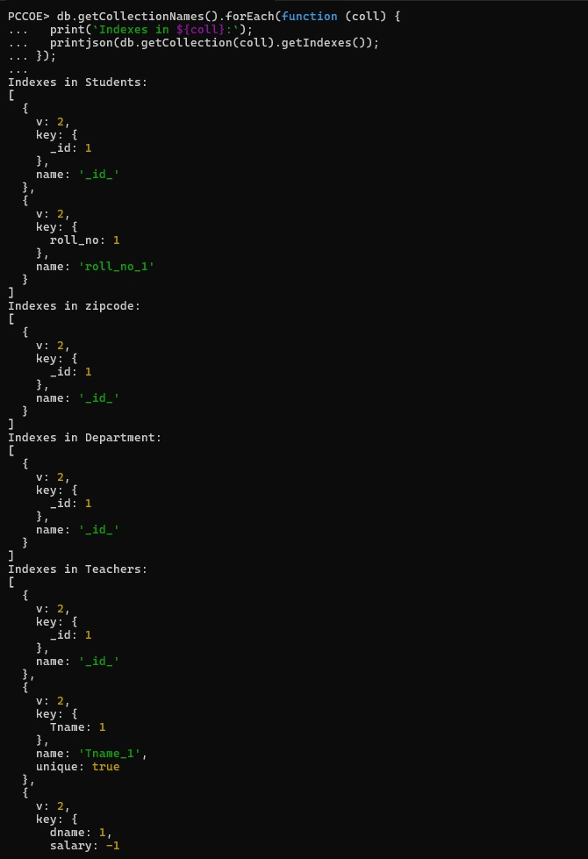

1. **Show all the indexes created in Teachers collections.**

