SHEETAH · EXCEL FOUNDATIONS · MODULE 1: WELCOME TO EXCEL · LESSON NOTES

1.2 A tour of the window
The ribbon, Quick Access Toolbar, formula bar, Name Box, status bar and Backstage view.

By the end of this lesson you can
- Find the ribbon’s tabs and groups, and the Quick Access Toolbar.
- Use the Name Box and the formula bar.
- Read Sum, Average and Count in the status bar.
- Open Backstage view from the File tab.

Lecture

The top of the window

The Excel window at a glance
Every Excel window has the same seven parts. Learn them once and you can find your way on any computer.
- Top: tabs and the ribbon of buttons.
- Middle: the Name Box, the formula bar and the grid.
- Bottom: sheet tabs and the status bar.
1. Tabs: Home, Insert, Formulas, Data…
2. Ribbon: the buttons for the chosen tab
3. Name Box: the address of the active cell
4. Formula bar: what is really inside that cell
5. Grid: where your data lives
6. Sheet tabs: switch between worksheets
7. Status bar: quick maths on what you select
In real life · Any office laptop: Excel 2016, 2021 or Microsoft 365: they all have these parts, so this map works wherever you work.

The ribbon: tabs, then groups, then buttons
Click a tab and the ribbon shows its groups of buttons. Home has what you use most.
- Can't find a button? Ask which tab's job it is.
- Printing → Page Layout. Protecting → Review. Freezing rows → View.
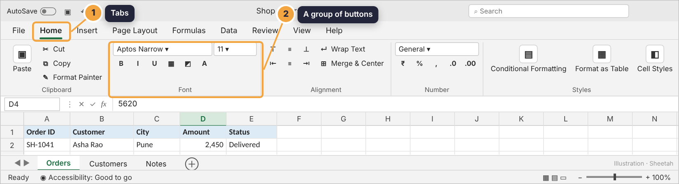
The Home tab: groups such as Font, Alignment and Number, each labelled underneath.
In real life · Deepa, an admin assistant: Spent five minutes hunting for Freeze Panes on Home. It lives on View, because it changes how you view the sheet.
Tab: a page of the ribbon, like Home
Group: a set of related buttons, like Font

Quick Access Toolbar: Save and Undo, always there
Above the ribbon sit Save, Undo and Redo, one click away whatever tab you are on.
- Undo is Ctrl+Z: your safety net.
- AutoSave saves every change when the file is on OneDrive or SharePoint.
1. Save · Undo · Redo, the file name, and the AutoSave switch
In real life · Kavya, a sales coordinator: Deleted a whole column just before a client call. Ctrl+Z brought it back in one second.
Check yourself: Where do you find the button that freezes the top row?

The middle and the bottom

The Name Box and the formula bar
The cell shows the answer. The formula bar shows how the answer was worked out.
- Name Box (left): the active cell's address. Type one there and press Enter to jump.
- Formula bar (after fx): what is really inside the cell.
- D8: the cell shows 14,260; the bar shows the formula behind it
In real life · An auditor at a large firm: Never trusts a number until she clicks it and reads the formula bar: was it typed in, or calculated?
Name Box: shows, or jumps to, an address
Formula bar: shows what is inside the cell

The status bar does quick maths
Select some numbers and the bar at the bottom shows their Average, Count and Sum. No formula needed.
- Perfect for a quick check before you write a formula.
- On the right: the view buttons and the zoom slider.
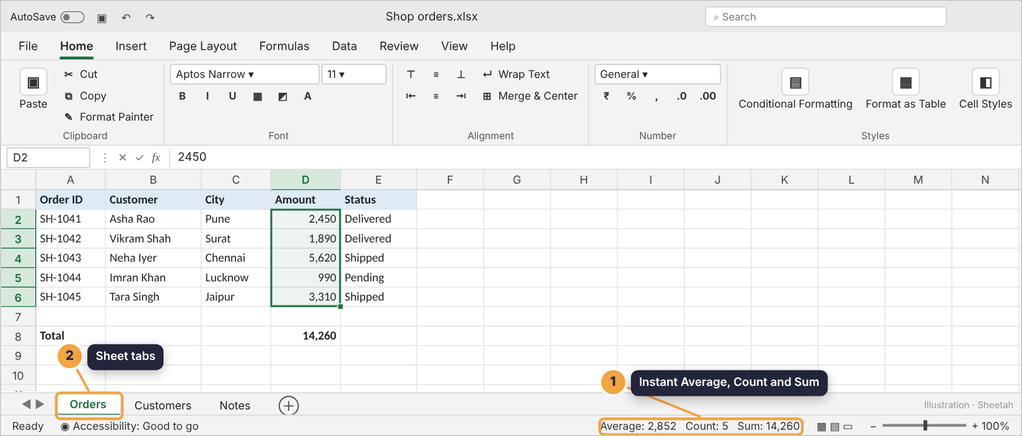
Select some numbers and read Average, Count and Sum at the bottom right.
In real life · Rohit, a store manager: Selects the day's bill amounts and reads the Sum in the status bar before he closes the counter.

File opens Backstage view
The File tab doesn't open a ribbon. It opens a full-screen menu for the whole file.
- Save, open, print, share and export live here.
- Press Esc or the back arrow to return to your sheet.
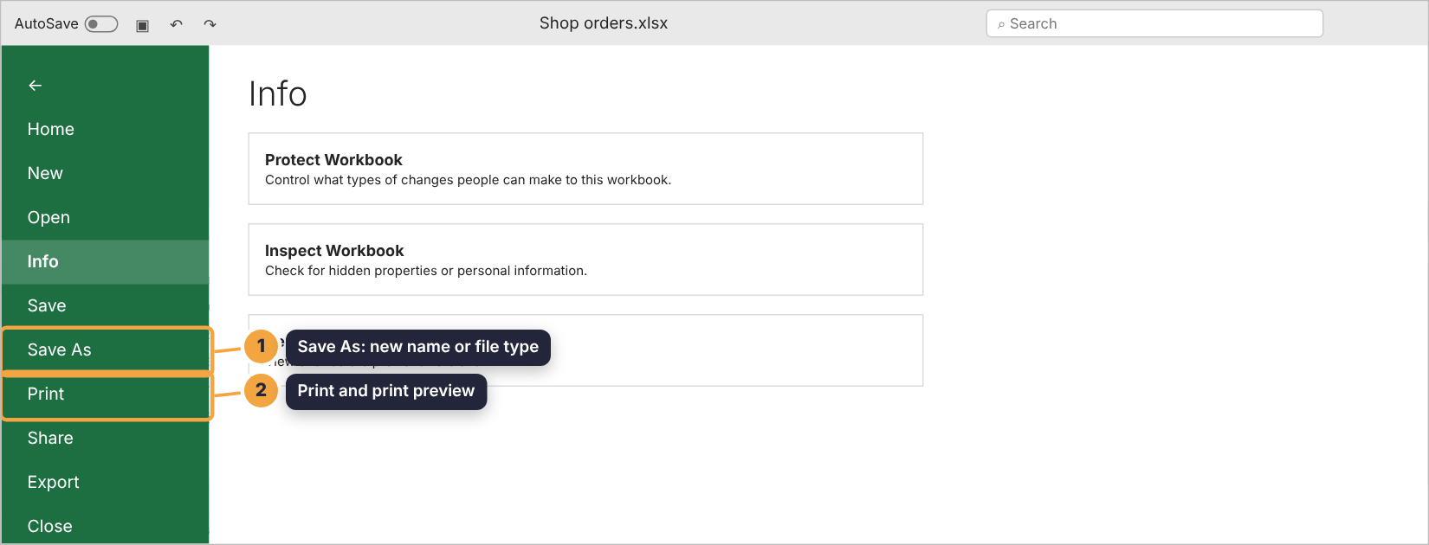
Backstage view: save, open, print, share and export.
Check yourself: You select five numbers. Where can you see their total without writing a formula?

Guided demo
Step through the window, one area at a time.
1. The ribbon: tabs across the top, groups of buttons below. Home holds the everyday tools.
2. The Name Box (left) shows the active cell. The formula bar shows what’s inside it.
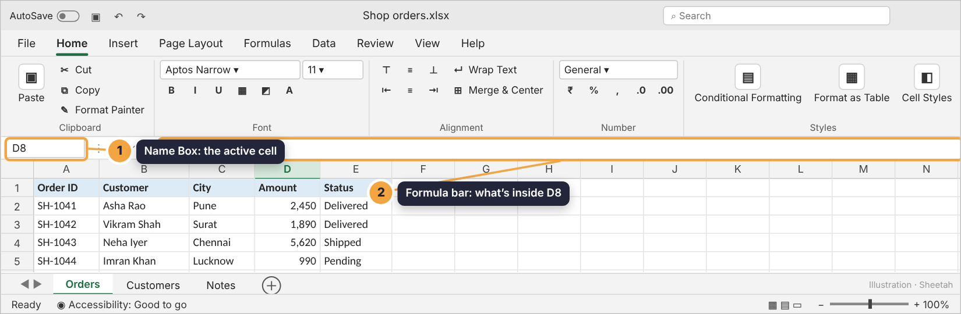
3. Select a range and the status bar does instant maths: Average, Count, Sum.
4. File opens Backstage view, where you save, print, share and export.

Lab: try it yourself
Click on the screenshot to find each part of the window. Sheetah tells you what you clicked.
Open the practice workbook that comes with this lesson, or do the lab in the app.
1. Click the Name Box.
Hint 1: It’s just above the grid.
Hint 2: Left side, next to fx.
Hint 3: It shows the active cell’s address: D4.
2. Click the formula bar.
Hint 1: Above the grid.
Hint 2: To the right of the fx sign.
Hint 3: It shows 5620, the content of D4.
3. Click the tab you’d use to sort and filter data.
Hint 1: It’s one of the ribbon’s tabs.
Hint 2: Sorting and filtering are about data.
Hint 3: Click the Data tab.
4. Click the Quick Access Toolbar, where Save and Undo live.
Hint 1: It’s in the very top bar.
Hint 2: Left of the file name.
Hint 3: The small save and undo icons.
5. Click where you would go to save, print or export the file.
Hint 1: It isn’t a ribbon button.
Hint 2: It’s the first tab.
Hint 3: File opens Backstage view.
6. You select D2:D6 in the order list. What does the status bar show?
- Only the Sum
- Average, Count and Sum
- The formula =SUM(D2:D6)
- Nothing until you write a formula
Hint 1: The status bar works on the selection.
Hint 2: It shows three numbers for a range of numbers.
Hint 3: Average, Count and Sum.

Quiz
1. Which tab holds Freeze Panes and Zoom?
- Home
- View
- Data
- Review
2. What does the Name Box show when you click cell F12?
- The formula in F12
- F12
- The sheet name
- The file name
3. You want to jump to cell X500. Fastest way?
- Scroll down and right
- Type X500 in the Name Box and press Enter
- Use Find
- Insert a new sheet
4. Which opens Backstage view?
- The Home tab
- Pressing F2
- The File tab
- Right-clicking a cell
5. What does AutoSave need to work?
- A file saved on OneDrive or SharePoint
- A password
- Macros
- A Table

Recap
- The ribbon has tabs, groups and buttons; think about which tab’s job a tool is.
- The Name Box shows and jumps to addresses; the formula bar shows what’s really in a cell.
- The status bar gives Sum, Average and Count of any selection.
- File opens Backstage view: save, print, share, export.
Keep this line: Name Box = where you are. Formula bar = what’s really there. Status bar = quick maths.

Answers

Lab
1. Name Box Type an address here and press Enter to jump to it.
2. formula bar
3. Data tab Home has a Sort & Filter button too, but the Data tab holds the full set.
4. Quick Access Toolbar
5. File tab
6. Average, Count and Sum Instant maths, no formula needed. Right-click the status bar to choose Min, Max and more.

Quiz
1. View. Viewing tools live on the View tab.
2. F12. It shows the active cell’s address.
3. Type X500 in the Name Box and press Enter. The Name Box jumps anywhere instantly.
4. The File tab. File opens Backstage view for saving, printing and sharing.
5. A file saved on OneDrive or SharePoint. AutoSave saves continuously to cloud files; for files on your laptop, save with Ctrl+S.

