SHEETAH · EXCEL FOUNDATIONS · MODULE 1: WELCOME TO EXCEL · LESSON NOTES

1.3 Files that last
Saving and AutoSave, file types (.xlsx, .xlsm, .csv), and how Excel versions differ.

By the end of this lesson you can
- Save, and Save As with a new name, place or file type.
- Choose between .xlsx, .xlsm, .csv and .pdf.
- Know what AutoSave and version history do, and what changes between Excel versions.

Lecture

Saving without losing work

Save, or Save As?
Save keeps one file up to date. Save As makes a new copy.
- The first time you save, Excel asks for a name and a folder.
- Make it a habit: Ctrl+S every few minutes.
- 💾 Save · Ctrl+S: updates the same file, in the same place
- 📑 Save As · F12: a copy with a new name, place or file type
In real life · Meera, an accountant: Opens March's file and uses Save As to make *Accounts April.xlsx*, so March stays exactly as it was.

AutoSave and version history
On OneDrive or SharePoint, every change saves itself, and you can go back to an earlier copy.
- File › Info › Version History brings back an older copy.
- On your own laptop AutoSave is off, so press Ctrl+S.
- AutoRecover helps after a crash, but don't rely on it.
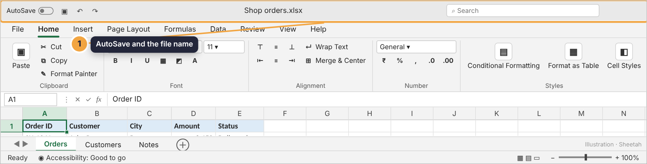
The AutoSave switch sits at the top left.
In real life · A finance team in Gurugram: Shares one budget on OneDrive. When someone overwrote a total, they restored yesterday's version in a minute.
Check yourself: Your file is saved on your laptop's desktop. What keeps your latest changes?

Choosing a file type

Four file types you'll meet
The letters after the dot decide what a file can hold.
- Use .xlsx for almost everything.
- CSV is how systems swap data; PDF is for sending a final copy.
- 📗 .xlsx: the normal workbook: sheets, formulas, formats
- ⚙️ .xlsm: a workbook with macros
- 📄 .csv: plain text: one sheet, values only
- 🧾 .pdf: a print-ready copy nobody can edit
Extension: the letters after the dot

Why saving as CSV loses things
CSV keeps only plain values. Colours, formulas and extra sheets disappear.
- Excel warns about possible data loss: choose Save As › Excel Workbook (.xlsx).
- Downloaded a CSV? Save it as .xlsx before you start working.
Action: Save as CSV
In real life · Imran, a finance intern: Downloaded a bank statement as CSV, added formulas, saved, and lost them all. Now he saves as .xlsx first.

Which Excel are you using?
Files open across versions, but brand-new functions can show as errors on older ones.
- Sharing a file? Ask which Excel the other person uses.
- Excel for the web handles most everyday work.
- 🔄 Microsoft 365: updates itself; new functions first
- 📦 Excel 2019 / 2021: bought once; no new features
- 🌐 Excel for the web: free with a Microsoft account
In real life · A college in Kochi: Its lab runs an older Excel, so students avoid the newest functions in files they share with teachers.
Check yourself: You open a CSV, add formulas and colours, and save it as CSV. What happens?

Guided demo
Save a copy of the workbook as an Excel Workbook with a new name.
1. Press F12 (or File › Save As). Choose where to save: a folder on your laptop or OneDrive.
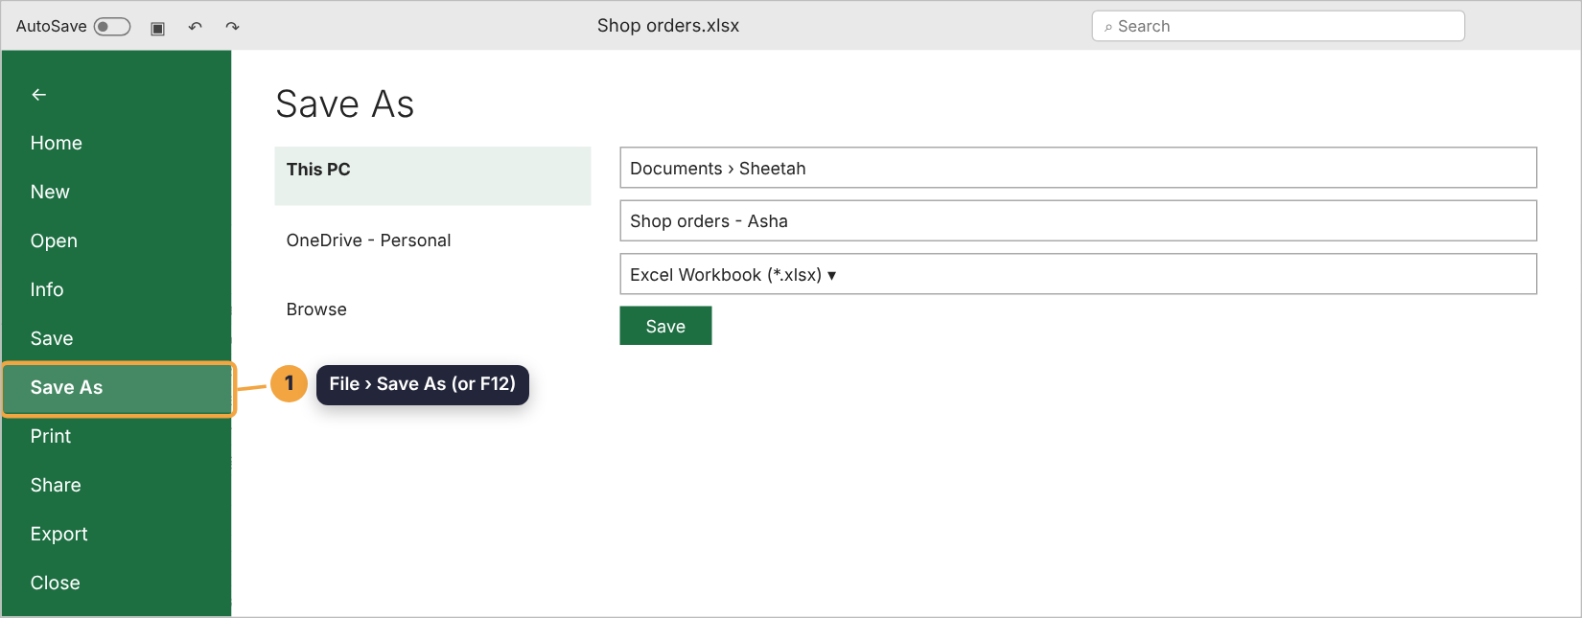
2. Type a clear file name, then open Save as type and pick Excel Workbook (*.xlsx).
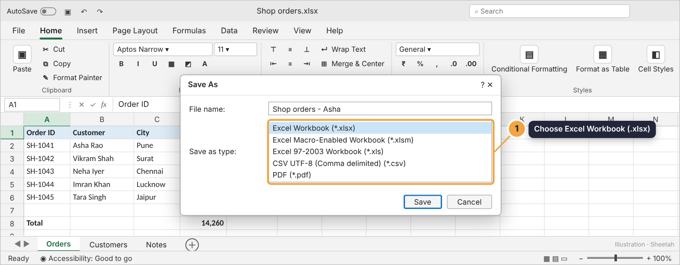
3. Back in the window, the new name shows in the title bar. On OneDrive, switch AutoSave on.

Lab: try it yourself
Decide on file types, then put the Save As steps in order. Finish with a real save in Excel.
Open the practice workbook that comes with this lesson, or do the lab in the app.
1. A bank lets you download your statement as CSV. You add a formula and some colour, then press Ctrl+S, keeping CSV. What happens?
- Everything is kept
- The formula is replaced by its value and the colours are lost
- Excel refuses to save
- The file becomes a PDF
Hint 1: Think about what CSV can store.
Hint 2: CSV is plain text: values and commas.
Hint 3: Formulas and colours can’t be stored in plain text.
2. Which file type do you need for a workbook with macros?
- .xlsx
- .xlsm
- .csv
- .pdf
Hint 1: Macros are code.
Hint 2: Most types refuse to hold code for safety.
Hint 3: The m stands for macro.
3. You must share a final fee summary that nobody should change by accident and that looks the same on every phone. Best format?
- .xlsx
- .csv
- .pdf
- .xlsm
Hint 1: Think about read-only.
Hint 2: Layout must stay the same everywhere.
Hint 3: Export as…
4. Put the steps for saving a copy as an Excel Workbook in order.
- Press F12 (Save As)
- Choose the folder
- Type a new file name
- Choose Excel Workbook (*.xlsx) as the type
- Click Save
Hint 1: Start by opening Save As.
Hint 2: Then choose where, then the name.
Hint 3: The file type comes just before Save.
5. Your file is on OneDrive with AutoSave on. You made a mess an hour ago. What helps?
- Ctrl+Z a hundred times
- Version History
- Save As .csv
- Close without saving
Hint 1: AutoSave keeps saving, so Undo may not reach that far.
Hint 2: OneDrive keeps earlier copies.
Hint 3: File › Info has it.

Real Excel task: Save a workbook properly
1. Add a new sheet with the ⊕ button and rename it Summary.
2. In Summary!A1, type your full name.
3. Press F12 (Save As) and save it as Excel Workbook (.xlsx) with a new name, like *Shop orders - your name.xlsx*.

Quiz
1. What does Ctrl+S do the first time you save a new workbook?
- Nothing
- Asks where to save it and what to call it
- Saves it as CSV
- Prints it
2. Which file type keeps only one sheet of plain values?
- .xlsx
- .xlsm
- .csv
- .pdf
3. Excel warns “Some features might be lost if you save this workbook in CSV”. What should you usually do?
- Click Yes and carry on
- Save As an Excel Workbook (.xlsx) instead
- Delete the formulas
- Ignore it
4. A colleague on Excel 2016 opens your file and sees errors where you used a brand-new function. Why?
- The file is damaged
- Older versions don’t have the newest functions
- They need a password
- CSV was used
5. Which is free to use in a browser?
- Excel for the web
- Excel 2021
- Excel 2019
- Power Pivot

Recap
- Ctrl+S saves; F12 / Save As makes a copy with a new name, place or type.
- .xlsx keeps everything; .csv keeps one sheet of values; .xlsm holds macros; .pdf is a read-only picture.
- On OneDrive, AutoSave and Version History protect your work.
Keep this line: Work in .xlsx. Export to .csv or .pdf only when someone needs that format.

Answers

Lab
1. The formula is replaced by its value and the colours are lost Save As › Excel Workbook (.xlsx) to keep your work.
2. .xlsm
3. .pdf File › Export › PDF, or choose PDF in Save As.
4. Press F12 (Save As) → Choose the folder → Type a new file name → Choose Excel Workbook (*.xlsx) as the type → Click Save
5. Version History Version History lists earlier saves; open one and restore it.

Quiz
1. Asks where to save it and what to call it. The first save is really a Save As.
2. .csv. CSV is plain text: no formats, no formulas, one sheet.
3. Save As an Excel Workbook (.xlsx) instead. Unless a system needs CSV, keep your work in .xlsx.
4. Older versions don’t have the newest functions. New functions arrive in Microsoft 365 first.
5. Excel for the web. Excel for the web is free with a Microsoft account.

