SHEETAH · FORMULAS & FUNCTIONS · MODULE 1: HOW EXCEL CALCULATES · LESSON NOTES

1.1 Anatomy of a function
What a function is made of, how to read Excel’s tooltip, Insert Function, and functions inside functions.

By the end of this lesson you can
- Name the parts of a function: name, brackets, arguments and separators.
- Tell required arguments from optional ones in Excel’s tooltip.
- Build a function with Insert Function (Shift+F3) and the Function Arguments box.
- Nest one function inside another and read it from the inside out.

Lecture

What a function is

A function is a ready-made calculation
A function is a calculation Excel already knows. You hand it some values; it hands back one answer.
- Excel has over 500 functions. About 40 cover most everyday work, and this course teaches them.
- You already know five from C1: SUM, AVERAGE, MIN, MAX and COUNT.
- Change an input and the answer updates by itself.
- 📥 You give it inputs: the arguments: cells, numbers or text
- ⚙️ The function does the work: SUM adds, ROUND rounds, IF decides
- 📤 One answer comes back: and appears in the cell
In real life · A chartered accountant in Surat: doesn’t add 2,000 GST invoices by hand. One =SUM(F2:F2001) does it, and redoes it whenever an invoice changes.
Function: a named, ready-made calculation
Argument: a value you hand to the function

The parts of a function
Every function is written the same way: =NAME(argument1, argument2, …).
- Arguments go inside the brackets, with a comma between each.
- An argument can be a number, a cell, a range, text in "quotes", or another calculation.
- A space after a comma is allowed but not needed.
=ROUND(B2*1.18,0)
- = starts every formula
- ROUND the function’s name
- B2*1.18 argument 1: what to round
- , separator
- 0 argument 2: decimal places
Result: 15929 (when B2 is ₹13,499: 13,499 × 1.18 = 15,928.82, rounded to whole rupees)
In real life · A mobile shop in Lucknow: prices every phone with 18% GST in whole rupees: =ROUND(B2*1.18,0) turns ₹13,499 into ₹15,929.
Separator: the comma between arguments
Syntax: the way a function must be written

Required and optional arguments
As you type a function, Excel shows a tooltip. The argument you’re on is bold; anything in [square brackets] is optional.
- Leave out an optional argument and Excel uses its default value.
- Click the function’s name in the tooltip to open its help page.
- Type =ROUND then press Ctrl+Shift+A and Excel writes in every argument’s name as a reminder.
SUM(number1, [number2], …)
- number1 required
- [number2] optional: in [brackets]
- , … as many more as you like
The tooltip Excel shows while you type =SUM(
In real life · Priya, a data analyst in Bengaluru: never memorises the order of arguments. She types the function, then reads the tooltip one bold word at a time.
Required: must be given
Optional: shown in [brackets]; has a default
Check yourself: In =ROUND(B2*1.18,0), what is the second argument?

Building functions without memorising

Insert Function: Excel fills in the form
Not sure which function, or what goes where? Click fx beside the formula bar (or press Shift+F3) and Excel walks you through it.
- Search in plain words, such as “round a number” or “working days”.
- Pick a function and click OK: the Function Arguments box opens.
- It has one box per argument, says what each one means, and previews the answer.
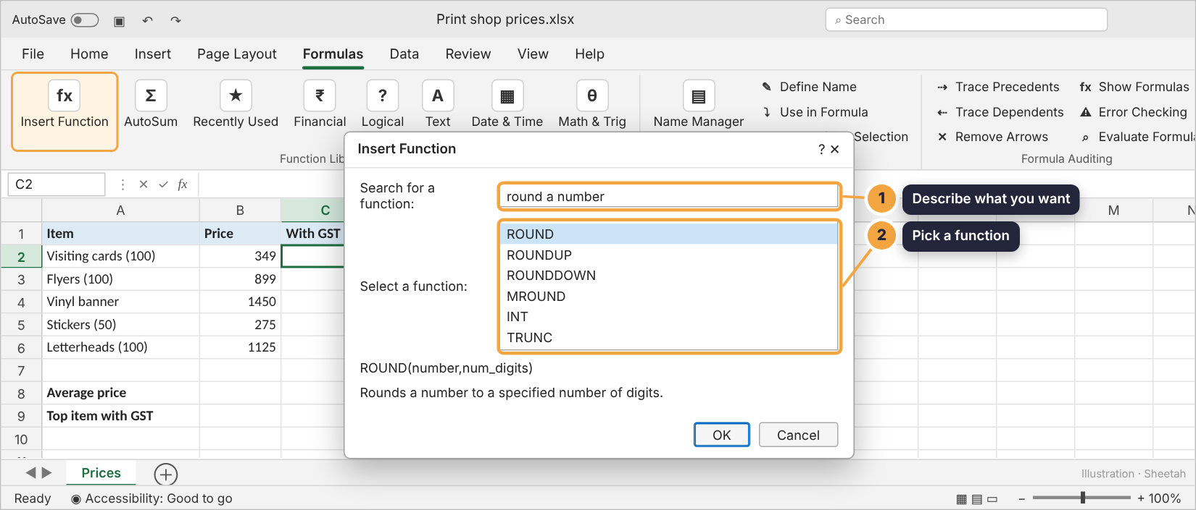
Insert Function: describe what you want in plain words
In real life · A school clerk in Kochi: typed “working days” into Insert Function’s search box and found NETWORKDAYS for the staff-leave sheet. She’d never heard of it.

The Function Arguments box
Fill one box per argument. Excel shows each argument’s value on the right and the final answer at the bottom, before you click OK.
- Click into a box, then click cells on the sheet to fill it.
- Click fx again on an existing formula to reopen this box and check it.
- Great for learning a new function’s arguments.
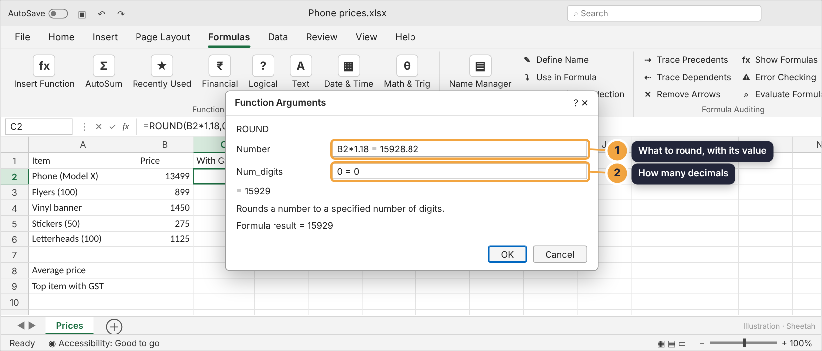
Function Arguments for ROUND: the answer is previewed before you commit
In real life · Imran, a store manager in Bhopal: checks every new formula in Function Arguments first: if the preview looks wrong, he fixes it before anyone sees the report.

Functions inside functions
An argument can itself be a function. Excel works out the inner one first, then hands its answer to the outer one.
- Read a nested formula from the inside out.
- Every ( needs its ). While you type, Excel colours each bracket pair to help you match them.
- Excel allows 64 levels; two or three keep a formula readable.
1. =ROUND(AVERAGE(B2:B4),1) the inner function goes first
2. =ROUND(78.6666…,1) its answer becomes ROUND’s first argument
3. 78.7
With B2:B4 holding 72, 81 and 83.
In real life · A cricket academy in Rajkot: shows each batter’s average to one decimal with =ROUND(AVERAGE(C2:C11),1): AVERAGE runs first, then ROUND tidies it.
Nesting: a function inside another function
Inside out: the order Excel works a nested formula
Check yourself: In =ROUND(SUM(A1:A3)/3,0), what does Excel work out first?

Guided demo
Price the print shop’s list with 18% GST in whole rupees, then nest AVERAGE inside ROUND.
1. Start with the inner calculation: the price plus 18% GST.
2. 411.82 isn’t a price anyone charges. Wrap it in ROUND, with 0 decimal places.
3. Fill it down: every price is rounded the same way.
4. Now the average price…
5. …rounded to whole rupees: AVERAGE goes inside ROUND.
6. The fx? button shows how Excel works it out: the inner AVERAGE first, then ROUND.

Lab: try it yourself
The print shop needs prices with GST. Type each formula in the grid; the hints show the shape if you get stuck.
Open the practice workbook that comes with this lesson, or do the lab in the app.
1. In C2:C6, show each price with 18% GST, rounded to whole rupees. Write it once in C2 and fill down.
Hint 1: The inner part is the price times 1.18: B2*1.18.
Hint 2: Wrap it in ROUND with 0 as the second argument.
Hint 3: =ROUND(B2*1.18,0), then drag the fill handle down to C6.
2. In B8, show the average price of the five items, rounded to whole rupees, with AVERAGE inside ROUND.
Hint 1: AVERAGE(B2:B6) is the inner part.
Hint 2: ROUND( that , 0 ).
Hint 3: =ROUND(AVERAGE(B2:B6),0)
3. In B9, show the price of the most expensive item with GST, in whole rupees.
Hint 1: MAX(B2:B6) finds the highest price.
Hint 2: Multiply that by 1.18, then round.
Hint 3: =ROUND(MAX(B2:B6)*1.18,0)
4. The tooltip for SUM reads SUM(number1, [number2], …). Which is true?
- You must give at least two numbers
- number1 is required; the rest are optional
- SUM takes exactly two arguments
- The brackets mean the value must be text
Hint 1: Look at the square brackets.
Hint 2: Bracketed arguments can be left out.
Hint 3: The … means you can keep going.
5. Put the parts of a function in the order you type them.
- =
- the function name
- (
- the arguments, separated by commas
- )
Hint 1: Every formula starts the same way.
Hint 2: The name comes before the brackets.
Hint 3: Arguments sit between ( and ).

Real Excel task: Price the list in real Excel
1. Open the practice workbook.
2. In C2, type =ROUND( and read the tooltip: number, num_digits.
3. Finish =ROUND(B2*1.18,0) and fill it down to C6.
4. In B8, use fx (Insert Function) to build =ROUND(AVERAGE(B2:B6),0) in the Function Arguments box.
5. Save as .xlsx and upload it here.

Quiz
1. What is an argument?
- The function’s name
- A value you give a function to work with
- The answer a function gives back
- An error message
2. B2 holds 13,499. What does =ROUND(B2*1.18,0) show?
- 15928.82
- 15929
- 15928
- 13499
3. In a function’s tooltip, what do [square brackets] around an argument mean?
- It must be text
- It is optional
- It must be a range
- It is an error
4. Which key opens Insert Function?
- F2
- Shift+F3
- Ctrl+1
- F4
5. In what order does Excel work out =ROUND(AVERAGE(B2:B4),1)?
- ROUND, then AVERAGE
- AVERAGE first, then ROUND
- Both at the same time
- Left to right, ignoring brackets
6. Which formula is written correctly?
- =ROUND(B2*1.18,0
- =ROUND B2*1.18, 0
- =ROUND(B2*1.18,0)
- ROUND(B2*1.18,0)

Recap
- A function is =NAME(arguments): a ready-made calculation that gives one answer.
- Arguments are separated by commas; ones in [brackets] are optional.
- Nested functions work inside out. fx (Shift+F3) builds one for you.
Keep this line: =NAME(argument1, argument2): inner functions first.

Answers

Lab
1.
2. =ROUND(AVERAGE(B2:B6),0)
3. =ROUND(MAX(B2:B6)*1.18,0)
4. number1 is required; the rest are optional Only number1 is required. [number2] and the … are optional extras.
5. = → the function name → ( → the arguments, separated by commas → ) = NAME ( arguments ): the same shape for every function.

Quiz
1. A value you give a function to work with. Arguments are the inputs inside the brackets.
2. 15929. 13,499 × 1.18 = 15,928.82, and ROUND(…,0) gives the nearest whole number: 15,929.
3. It is optional. Bracketed arguments can be left out; Excel uses a default.
4. Shift+F3. Shift+F3, or click fx beside the formula bar.
5. AVERAGE first, then ROUND. Inner functions first: AVERAGE’s answer is handed to ROUND.
6. =ROUND(B2*1.18,0). The first is missing its ), the second its brackets, and the last its = sign (Excel would show it as text).

